Effect of TEN on protein expression of Beclin-1、p62、LC3II/I、Parkin and PINK1 in rat brain tissue induced by ROT
Protein name | Original image | Used in Figure 4
actin | 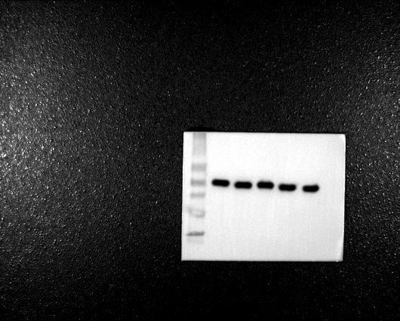 | 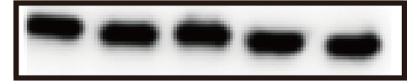
Beclin | 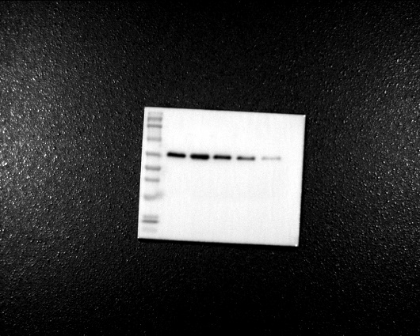 | 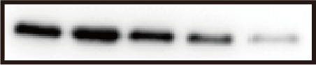
LC3 | 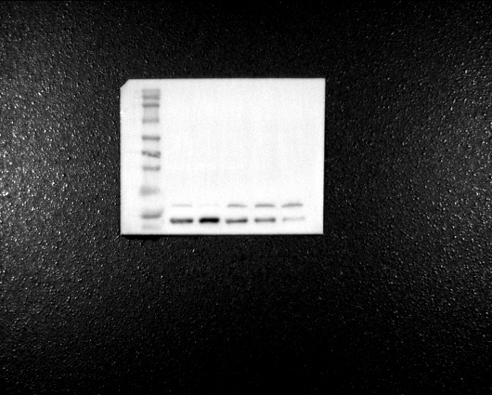 | 
p62 | 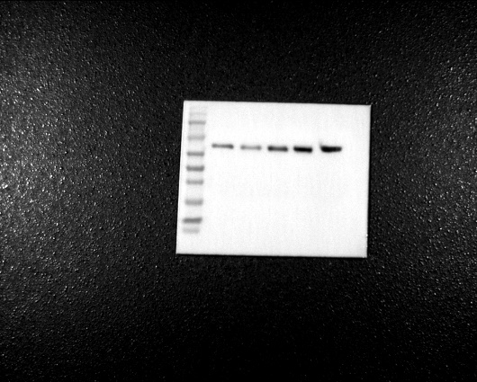 | 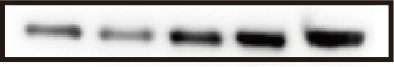
Parkin | 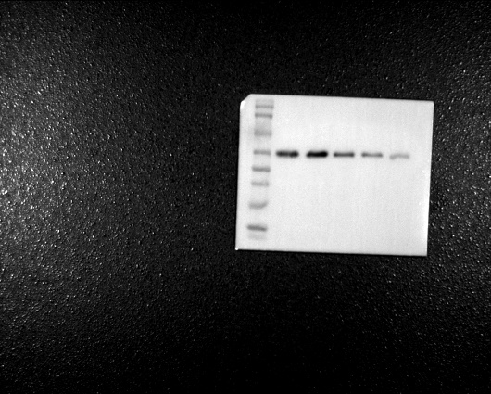 | 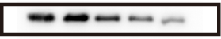
Pink1 | 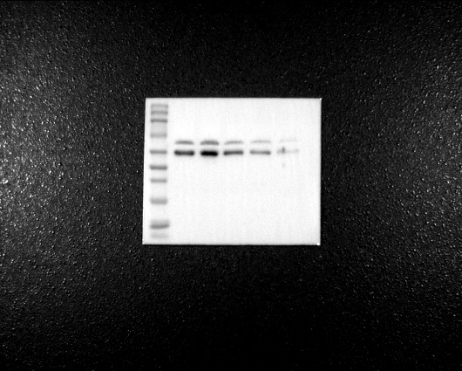 | 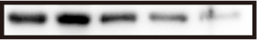
Supplement figure for Figure 4：The black boxes mark the groups we use in Figure 4.All of our images have been exposed with only one development.

Effect of TEN on protein expression of Beclin-1、p62、LC3II/I、Parkin and PINK1 in PC12 cells induced by ROT
Protein name | Original image | Used in Figure 5
actin |  | 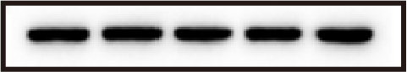
Beclin |  | 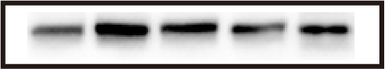
LC3 |  | 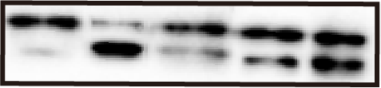
p62 | 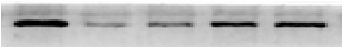 | 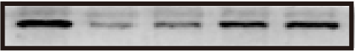
Parkin |  | 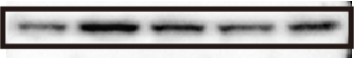
Pink1 |  | 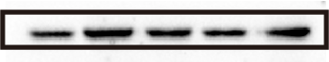
Supplement figure for Figure 5：The black boxes mark the groups we use in Figure 5.All of our images have been exposed with only one development.

