Authors' information
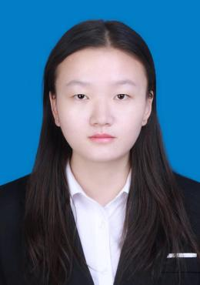
Yunyun Wang received her bachelor’s degree in environment engineering from Shihezi University, China, in 2021. Currently, she is a doctoral student at Shihezi University working under the supervision of Prof. Genlin Zhang. Her research interests pertain to nanobiomaterials that can deliver insulin orally as a diabetes treatment.

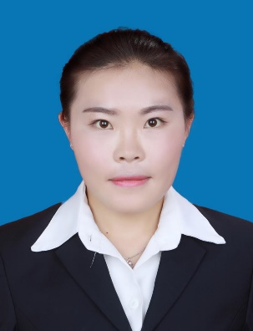
Wangdi Song is studying for a doctorate in chemical engineering and technology at Shihezi University. She got a Master’s degree in 2018, China. Her main research focuses on the application of new ingredients and new dosage forms of plant medicines.



Shengnan Xue is a master student at Shihezi University working under the supervision of Prof. Genlin Zhang in China. She does research in the field of gut microbiology. Her main research focus on gut probiotics and their application.

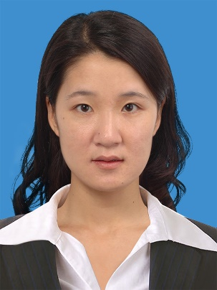
Yan Zhang received her Ph.D in biochemical engineering from East China University Of Science and Technology. She graduated with a Master’s degree in fermentation engineering from Tianjin University of Science and Technology. She is currently working at the School of Chemistry and Chemical Engineering at Shihezi University. Her primary research focuses on biosensing and drug delivery.

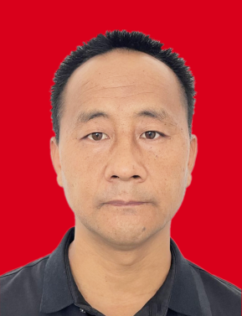
Bo Gao received a bachelor of technology from Tarim University, China, in 2003. He is currently external tutor for master students of agricultural college at Shihezi University. His research area includes pharmaceutical fertilizer new product development and application.

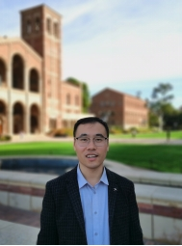
Genlin Zhang received his Ph.D in biochemical engineering from Beijing Institute of Technology, China, in 2015. He graduates with his Master’s in 2007. He is currently a professor of chemical engineering at Shihezi University. His primary research focuses on biomaterials for drug delivery, and biosynthesis of natural products.

