Full unedited gels for Figure 2a
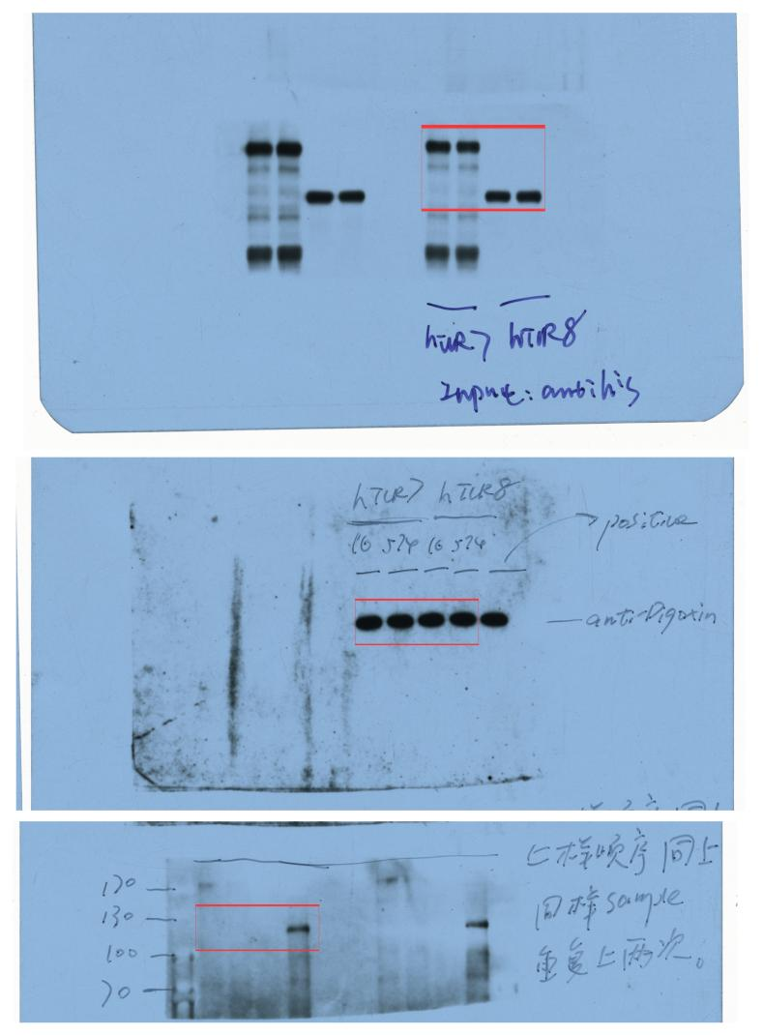

Full unedited gels for Figure 2b
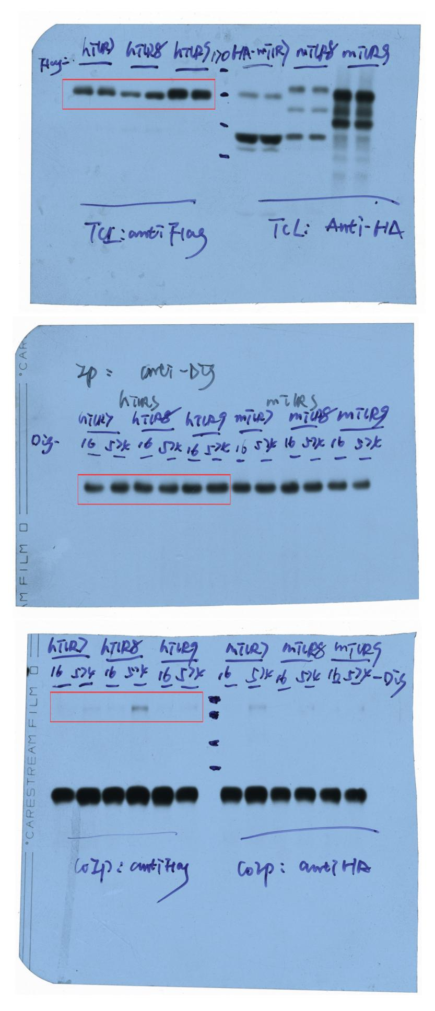

Full unedited gels for Figure 2c
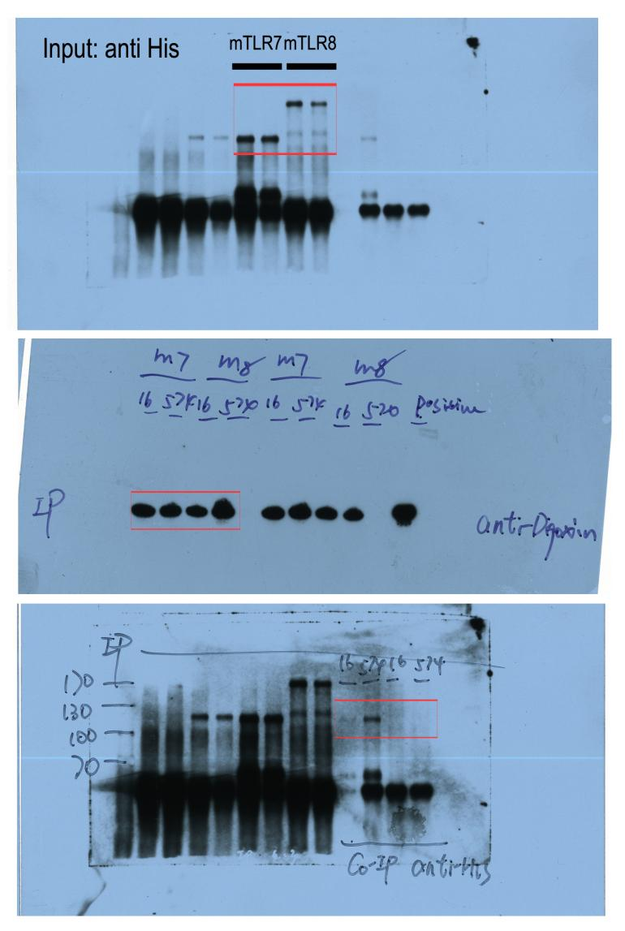

Full unedited gels for Figure 2d
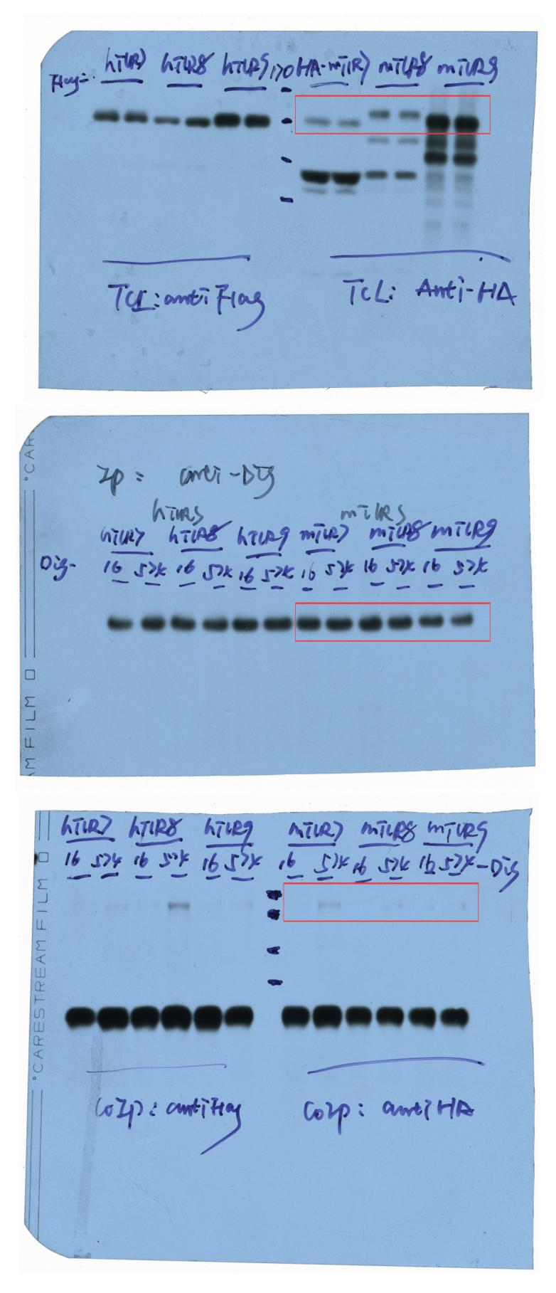

Full unedited gels for Figure 3c
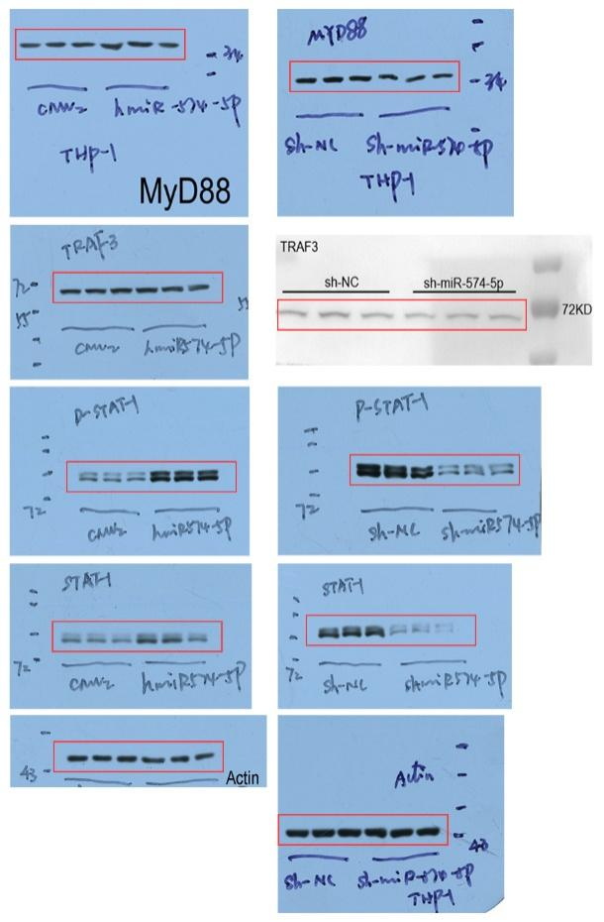

Full unedited gels for Figure 4c
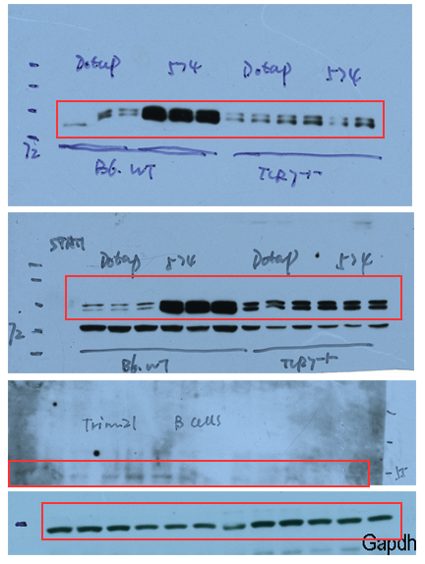

Full unedited gels for Figure 8a
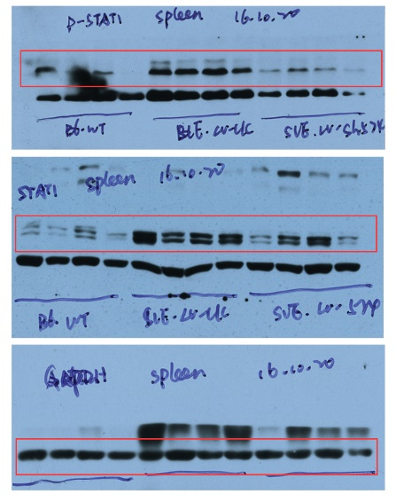

Full unedited gels for Figure S5c
