Uncovering the Relationship between Heavy Metal Exposure, Cognitive Function, and Dietary Inflammation Index in Elderly Americans from the National Health and Nutrition Examination Survey 2011-2014
Chunlan Tang^{1,2}, Min Shen³, Hang Hong^{1,*}
¹School of Public Health, Health Science Center, Ningbo University, Ningbo, Zhejiang, 315211, China
² Key Laboratory of Diagnosis and Treatment of Digestive System Tumors of Zhejiang Province, 2019E10020
³ Reference Laboratory, Medical System Biotechnology Co., Ltd. Ningbo, Zhejiang, 315104, China

* Corresponding author:
School of Public Health, Health Science Center, Ningbo University, Ningbo, Zhejiang, 315211, China
E-mail address: honghang28@163.com (H.Hong)

Table S1 The distribution of the five metals in different populations
Variables | Cd | Pd | Mn | Hg | Se
Sex, n (%)
female | -0.39 ± 0.29 | 0.13 ± 0.24 | 0.96 ± 0.16 | -0.03 ± 0.42 | 2.28 ± 0.07
male | -0.43 ± 0.31 | 0.24 ± 0.27 | 0.92 ± 0.15 | 0.00 ± 0.45 | 2.29 ± 0.06
Age group, n (%)
60-69 years | -0.42 ± 0.32 | 0.17 ± 0.26 | 0.94 ± 0.15 | 0.00 ± 0.43 | 2.29 ± 0.06
70-79 years | -0.39 ± 0.30 | 0.18 ± 0.25 | 0.95 ± 0.15 | -0.01 ± 0.44 | 2.29 ± 0.06
80+ years | -0.39 ± 0.27 | 0.23 ± 0.25 | 0.93 ± 0.17 | -0.05 ± 0.45 | 2.28 ± 0.07
Race, n (%)
Mexican American | -0.49 ± 0.26 | 0.08 ± 0.26 | 0.95 ± 0.13 | -0.25 ± 0.38 | 2.30 ± 0.06
Non-Hispanic Black | -0.40 ± 0.32 | 0.25 ± 0.27 | 0.89 ± 0.16 | -0.01 ± 0.40 | 2.28 ± 0.06
Non-Hispanic White | -0.42 ± 0.30 | 0.19 ± 0.24 | 0.94 ± 0.16 | -0.05 ± 0.43 | 2.29 ± 0.07
Other Hispanic | -0.44 ± 0.28 | 0.12 ± 0.25 | 0.97 ± 0.16 | 0.08 ± 0.38 | 2.29 ± 0.06
Other/multiracial | -0.27 ± 0.28 | 0.19 ± 0.25 | 1.04 ± 0.13 | 0.32 ± 0.49 | 2.30 ± 0.06
Education attainment, n (%)
Less Than 9th Grade | -0.39 ± 0.30 | 0.19 ± 0.31 | 0.93 ± 0.16 | -0.17 ± 0.42 | 2.28 ± 0.06
9-11th Grade | -0.35 ± 0.33 | 0.23 ± 0.27 | 0.94 ± 0.16 | -0.07 ± 0.44 | 2.28 ± 0.07
High School Grad/GED | -0.40 ± 0.32 | 0.19 ± 0.26 | 0.93 ± 0.17 | -0.08 ± 0.42 | 2.28 ± 0.06
Some College or AA degree | -0.41 ± 0.30 | 0.17 ± 0.24 | 0.94 ± 0.15 | -0.04 ± 0.40 | 2.29 ± 0.06
College Graduate or above | -0.45 ± 0.26 | 0.19 ± 0.24 | 0.97 ± 0.15 | 0.19 ± 0.44 | 2.29 ± 0.06
Income status, n (%)
<= 1.30 | -0.36 ± 0.33 | 0.20 ± 0.28 | 0.95 ± 0.17 | -0.12 ± 0.44 | 2.28 ± 0.06
1.31to<3.5 | -0.41 ± 0.30 | 0.18 ± 0.26 | 0.93 ± 0.15 | -0.06 ± 0.41 | 2.29 ± 0.06
>3.5 | -0.45 ± 0.28 | 0.18 ± 0.23 | 0.95 ± 0.15 | 0.13 ± 0.43 | 2.29 ± 0.06
Marital status, n (%)
Never Married | -0.38 ± 0.30 | 0.19 ± 0.26 | 0.93 ± 0.16 | 0.01 ± 0.43 | 2.30 ± 0.08
Married/Living with partner | -0.44 ± 0.29 | 0.18 ± 0.25 | 0.94 ± 0.15 | 0.03 ± 0.45 | 2.29 ± 0.06
Widowed/Divorced/ Separated | -0.37 ± 0.31 | 0.19 ± 0.27 | 0.95 ± 0.17 | -0.09 ± 0.41 | 2.27 ± 0.06
Drinking, n (%)
Non-drinker | -0.43 ± 0.29 | 0.13 ± 0.24 | 0.95 ± 0.17 | -0.07 ± 0.43 | 2.29 ± 0.07
drinker | -0.40 ± 0.31 | 0.21 ± 0.26 | 0.94 ± 0.15 | 0.01 ± 0.44 | 2.29 ± 0.06
Smoke, n (%)
Never smoker | -0.51 ± 0.25 | 0.15 ± 0.24 | 0.95 ± 0.16 | 0.01 ± 0.44 | 2.29 ± 0.06
smoker | -0.31 ± 0.31 | 0.22 ± 0.27 | 0.94 ± 0.15 | -0.03 ± 0.43 | 2.28 ± 0.07
BMI, n (%)
Underweight(<18.5) | -0.24 ± 0.21 | 0.33 ± 0.38 | 0.95 ± 0.23 | 0.10 ± 0.52 | 2.26 ± 0.07
Normal(18.5 to <25) | -0.31 ± 0.32 | 0.25 ± 0.25 | 0.95 ± 0.17 | 0.03 ± 0.48 | 2.28 ± 0.07
Overweight(25 to <30) | -0.42 ± 0.30 | 0.19 ± 0.25 | 0.94 ± 0.15 | 0.01 ± 0.44 | 2.29 ± 0.06
Obese(30 or greater) | -0.47 ± 0.28 | 0.14 ± 0.25 | 0.94 ± 0.15 | -0.07 ± 0.39 | 2.28 ± 0.06
Physical activity, n (%)
Low | -0.38 ± 0.30 | 0.18 ± 0.26 | 0.95 ± 0.16 | -0.07 ± 0.42 | 2.28 ± 0.06
High | -0.43 ± 0.30 | 0.19 ± 0.25 | 0.94 ± 0.15 | 0.04 ± 0.44 | 2.29 ± 0.07
Diabetes, n (%)
No | -0.39 ± 0.30 | 0.21 ± 0.25 | 0.95 ± 0.16 | 0.00 ± 0.44 | 2.29 ± 0.06
Yes | -0.45 ± 0.31 | 0.13 ± 0.27 | 0.93 ± 0.16 | -0.06 ± 0.42 | 2.29 ± 0.06
Hypertension, n (%)
No | -0.40 ± 0.30 | 0.18 ± 0.26 | 0.95 ± 0.15 | 0.03 ± 0.47 | 2.28 ± 0.06
Yes | -0.41 ± 0.30 | 0.19 ± 0.26 | 0.94 ± 0.16 | -0.02 ± 0.43 | 2.29 ± 0.06
Hyperlipidemia, n (%)
No | -0.38 ± 0.31 | 0.21 ± 0.27 | 0.95 ± 0.16 | -0.03 ± 0.44 | 2.28 ± 0.07
Yes | -0.42 ± 0.30 | 0.17 ± 0.25 | 0.94 ± 0.15 | -0.01 ± 0.43 | 2.29 ± 0.06
DII group, n (%)
pro-inflammatory diet | -0.39 ± 0.31 | 0.19 ± 0.26 | 0.94 ± 0.17 | -0.07 ± 0.42 | 2.28 ± 0.06
anti-inflammatory diet | -0.44 ± 0.28 | 0.18 ± 0.25 | 0.95 ± 0.14 | 0.06 ± 0.44 | 2.30 ± 0.07

Table S2 Univariate linear regression analysis of the association between Se, Cd and DSST scores, Se and IRT scores.
Variable | DSST
Se | Model 1 | Model 2 | Model 3 | Model 4 | Model 5
Continuous | 15.26 (9.85~20.67) | 14.46 (9.23~19.7) | 7.18 (3.08~11.29) | 6.18 (2.11~10.26) | 6.41 (2.35~10.46)
P | <0.001 | <0.001 | 0.001 | 0.003 | 0.002
Q1 | 0(Ref) | 0(Ref) | 0(Ref) | 0(Ref) | 0(Ref)
Q2 | 6.33 (4.07~8.58) | 5.8 (3.63~7.97) | 3.1 (1.41~4.8) | 2.95 (1.28~4.62) | 2.87 (1.2~4.53)
Q3 | 7.21 (4.95~9.46) | 6.65 (4.48~8.83) | 3.62 (1.92~5.32) | 3.29 (1.61~4.97) | 3.14 (1.46~4.81)
Q4 | 6.5 (4.25~8.75) | 6.3 (4.12~8.47) | 2.83 (1.11~4.54) | 2.43 (0.73~4.12) | 2.54 (0.85~4.22)
P-t | <0.001 | <0.001 | 0.001 | 0.006 | 0.004
Cd | DSST
Continuous | -2.51 (-3.66~-1.35) | -2.54 (-3.65~-1.43) | -1.21 (-2.11~-0.32) | -1.01 (-1.97~-0.05) | -1.17 (-2.13~-0.22)
P | <0.001 | <0.001 | 0.008 | 0.04 | 0.016
Q1 | 0(Ref) | 0(Ref) | 0(Ref) | 0(Ref) | 0(Ref)
Q2 | -1.12 (-3.41~1.18) | -1.02 (-3.23~1.19) | -1.69 (-3.4~0.01) | -1.71 (-3.4~-0.02) | -1.91 (-3.59~-0.23)
Q3 | -2.04 (-4.31~0.24) | -1.78 (-3.98~0.43) | -1.65 (-3.36~0.07) | -1.58 (-3.3~0.13) | -1.87 (-3.57~-0.16)
Q4 | -4.68 (-6.95~-2.41) | -4.52 (-6.71~-2.32) | -2.36 (-4.12~-0.61) | -1.98 (-3.84~-0.12) | -2.33 (-4.18~-0.48)
P-t | <0.001 | <0.001 | 0.013 | 0.049 | 0.019
Se | IRT
Continuous | 3.13 (1.68~4.58) | 2.11 (0.76~3.45) | 2.01 (0.66~3.37) | 2.06 (0.7~3.41) | 1.95 (0.58~3.31)
P | <0.001 | 0.002 | 0.004 | 0.003 | 0.005
Q1 | 0(Ref) | 0(Ref) | 0(Ref) | 0(Ref) | 0(Ref)
Q2 | 1.34 (0.74~1.95) | 0.89 (0.33~1.45) | 0.89 (0.34~1.45) | 0.89 (0.33~1.45) | 0.89 (0.32~1.45)
Q3 | 1.03 (0.43~1.64) | 0.53 (-0.03~1.09) | 0.5 (-0.06~1.06) | 0.49 (-0.07~1.05) | 0.47 (-0.1~1.03)
Q4 | 1.22 (0.61~1.82) | 0.78 (0.22~1.34) | 0.74 (0.17~1.31) | 0.76 (0.19~1.32) | 0.73 (0.16~1.3)
P-t | 0.001 | 0.031 | 0.047 | 0.042 | 0.058
Model 1:Crude model
Model 2:adjusted by sex, age, race, education, income, marital status.
Model 3:adjusted by sex, age, race, education, income, marital status, physical activity, drinking, smoking, BMI, DII.
Model 4:adjusted by sex, age, race, education, income, marital status, physical activity, drinking, smoking, BMI, DII, diabetes, hypertension, hyperlipidemia.
Model 5:adjusted by sex, age, race, education, income, marital status, physical activity, drinking, smoking, BMI, DII, diabetes, hypertension, hyperlipidemia, and other four metals

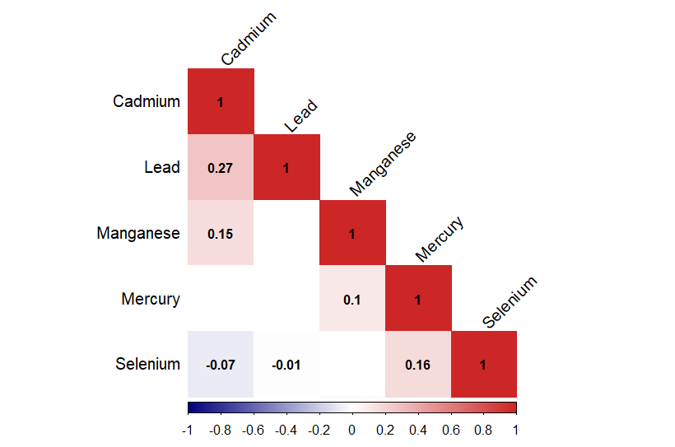
Fig S1 Pearson correlations between ln-transformed concentrations of five heavy metals

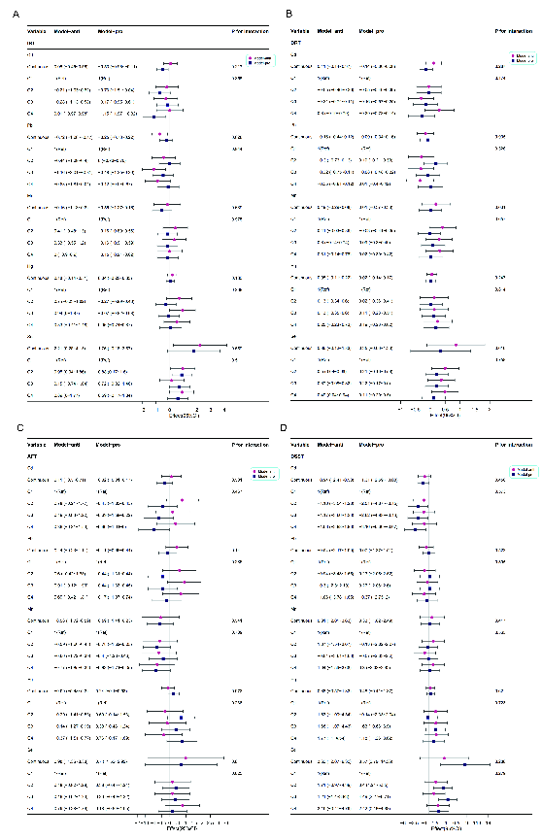
Fig S2 Associations between blood metals (continuous and quartile variables) and four cognitive performance tests in the anti-inflammatory and pro-inflammatory diet. The model was adjusted for adjusted by sex, age, race, education, income, marital status, physical activity, drinking, smoking, BMI, DII, diabetes, hypertension, and hyperlipidemia.

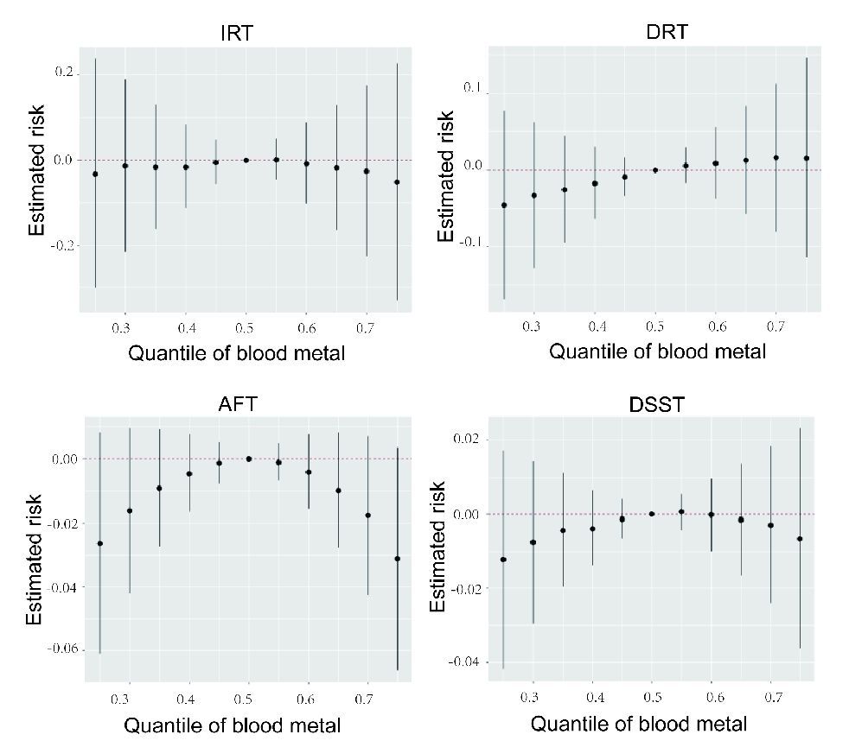
Fig S3 Joint effect (95% CI) of the metals on IRT, DRT, AFT, and DSST when all the metals at particular percentiles were compared to those at their 50th percentile in the whole population by the BKMR model. The model was adjusted for adjusted by sex, age, race, education, income, marital status, physical activity, drinking, smoking, BMI, diabetes, hypertension, hyperlipidemia, and DII.
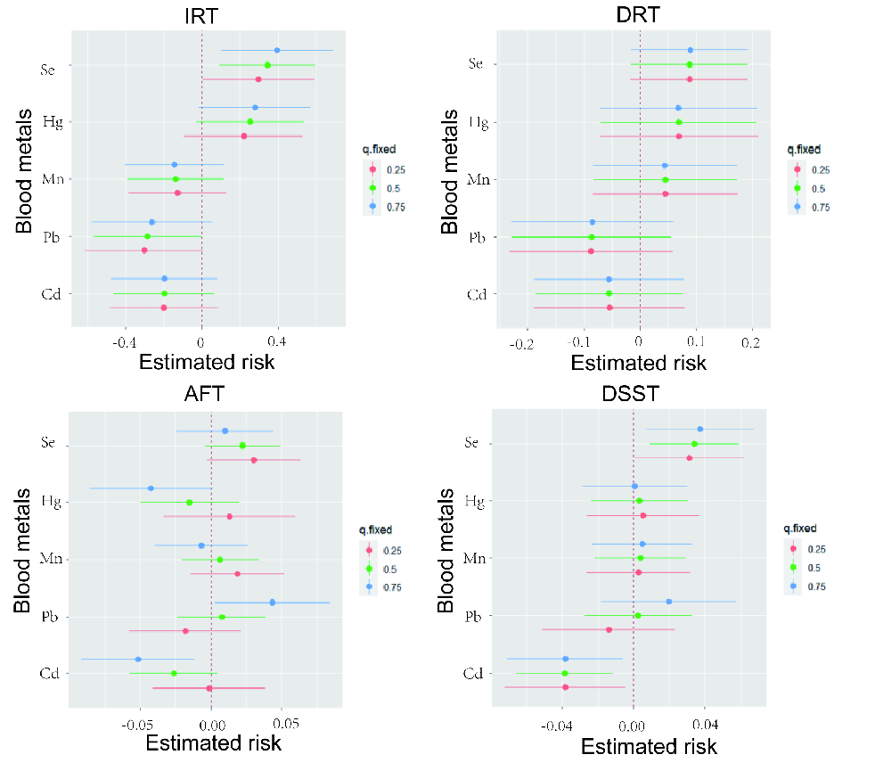
Fig S4 The effect of a single metal variable at the 25th to 75th percentile on the IRT, DRT, AFT, and DSST by BKMR model analysis in the whole population when other metals were fixed at the 25th, 50th, and 75th percentiles.

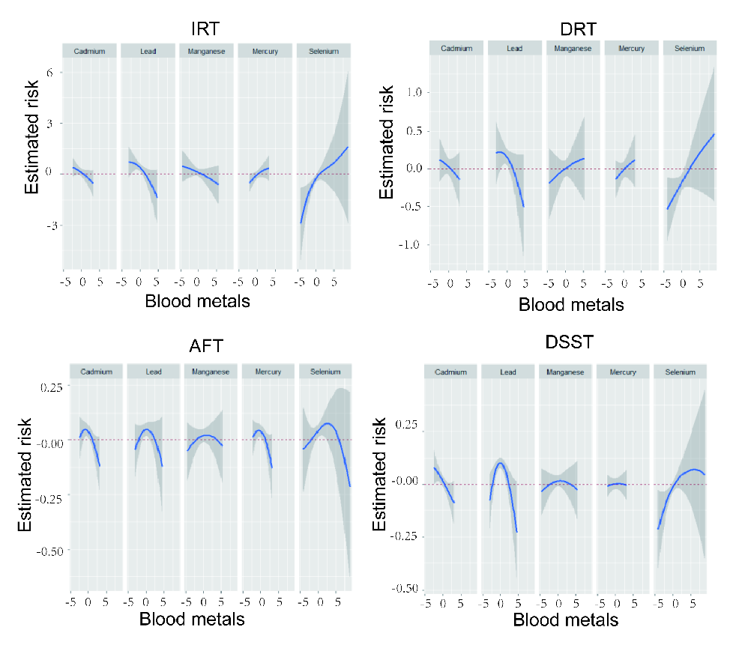
Fig S5 Univariate exposure-response relationships (95% CI) between the metal and cognitive performance tests (IRT, DRT, AFT, and DSST) while fixing at the median for other four metal concentrations in the whole population by the BKMR model. The model was adjusted for adjusted by sex, age, race, education, income, marital status, physical activity, drinking, smoking, BMI, diabetes, hypertension, hyperlipidemia, and DII.
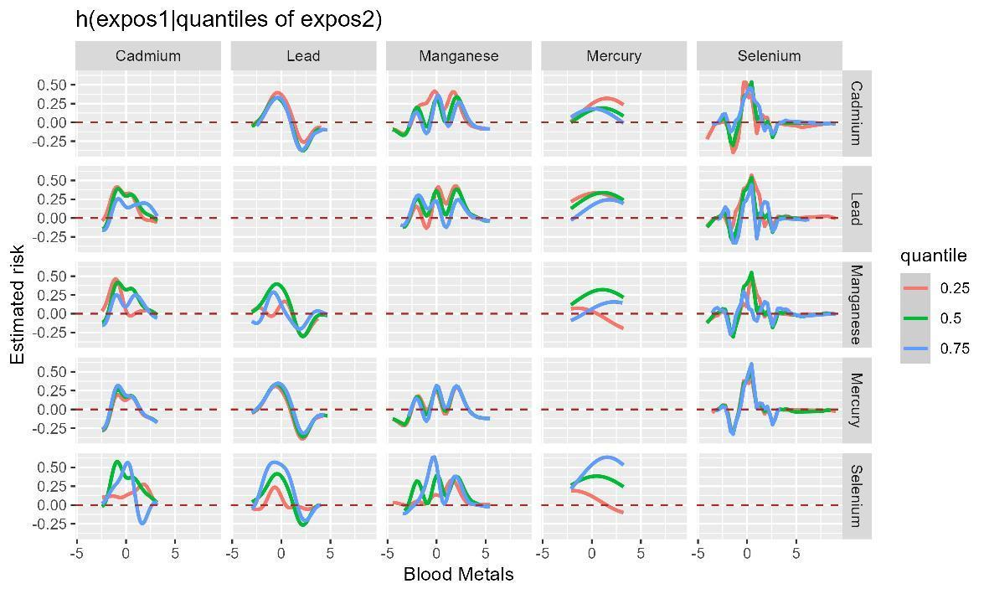
Fig S6 Bivariate exposure-response relationship for each metal on IRT when the other metals were fixed at 25th, 50th, and 75th in the whole population by the BKMR model. The model was adjusted for adjusted by sex, age, race, education, income, marital status, physical activity, drinking, smoking, BMI, diabetes, hypertension, hyperlipidemia, and DII.

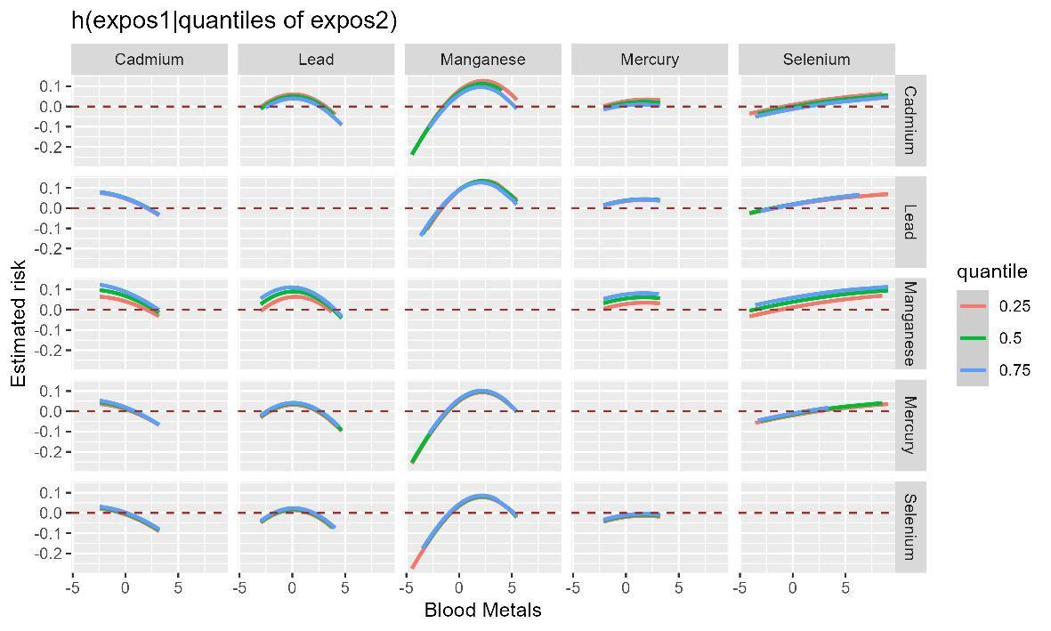
Fig S7 Bivariate exposure-response relationship for each metal on DRT when the other metals were fixed at 25th, 50th, and 75th in the whole population by the BKMR model. The model was adjusted for adjusted by sex, age, race, education, income, marital status, physical activity, drinking, smoking, BMI, diabetes, hypertension, hyperlipidemia, and DII.

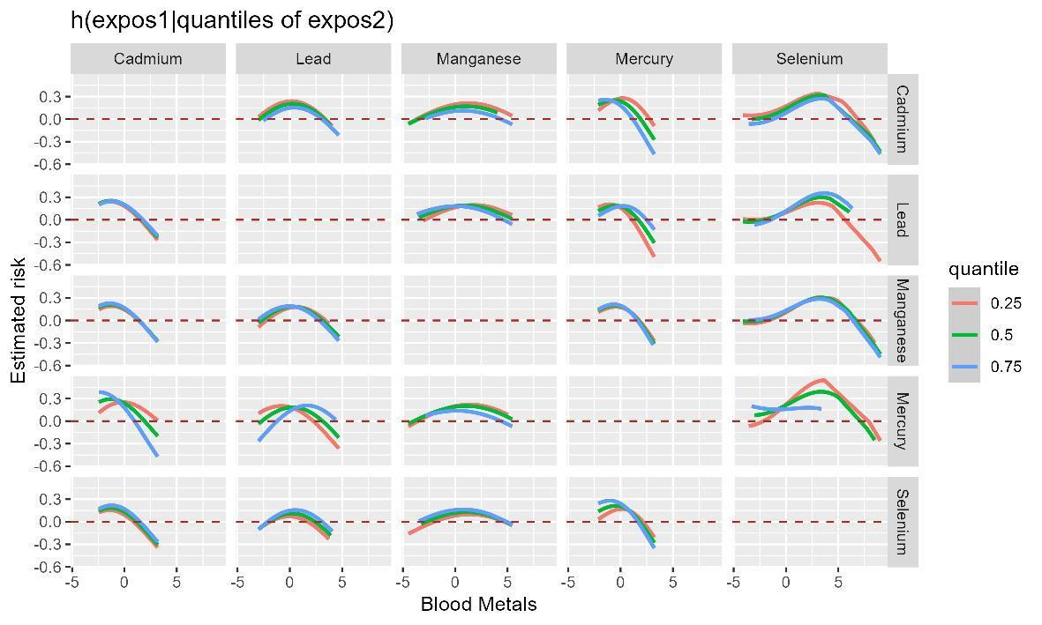

Fig S8 Bivariate exposure-response relationship for each metal on AFT when the other metals were fixed at 25th, 50th, and 75th in the whole population by the BKMR model. The model was adjusted for adjusted by sex, age, race, education, income, marital status, physical activity, drinking, smoking, BMI, diabetes, hypertension, hyperlipidemia, and DII.

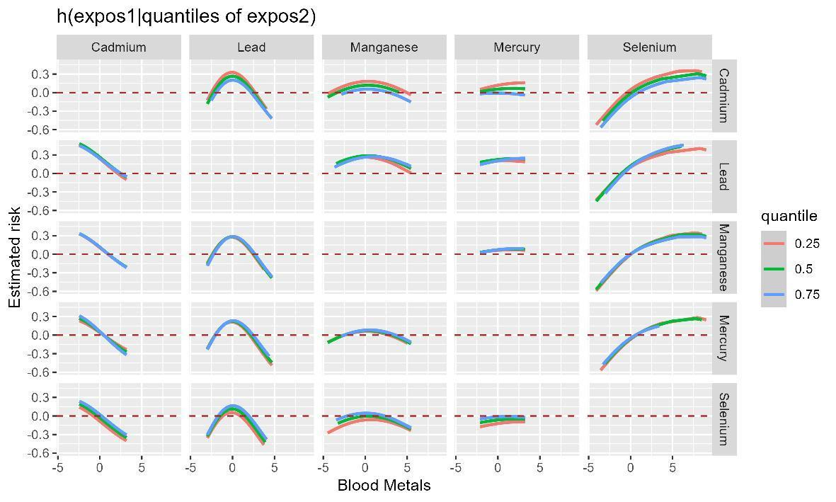
Fig S9 Bivariate exposure-response relationship for each metal on DSST when the other metals were fixed at 25th, 50th, and 75th in the whole population by the BKMR model. The model was adjusted for adjusted by sex, age, race, education, income, marital status, physical activity, drinking, smoking, BMI, diabetes, hypertension, hyperlipidemia, and DII.

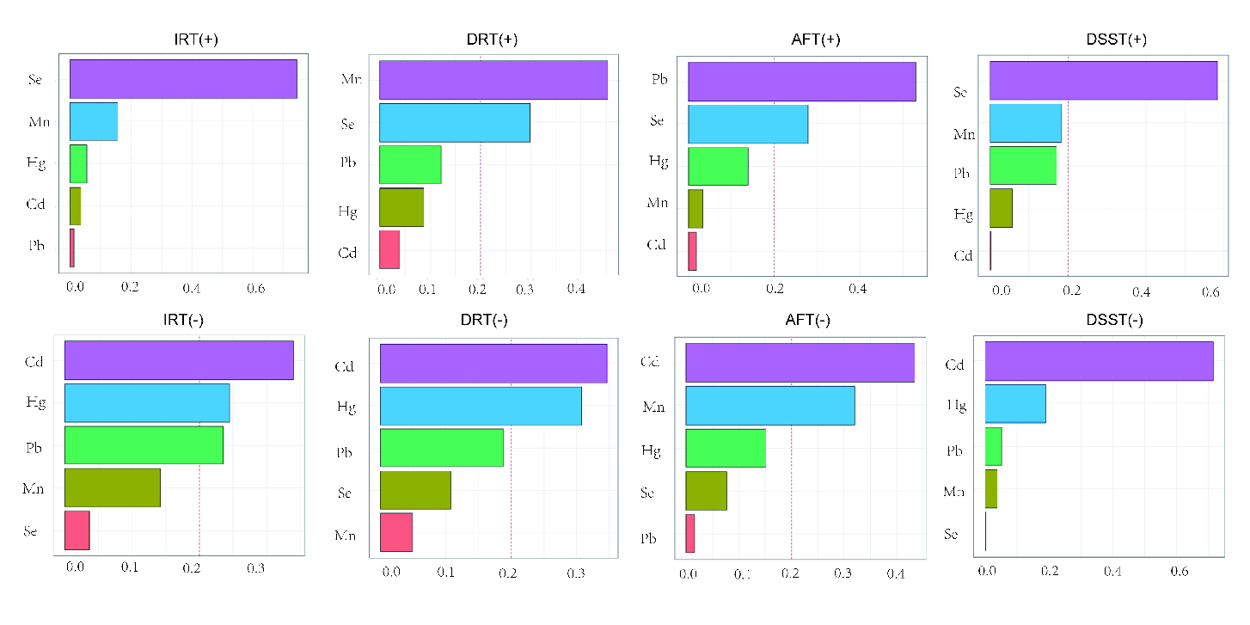
Fig S10 WQS model regression index weights for blood heavy metals and cognitive function in the whole population. The model was adjusted for sex, age, race, education, income, marital status, physical activity, drinking, smoking, BMI, diabetes, hypertension, hyperlipidemia, and DII.
Fig S11 Qg-comp model regression index weights for blood heavy metals and cognitive function in the whole population. The model was adjusted for sex, age, race, education, income, marital status, physical activity, drinking, smoking, BMI, diabetes, hypertension, hyperlipidemia, and DII.
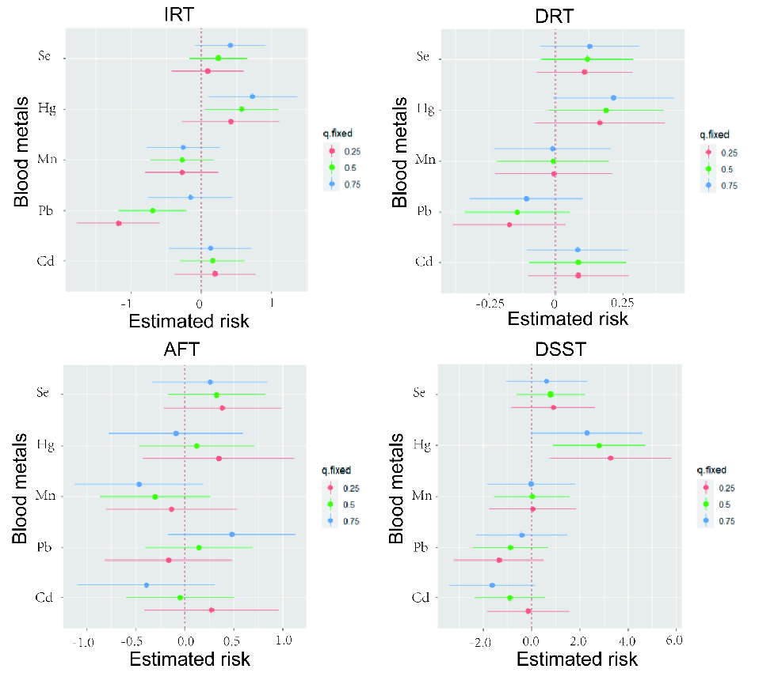
Fig S12 The effect of a single metal variable at the 25th to 75th percentile on the IRT, DRT, AFT, and DSST by BKMR model analysis in the anti-inflammatory population when other metals were fixed at the 25th, 50th, and 75th percentiles.
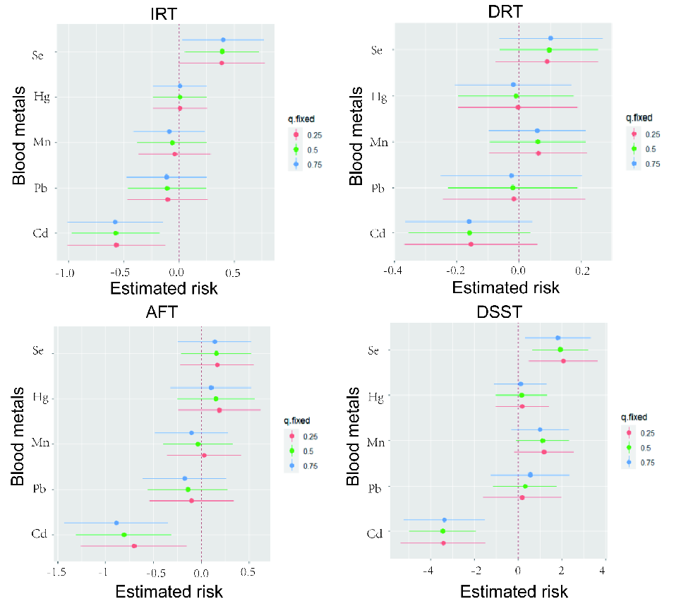
Fig S13 The effect of a single metal variable at the 25th to 75th percentile on the IRT, DRT, AFT, and DSST by BKMR model analysis in the pro-inflammatory population when other metals were fixed at the 25th, 50th, and 75th percentiles.

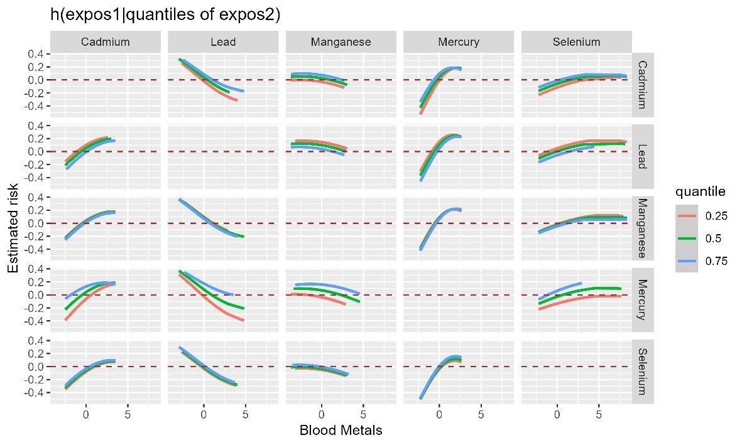
Fig S14 Bivariate exposure-response relationship for each metal on IRT when the other metals were fixed at 25th, 50th, and 75th in the anti-inflammatory population by the BKMR model. The model was adjusted for adjusted by sex, age, race, education, income, marital status, physical activity, drinking, smoking, BMI, diabetes, hypertension, and hyperlipidemia.

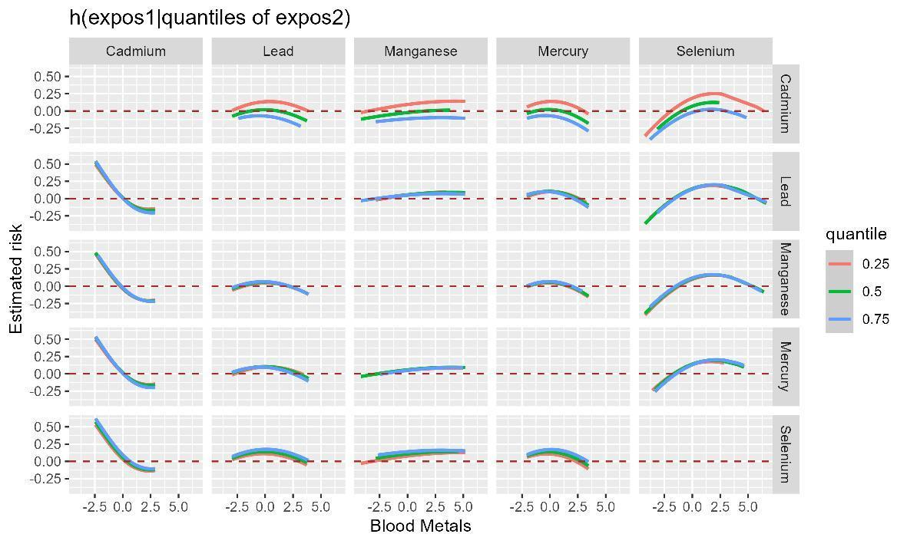
Fig S15 Bivariate exposure-response relationship for each metal on DRT when the other metals were fixed at 25th, 50th, and 75th in the anti-inflammatory population by the BKMR model. The model was adjusted for adjusted by sex, age, race, education, income, marital status, physical activity, drinking, smoking, BMI, diabetes, hypertension, and hyperlipidemia.

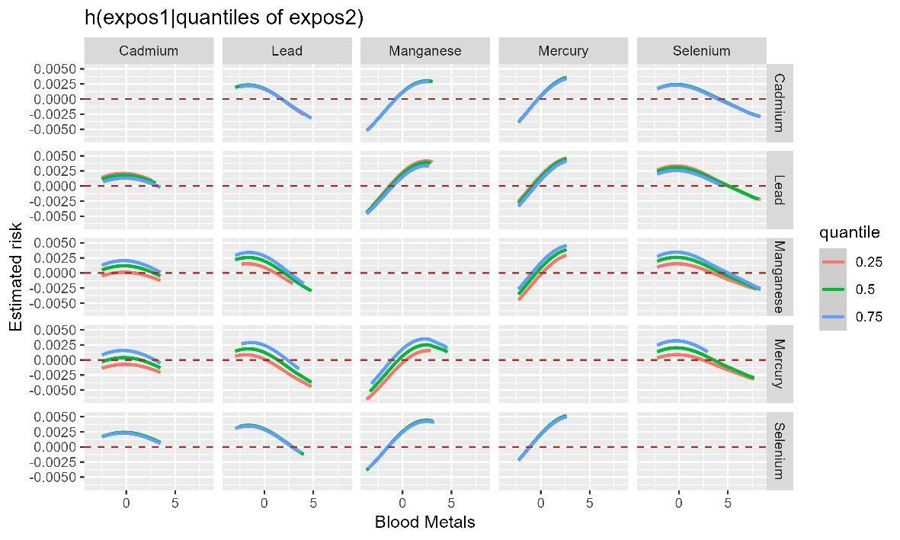
Fig S16 Bivariate exposure-response relationship for each metal on AFT when the other metals were fixed at 25th, 50th, and 75th in the anti-inflammatory population by the BKMR model. The model was adjusted for adjusted by sex, age, race, education, income, marital status, physical activity, drinking, smoking, BMI, diabetes, hypertension, and hyperlipidemia.

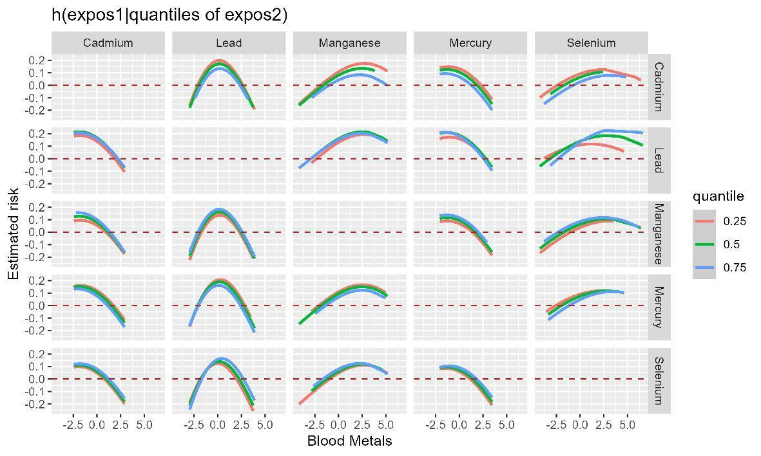
Fig S17 Bivariate exposure-response relationship for each metal on DSST when the other metals were fixed at 25th, 50th, and 75th in the anti-inflammatory population by the BKMR model. The model was adjusted for adjusted by sex, age, race, education, income, marital status, physical activity, drinking, smoking, BMI, diabetes, hypertension, and hyperlipidemia.

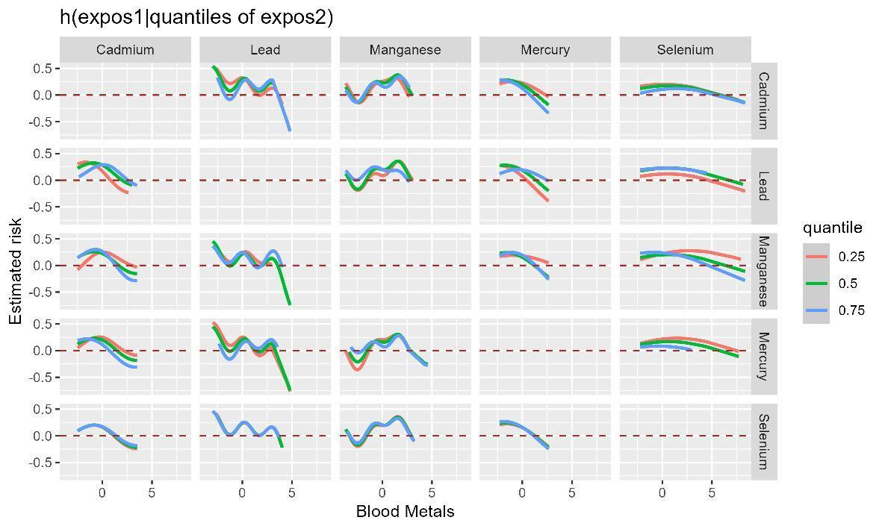
Fig S18 Bivariate exposure-response relationship for each metal on IRT when the other metals were fixed at 25th, 50th, and 75th in the pro-inflammatory population by the BKMR model. The model was adjusted for adjusted by sex, age, race, education, income, marital status, physical activity, drinking, smoking, BMI, diabetes, hypertension, and hyperlipidemia.

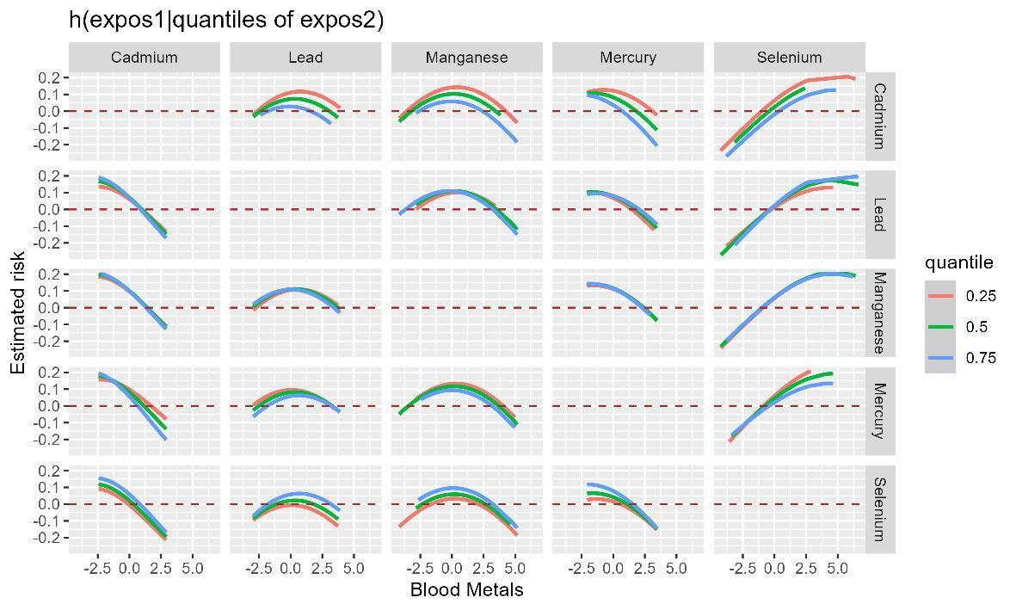
Fig S19 Bivariate exposure-response relationship for each metal on DRT when the other metals were fixed at 25th, 50th, and 75th in the pro-inflammatory population by the BKMR model. The model was adjusted for adjusted by sex, age, race, education, income, marital status, physical activity, drinking, smoking, BMI, diabetes, hypertension, and hyperlipidemia.

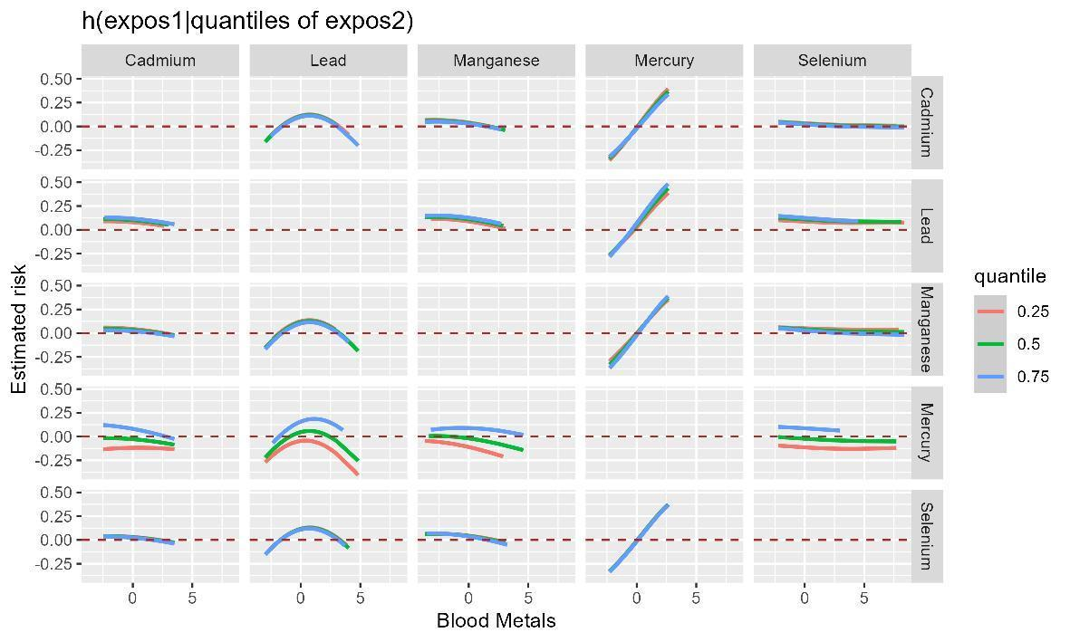
Fig S20 Bivariate exposure-response relationship for each metal on AFT when the other metals were fixed at 25th, 50th, and 75th in the pro-inflammatory population by the BKMR model. The model was adjusted for adjusted by sex, age, race, education, income, marital status, physical activity, drinking, smoking, BMI, diabetes, hypertension, and hyperlipidemia.

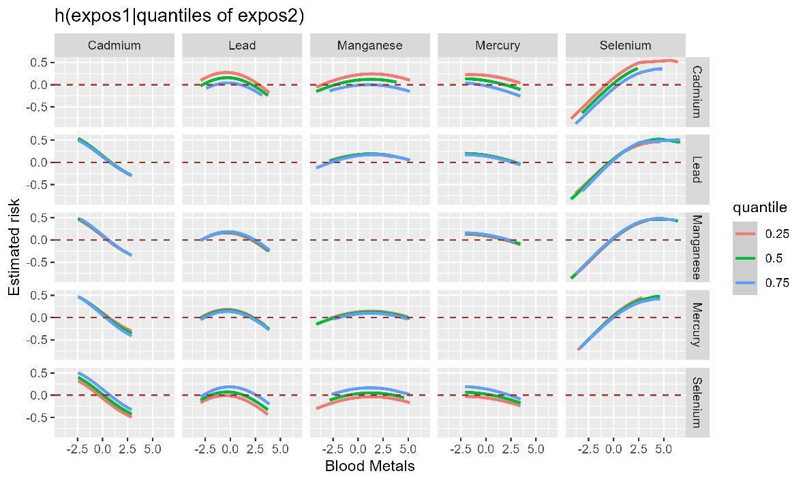
Fig S21 Bivariate exposure-response relationship for each metal on DSST when the other metals were fixed at 25th, 50th, and 75th in the pro-inflammatory population by the BKMR model. The model was adjusted for adjusted by sex, age, race, education, income, marital status, physical activity, drinking, smoking, BMI, diabetes, hypertension, and hyperlipidemia.

