Supplementary Appendix S1.
Development of modified nutrition-dense smoothie diets
The development of modified nutrition-dense smoothie diets involved formulating four smoothies rich in macronutrients using locally available raw materials, enhanced with micronutrients from high-quality herbs and fruits. These formulations were tailored to suit the taste preferences of the Thai older population and adhered to the principles of balanced energy, targeting 1 kcal/ml. The primary ingredients included soy, eggs, vegetable oils, tropical fruits, sesame, and shiitake mushrooms. The formulation process entailed precise calculations and adjustments of nutrients for each recipe, emphasizing high protein content and low, particularly simple, carbohydrate levels. The ingredients were meticulously mixed and blended until achieving homogeneity. The final products underwent sterilization at a high standard (121°C) and were packaged in retort pouch containers, ensuring a one-year shelf life at room temperature in a dry environment. This collaborative effort with the Institute of Food Research and Product Development at Kasetsart University, Thailand, prioritized safety. Rigorous testing for microorganisms (Salmonella spp., Escherichia coli, Staphylococcus aureus, Bacillus cereus, Clostridium spp., and total coliforms), and other toxic substances (Tin, Lead, Mercury, Arsenic, Aflatoxin) were tested and revealed values within the normal range, aligning with the guidelines of the Thai Food and Drug Administration.

Supplementary Appendix S2.
Screening questionnaires for separating participants into asymptomatic swallowing difficulty (ASD) and symptomatic swallowing difficulty (SSD) groups
The screening questionnaire was developed based on both healthcare professionals’ experience and previous reports [1-4]. It was designed to check if individuals had experienced the following symptoms more than one time per week: 'Did you have a swallowing problem?'
- Food stuck in throat
- Choking on food
- Painful swallowing
- Throat irritation
- Nasal regurgitation
- Repeated swallowing
- Not able to eat dry foods or liquid foods

References
1. Dagna C, Avenali M, De Icco R, Gandolfi M, Solaro C, Restivo D, Bartolo M, Meneghello F, Sandrini G, Tassorelli C. From DYMUS to DYPARK: validation of a screening questionnaire for dysphagia in parkinson’s disease. Dysphagia. 2022:1-7.
2. Etges CL, Scheeren B, Gomes E, Barbosa LDR: Screening tools for dysphagia: a systematic review. In: Codas: 2014. SciELO Brasil: 343-9.
3. Kawashima K, Motohashi Y, Fujishima I. Prevalence of dysphagia among community-dwelling elderly individuals as estimated using a questionnaire for dysphagia screening. Dysphagia. 2004;19:266-71.
4. Simons JA, Fietzek UM, Waldmann A, Warnecke T, Schuster T, Ceballos-Baumann AO. Development and validation of a new screening questionnaire for dysphagia in early stages of parkinson's disease. Parkinsonism Relat Disord. 2014;20(9):992-8.

Supplementary Appendix S3.
A 9-point hedonic scale for sensory evaluation
(1 = dislike extremely; 2 = very dislike; 3 = dislike moderately; 4 = dislike slightly; 5 = neutral; 6 = like slightly; 7 = like moderately; 8 = very like; 9 = like extremely)
Pre-test
Sensory attributes | Scoring
Sensory attributes | 1 | 2 | 3 | 4 | 5 | 6 | 7 | 8 | 9
Characteristic |  |  |  |  |  |  |  |  | 
Color |  |  |  |  |  |  |  |  | 
Smell |  |  |  |  |  |  |  |  | 
Viscosity |  |  |  |  |  |  |  |  | 
Satisfaction |  |  |  |  |  |  |  |  | 

Post-test
Sensory attributes | Scoring
Sensory attributes | 1 | 2 | 3 | 4 | 5 | 6 | 7 | 8 | 9
Color |  |  |  |  |  |  |  |  | 
Smell |  |  |  |  |  |  |  |  | 
Taste |  |  |  |  |  |  |  |  | 
Viscosity |  |  |  |  |  |  |  |  | 
Homogeneity |  |  |  |  |  |  |  |  | 
Swallowing |  |  |  |  |  |  |  |  | 
Satisfaction |  |  |  |  |  |  |  |  | 

Supplementary Appendix S4.
The evaluation by healthcare professionals from the findings of the FEES
The food residue was evaluated from the findings of the FEES for the presence or absence of post swallow residue in the four areas: 1) retention of the bolus in the valleculae of the pharynx, 2) nasopharyngeal regurgitation of food or water in the nasal cavity, 3) penetration of the larynx if food goes down into the larynx, and 4) aspiration if food passes through the trachea. If residue was present, then additional scores were weighed toward three anatomical regions: 5) premature spillage when the bolus leaks or falls into the hypopharynx before swallowing, 6) retention of the bolus and/or secretion, and 7) entrance of the bolus into the larynx or trachea. The healthcare professional rated the food residue in 5) and 6) as a percent of the space filled by assigning 5 scores based on the perception of the amount of residue compared to the total amount of bolus swallowed. A '5, none' represented no residue, '4, mild' refers to <26% remaining in the bolus, '3, moderate' refers to 26-50%, '2, marked' refers to 51-75% and “1, severe” referred to >75%. The scores of 7) were classified according to the following criteria: '5' represented no entry of materials into the larynx or trachea, '4' referred to the entry of materials into the larynx above the trachea with reflex cough, '3' referred to the entry of materials into the larynx above the trachea without reflex cough, '2' referred to the entry of materials into the larynx with the formation of reflex cough, and '1' referred to the entrance of materials into the trachea without reflex cough.

Fiber-optic Endoscopic Evaluation of Swallowing (FEES)
Findings from FEES
Retention of bolus |  0=not found  1=found
Nasopharyngeal regurgitation |  0=not found  1=found
Laryngeal penetration |  0=not found  1=found
Aspiration |  0=not found  1=found

Problem | Severity | Score
Premature spillage of material |  None: 0% total amount of bolus swallowed   Mild: <26% total amount of bolus swallowed   Moderate: 26-50% total amount of bolus swallowed   Marked: 51-75% total amount of bolus swallowed   Severe: >75% total amount of bolus swallowed | 5 scores  4 scores  3 scores  2 scores  1 score
Retention/pooling of material and/or secretion |  None: 0% total amount of bolus swallowed or saliva   Mild: <26% total amount of bolus swallowed or saliva   Moderate: 26-50% total amount of bolus swallowed or saliva   Marked: 51-75% total amount of bolus swallowed or saliva   Severe: >75% total amount of bolus swallowed or saliva | 5 scores  4 scores  3 scores  2 scores  1 score
Entrance of material and/or secretion into the larynx or trachea: presence/absence of reflex cough |  No entrance of materials into larynx or trachea   Entrance of materials into larynx above trachea/reflex cough   Entrance of materials into larynx about trachea/no reflex cough   Entrance of materials into trachea with reflex cough forming   Entrance of materials into trachea/no reflex cough | 5 scores  4 scores  3 scores  2 scores  1 score
Total Score |  | …. / 15 scores
*Total score 15 scores means no swallowing difficulties

Supplementary Figure S1. Test diets. Panel (A) The five types of diet for sensory tests. From left to right, these include WS, WSLC, BSLC, CS, and Ensure® (control), Panel (B) The three types of diet for the swallowing test. From left to right, these include WS, CS, and Ensure® (control), green-dyed water (for rinse after swallowing).
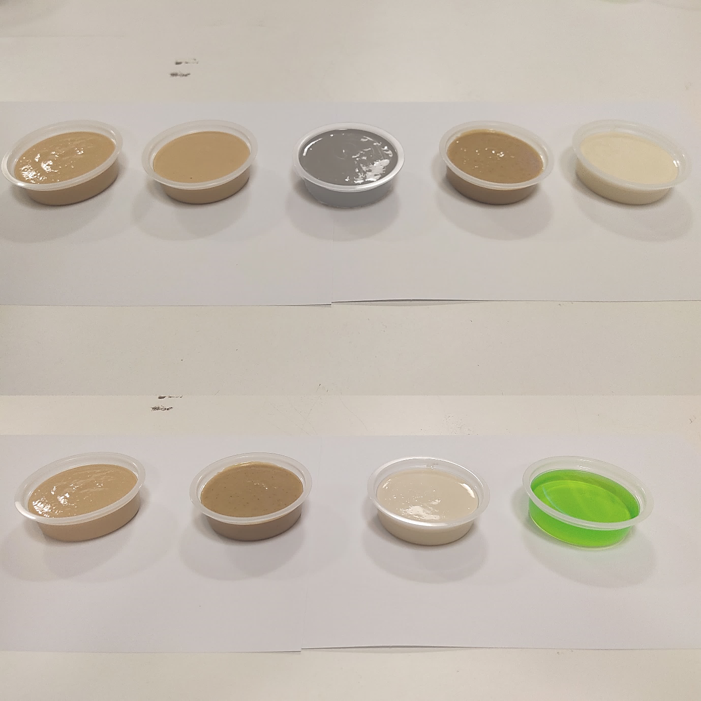
(A)
(B)

Supplementary Table S1. Sensory rating of key properties of test diets
Properties | WS |  | WSLC |  | BSLC |  | CS |  | Ensure® |  | p-value*
Properties | Median | (IQR) | Median | (IQR) | Median | (IQR) | Median | (IQR) | Median | (IQR) | p-value*
Panel 1: Pre-test
Characteristic | 5ª | (5-7) | 5^{ab} | (4-7) | 5^{c} | (3-5) | 5^{b} | (4-7) | 7^{d} | (5-8) | <0.001
Color | 7ª | (5-8) | 6^{ab} | (5-7) | 5^{c} | (3-6) | 5^{b} | (5-7) | 7^{d} | (6-8) | <0.001
Smell | 5ª | (5-7) | 5ª | (4-7) | 5ª | (5-7) | 5ª | (3-7) | 7^{b} | (7-8) | <0.001
Viscosity | 6^{ab} | (5-7) | 5^{b} | (4-7) | 5^{b} | (3-7) | 7^{ac} | (5-7) | 7^{c} | (5-7) | 0.001
Satisfaction | 6ª | (5-7) | 5ª | (5-7) | 5ª | (4-7) | 7ª | (5-7) | 7^{b} | (7-8) | <0.001
Panel 2: Post-test
Color | 7ª | (5-7) | 7ª | (5-7) | 5^{b} | (3-5) | 5ª | (5-7) | 8^{c} | (7-8) | <0.001
Smell | 6ª | (5-7) | 5^{ab} | (4-7) | 5^{b} | (4-7) | 6^{ab} | (3-7) | 7^{c} | (7-8) | <0.001
Taste | 7ª | (5-8) | 5^{b} | (4-7) | 5^{b} | (4-7) | 5^{ab} | (3-7) | 7^{c} | (6-8) | <0.001
Viscosity | 7ª | (5-8) | 5^{b} | (4-7) | 5^{b} | (3-7) | 7^{ab} | (5-8) | 7ª | (5-8) | 0.001
Homogeneity | 7^{ab} | (5-8) | 6ª | (4-7) | 6ª | (5-7) | 7ª | (5-8) | 7^{b} | (5-8) | 0.002
Swallowing | 7ª | (5-8) | 6ª | (5-7) | 5ª | (4-7) | 7ª | (5-7) | 8^{b} | (6-8) | <0.001
Satisfaction | 7ª | (5-8) | 6ª | (5-7) | 6ª | (4-7) | 7ª | (5-8) | 8^{b} | (7-8) | <0.001
*p-value for differences between five test meals using the nonparametric Kruskal-Wallis method (p < 0.05); Within a row, values with different superscript letters (a,b,c,d) are significantly different using Mann-Whitney comparisons (Bonferroni adjusted) (p < 0.05). Abbreviations: BSLC, black sesame soy milk smoothie (low carbohydrate); CS, chicken shitake smoothie; IQR, Interquartile range; WS, white sesame soy milk smoothie; WSLC, white sesame soy milk smoothie (low carbohydrate).

Supplementary Table S2. The findings of the FEES for the presence or absence of post-swallow residue in the four areas
Test diets | Participant  group | Findings, n (%)
Test diets | Participant  group | Retention of bolus | Nasopharyngeal regurgitation | Laryngeal penetration | Aspiration
WS | ASD | 21 (65.6) | 0 (0.0) | 0 (0.0) | 0 (0.0)
WS | SSD | 19 (61.3) | 0 (0.0) | 4 (12.9) | 0 (0.0)
CS | ASD | 15 (46.9) | 0 (0.0) | 0 (0.0) | 0 (0.0)
CS | SSD | 19 (61.3) | 0 (0.0) | 2 (6.5) | 0 (0.0)
Ensure® | ASD | 19 (59.4) | 0 (0.0) | 1 (3.1) | 0 (0.0)
Ensure® | SSD | 22 (71.0) | 0 (0.0) | 4 (12.9) | 0 (0.0)
Abbreviations: ASD, asymptomatic swallowing difficulty; CS, chicken shitake smoothie; SSD, symptomatic swallowing difficulty; WS, white sesame soy milk smoothie.

Supplementary Table S3. The proportion of participants in each level of swallowing disorders by FEES
Participants, n (%) | ASD |  |  | SSD
Test diets | WS | CS | Ensure® | WS | CS | Ensure®
Premature spillage of material
None | 31 (96.9) | 32 (100) | 27 (84.4) | 30 (96.8) | 29 (93.5) | 24 (77.4)
Mild | 1 (3.1) | 0 (0) | 4 (12.5) | 1 (3.2) | 2 (6.5) | 4 (12.9)
Moderate | 0 (0) | 0 (0) | 0 (0) | 0 (0) | 0 (0) | 3 (9.7)
Marked | 0 (0) | 0 (0) | 1 (3.1) | 0 (0) | 0 (0) | 0 (0)
Severe | 0 (0) | 0 (0) | 0 (0) | 0 (0) | 0 (0) | 0 (0)
p-value | 0.105 |  |  | 0.068
Retention/pooling of material and/or secretion
None | 12 (37.5) | 17 (53.1) | 13 (40.6) | 12 (38.7) | 13 (41.9) | 9 (29.0)
Mild | 18 (56.3) | 13 (40.6) | 18 (56.3) | 10 (32.3) | 11 (35.5) | 17 (54.8)
Moderate | 1 (3.1) | 2 (6.3) | 0 (0) | 5 (16.1) | 3 (9.7) | 4 (12.9)
Marked | 1 (3.1) | 0 (0) | 1 (3.1) | 4 (12.9) | 3 (9.7) | 1 (3.2)
Severe | 0 (0) | 0 (0) | 0 (0) | 0 (0) | 1 (3.2) | 0 (0)
p-value | 0.541 |  |  | 0.507
Entrance of material and/or secretion into the larynx or trachea
5 scores | 32 (100) | 32 (100) | 31 (96.9) | 30 (96.8) | 30 (96.8) | 28 (90.3)
4 scores | 0 (0) | 0 (0) | 1 (3.1) | 0 (0) | 0 (0) | 2 (6.5)
3 scores | 0 (0) | 0 (0) | 0 (0) | 1 (3.2) | 0 (0) | 1 (3.2)
2 scores | 0 (0) | 0 (0) | 0 (0) | 0 (0) | 0 (0) | 0 (0)
1 score | 0 (0) | 0 (0) | 0 (0) | 0 (0) | 1 (3.2) | 0 (0)
p-value | 0.364 |  |  | 0.313
Abbreviations: ASD, asymptomatic swallowing difficulty; CS, chicken shitake smoothie; SSD, symptomatic swallowing difficulty; WS, white sesame soy milk smoothie.

