Supplementary figures
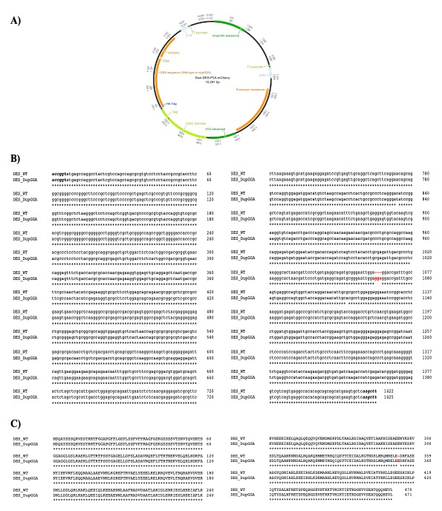
Supp. Fig. 1. A) Scheme of the plasmid used for DES_dupGGA and DES_WT overexpression in HEK cells. B) DES_WT and DES_dupGGA sequence alignment. The only difference is the GGA insertion (in red) in DES_dupGGA sequence. Part of the plasmid sequence is shown in italic bold. C) Alignment of DES_dupGGA and DES_WT translation. The Glu (E) insertion in DES_dupGGA protein sequence is shown in red.

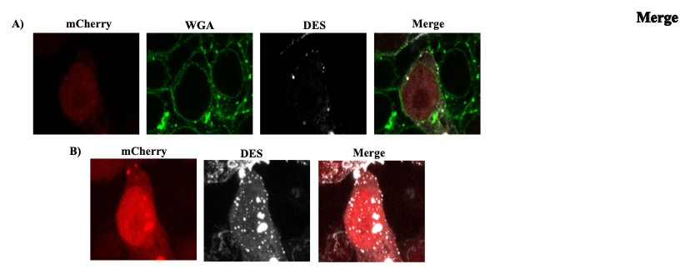

Supp. Fig. 2. Confocal microscopy of one HEK cell that expresses mCherry and DES_dupGGA. Cell membrane is stained with WGA (green). a) Image of one of the Z planes where the formation of DES aggregates (in white) in the membrane can be seen. b) Compilation of all Z images of the HEK cell where all DES aggregates can be appreciated.

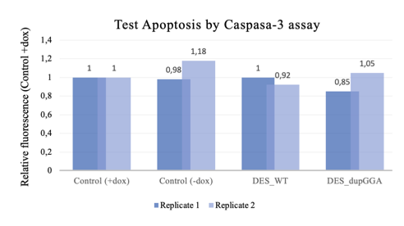
Supp. Fig. 3. Relative values of Caspase 3 activity comparing HEK cells after 3 days of doxycycline incubation. The experimental groups were HEK cells that were incubated with doxycycline (Control +dox group), HEK cells that were not incubated with doxycycline (Control -dox group), HEK cells that had incorporated the DES_WT plasmid and were incubated with doxycycline (DES_WT group) and HEK cells that had incorporated the DES_dupGGA plasmid and were incubated with doxycycline (DES_dupGGA group).

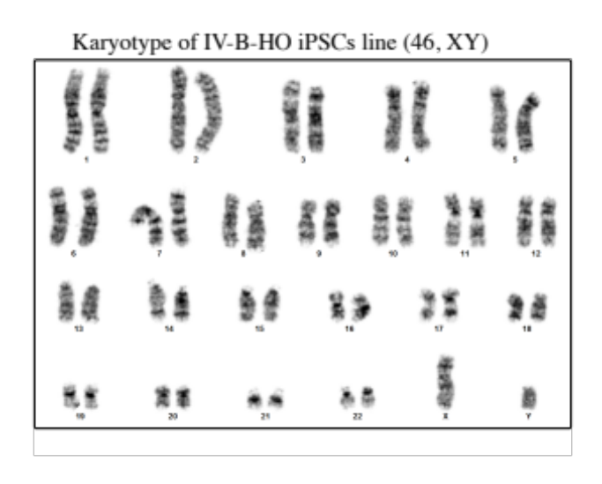
Supp. Fig. 4. Normal karyotype of the IV-B-HO iPSCs line

Supplementary Tables
Antigen | Antibody reference | Dilution factor | Specificity
NANOG | 5232X, Cell Signaling | 200 | Pluripotency transcription factor
OCT4 | 5677X, Cell Signaling | 200 | Pluripotency transcription factor
SOX2 | 3579S, Cell Signaling | 200 | Pluripotency transcription factor
CD326 | A15782, Molecular Probes | 50 | Pluripotency membrane marker
β-TUBULIN | sc-5274, Santa Cruz Biotechnology | 50 | Cytoskeletal marker of ectodermal derivatives
NESTIN | MAB5326, Millipore | 200 | Cytoskeletal marker of ectodermal derivatives
DESMIN | ab32362, Abcam | 200 | Cytoskeletal marker of mesoderm derivatives
α-FETOPROTEIN | sc-166325, Santa Cruz Biotechnology | 50 | Cytoplasmic marker of endodermal derivatives
SOX17 | MA5-24885, Invitrogen | 200 | Transcription factor of endodermal derivatives
Supp. Table 1. List of primary antibodies used to characterize iPSCs or embryoid bodies derived from iPSCs by immunofluorescence or flow cytometry.
Target | Primer forward | Primer reverse
DES gDNA | TCCTCTTCCCTTCCTTGACCT | TCCTGGGGACAGAAATGGACC
GAPDH | ACAGCCTCAAGATCATCAG | GAGTCCTTCCACGATACC
RPL7 | AATGGCGAGGATGGCAAG | TGACGAAGGCGAAGAAGC
SOX2-cMYC of STEMCCA cassette | TTGGCTCCATGGGTTCGGTG | AAGGGTGTGACCGCAACGTAGG
NANOG | AAAGGATCTTCACCTATGCC | GAAGGAAGAGGAGAGACAGT
OCT4 | CTGGGTTGATCCTCGGACCT | CACAGAACTCATACGGCGGG
SOX2 | AGCATGGAGAAAACCCGGTACGC | CGTGAGTGTGGATGGGATTGGTGT
β-TUBULIN | ATTCTGGTGGACCTGGAACC | ATACTCCTCACGCACCTTGC
NKX2.5 | CCCACGCCCTTCTCAGTCAA | GTAGGCCTCTGGCTTGAAGG
α-FETOPROTEIN | TGCTGGATTGTCTGCAGGA | ACGTTCCAGCGTGGTCAGTTT
Supp. Table 2. List of primers used to characterize iPSCs or embryoid bodies derived from iPSCs by RT-qPCR.

Results: Autosomal markers
 | IV-B PBMC  (index patient) | IV-B iPSCs  (index patient) | IV-A PBMC | IV-A iPSCs | IV-C PBMC | IV-C iPSCs
Amelogenin | XY | XY | XX | XX | XY | XY
D3S1358 | 16,18 | 16,18 | 17, 18 | 17, 18 | 15, 17 | 15, 17
D1S1656 | 17.3, 18.3 | 17.3, 18.3 | 17.3, 18.3 | 17.3, 18.3 | 13, 19.3 | 13, 19.3
D2S441 | 11, 13 | 11, 13 | 14, 15 | 14, 15 | 13, 14 | 13, 14
D10S1248 | 15, 17 | 15, 17 | 14, 15 | 14, 15 | 15, 17 | 15, 17
D13S317 | 9, 11 | 9, 11 | 11, 12 | 11, 12 | 8, 12 | 8, 12
PENTA E | 8, 18 | 8, 18 | 8, 18 | 8, 18 | 8, 18 | 8, 18
D16S539 | 8, 11 | 8, 11 | 11, 11 | 11, 11 | 8, 13 | 8, 13
D18S51 | 12, 14 | 12, 14 | 13, 15 | 13, 15 | 14, 15 | 14, 15
D2S1338 | 17, 19 | 17, 19 | 19, 23 | 19, 23 | 17, 19 | 17, 19
CSF1PO | 12, 13 | 12, 13 | 11, 12 | 11, 12 | 12, 13 | 12, 13
PENTA D | 9, 11 | 9, 11 | 11, 14 | 11, 14 | 9, 14 | 9, 14
TH01 | 7, 9 | 7, 9 | 7, 9 | 7, 9 | 7, 9 | 7, 9
VWA | 16,18 | 16,18 | 16, 18 | 16, 18 | 16, 17 | 16, 17
D21S11 | 30.2, 31.2 | 30.2, 31.2 | 29, 30.2 | 29, 30.2 | 29, 29 | 29, 29
D7S820 | 8, 10 | 8, 10 | 8, 10 | 8, 10 | 8, 8 | 8, 8
D5S818 | 11, 12 | 11, 12 | 11, 12 | 11, 12 | 12, 13 | 12, 13
TPOX | 8, 8 | 8, 8 | 11, 11 | 11, 11 | 11, 11 | 11, 11
D8S1179 | 13, 15 | 13, 15 | 12, 15 | 12, 15 | 13, 15 | 13, 15
D12S391 | 15, 23 | 15, 23 | 15, 23 | 15, 23 | 15, 19.3 | 15, 19.3
D19S433 | 13, 14 | 13, 14 | 13, 14 | 13, 14 | 12, 13 | 12, 13
SE33 | 15, 15 | 15, 15 | 18, 18 | 18, 18 | 15, 24.2 | 15, 24.2
D22S1045 | 15, 16 | 15, 16 | 15, 16 | 15, 16 | 15, 16 | 15, 16
FGA | 23, 24 | 23, 24 | 23, 24 | 23, 24 | 21, 14 | 21, 14
DYS391 | 9 | 9 | NA | NA | 9 | 9
DYS576 | 18 | 18 | NA | NA | 18 | 18
DVS570 | 19 | 19 | NA | NA | 19 | 19
Supp. Table 3. STR analysis comparing patients´ PBMCs and the derived iPSCs.

