Supplementary Material

Supplementary Methods
Patient Inclusion and Exclusion Criteria
- Patient Inclusion Criteria:
  - Histologically or cytological confirmed stage III/IV non-small cell lung cancer (NSCLC) (defined according to the 7th edition of the General Rule for Clinical and Pathological Record of Lung Cancer)¹ or recurrent disease.
  - Patients with tumours harbouring an epidermal growth factor receptor (EGFR) Del19 or L858R mutation (excluding patients whose tumours harboured uncommon mutations such as T790M, in combination with EGFR Del19 or L858R mutations).
  - No prior chemotherapy and no prior treatment with EGFR-targeting small molecules or antibodies.
  - Criteria regarding pretreatments and washout periods before entry included: ≥ 12 months since the day of final administration of preoperative or postoperative adjuvant chemotherapy; ≥ 2 weeks since the last pleurodesis that did not use anticancer drugs; ≥ 2 weeks must have elapsed since the systemic administration of steroids for any period of time exceeding 4 weeks; and ≥4 weeks since the administration of other investigational drugs.
  - ≥ 1 measurable lesion per Response Evaluation Criteria In Solid Tumours (RECIST), version 1.1.
  - Aged ≥ 75 years.
  - Eastern Cooperative Oncology Group performance status (ECOG PS) 0 or 1
  - Adequate organ function, including:
    - Neutrophil count ≥ 1,500/mm³.
    - Haemoglobin ≥ 9.0 g/dL.
    - Platelet count ≥ 7.5 x 10⁴/mm³.
    - Total bilirubin ≤ 1.5 times the upper limit of the site’s standard values.
    - Aspartate transaminase (AST)/alanine transaminase (ALT) ≤ 3.0 times the upper limit of the site’s standard values.
    - Serum creatinine ≤ 1.5 times the upper limit of the site’s standard values.
    - PaO₂ (room air) ≥ 60 Torr, or SpO₂ ≥ 93%.
  - Life expectancy > 3 months.
  - Written informed consent.
- Patient Exclusion Criteria:
  - Chemotherapy, biological therapy, or investigational agents for other carcinomas within 4 weeks prior to the start of study treatment.
  - Hormonal treatment within 2 weeks prior to start of study treatment.
  - Previous radiotherapy to the primary tumour or measurable lesion.
  - Major surgery within 4 weeks before starting study treatment, or scheduled for surgery during the projected course of the study.
  - Complications with concurrent cancers that have a disease-free period of < 5 years.
  - Active lung disease such as interstitial pneumonia, active radiation pneumonitis, or drug-induced pneumonitis.
  - Symptomatic brain metastases (patients with asymptomatic brain metastasis were eligible to enrol in the study).
  - Any other concurrent illnesses or conditions and/or infections that could interfere with the conduct of the trial.
  - Women who are currently pregnant or breastfeeding.
  - Known hypersensitivity to afatinib or the excipients of any of the trial drugs.
  - Individuals who are deemed to be unsuitable for participation in this study by the principal investigator or sub-investigators, due to comorbidity of mental disorders such as dementia, or for any other reason (cognitive decline is a particularly important exclusion criterion).

Assessments
Progression-free survival (PFS) was defined as the time from registration until disease progression with first-line treatment, or death. Overall survival (OS) was defined as time from registration until death. Best tumour response was defined without confirmation. Objective response was defined as complete response (CR) or partial response (PR). Disease control was defined as CR, PR, or stable disease. Time to treatment failure (TTF) was defined as the time from registration until discontinuation of afatinib treatment, regardless of reasons such as disease progression, adverse event (AE), and death.

EGFR mutation detection
EGFR mutation analysis was performed on DNA extracted from paraffin embedded tissue sections or cytological specimens. A definitive diagnosis of the presence or absence of activating EGFR mutations was made during the course of routine medical care using a test covered by the patient’s health insurance, including high sensitivity detection methods such as the peptide nucleic acid-locked nucleic acid polymerase chain reaction clamp method.

Statistical considerations
A sample size of 35 patients was required based on the assumption that an expected objective response rate (ORR) of > 70% would be clinically acceptable efficacy, and < 45% would be unacceptable. For an α error = 0.05, β error = 0.1 and one-sided tests, 33 patients were required. Allowing approximately 10% loss of patients in follow-up, a total of 35 patients were planned to be enrolled. Afatinib administered at < 20 mg was considered to be a deviation from the protocol. PFS was censored in patients treated with < 20 mg afatinib.

Reference
1. The Japan Lung Cancer Society. General rule for clinical and pathological record of lung cancer, 7th edition. Kanehara & Co, Tokyo, Japan; 2010.

Supplementary Figure 1. Patient Disposition.
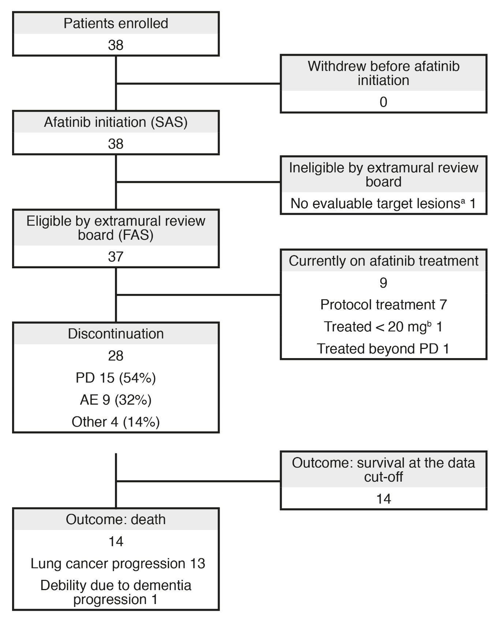
Abbreviations: AE = adverse event; FAS = full analysis set; PD = progressive disease; SAS = safety analysis set.
ªCurrently on PD (Figure 2, Patient 23); ^{b}Protocol violation.

Supplementary Figure 2. Individual Patient Best Overall Response in the Safety Analysis Set (n = 38). Shown is a Waterfall Plot of Maximum Tumour Reduction From Baseline Assessed According RECIST v1.1 Criteria in 36 Patients. Confirmation of Response Could not be Obtained for 2 Non-evaluable Patients.
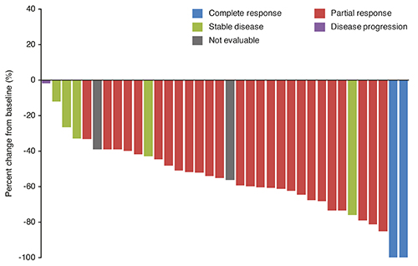
Abbreviation: RECIST = Response Evaluation Criteria in Solid Tumours.

Supplementary Figure 3. Kaplan–Meier Survival Analysis by EGFR Mutation Type in the Full Analysis Set (n = 37). (A) Progression-free Survival (PFS). (B) Overall Survival (OS). (C) Time to Treatment Failure (TTF).
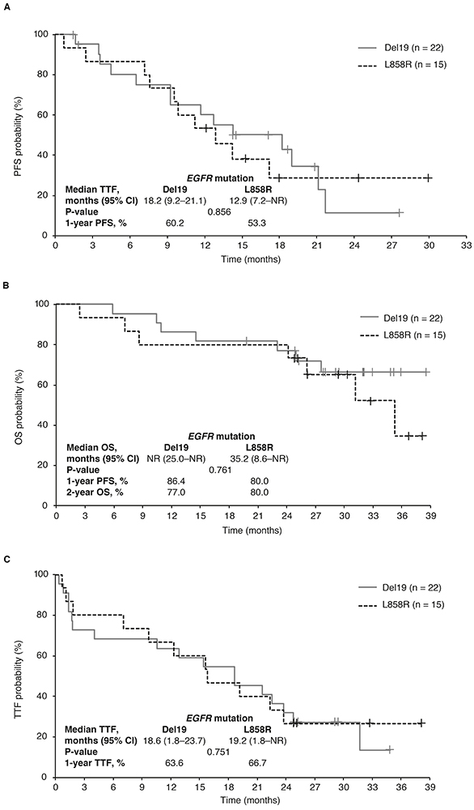
Abbreviations: CI = confidence interval; EGFR = epidermal growth factor; NR = not reached.

