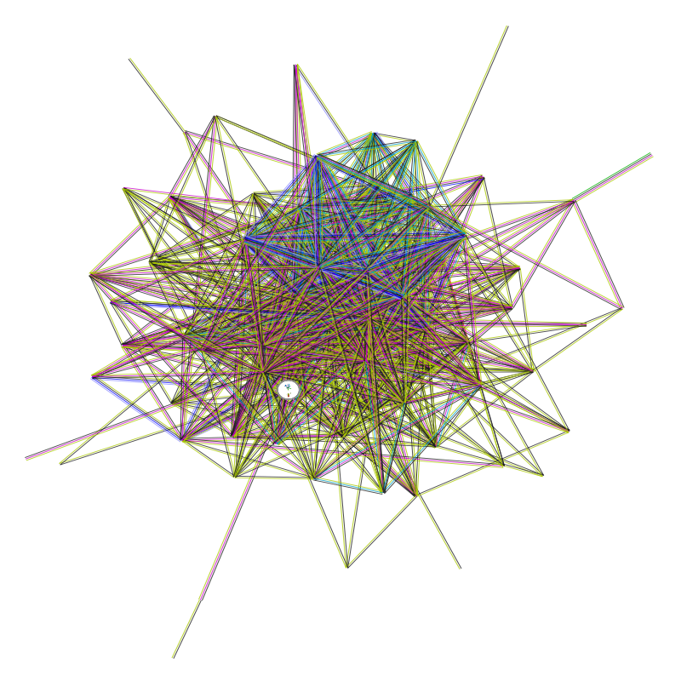
Supplementary Figure S1. Diagram of protein-protein interaction network of 100 LOXL1-related genes.

