Supplementary Materials
Table S1 . Lactiplantibacillus plantarum used in this study and results of initial screening of their acid-producing capacity
No. | Strain | Source | Acid production capacity
1 | PG5 | apple | ++
2 | CAUH2-1 | CAUH2 space mutant | +++
3 | BM-1 | croaker | +
4 | SR1-3 | cured meat | ++
5 | ST1 | Fermented corn | ++
6 | ST2 | fermented corn | +
7 | ZSS2 | Fermented sweet potatoes | +
8 | M4 | fresh milk | ++
9 | SCY71 | Fresh vegetables | ++
10 | MC2 | horse sausage | ++
11 | APC2 | Kimchi | ++
12 | JS13 | kimchi water | +++
13 | GY4 | kimchi water | ++
14 | SJ-1 | kimchi water | +++
15 | JS17 | kimchi water | +
16 | JS32 | kimchi water | +
17 | JS8 | kimchi water | +
18 | GY7 | kimchi water | +
19 | 07-191 | Koumiss | ++
20 | K2 | Koumiss | ++
21 | QL12-3 | milk pomace | +
22 | 14--3 | milk pomace | +
23 | CAUH2 | pickle | ++
24 | SLB-1 | pickle | +++
25 | XC1 | pickle | +++
26 | G2-4 | pickle | +
27 | G2-3 | pickle | +
28 | G2-4 | pickle | +
29 | PC-B3 | pickle | +
30 | PC-B5 | pickle | +
31 | PC-CD4 | pickle | +
32 | PC-CD6 | pickle | +
33 | WQ0818 | pickle | +
34 | Z3 | pickle | +
35 | PC-M4 | pickle | +
36 | GY3 | pickle | +
37 | DBSC1 | Pickled Cabbage | +++
38 | DBSC2 | Pickled Cabbage | ++
39 | XJSC1 | Pickled Cabbage | +++
40 | XJSC2 | Pickled Cabbage | ++
41 | YC1-2 | pickled fish | ++
42 | YC41 | pickles | ++
43 | XC2 | pickles | +
44 | JY | Raw milk | ++
45 | SN | Raw milk | ++
46 | XL | Raw milk | ++
47 | NICMB 8826 | saliva | ++
48 | WC | saliva | ++
49 | LC-H2-1 | sausage | +
50 | LC-H2-3 | sausage | +
51 | PC1 | Sichuan Pickles | ++
52 | PC-LS1 | Sichuan Pickles | ++
53 | CAUH2-3 | Sichuan Pickles | +++
54 | PC3 | Sichuan Pickles | +++
55 | PC-LS4 | Sichuan Pickles | +
56 | PC2 | Sichuan Pickles | +
57 | PC5 | Sichuan Pickles | +
58 | PC-LS2 | Sichuan Pickles | +
59 | PC-M2 | Sichuan Pickles | ++
60 | PC-M3 | Sichuan Pickles | +
61 | G4 | sour mare's milk | +
62 | 99105 | unknown | +
63 | AS1.2986 | unknown | +
64 | LB-B1 | vagina | ++
65 | Y25-6-1 | vagina | +
66 | Y9-4-1 | vagina | +
67 | Y7 | yoghurt | ++
68 | Y9 | yoghurt | +
+++: The radius of the calcium dissolved circle is greater than or equal to 5mm; ++: The radius of the dissolved calcium ring is between 4.5 (inclusive) and 5 mm; +: The radius of the calcium dissolving ring is less than 4.5mm

Table S2. Oligonucleotide primers used in this study
Oligonucleotide primers | Sequence | Reference
ldhD-up_F | CCGGAATTCCATGATTTTAATGACCGTACCT | This study
ldhD-up_R | ATTTTTGTATTTGAAGCGTTAACCCCAAG | This study
ldhD-down_F | CGCTTCAAATACAAAAATTCCTCCTATATATTG | This study
ldhD-down_R | CGCGGATCCGTGGATACCGTCTTGTGTAAC | This study
ldhD-check_F | CTTTGAGCAGCACTGAATTG | This study
ldhD-check_R | CAACGCAGTGTTATTTTGAAC | This study
larA-up_F | CCGGAATTCCGTCTGTTCGTAATTCCTTG | This study
larA-up_R | AATATTTCTTTTTACATGCACGTTTTGTTAT | This study
larA-down_F | CATGTAAAAAGAAATATTACAACAAGTGGCG | This study
larA-down_R | CGCGGATCCTAATCCCCGAAAAAGCGTC | This study
larA-check_F | GAATATGCACGGATGAGC | This study
larA-check_R | AGCTCGTGCCATAGATGC | This study
For primers, restriction enzyme sites and complementary sequence are underlined.

Fig. S1 pUChlyL vector Profile
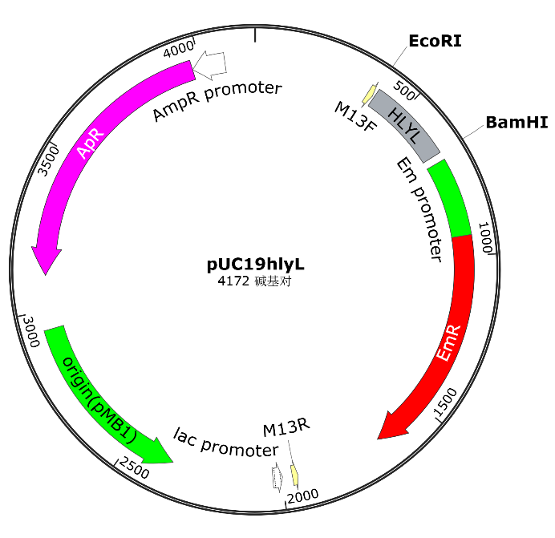

Fig. S2 pNZepsCD vector Profile
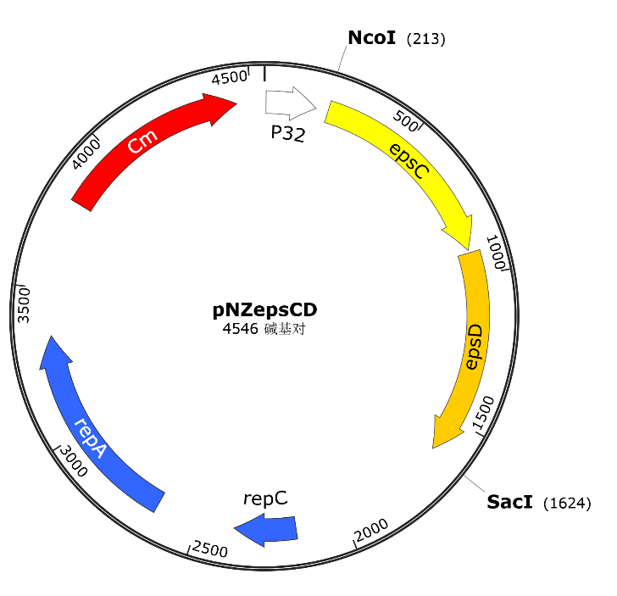

Fig. S3 Amylase activity of fermented supernatant during starch fermentation by L. plantarum CAUH2-4
