ADDITIONAL FILES

SUPPLEMENTS
Supplement 1. Total score distribution of the DLQI-col

Supplement 2. Response options distribution for each item

Supplement 3. Correlation matrix table
 | Item 1 | Item 2 | Item 3 | Item 4 | Item 5 | Item 6 | Item 7a | Item 7b | Item 8 | Item 9 | Score
Item 1 | 1.00
Item 2 | 0.43 | 1.00
Item 3 | 0.28 | 0.47 | 1.00
Item 4 | 0.36 | 0.47 | 0.41 | 1.00
Item 5 | 0.40 | 0.62 | 0.48 | 0.52 | 1.00
Item 6 | 0.34 | 0.41 | 0.43 | 0.37 | 0.48 | 1.00
Item 7 dichot | 0.09 | 0.22 | 0.37 | 0.28 | 0.34 | 0.26 | 1.00
Item 7 ordin | 0.20 | 0.28 | 0.33 | 0.27 | 0.34 | 0.25 | 0.99 | 1.00
Item 8 | 0.28 | 0.38 | 0.45 | 0.39 | 0.42 | 0.43 | 0.30 | 0.27 | 1.00
Item 9 | 0.28 | 0.43 | 0.45 | 0.42 | 0.39 | 0.41 | 0.36 | 0.32 | 0.68 | 1.00
Item 10 | 0.38 | 0.36 | 0.34 | 0.39 | 0.40 | 0.35 | 0.15 | 0.22 | 0.38 | 0.42
Score | 0.57 | 0.72 | 0.68 | 0.69 | 0.75 | 0.66 | 0.65 | 0.54 | 0.69 | 0.71 | 1.00

Supplement 4. Horn’s parallel analysis (A) and alternative two-factor model (B)
(A) | 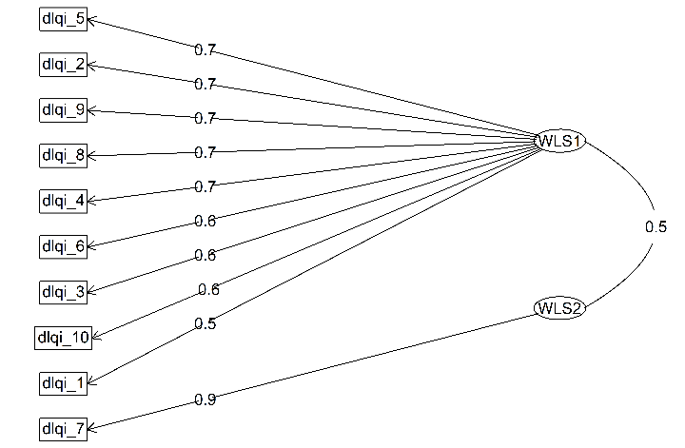  (B)

Supplement 5. Characteristic curves of the items using the Partial Credit Model (PCM) for polytomic items.

Supplement 6: Figure of information-generating functions

Supplement 6: DLQI differential item functioning according to gender.
 | Sex
 | Stat | P-value | Effect
Item 1 | 0,0001 | 0,9938 | Moderate
Item 2 | 19,1241 | 0,0000 | Large
Item 3 | 2,4369 | 0,1185 | Moderate
Item 4 | 2,8202 | 0,0931 | Large
Item 5 | 1,3785 | 0,2404 | Moderate
Item 6 | 0,9323 | 0,3343 | Negligible
Item 7 | 0,1723 | 0,6781 | Negligible
Item 8 | 2,5006 | 0,1138 | Large
Item 9 | 0,0112 | 0,9158 | Negligible
Item 10 | 3,4631 | 0,0628 | Negligible

