Supplementary Information for
Mechano-responsive hydrogen-bonding array of thermoplastic polyurethane elastomer captures both strength and self-healing
Eom et al.
1. Supplementary Tables
Supplementary Table 1. Polymer information and polymerization results
Entryª | Content of chain-extender^{b} (wt%) | M_{n} (g mol⁻¹)^{c} | M_{w} (g mol⁻¹)^{c} | PDI^{c}
C-IP-SS | 14.6 | 16,500 | 24,100 | 1.46
E-IP-SS | 14.6 | 30,400 | 45,600 | 1.50
Es-MD | - | 55,400 | 98,600 | 1.78
ªC: Poly(hexamethylene carbonate) diol, E: Poly(tetramethylene ether)glycol, Es: polyester-type macrodiol, IP: isophorone diisocyanate, MD: 4,4’-methylenebis(phenyl isocyanate), SS: bis(4-hydroxyphenyl)disulfide. ^{b}Based on the weight percentages of chain-extender included in the total monomer weight. ^{c}Determined by THF-GPC using polystyrene standards (RI detector).

Supplementary Table 2. Information on tensile properties of TPU films and the degree of recovery after self-healing
Entry |  | C-IP-SSª | E-IP-SS^{b} | Es-MD
Virgin sample | Young's modulus (MPa) | 15.5 ± 0.8 | 1.45 | 8.86 ± 0.4
Virgin sample | UTS (MPa) | 42.9 ± 1.4 | 6.76 | 35.8 ± 0.8
Virgin sample | Elongation at break (%) | 480 ± 3 | 920 | 880 ± 8
Virgin sample | Toughness (MJ m⁻³) | 75.1 ± 2.3 | 26.9 | 115 ± 2
Cut & healed sample | Young's modulus (MPa) | 15.3 ± 0.4 | 1.47 | -^{c}
Cut & healed sample | UTS (MPa) | 33.1 ± 0.4 | 5.96 | -
Cut & healed sample | Recovery of UTS (%) | 77.2 | 88.2 | -
Cut & healed sample | Elongation at break (%) | 400 ± 6 | 920 | -
Cut & healed sample | Recovery of elongation (%) | 82.7 | 99.6 | -
Cut & healed sample | Toughness (MJ m⁻³) | 48.4 ± 0.6 | 20.6 | -
Cut & healed sample | Recovery of toughness (%) | 64.4 | 76.6 | -
ªSelf-healing for 48 h at 35 °C. ^{b}Self-healing for 2 h at 25 °C. Tensile data obtained from the previous report (Adv. Mater. 2018, 30, 1705145). ^{c}No mechanical recovery was observed.

Supplementary Table 3. Tensile and self-healing properties of elastomers (tensile strength over 10 MPa, and self-healing efficiency over 60%)
 | Self-healing motif/type of polymerª | The highest UTS (MPa) | Self-healing temperature (°C) | Recovery time | UTS recovery (%) | Ref.
Elastomer | Disulfide/TPU | 43 | 35 | 24 h  (48 h) | 65  (77) | This work
Elastomer | Anisyl group /polyolefin | 17.7 | 25 | 120 h | 71 | 1
Elastomer | M-L, HB/PU | 14.8 | Room temp.^{b} | 130 h | 93 | 2
Elastomer | M-L/PEI | 10.5 | 25 | 12 h | ~100 | 3
Elastomer | Electrostatic, HB/dual cross-linked polymer | 27.4 | 25 (humid environ.)^{c} | 48 h | 94 | 4
Elastomer | Ditelluride, HB/PUU | 21.7 | Ambient (up to 40 °C) (visible light)^{d} | 10 min | 85.6 | 5
Elastomer | Diselenide, HB/PUU | ~15 | Ambient (photo reactor)^{e} | 10 min | ~95 | 6
Elastomer | Dioxetane, disulfide/TPU | ~25 | 40 (UV light)^{f} | 0.5 h | 100 | 7
Elastomer | HB/PUU | 48.5 | 80 | 48 h | 88 | 8
Elastomer | Disulfide/PU | 26.3 | 70 | 0.5 h | ~98 | 9
Elastomer | Disulfide/TPU | 25 | 70 | 6 h | 86 | 10
Elastomer | M-L/Polyolefin | 24.8 | 80 | 12 h | 79 | 11
Elastomer | Disulfide, HB/PUU | 25 | 100 | 2 h | 92 | 12
Elastomer | M-L/polyisoprene | 21 | 80 | 24 h | 74 | 13
Elastomer | Disulfide/PU | ~20 | 90 | 24 h | 94 | 14
Elastomer | D-A/polyacrylates | 13 | 60 | 1 week | 79 | 15
Elastomer | Oxime-carbamate, HB/poly(oxime-urethane) | 13.5 | 100 | 2 h | ~100 | 16
Elastomer | Boronic ester/ENR | ~10 | 80 | 24 | 85 | 17
Plastic^{g} | HB/poly(thiourea-ether) | 45 | 21 | 30 sec | unknown | 18
Plastic | vdW/polyacrylates | 9.74 | Ambient | 86 h | 70 | 19
Plastic | Ionic interaction, HB/PU | 16.9 | 40 | 2 h | 70 | 20
ªTPU: Thermoplastic polyurethane. M-L: Metal-ligand. HB: Hydrogen bonding. PEI: polyethyleneimine. PUU: poly(urethane-urea). D-A: Diels-Alder. ENR: epoxidized natural rubber. vdW: van der Waals.
^{b}The exact room temperature was not recorded. Thus, general 25 °C was recorded in the Ashby graph.
^{c}Humid environment: Relative humidity of ~90%.
^{d}The light intensity of approximately 200000 lx.
^{e}A photoreactor (300 W, 400–800 nm) with a higher light intensity of approximately 200000 lx.
^{f}A high-pressure mercury lamp (500 W) with 365 nm optical filter.
^{g}Recoginized as plastic-type owing to an appearance of a yield point.

Supplementary Table 4. The transition strain (έ) and stress (σ_{t}) of C-IP-SS at different temperatures
Temperature (K) | Transition strain (έ) | Transition stress (σ_{t})
243 | 1.40 | 57.46
253 | 1.56 | 48.12
263 | 1.79 | 27.41
273 | 1.89 | 8.40
283 | 2.17 | 2.57
293 | 2.38 | 1.40
303 | 2.38 | 1.00
308 | 2.38 | 0.65
313 | 2.38 | 0.47

Supplementary Table 4. The frequency shift factors (α_{T}) employed in obtaining TTS master curves for C-IP-SS and E-IP-SS, respectively
Measurement temperature (°C) | α_{T} of C-IP-SS | α_{T} of E-IP-SS
25 | Reference temperature
35 | 6.20$×$10⁻² | 4.47$×$10⁻¹
45 | 7.67$×$10⁻³ | 1.28$×$10⁻¹
55 | 1.80$×$10⁻³ | 4.74$×$10⁻²
65 | 4.00$×$10⁻⁴ | 1.76$×$10⁻²
75 | 1.13$×$10⁻⁴ | 8.21$×$10⁻³
85 | 3.30$×$10⁻⁵ | 3.42$×$10⁻³

2. Supplementary Figures

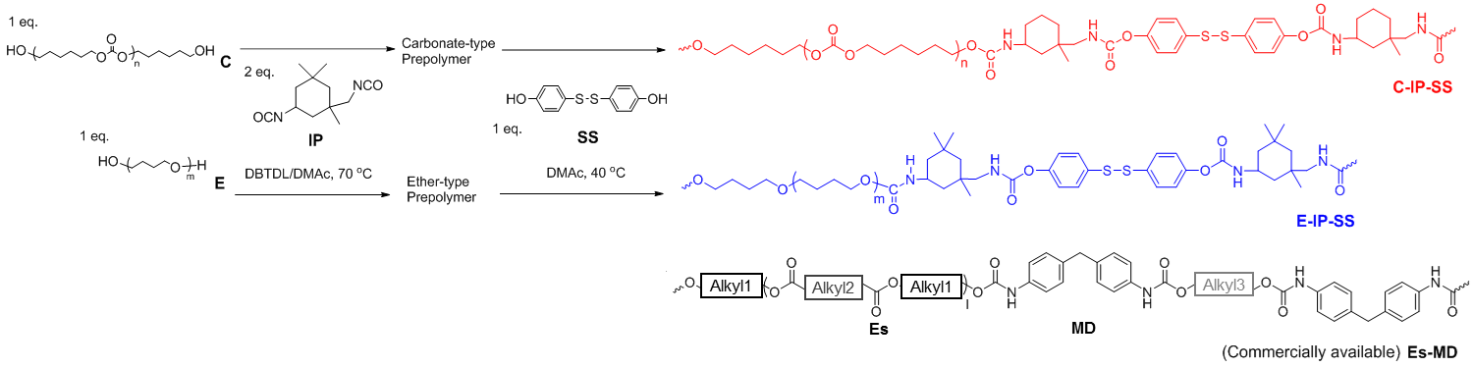
Supplementary Figure 1. Synthetic route to TPUs with different components. The TPUs are designated as X-Y-Z, where X, Y, and Z denote the abbreviation of the type of macrodiol, diisocyanate monomer, and chain extender, respectively (C-IP-SS, E-IP-SS, and Es-MD).

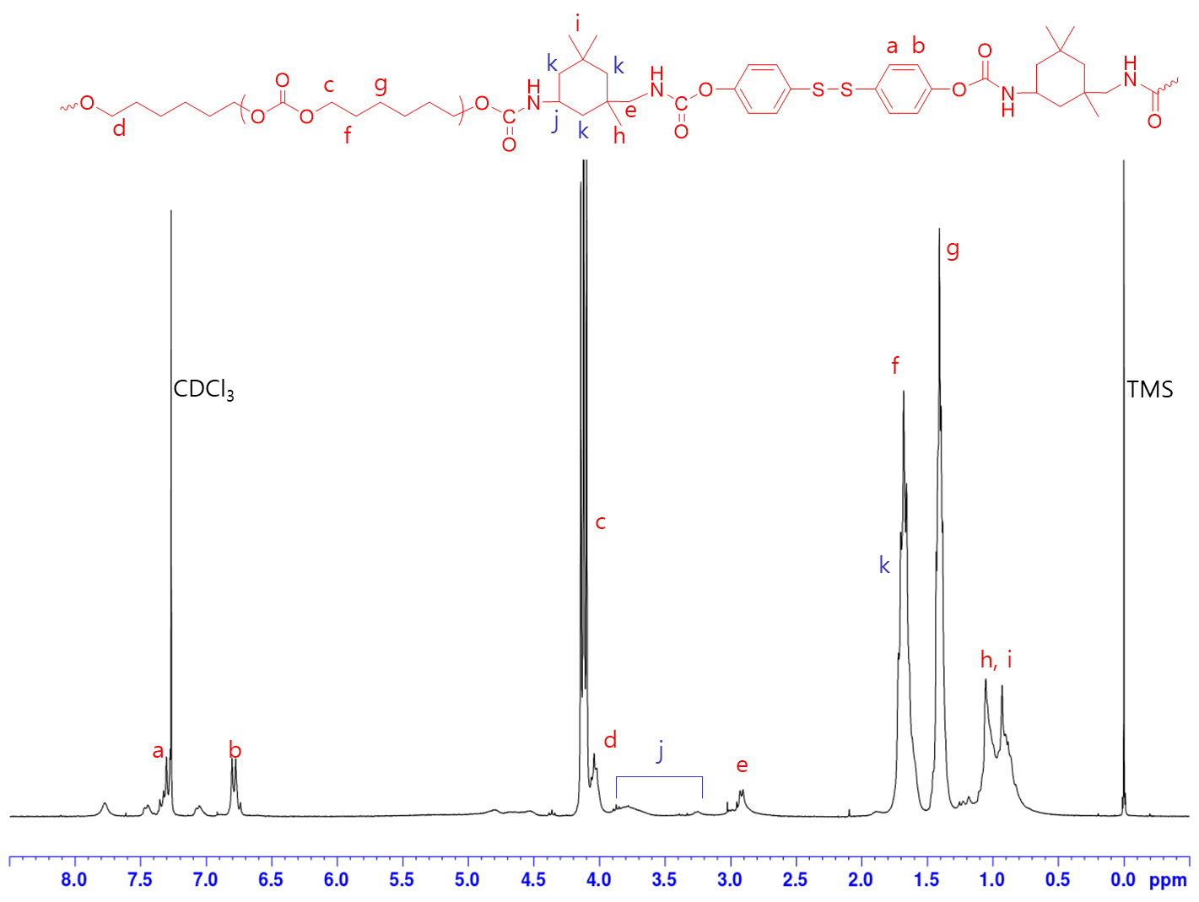
Supplementary Figure 2. ¹H NMR spectrum of C-IP-SS in CDCl₃ (300 MHz). In the ¹H NMR spectrum of C-IP-SS, the peaks of SS aromatic unit appeared at 7.4~6.6 ppm, the peaks of protons adjacent to carbonate group of poly(hexamethylene carbonate) diol (C) appeared at 4.2~4.0 ppm, and the peaks of IP alkyl unit appeared at 1.1~0.8 ppm. Integral ratio of each units was well-matched with feed molar ratio.

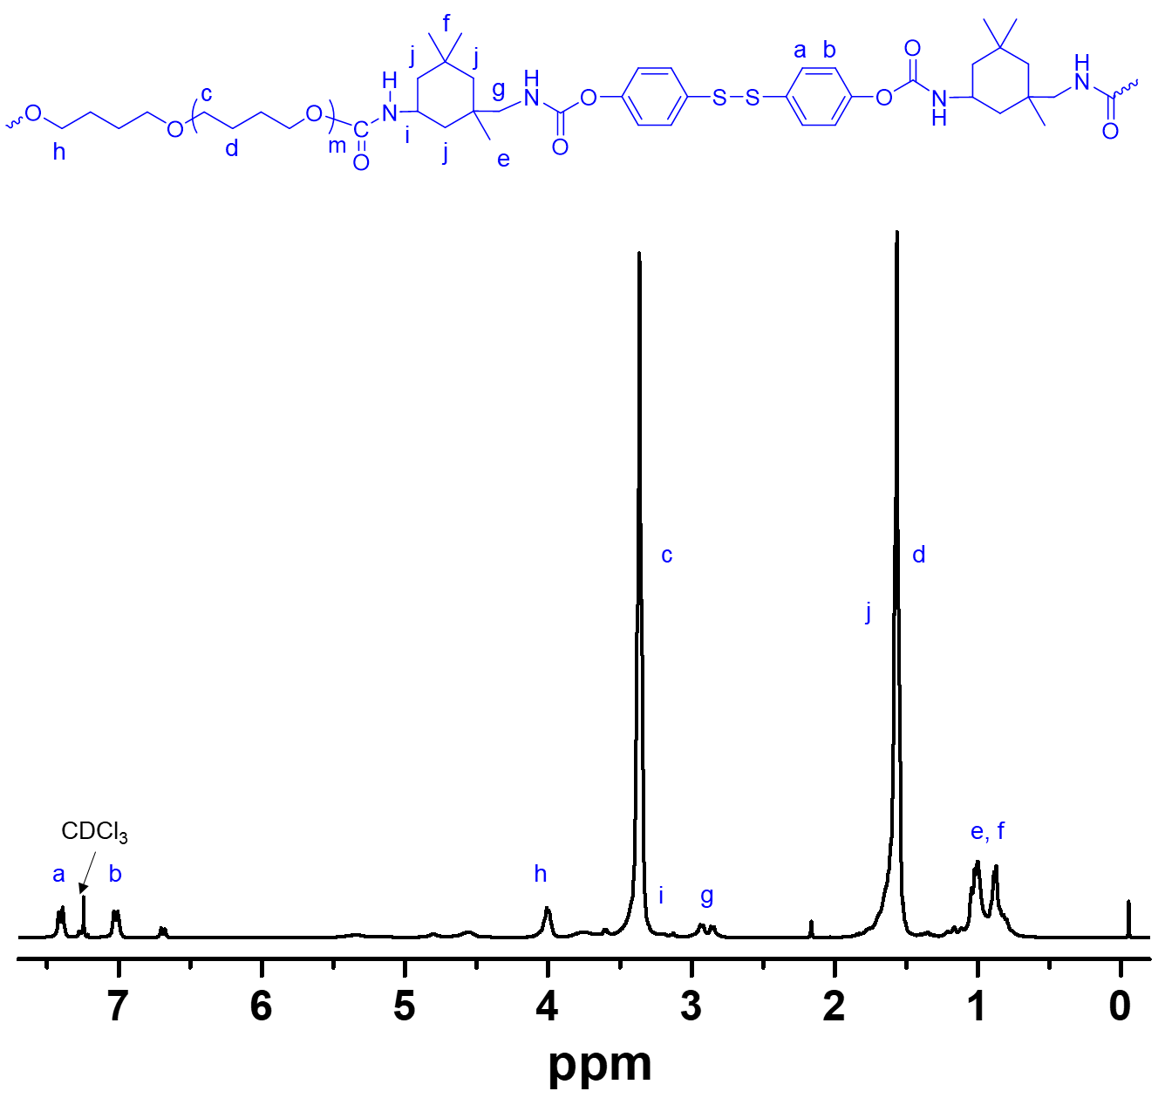
Supplementary Figure 3. ¹H NMR spectrum of E-IP-SS in CDCl₃ (300 MHz). In the ¹H NMR spectrum of E-IP-SS, the peaks of SS aromatic unit appeared at 7.4~6.6 ppm, the peaks of PTMEG (E) protons appeared at 3.4 and 1.6 ppm, and the peaks of IP alkyl unit appeared at 1.1~0.8 ppm. Integral ratio of each units was well-matched with feed molar ratio.

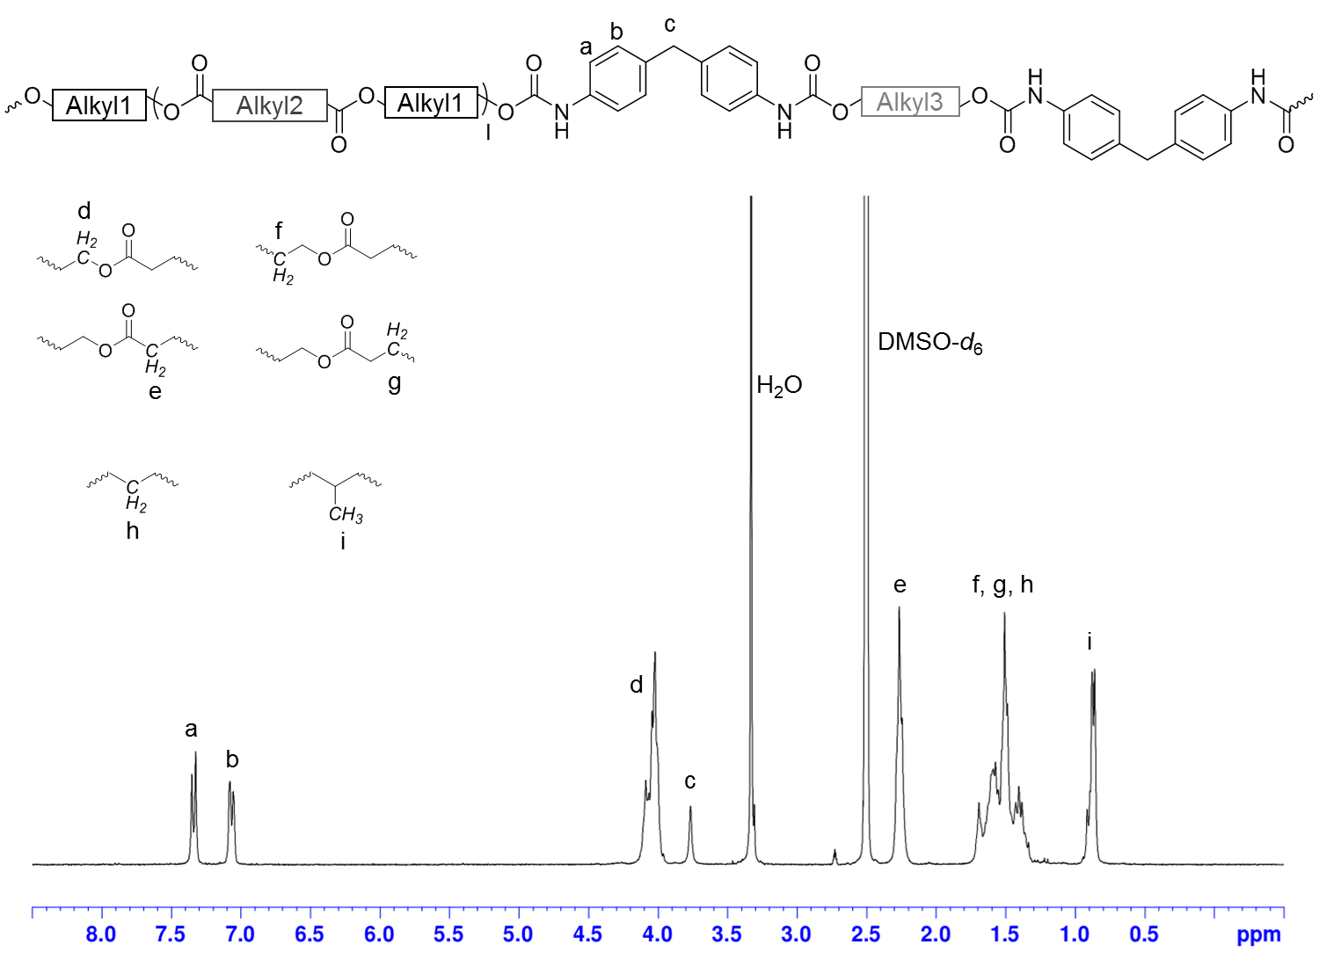
Supplementary Figure 4. ¹H NMR spectrum of Es-MD in DMSO-d₆ (300 MHz). In the ¹H NMR spectrum of Es-MD, the peaks of MD aromatic unit appeared at 7.4~7.0 and 3.8 ppm. The peaks of protons adjacent to ester C-O appeared at 4.2~4.0 ppm, and those adjacent to ester C=O appeared at 2.3-2.2 ppm, respectively, suggesting that soft segment is composed of polyester-type macrodiol (Es). Methylene protons appeared at 1.7~1.3 ppm and α-methyl protons (-CH₃) appeared at 1.0~0.8 ppm.

Supplementary Figure 5. THF-GPC profiles of TPUs.

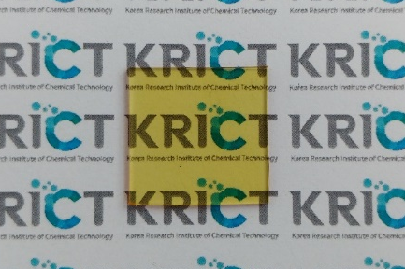
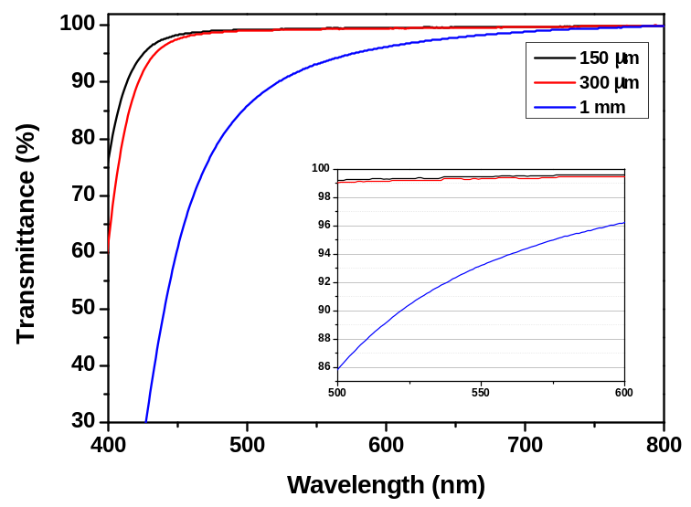

Supplementary Figure 6. Photograph of C-IP-SS films with a dimension of 20 mm $×$ 20 mm $×$ 1 mm, and transmission spectra with various thicknesses.
Supplementary Figure 7. Ashby plot of “ultimate tensile strength” versus “self-healing temperature” of C-IP-SS and other elastomers reported in literature.

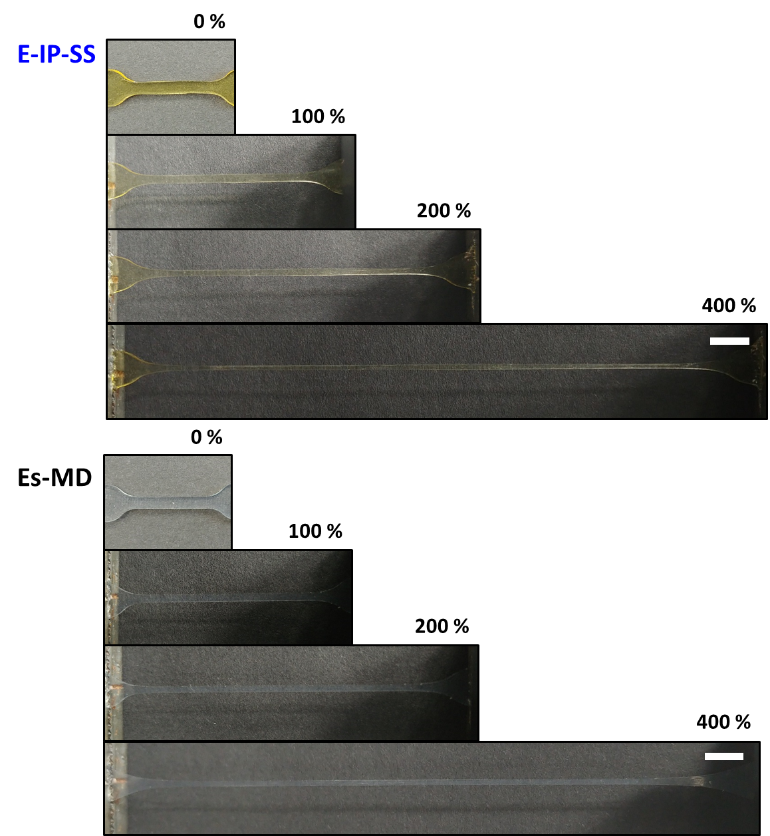
Supplementary Figure 8. Photographs of dumbbell-shaped films of E-IP-SS and Es-MD of various stretching ratio (scale bar: 6 mm).

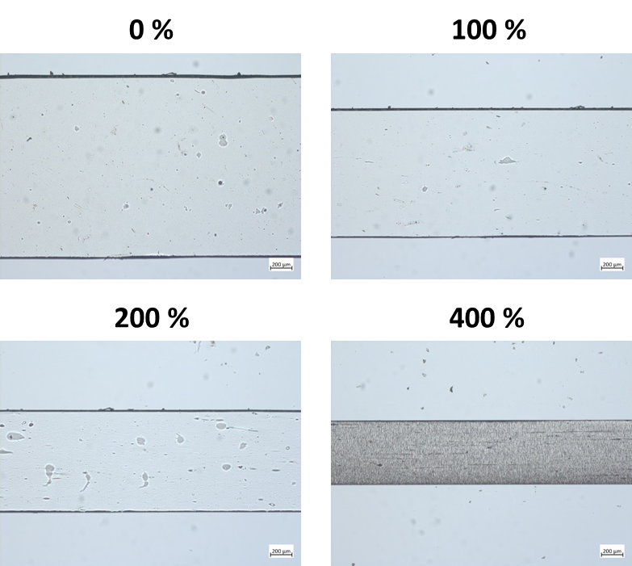
Supplementary Figure 9. OM images of dumbbell-shaped film of C-IP-SS (thickness: 300 µm) at different strains.

Supplementary Figure 10. Cyclic stress-strain curves of C-IP-SS with two cycles of 200% tensile strains. The second cycle was carried out after waiting for 24 h.

Supplementary Figure 11. Differential scanning calorimetry curves of C-IP-SS and Es-MD (first scan).

Supplementary Figure 12. The carbonyl region of FT-IR spectrum with peak deconvolution for Es-MD.

Supplementary Figure 13. Rheological properties of the three TPUs at 25 °C. (a) Complex viscosity versus angular frequency of 0.05−500 rad s⁻¹. (b) Casson plots to obtain the yield stress. The yield stress was calculated from the square value of the intercept of the plot. (c) The modified Cole−Cole plot.

Supplementary Figure 14. Relaxation time curves of self-healable TPUs, C-IP-SS and E-IP-SS, over the frequency range of 0.05−500 rad s⁻¹ at 25 °C.

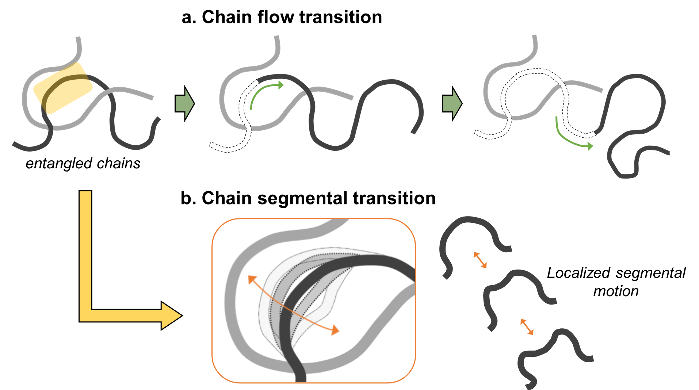
Supplementary Figure 15. Schematic illustration of the movement of (a) chain flow transition and (b) chain segmental transition.

Supplementary Figure 16. The 1D SAXS patterns of (a) C-IP-SS, (b) E-IP-SS and (c) Es-MD at different degrees of stretching.

Supplementary Figure 17. The 2D SAXS patterns of the three types of TPUs at different degrees of stretching.

Supplementary Figure 18. The 1D WAXS patterns of Es-MD at different degrees of stretching.

Supplementary Figure 19. Schematic illustration of mechano-responsive change in chain alignment and relevant H-bond array for C-IP-SS.

Supplementary Figure 20. The recovery of the 2D WAXS patterns for C-IP-SS after instantaneous release of the 400%-stretched specimen.

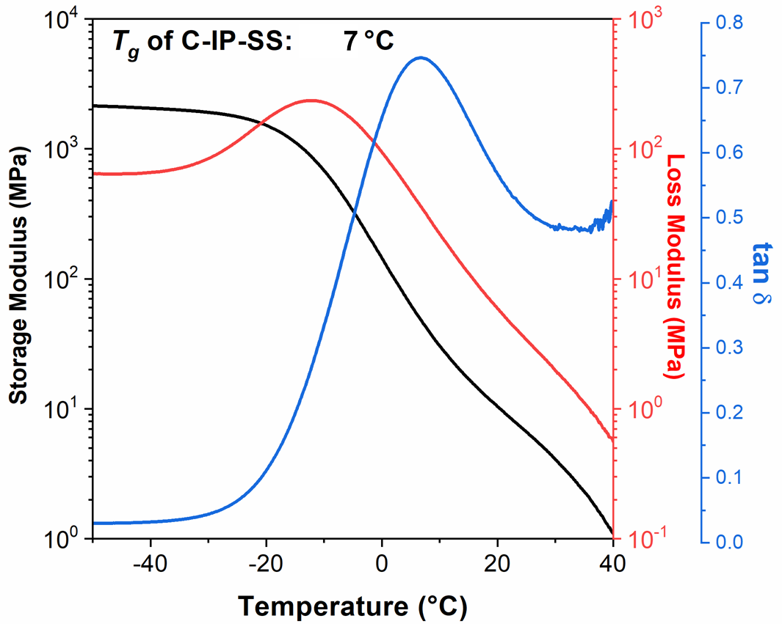
Supplementary Figure 21. DMA curves of C-IP-SS at 1 Hz over the temperature range of −80 to 80 °C in a liquid N₂ atmosphere.

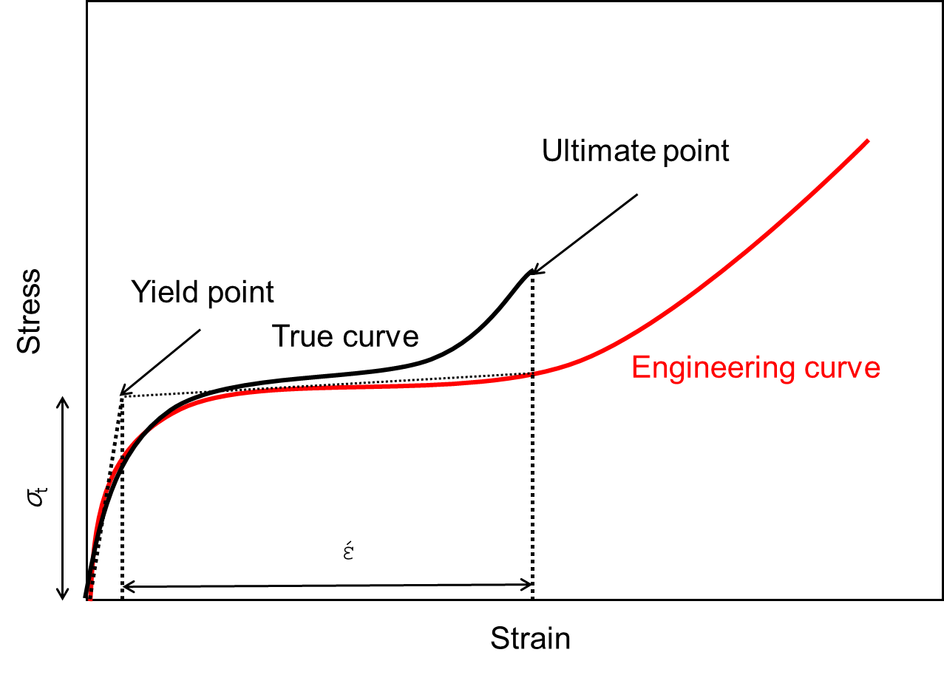
Supplementary Figure 22. Typical “engineering” and “true” stress−strain curves of C-IP-SS, and the transition stress and strain of C-IP-SS.

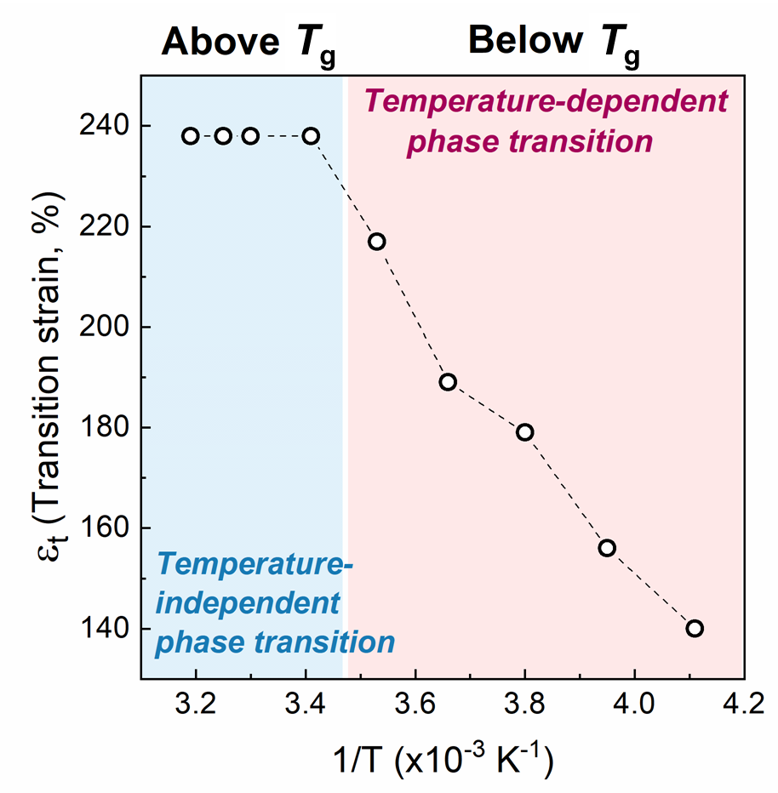
Supplementary Figure 23. Transition strain (έ) as a function of temperature (1/T) of C-IP-SS.

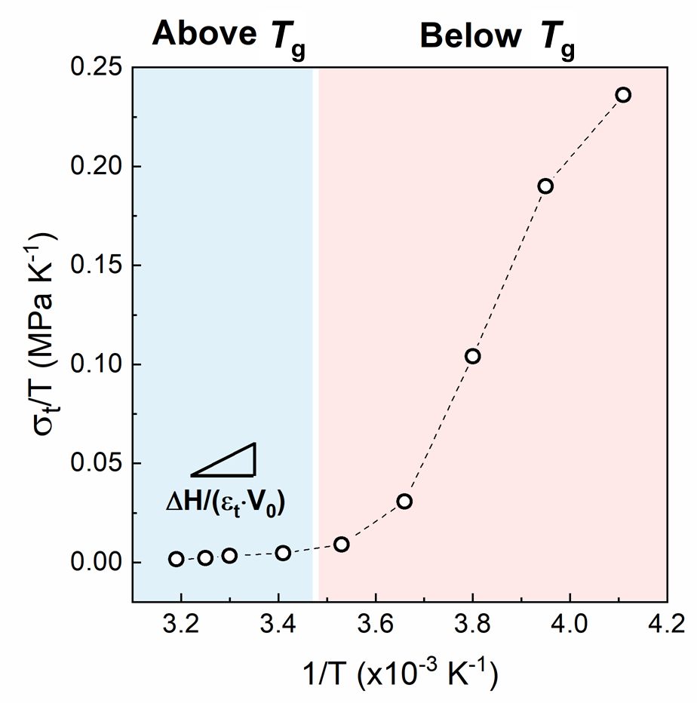
Supplementary Figure 24. Plot of (σ_{t}/T) as a function of temperature (1/T) of C-IP-SS.
3. Supplementary Note
Supplementary Note 1: Calculation of an enthalpy of strain-induced phase conversion for C-IP-SS
The report by Miserez et al. evaluated an enthalpy change (ΔH) of phase transformation of reversibly deformable elastomers. Because this phenomenon is reminiscent of a shape-memory effect in a metallic alloy, it can be modelled by the Clausius-Clapeyron relation²¹. Our system was also applied to this relation because the mechano reversible change of internal structure of C-IP-SS thermodynamically resembles this biomaterial system.
Hence, based on the Gibbs free energy of a system, an applied force f can be express as a function of temperature and given by:
($\frac{∂f}{∂T})= \frac{f}{T}-\frac{∆H}{T∙∆L}$ (1)
Or, being in a different form by considering the Clausius-Clapeyron relationship with force and length replacing pressure and volume:
${(\frac{∂(f/T)}{∂(1/T)})}_{P}=\frac{∆H}{∆L}$ (2)
ΔL and ΔH respectively represent the changes in length and enthalpy during strain-induced crystallization; temperature T and pressure P.
In our system, f indicates the force at a yielding point for the conformational change during reversible crystallization. Hence, the equation (2) can be expressed with respect to stress and strain as:
${(\frac{∂(σ_{t}/T)}{∂(1/T)})}_{P}=\frac{∆H}{ε_{t}∙V_{0}}$ (3)
σ_{t} and ε_{t} indicate the transition stress and strain, respectively, which are originally defined at stress-induced phase transition point defined in metal science. However, in polymer science, the σ_{t} and ε are respectively defined by the stress and strain at the point of strain-hardening where amorphous phase is transformed to crystal phase. Typically, strain-hardening occurs from the beginning of yield point to the end of ultimate strength point^{22,23}. In the tensile stress-strain curves of C-IP-SS, it is difficult to define the both points because C-IP-SS has a too long strain. It can be clear by comparison between the true and engineering curves^{21,24}. The engineering curves were corrected to the true stress-strain curves by the measured Poisson’s ratios (Supplementary Fig. 22). As a result, the σ_{t} and ε for particular temperature were obtained in Supplementary Table S4.
Then, according to equation (3), we constructed the plot of (σ_{t}/T) versus the inverse of the temperature 1/T from our experimental results (Supplementary Figs. 23 and 24). The slope of the plot corresponds to the enthalpy change ΔH per unit volume V₀ when ε_{t} is temperature-independent.
In the temperature range of above T_{g} where the reversible transition occurs, ε_{t} is constant and the plot of (σ_{t}/T) gives a linear curve.
Finally, by solving equation (3), we obtained the enthalpy of the strain-induced crystallization of C-IP-SS at above T_{g} ≈ 6.47 cal cm⁻³ (ΔH/V₀). Approximating the density of polyurethane (TPU) as 1.25 g cm⁻³, the enthalpy can be converted to 5.17 g cm⁻³.

Supplementary References
1. Wang, H., Yang, Y., Nishiura, M., Higaki, Y., Takahara, A. & Hou, Z. Synthesis of self-healing polymers by scandium-catalyzed copolymerization of ethylene and anisylpropylenes. J. Am. Chem. Soc. 141, 3249-3257 (2019).
2. Zhang, L. et al. A highly efficient self‐healing elastomer with unprecedented mechanical properties. Adv. Mater. 31, 1901402 (2019).
3. Li, F. et al. Facile fabrication of self-healable and antibacterial soy protein-based films with high mechanical strength. ACS Appl. Mater. Interfaces 11, 16107-16116 (2019).
4. Guo, H., Fang, X., Zhang, L. & Sun, J. Facile fabrication of room-temperature self-healing, mechanically robust, highly stretchable, and tough polymers using dual dynamic cross-linked polymer complexes. ACS Appl. Mater. Interfaces 11, 33356-33363 (2019).
5. Fan, W. et al. Achieving fast self-healing and reprocessing of supertough water-dispersed" living" supramolecular polymers containing dynamic ditelluride bonds under visible light. ACS Appl. Mater. Interfaces 12, 6383-6395 (2020).
6. Fan, W., Jin, Y., Shi, L., Du, W. & Zhou, R. Transparent, eco-friendly, super-tough “living” supramolecular polymers with fast room-temperature self-healability and reprocessability under visible light. Polymer 190, 122199 (2020).
7. Yan, C., Yang, F., Wu, M., Yuan, Y., Chen, F. & Chen, Y. Phase-locked dynamic and mechanoresponsive bonds design toward robust and mechanoluminescent self-healing polyurethanes: A microscopic view of self-healing behaviors. Macromolecules 52, 9376-9382 (2019).
8. Song, Y., Liu, Y., Qi, T. & Li, G. L. Towards dynamic but supertough healable polymers through biomimetic hierarchical hydrogen‐bonding interactions. Angew. Chem. Int. Ed. 57, 13838-13842 (2018).
9. Ha, Y.-m. et al. Robust and stretchable self-healing polyurethane based on polycarbonate diol with different soft-segment molecular weight for flexible devices. Eur. Polym. J. 118, 36-44 (2019).
10. Lai, Y., Kuang, X., Zhu, P., Huang, M., Dong, X. & Wang, D. Colorless, transparent, robust, and fast scratch‐self‐healing elastomers via a phase‐locked dynamic bonds design. Adv. Mater. 30, 1802556 (2018).
11. Zou, C. & Chen, C. Polar‐functionalized, crosslinkable, self‐healing, and photoresponsive polyolefins. Angew. Chem. Int. Ed. 59, 395-402 (2020).
12. Hu, J., Mo, R., Jiang, X., Sheng, X. & Zhang, X. Towards mechanical robust yet self-healing polyurethane elastomers via combination of dynamic main chain and dangling quadruple hydrogen bonds. Polymer 183, 121912 (2019).
13. Liu, J. et al. An advanced elastomer with an unprecedented combination of excellent mechanical properties and high self-healing capability. J. Mater. Chem. A 5, 25660-25671 (2017).
14. Liu, M. et al. A high stiffness and self-healable polyurethane based on disulfide bonds and hydrogen bonding. Eur. Polym. J., 124, 109475 (2020).
15. Peng, Y., Yang, Y., Wu, Q., Wang, S., Huang, G. & Wu, J. Strong and tough self-healing elastomers enabled by dual reversible networks formed by ionic interactions and dynamic covalent bonds. Polymer 157, 172-179 (2018).
16. Fu, D. et al. A facile dynamic crosslinked healable poly (oxime-urethane) elastomer with high elastic recovery and recyclability. J. Mater. Chem. A 6, 18154-18164 (2018).
17. Chen, Y., Tang, Z., Liu, Y., Wu, S. & Guo, B. Mechanically robust, self-healable, and reprocessable elastomers enabled by dynamic dual cross-links. Macromolecules 52, 3805-3812 (2019).
18. Yanagisawa, Y., Nan, Y., Okuro, K. & Aida, T. Mechanically robust, readily repairable polymers via tailored noncovalent cross-linking. Science 359, 72-76 (2018).
19. Urban, M. W., Davydovich, D., Yang, Y., Demir, T., Zhang, Y. & Casabianca, L. Key-and-lock commodity self-healing copolymers. Science 362, 220-225 (2018).
20. Duan, N., Sun, Z., Ren, Y., Liu, Z., Liu, L. & Yan, F. Imidazolium-based ionic polyurethanes with high toughness, tunable healing efficiency and antibacterial activities. Polym. Chem. 11, 867-875 (2020).
21. Miserez, A., Wasko, S. S., Carpenter, C. F. & Waite, J. H. Non-entropic and reversible long-range deformation of an encapsulating bioelastomer. Nat. Mater. 8, 910-916 (2009).
22. Lim, H. & Hoag, S. W. Plasticizer effects on physical–mechanical properties of solvent cast soluplus® films. AAPS PharmSciTech 14, 903-910 (2013).
23. Stachurski, Z. Strength and deformation of rigid polymers: The stress–strain curve in amorphous pmma. Polymer 44, 6067-6076 (2003).
24. Roylance, D. Stress-strain curves. (Massachusetts Institute of Technology Press, Cambridge, 2001).

