Statement
- Study Design：This experiment is a research animal experiment containing control group, model group and treatment group. In addition to the control group, the PD rat model was replicated by estradiol benzoate combined with oxytocin in the model group and the treatment group. From the first day of modeling, the treatment group was given GWUAP application intervention and fixed with medical tape. The control group and the model group did not do the application intervention, but in order to maintain the same pressure, only the medical tape was wound around the corresponding acupoints for a total of 10 d, 1 time / d, 5 h / time. On the 11 th day, each rat was intraperitoneally injected with 2 U of oxytocin, and the writhing reaction of uterine contraction in rats was used as the standard for successful replication of PD model. The rotation reaction of rats in each group was recorded. At the same time, 4 fresh feces of rats were collected from each group.
- Sample size：During the treatment, the number of rats in each group was 4 ( N = 4 ), a total of 12, and no shedding.
- Inclusion and exclusion criteria: The inclusion criteria were healthy female rats aged 3 months, weighing between 180 g and 220 g.
- Randomisation: Twelve 3-month-old female Sprague-Dawley rats were obtained from Changchun Yisi Experimental Animal Technology Co., Ltd. ( Changchun, China ) and randomly divided into 3 groups ( 4 rats / group ) : control group, model group and treatment group. Random numbers were generated using the standard = RAND ( ) function in Microsoft Excel.
- Blinding/Masking:During allocation used the blind method, and the first researcher grouped according to the randomization table. During the conduct of the experiment, the blind method was not used, and the second researcher adopted different methods for modeling and treatment intervention according to the grouping situation. During the outcome assessment, the blind method was used. The third researcher performed behavioral observation and pathological examination on all rats without knowing the grouping. During the data analysis, the blind method was used, and the fourth researcher performed statistical analysis according to the number without knowing the grouping.
- Outcome measures:The behavioral evaluation of rats in each group was carried out, including the latency time of writhing reaction, the number of writhing in 30 min and the writhing score. The pathological changes of rat uterus were observed. The levels of serum E2, PGF2α, β-EP and TNF-α were detected. The changes of fecal microorganisms and metabolites were detected.
- Statistical methods:The data were analyzed by statistical software SPSS26.0, and the measurement data were expressed as means ± SD. One-way ANOVA was used for comparison between multiple groups, and Student 's unpaired t-test was used for comparison between groups. P < 0.05 was considered statistically significant.
- Experimental animals:Twelve SPF female SD rats, healthy and unmated, weighing 180 g-220 g, 3 months old, were purchased from Changchun Yisi Experimental Animal Technology Co., Ltd. The initial body weight was measured on the day before the experiment. The body weights of the three groups were 201.75 ± 2.32 g, 202.25 ± 1.55 g and 201.25 ± 2.18 g, respectively ( mean ± SEM ). Animal quality certificate number : 202200042265, animal production license number : SCXK ( Ji ) -2020-0002. All experimental programs have been approved by the Animal Ethics Committee of Changchun University of Traditional Chinese Medicine ( approval number : 2022005 ).
- Experimental procedures:The rats were free to eat and drink water, and were fed with ordinary feed. After 12 hours of alternating light and dark cycle adaptive feeding for 1 week, they were randomly divided into three groups : control group, model group and treatment group, with 4 rats in each group. In addition to the control group, the PD rat model was replicated by estradiol benzoate combined with oxytocin in the model group and the treatment group. The rats were subjected to abdominal hair removal ( 3 cm × 3 cm ) 24 h before the start of the experiment, and then the rats were subcutaneously injected with estradiol benzoate injection at the same time every day. In order to avoid subcutaneous induration, the left side was injected on odd days, and the right side was injected on even days, once a day for 10 consecutive days, 0.25 mL / only on the 1 st and 10 th days, and 0.1 mL / only on the 2 nd to 9 th days. At the same time of behavioral experiment observation, 4 fresh feces of rats were collected from each group, and 3-5 granules were taken from each. It was placed in a sterile cryopreservation tube and sealed, frozen in liquid nitrogen, and then transferred to a refrigerator at − 80 ° C for subsequent 16S rDNA sequencing and metabolomics analysis.After the torsion reaction was recorded, 2 % pentobarbital sodium was injected intraperitoneally at a dose of 40 mg / kg for anesthesia, supine fixation, laparotomy, and about 4 mL of blood was taken from the abdominal aorta with a disposable blood collection needle. The blood was placed at room temperature for 2 h, centrifuged for 15 min, and the isolated serum was frozen in the refrigerator at-20 °C for the determination of E2, PGF2α, β-EP and TNF-α. Subsequently, the rats were sacrificed by cervical dislocation, and the complete uterine tissue was dissected for pathomorphological detection.
- Results:

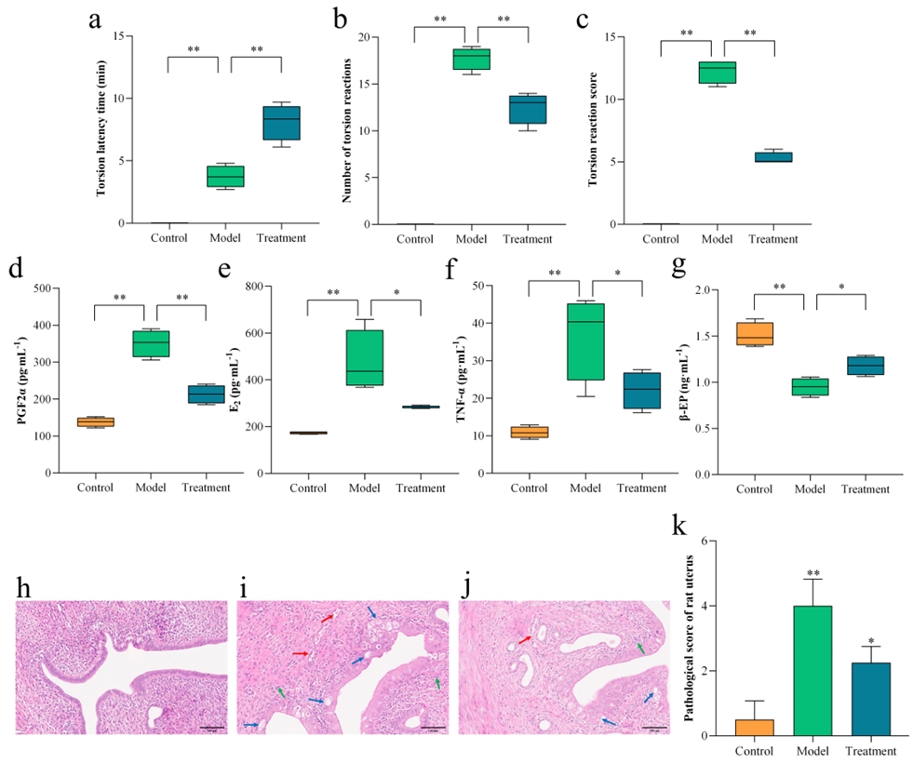
In summary, this study was carried out in strict accordance with ARRIVE guidelines.

