Supplementary materials for Kai Liao et al.

Machine learning techniques based on ¹⁸F-FDG PET radiomics features of temporal regions for classification of temporal lobe epilepsy patients from healthy controls

Kai Liao ^{1†}, Huanhua Wu^{1,2†}, Yuanfang Jiang¹, Chenchen Dong¹, Hailing Zhou^{1,3}, Biao Wu¹, Yongjin Tang¹, Jian Gong¹, Weijian Ye¹, Youzhu Hu^{1,2,}*, Qiang Guo^{3,}*, Hao Xu^{1,}*

1 Department of Nuclear Medicine and PET/CT-MRI Center, The First Affiliated Hospital of Jinan University & Institute of Molecular and Functional Imaging, Jinan University, Guangzhou, 510630, P.R.China.
2 The Affiliated Shunde Hospital of Jinan University, Foshan, Guangdong Province, 528305, P.R.China.
3 Department of Radiology, Central People's Hospital of Zhanjiang, Zhanjiang, Guangdong Province, 524045, P.R. China
4 Epilepsy Center, Guangdong 999 Brain Hospital, Affiliated Brain Hospital of Jinan University, Guangzhou, Guangdong Province, 510510, P.R.China.

* Corresponding authors, email: lingxuey@163.com; guoqiang999brain@163.com; txh@jnu.edu.cn
†These authors have contributed equally to this work

Boruta is an all relevant feature selection wrapper algorithm, capable of working with any classification method that output variable importance measure (VIM); by default, Boruta uses Random Forest.¹ The method performs a top-down search for relevant features by comparing original attributes' importance with importance achievable at random, estimated using their permuted copies, and progressively eliminating irrelevant features to stabilise that test.

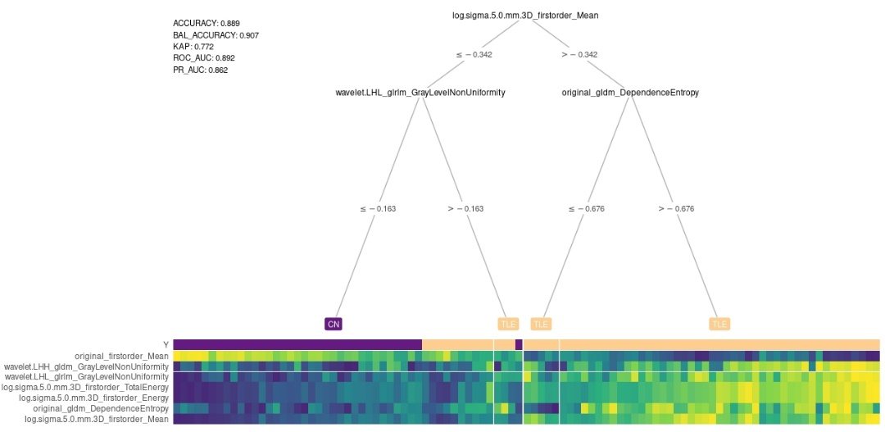
Figure S1: The result of decision tree model using the 7 radiomics features selected by LASSO and Boruta algorithms.

Figure S1 displayed an interpretable decision tree visualization by integrating a heatmap at its terminal nodes.² We created interpretable decision tree visualizations with the final 7 PET radiomics features represented as a heatmap at the tree's leaf nodes (original_firstorder_Mean, original_gldm_DependenceEntropy, log.sigma.5.0.mm.3D_firstorder_Energy, log.sigma.5.0.mm.3D_firstorder_Mean, log.sigma.5.0.mm.3D_firstorder_TotalEnergy, wavelet.LHL_glrlm_GrayLevelNonUniformity, wavelet.LHH_gldm_GrayLevelNonUniformity).

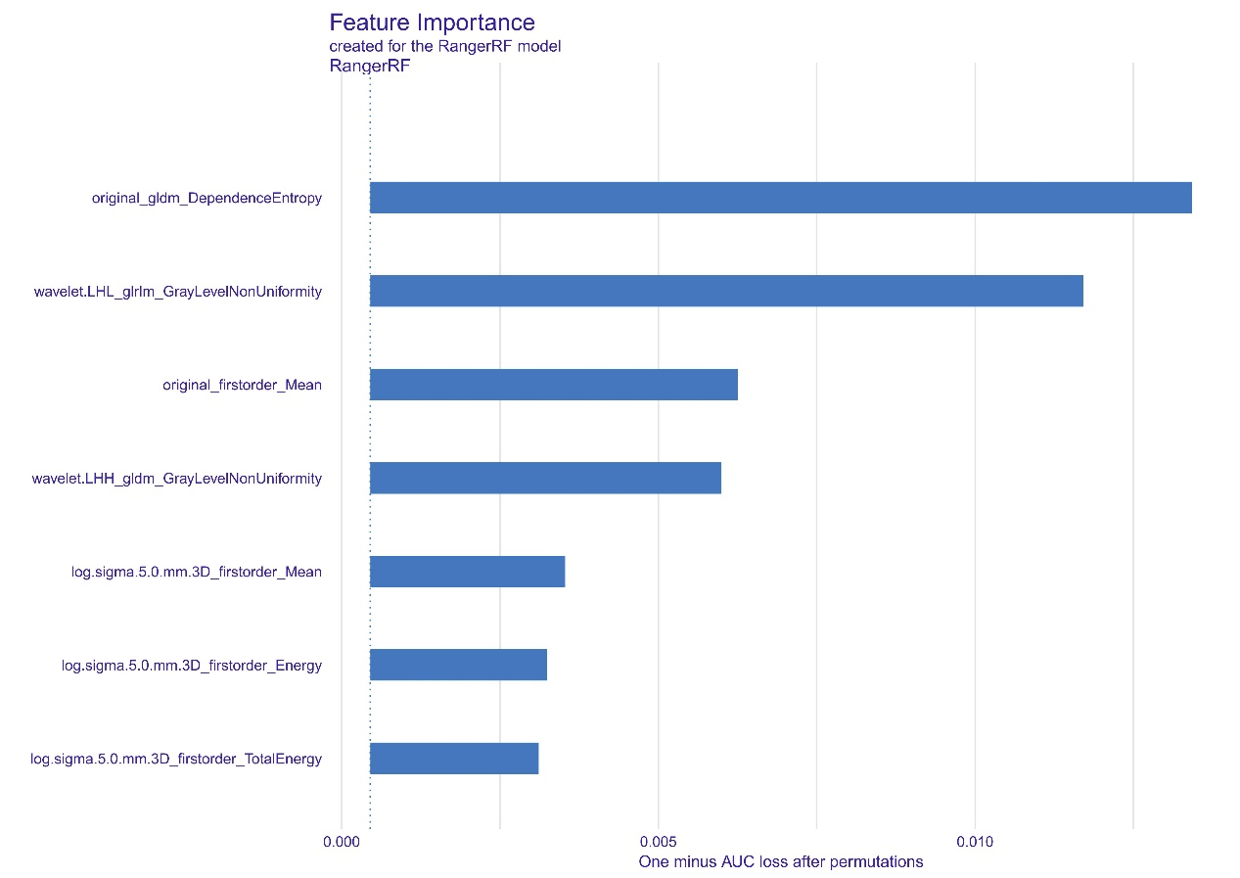
Figure S2: Means (over 10 permutations) of permutation-based variable-importance measures for the explanatory variables included in the random forest model for our PET radiomics data using 1-AUC as the loss function.

Figure S2 showed the variable importance as change in loss function after variable permutations in our PET radiomics dataset.³ We used the area under the ROC curve (AUC) as the model-performance measure. The plot in Figure S2 suggests that the most important variable in the model is original_gldm_DependenceEntropy. This agrees with the conclusions drawn in the exploratory analysis presented in table3. The next two important variables are wavelet.LHL_glrlm_GrayLevelNonUniformity, and original_firstorder_Mean.

References
1 Kursa MB, Rudnicki WR. Feature selection with the Boruta package. Journal of statistical software 2010; 36: 1–13.
2 Le T, Moore J. treeheatr: Heatmap-integrated decision tree visualizations. 2020 https://CRAN.R-project.org/package=treeheatr.
3 Biecek P. DALEX: Explainers for complex predictive models in R. Journal of Machine Learning Research 2018; 19: 1–5.

