Supplementary information
Sp3-rich Porous Carbon for Doublet Layer Supercapacitors
Tamoghna Bhattacharyya^{˦, Φ, *}
˦Department of Chemistry, Carnegie Mellon University, 4400 Fifth Avenue, Pittsburgh, PA 15213, USA
^{Φ}Currently at: Electronics and Nanoscale Engineering Division, James Watt School of Engineering, University of Glasgow, Glasgow G12 8QQ, UK
*E-mail: tbhattacharyya2010@gmail.com

Materials & methods
Synthesis of sp³-rich carbon materials:
500mg of N doped rG-O powder was dispersed in 200 ml of liquid NH₃ that was condensed at −78 °C in a closed reaction vessel using a dry ice-acetone bath. The mixture was stirred for 1h until rG-O was dispersed in the liquid NH₃. NaBH₄ was then added, and the mixture was further stored in −78 °C for 1h with constant stirring. Afterward, the cooling bath was removed and the NH₃ underwent evaporation while the mixture warmed to room temperature. The product was further isolated by filtration using a PTFE membrane (Millipore, 0.2 µm pore size), washed with distilled water, dry ethanol and distilled water again, and then dried in vacuum filtration at room temperature.
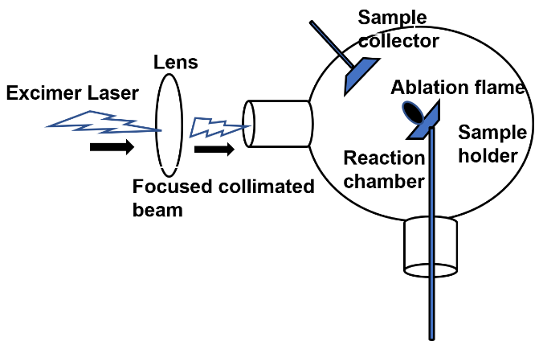
Fig S1. Scheme of Laser ablation process to generate the sp³-rich carbon material.
Further, the material was mounted as shown in the above figure and ablation was carried out under vacuum in an inert atmosphere using a high-power excimer laser (KrF laser, 248 nm). The laser beam was focused on the target produced a plasma cloud-plume that spreads symmetrically around a perpendicular axis to the target surface, and finally precipitates at the surface to generate the sp³-rich material.
Fabrication of Supercapacitor
Two-electrode system: Typically, 80 wt% sp³ -rich carbon materials, 15 wt% conducting carbon, and 5 wt% PTFE (60 wt% dispersion in water) were homogeneously mixed into a paste using an agate mortar and pestle. Then the mixture was rolled into uniform thickness sheets (ranged from 20 to 40 μm) and punched into about 0.7 cm diameter electrodes. After dried at 60ºC for 24 h, the as-prepared electrodes were soaked with the KOH solution (6 M). The two identical (by weight and size) electrodes were assembled in a test cell, which consisted of two current collectors, two electrodes, and a separator supported in a test fixture consisting of two stainless steel plates.
Three-electrode system: Electrochemical measurements were carried out by using an Ag/AgCl (saturated KCl) electrode and Pt wire as the reference and the counter electrodes, respectively. An ITO electrode for working electrodes was washed with water and acetone. acetone. 8 mg TB and 1.5 mg conducting carbon were dispersed ultrasonically in 2 ml NMP solution of 0.5% PETF to obtain a homogeneous black suspension solution. 10 μl of this solution was drop cast onto a ITO electrode surface and dried at 60ºC for 24 h.

