Supplementary material
Heat exposure and perinatal mortality: A time-stratified case-crossover study from 16 hospitals in Benin, Malawi, Tanzania and Uganda

Claudia Hanson, Jeroen de Bont (joint first), Kristi Sidney Annerstedt, Maria del Rosario Alsina, Federica Nobile, Nathalie Roos, Peter Waiswa, Jean-Paul Dossou, Effie Chipeta. Lenka Benova, Hussein Kidanto, Andrea Pembe, Cherie Part, Massimo Stafoggia, Veronique Filippi, Petter Ljungman.

Table S1| Associations between temperature indicators and perinatal mortality (75th vs 99th percentile).
Table S2| Associations between temperature indicators and perinatal mortality (50th vs 99th percentile).
Fig. S1| Flowchart of the study population.
Fig. S2| Distribution of the temperature indicators by country.
Fig. S3| Sensitivity analysis: associations between mean temperature and perinatal mortality during the 6 hottest consecutive months.
Fig. S4| Sensitivity analysis: associations between mean temperature and perinatal mortality by different lags (0, 0-1, 0-2 and 0-6).
Fig. S5| Sensitivity analysis: associations between mean daily temperature (lag 0-6) and perinatal mortality adjusted by dew point.
Fig. S6| Cumulative exposure-response curve between maximum temperature (lag 0-6) and perinatal mortality with 95%CIs (the figure represents the relative risk of temperature against the 75th percentile of annual mean temperature).
Fig. S7| Cumulative exposure-response curve between minimum temperature (lag 0-6) and perinatal mortality with 95%CIs (the figure represents the relative risk of temperature against the 75th percentile of annual mean temperature).

Table S1| Associations between temperature indicators and perinatal mortality (75th vs 99th percentile).
 | Stillbirth |  | Antepartum stillbirth |  | Intrapartum stillbirth |  | Perinatal death
Country | 75th (°C) | OR (95%CI) | 75th (°C) | OR (95%CI) | 75th (°C) | OR (95%CI) | 75th (°C) | OR (95%CI)
Mean temperature
Benin | 28.4 | 1.21 (0.63; 2.32) | 28.3 | 2.80 (0.90; 8.70) | 28.4 | 0.64 (0.27; 1.50) | 28.3 | 1.17 (0.63; 2.20)
Malawi | 22.7 | 1.27 (0.57; 2.83) | 22.9 | 0.61 (0.17; 2.19) | 22.6 | 2.38 (0.79; 7.12) | 22.8 | 0.93 (0.46; 1.87)
Tanzania | 25.9 | 0.94 (0.29; 3.11) | 26.0 | 0.38 (0.07; 2.03) | 25.8 | 24.29 (1.49; 395.06) | 26.0 | 1.00 (0.35; 2.85)
Uganda | 23.7 | 1.26 (0.73; 2.18) | 23.7 | 1.27 (0.53; 3.06) | 23.8 | 1.26 (0.61; 2.63) | 23.7 | 1.35 (0.81; 2.23)
Meta-analysis |  | 1.22 (0.85; 1.73) |  | 1.10 (0.51; 2.34) |  | 1.54 (0.63; 3.73) |  | 1.16 (0.84; 1.61)
Max temperature
Benin | 30.4 | 1.32 (0.54; 3.19) | 30.3 | 2.15 (0.56; 8.32) | 30.4 | 0.86 (0.26; 2.83) | 30.4 | 1.25 (0.54; 2.92)
Malawi | 27.9 | 1.72 (0.73; 4.05) | 28.0 | 0.89 (0.23; 3.47) | 27.7 | 3.28 (1.04; 10.42) | 28.0 | 1.27 (0.61; 2.67)
Tanzania | 31.3 | 1.07 (0.23; 4.97) | 31.4 | 0.48 (0.04; 5.56) | 31.1 | 31.60 (1.42; 704.57) | 31.3 | 1.01 (0.28; 3.65)
Uganda | 27.9 | 1.10 (0.63; 1.90) | 27.9 | 1.08 (0.43; 2.66) | 27.9 | 0.91 (0.43; 1.91) | 27.9 | 1.17 (0.70; 1.96)
Meta-analysis |  | 1.25 (0.84; 1.86) |  | 1.14 (0.60; 2.15) |  | 1.73 (0.64; 4.68) |  | 1.20 (0.83; 1.72)
Min temperature
Benin | 26.6 | 2.06 (0.94; 4.55) | 26.6 | 2.62 (0.82; 8.38) | 26.7 | 1.68 (0.57; 5.00) | 26.6 | 2.02 (0.96; 4.27)
Malawi | 18.8 | 0.86 (0.35; 2.12) | 18.8 | 0.57 (0.14; 2.38) | 18.7 | 1.02 (0.31; 3.31) | 18.8 | 0.61 (0.28; 1.34)
Tanzania | 22.2 | 0.99 (0.25; 3.86) | 22.3 | 0.60 (0.10; 3.48) | 22.2 | 1.97 (0.16; 23.83) | 22.3 | 0.85 (0.26; 2.82)
Uganda | 20.5 | 1.29 (0.69; 2.42) | 20.5 | 0.95 (0.32; 2.87) | 20.5 | 1.41 (0.67; 3.01) | 20.5 | 1.19 (0.69; 2.07)
Meta-analysis |  | 1.31 (0.87; 1.98) |  | 1.08 (0.52; 2.24) |  | 1.40 (0.82; 2.39) |  | 1.11 (0.67; 1.84)

Table S2| Associations between temperature indicators and perinatal mortality (50th vs 99th percentile).
 | Stillbirth |  | Antepartum stillbirths |  | Intrapartum stillbirths |  | Perinatal death
Country | 50th (°C) | OR (95%CI) | 50th (°C) | OR (95%CI) | 50th (°C) | OR (95%CI) | 50th (°C) | OR (95%CI)
Mean temperature
Benin | 27.4 | 1.21 (0.61; 2.38) | 27.3 | 2.51 (0.78; 8.09) | 27.5 | 0.69 (0.29; 1.69) | 27.3 | 1.19 (0.62; 2.28)
Malawi | 21.1 | 1.19 (0.53; 2.67) | 21.2 | 0.71 (0.20; 2.56) | 21.0 | 1.76 (0.57; 5.43) | 21.1 | 0.83 (0.41; 1.69)
Tanzania | 24.7 | 0.92 (0.29; 2.92) | 24.8 | 0.32 (0.07; 1.58) | 24.7 | 25.79 (1.77; 376.62) | 25.0 | 0.92 (0.34; 2.52)
Uganda | 22.9 | 1.27 (0.73; 2.22) | 22.8 | 1.27 (0.53; 3.05) | 22.9 | 1.27 (0.60; 2.68) | 22.8 | 1.38 (0.83; 2.30)
Meta-analysis |  | 1.20 (0.84; 1.72) |  | 1.06 (0.52; 2.17) |  | 1.32 (0.70; 2.50) |  | 1.14 (0.82; 1.59)
Max temperature
Benin | 29.5 | 1.49 (0.60; 3.74) | 29.4 | 2.19 (0.53; 9.05) | 29.5 | 1.04 (0.31; 3.56) | 29.4 | 1.41 (0.59; 3.40)
Malawi | 25.7 | 1.64 (0.70; 3.88) | 25.8 | 0.96 (0.25; 3.70) | 25.5 | 2.68 (0.83; 8.62) | 25.8 | 1.17 (0.56; 2.45)
Tanzania | 29.5 | 0.96 (0.22; 4.14) | 29.6 | 0.35 (0.03; 3.50) | 29.5 | 28.59 (1.44; 566.79) | 29.8 | 0.91 (0.27; 3.07)
Uganda | 26.7 | 1.02 (0.58; 1.81) | 26.7 | 1.05 (0.42; 2.65) | 26.6 | 0.82 (0.38; 1.78) | 26.9 | 1.09 (0.64; 1.86)
Meta-analysis |  | 1.22 (0.81; 1.83) |  | 1.10 (0.58; 2.10) |  | 1.60 (0.65; 3.91) |  | 1.14 (0.79; 1.65)
Min temperature
Benin | 25.5 | 1.70 (0.77; 3.73) | 25.4 | 2.33 (0.73; 7.51) | 25.6 | 1.35 (0.46; 3.96) | 25.5 | 1.69 (0.80; 3.56)
Malawi | 16.8 | 0.92 (0.37; 2.30) | 16.9 | 0.61 (0.15; 2.43) | 16.7 | 1.16 (0.33; 4.01) | 16.5 | 0.59 (0.27; 1.30)
Tanzania | 20.9 | 1.09 (0.26; 4.57) | 20.9 | 0.47 (0.07; 3.06) | 20.9 | 2.83 (0.22; 36.02) | 21.3 | 0.82 (0.23; 2.88)
Uganda | 19.8 | 1.37 (0.75; 2.53) | 19.7 | 1.25 (0.43; 3.62) | 19.8 | 1.31 (0.62; 2.75) | 19.6 | 1.30 (0.76; 2.25)
Meta-analysis |  | 1.32 (0.88; 1.98) |  | 1.15 (0.61; 2.19) |  | 1.33 (0.78; 2.28) |  | 1.09 (0.68; 1.74)

Fig. S1| Flowchart of the study population.

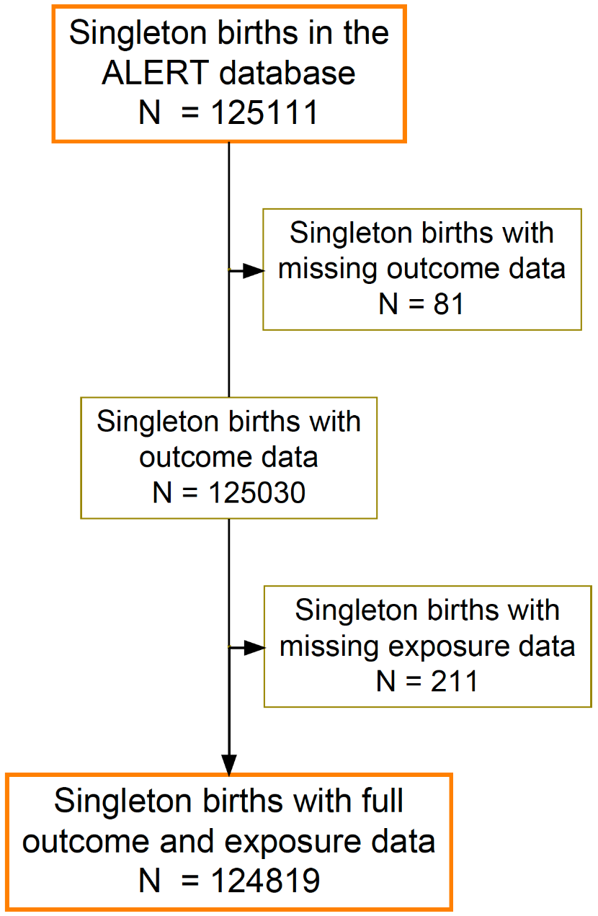

Fig. S2| Distribution of the temperature indicators by country.

Fig. S3| Sensitivity analysis: associations between mean temperature and perinatal mortality during the 6 hottest consecutive months.

Fig. S4| Sensitivity analysis: associations between mean temperature and perinatal mortality by different lags (0, 0-1, 0-2 and 0-6).

Fig. S5| Sensitivity analysis: associations between mean daily temperature (lag 0-6) and perinatal mortality adjusted by dew point.

Fig. S6| Cumulative exposure-response curve between maximum temperature (lag 0-6) and perinatal mortality with 95%CIs (the figure represents the relative risk of temperature against the 75th percentile of annual mean temperature).

Fig. S7| Cumulative exposure-response curve between minimum temperature (lag 0-6) and perinatal mortality with 95%CIs (the figure represents the relative risk of temperature against the 75th percentile of annual mean temperature).

