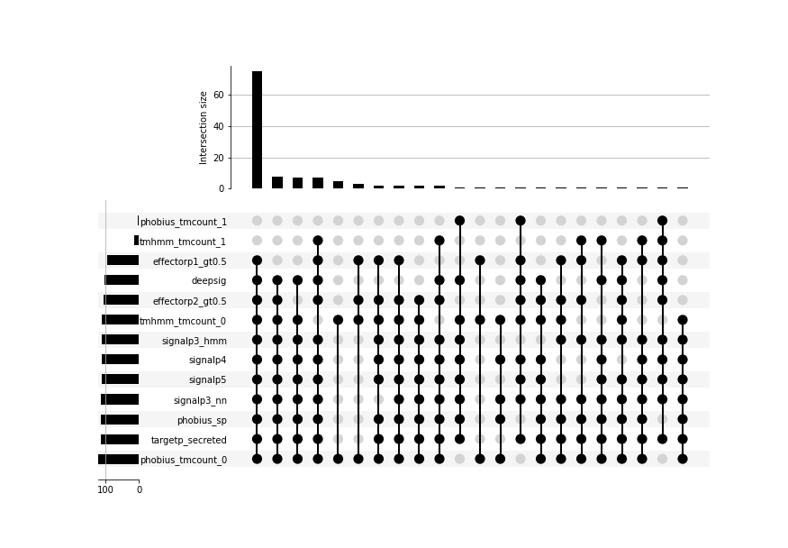
Supp. Figure 1.
UpSet plot showing predictions of signal peptides, transmembrane domains, and effector-like properties for all known effectors in the training dataset (N=125). Rows indicate sets of proteins predicted to have a property related to effector prediction (e.g. a signal peptide), with the horizontal bar chart indicating set size. Columns indicate where the horizontal sets intersect with each other, where the vertical bar-chart indicates the number of proteins in that intersection. This is the same as figure 1, but with all intersections included.

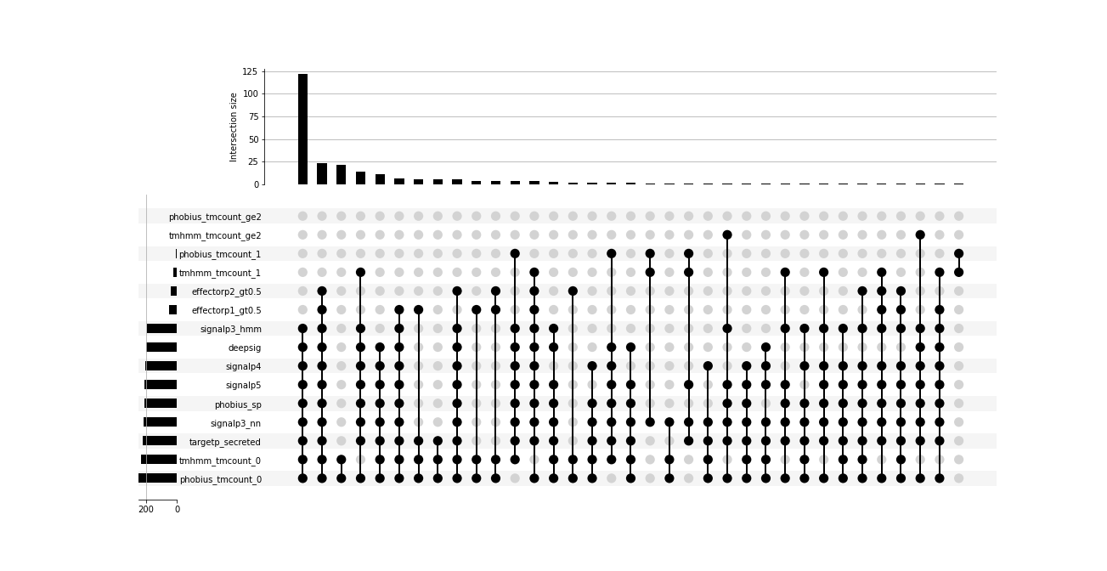

Supp. Figure 2.
UpSet plot showing predictions of signal peptides, transmembrane domains, and effector-like properties for all fungal proteins in SwissProt annotated as secreted in the training dataset (N=256). Rows indicate sets of proteins predicted to have a property related to effector prediction (e.g. a signal peptide), with the horizontal bar chart indicating set size. Columns indicate where the horizontal sets intersect with each other, where the vertical bar-chart indicates the number of proteins in that intersection.

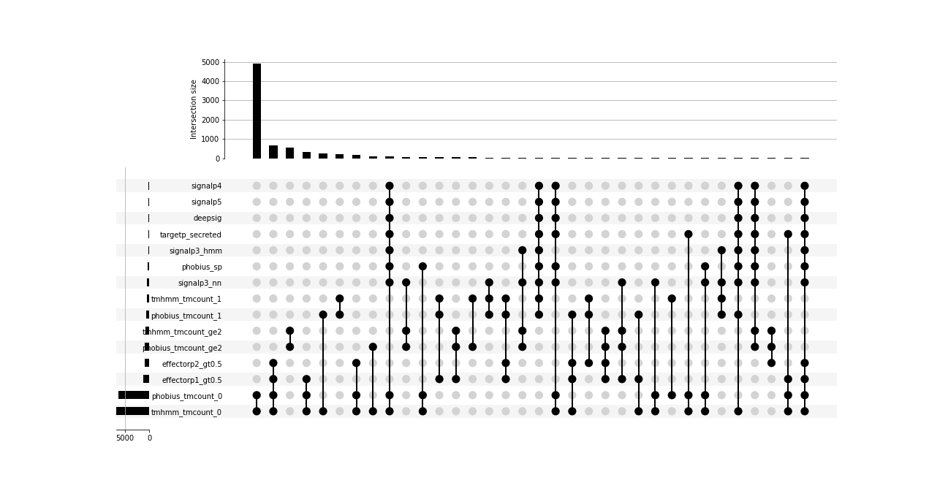
Supp. Figure 3
UpSet plot showing predictions of signal peptides, transmembrane domains, and effector-like properties for all fungal proteins in SwissProt annotated as non-secreted in the training dataset (N=8676). Rows indicate sets of proteins predicted to have a property related to effector prediction (e.g. a signal peptide), with the horizontal bar chart indicating set size. Columns indicate where the horizontal sets intersect with each other, where the vertical bar-chart indicates the number of proteins in that intersection. Intersections with less than 10 members are removed for clarity.

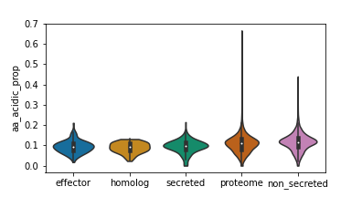
Supp. Figure 4
Proportion of acidic (B, D, E or Z) amino acids in proteins in training datasets.
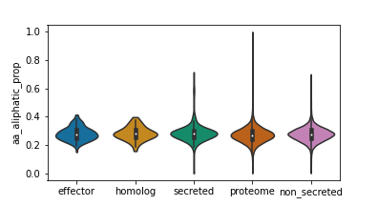
Supp. Figure 5
Proportion of aliphatic (A, I, L, or V) amino acids in proteins in training datasets.

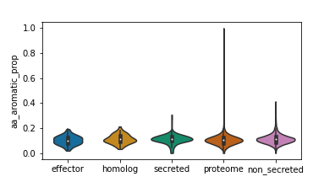
Supp. Figure 6
Proportion of aromatic (F, H, W, or Y) amino acids in proteins in training datasets.

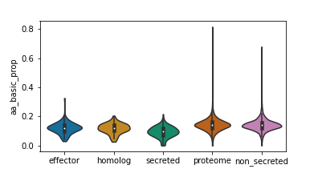
Supp. Figure 7
Proportion of basic (H, K, or R) amino acids in proteins in training datasets.

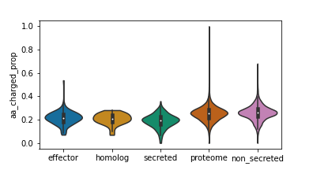
Supp. Figure 8
Proportion of charged (B, D, E, H, K, R, or Z) amino acids in proteins in training datasets.

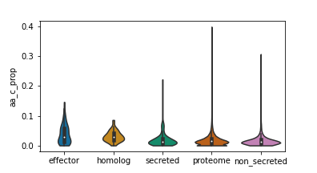
Supp. Figure 9
Proportion of cysteine amino acids in proteins in training datasets.

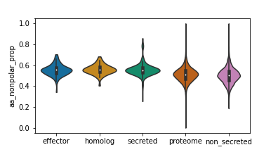
Supp. Figure 10
Proportion of non-polar (A, C, F, G, I, L, M, P, V, W, or Y) amino acids in proteins in training datasets.

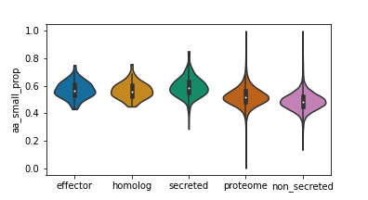
Supp. Figure 11
Proportion of small (A, B, C, D, G, N, P, S, T, or V) amino acids in proteins in training datasets.

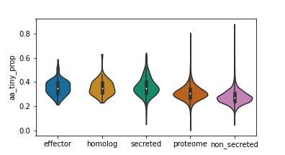
Supp. Figure 12
Proportion of small (A, C, G, S, or T) amino acids in proteins in training datasets.

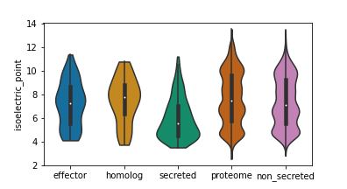
Supp. Figure 13
Distributions of protein isoelectric points in training datasets.

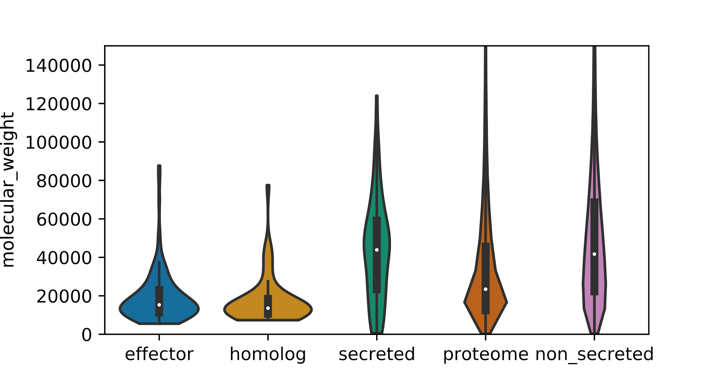
Supp. Figure 14
Distributions of molecular weight in Daltons for proteins in the training datasets.

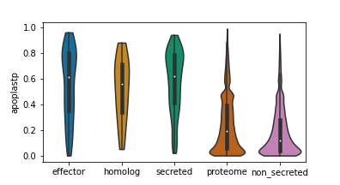
Supp. Figure 15
ApoplastP pseudo-probability of apoplastic localisation for proteins in training datasets.

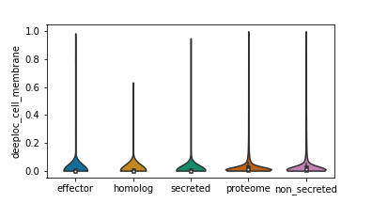
Supp. Figure 16
DeepLoc pseudo-probability of cell membrane localisation for proteins in training datasets. This probability and all other DeepLoc scores except membrane are from a multiclass classifier and sum to one for each individual protein.

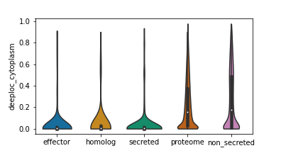
Supp. Figure 17
DeepLoc pseudo-probability of cytoplasmic localisation for proteins in training datasets. This probability and all other DeepLoc scores except membrane are from a multiclass classifier and sum to one for each individual protein.

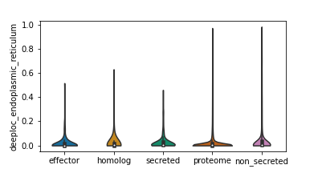
Supp. Figure 18
DeepLoc pseudo-probability of endoplasmic reticulum localisation for proteins in training datasets. This probability and all other DeepLoc scores except membrane are from a multiclass classifier and sum to one for each individual protein.

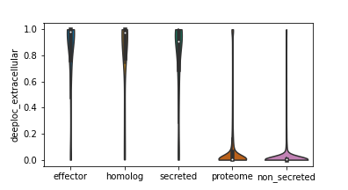
Supp. Figure 19
DeepLoc pseudo-probability of extracellular localisation for proteins in training datasets. This probability and all other DeepLoc scores except membrane are from a multiclass classifier and sum to one for each individual protein.

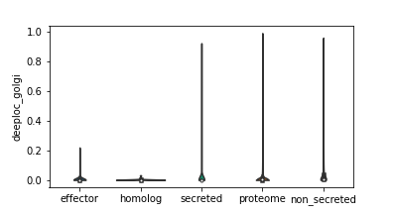
Supp. Figure 20
DeepLoc pseudo-probability of golgi localisation for proteins in training datasets. This probability and all other DeepLoc scores except membrane are from a multiclass classifier and sum to one for each individual protein.

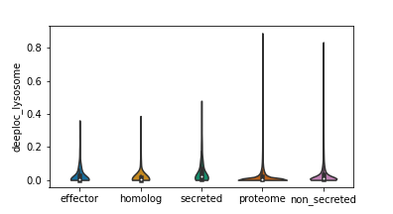
Supp. Figure 21
DeepLoc pseudo-probability of lysosome localisation for proteins in training datasets. This probability and all other DeepLoc scores except membrane are from a multiclass classifier and sum to one for each individual protein.
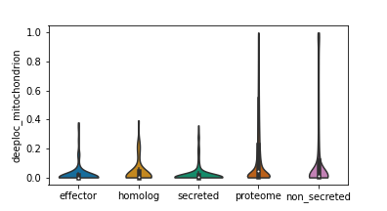
Supp. Figure 22
DeepLoc pseudo-probability of mitochondrial localisation for proteins in training datasets. This probability and all other DeepLoc scores except membrane are from a multiclass classifier and sum to one for each individual protein.

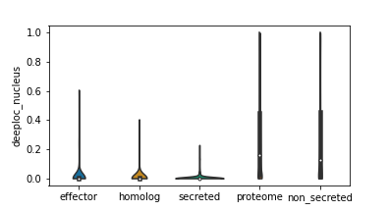
Supp. Figure 23
DeepLoc pseudo-probability of nuclear localisation for proteins in training datasets. This probability and all other DeepLoc scores except membrane are from a multiclass classifier and sum to one for each individual protein.

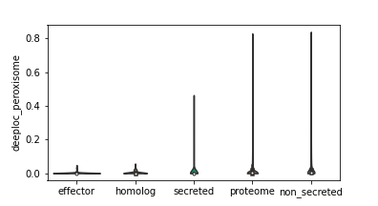
Supp. Figure 24
DeepLoc pseudo-probability of peroxisomal localisation for proteins in training datasets. This probability and all other DeepLoc scores except membrane are from a multiclass classifier and sum to one for each individual protein.

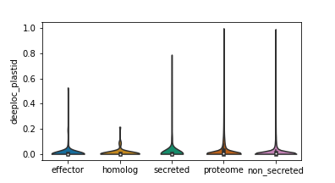
Supp. Figure 25
DeepLoc pseudo-probability of plastid localisation for proteins in training datasets. This probability and all other DeepLoc scores except membrane are from a multiclass classifier and sum to one for each individual protein.
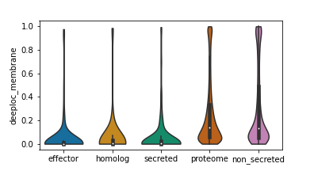
Supp. Figure 26
DeepLoc pseudo-probability of membrane association for proteins in training datasets.

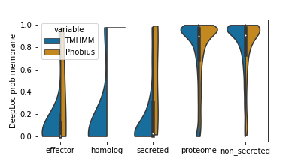
Supp. Figure 27
Split violin plot showing DeepLoc pseudo-probability of membrane association for proteins in the training dataset with at least one transmembrane domain predicted by TMHMM (left) or Phobius (right).

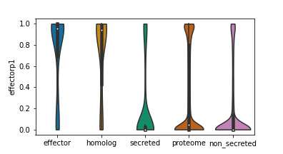
Supp. Figure 28
EffectorP 1 pseudo-probability of effector classification for proteins in the training dataset. This distribution is on the full dataset, including proteins without signal peptides.
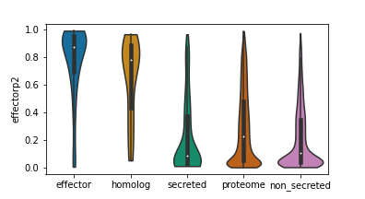
Supp. Figure 29
EffectorP 2 pseudo-probability of effector classification for proteins in the training dataset. This distribution is on the full dataset, including proteins without signal peptides.

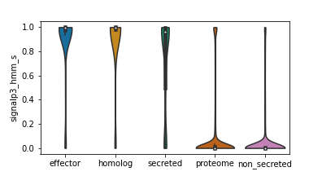
Supp. Figure 30
Distributions of SignalP 3 - HMM S-scores for proteins in the training dataset.

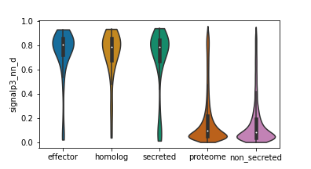
Supp. Figure 31
Distributions of SignalP 3 - NN D-scores for proteins in the training dataset.

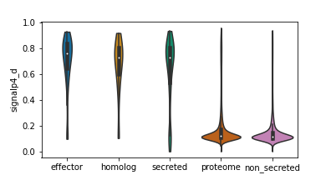
Supp. Figure 32
Distributions of SignalP 4 D-scores for proteins in the training dataset.

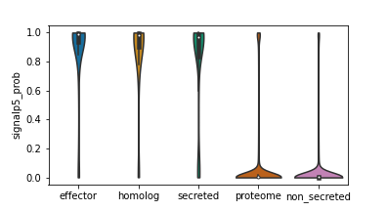
Supp. Figure 33
Distributions of SignalP 5 pseudo-probabilities of having a signal peptide for proteins in the training dataset.

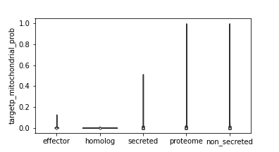
Supp. Figure 34
Distributions of TargetP pseudo-probabilities of having a mitochondrial target peptide for proteins in the training dataset. This probability and all other TargetP scores are from a multiclass classifier and sum to one for each individual protein.

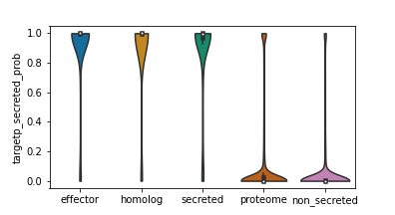
Supp. Figure 35
Distributions of TargetP pseudo-probabilities of having a secretion target peptide for proteins in the training dataset. This probability and all other TargetP scores are from a multiclass classifier and sum to one for each individual protein.

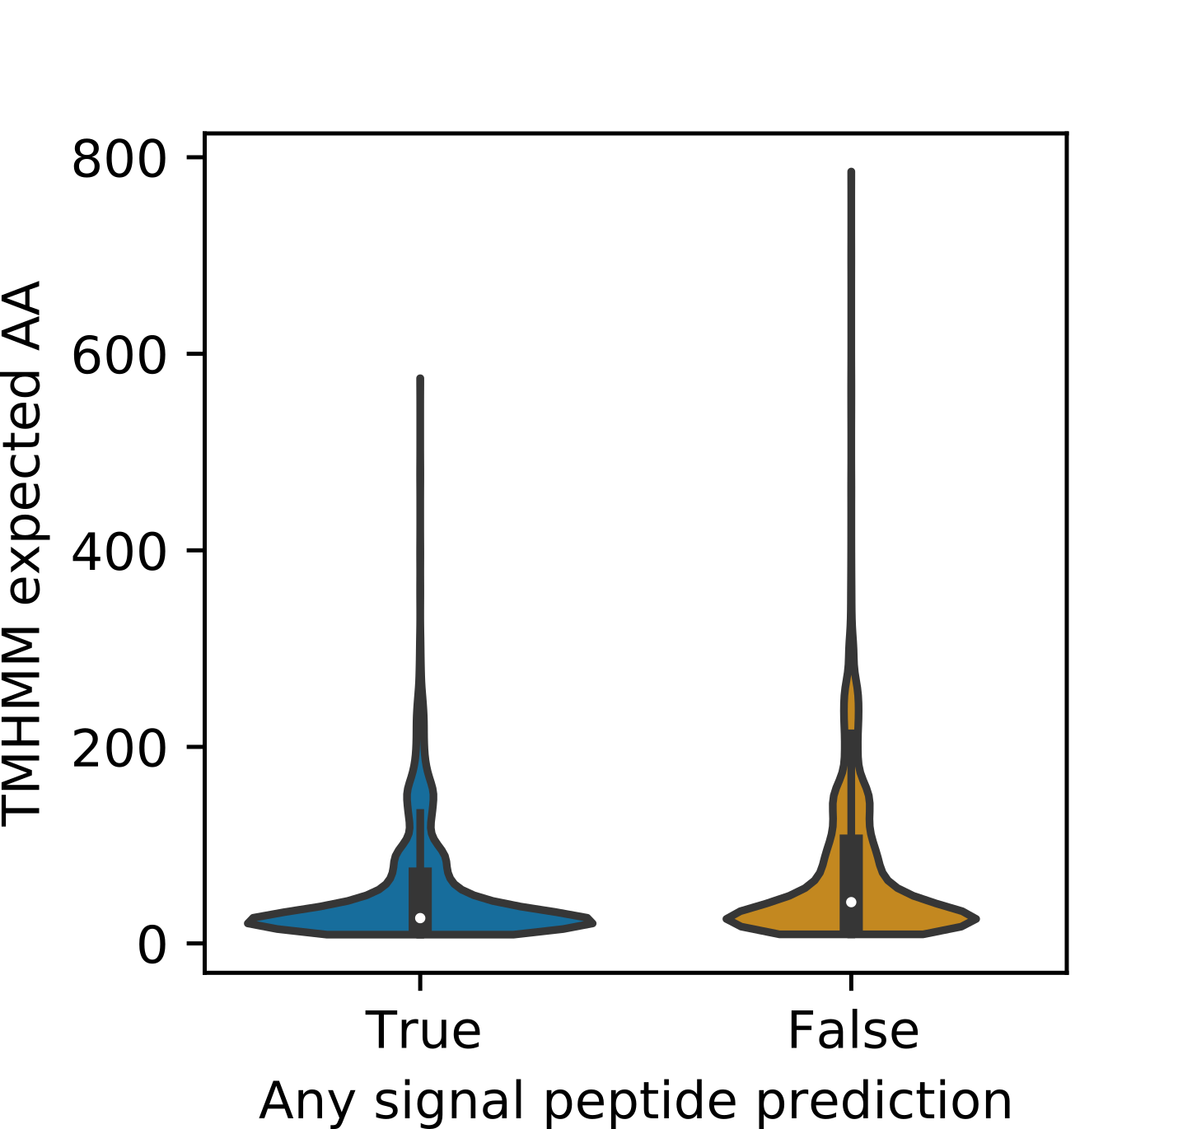
Supp. Figure 36
Distributions of TMHMM expected number of AAs in transmembrane domains for proteins with and without a signal peptide, for proteins in the training dataset.

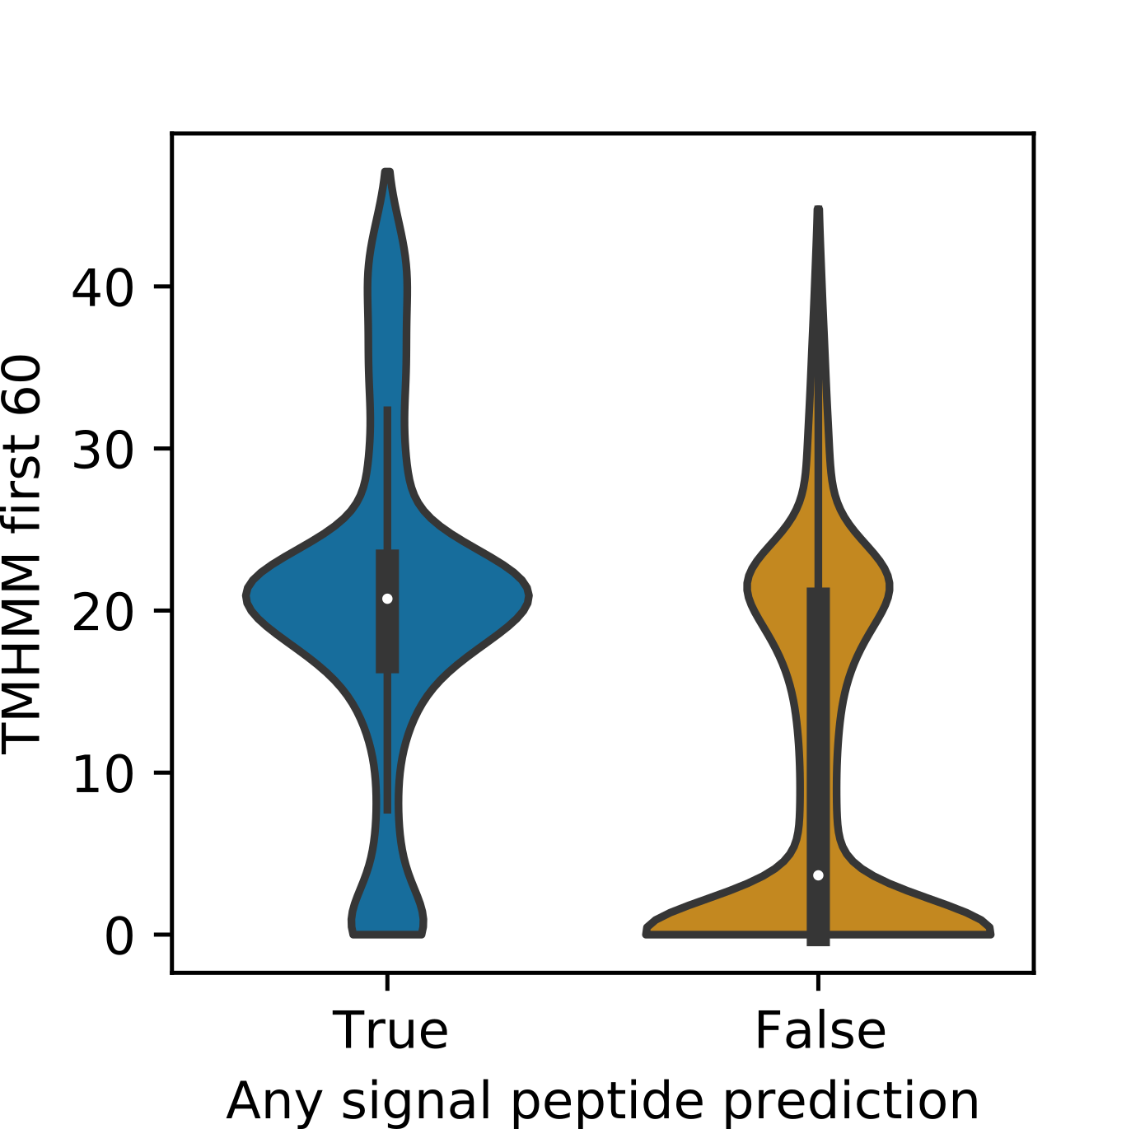
Supp. Figure 37
Distributions of TMHMM expected number of AAs in transmembrane domains in the first 60 residues for proteins with and without a signal peptide, for proteins in the training dataset.

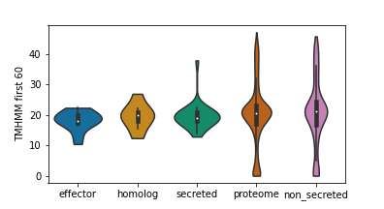
Supp. Figure 38
Distributions of TMHMM expected number of AAs in transmembrane domains in the first 60 residues for proteins in the training datasets.

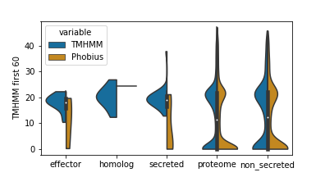
Supp. Figure 39
Split violin plot showing the distribution TMHMM expected number of AAs in transmembrane domains in the first 60 residues for proteins for proteins predicted to have at least one transmembrane domain by TMHMM (left) of Phobius (right), for each class in the training dataset.

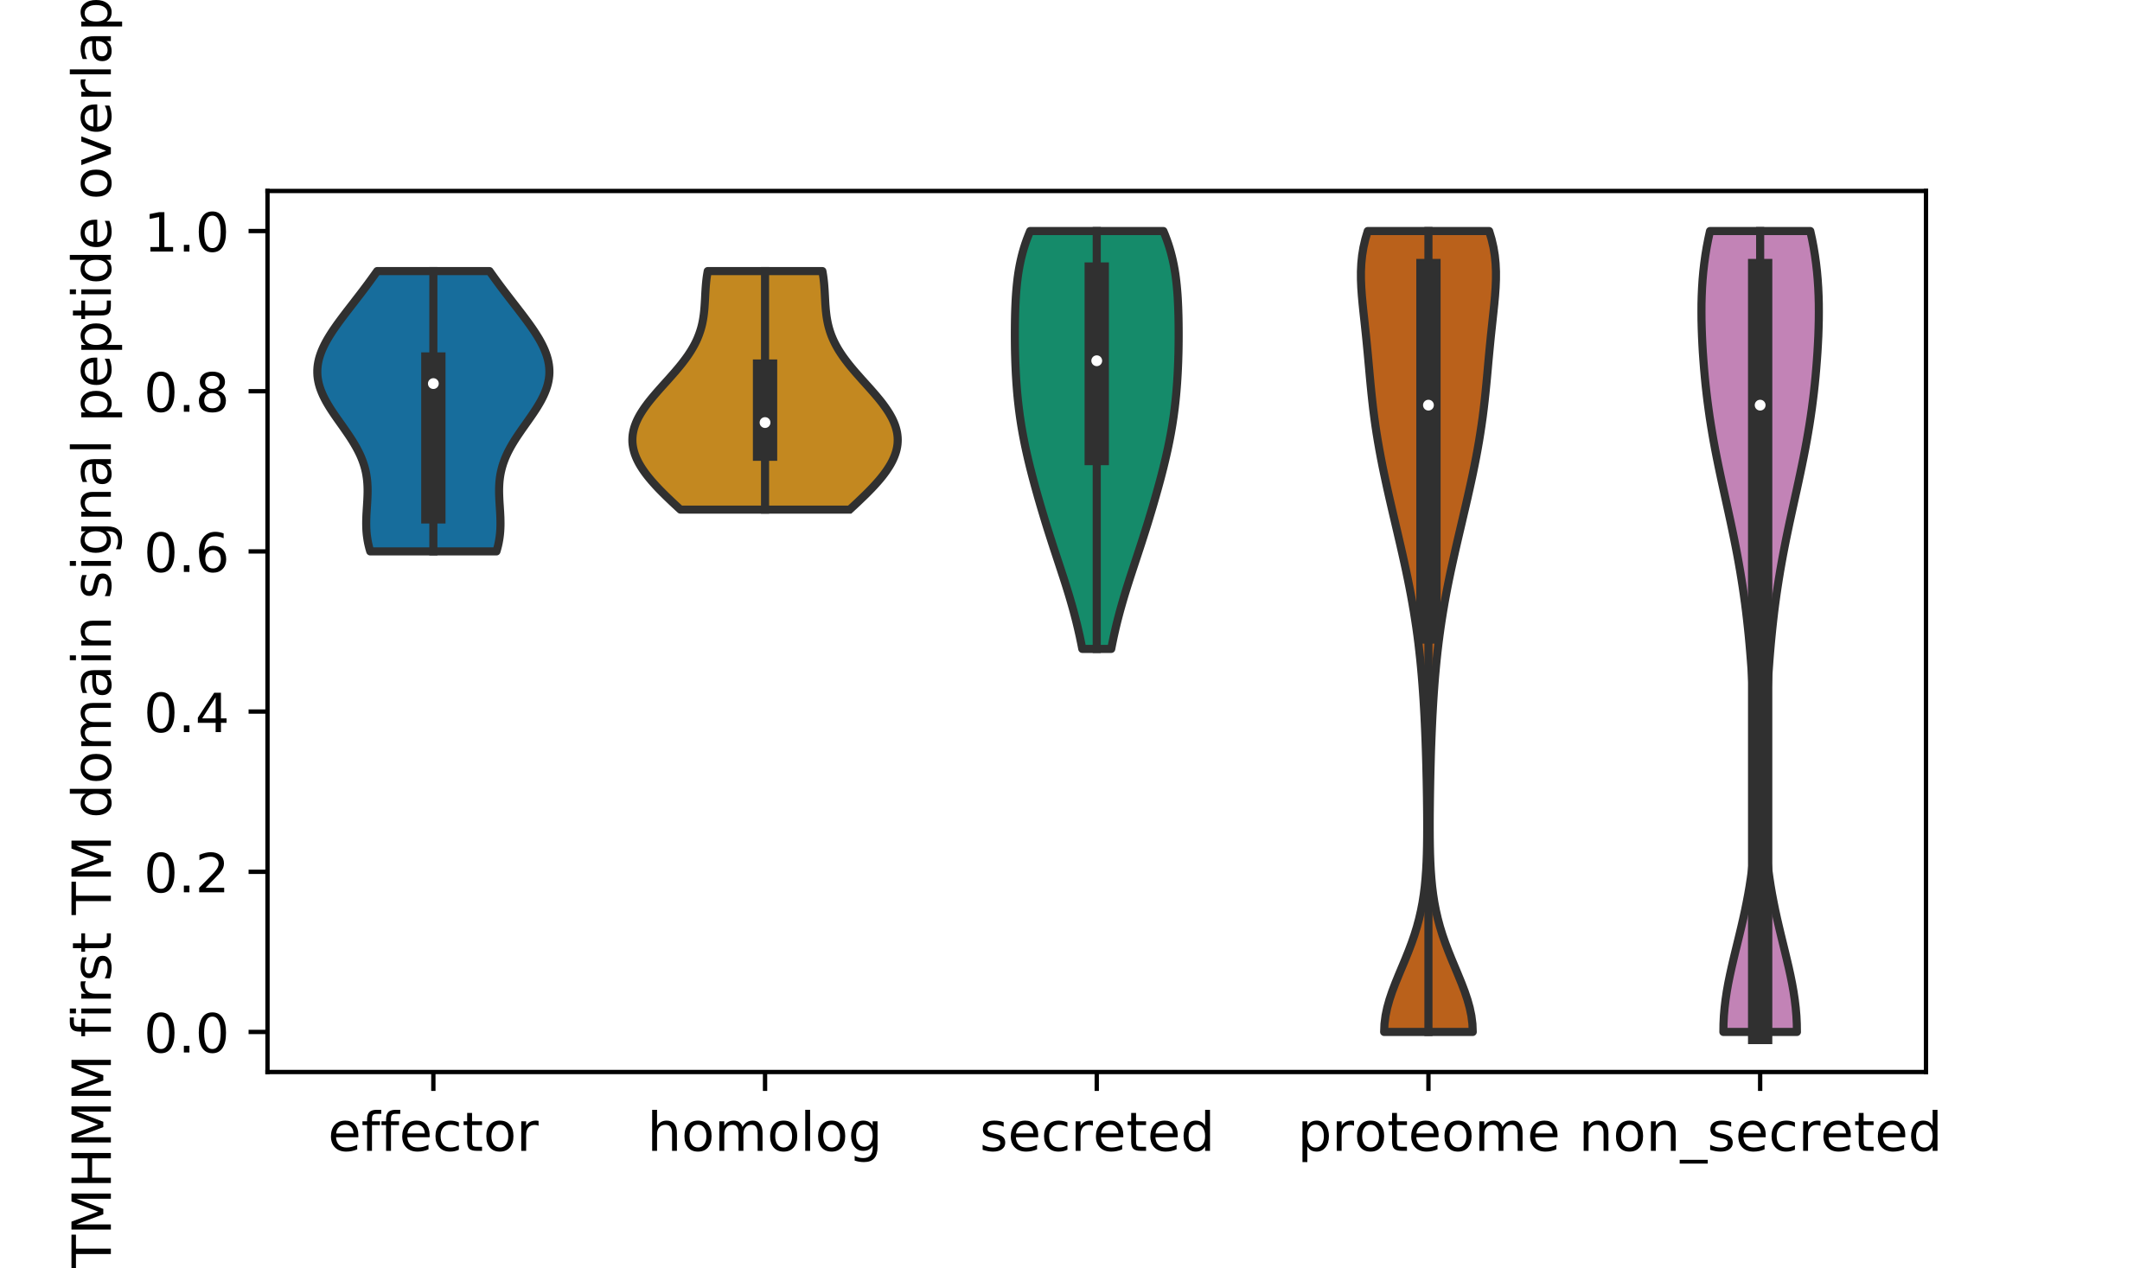
Supp. Figure 40
Distribution of proportion of overlap between the median predicted signal peptide cut-site and the first transmembrane domain predicted by TMHMM. Only includes proteins with both a signal peptide and at least one transmembrane domain in the training datasets.

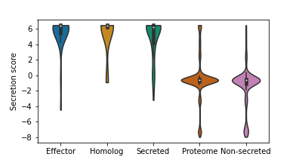
Supp. Figure 41
Manually created secretion score with default weights, for each class in the test dataset.

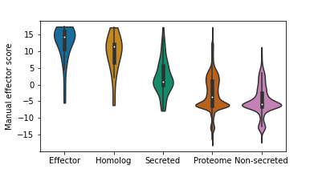
Supp. Figure 42
Manually created effector score with default weights for each class in the test dataset.

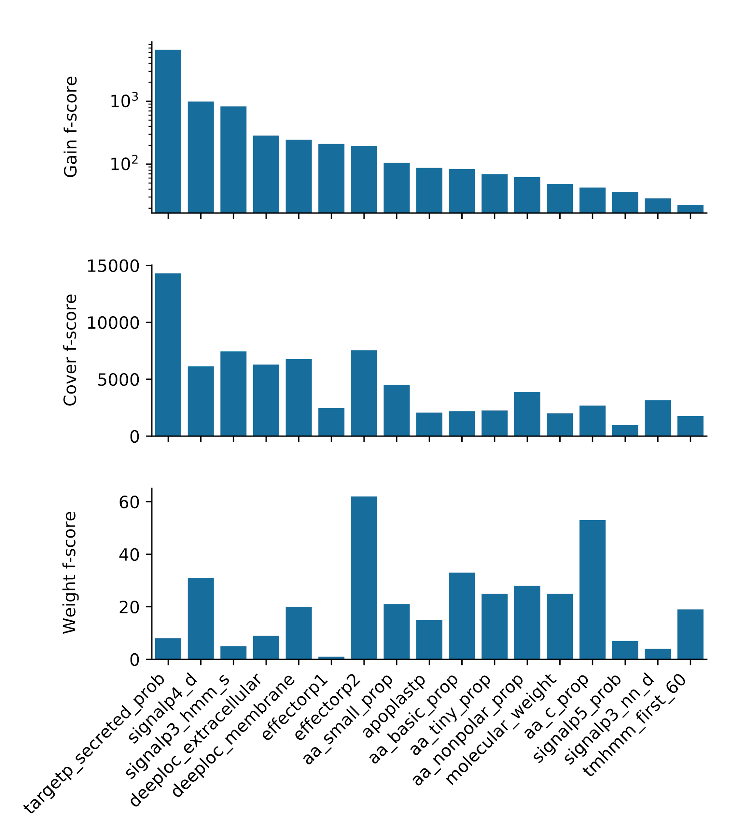

Supp. Figure 43
Feature importances for the trained learning-to-rank (LTR) model.
Gain is the improvement in score given by branches that use the feature and is the best indicator of feature importance generally (note the log scale). Cover is the average number of samples that are affected by each split. Weight is how many times a feature is used in the trees.

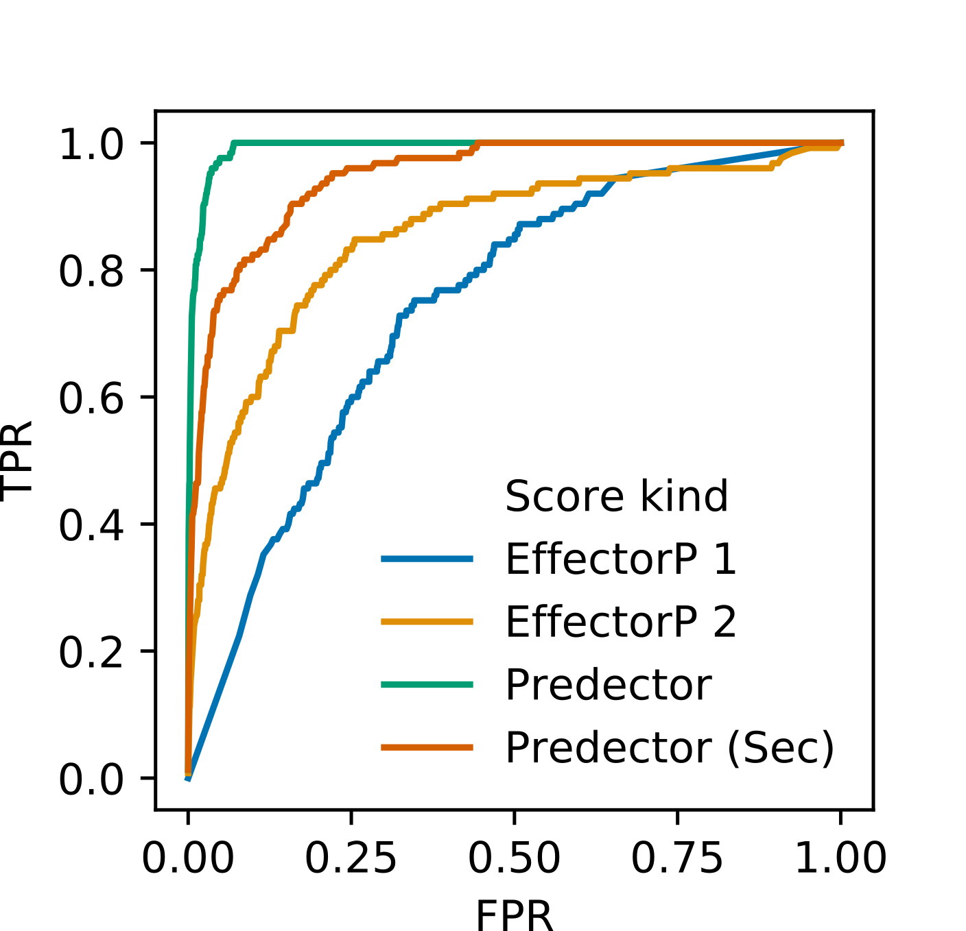
Supp. Figure 44
Receiver operator characteristic (ROC) curves for the training dataset for Predector and EffectorP scores. EffectorP 1 and 2, and “Predector (Sec)” were only tested on the subset of proteins predicted to be secreted. The curve for “Predector” is evaluated on the full dataset.

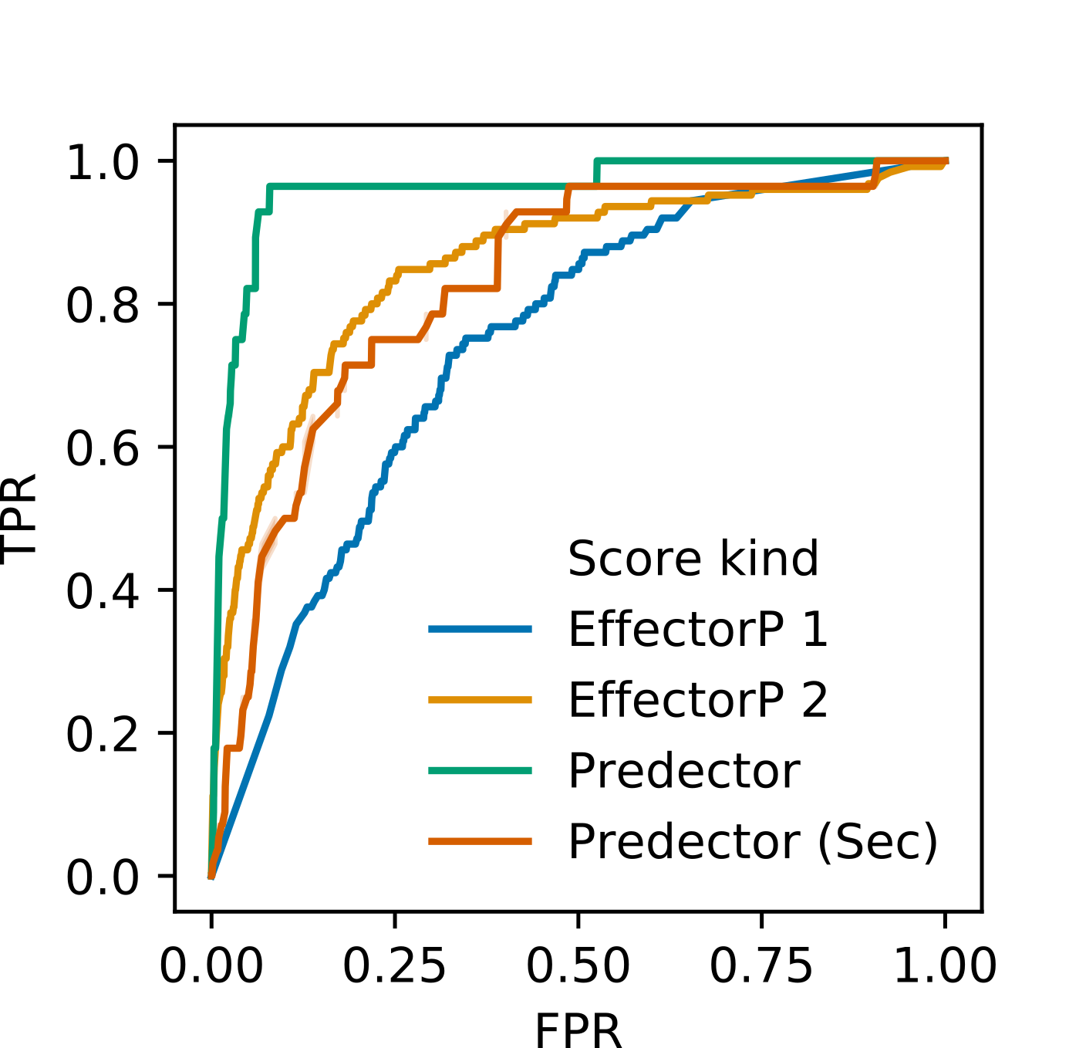
Supp. Figure 45
Receiver operator characteristic (ROC) curves for the testing dataset for Predector and EffectorP scores. EffectorP 1 and 2, and “Predector (Sec)” were only tested on the subset of proteins predicted to be secreted. The curve for “Predector” is evaluated on the full dataset.
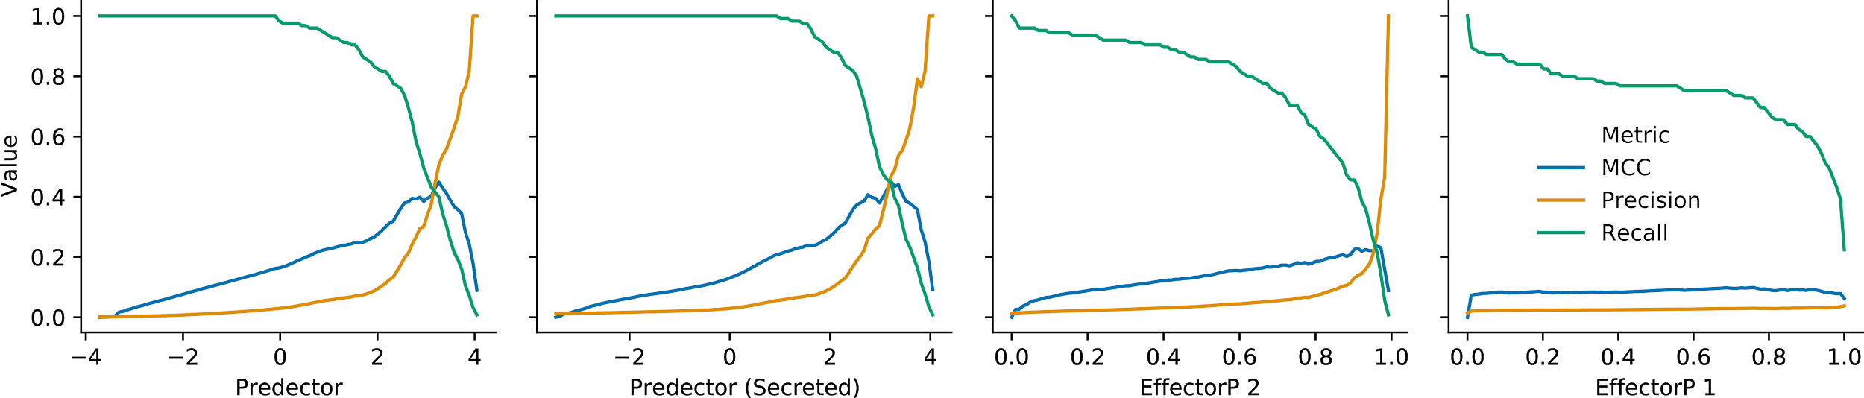
Supp. Figure 46
Precision, Recall, and MCC at different 100 binary classification thresholds in the training data. EffectorP 1 and 2, and “Predector (Sec)” were only tested on the subset of proteins predicted to be secreted. The curves for “Predector” are evaluated on the full dataset.

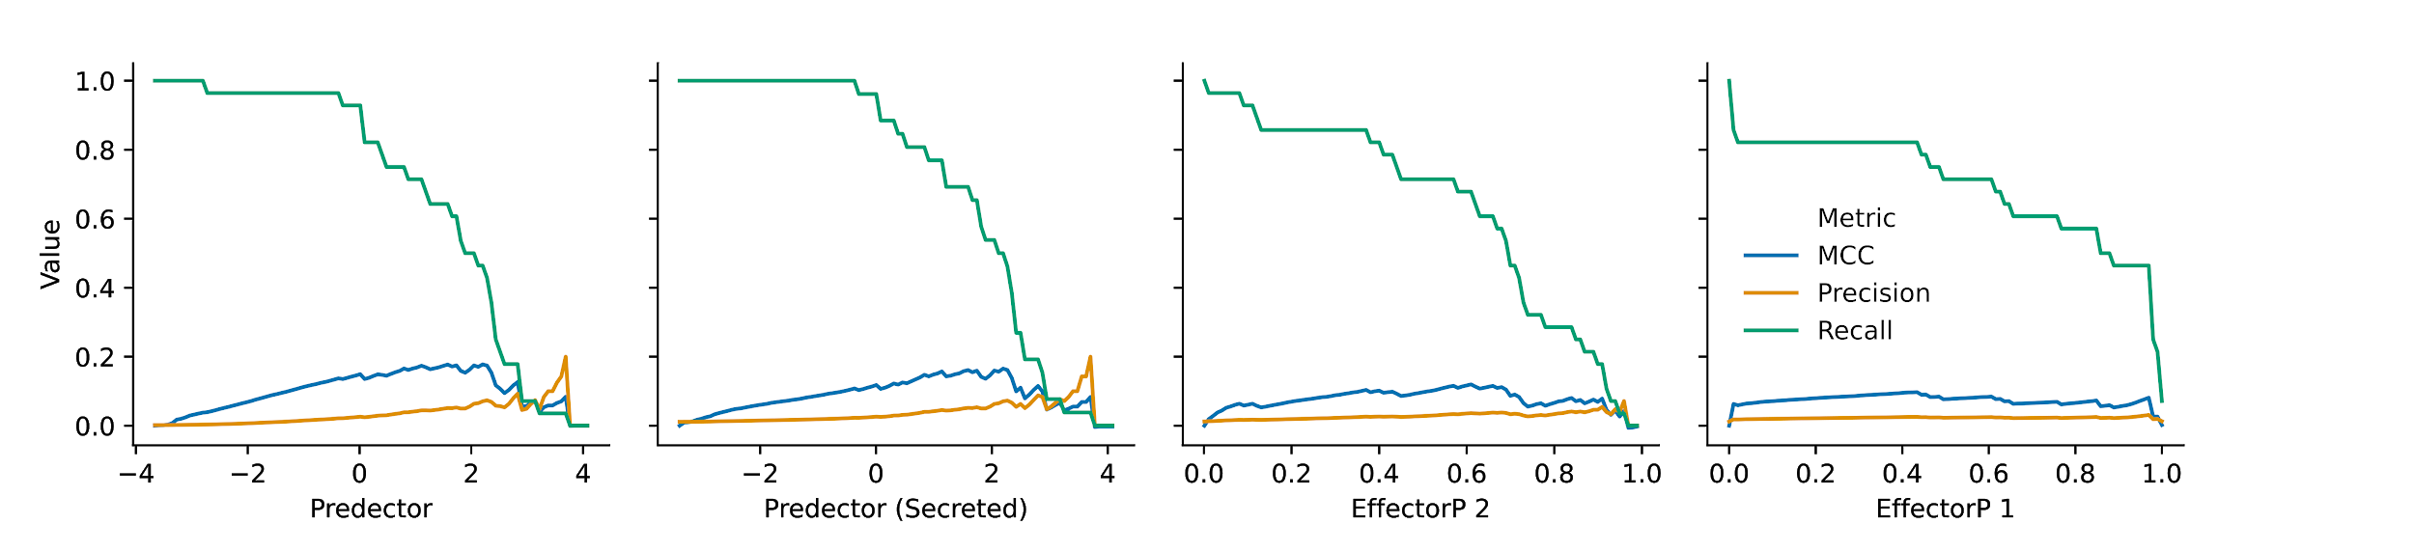
Supp. Figure 47
Precision, Recall, and MCC at different 100 binary classification thresholds in the testing data. EffectorP 1 and 2, and “Predector (Sec)” were only tested on the subset of proteins predicted to be secreted. The curves for “Predector” are evaluated on the full dataset.

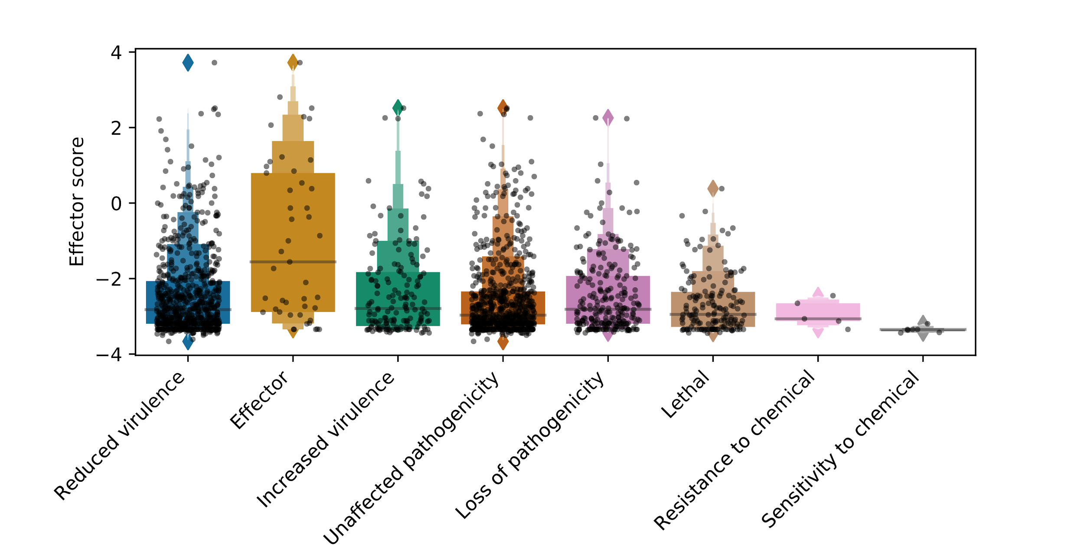
Supp. Figure 48
Distribution of Predector “effector” scores for proteins with a significant PHI-base match with each phenotype for proteins in the test dataset. Proteins may have multiple phenotypes associated with them. The effector class includes non-fungal effectors (e.g. from Bacteria or Oomycetes).

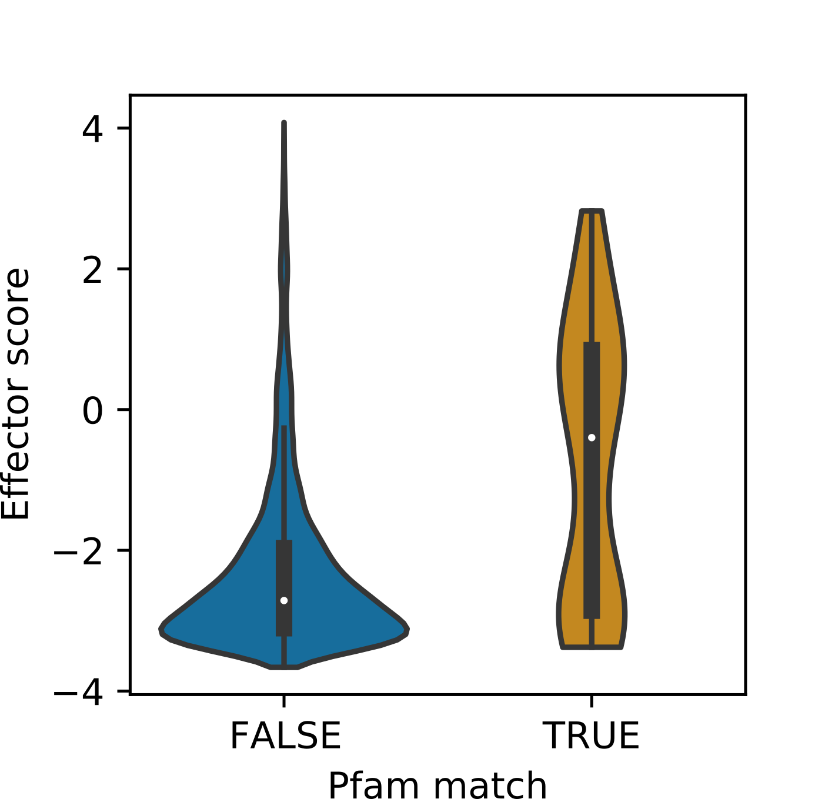
Supp. Figure 49
Distribution of Predector “effector” score for proteins with a significant match to one of the Pfam domains indicative of effector activity.

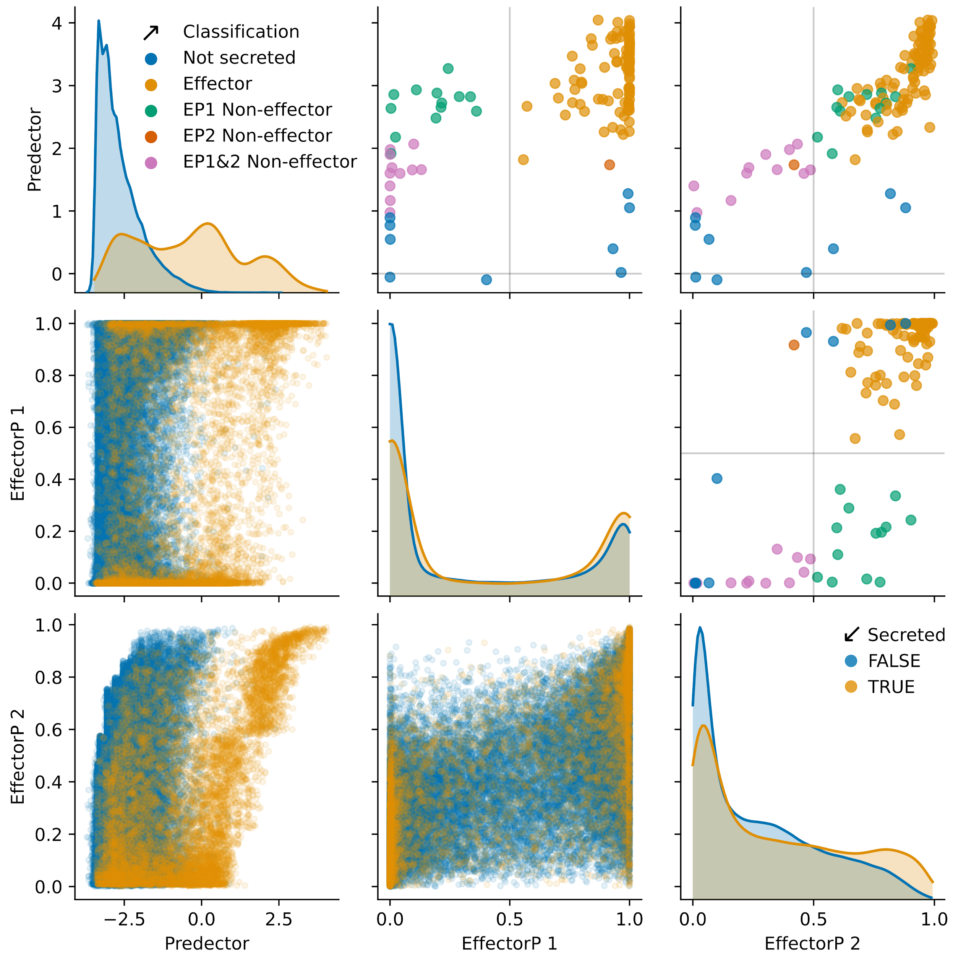

Supp. Figure 50
Comparing the scores of Predector with EffectorP versions 1 and 2 for proteins in the training dataset. Scatter plots in the lower-left corner indicate comparisons of predictive scores between methods, with predicted secreted proteins (any signal peptide and fewer than two TM domains predicted) indicated in yellow, and non-secreted proteins indicated in blue. Density plots along the diagonal indicate distributions of the full test dataset versus predictive scores for each method (indicated along the x-axis), also coloured by secretion prediction as before (Note: there are far more non-secreted than secreted proteins in the dataset). Scatter plots in the top-right corner indicate score comparisons between methods for confirmed effectors, coloured by whether they have been predicted as secreted (criteria as above), or additionally predicted by EffectorP versions 1 or 2.

