Supporting Information for
Repositioning Therapeutics for COVID-19: Virtual Screening of the Potent Synthetic and Natural Compounds as SARS-CoV-2 3CLpro Inhibitors
Ahmad Sattari,ª Ali Ramazani*^{a,b} and Hamideh Aghahosseini^{a,b}
ªDepartment of Chemistry, University of Zanjan, P O Box 45195-313, Zanjan, Iran.
^{b}Research Institute of Modern Biological Techniques (RIMBT), University of Zanjan, Zanjan, Iran.
* Corresponding author: Ali Ramazani
Tel: (+98)2433052572
Fax: (+98)2433052477
E-mail addresses: aliramazani@gmail.com; aliramazani@znu.ac.ir
Table 1. The physical information and pharmaceutical activities of several drugs and a number of chemical compounds from different resources as 3CLpro inhibitors
No | Name/ Comound Cod | No.ª HBD | No.^{b} HBA | HAC | Pharmaceutical function ^{c}
1 | Compound1  CID:134816013 | 4 | 6 | 39 | -
2 | Licofelone acyl glucuronide  CID: 71749786 | 4 | 8 | 39 | Anti-inflammatory, relevant inhibitor of CYP2C8^{[1]}
3 | Ritonavir impurity H [EP]  CID: 66832842 | 1 | 8 | 41 | -
4 | delta-Bilirubin  CID:129320333 | 4 | 6 | 43 | Antioxidant
5 | Raltegravir  CID: 54671008 | 3 | 9 | 32 | Anti-HIV
6 | Nigericin  ZINC000085552063 | 3 | 11 | 51 | Anti-microbial & anti-bacterial
7 | Pradimicin A  ZINC000169346835 | 11 | 19 | 60 | Anti-HIV & antifungal
8 | Rupintrivir  ZINC000003919807 | 3 | 9 | 43 | Anti-HRV
9 | Lopinavir  ZINC000003951740 | 4 | 5 | 46 | Anti- HIV & AIDS
10 | Adenylyl-(3'-5') ribavirin  CID: 196553 | 7 | 17 | 39 | Anti- influenza A virus^{[2]}
11 | Novobiocin  ZINC000076945632 | 5 | 11 | 44 | Anti-bacterial
12 | Megazone  CID: 27624 | 0 | 7 | 37 | Anti-inflammatory^{[3]}
13 | CHEMBL21082  ZINC000028231984 | 4 | 9 | 44 | Anti-HRV^{[4]}
14 | Simeprevir  ZINC000085540268 | 2 | 10 | 52 | Anti-HCV
15 | CGP 75136  ZINC000004394015 | 5 | 10 | 50 | Anti-HIV
16 | Amenamevir  CID: 11397521 | 1 | 7 | 34 | Antiviral
17 | Conivaptan  CID: 151171 | 2 | 3 | 38 | Inhibitor of antidiuretic  hormone
18 | CHEMBL140521  CID: 6479024 | 3 | 8 | 43 | Anti-HRV^{[5]}
19 | Indinavir  CID: 5362440 | 4 | 7 | 45 | Anti- HIV & AIDS
20 | Compound 20  CID: 134814833 | 3 | 11 | 48 | Anti-HIV & anti- TB activity^{[6]}
21 | Oxaprozin  CID: 4614 | 1 | 4 | 22 | Anti-inflammatory
22 | Telmisartan | 1 | 4 | 39 | Anti-hypertensives
  CID: | 65999
23 | Boceprevir  CID: 10324367 | 4 | 5 | 37 | Anti-HCV
24 | Elvitegravir  CID: 5277135 | 2 | 7 | 31 | Anti-HIV
25 | Telaprevir  CID: 3010818 | 4 | 8 | 49 | Anti-HCV
26 | Saquinavir  ZINC000003914596 | 5 | 7 | 49 | Anti- HIV & AIDS
27 | Atazanavir  ZINC000003941496 | 5 | 9 | 51 | Anti-HIV
28 | Maraviroc  CID: 3002977 | 1 | 6 | 37 | Anti- HIV & AIDS
29 | Compound 29  CID: 134815433 | 1 | 10 | 46 | Anti-HIV & anti-TB activity^{[6]}
30 | CHEMBL289920  CID: 6477669 | 3 | 9 | 43 | Anti-HRV^{[7]}
31 | CHEMBL345023  CID: 6478681 | 3 | 8 | 42 | Anti-HRV^{[5]}
32 | Geneticin  CID: 134688573 | 10 | 14 | 34 | Anti-bacterial
33 | Ritonavir  CID: 392622 | 4 | 9 | 50 | Anti-HIV
34 | Vancomycin Mimic  ZINC000150553684 | 7 | 11 | 75 | Antimicrobial^{[8]}
35 | Ribavirin 5'- Triphosphate  CID: 122108 | 7 | 16 | 29 | Antiviral^{[9]}
36 | Oseltamivir  CID: 65028 | 2 | 5 | 22 | Anti-influenza viruses
37 | Phenylbutazone  CID: 4781 | 0 | 2 | 23 | Anti-inflammatory, antipyretic, and analgesic
38 | Licofelone  CID: 133021 | 1 | 2 | 27 | Anti-inflammatory, anti-analgesic
39 | Parecoxib  CID: 119828 | 1 | 5 | 26 | Anti-inflammatory, antipyretic activities
40 | Sofosbuvir  CID: 45375808 | 3 | 11 | 36 | Anti-HCV
41 | Lopinavir free Amine  CID: 17755107 | 4 | 4 | 34 | -
42 | Isoxicam  CID: 54677972 | 2 | 7 | 23 | Anti-inflammatory and anti-rheumatic
43 | (1R,2R)-2-azido-1,2-dihydro oseltamivir  CID: 76968516 | 2 | 7 | 25 | -
44 | Etoricoxib  CID: 123619 | 0 | 4 | 24 | NSAID, antipyretic, analgesic
45 | Fingolimod  CID: 107970 | 3 | 3 | 22 | Immunomodulatory drug, used to treat MS
46 | Chloroquine  CID: 2719 | 1 | 3 | 22 | Anti-inflammatory, antimalarial
47 | Firocoxib  CID: 208910 | 0 | 5 | 23 | Anti-inflammatory & antineoplastic
48 | Romidepsin  CID: 123135747 | 4 | 8 | 36 | Antineoplastic activity
49 | Mesalazine  CID: 4075 | 3 | 4 | 11 | Antiinflammatory
50 | Favipiravir  CID: 492405 | 2 | 4 | 11 | Antiviral
ª The number of hydrogen bond donors
^{b} The number of hydrogen bond acceptors
^{c} All of the pharmaceutical function information are recorded from PubCheme except the ligands containing references which are mentioned in supplementary information.

Table 2. The physical information and pharmaceutical activities of SARS-CoV-2 inhibitors from natural sources
No. | Name/ Comound Cod | No. HBD | No. HBA | HAC | Pharmaceutical functionª | Sourceª
1 | kappa-Carrageenan conformer  ZINC96061851 | 10 | 25 | 51 | Antiviral activity  against myxoviridae,  and coronaviridae^{[10]} | Red Algae
2 | beta-D- Galactopyranosyl  CID: 23656242 | 9 | 19 | 50 | Anti-inflammatory^{[11]} | Rosa canina
3 | Calycosin 7-O-  glucoside  CID: 5318267 | 5 | 10 | 32 | Antiviral^{[12]} | Astragalus
4 | Gallic acid 3-cholesteryl ester  CID: 101021751 | 3 | 5 | 39 | Antimicrobial activity^{[13]} | Ficus carica
5 | Spicoside A  CID: 44258517 | 0 | 7 | 30 | Neuroprotective potency^{[14]} | Cichorum intybus
6 | Corilagin  CID: 73568 | 11 | 18 | 45 | NSAID, antihypertensive agent | Euphorbiaceae
7 | Astragalin  CID: 5282102 | 7 | 11 | 32 | Anti-inflammatory^{[11]} | Rosa canina
8 | Podophyllotoxin acetate  CID: 164791 | 0 | 9 | 33 | Anticancer, antiviral^{[15]} | Euphorbia
9 | Rhamnetin 3-O-beta-glucopyranoside  CID: 14704554 | 7 | 12 | 34 | - | Syzygium aromaticum
10 | Astragalus polyphenol  CID: 5321884 | 7 | 9 | 29 | Anti-inflammatory antioxidant | Astragalus
11 | Geraniin  ZINC000169289506 | 14 | 27 | 68 | antiviral^{[16]} | Nephelium lappaceum
12 | Gallic Acid Tribenzyl Ether  CID: 11133969 | 1 | 5 | 33 | Antimicrobial^{[13]} | Ficus carica
13 | Linalool-3-Rutinoside  CID: 21630850 | 6 | 10 | 32 | Antibacterial, antifungal and antiviral^{[17]} | Myrtus communis
14 | Rhamnopyranoside  CID: 21606527 | 9 | 15 | 42 | Inhibitor of  topoisomerase I and II | Cichorum intybus
15 | Catechin gallate  CID: 5276454 | 7 | 10 | 32 | Anti-inflammatory^{[11]} | Rosa canina
16 | Chicoric acid  CID: 5281764 | 6 | 12 | 34 | Anti-HIV^{[18]} | Echinacea
17 | Tiliroside  CID: 5320686 | 7 | 13 | 43 | Anti-inflammatory^{[11]} | Rosa canina
18 | Glycyrrhizic acid  CID: 14982 | 8 | 16 | 58 | Anti-allergic, antiviral and anti-inflammatory | Licorice
19 | Hyperin  CID: 133568467 | 8 | 12 | 33 | Anti-inflammatory | Rosa canina
20 | Licorice glycoside E  CID: 101938909 | 7 | 14 | 50 | - | Licorice
21 | Rosmarinic acid  CID: 5281792 | 5 | 8 | 26 | Anti-inflammatory, antiviral^{[19]} | Peperminte
22 | Syringin  CID: 5316860 | 5 | 9 | 26 | Immunopotentiating, immunostimulatory, radioptotective^{[20]} | Ginseng
23 | Carboxymethyl inulin  CID: 446984 | 3 | 2 | 32 | - | Cichorum intybus
24 | Rutin  CID: 5280805 | 10 | 16 | 43 | Anti-inflammatory^{[11]} | Rosa canina
25 | Quercetin  CID: 5280343 | 5 | 7 | 22 | Anti-inflammatory^{[11]} | Rosa canina
26 | Rhamnetin  CID: 5281691 | 4 | 7 | 23 | Anti-inflammatory, antioxidant | Syzygium aromaticum
27 | beta- Sitosterol  CID: 222284 | 1 | 1 | 30 | Anti-carcinogenic, anti-atherogenic | Cichorum intybus
28 | Sageone  CID: 6481824 | 2 | 3 | 22 | Anti- HIV-1^{[21]} | Sage
29 | Apigenin  CID: 5280443 | 3 | 5 | 20 | Anti-HSV, Anti-ADV, Anti- HBV^{[22]} | Basill
30 | Oleanolic acid  CID: 10494 | 2 | 3 | 33 | Antiviral, Anti-HIV, Anti-influenza^{[23]} | Rosemary
31 | Deoxylactucin  CID: 442196 | 1 | 4 | 19 | Antifungal^{[24]} | Cichorum intybus
32 | Sambucus nigra  Degraded cyanogenic  glycosides (2'-Epimer)  CID: 131751786 | 2 | 9 | 25 | Anti-influenza virus, reducer of upper  respiratory symptoms^{[25]} | Black elderberry (Sambucus nigra)
33 | Luteine (Xanthophyll)  CID: 5368396 | 2 | 2 | 42 | anti-inflammatory^{[11]} | Rosa canina
34 | Shogaol  CID: 5281794 | 1 | 3 | 20 | anti-inflammatory, antimicrobial^{[26]} | Ginger
35 | Theophylline  CID: 2153 | 1 | 3 | 13 | Bronchodilator & Vasodilator Agents | amellia sinensis & Coffea arabica
36 | Carvacrol  CID: 10364 | 1 | 1 | 11 | Anti-MNV, Anti-RSV  Anti-HSV-1^{[27]} | Oregano
37 | Menthol  ZINC000001482164 | 1 | 1 | 11 | Anti-inflammatory, antiviral^{[19]} | Peperminte
38 | Germacrene D  CID: 5373727 | 0 | 0 | 15 | Antiviral, antifungal,  antibacterial^{[17]} | Myrtus communis
39 | trans-Pinocarveol  CID 88302 | 1 | 1 | 11 | antimicrobial activity^{[28]} | Erodium cicutarium
40 | Diallyl trisulfide  ZINC000001531082 | 0 | 2 | 8 | Anticancer & antiviral^{[29]} | Garlic

ª All of the pharmaceutical function and sources information are recorded from PubCheme except the ligands containing references which are mentioned in supplementary information

Figure S1. 2D images of ligand- receptor interactions for A, C) crystallographic and B, D) cognate ligands. A, B and C, D analyzed by discovery studio and Lig plot++, respectively.
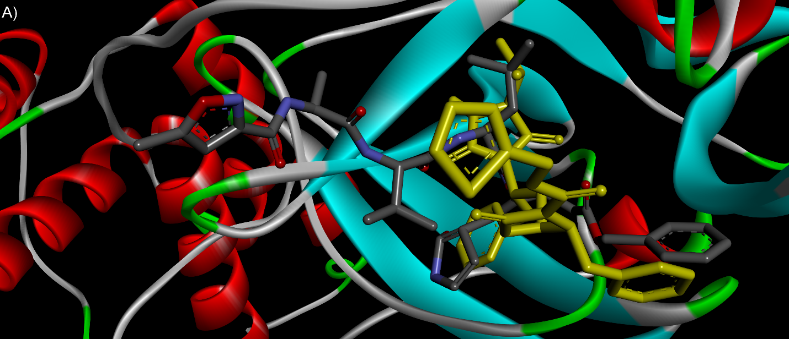
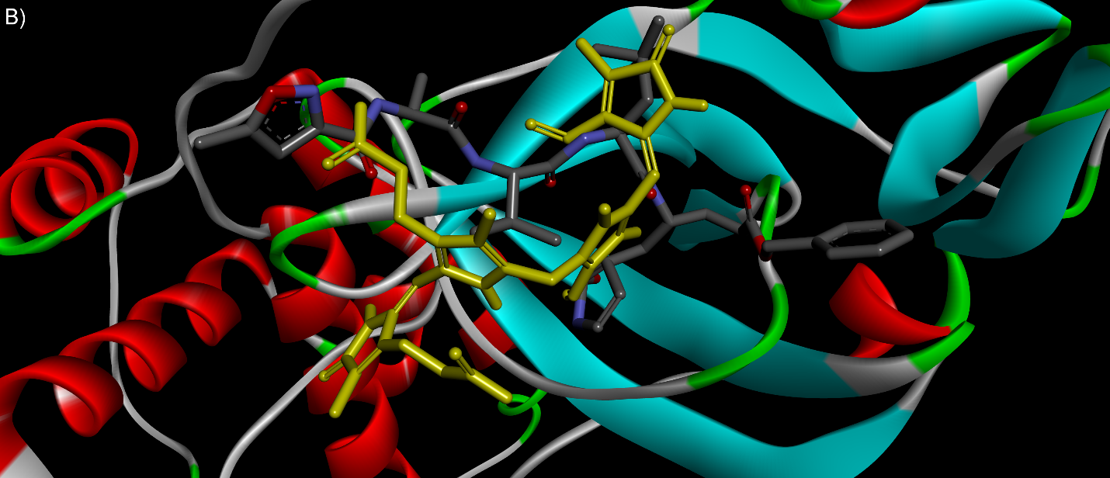
Figure S2. The overlap images of crystallographic binding mode of ligand N3 ( ) and predicted binding mode of potential inhibitors ( ). A) Ritonavir impurity H [EP] and B) delta-Bilirubin
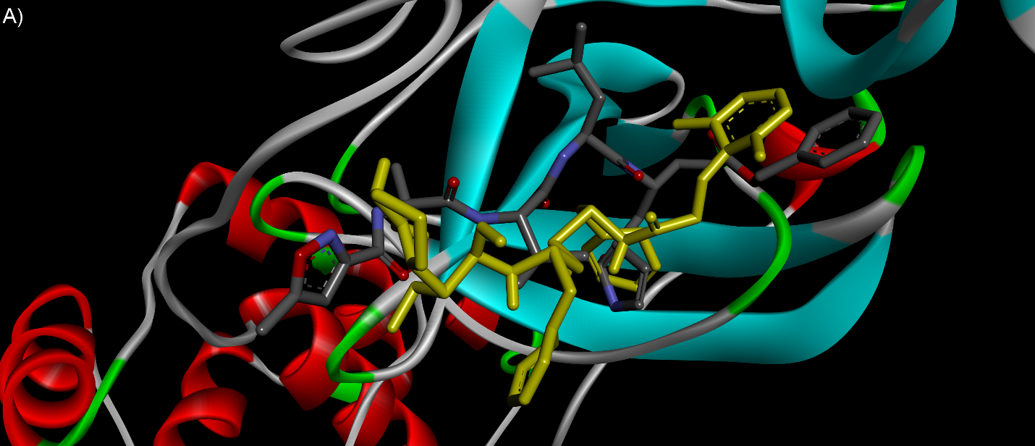
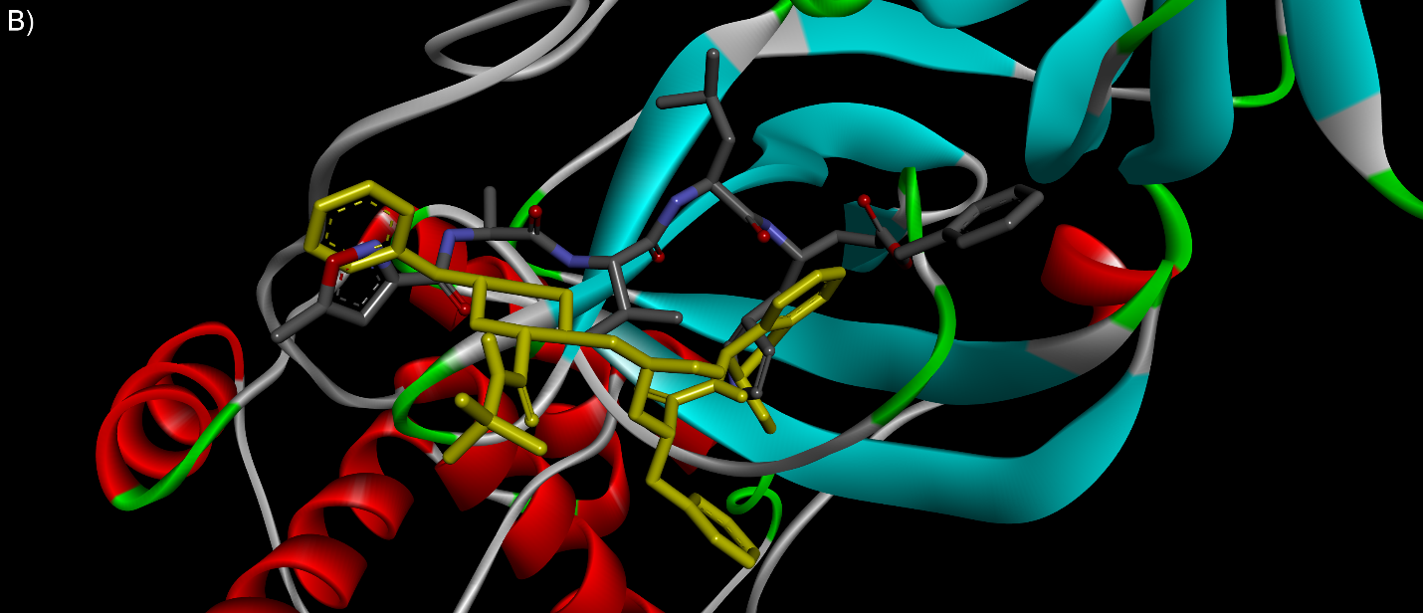
Figure S3. The overlap images of crystallographic binding mode of ligand N3 ( ) and predicted binding mode of potential inhibitors ( ). A) Lopinavir and B) Indinavir

Figure S4. 2D images of synthetic ligand interactions by target: A) Compound1, B) Licofelone Acyl glucuronide, C) Des(isopropylthiazolyl) Hydantoin-oxazolidinone Ritonavir and D) delta-Bilirubin.

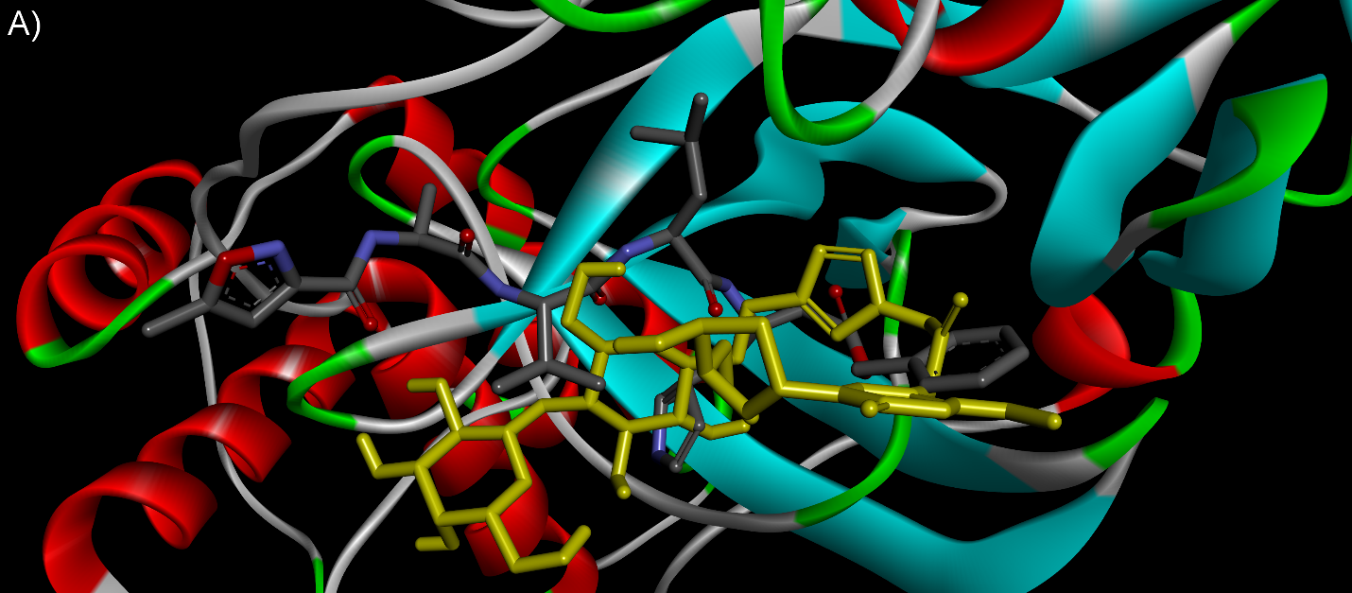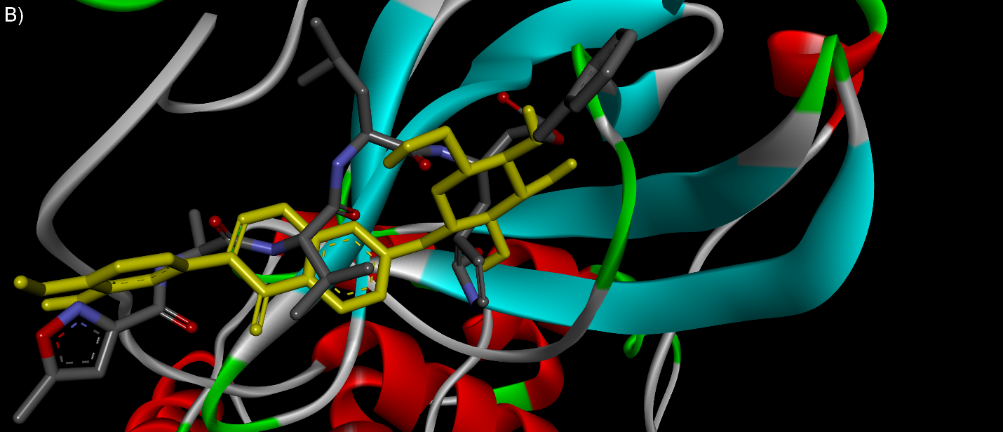
Figure S5. The overlap images of crystallographic binding mode of ligand N3 ( ) and predicted binding mode of potential inhibitors ( ). A) beta-D-galactopyranosyl, and B) Calycosin 7-O-glucoside.

Figure S6. 2D images of natural ligands interactions by target: A) beta-D-galactopyranosyl, B) Calycosin 7-O-glucoside, C) Spicoside A, and D) Gallic acid 3-cholesteryl ester

References
[1] Y. Ma, Y. Fu, S. C. Khojasteh, D. Dalvie, D. Zhang, J. Med. Chem. 2017, 60, 8691-8705.
[2] N. Pravdina, V. Shobukhov, G. Galegov, Dokl. Akad. Nauk. SSSR. 1984, 274, 975.
[3] J. Cubeiro, C. Ciuro, A. Farre, J. Caldero, M. Bartolome, A. Jurado, Therapie 1972, 27, 589.
[4] P. S. Dragovich, T. J. Prins, R. Zhou, S. E. Webber, J. T. Marakovits, S. A. Fuhrman, A. K. Patick, D. A. Matthews, C. A. Lee, C. E. Ford, J. Med. Chem. 1999, 42, 1213-1224.
[5] P. S. Dragovich, T. J. Prins, R. Zhou, T. O. Johnson, Y. Hua, H. T. Luu, S. K. Sakata, E. L. Brown, F. C. Maldonado, T. Tuntland, J. Med. Chem. 2003, 46, 4572-4585.
[6] L. Alexandrova, S. Zicari, E. Matyugina, A. Khandazhinskaya, T. Smirnova, S. Andreevskaya, L. Chernousova, C. Vanpouille, S. Kochetkov, L. Margolis, Antivir. Res. 2017, 145, 175-183.
[7] P. S. Dragovich, T. J. Prins, R. Zhou, E. L. Brown, F. C. Maldonado, S. A. Fuhrman, L. S. Zalman, T. Tuntland, C. A. Lee, A. K. Patick, J. Med. Chem. 2002, 45, 1607-1623.
[8] L. Frish, F. Sansone, A. Casnati, R. Ungaro, Y. Cohen, J. Org. Chem. 2000, 65, 5026-5030.
[9] K. Moriyama, T. Suzuki, K. Negishi, J. D. Graci, C. N. Thompson, C. E. Cameron, M. Watanabe, J. Med. Chem. 2008, 51, 159-166.
[10] A. a. P.-G. Grassauer, Eva, US, 2009.
[11] K. Winther, A. S. V. Hansen, J. Campbell-Tofte, Botanics 2016, 6, 11.
[12] H. Zhu, Y. Zhang, G. Ye, Z. Li, P. Zhou, C. Huang, Biol. Pharm. Bull. 2009, 32, 68-73.
[13] S. Choubey, L. R. Varughese, V. Kumar, V. Beniwal, Pharm. Pat. Anal. 2015, 4, 305-315.
[14] M. Naoi, M. Shamoto-Nagai, W. Maruyama, Future Neurol. 2019, 14, FNL9.
[15] J. Y. Choi, W. G. Hong, J. H. Cho, E. M. Kim, J. Kim, C.-H. Jung, S.-G. Hwang, H.-D. Um, J. K. Park, Int. J. Oncol. 2015, 47, 1257-1265.
[16] S. A. A. Ahmad, U. D. Palanisamy, B. A. Tejo, M. F. Chew, H. W. Tham, S. S. Hassan, Virol. J. 2017, 14, 229.
[17] V. Aleksic, P. Knezevic, Microbio.l Res. 2014, 169, 240-254.
[18] W. E. Robinson Jr, Antivir. Res. 1998, 39, 101-111.
[19] D. L. McKay, J. B. Blumberg, Phytother. Rese. 2006, 20, 619-633.
[20] M. Davydov, A. D. Krikorian, J. Ethnopharmacol. 2000, 72, 345-393.
[21] S. Geuenich, C. Goffinet, S. Venzke, S. Nolkemper, I. Baumann, P. Plinkert, J. Reichling, O. T. Keppler, Retrovirology 2008, 5, 27.
[22] L. C. Chiang, L. T. Ng, P. W. Cheng, W. Chiang, C. C. Lin, Clin. Exp. Pharmacol. Physiol. 2005, 32, 811-816.
[23] V. Khwaza, O. O. Oyedeji, B. A. Aderibigbe, Molecules 2018, 23, 2300.
[24] D. Varijakzhan, C.-M. Chong, A. Abushelaibi, K.-S. Lai, S.-H. E. Lim, Molecules 2020, 25, 1126.
[25] J. Hawkins, C. Baker, L. Cherry, E. Dunne, Complement. Ther. Med. 2019, 42, 361-365.
[26] Q.-Q. Mao, X.-Y. Xu, S.-Y. Cao, R.-Y. Gan, H. Corke, H.-B. Li, Foods 2019, 8, 185.
[27] M. R. Pilau, S. H. Alves, R. Weiblen, S. Arenhart, A. P. Cueto, L. T. Lovato, Braz. J. Microbiol. 2011, 42, 1616-1624.
[28] Z. Stojanović-Radić, L. Čomić, N. Radulović, M. Dekić, V. Ranđelović, O. Stefanović, Chem. Pap. 2010, 64, 368-377.
[29] L. Bayan, P. H. Koulivand, A. Gorji, Avicenna J. Phytomed. 2014, 4, 1.

