Supplementary file：
Legend：
Supplementary Table S1 Association between the number of Induced abortions and bipolar disorder and major depression in the age subgroups.
Supplementary Table S2 Association between the number of Induced abortions and bipolar disorder and major depression in the BMI subgroups.
Supplementary Table S3 Association between the number of Induced abortions and bipolar disorder and major depression in the Annual household income subgroups.
Supplementary Table S4 Association between the number of Induced abortions and bipolar disorder and major depression in the Smoking status subgroups.
Supplementary Table S5 Association between the number of Induced abortions and bipolar disorder and major depression in the Frequency of alcohol intake subgroups.
Supplementary Table S6 Association between the number of Induced abortions and bipolar disorder and major depression in the Oral contraceptives subgroups.
Supplementary Table S7 Association between the number of Induced abortions and bipolar disorder and major depression in the spontaneous abortions subgroups.
Supplementary Table S8 Association between the number of Induced abortions and bipolar disorder and major depression in the live births subgroups.
Supplementary Table S9 Association between the number of Induced abortions and bipolar disorder and major depression in the sensitivity analysis.
Supplementary Table S10 Multinomial logistic regression models of the Association
between the number of Induced abortions with major depression, relative to Non-MD.
Supplementary Figure S1 Balance test of the respective variables between the two groups (Non-IA,IA) after inverse probability weighting and propensity scores matching.
Supplementary Figure S2 Histogram of the distribution of the number of induced abortions in the total population.
Supplementary Figure S3 Proportion of bipolar disorder and major depression between the Non-IA and IA groups
Supplementary Figure S4 Forestplot of the subgroup analysis in the crude Multivariate adjustment model.
Supplementary Figure S5 Forestplot of the subgroup analysis in the PSM Multivariate adjustment model.
Supplementary Figure S6 Number and combinations of missing values.
Supplementary Figure S7 The odds ratios for the subgroup analysis.

Supplementary Table S1 Association between the number of Induced abortions and bipolar disorder and major depression in the age subgroups.
Model ª | IA | Multivariate-adjusted Logistic Regression |  | IPTW-multivariate adjusted Logistic Regression |  | PSM-multivariate adjusted Logistic Regression
Model ª | IA | ORs (95%CI) | P | ORs (95%CI) | P | ORs (95%CI) | P
Age < 55, y (IPTW:n = 6,369 ; PSM: n = 2,261)
Model 1 | Non-IA | 1 |  | 1 |  | 1
 | IA | 1.17(1.06-1.29) | 0.002 | 1.15(1.06-1.23) | <0.001 | 1.23(1.04-1.46) | 0.013
Model 2 | Non-IA | 1 |  | 1 |  | 1
 | IA | 1.17(1.06-1.30) | 0.003 | 1.15(1.07-1.24) | <0.001 | 1.25(1.06-1.48) | 0.010
Model 3 | Non-IA | 1 |  | 1 |  | 1
 | IA | 1.10(0.99-1.22) | 0.071 | 1.15(1.06-1.24) | 0.001 | 1.25(1.06-1.49) | 0.009
Model 4 | Non-IA | 1 |  | 1 |  | 1
 | IA | 1.25(1.08-1.44) | 0.003 | 1.17(1.08-1.26) | <0.001 | 1.26(1.06-1.50) | 0.008
Age ≥ 55, y (IPTW:n = 6,831 ; PSM: n = 2,051)
Model 1 | Non-IA | 1 |  | 1 |  | 1
 | IA | 1.30(1.17-1.43) | <0.001 | 1.30(1.21-1.40) | <0.001 | 1.24(1.04-1.48) | 0.018
Model 2 | Non-IA | 1 |  | 1 |  | 1
 | IA | 1.31(1.19-1.45) | <0.001 | 1.31(1.22-1.41) | <0.001 | 1.25(1.05-1.50) | 0.015
Model 3 | Non-IA | 1 |  | 1 |  | 1
 | IA | 1.25(1.13-1.38) | <0.001 | 1.32(1.23-1.42) | <0.001 | 1.25(1.04-1.50) | 0.015
Model 4 | Non-IA | 1 |  | 1 |  | 1
 | IA | 1.34(1.16-1.54) | <0.001 | 1.32(1.23-1.42) | <0.001 | 1.21(1.01-1.46) | 0.040
Notes:model 1 was unadjusted; model 2 was adjusted for age, education, annual household income, employment status, ethnicity, and TDI; model 3 with additional adjustment for BMI, smoking status, frequency of alcohol intake, and MET upon model2; model 4 with additional adjustment for diabetes, hypertension, cancer,living births, oral contraceptives, age at menarche, spontaneous abortion and bilateral oophorectomy upon model 3.

Supplementary Table S2 Association between the number of Induced abortions and bipolar disorder and major depression in the BMI subgroups.
Model | IA | Multivariate-adjusted Logistic Regression |  | IPTW-multivariate adjusted Logistic Regression |  |  | PSM-multivariate adjusted Logistic Regression
Model | IA | ORs (95%CI) | P |  | ORs (95%CI) | P | ORs (95%CI) | P
BMI < 25, kg/m² (IPTW:n = 5,597; PSM: n = 1,848)
Model 1 | Non-IA | 1 |  |  | 1 |  | 1
 | IA | 1.14(1.02-1.27) | 0.021 |  | 1.11(1.02-1.20) | 0.012 | 1.07(0.89-1.29) | 0.477
Model 2 | Non-IA | 1 |  |  | 1 |  | 1
 | IA | 1.08(0.96-1.20) | 0.200 |  | 1.10(1.01-1.19) | 0.031 | 1.04(0.86-1.26) | 0.678
Model 3 | Non-IA | 1 |  |  | 1 |  | 1
 | IA | 1.00(0.89-1.12) | 0.976 |  | 1.10(1.01-1.19) | 0.029 | 1.02(0.84-1.24) | 0.821
Model 4 | Non-IA | 1 |  |  | 1 |  | 1
 | IA | 1.10(0.94-1.28) | 0.253 |  | 1.12(1.03-1.22) | 0.011 | 1.03(0.84-1.25) | 0.793
BMI 25 ~ 30, kg/m² (IPTW:n = 4,686; PSM: n = 1,499)
Model 1 | Non-IA | 1 |  |  | 1 |  | 1
 | IA | 1.39(1.24-1.57) | <0.001 |  | 1.31(1.20-1.43) | <0.001 | 1.31(1.07-1.61) | 0.009
Model 2 | Non-IA | 1 |  |  | 1 |  | 1
 | IA | 1.38(1.22-1.56) | <0.001 |  | 1.33(1.22-1.45) | <0.001 | 1.37(1.11-1.68) | 0.003
Model 3 | Non-IA | 1 |  |  | 1 |  | 1
 | IA | 1.31(1.16-1.48) | <0.001 |  | 1.31(1.20-1.43) | <0.001 | 1.34(1.08-1.65) | 0.007
Model 4 | Non-IA | 1 |  |  | 1 |  | 1
 | IA | 1.36(1.15-1.61) | <0.001 |  | 1.31(1.20-1.43) | <0.001 | 1.34(1.09-1.66) | 0.006
BMI ≥ 30, kg/m² (IPTW:n = 2,917; PSM: n = 965)
Model 1 | Non-IA | 1 |  |  | 1 |  | 1
 | IA | 1.31(1.13-1.51) | <0.001 |  | 1.38(1.24-1.53) | <0.001 | 1.48(1.15-1.91) | 0.002
Model 2 | Non-IA | 1 |  |  | 1 |  | 1
 | IA | 1.31(1.12-1.52) | 0.001 |  | 1.36(1.22-1.52) | <0.001 | 1.52(1.17-1.97) | 0.002
Model 3 | Non-IA | 1 |  |  | 1 |  | 1
 | IA | 1.24(1.06-1.45) | 0.006 |  | 1.34(1.20-1.50) | <0.001 | 1.59(1.22-2.08) | 0.001
Model 4 | Non-IA | 1 |  |  | 1 |  | 1
 | IA | 1.59(1.29-1.97) | <0.001 |  | 1.42(1.27-1.59) | <0.001 | 1.65(1.26-2.17) | <0.001
Notes:model 1 was unadjusted; model 2 was adjusted for age, education, annual household income, employment status, ethnicity, and TDI; model 3 with additional adjustment for BMI, smoking status, frequency of alcohol intake, and MET upon model2; model 4 with additional adjustment for diabetes, hypertension, cancer,living births, oral contraceptives, age at menarche, spontaneous abortion and bilateral oophorectomy upon model 3.

Supplementary Table S3 Association between the number of Induced abortions and bipolar disorder and major depression in the Annual household income subgroups.
Model ª | IA | Multivariate-adjusted Logistic Regression |  | IPTW-multivariate adjusted Logistic Regression |  | PSM-multivariate adjusted Logistic Regression
Model ª | IA | ORs (95%CI) | P | ORs (95%CI) | P | ORs (95%CI) | P
Annual household income < £31,000 (IPTW:n = 5,631; PSM: n = 1,822)
Model 1 | Non-IA | 1 |  | 1 |  | 1
 | IA | 1.22(1.09-1.35) | <0.001 | 1.17(1.08-1.26) | <0.001 | 1.17(0.98-1.41) | 0.090
Model 2 | Non-IA | 1 |  | 1 |  | 1
 | IA | 1.14(1.02-1.27) | 0.020 | 1.13(1.04-1.22) | 0.002 | 1.15(0.95-1.39) | 0.144
Model 3 | Non-IA | 1 |  | 1 |  | 1
 | IA | 1.09(0.97-1.22) | 0.142 | 1.13(1.05-1.23) | 0.002 | 1.16(0.96-1.41) | 0.130
Model 4 | Non-IA | 1 |  | 1 |  | 1
 | IA | 1.20(1.03-1.40) | 0.017 | 1.17(1.08-1.27) | <0.001 | 1.14(0.94-1.38) | 0.196
Annual household income ≥ £31,000(IPTW:n = 7,569; PSM: n = 2,490)
Model 1 | Non-IA | 1 |  | 1 |  | 1
 | IA | 1.29(1.18-1.42) | <0.001 | 1.31(1.22-1.40) | <0.001 | 1.28(1.09-1.50) | 0.003
Model 2 | Non-IA | 1 |  | 1 |  | 1
 | IA | 1.28(1.16-1.41) | <0.001 | 1.31(1.23-1.41) | <0.001 | 1.30(1.10-1.53) | 0.002
Model 3 | Non-IA | 1 |  | 1 |  | 1
 | IA | 1.20(1.09-1.33) | <0.001 | 1.30(1.21-1.40) | <0.001 | 1.30(1.10-1.53) | 0.002
Model 4 | Non-IA | 1 |  | 1 |  | 1
 | IA | 1.35(1.18-1.54) | <0.001 | 1.32(1.23-1.42) | <0.001 | 1.32(1.11-1.55) | 0.001
Notes:model 1 was unadjusted; model 2 was adjusted for age, education, annual household income, employment status, ethnicity, and TDI; model 3 with additional adjustment for BMI, smoking status, frequency of alcohol intake, and MET upon model2; model 4 with additional adjustment for diabetes, hypertension, cancer,living births, oral contraceptives, age at menarche, spontaneous abortion and bilateral oophorectomy upon model 3.

Supplementary Table S4 Association between the number of Induced abortions and bipolar disorder and major depression in the Smoking status subgroups.
Model ª | IA | Multivariate-adjusted Logistic Regression |  | IPTW-multivariate adjusted Logistic Regression |  | PSM-multivariate adjusted Logistic Regression
Model ª | IA | ORs (95%CI) | P | ORs (95%CI) | P | ORs (95%CI) | P
Smoking status :Never ((IPTW:n = 7,354; PSM: n = 2,211)
Model 1 | Non-IA | 1 |  | 1 |  | 1
 | IA | 1.18(1.07-1.30) | 0.001 | 1.24(1.16-1.33) | <0.001 | 1.18(0.99-1.41) | 0.055
Model 2 | Non-IA | 1 |  | 1 |  | 1
 | IA | 1.20(1.08-1.32) | <0.001 | 1.23(1.15-1.32) | <0.001 | 1.21(1.01-1.44) | 0.035
Model 3 | Non-IA | 1 |  | 1 |  | 1
 | IA | 1.20(1.08-1.32) | <0.001 | 1.24(1.16-1.33) | <0.001 | 1.20(1.01-1.43) | 0.041
Model 4 | Non-IA | 1 |  | 1 |  | 1
 | IA | 1.27(1.10-1.46) | 0.001 | 1.25(1.17-1.34) | <0.001 | 1.20(1.01-1.44) | 0.041
Smoking status :Previous ((IPTW:n = 4,541; PSM: n = 1,578)
Model 1 | Non-IA | 1 |  | 1 |  | 1
 | IA | 1.18(1.05-1.33) | 0.006 | 1.27(1.16-1.38) | <0.001 | 1.31(1.07-1.60) | 0.008
Model 2 | Non-IA | 1 |  | 1 |  | 1
 | IA | 1.14(1.01-1.28) | 0.040 | 1.26(1.15-1.38) | <0.001 | 1.32(1.08-1.62) | 0.007
Model 3 | Non-IA | 1 |  | 1 |  | 1
 | IA | 1.16(1.03-1.31) | 0.017 | 1.28(1.17-1.41) | <0.001 | 1.37(1.12-1.68) | 0.003
Model 4 | Non-IA | 1 |  | 1 |  | 1
 | IA | 1.34(1.14-1.59) | 0.001 | 1.34(1.22-1.47) | <0.001 | 1.35(1.09-1.65) | 0.005
Smoking status :Current ((IPTW:n = 1,305; PSM: n = 523)
Model 1 | Non-IA | 1 |  | 1 |  | 1
 | IA | 1.06(0.84-1.34) | 0.612 | 0.98(0.83-1.15) | 0.789 | 1.16(0.82-1.65) | 0.396
Model 2 | Non-IA | 1 |  | 1 |  | 1
 | IA | 1.01(0.79-1.27) | 0.960 | 0.98(0.83-1.16) | 0.810 | 1.17(0.82-1.67) | 0.386
Model 3 | Non-IA | 1 |  | 1 |  | 1
 | IA | 1.02(0.81-1.30) | 0.843 | 0.95(0.80-1.12) | 0.538 | 1.21(0.85-1.74) | 0.293
Model 4 | Non-IA | 1 |  | 1 |  | 1
 | IA | 1.26(0.92-1.72) | 0.151 | 0.99(0.83-1.18) | 0.890 | 1.26(0.87-1.84) | 0.217
Notes:model 1 was unadjusted; model 2 was adjusted for age, education, annual household income, employment status, ethnicity, and TDI; model 3 with additional adjustment for BMI, smoking status, frequency of alcohol intake, and MET upon model2; model 4 with additional adjustment for diabetes, hypertension, cancer,living births, oral contraceptives, age at menarche, spontaneous abortion and bilateral oophorectomy upon model 3.

Supplementary Table S5 Association between the number of Induced abortions and bipolar disorder and major depression in the Frequency of alcohol intake subgroups.
Model ª | IA | Multivariate-adjusted Logistic Regression |  | IPTW-multivariate adjusted Logistic Regression |  | PSM-multivariate adjusted Logistic Regression
Model ª | IA | ORs (95%CI) | P | ORs (95%CI) | P | ORs (95%CI) | P
Frequency of alcohol intake:< 3 times/week or never (IPTW:n = 7,895; PSM: n = 2,629)
Model 1 | Non-IA | 1 |  | 1 |  | 1
 | IA | 1.30(1.19-1.42) | <0.001 | 1.22(1.14-1.30) | <0.001 | 1.25(1.07-1.45) | 0.005
Model 2 | Non-IA | 1 |  | 1 |  | 1
 | IA | 1.29(1.17-1.41) | <0.001 | 1.22(1.14-1.30) | <0.001 | 1.26(1.08-1.47) | 0.004
Model 3 | Non-IA | 1 |  | 1 |  | 1
 | IA | 1.21(1.10-1.33) | <0.001 | 1.21(1.13-1.30) | <0.001 | 1.26(1.08-1.48) | 0.004
Model 4 | Non-IA | 1 |  | 1 |  | 1
 | IA | 1.28(1.12-1.46) | <0.001 | 1.23(1.15-1.32) | <0.001 | 1.26(1.07-1.48) | 0.005
Frequency of alcohol intake:≥ 3 times/week (IPTW:n = 5,305; PSM: n = 1,683)
Model 1 | Non-IA | 1 |  | 1 |  | 1
 | IA | 1.21(1.08-1.35) | 0.001 | 1.26(1.16-1.37) | <0.001 | 1.22(1.00-1.48) | 0.046
Model 2 | Non-IA | 1 |  | 1 |  | 1
 | IA | 1.15(1.03-1.29) | 0.013 | 1.26(1.16-1.37) | <0.001 | 1.22(1.00-1.48) | 0.048
Model 3 | Non-IA | 1 |  | 1 |  | 1
 | IA | 1.09(0.98-1.23) | 0.124 | 1.26(1.16-1.37) | <0.001 | 1.22(0.99-1.49) | 0.051
Model 4 | Non-IA | 1 |  | 1 |  | 1
 | IA | 1.31(1.12-1.54) | 0.001 | 1.29(1.18-1.40) | 0.040 | 1.20(0.98-1.46) | 0.083
Notes:model 1 was unadjusted; model 2 was adjusted for age, education, annual household income, employment status, ethnicity, and TDI; model 3 with additional adjustment for BMI, smoking status, frequency of alcohol intake, and MET upon model2; model 4 with additional adjustment for diabetes, hypertension, cancer,living births, oral contraceptives, age at menarche, spontaneous abortion and bilateral oophorectomy upon model 3.

Supplementary Table S6 Association between the number of Induced abortions and bipolar disorder and major depression in the Oral contraceptives subgroups.
Model ª | IA | Multivariate-adjusted Logistic Regression |  | IPTW-multivariate adjusted Logistic Regression |  | PSM-multivariate adjusted Logistic Regression
Model ª | IA | ORs (95%CI) | P | ORs (95%CI) | P | ORs (95%CI) | P
Oral contraceptives:No (IPTW:n = 1,520; PSM: n = 520)
Model 1 | Non-IA | 1 |  | 1 |  | 1
 | IA | 1.22(0.98-1.52) | 0.077 | 1.30(1.10-1.52) | 0.002 | 1.51(1.02-2.22) | 0.034
Model 2 | Non-IA | 1 |  | 1 |  | 1
 | IA | 1.26(0.99-1.59) | 0.058 | 1.30(01.11-1.53) | 0.002 | 1.50(1.02-2.23) | 0.042
Model 3 | Non-IA | 1 |  | 1 |  | 1
 | IA | 1.17(0.92-1.49) | 0.197 | 1.26(1.07-1.49) | 0.006 | 1.51(1.02-2.24) | 0.042
Model 4 | Non-IA | 1 |  | 1 |  | 1
 | IA | 1.22(0.90-1.66) | 0.205 | 1.27(1.07-1.50) | 0.005 | 1.54(1.04-2.31) | 0.033
Oral contraceptives:Yes (IPTW:n = 11,680; PSM: n = 3,792)
Model 1 | Non-IA | 1 |  | 1 |  | 1
 | IA | 1.24(1.15-1.33) | <0.001 | 1.22(1.16-1.29) | <0.001 | 1.21(1.06-1.37) | 0.004
Model 2 | Non-IA | 1 |  | 1 |  | 1
 | IA | 1.21(1.12-1.30) | <0.001 | 1.22(1.16-1.29) | <0.001 | 1.23(1.08-1.40) | 0.002
Model 3 | Non-IA | 1 |  | 1 |  | 1
 | IA | 1.15(1.06-1.24) | <0.001 | 1.23(1.16-1.30) | <0.001 | 1.23(1.08-1.41) | 0.002
Model 4 | Non-IA | 1 |  | 1 |  | 1
 | IA | 1.30(1.17-1.45) | <0.001 | 1.25(1.18-1.32) | <0.001 | 1.23(1.08-1.40) | 0.002
Notes:model 1 was unadjusted; model 2 was adjusted for age, education, annual household income, employment status, ethnicity, and TDI; model 3 with additional adjustment for BMI, smoking status, frequency of alcohol intake, and MET upon model2; model 4 with additional adjustment for diabetes, hypertension, cancer,living births, oral contraceptives, age at menarche, spontaneous abortion and bilateral oophorectomy upon model 3.

Supplementary Table S7 Association between the number of Induced abortions and bipolar disorder and major depression in the Spontaneous abortion subgroups.
Model ª | IA | Multivariate-adjusted Logistic Regression |  | IPTW-multivariate adjusted Logistic Regression |  | PSM-multivariate adjusted Logistic Regression
Model ª | IA | ORs (95%CI) | P | ORs (95%CI) | P | ORs (95%CI) | P
Spontaneous abortion :Non-SA ((IPTW:n = 5,081; PSM: n = 611)
Model 1 | Non-IA | 1 |  | 1 |  | 1
 | IA | 1.43(1.12-1.83) | 0.004 | 1.16(1.06-1.26) | 0.001 | 1.30(0.93-1.80) | 0.123
Model 2 | Non-IA | 1 |  | 1 |  | 1
 | IA | 1.31(1.02-1.69) | 0.034 | 1.13(1.03-1.24) | 0.007 | 1.16(0.82-1.65) | 0.404
Model 3 | Non-IA | 1 |  | 1 |  | 1
 | IA | 1.27(0.99-1.65) | 0.061 | 1.11(1.02-1.22) | 0.021 | 1.16(0.81-1.66) | 0.424
Model 4 | Non-IA | 1 |  | 1 |  | 1
 | IA | 1.26(0.98-1.63) | 0.077 | 1.17(1.06-1.28) | 0.002 | 1.20(0.82-1.76) | 0.345
Spontaneous abortion :OSA ((IPTW:n = 7,285; PSM: n = 3,312)
Model 1 | Non-IA | 1 |  | 1 |  | 1
 | IA | 1.44(1.28-1.60) | <0.001 | 1.33(1.24-1.42) | <0.001 | 1.27(1.11-1.46) | 0.001
Model 2 | Non-IA | 1 |  | 1 |  | 1
 | IA | 1.42(1.27-1.59) | <0.001 | 1.33(1.24-1.42) | <0.001 | 1.30(1.13-1.50) | <0.001
Model 3 | Non-IA | 1 |  | 1 |  | 1
 | IA | 1.32(1.18-1.49) | 0.017 | 1.34(1.25-1.43) | <0.001 | 1.29(1.12-1.49) | <0.001
Model 4 | Non-IA | 1 |  | 1 |  | 1
 | IA | 1.31(1.17-1.48) | 0.001 | 1.34(1.25-1.44) | <0.001 | 1.30(1.13-1.50) | <0.001
Spontaneous abortion :RSA ((IPTW:n = 834; PSM: n = 389)
Model 1 | Non-IA | 1 |  | 1 |  | 1
 | IA | 1.13(0.83-1.55) | 0.441 | 1.01(0.83-1.23) | 0.900 | 0.88(0.59-1.31) | 0.528
Model 2 | Non-IA | 1 |  | 1 |  | 1
 | IA | 1.12(0.81-1.55) | 0.487 | 1.06(0.87-1.30) | 0.547 | 0.91(0.60-1.38) | 0.656
Model 3 | Non-IA | 1 |  | 1 |  | 1
 | IA | 1.16(0.83-1.62) | 0.382 | 1.12(0.91-1.39) | 0.273 | 1.45(0.68-1.62) | 0.841
Model 4 | Non-IA | 1 |  | 1 |  | 1
 | IA | 1.14(0.81-1.60) | 0.454 | 1.15(0.93-1.42) | 0.212 | 1.08(0.69-1.71) | 0.732

Supplementary Table S8 Association between the number of Induced abortions and bipolar disorder and major depression in the Living births subgroups.
Model ª | IA | Multivariate-adjusted Logistic Regression |  | IPTW-multivariate adjusted Logistic Regression |  | PSM-multivariate adjusted Logistic Regression
Model ª | IA | ORs (95%CI) | P | ORs (95%CI) | P | ORs (95%CI) | P
Living births:No (IPTW:n = 1,766; PSM: n = 465)
Model 1 | Non-IA | 1 |  | 1 |  | 1
 | IA | 0.78(0.63-0.97) | 0.023 | 0.98(0.83-1.14) | 0.756 | 0.85(0.59-1.22) | 0.377
Model 2 | Non-IA | 1 |  | 1 |  | 1
 | IA | 0.73(0.59-0.90) | 0.004 | 0.90(0.76-1.06) | 0.211 | 0.78(0.53-1.15) | 0.209
Model 3 | Non-IA | 1 |  | 1 |  | 1
 | IA | 0.70(0.56-0.87) | 0.002 | 0.82(0.69-0.97) | 0.020 | 0.73(0.49-1.09) | 0.128
Model 4 | Non-IA | 1 |  | 1 |  | 1
 | IA | 0.93(0.66-1.33) | 0.700 | 0.95(0.79-1.16) | 0.633 | 0.80(0.52-1.23) | 0.318
Living births:Yes (IPTW:n = 11,434; PSM: n = 3,847)
Model 1 | Non-IA | 1 |  | 1 |  | 1
 | IA | 1.31(1.21-1.41) | <0.001 | 1.26(1.19-1.33) | <0.001 | 1.29(1.13-1.47) | <0.001
Model 2 | Non-IA | 1 |  | 1 |  | 1
 | IA | 1.30(1.20-1.40) | <0.001 | 1.27(1.20-1.34) | <0.001 | 1.32(1.16-1.50) | <0.001
Model 3 | Non-IA | 1 |  | 1 |  | 1
 | IA | 1.22(1.13-1.33) | <0.001 | 1.27(1.20-1.35) | <0.001 | 1.32(1.16-1.51) | <0.001
Model 4 | Non-IA | 1 |  | 1 |  | 1
 | IA | 1.33(1.20-1.48) | <0.001 | 1.28(1.21-1.36) | <0.001 | 1.31(1.15-1.50) | 0.002
Notes:model 1 was unadjusted; model 2 was adjusted for age, education, annual household income, employment status, ethnicity, and TDI; model 3 with additional adjustment for BMI, smoking status, frequency of alcohol intake, and MET upon model2; model 4 with additional adjustment for diabetes, hypertension, cancer,living births, oral contraceptives, age at menarche, spontaneous abortion and bilateral oophorectomy upon model 3.

Supplementary Table S9 Association between the number of Induced abortions and bipolar disorder and major depression in the sensitivity analysis.
Model | IA | Logistic model |  | IPTW-adjusted Logistic model
Model | IA | OR(95%CI) | P | OR(95%CI) | P
Multiple imputation data sets (m = 10, N = 21,259)
Model 1 | Non-IA | 1 |  | 1
 | IA | 1.36(1.29-1.44) | <0.001 | 1.22(1.18-1.28) | <0.001
Model 2 | Non-IA | 1 |  | 1
 | IA | 1.24(1.16-1.32) | <0.001 | 1.23(1.18-1.29) | <0.001
Model 3 | Non-IA | 1 |  | 1
 | IA | 1.17(1.09-1.26) | <0.001 | 1.27(1.21-1.34) | <0.001
Model 4ª | Non-IA | 1 |  | 1
 | IA | 1.28(1.16-1.42) | <0.001 | 1.28(1.21-1.35) | <0.001
People without cancer (N = 10,412)
Model 1 | Non-IA | 1 |  | 1
 | IA | 1.29(1.20-1.40) | <0.001 | 1.26(1.19-1.34) | <0.001
Model 2 | Non-IA | 1 |  | 1
 | IA | 1.26(1.17-1.37) | <0.001 | 1.27(1.19-1.34) | <0.001
Model 3 | Non-IA | 1 |  | 1
 | IA | 1.19(1.10-1.30) | <0.001 | 1.26(1.19-1.34) | <0.001
Model 4^{b} | Non-IA | 1 |  | 1
 | IA | 1.28(1.16-1.42) | <0.001 | 1.28(1.16-1.42) | <0.001
Notes:model 1 was unadjusted; model 2 was adjusted for age, education, annual household income, employment status, ethnicity, and TDI; model 3 with additional adjustment for BMI, smoking status, frequency of alcohol intake, and MET upon model2; model 4a with additional adjustment for diabetes, hypertension, cancer, living birth, oral contraceptives, age at menarche, spontaneous abortion and bilateral oophorectomy upon model 3.model 4b with additional adjustment for diabetes, hypertension, living birth, oral contraceptives, age at menarche, spontaneous abortion and bilateral oophorectomy upon model 3

Supplementary Table S10 Multinomial logistic regression models of the association between the number of Induced abortions with major depression, relative to Non-MD
Model | IA | Signle MD |  | Moderate MD |  | Severe MD
Model | IA | RRRs(95%CI) | P | RRRs(95%CI) | P | RRRs(95%CI) | P
Multivariate-adjusted Logistic Regression
Model 1 | Non-IA | 1 |  | 1 |  | 1
 | IA | 1.06(0.94-1.20) | 0.332 | 1.19(1.09-1.30) | <0.001 | 1.44(1.28-1.61) | <0.001
Model 2 | Non-IA | 1 |  | 1 |  | 1
 | IA | 1.08(0.95-1.22) | 0.244 | 1.17(1.07-1.28) | 0.001 | 1.36(1.21-1.54) | <0.001
Model 3 | Non-IA | 1 |  | 1 |  | 1
 | IA | 1.02(0.90-1.15) | 0.801 | 1.13(1.03-1.24) | 0.008 | 1.26(1.12-1.42) | <0.001
Model 4 | Non-IA | 1 |  | 1 |  | 1
 | IA | 0.99(0.82-1.18) | 0.874 | 1.26(1.11-1.43) | <0.001 | 1.41(1.20-1.66) | <0.001
IPTW-adjusted Logistic Regression
Model 1 | Non-IA | 1 |  | 1 |  | 1
 | IA | 0.91(0.83-0.99) | 0.039 | 1.29(1.21-1.38) | <0.001 | 1.30(1.19-1.41) | <0.001
Model 2 | Non-IA | 1 |  | 1 |  | 1
 | IA | 0.91(0.83-0.99) | 0.039 | 1.29(1.20-1.38) | <0.001 | 1.30(1.20-1.42) | <0.001
Model 3 | Non-IA | 1 |  | 1 |  | 1
 | IA | 0.90(0.82-0.98) | 0.020 | 1.29(1.21-1.38) | <0.001 | 1.29(1.19-1.41) | <0.001
Model 4 | Non-IA | 1 |  | 1 |  | 1
 | IA | 0.88(0.81-0.97) | 0.007 | 1.33(1.24-1.42) | <0.001 | 1.30(1.19-1.42) | <0.001
PSM-adjusted Logistic Regression
Model 1 | Non-IA | 1 |  | 1 |  | 1
 | IA | 0.96(0.77-1.18) | 0.675 | 1.20(1.03-1.41) | 0.020 | 1.40(1.15-1.70) | 0.001
Model 2 | Non-IA | 1 |  | 1 |  | 1
 | IA | 0.97(0.79-1.21) | 0.814 | 1.22(1.04-1.43) | 0.013 | 1.40(1.15-1.70) | 0.001
Model 3 | Non-IA | 1 |  | 1 |  | 1
 | IA | 0.98(0.79-1.21) | 0.824 | 1.23(1.05-1.44) | 0.011 | 1.40(1.15-1.71) | 0.001
Model 4 | Non-IA | 1 |  | 1 |  | 1
 | IA | 0.97(0.78-1.20) | 0.793 | 1.23(1.05-1.44) | 0.011 | 1.39(1.14-1.69) | 0.001
Notes:Non-MD(no episode),Signle MD(Only 1 episode),Moderate MD(≥2 episodes),Severe MD (Episode lasted ≥2 weeks).model 1 was unadjusted; model 2 was adjusted for age, education, annual household income, employment status, ethnicity, and TDI; model 3 with additional adjustment for BMI, smoking status, frequency of alcohol intake, and MET upon model2; model 4 with additional adjustment for diabetes, hypertension, cancer,living births, oral contraceptives, age at menarche, spontaneous abortion and bilateral oophorectomy upon model 3.

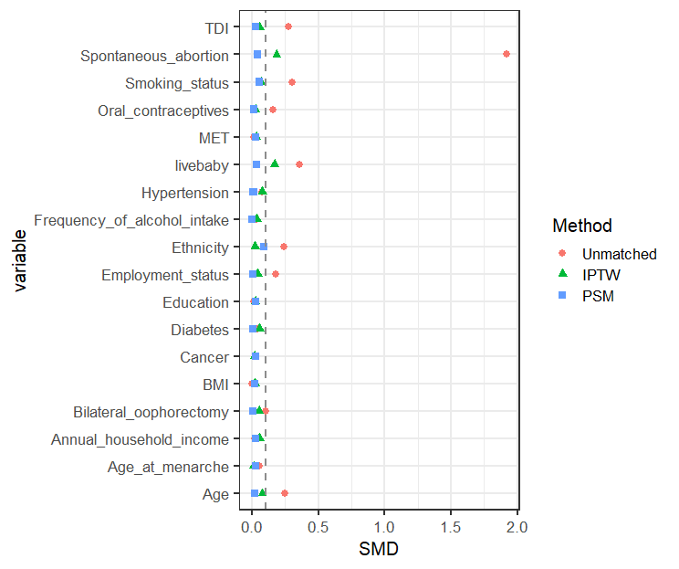

Supplementary Figure S1 Balance test of the respective variables between the two groups (Non-IA, IA) after inverse probability weighting and propensity scores matching. Equilibrium was considered better with an SMD < 0.1.

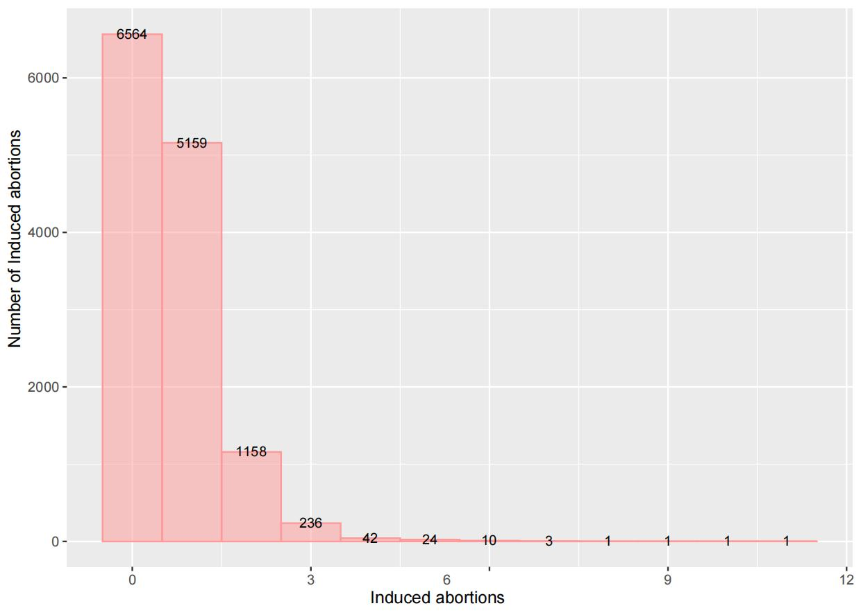

Supplementary Figure S2 Histogram of the distribution of the number of induced abortions in the total population.

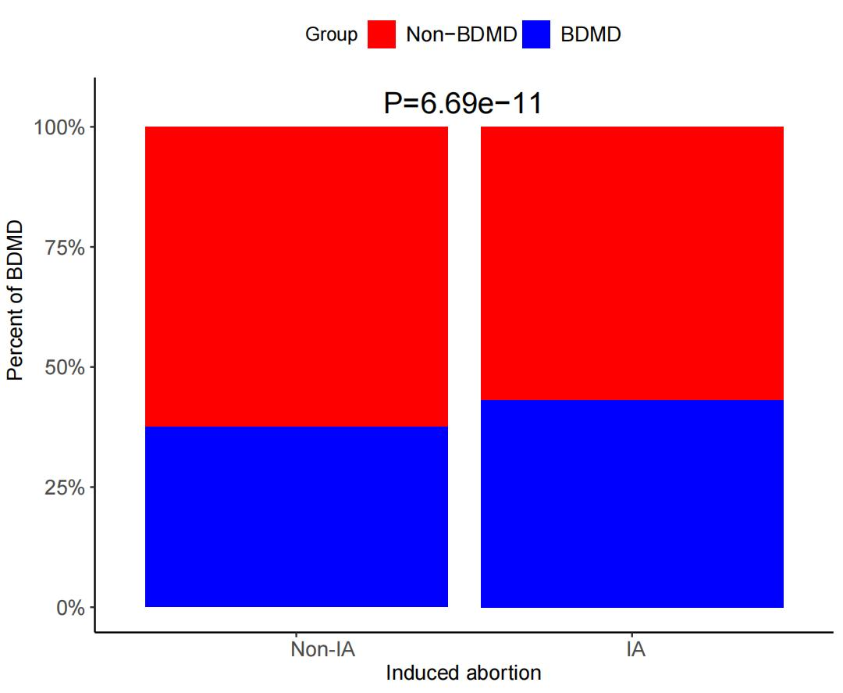

Supplementary Figure S3 Proportion of bipolar disorder and major depression between the Non-IA and IA groups

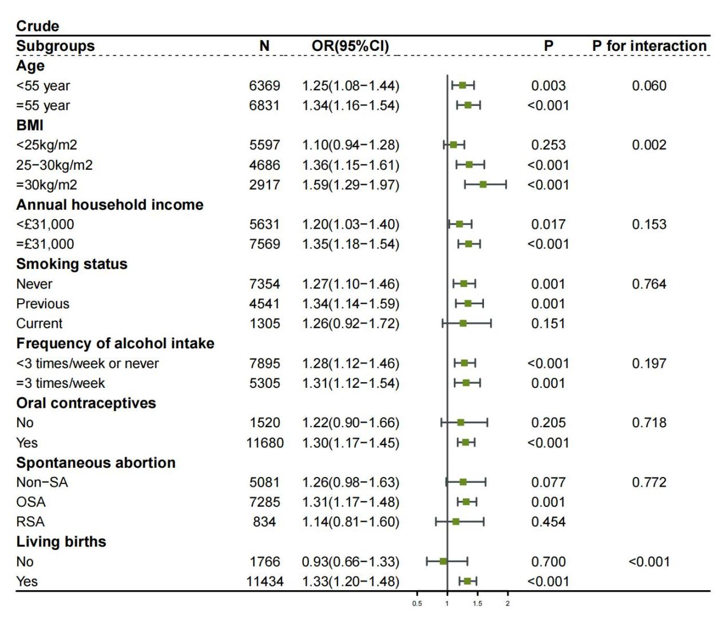
Supplementary Figure S4 Forestplot of the subgroup analysis in the crude Multivariate adjustment model.Association between the IA and BDMD in subgroups. The ORs with 95% CI, P values, and P for interaction were calculated by IPTW-multivariate adjustment. Adjusting sociodemographic characteristics, lifestyle factors, and clinical factors.

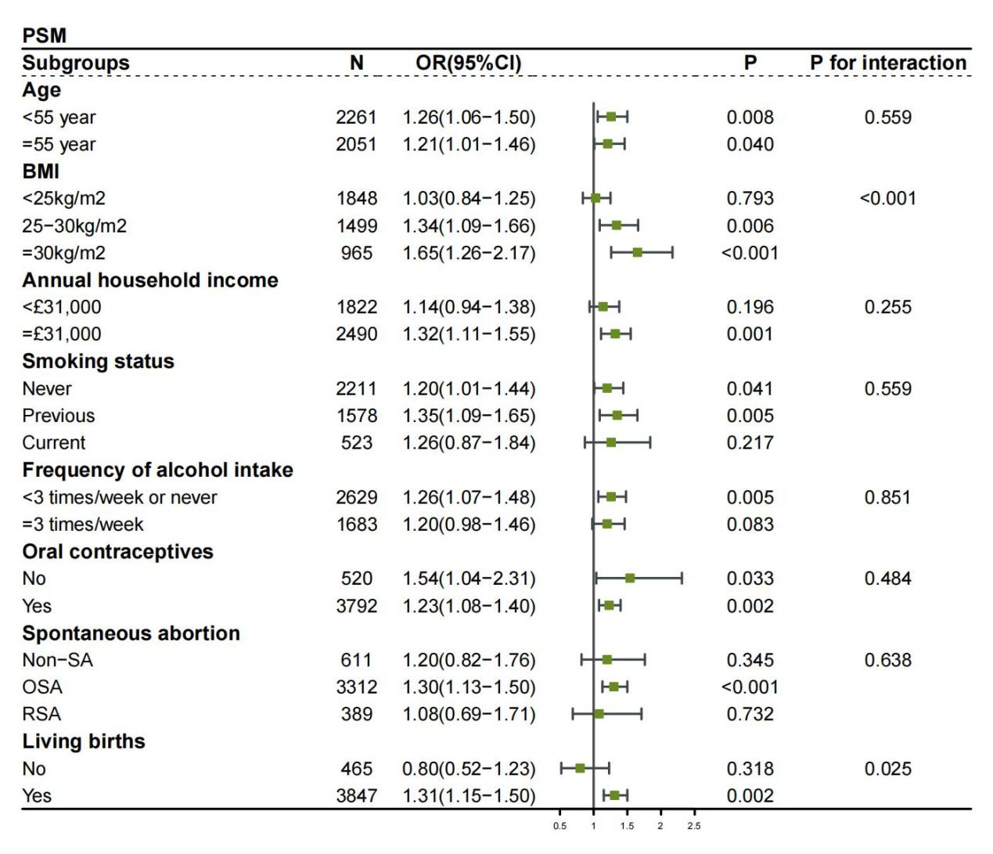
Supplementary Figure S5 Forestplot of the subgroup analysis in the PSM Multivariate adjustment model.Association between the IA and BDMD in subgroups. The ORs with 95% CI, P values, and P for interaction were calculated by IPTW-multivariate adjustment. Adjusting sociodemographic characteristics, lifestyle factors, and clinical factors.

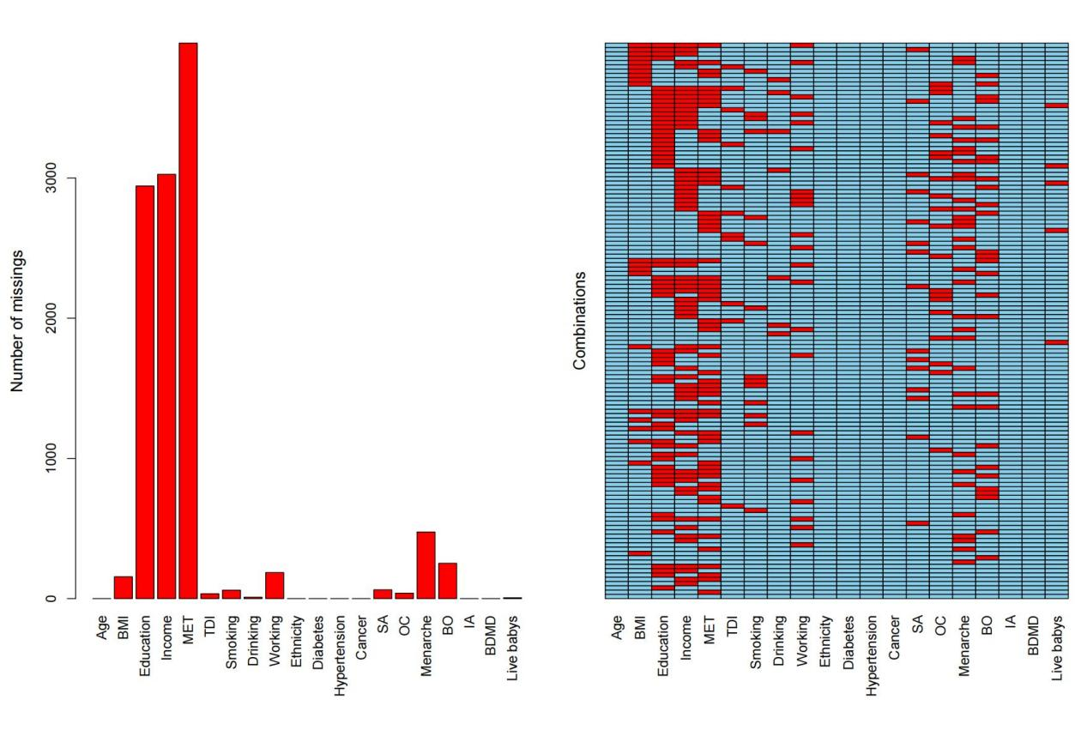
Supplementary Figure S6 Number and combinations of missing values.

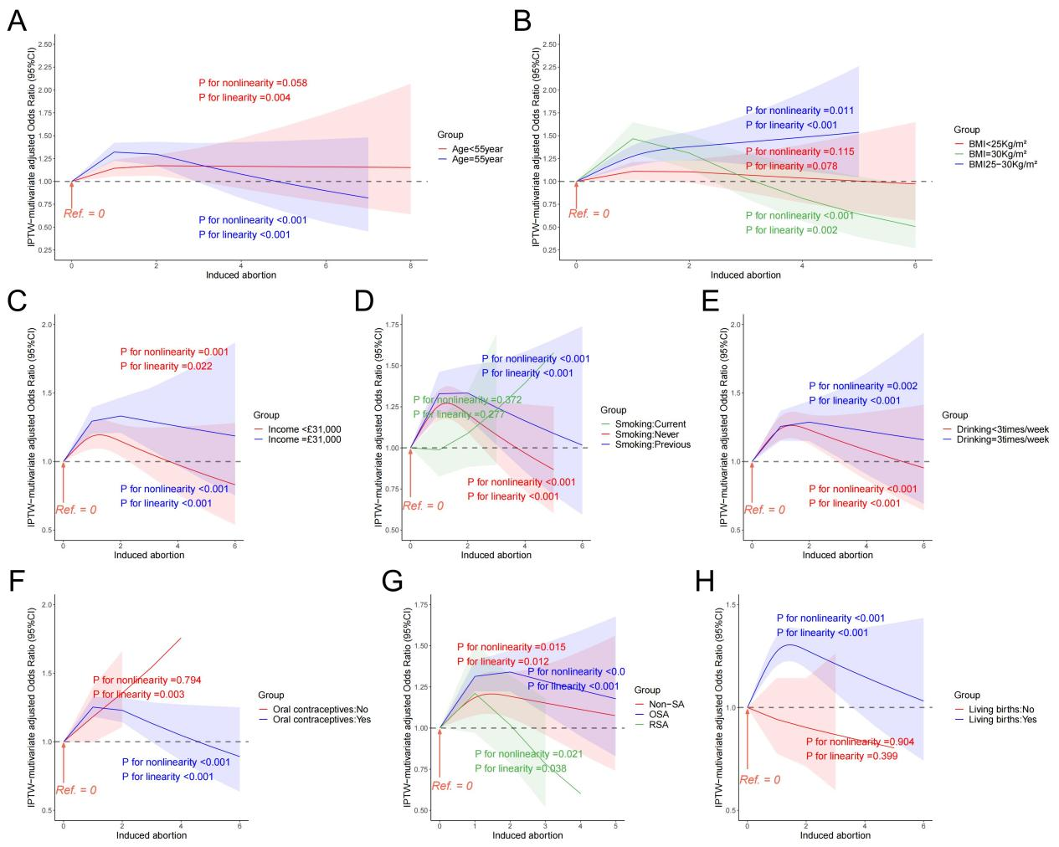
Supplementary Figure S7 The odds ratios for the subgroup analysis.The ORs with 95% CI and P values were calculated by IPTW-multivariate adjustment. Adjusting sociodemographic characteristics, lifestyle factors, and clinical factors.IPTW, inverse probability of treatment weight.

