Supplemental Materials:

Diagnostic Accuracy of Contrast-enhanced Ultrasonography Liver Imaging Reporting and Data System in Hepatocellular Carcinoma: A Systematic Review

Contents:
Appendix 1. Search strategies
Appendix 2. Results of QUADAS-2 quality assessment.
Appendix 3. Diagnostic performance of the LR-5 category for HCC
Appendix 4. Diagnostic performance of the LR-M category for non-HCC malignancy
Appendix 5. Hierarchical summary receiver operating characteristic curve
Appendix 6. Forest plots for each LI-RADS category
Appendix 7. Meta-regression results

Appendix 1. search strategies

Database: MEDLINE/Pubmed, 2014 to April 2020
Search Strategy
- (hepatocellular carcinoma* or hepatocellular neoplasm* or hepatocellular cancer or hepatic cell carcinoma* or HCC or cholangiocarcinoma* or hepatic nodule* or liver lesion* or adrenocortical carcinoma*).ti,ab.
- Carcinoma, Hepatocellular/ or Cholangiocarcinoma/
- liver imaging
- Or/1-3
- "liver imaging reporting and data system".tw,kw.
- (LI-RADS or LIRADS or US LI-RADS).tw,kw.
- (LR-1 or LR-2 or LR-3 or LR-4 or LR-5 or LR-M).tw.
- 5 or 6
- ultrasound or ultrasonogra* or US or CEUS or sonogra* or echogra* or echotomogra*
- 4 and 7
- 10 or 8
- 11 and 9 (80 records)；

Database: Cochrane, 2014 to April 2020
Search Strategy:
- Carcinoma, Hepatocellular
- Liver Neoplasms
- (hepatocellular carcinoma* or hepatocellular neoplasm* or hepatocellular cancer or hepatic cell carcinoma* or HCC or cholangiocarcinoma* or hepatic nodule* or liver lesion* or adrenocortical carcinoma*).tw,kw.
- Or/1-3
- "liver imaging reporting and data system".tw,kw.
- (LI-RADS or LIRADS or US LI-RADS).tw,kw.
- (LR-1 or LR-2 or LR-3 or LR-4 or LR-5 or LR-M).tw.
- 5 OR 6
- Ultrasonography
- (ultrasound or ultrasonogra* or US or CEUS or sonogra* or echogra* or echotomogra*
- 9 OR 10
- 4 AND 7
- 12 OR 8
- 13 AND 11 (20 records)

Database: Embase, 2014 to April 2020
Search Strategy:
1.‘exp liver cell carcinoma
2. exp liver tumor/
3. hepatocellular carcinoma’ or ‘hepatoma’ or ‘hepatocarcinoma’ or ‘liver cell carcinoma’ or ‘hepatocellular neoplasm’ or ‘hepatocellular cancer’ or ‘hepatic cell carcinoma’ or ‘HCC’ or ‘cholangiocarcinoma’ or ‘hepatic nodule’ or ‘liver lesion’
4.1 OR 2 OR 3
4. "liver imaging reporting and data system".tw,kw.
5. (LI-RADS or LIRADS).tw,kw.
6. (LR-1 or LR-2 or LR-3 or LR-4 or LR-5 or LR-M).tw.
7.or 4-5
8. exp echography/
9. exp ultrasound/
10. (ultrasound or ultrasonogra* or US or CEUS or sonogra* or echogra* or echotomogra*
11.or 8-10
12.4 and 6
13. 12 OR 7
14. 13 and 1 (121 records)

Database:Web of science, 2014 to April 2020
Search Strategy:
#9 TS=#8 AND #2 (93 records)
#8 TS=#6 OR #7
#7 TS=#1 AND #5
#6 TS=#3 OR #4
#5 TS=(LR-1 or LR-2 or LR-3 or LR-4 or LR-5 or LR-M)
#4 TS=(LI-RADS or LIRADS)
#3 TS=(liver imaging reporting and data system)
#2 TS=(ultrasound or ultrasonogra* or US or CEUS or sonogra* or echogra* or echotomogra*)
#1 TS=(((liver or hepato*) and (carcinom* or cancer* or neoplasm* or malign* or tumo*)) or HCC)

Database: SinoMed CBM, 2014 to April 2020
1. 肝细胞癌 OR 肝癌 OR 肝细胞性肝癌 OR 肝胆管细胞癌 OR 肝脏肿瘤 OR 肝结节 OR HCC
2. 主题词="肝细胞癌"[不加权:扩展]
3. liver imaging reporting and data system OR LI-RADS OR LIRADS OR 肝脏影像报告与数据系统
4. 超声造影 OR 超声 OR 超声检查 OR 肝脏超声造影
5. (#3) OR (#2) OR (#1) (8 records)
Database: CNKI, 2014 to April 2020
SU=‘肝细胞癌’+‘肝癌’+‘肝细胞性肝癌’+‘肝胆管细胞癌’+‘肝脏肿瘤’+‘肝结节’+ ‘HCC’ AND SU=‘liver imaging reporting and data system’+ ‘LI-RADS’+ ‘LIRADS’ + ‘肝脏影像报告与数据系统’ AND SU=‘超声造影’+‘超声’+‘超声检查’+‘肝脏超声造影’ (24 recoeds)
Database: Chinese Technical Periodicals (VIP), 2014 to April 2020
M=（肝癌+肝胆管细胞癌+hcc+hepatocellular carcinoma+hepatoma+liver cancer+liver neoplasms+肝恶性肿瘤+原发性肝细胞癌+肝脏恶性肿瘤+肝腺癌+肝肿瘤+肝细胞癌）AND （liver imaging reporting and data system+ LI-RADS + LIRADS + 肝脏影像报告与数据系统）AND （超声造影+超声+超声检查+肝脏超声造影）(4 records)

Database: WANFANG, 2014 to April 2020
主题:（ “肝细胞癌”+ “肝癌”+ “肝细胞性肝癌”+ “肝胆管细胞癌”+ “肝脏肿瘤”+ “肝结节”+ “HCC” ）AND 主题:（“liver imaging reporting and data system”+“LI-RADS” + “LIRADS”+“肝脏影像报告与数据系统”）AND 主题:（“超声造影”+“超声”+“超声检查”+“肝脏超声造影”）
(56 records)

Appendix 2. Results of QUADAS-2 quality assessment.
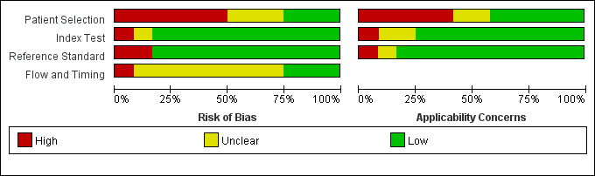

Appendix 3. Diagnostic performance of the LR-5 category for HCC
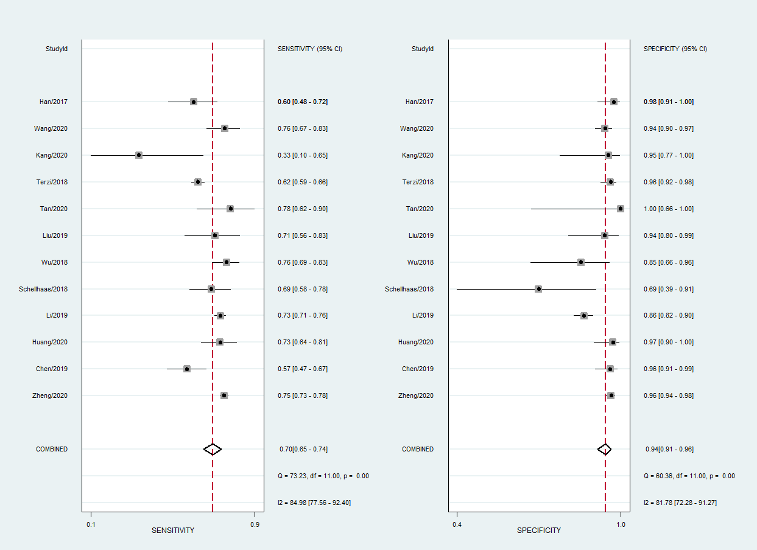

Appendix 4. Diagnostic performance of the LR-M category for non-HCC malignancy
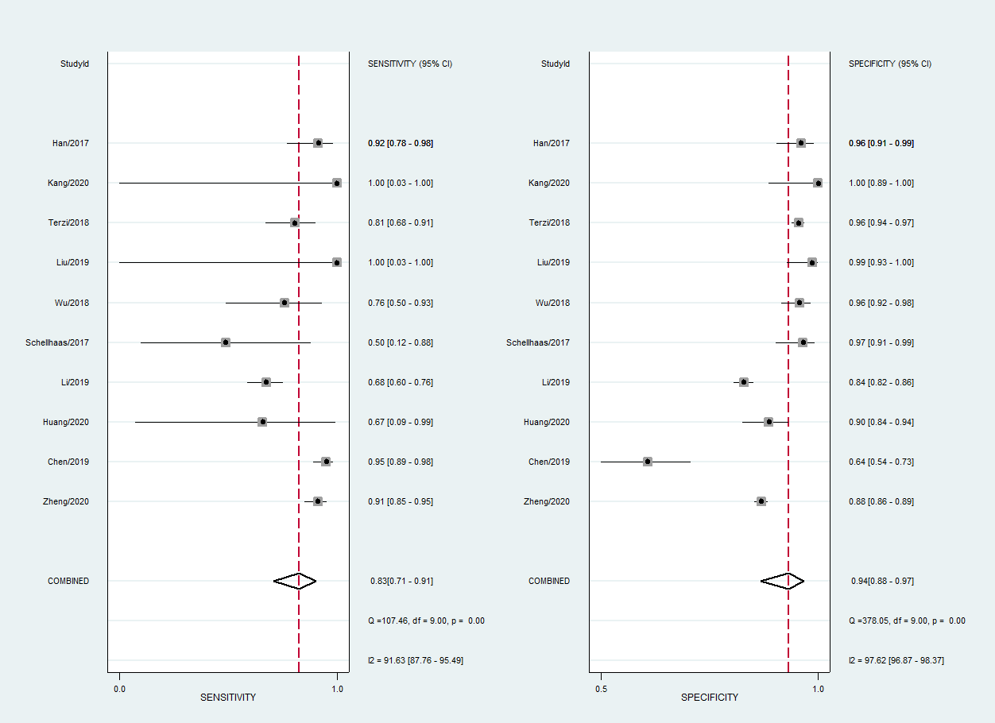

Appendix 5. Hierarchical summary receiver operating characteristic curve showing the performance of the LR-5 for diagnosing HCC.
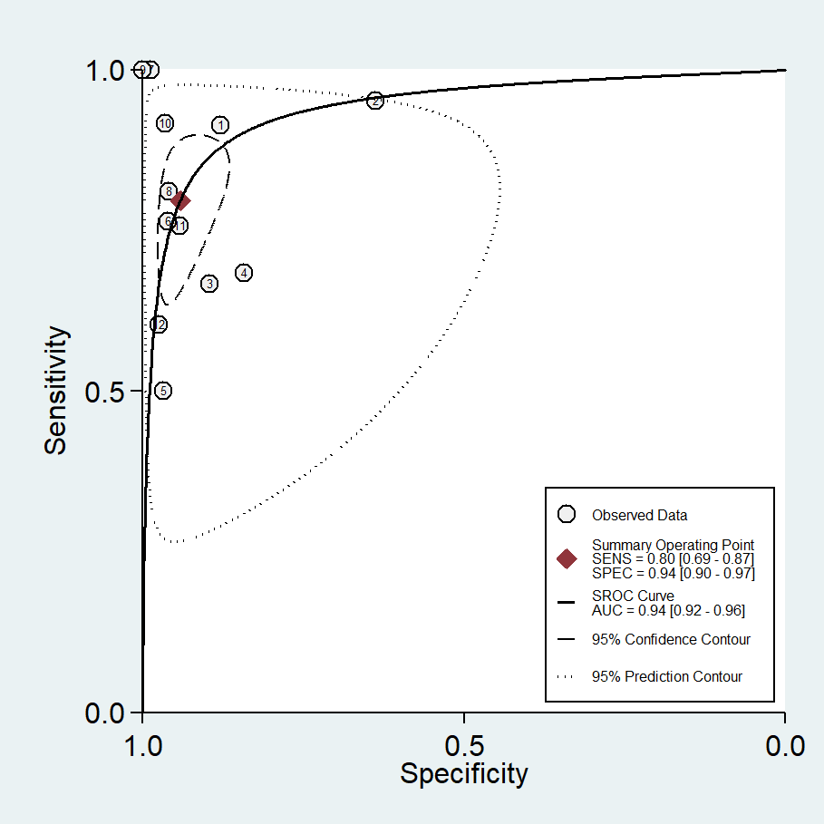

Appendix 6. Forest plots for each LI-RADS category
LR-1 proportion of overall malignancy
LR-2 proportion of HCC

LR-2 proportion of overall malignancy

LR-3 proportion of HCC
LR-3 proportion of overall malignancy

LR-4 proportion of HCC
LR-4 proportion of overall malignancy

LR-5 proportion of HCC
LR-5 proportion of overall malignancy

LR-M proportion of HCC
LR-M proportion of overall malignancy

LR-TIV proportion of HCC

Appendix 7. Meta-regression results
LI-RADS 5 percentage of HCC (K=12)
 | estimate | SE | P | 95%CI
intercept | 1.3313 | 0.0806 | <.0001 | 1.1733, 1.4893
study design | -0.1566 | 0.0725 | 0.0308 | -0.2986, -0.0145
Image reviewer | -0.2424 | 0.0622 | <.0001 | -0.3642, -0.1205
LIRADS version | 0.0953 | 0.0846 | 0.2595 | -0.0704, 0.2611
Reference standard | -0.0957 | 0.0376 | 0.0109 | -0.1694, -0.0220
Subject enrollment | -0.1304 | 0.0700 | 0.0625 | -0.2676, 0.0068
Nation of publication | 0.1215 | 0.0878 | 0.1662 | -0.0505, 0.2935

LI-RADS 5 percentage of overall malignancy (K=12)
 | estimate | SE | P | 95%CI
intercept | 1.4951 | 0.0942 | <.0001 | 1.3106, 1.6797
study design | -0.1752 | 0.0943 | 0.0633 | -0.3600, 0.0097
Image reviewer | -0.1879 | 0.0844 | 0.0260 | -0.3534, -0.0224
LIRADS version | 0.0630 | 0.1020 | 0.5373 | -0.2630, 0.1370
Reference standard | 0.0458 | 0.0598 | 0.4443 | -0.0715, 0.1631
Subject enrollment | 0.0411 | 0.0883 | 0.6416 | -0.1320, 0.2142
Nation of publication | -0.0181 | 0.1108 | 0.8701 | -0.2352, 0.1990

LI-RADS 4 percentage of HCC (K=12)
 | estimate | SE | P | 95%CI
intercept | 1.1882 | 0.2330 | <.0001 | 0.7316, 1.6448
study design | -0.1013 | 0.2440 | 0.6779 | -0.5796, 0.3770
Image reviewer | -0.7662 | 0.3618 | 0.0342 | -1.4753, -0.0571
LIRADS version | -0.1602 | 0.2640 | 0.5440 | -0.6775, 0.3572
Reference standard | 0.0846 | 0.1990 | 0.6709 | -0.3055, 0.4747
Subject enrollment | -0.1786 | 0.2612 | 0.4942 | -0.6905, 0.3333
Nation of publication | 0.1548 | 0.3019 | 0.6082 | -0.4370, 0.7465

LI-RADS 4 percentage of overall malignancy (K=12)
 | estimate | SE | P | 95%CI
intercept | 1.2505 | 0.2485 | <.0001 | 0.7635, 1.7376
study design | -0.2383 | 0.2592 | 0.3578 | -0.7463, 0.2697
Image reviewer | -0.3883 | 0.3746 | 0.3000 | -1.1226, 0.3460
LIRADS version | -0.2077 | 0.2813 | 0.4603 | -0.7591, 0.3436
Reference standard | 0.0808 | 0.2129 | 0.3793 | -0.3366, 0.4981
Subject enrollment | 0.0026 | 0.2755 | 0.9924 | -0.5374, 0.5427
Nation of publication | 0.1723 | 0.3230 | 0.5938 | -0.4608, 0.8054

LI-RADS 3 percentage of HCC (K=12)
 | estimate | SE | P | 95%CI
intercept | 0.8357 | 0.1855 | <.0001 | 0.4722, 1.1992
study design | -0.1484 | 0.1847 | 0.4218 | -0.5105, 0.2137
Image reviewer | 0.0017 | 0.1219 | 0.9887 | -1.2371, 0.2406
LIRADS version | -0.4654 | 0.1956 | 0.0174 | -0.8489, -0.0820
Reference standard | 0.0074 | 0.1138 | 0.9478 | -0.2156, 0.2305
Subject enrollment | 0.4533 | 0.2269 | 0.0457 | 0.0087, 0.8980
Nation of publication | -0.0584 | 0.2080 | 0.7790 | -0.4665, 0.3496

LI-RADS 3 percentage of overall malignancy (K=12)
 | estimate | SE | P | 95%CI
intercept | 0.8357 | 0.1895 | <.0001 | 0.4642, 1.2072
study design | -0.0219 | 0.1905 | 0.9086 | -0.3953, 0.3516
Image reviewer | -0.3883 | 0.3746 | 0.3000 | -1.1226, 0.3460
LIRADS version | -0.4633 | 0.2007 | 0.0209 | -0.8566, -0.0700
Reference standard | 0.0367 | 0.1202 | 0.7600 | -0.1988, 0.2723
Subject enrollment | 0.3431 | 0.2333 | 0.1414 | -0.1142, 0.8005
Nation of publication | -0.0243 | 0.2151 | 0.9099 | -0.4460, 0.3973

LI-RADS M percentage of HCC (K=11)
 | estimate | SE | P | 95%CI
intercept | -3.4965 | 1.0150 | 0.0006 | -5.4860, -1.5071
study design | 0.0976 | 0.8459 | 0.9081 | -1.5603, 1.7556
LIRADS version | 4.1096 | 1.0209 | <.0001 | 2.1088,6.1105
Reference standard | -0.1135 | 0.1635 | 0.4878 | -0.4339, 0.2070
Subject enrollment | -1.5807 | 0.2195 | <.0001 | -2.0109, -1.1505
Nation of publication | 3.3989 | 1.0388 | 0.0011 | 1.3628,5.4350

LI-RADS M percentage of overall malignancy (K=11)
 | estimate | SE | P | 95%CI
intercept | 1.2632 | 0.2046 | <.0001 | 0.8621, 1.6642
study design | -0.4568 | 0.2761 | 0.0980 | -0.9979, 0.0843
LIRADS version | -0.0084 | 0.2412 | 0.9722 | -0.4812, 0.4644
Reference standard | 0.0438 | 0.1918 | 0.8193 | -0.3322, 0.4198
Subject enrollment | 0.1684 | 0.2223 | 0.4488 | -0.2673, 0.6041
Nation of publication | 0.3613 | 0.2756 | 0.1899 | -0.1788, 0.9014

K represents the number of included studies in the meta-regression

