Supplementary Table 1: qPCR primers used in the experiment
Gene | Forward 5'-3' | Reverse 3'-5'
H-SIRT1 | GCAAAGGAGCAGATTAGTAGGC | GTTACTGCCACAAGAACTAGAGG
H-β-actin | GGATTCCTATGTGGGCGACGA | GCGTACAGGGATAGCACAGC
M-SIRT1 | GCTGACGACTTCGACGACG | TCGGTCAACAGGAGGTTGTCT
M-SREBP-1C | AATCACTGAAGGACCTGGTGT | CTCAGAGTCACTACCACCACTG
M-ACC-1 | GTTCTGTTGGACAACGCCTTCAC | GGAGTCACAGAAGCAGCCCATT
M-FAS | CTGCGATTCTCCTGGCTGTGAA | CAACAACCATAGGCGATTTCTGG
M-SCD-1 | CAGGTTTCCAAGCGCAGTTC | ACTGGAGATCTCTTGGAGCA
M-PPAR-α | AGAGCCCCATCTGTCCTCTC | ACTGGTAGTCTGCAAAACCAAA
M-PGC-1α | CATGGATGGCCTATTTGATGAC | CACGGAGAGTTAAAGGAAGAGC
M-CPT-1α | CTTCCAAGGCAGAAGAGTGGG | GAACCTTGGCTGCGGTAAGAC
M-β-actin | GTGCTATGTTGCTCTAGACTTCG | ATGCCACAGGATTCCATACC
SIRT1,Sirtuin 1; SREBP-1C, Sterol regulatory element binding protein-1; ACC-1, Acetyl-CoA-carboxylase 1; FAS, Fatty Acid Synthase; SCD-1, Stearoyl-CoA desaturase-1; PPAR-α, Peroxisome proliferator-activated receptor alpha; PGC-1α, Peroxisome proliferator-activated receptor-gamma coactivator -1alpha; CPT-1α, Carnitine palmitoyl transferase 1A.

Supplementary Figure 2
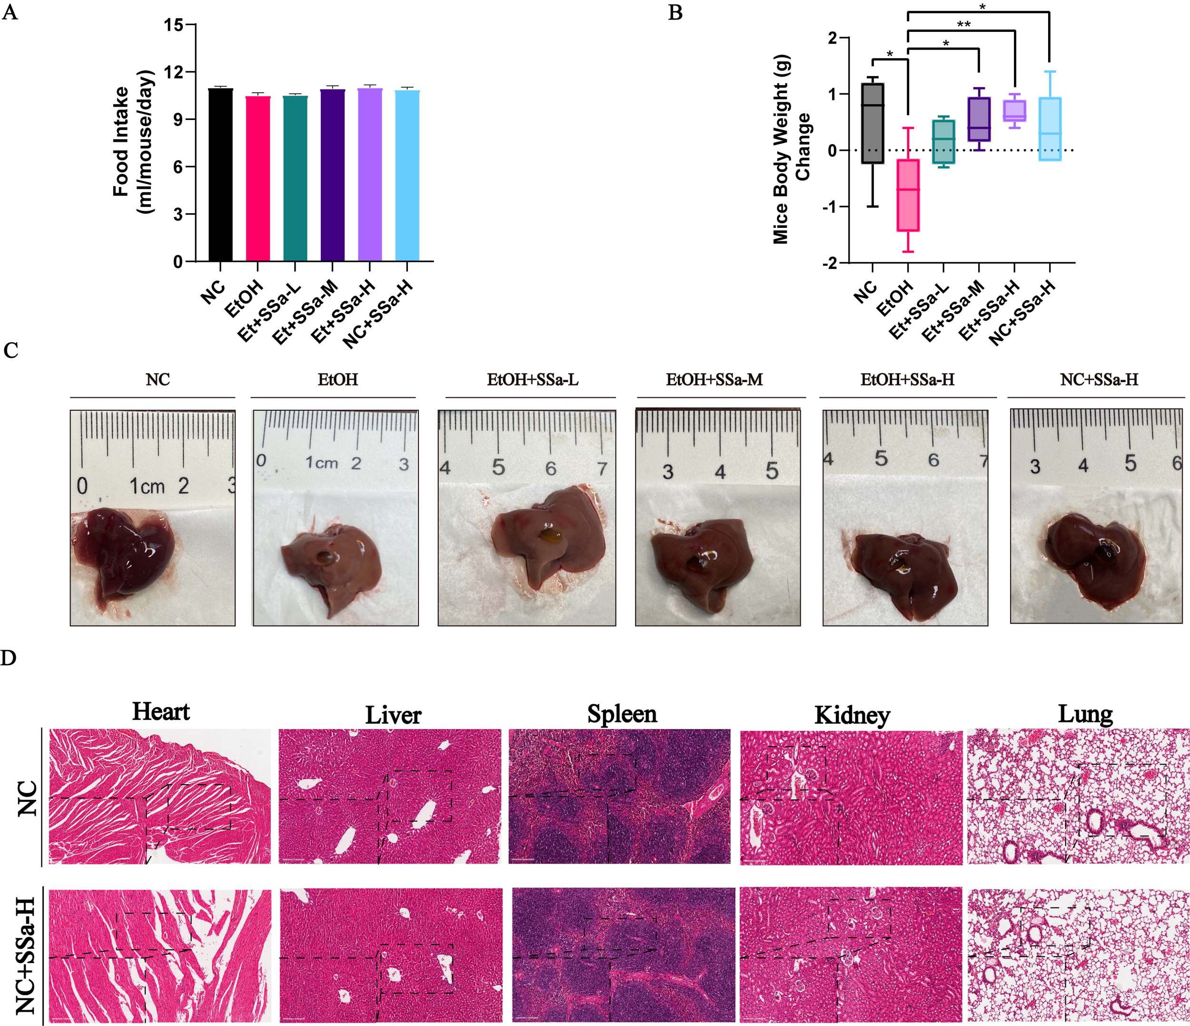
Supplementary Figure 2 (A) Evaluation of the effects of chronic-plus-binge ethanol feeding on food intake in each group of mice (n=6). (B) Assessment of changes in body weight (g) of mice (calculated as the difference between the weight on day 17 and day 6) (n=6). (C) Liver images. (D) Histological examination of the liver, kidney, spleen, lung, and heart (H&E staining, scale bar:100 µm, magnified field of view: scale bar:200 µm) (n=4).

Supplementary Figure 3
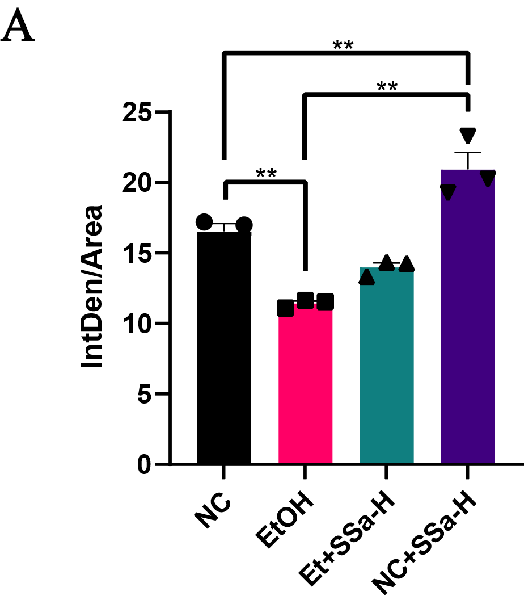
Supplementary Figure 3 (A) Quantification of the SIRT1-positive area using confocal microscopy images of SIRT1 immunostaining in mouse livers (n=3).

Supplementary Figure 4

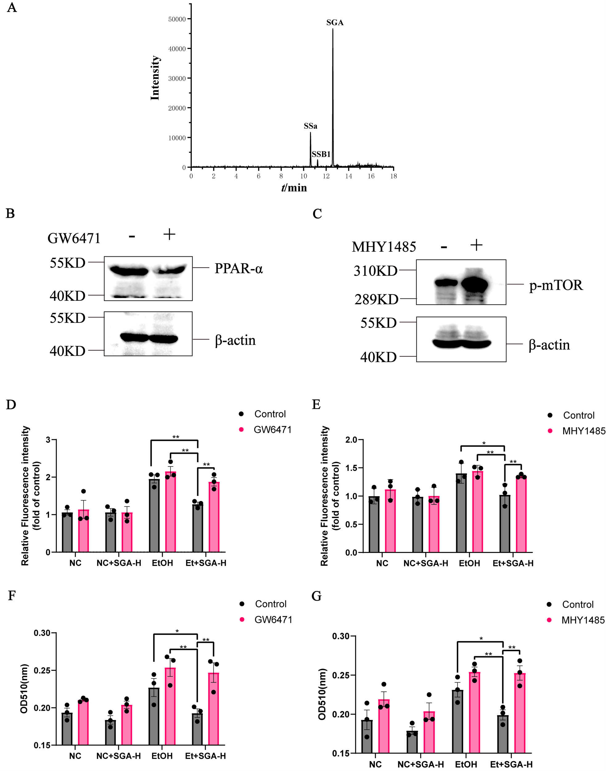
Supplementary Figure 4 (A) Total ion flow diagrams of Saikosaponin a, Saikosaponin B1, and Saikogenin a. (B, C) Assessment of changes in the protein levels of PPAR-α or phosphorylated mTOR following treatment with the PPAR-α inhibitor GW6471 or mTOR activator MHY1485, respectively. (D, E) Analysis of ROS levels using FCM in HepG2 cells subjected to ethanol and/or SGA (7.5 μmol/L) co-treatment, with or without GW6471/MHY1485 treatment (n=3). (F, G) Isopropanol elution and quantification of cellular lipid droplets under the influence of SGA (7.5 μmol/L) on ethanol-induced lipid storage, with or without GW6471/MHY1485 treatment in HepG2 cells, measured at OD510 nm (n=3).

Supplementary Table 2: Molecular docking analysis for Saikosaponin a and its metabolisms
Saikosaponins | Molecular formula | Gock score | Interacting amino acid
Saikosaponin a | C₄₂H₆₈O₁₃ | -6.56 | HIS-363;VAL-412;ARG-446
Saikosaponin B1 | C₄₂H₆₈O₁₃ | -5.05 | GLN-190;GLU-467
Saikogenin A | C₃₀H₄₈O₄ | -9.08 | PHE-297;HIS-363;VLA-412;PHE-414;GLY-415;GLU-416

Supplementary Figure 5
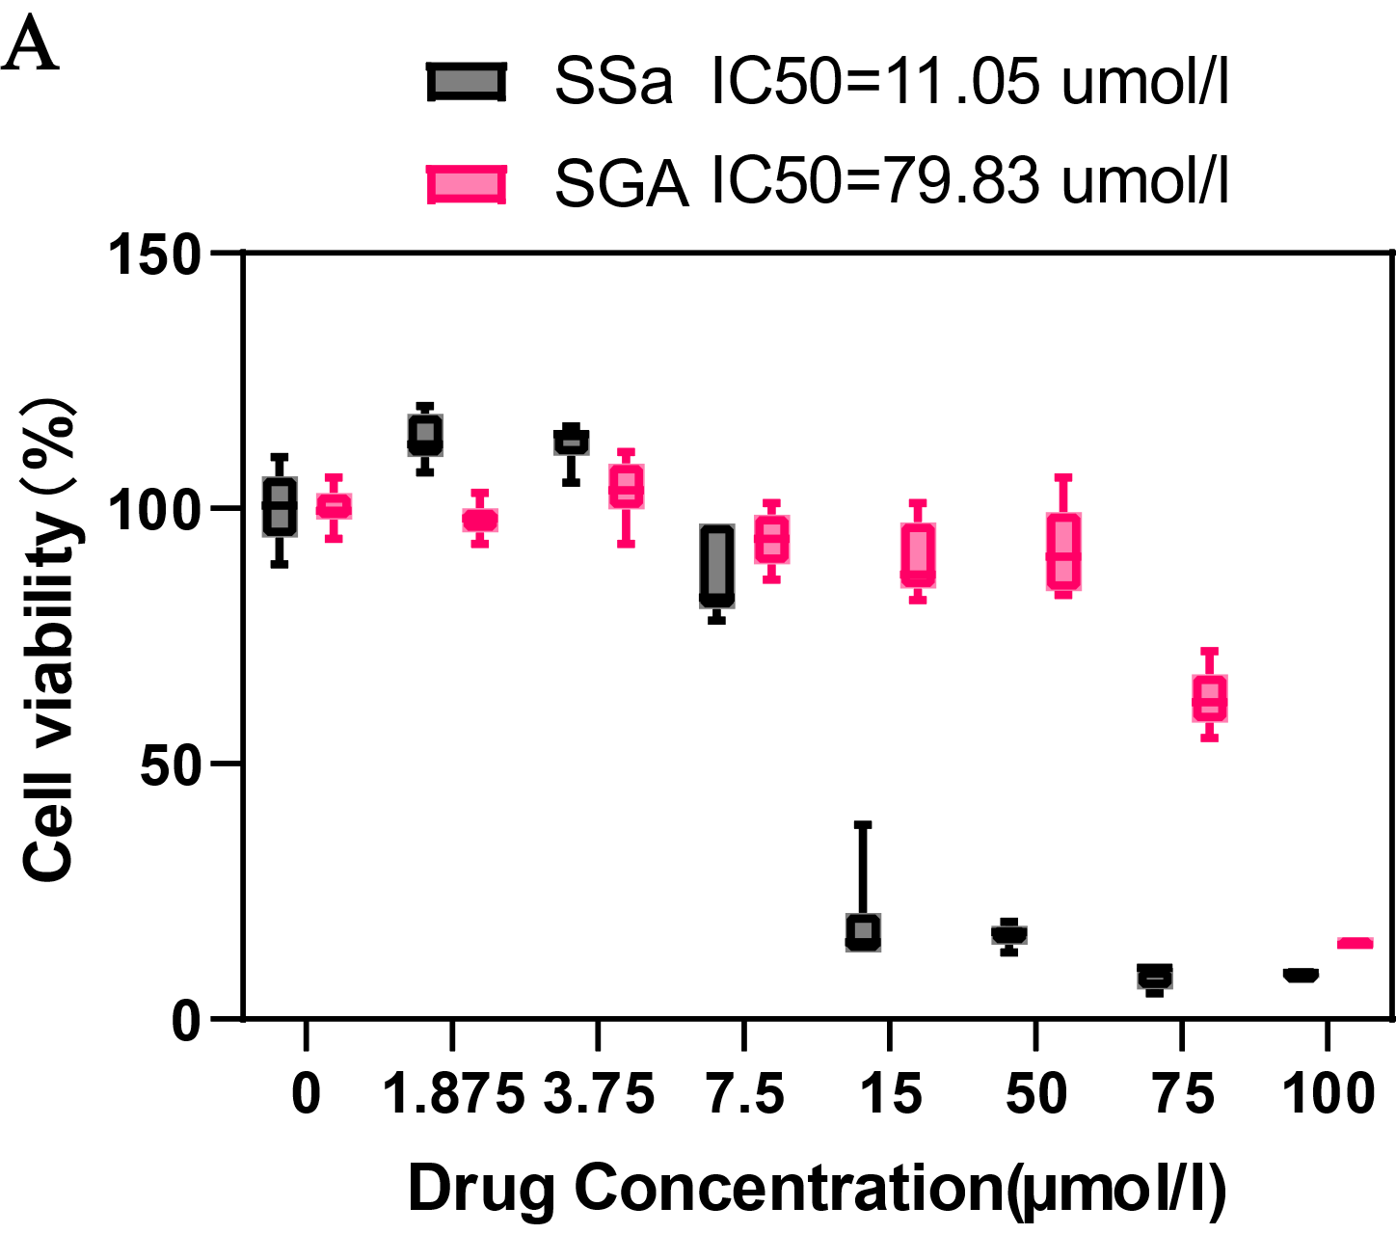
Supplementary Figure 5 (A) Cells were subjected to various concentrations of SGA or SSa for 24 hours. Logarithmic transformation of SGA or SSa concentrations and cell viability data were fitted to a nonlinear regression curve (log(inhibitor) vs. response-variable slope) to ascertain the LC50 of LO₂ (n=6).

Supplementary Figure 6
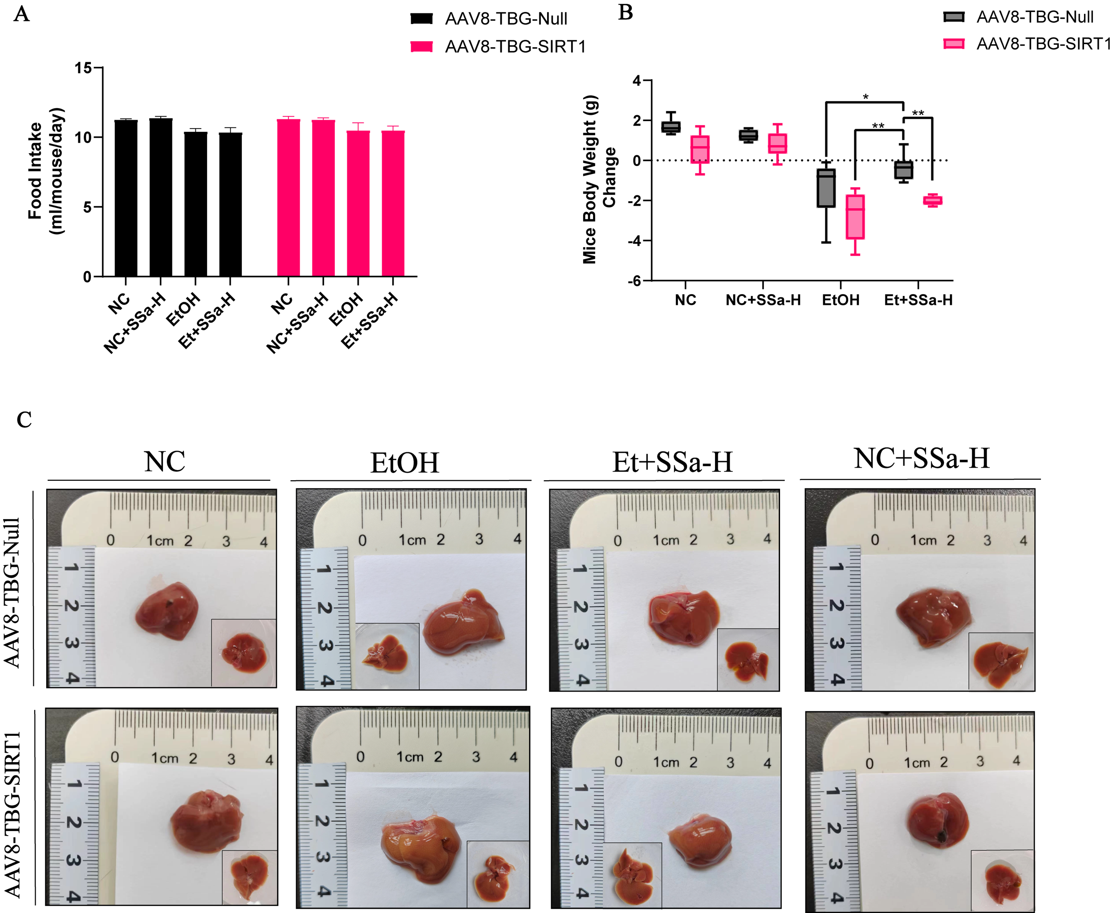
Supplementary Figure 6 (A) Assessment of the impact of chronic-plus-binge ethanol feeding on food intake in each group of mice, with or without hepatic SIRT1 knockdown (n=6). (B) Evaluation of changes in body weight (g) of mice with or without hepatic knockdown of SIRT1 (calculated as the difference between the weight on day 17 and day 6) (n=6). (C) Liver images (Thumbnail: liver rear image).

Supplementary Figure 7
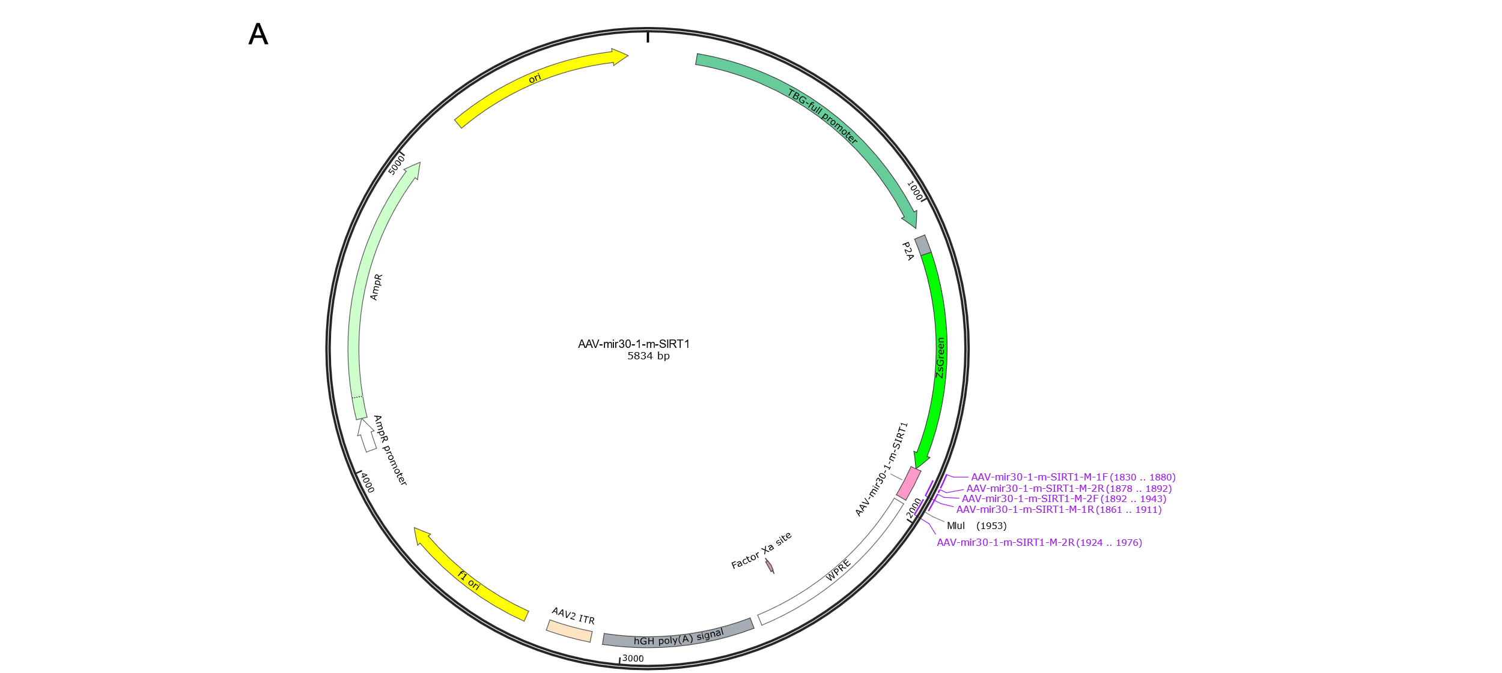
Supplementary Figure 7 (A) AAV8-TBG-mir30-m-SIRT1 vector

