Addition Details on Methodology

SWAT Validation
Potential Evapotranspiration (PET) is one of the key factors studied in hydrological cycles. However, different assessment methods can lead to different results. The semi-empirical and semi-theoretical Priestley-Taylor model requires fewer parameters and can be applied to calculate PET for different underlying surfaces (Priestley and Taylor, 1972). Additionally, simulation results of daily runoff in the southeastern United States show that the Priestley-Taylor method performs better in simulating runoff compared to the Hargreaves and Penman-Monteith methods, especially under extreme conditions(Samadi, 2016). In this study, the Priestley-Taylor method was selected to calculate PET. The simulated valve was compared with the measured values from a meteorological station in 2019 to evaluate the performance of the SWAT model. The measured and simulated evaporation values in the study area are shown in Fig S8. The correlation coefficient (R²) between them is 0.7487, which means that the fit is good and the evaporation obtained from the SWAT simulation is in line with the actual situation.

SWAT-MODFLOW Validation
The validation of the coupled model includes MODFLOW and SWAT. In this section, MODFLOW will validate based on the joint simulation of SWAT and MODFLOW. The validation results are determined by analyzing the groundwater levels obtained from the joint simulation. The groundwater flow field at the end of the period simulated by this coupled model is shown in Fig S9. The groundwater level is generally high in the southeast and low in the northwest. From the groundwater level fitting results shown in Fig. S10, it can be seen that the coupled model achieves a good fit between the simulated groundwater levels and the measured values, with a correlation coefficient of R²=0.85.

Reference
PRIESTLEY, C.H.B., TAYLOR, R.J., 1972. On the Assessment of Surface Heat Flux and Evaporation Using Large-Scale Parameters. Mon. Weather Rev. 100, 81–92. https://doi.org/10.1175/1520-0493(1972)100<0081:OTAOSH>2.3.CO;2
Samadi, S.Z., 2016. Assessing the sensitivity of SWAT physical parameters to potential evapotranspiration estimation methods over a coastal plain watershed in the southeastern United States. Hydrol. Res. 48, 395–415. https://doi.org/10.2166/nh.2016.034

Figure
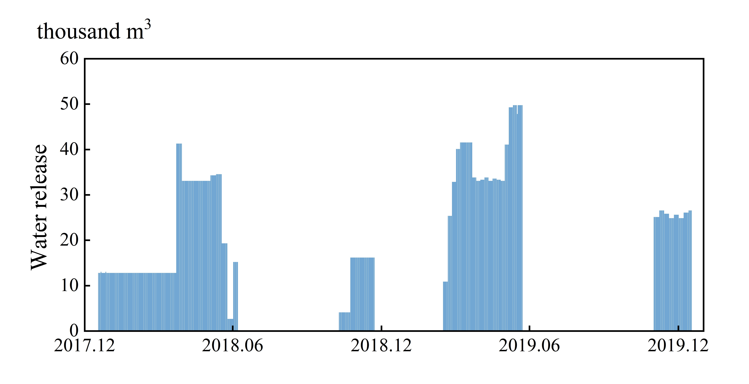
Fig.S1 Artificial recharge volume of Wohushan Reservoir during the simulation period.

Fig.S2 Geographical inputs for HRU definition in SWAT: (a) soil types (b) land use and (c) slope classes.
Fig.S3 Initial groundwater flow field in the study area.

Fig.S4 Generalization of aquifer boundary conditions.

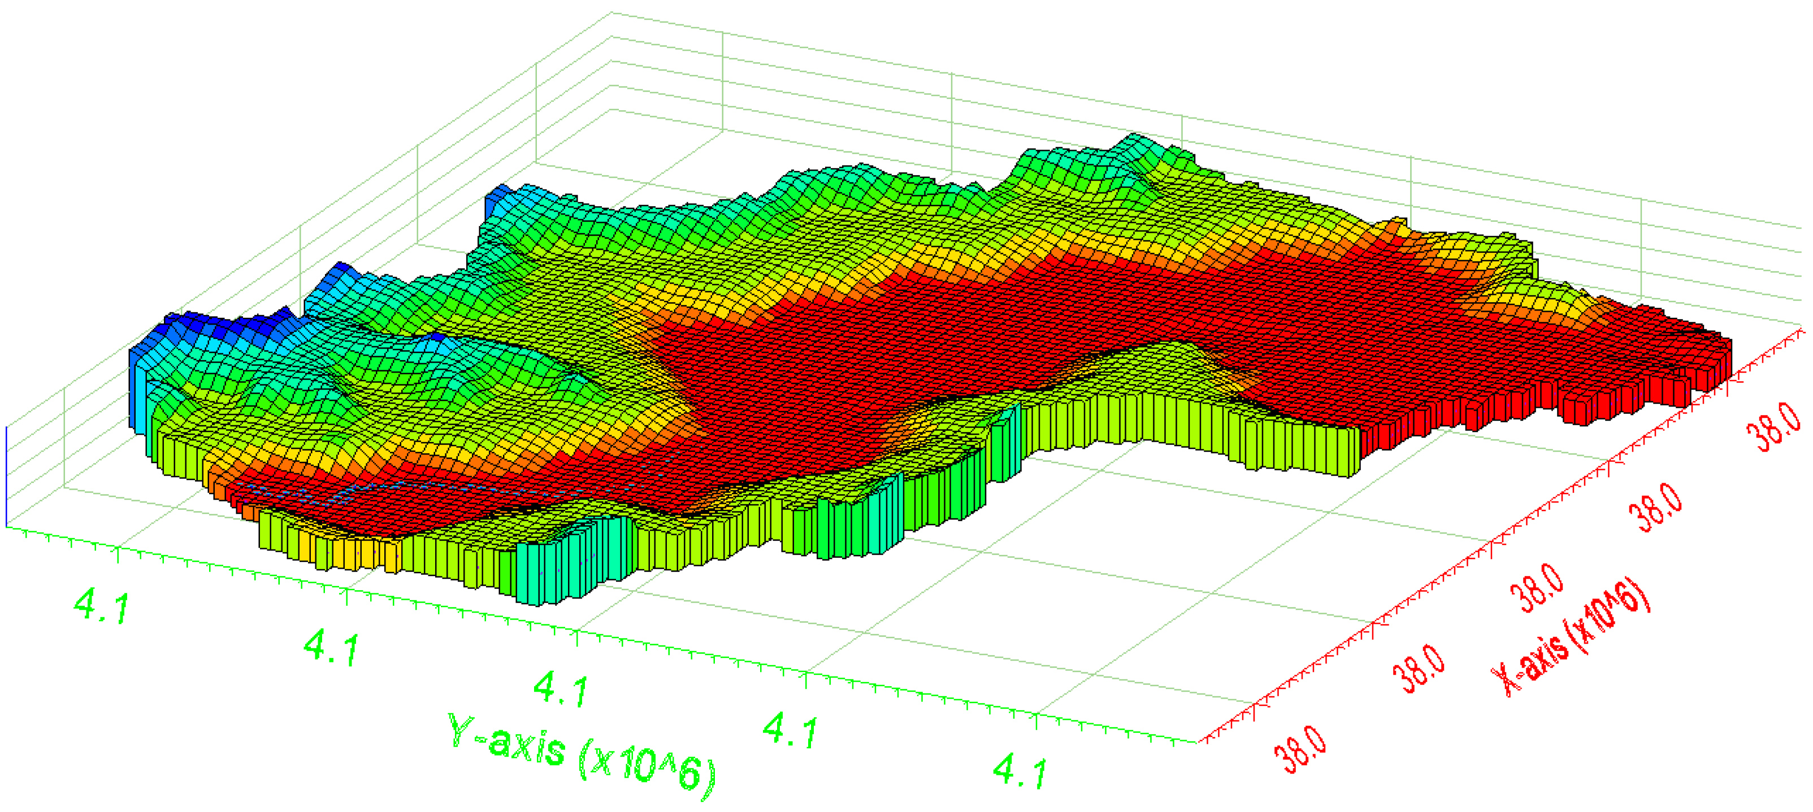
Fig.S5 Schematic diagram of the conceptual model of the study area.

Fig.S6 Data transfer process for coupled model.
Fig.S7 Changes in water levels at different observation points during artificial recharge. (a) upstream (b) midstream (c) downstream. The solid lines represent points close to the river and the dashed lines represent points far from the river.

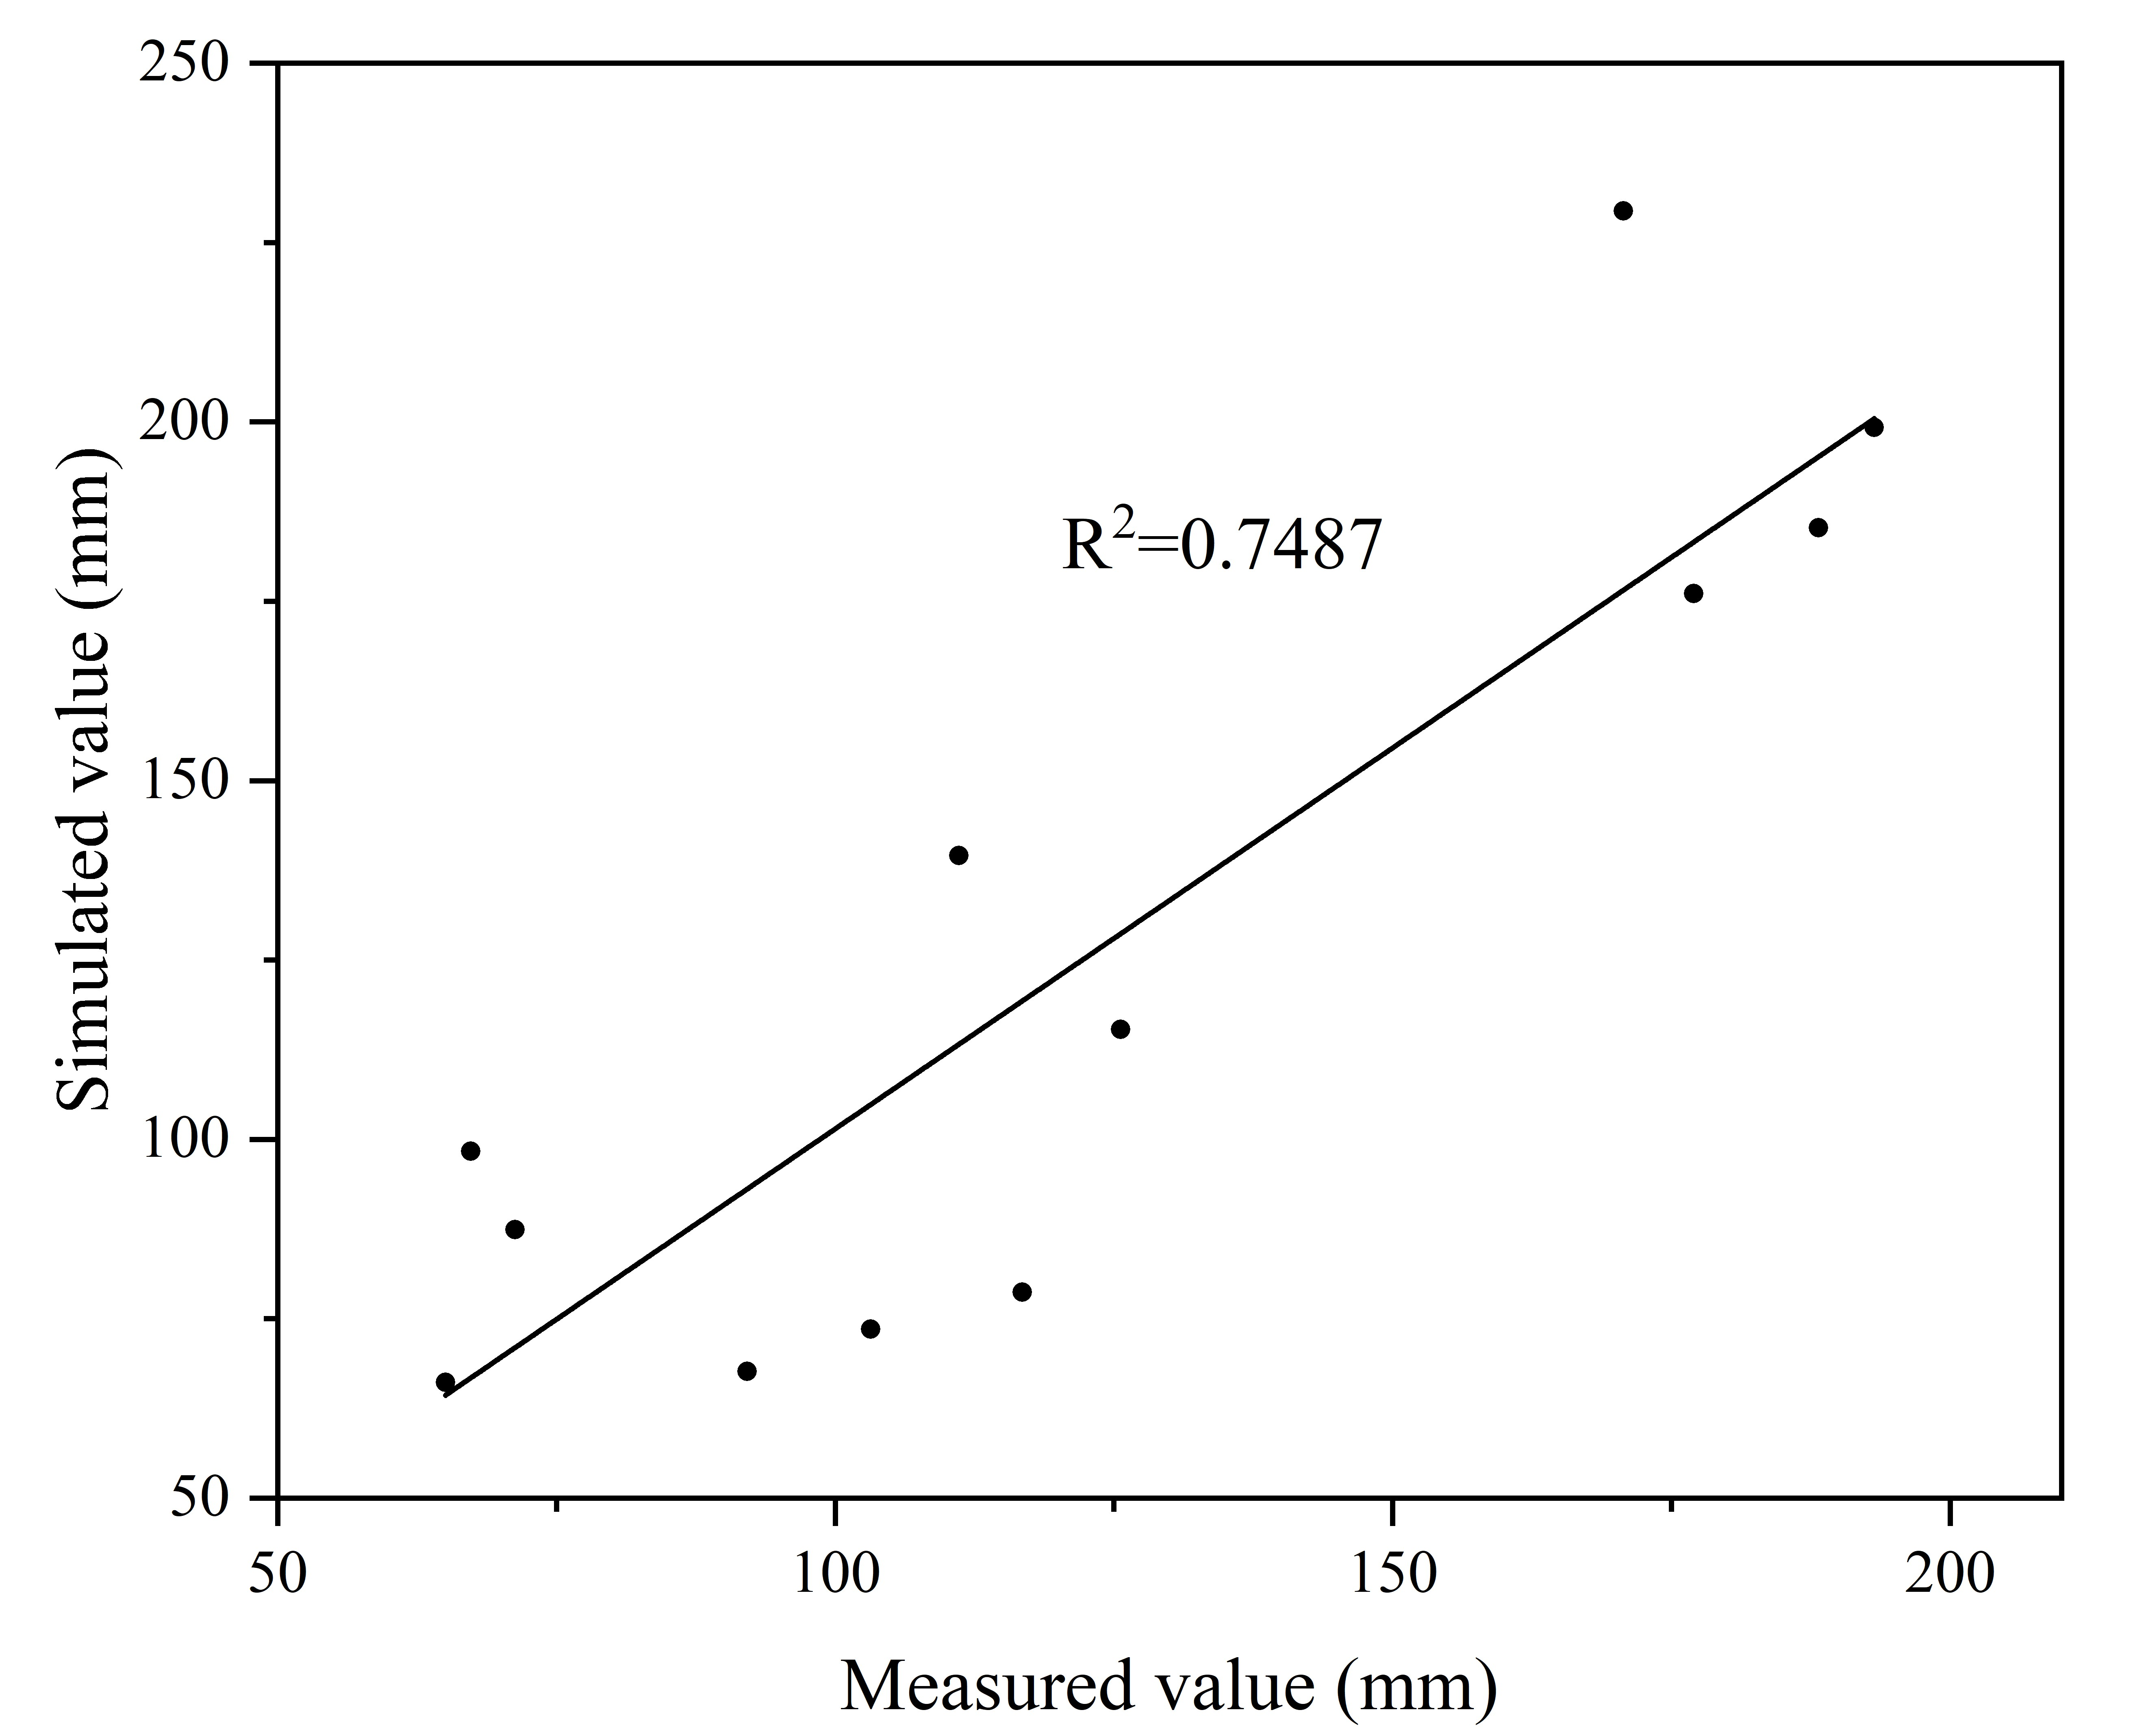
Fig.S8 Correlation analysis between measured and simulated values of evaporation.

Fig.S9 The simulated flow field in January 2020.
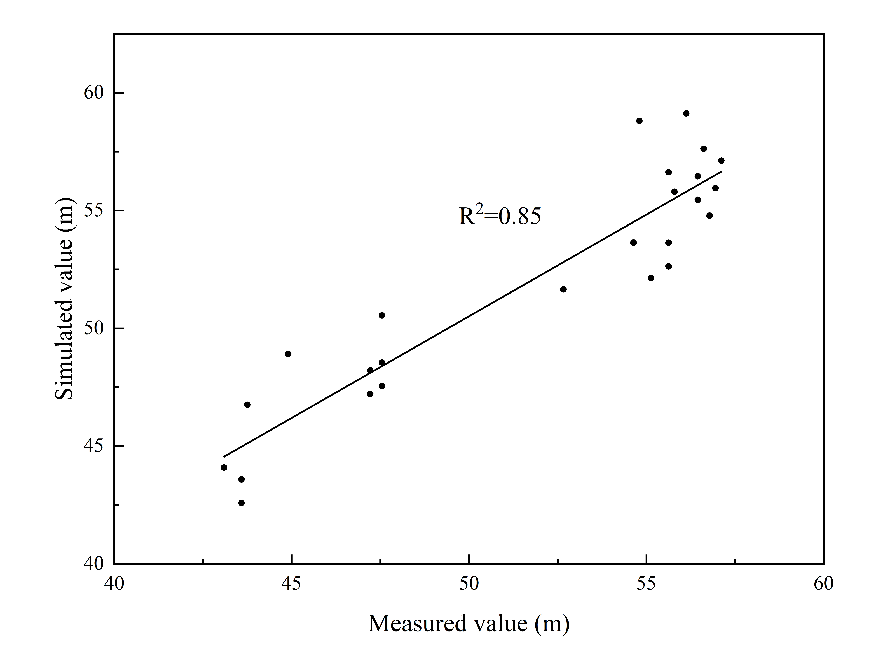
Fig.S10 Correlation analysis between measured values and simulated values of groundwater level.

Table
Table S1. Water recharge and DOC input under multiple scenarios
Data  (year) | Precipitation  (mm) | Recharged by Yellow River water(mm) | DOC Input  (kg/ha) | Recharged by Yangtze River water(mm) | DOC Input  (kg/ha) | Recharged by multi-source water | DOC Input  (kg/ha)
2021 | 779.8 | 55.89 | 6.14 | 33.68 | 5.23 | 65.22 | 9.58
2022 | 796.6 | 56.28 | 6.18 | 33.94 | 5.55 | 65.64 | 9.66
2023 | 813.4 | 56.34 | 6.22 | 34.05 | 5.53 | 65.72 | 10.13
2024 | 831 | 56.68 | 6.55 | 34.25 | 5.75 | 66.05 | 10.27
2025 | 847.4 | 56.48 | 6.86 | 34.27 | 6.50 | 65.64 | 10.35
2026 | 864.6 | 56.09 | 6.24 | 34.31 | 6.14 | 64.93 | 10.39
2027 | 881.5 | 55.33 | 6.40 | 34.37 | 6.13 | 63.96 | 10.39
2028 | 898.5 | 54.39 | 7.18 | 34.15 | 5.88 | 62.78 | 10.36
2029 | 915.4 | 52.97 | 6.35 | 33.46 | 5.23 | 61.28 | 10.12
2030 | 932.7 | 52.07 | 6.47 | 32.69 | 5.01 | 60.54 | 9.95

Table S2. Results of sensitivity analysis
Parameter | ΔX_{i}
Parameter | -20% | -10% | 10% | 20%
K | 0.12 | 0.12 | 0.04 | 0.11
X_{AR} | 0.20 | 0.10 | 0.10 | 0.10
φ | 0.63 | 0.67 | 0.67 | 0.65

