Supplemental information

HealthyPlan.City: A Web Tool to Support Urban Environmental Equity and Public Health in Canadian Communities
Dany Doiron¹*†, Eleanor M Setton²*, Joey Syer³, Andre Redivo², Allan McKee³, Mohammad Noaeen³, Priya Patel³, Gillian L Booth⁴, Michael Brauer⁵, Daniel Fuller⁶, Yan Kestens⁷, Laura C Rosella³, Dave Stieb⁸, Paul Villeneuve⁹, Jeffrey R Brook³
¹ Respiratory Epidemiology and Clinical Research Unit, Research Institute of the McGill University Health Centre, Montréal, Québec, Canada
² Geography Department, University of Victoria, Victoria, BC, Canada
³ Dalla Lana School of Public Health, University of Toronto, Toronto, ON, Canada
⁴ Department of Medicine, University of Toronto, Toronto, ON, Canada
⁵ School of Population and Public Health, The University of British Columbia, Vancouver BC Canada
⁶ Department of Community Health and Epidemiology, College of Medicine, University of Saskatchewan.
⁷ École de santé publique de l'Université de Montréal, Canada, QC, Canada
⁸ Environmental Health Science and Research Bureau, Health Canada, Vancouver, BC, Canada
⁹ Department of Neuroscience, Carleton University, Ottawa, ON, Canada
*Co-first authors
† Correspondence to:
D. Doiron, Respiratory Epidemiology and Clinical Research Unit, Research Institute of the McGill University Health Centre, email: dany.doiron@mail.mcgill.ca

Figure S1: The municipal (CSD) boundary for the City of Regina is presented in shown in blue. All areas in green have a population density of 400 person/km2 and represent the Population Centres (PC) for which data are mapped within municipal boundaries.

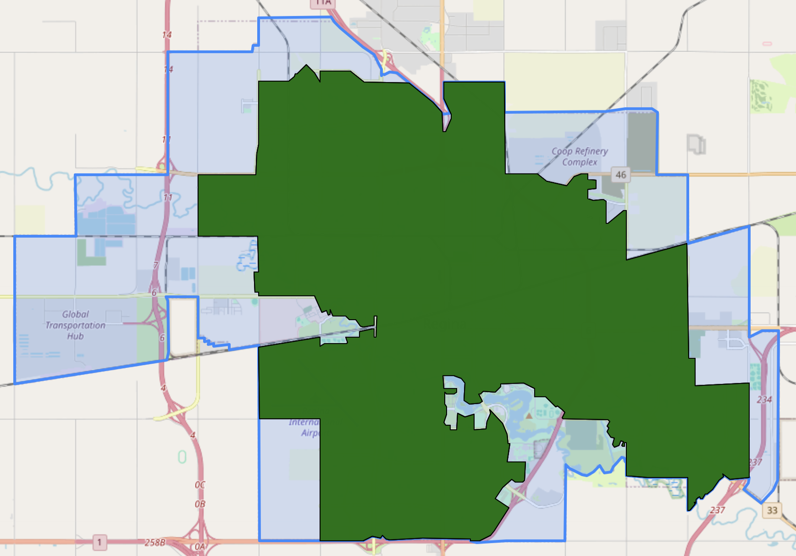

Table S1: Demographic and environmental data
 | Variable and definition | Source
Demographic indicators | Children: Percentage of population under 15 years of age | 2021 Canadian Census
Demographic indicators | Older adults: Percentage of population over 64 years of age | 2021 Canadian Census
Demographic indicators | Visible minority individuals: Percentage of population that identify as a visible minority | 2021 Canadian Census
Demographic indicators | Individuals living alone: Percentage of population in private households who live alone | 2021 Canadian Census
Demographic indicators | Newly-arrived immigrants: Percentage of population who are immigrants to Canada between 2011 and 2021 | 2021 Canadian Census
Demographic indicators | First-generation immigrants: Percentage of population who are immigrants born outside of Canada | 2021 Canadian Census
Demographic indicators | Low-income individuals: Percentage of population under the after-tax low-income threshold | 2021 Canadian Census
Demographic indicators | Low-income children: Percentage of children (under 18 y/o) under the after-tax low-income threshold | 2021 Canadian Census
Demographic indicators | Low-income older adults: Percentage of older adults (over 64 y/o) under the after-tax low-income threshold | 2021 Canadian Census
Demographic indicators | Low-income visible minority individuals: Percentage of population under the after-tax low-income cut-off threshold that identify as a visible minority | 2021 Canadian Census
Demographic indicators | Low-income individuals living alone: Percentage of population under the after-tax low-income cut-off threshold that live alone | 2021 Canadian Census
Demographic indicators | Low-income newly-arrived immigrants: Percentage of population under the after-tax low-income cut-off threshold who are immigrants to Canada between 2011 and 2021 | 2021 Canadian Census
Demographic indicators | Low-income first-generation immigrants: Percentage of population under the after-tax low-income cut-off threshold who are immigrants born outside of Canada | 2021 Canadian Census
Built environment indicators | Average summer temperature: Mean land surface temperature from May to September 2019-2021, averaged within dissemination blocks. | LandSat 8 satellite imagery
Built environment indicators | Tree canopy cover: Satellite-derived vegetation coverage from trees and large woody plants, averaged within dissemination blocks. | LandSat 8 satellite imagery[1]
Built environment indicators | Flood susceptibility: Areas prone to flooding based on patterns of historic flood events, averaged within dissemination blocks. | Natural Resources Canada's Flood Susceptibility Index[2]
Built environment indicators | Transit stops: Number of public transit amenities such as bus and tram stops, subway stations and car sharing locations within a 1 km radius from dissemination block centroids. | Open Database of Infrastructure[3]
Built environment indicators | Education and culture: Number of facilities such as schools, libraries, museums, and event venues within a 1 km radius from dissemination block centroids. | OpenStreetMap database, extracted in November 2022
Built environment indicators | Retail and services: Number of outlets such as stores, restaurants, professional services, and pharmacies within a 1 km radius from dissemination block centroids. | OpenStreetMap database, extracted in November 2022
Built environment indicators | Healthy food outlets: Number of fresh food outlets such as supermarkets, groceries, delis, and markets within a 1 km radius from dissemination block centroids. | OpenStreetMap database, extracted in November 2022
Built environment indicators | Large natural areas: Number of forests, beaches, wetlands and nature reserves within a 1 km radius from dissemination block centroids. | OpenStreetMap database, extracted in November 2022
Built environment indicators | Parks: Number of community gardens, neighbourhood parks and large parks within a 1 km radius from dissemination block centroids. | OpenStreetMap database, extracted in November 2022
Built environment indicators | Recreation and sports facilities: Number of facilities such as arenas, swimming pools, fitness centers and bowling alleys within a 1 km radius from dissemination block centroids. | OpenStreetMap database, extracted in November 2022
Built environment indicators | Air pollution: Nitrogen dioxide air pollution for the year 2016, averaged within dissemination blocks. | Developed by Hystad et al.[4]
Built environment indicators | Noise pollution: Number of noise pollution features within a distance that varies by their type (ranging from 250 m to 1 km), including airports, runways, helipads, railroads, fire and ambulance stations, and major roads. | OpenStreetMap database, extracted in November 2022

1. Sexton, J.O., et al., Global, 30-m resolution continuous fields of tree cover: Landsat-based rescaling of MODIS vegetation continuous fields with lidar-based estimates of error. International Journal of Digital Earth, 2013. 6(5): p. 427-448.
2. McGrath, H. and P.N. Gohl, Prediction and Classification of Flood Susceptibility Based on Historic Record in a Large, Diverse, and Data Sparse Country. Environmental Sciences Proceedings, 2023. 25(1): p. 18.
3. Statistics Canada. The Open Database of Infrastructure. 2023 [cited 2023 Dec 14]; Available from: https://www150.statcan.gc.ca/n1/pub/34-26-0003/342600032023001-eng.htm.
4. Hystad, P., et al., Creating national air pollution models for population exposure assessment in Canada. Environmental Health Perspectives, 2011. 119(8): p. 1123-1129.

