Supplementary Material

The relation of synaptic biomarkers with Aβ, tau, glial activation, and neurodegeneration in Alzheimer’s disease.
Yi-Ting Wang¹, Nicholas J. Ashton^{2,3,4,5}, Stijn Servaes¹, Johanna Nilsson², Marcel S. Woo^{1,6,7}, Tharick A. Pascoal^{8,9}, Cécile Tissot¹, Nesrine Rahmouni¹, Joseph Therriault¹, Firoza Lussier, Mira Chamoun¹, Serge Gauthier¹⁰, Ann Brinkmalm², Henrik Zetterberg^{2,11,12,13,14,15}, Kaj Blennow^{2,11}, Pedro Rosa-Neto^{1,16,17} and Andréa L. Benedet ²

Contents

Supplementary Methods ……………………………………………………………………..  Table S1. Demographics and biomarker information …………………………………………  Table S2. Cross-correlation matrix between synaptic biomarkers ……………………………. | 2  5  6
Table S3. Post hoc analysis of the biomarker concentrations across groups …………………. | 7
Table S4. Results of the linear regression analysis ……………………………………………. | 8
Table S5. Results of the path analysis ………………………………………………………… | 9
Figure S1. Synaptic biomarker concentrations across groups – z-scored ……………………..  Figure S2. Synaptic biomarker concentrations across groups – raw values …………………..  Figure S3. Synaptic biomarkers and brain PET ……………………………………………….  Figure S4. Interconnection of biomarkers in the AD continuum.…………………………....... | 10  11  12  13

Supplementary Methods

Study Design
This cross-sectional study included participants from the Translational Biomarkers in Aging and Dementia (TRIAD) cohort. TRIAD is a biomarker-based study launched in 2017 as part of the McGill Centre for Studies in Aging. All participants underwent multimodal imaging assessments including structural magnetic resonance imaging (MRI), Aβ-PET with [¹⁸F]AZD4694, and tau-PET with [¹⁸F]MK6240. They also had biofluid collection and clinical and neuropsychological assessments, including the Mini-Mental State Examination and Clinical Dementia Rating (CDR). This study primarily includes individuals within the AD spectrum who have both synaptic biomarkers quantified in the CSF and PET imaging data available. For AD dementia participants, CDR scores were equal to or greater than 1, while those with mild cognitive impairment (MCI) had a CDR of 0.5, and cognitively unimpaired (CU) participants had a CDR of 0, all of whom met standard diagnostic criteria. For the initial descriptive analysis, the study sample consisted of 167 participants, including 26 young participants (<30 years old), 79 CU participants, 31 MCI participants, and 12 AD participants, who were further categorized according to their brain Aβ status defined by visual rating of [¹⁸F]AZD4694 PET imaging. For subsequent analyses, participants with cognitive impairment who did not have evidence of Aβ pathology (non-AD) were excluded, leading to a sample size of 144 participants. The TRIAD study was approved by the Montreal Neurological Institute PET Working Committee and the Douglas Mental Health University Institute Research Ethics Board. Written informed consent was obtained from all participants.

CSF Analysis
CSF collection in the TRIAD cohort followed procedures previously described³⁵. CSF data was analyzed at the University of Gothenburg, Sweden by scientists blinded to participant clinical information. CSF Aβ₄₀, Aβ₄₂, p-tau₁₈₁ and total-tau concentrations were quantified with the LUMIPULSE G1200 (Fujirebio) assay, while p-tau₂₁₇ and p-tau₂₃₁ concentrations were measured using a custom Single molecule array (Simoa) assay (Quanterix, Billerica, MA, USA), as described previously³⁶. For synaptic biomarkers, GAP43 and NRGN concentrations were measured using in-house immunoassays^{37,38}, whereas SNAP25 and SYT1 concentrations were quantified using an immunoprecipitation mass spectrometry method³⁴. For glial activation/neuroinflammation biomarkers, CSF sTREM2 concentration was measured using an in-house electrochemiluminescence assay on the MesoScale Discovery SECTOR imager 6000 (MesoScale Discovery (MSD), Maryland, USA)^{18,39}. CSF YKL40 concentration was quantified with a commercial ELISA assay (R&D Systems, Minneapolis, MN) while GFAP concentration was quantified using a commercial single-plex assay (CSF) and a 4-plex assay (plasma) on the Simoa HD-X instrument (Quanterix, Billerica, MA, USA).

Imaging Analysis
All participants have acquired 3T T1-weighted MR images for structural analysis as well as co-registration purposes. T1-weighted images were segmented using the SPM12 tool, then non-linearly registered to the ADNI template using ANTS, as previously reported⁴⁰. MRI images were also processed with an optimized Voxel-Based Morphometry (VBM) protocol. In addition to grey matter (GM) VBM, brain atrophy was estimated using hippocampal volume, which was adjusted for total intracranial volume (ICV). ICV adjustment was performed using data from cognitively unimpaired (CU) subjects at baseline.
PET imaging acquisition was performed with a Siemens High Resolution Research Tomograph. For Aβ PET, [¹⁸F]AZD4694 images were acquired at 40–70 min after the intravenous bolus injection of the tracer and reconstructed with an ordered subset expectation maximization (OSEM) algorithm on a four-dimensional (4D) volume with 3 frames (3 × 600 s). For tau PET, [¹⁸F]MK-6240 images were acquired at 90–110 min after the intravenous bolus injection of the tracer and reconstructed using the same OSEM algorithm on a 4D volume with 4 frames (4 × 300 s). At the end of each PET emission acquisition, a 6-min transmission scan with a rotating ¹³⁷Cs point source was performed for attenuation correction. PET images were also corrected for motion, dead time, decay and scattered and random coincidences. Briefly, PET images were linearly registered to the native T1-weighted MRI and MRIs were linearly and nonlinearly registered to the ADNI standardized space. Then, PET images in the T1 space were brought to the ADNI standardized space using transformations from native MRI to the ADNI standardized space. PET images were subsequently spatially smoothed to an 8-mm full-width at half maximum resolution (FWHM)⁴¹. The whole cerebellum and inferior cerebellum gray matter were used as the reference regions for [¹⁸F]AZD4694 and [¹⁸F]MK6240, respectively. Tau PET SUVR was estimated from a composite area including the transentorhinal (Braak I-II) and limbic (Braak III-IV) cortices⁴². Neocortical [¹⁸F]AZD4694 SUVR value was estimated for each participant by averaging the SUVR from the precuneus, prefrontal, orbitofrontal, parietal, temporal, anterior and posterior cingulate cortices⁴³. For PET and GM VBM, additional average quantifications were done for 68 brain anatomical regions as segmented in the ANIMAL atlas⁴⁴. Within each of these regions, the top and bottom 5% voxels with extreme volumes were trimmed out before averaging left and right sides, resulting in 34 regions assessed (Supplementary material).

Statistical Analysis
All non-imaging statistical analyses were performed using the R software (version 4.0). Cross-sectional demographic and clinical data were assessed with t tests and χ² tests. Spearman rank correlation tests were applied to evaluate the association between biomarkers. Fluid biomarkers were log-transformed when needed. Linear regression models also tested the association between biomarkers, always adjusting by age and sex. Similar models were also applied to evaluate group differences and, when necessary, the Tukey honestly significant difference (HSD) test was used in the post hoc analysis.
Voxel-wise analyses were performed using RMINC, a R toolkit for statistical analysis of neuroimaging data. Initially, voxel-based linear regression models evaluated the associations between synaptic biomarkers and imaging outcomes, adjusting for age and sex. Random field theory (RFT) was used to correct the resulting t-parametric maps for multiple comparisons. For the subsequent analysis with PET, an ROI-based average SUVR was obtained by using a mask encompassing the brain voxels that were significantly associated with 3 out of the 4 synaptic biomarkers evaluated, as presented in the results. These ROI SUVRs were then used in linear regression models, as previously described, to obtain the standardized estimation values for each biomarker. Finally, Spearman was employed for each of the synaptic biomarkers to test their correlations with all 34 brain anatomical regions (for both PET tracers and GM VBM). The correlations that survived FDR correction were then plotted in a chord diagram (“circlize” package) where the density of correlations and their strength can be visually compared within and between biomarkers.
Given the significant associations and correlations between the majority of the biomarkers, we aimed to evaluate the complex associations between biomarkers altogether. We conducted a path analysis, which is a type of structural equation modelling, with full information maximum likelihood (FIML) estimation to test the fit of our hypothesized model using the R package ‘lavaan’, with bootstrapped standard errors calculated using 1000 draws. We then selected the “best” biomarker to represent each of the classes used in the model (Amyloid, Tau, Glial Activity, Synaptic, Neurodegeneration and Cognition). Following a biological framework, we hypothesized and tested the following model:

$$'Glial activity\sim Amyloid(CSF) + Age + Sex$$
$$Tau (CSF)\sim Amyloid(CSF) + Glial activity+ Age + Sex$$
$$Amyloid\left(PET\right)\sim Amyloid\left(CSF\right)+Tau(CSF)+Glial activity+ Age + Sex$$
$$Synaptic \sim Amyloid\left(CSF\right)+ Tau(CSF) + Glial activity + Age + Sex$$
$$Tau \left(PET\right)\sim Synaptic+ Tau(CSF) + Amyloid(PET) + Glial activity+ Age +Sex$$
$$Neurodegeneration \sim Tau (PET) + Synaptic + Glial activity + Age + Sex$$
$$Cognition \sim Tau (PET) + Neurodegeneration + Glial activity + Age + Sex'$$

The fit of our hypothesized model was assessed using the Root Mean Square Error of Approximation (RMSEA), Standardized Room Mean Square Residual (SRMR), Comparative Fit Index (CFI), and Tucker Lewis Index (TLI). We removed variables that were not significant in the paths resulting in a poor model fit. Values <0.05 and 0.08 indicate a good fit for the RMSEA and SRMR, respectively, and values >0.9 indicate a good fit for the CFI and TLI. Results are displayed in a diagram in which the distance and position of the nodes are arbitrarily defined.

Table S1. Demographics and biomarker information.
 | Young  (N=26) | CU-  (N=55) | CU+  (N=24) | MCI+  (N=19) | AD  (N=20)
Sex (F) | 16 (61.5) | 34 (61.8) | 15 (62.5) | 9 (47.4) | 8 (40.0)
Age (years) | 23.4 (1.91) | 71.1 (7.39) | 71.7 (7.66) | 71.80 (5.88) | 63.5 (7.44)
NRGN^{(a)} (pg/mL) | 187 (50.8) | 206 (114) | 252 (83.8) | 288 (106) | 258 (115)
GAP43^{(a)} (pg/mL) | 2490 (1260) | 3070 (1360) | 3240 (1460) | 3930 (1880) | 3780 (1650)
SNAP25^{(a)} (pmol/L) | 9.41 (8.42) | 12.80 (10.9) | 23.0 (11.6) | 29.3 (7.88) | 26.4 (21.7)
SYT1^{(a)} (pmol/L) | 37.8 (15.0) | 61.00 (23.4) | 65.8 (28.9) | 65.8 (29.7) | 58.5 (42.0)
Amyloid PET (SUVR) | 1.17 (0.08) | 1.26 (0.10) | 1.94 (0.43) | 2.39 (0.42) | 2.38 (0.45)
Hippoc. Vol. (mm³) | 4.11 (0.355) | 3.56 (0.35) | 3.55 (0.43) | 3.25 (0.36) | 2.84 (0.51)
Tau PET (SUVR) | 0.82 (0.08) | 0.90 (0.10) | 1.00 (0.15) | 1.56 (0.46) | 2.20 (0.61)
Data are presented as count (%) or mean (SD), except for synaptic biomarkers (ª) which were given in median (IQR).
Abbreviations: AD, Alzheimer’s disease; CSF, cerebrospinal fluid; CU−, Aβ-negative cognitively unimpaired; CU+, Aβ-positive cognitively unimpaired; F, female; GAP43, growth-associated protein-43; Hippoc. Vol., hippocampal volume adjusted for intra-cranial volume; IQR, interquartile range; MCI+, Aβ-positive mild cognitive impairment; NRGN, Neurogranin; SD, Standard deviation; SNAP25, synaptosomal-associated protein-25; SYT1, synaptotagmin-1.

Table S2. Cross-correlation matrix between synaptic biomarkers (Spearman’s rho correlation coefficient).

 | GAP43 | NRGN | SNAP25 | SYT1
GAP43 | 1
NRGN | 0.81*** | 1
SNAP25 | 0.652*** | 0.542*** | 1
SYT1 | 0.725*** | 0.6*** | 0.611*** | 1
***P<0.0001

Abbreviations: GAP43, growth-associated protein-43; NRGN, Neurogranin; SNAP25, synaptosomal-associated protein-25; SYT1, synaptotagmin-1.
Table S3. Post hoc analysis (Tukey contrasts) of the biomarker concentrations across groups, accounting for age and sex.

 | GAP43 |  | NRGN |  | SNAP25 |  | SYT1
 | T value | P value | T value | P value | T value | P value | T value | P value
CU- - Young | -0.431 | 0.992 | -0.319 | 0.997 | -0.170 | 1.000 | -1.089 | 0.792
CU+ - Young | -0.392 | 0.994 | -0.129 | 1.000 | 0.846 | 0.905 | -0.932 | 0.870
MCI+ - Young | 0.777 | 0.929 | 0.659 | 0.960 | 1.664 | 0.429 | -0.880 | 0.892
AD - Young | 0.738 | 0.940 | 1.106 | 0.783 | 1.604 | 0.467 | -1.278 | 0.679
CU+ - CU- | 0.065 | 0.999 | 0.496 | 0.985 | 2.824 | 0.037 * | 0.325 | 0.997
MCI+ - CU- | 3.065 | 0.018 * | 2.486 | 0.087 . | 4.732 | < 1e-04 *** | 0.400 | 0.994
AD - CU- | 2.568 | 0.072 . | 3.087 | 0.017 * | 3.809 | 0.001 ** | -0.163 | 1.000
MCI+ - CU+ | 2.609 | 0.065 . | 1.763 | 0.370 | 1.863 | 0.315 | 0.089 | 1.000
AD - CU+ | 2.186 | 0.172 | 2.310 | 0.132 | 1.176 | 0.742 | -0.388 | 0.994
AD - MCI+ | -0.289 | 0.998 | 0.602 | 0.971 | -0.575 | 0.975 | -0.453 | 0.990

Abbreviations: CU−, Aβ-negative cognitively unimpaired; CU+, Aβ-positive cognitively unimpaired; GAP43, growth-associated protein-43; MCI+, Aβ-positive mild cognitive impairment; NRGN, Neurogranin; SNAP25, synaptosomal-associated protein-25; SYT1, synaptotagmin-1.
Table S4. Standardized estimates of the linear regression models of associations between synaptic biomarkers and other CSF/imaging biomarkers, adjusted by age and sex (for future cognition, baseline scores were also accounted for in the models).

Class | Synaptic Biomarkers | Other Biomarkers | β Estimate | P value | CI 2.5 | CI 97.5
Amyloid | GAP43 | Aβ PET | 0.308 | 0.00023 | 0.147 | 0.469
Amyloid | NRGN | Aβ PET | 0.275 | 0.00124 | 0.110 | 0.439
Amyloid | SNAP25 | Aβ PET | 0.440 | 3.15E-08 | 0.292 | 0.589
Amyloid | SYT1 | Aβ PET | 0.072 | 0.37241 | -0.087 | 0.231
Amyloid | GAP43 | CSF Aβ42/40 | -0.410 | 6.60E-07 | -0.566 | -0.255
Amyloid | NRGN | CSF Aβ42/40 | -0.380 | 6.23E-06 | -0.540 | -0.220
Amyloid | SNAP25 | CSF Aβ42/40 | -0.407 | 5.11E-07 | -0.559 | -0.254
Amyloid | SYT1 | CSF Aβ42/40 | -0.151 | 0.06134 | -0.309 | 0.007
Tau | GAP43 | CSF pTau181 | 0.753 | 6.36E-23 | 0.628 | 0.879
Tau | NRGN | CSF pTau181 | 0.723 | 5.77E-20 | 0.590 | 0.856
Tau | SNAP25 | CSF pTau181 | 0.760 | 5.59E-23 | 0.634 | 0.886
Tau | SYT1 | CSF pTau181 | 0.534 | 8.90E-12 | 0.392 | 0.676
Tau | GAP43 | CSF pTau217 | 0.563 | 3.94E-12 | 0.417 | 0.710
Tau | NRGN | CSF pTau217 | 0.531 | 1.85E-10 | 0.378 | 0.683
Tau | SNAP25 | CSF pTau217 | 0.608 | 5.35E-15 | 0.471 | 0.745
Tau | SYT1 | CSF pTau217 | 0.333 | 3.87E-05 | 0.178 | 0.487
Tau | GAP43 | CSF pTau231 | 0.667 | 1.56E-17 | 0.532 | 0.801
Tau | NRGN | CSF pTau231 | 0.623 | 1.39E-14 | 0.480 | 0.766
Tau | SNAP25 | CSF pTau231 | 0.633 | 5.48E-16 | 0.497 | 0.769
Tau | SYT1 | CSF pTau231 | 0.396 | 7.20E-07 | 0.245 | 0.547
Tau | GAP43 | Tau PET | 0.334 | 2.29E-05 | 0.183 | 0.485
Tau | NRGN | Tau PET | 0.313 | 9.53E-05 | 0.159 | 0.467
Tau | SNAP25 | Tau PET | 0.397 | 1.92E-07 | 0.254 | 0.540
Tau | SYT1 | Tau PET | 0.073 | 0.33928 | -0.078 | 0.224
Glial activation | GAP43 | CSF GFAP | 0.766 | 1.25E-10 | 0.549 | 0.984
Glial activation | NRGN | CSF GFAP | 0.672 | 4.79E-08 | 0.442 | 0.902
Glial activation | SNAP25 | CSF GFAP | 0.879 | 2.93E-14 | 0.674 | 1.083
Glial activation | SYT1 | CSF GFAP | 0.664 | 5.27E-09 | 0.453 | 0.875
Glial activation | GAP43 | CSF sTREM2 | 0.415 | 1.39E-05 | 0.233 | 0.597
Glial activation | NRGN | CSF sTREM2 | 0.396 | 4.47E-05 | 0.210 | 0.582
Glial activation | SNAP25 | CSF sTREM2 | -0.017 | 0.85969 | -0.211 | 0.176
Glial activation | SYT1 | CSF sTREM2 | 0.478 | 6.29E-08 | 0.313 | 0.643
Glial activation | GAP43 | CSF YKL40 | 0.715 | 1.36E-08 | 0.481 | 0.948
Glial activation | NRGN | CSF YKL40 | 0.707 | 3.17E-08 | 0.469 | 0.946
Glial activation | SNAP25 | CSF YKL40 | 0.737 | 2.73E-09 | 0.508 | 0.966
Glial activation | SYT1 | CSF YKL40 | 0.650 | 5.03E-08 | 0.427 | 0.872
Glial activation | GAP43 | plasma GFAP | 0.299 | 0.00297 | 0.104 | 0.495
Glial activation | NRGN | plasma GFAP | 0.354 | 0.00054 | 0.157 | 0.552
Glial activation | SNAP25 | plasma GFAP | 0.367 | 0.00021 | 0.177 | 0.558
Glial activation | SYT1 | plasma GFAP | 0.117 | 0.230877 | -0.075 | 0.308
Neurodegeneration | GAP43 | CSF NfL | 0.576 | 0.00105 | 0.238 | 0.914
Neurodegeneration | NRGN | CSF NfL | 0.316 | 0.06948 | -0.026 | 0.658
Neurodegeneration | SNAP25 | CSF NfL | 0.403 | 0.00501 | 0.125 | 0.681
Neurodegeneration | SYT1 | CSF NfL | 0.205 | 0.173632 | -0.092 | 0.502
Neurodegeneration | GAP43 | Hippo vol | -0.113 | 0.24402 | -0.305 | 0.078
Neurodegeneration | NRGN | Hippo vol | -0.138 | 0.16170 | -0.331 | 0.056
Neurodegeneration | SNAP25 | Hippo vol | -0.227 | 0.01643 | -0.411 | -0.042
Neurodegeneration | SYT1 | Hippo vol | 0.064 | 0.480456 | -0.115 | 0.243
Cognition | GAP43 | MMSE | -0.117 | 0.15285 | -0.277 | 0.044
Cognition | NRGN | MMSE | -0.142 | 0.08607 | -0.303 | 0.020
Cognition | SNAP25 | MMSE | -0.133 | 0.09693 | -0.290 | 0.024
Cognition | SYT1 | MMSE | 0.161 | 0.035462 | 0.011 | 0.311
Cognition | GAP43 | MMSE (future) | -0.207 | 0.02457 | -0.387 | -0.027
Cognition | NRGN | MMSE (future) | -0.239 | 0.01561 | -0.432 | -0.046
Cognition | SNAP25 | MMSE (future) | -0.248 | 0.00643 | -0.424 | -0.071
Cognition | SYT1 | MMSE (future) | 0.043 | 0.607703 | -0.122 | 0.207
Cognition | GAP43 | MOCA | -0.221 | 0.01109 | -0.391 | -0.051
Cognition | NRGN | MOCA | -0.274 | 0.00151 | -0.441 | -0.107
Cognition | SNAP25 | MOCA | -0.307 | 0.00019 | -0.465 | -0.149
Cognition | SYT1 | MOCA | 0.022 | 0.786960 | -0.137 | 0.180
Cognition | GAP43 | MOCA (future) | -0.255 | 0.00552 | -0.433 | -0.077
Cognition | NRGN | MOCA (future) | -0.291 | 0.00316 | -0.482 | -0.100
Cognition | SNAP25 | MOCA (future) | -0.293 | 0.00120 | -0.468 | -0.119
Cognition | SYT1 | MOCA (future) | 0.032 | 0.699659 | -0.133 | 0.197

Abbreviations: Aβ PET, Amyloid positron emission tomography; CI, confidence interval; CSF, cerebrospinal fluid; GAP43, growth-associated protein-43; GFAP, glial fibrillary acidic protein; Hippo. Vol, hippocampal volume adjusted for intra-cranial volume; MMSE, mini-mental state examination; MOCA, Montreal cognitive assessment; NRGN, Neurogranin; NfL, neurofilament light chain protein; pTau, phosphorylated Tau; SNAP25, synaptosomal-associated protein-25; sTREM2, soluble Triggering receptor expressed on myeloid cells 2; SYT1, synaptotagmin-1; YKL40, Chitinase-3-like protein 1.
Table S5. Parameters and estimates of the path analysis.

 | Full Model |  | Reduced Model
 | β Estimate (Std.Err.) | P value | β Estimate (Std.Err.) | P value
Regression Slopes
Glial
Amy (CSF) | -0.23(0.05) | <0.0001 | -0.24(0.05) | <0.0001
Age | 0.68(0.05) | <0.0001 | 0.69(0.05) | <0.0001
Sex | 0.09(0.10) | 0.361
Tau (CSF)
Amy (CSF) | -0.56(0.05) | <0.0001 | -0.56(0.05) | <0.0001
Glial | 0.57(0.07) | <0.0001 | 0.57(0.07) | <0.0001
Age | -0.19(0.07) | 0.005 | -0.19(0.07) | 0.006
Sex | -0.08(0.09) | 0.357
Amy (PET)
Amy (CSF) | -0.56(0.07) | <0.0001 | -0.56(0.07) | <0.0001
Tau (CSF) | 0.33(0.09) | <0.0001 | 0.32(0.07) | <0.0001
Glial | -0.02(0.09) | 0.864
Age | 0.01(0.08) | 0.930
Sex | 0.00(0.09) | 0.987
Syn
Amy (CSF) | 0.22(0.08) | 0.004 | 0.22(0.08) | 0.008
Tau (CSF) | 0.80(0.10) | <0.0001 | 0.82(0.10) | <0.0001
Glial | 0.33(0.11) | 0.002 | 0.21(0.07) | 0.004
Age | -0.13(0.08) | 0.120
Sex | 0.11(0.10) | 0.289
Tau (CSF)
Syn | -0.13(0.09) | 0.131
Tau (CSF) | 0.62(0.12) | <0.0001 | 0.51(0.09) | <0.0001
Amy (PET) | 0.33(0.08) | <0.0001 | 0.35(0.08) | <0.0001
Glial | 0.01(0.11) | 0.923
Age | -0.20(0.09) | 0.028 | -0.20(0.06) | 0.002
Sex | 0.04(0.11) | 0.694
Ndg
Tau (PET) | 0.14(0.07) | 0.043 | 0.21(0.06) | <0.0001
Syn | 0.20(0.13) | 0.126
Glial | 0.08(0.13) | 0.535 | 0.22(0.08) | 0.008
Age | 0.57(0.09) | <0.0001 | 0.55(0.08) | <0.0001
Sex | 0.17(0.11) | 0.111 | 0.22(0.10) | 0.028
Cog
Tau (PET) | -0.61(0.07) | <0.0001 | -0.59(0.07) | <0.0001
Ndg | -0.39(0.12) | 0.002 | -0.42(0.12) | 0.001
Syn | 0.02(0.07) | 0.724
Age | 0.30(0.11) | 0.005 | 0.33(0.11) | 0.002
Sex | -0.19(0.12) | 0.103
Residual Variances
Glial | 0.35(0.04) | <0.0001 | 0.35(0.04) | <0.0001
Tau (CSF) | 0.26(0.03) | <0.0001 | 0.26(0.03) | <0.0001
Amy (PET) | 0.31(0.04) | <0.0001 | 0.31(0.04) | <0.0001
Syn | 0.37(0.04) | <0.0001 | 0.38(0.05) | <0.0001
Tau (PET) | 0.43(0.05) | <0.0001 | 0.44(0.05) | <0.0001
Ndg | 0.29(0.06) | <0.0001 | 0.25(0.03) | <0.0001
Cog | 0.42(0.05) | <0.0001 | 0.42(0.05) | <0.0001
Amy (CSF) | 0.99+ |  | 0.99+
Age | 0.99+ |  | 0.99+
Sex | 0.25+ |  | 0.25+
Residual Covariances
Syn w/ Ndg | -0.15(0.06) | 0.025
Amy (CSF) w/Age | -0.35+ |  | -0.35+
Amy (CSF) w/Sex | -0.04+ |  | -0.04+
Age w/Sex | 0.01+ |  | 0.01+
Syn w/Cog |  |  | 0.01(0.04) | 0.739
Fit Indices
χ2 | 10.14(8) | 0.26 | 26.56(21) | 0.19
RMSEA | 0.04 |  | 0.04
CFI | 1 |  | 0.99
TLI | 0.99 |  | 0.99
BIC | 1897.87 |  | 1849.68
AIC | 1755.32 |  | 1745.73
SRMR | 0.02 |  | 0.03
⁺Fixed parameter

For this analysis, Amy (CSF) was proxied by CSF Aβ42/40, Tau (CSF) was proxied by CSF pTau181, Glial was proxied by CSF GFAP, Syn was proxied by SNAP25, Ndg was proxied by CSF NfL and Cog was proxied by MOCA.

Abbreviations: AIC, Aikaike Information Criterion; Amy, amyloid pathology; BIC, Bayesian Information Criterion; CFI, Comparative Fit Index; CSF, cerebrospinal fluid; Cog, cognition; Glial, glial activity; Ndg, neurodegeneration; PET, positron emission tomography; RMSEA, Root Mean Square Error of Approximation; SRMR, Standardized Room Mean Square Residual; Syn, synaptic; Tau, tau pathology; TLI, Tucker Lewis Index; χ2, Chi-square.

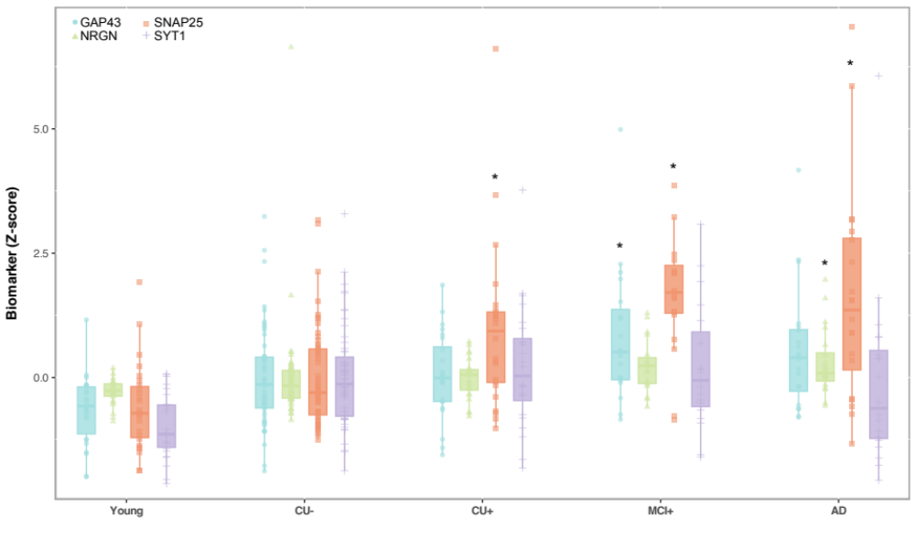

Figure S1. Biomarker concentration across groups – z-scores.
Boxplots displaying levels of CSF synaptic biomarkers across groups. The boxplots depict the median (horizontal bar), 25th to 75th percentiles (hinges) and whiskers indicate 10th and 90th percentiles. Group comparisons (presented in the Supplementary Table S2) were computed with a one-way ANCOVA adjusting for age and sex. Tukey honestly significant difference (HSD) test was used for the post hoc pairwise comparisons. The * indicates, for each biomarker, the groups that are significantly different from CU group.

Abbreviations: CU−, Aβ-negative cognitively unimpaired; CU+, Aβ-positive cognitively unimpaired; GAP43, growth-associated protein-43; MCI+, Aβ-positive mild cognitive impairment; NRGN, Neurogranin; SNAP25, synaptosomal-associated protein-25; SYT1, synaptotagmin-1.

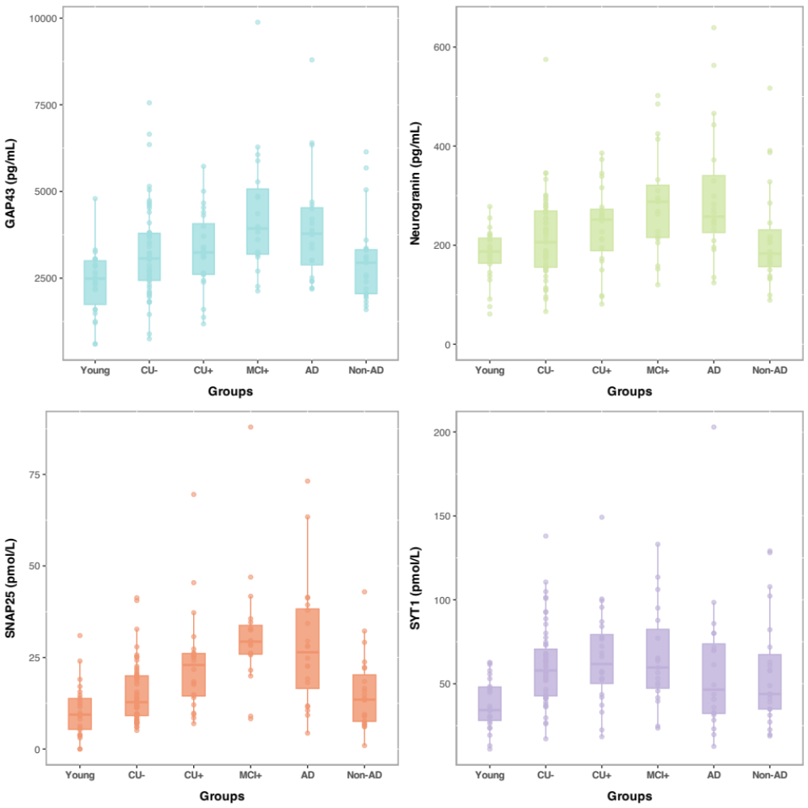

Figure S2. Biomarker concentration across groups – raw values.
Boxplots displaying levels of CSF synaptic biomarkers across groups. The boxplots depict the median (horizontal bar), 25th to 75th percentiles (hinges) and whiskers indicate 10th and 90th percentiles. Non-AD was included here for informative purposes only – these participants were not included in any of the statistical analyses.

Abbreviations: CU−, Aβ-negative cognitively unimpaired; CU+, Aβ-positive cognitively unimpaired; GAP43, growth-associated protein-43; MCI+, Aβ-positive mild cognitive impairment; NRGN, Neurogranin; SNAP25, synaptosomal-associated protein-25; SYT1, synaptotagmin-1.

Figure S3. Synaptic biomarkers and brain PET.
The black panels on the left show the T-parametric maps on the significant voxel-wise associations between synaptic biomarkers and Amyloid (Aβ) PET (top) and tau PET (bottom). The final brain map (middle orange panels) shows the brain regions where at least three (orange) or four (yellow) of the synaptic biomarkers had significant overlapping associations with Aβ PET (top) and tau PET (bottom). On the right side, the forest plots show the effect of the association between synaptic biomarkers and the average Aβ PET (top) and tau PET (bottom) SUVR of the overlapping brain regions depicted in the middle orange panels. The * indicates significant associations.

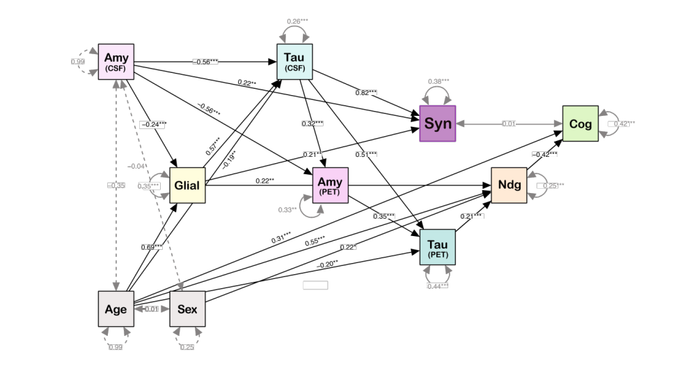

Figure S4. Interconnection of biomarkers in the AD continuum.
To evaluate the relationship between biomarkers simultaneously and incorporate the potential effect of these biomarkers via multiple pathways, we have performed path analysis. Following a biological framework, we hypothesized and tested the model described above. After removing the variables that were not significant in each regression (see Table S5), the final model above showed a good fit as indicated by the different indices reported (RMSEA=0.04; SRMR=0.02; CFI=0.99, TLI=0.98). The final model indicates that Amyloid CSF (represented by Aβ42/40), Tau CSF (represented by pTau181) and Glial activation (proxied by CSF GFAP) independently affect synaptic biomarker levels (Synaptic; proxied by SNAP25).
The network plot shows significant associations between biomarkers which are linked by straight black arrows indicating the directions of the causal relationship. Curved double-headed arrows represent the unexplained or residual variances in the quantified variables that are not accounted for by the predictors in the model. Gray dotted linear arrows represent residual covariance. The values displayed are the standardized estimates and their significance is indicated by asterisks when calculated.
Abbreviations: Amy, Aβ pathology; CSF, cerebrospinal fluid; Cog, cognition; Glial, glial activity; Ndg, neurodegeneration; PET, positron emission tomography; Syn, synaptic; Tau, tau pathology.

