Table 1. Researched and justified material resources according to the established criteria, Bauru, 2023.

Item description | Item photo | Quantity/unit price | Total US$
Polythene mannequin in the shape of a male bust. | 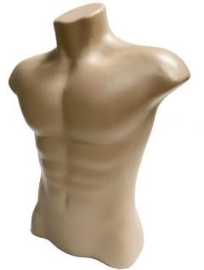 | 05 - US$ 11.8 | US$ 59.0
Acrylic plate with 4 screw holes. | 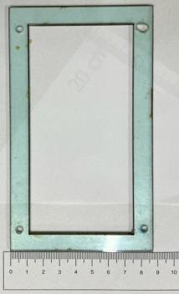 | 10 - 1.0 | 10.0
Piece of pork rib measuring 20X12 cm, rectangular in shape, with at least 5 ribs. | 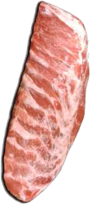 | 3 - 5.0 | 15.0
Deli collagen pouch. | 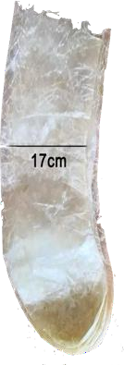 | 5 - 0.44 | 2.2
Ethyl Vinyl Acetate (EVA) mould. | 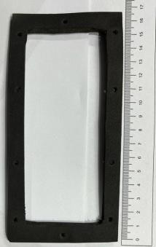 | 5 - 0.6 | 3.0

