Table 3. Scenario of patients with pleural effusion, according to the criteria proposed by Fabri et al (2019).
- Target audience
3rd-year medical students
- Primary objective

The student is able to:

Indicate and perform thoracic drainage in a patient with purulent pleural effusion

- Secondary objectives. The student is able to:

Identify the diagnosis and stratification of the type of parapneumonic effusion

Perform the thoracentesis procedure: choosing the necessary materials, positioning the patient, defining the puncture site, anesthesia, procedure sequence, collecting material for analysis

Perform respiratory physical examination techniques for patients with pleural effusion: auscultation

- Resources needed
Simulated patient, a pair of shorts or jeans, a short-sleeved shirt, a pair of trainers, artistic make-up, an identification bracelet, a stethoscope, a complete venturi mask, an oxygen mask with and without reservoir, an oxygen catheter, a laryngeal mask, mask valve bag, a low-fidelity thoracentesis simulator, a low-fidelity chest drainage simulator, procedure gloves, sterile gloves, sterile drapes, sterile apron, thoracentesis kit (antiseptic solution, gauze, glass with 1% lidocaine, 20mL syringe, aspiration needle, anesthesia needle, Jelco nº14, three-way stopcock, equipment, 3 sterile tubes for sample collection, collection bag), thoracic drainage kit, reclining stretcher, multiparametric monitor
- Characterization of the actor
The actor/patient is characterized by shorts or jeans, a short-sleeved shirt and trainers. In the scene, he/she is sitting up in bed, with an altered respiratory rate and paleness. Use artistic make-up to simulate the clinical condition.
Information for students

You're a third-year student doing your internship in Internal Medicine at a tertiary hospital.

You have been called to the ward to see a 42-year-old man who was admitted to the Emergency Department complaining of shortness of breath and chest pain for two days; he had already sought care at the Emergency Care Unit about two weeks previously for a fever and cough with expectoration. On admission, he was examined, additional tests were ordered and hospitalization was requested. Re-evaluate the patient, carry out a targeted anamnesis and physical examination interpret the tests requested, define the main diagnostic hypothesis, and carry out the necessary behavior to manage the individual's clinical condition.
The patient's current vital signs:

Blood Pressure = 130x90 millimeters of mercury;
Oxygen saturation = 94%;
Respiratory rate = 24 breaths per minute;
Heart rate = 110 beats per minute;
Temperature = 38.3°C
Blood count | Values | Reference values
ERYTHROGRAM
Red blood cells | 4.8 | 4.2 to 5.9 million/ µL
Hemoglobin | 14.2 | 13.0 to 18.0 g/dL
Hematocrit | 45 | 38 a 52%
Mean Corpuscular Volume | 88 | 80.0 to 100.0 fL
Mean Corpuscular Hemoglobin | 29 | 27.0 to 32.0 pg
Mean Corpuscular Hemoglobin Concentration | 33 | 31.0 to 36.0 g/dL
Red Cell Distribution Width | 12 | 10 a 16%
LEUCOGRAM
Total leucocytes | 21,320 | 4,000 to 11,000/mm³
Neutrophils | 18,469 | 1700 to 7,000/mm³
Rods | 2,360 | 0 to 800/mm³
Segmented | 16,109 | 1600 to 8,000/mm³
Basophils | 125 | 0 to 200/mm³
Eosinophils | 52 | 0 to 500/mm³
Monocytes | 218 | 100 to 1,000/mm³
Typical lymphocytes | 2,456 | 900 to 4000/mm³
PLATES | 230,000 | 140000 to 450,000/mm³

Chest X-ray
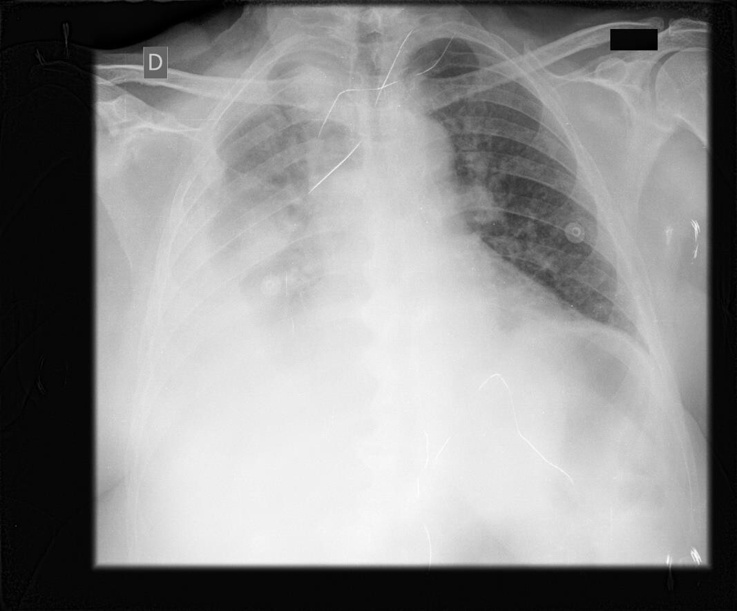

Source: researcher's personal collection

- Guidance for simulated patients

You are a 42-year-old patient called Gustavo and you are in hospital for treatment. You've been married for 20 years, are the father of 2 children, from Lins, and come from Bauru. You sought medical attention about a fortnight ago, complaining of a cough, "wheezing" and fever (not measured); you were given medication (antibiotics), but stopped taking it on the 3rd day of treatment, after feeling better. At the reassessment, he will report that he feels tired, feverish and has chest pain, as well as difficulty breathing, which is accentuated when walking, and has worsened since he arrived at the hospital, making it difficult to speak. When asked about some aspects of the history of your current illness, you should verbalize the following information:

- About his symptoms = they started a fortnight ago, with a cough with phlegm and fever, which improved at the start of treatment, and two days ago he began to feel short of breath, which worsened when he made any physical effort
- About her diagnosis the first time she sought help = "They said I had a lung infection"
- About the treatment = he took it well for the first three days but stopped when his symptoms improved
- About personal history = has been smoking since the age of 20, from 1 to 2 packets a day, and drinks socially at weekends; does not use continuous medication or illicit drugs
- About his condition at the moment = he feels weak/tired, feverish, and short of breath, which has worsened since he arrived at the hospital, and at the moment even makes it difficult to speak
- About the pain = it's a pain of moderate intensity (6/7 on a scale of 1 to 10), which presents itself during breathing, especially on inspiration
- Other information = not in the script/not relevant
- During questioning, you should speak in a paused, lowered voice, followed by attempts at deeper breathing, which may or may not be followed by an expression of pain, and phrases such as "It's hard to even talk, Doctor".
- Evolution of the scenario:
If thoracentesis is indicated, offer the simulator to the student
- Evaluation
Procedure checklist and OSAT [35]
References
[15,25,26,27,28,29,30,31]

