Supplementary Information:
4.8-μm CO-filled hollow-core silica fiber laser
Xuanxi Li, ^{1,2,3,†} Linyong Yang, ^{1,2,3,†} Zhiyue Zhou, ^{1,2,3,†} Zhixian Li, ^{1,2,3} Hao Li, ^{1,2,3} Wenxi Pei, ^{1,2,3} Wei Huang, ^{1,2,3} Jing Shi, ^{1,2,3} Luohao Lei, ^{1,2,3} Meng Wang, ^{1,2,3} and Zefeng Wang ^{1,2,3,*}
¹College of Advanced Interdisciplinary Studies, National University of Defense Technology, Changsha, 410073, China
²Nanhu Laser Laboratory, National University of Defense Technology, Changsha, 410073, China
³Hunan Provincial Key Laboratory of High Energy Laser Technology, National University of Defense Technology, Changsha, 410073, China
*zefengwang_nudt@163.com
S1. 2.33-μm Tm: ZBLAN fiber amplifier
A schematic diagram of the two-stage 2.33-μm fiber amplifier is shown in Fig. S1. The experimental setup employed two double-clad Tm: ZBLAN fibers with core and clad diameters measuring 7.5 μm (NA = 0.14) and 120 μm (NA = 0.5), respectively. The cutoff wavelength was approximately 1.9 μm. The fiber was cleaved at an angle of ∼ 9° at both ends to minimize the amount of back-reflected light. The pump power was provided by two commercial 793-nm laser diodes (LD) with a fiber pigtail of 105-μm core diameter (NA = 0.22). The seed laser utilized in the experiment was a single-frequency distributed feedback (DFB) diode laser with a power output of 5 mW and a linewidth of less than 2 MHz. It was equipped with a fiber pigtail that had a core diameter of 7 μm and a NA of 0.2. The standard operating wavelength of the seed laser was measured to be 2331.9 nm.
In the first-stage amplifier, the pump light was coupled into the fiber by means of two uncoated focus lenses with a focal length of 13.5 mm (FL1 and FL2) and a 45° inclined dichroic mirror (DM1) that exhibited high transmission at 793 nm and high reflectivity within the range of 1.8 to 2.4 μm. The DM1 was employed for the purpose of reflecting lasers with wavelengths of 2 and 2.3 μm. The estimated efficiency of the pump coupling was determined to be 70%. The pumping end of fiber was mounted in a water-cooled sink at 18°C and high refractive index glue was covered on the opposite end to prevent thermal damage and filter the residual pump light, respectively. The seed laser was effectively coupled into the fiber through the utilization of FL2, FL3, and DM2. The focal length of FL3, which has been coated with an anti-reflection coating at a wavelength of 2.3 μm, was measured to be 13.5 mm. A DM2 with high transmission at 2.3 μm and high reflectivity at ∼2 μm was intentionally tilted at an angle of 8° between FL2 and FL3. This tilt was implemented with the purpose of isolating the forward laser within the 2-μm wavelength range. The power of the signal that was coupled into the core of the gain fiber was ∼ 2 mW. The extraction of laser output at a wavelength of 2.3 μm from the 2-μm output was achieved through the utilization of the DM2.
The 2.33-μm laser output from the first-stage amplifier was coupled into the second-stage amplifier using the DM1 and FL2. The pump light was coupled into the fiber from the opposing end and the lenses employed were identical to those utilized in the first-stage amplifier. The final 2.33-μm laser output was achieved through the utilization of the DM3. The DM3 and the DM2 have the same parameters, the difference in numerical labels is only for the convenience of distinction.
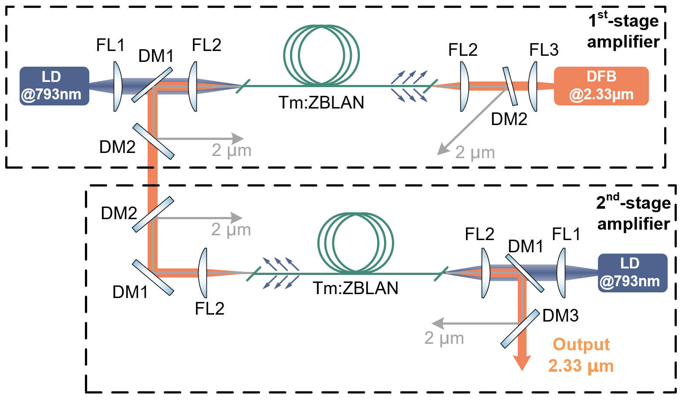
Fig. S1. Experimental setup of the Tm: ZBLAN fiber amplifier.
S2. The characteristic of CO molecules
a. The absorption linewidth
The absorption linewidth of the R(5) to R(9) absorption lines of CO molecules was measured by scanning the pump wavelength and then measured the power transmitted through the HCF with different pressures, as shown in Fig. S2. Through Voigt line fitting, it is found that for different pump lines, the absorption linewidth of CO molecules was between 290 and 370 MHz. This shows that the homemade 2.33-μm narrow-linewidth (less than 10 MHz) pump system can be fully absorbed by CO molecules.
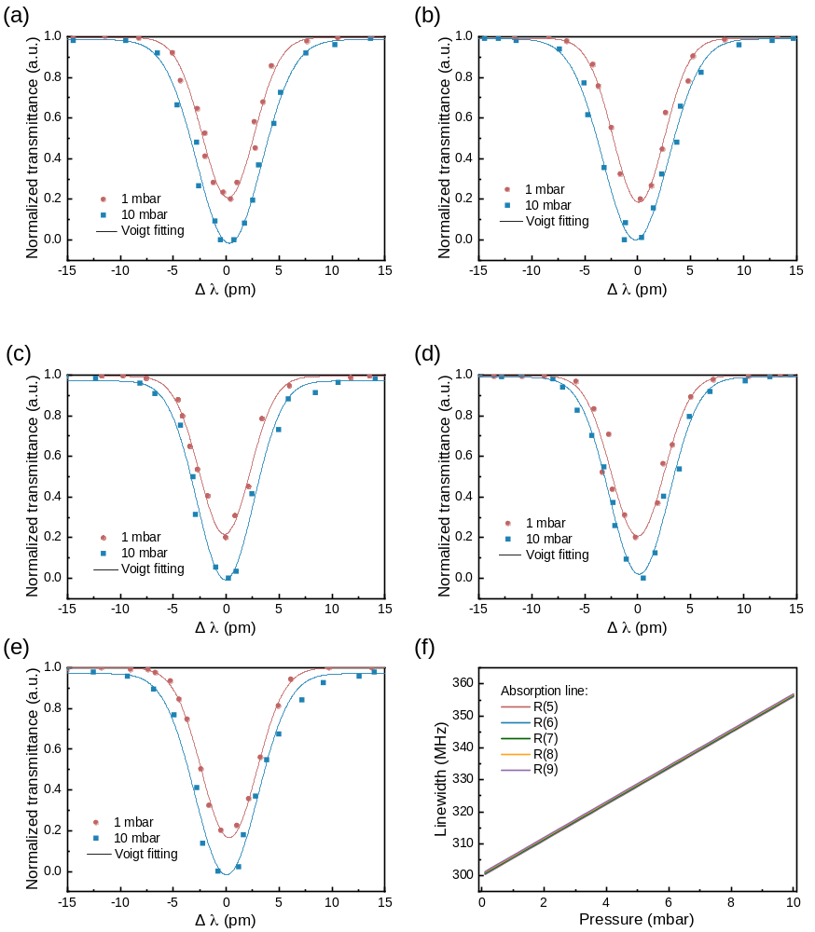
Fig. S2. Measured CO absorption linewidth for different absorption lines. (a) R(5) absorption line; (b) R(6) absorption line; (c) R(7) absorption line; (d) R(8) absorption line; (e) R(9) absorption line; (f) Calculated absorption linewidth.
The line shape of CO molecular is mainly affected by collision broadening and Doppler broadening, and ultimately appears as a Voigt line shape function:
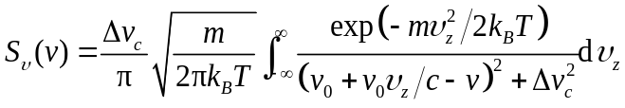 (1)
At the center frequency, the Voigt line shape is given by:
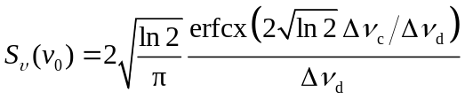 (2)
where the collision broadening linewidth, Δν_{c}, is equal to αP, and α is estimated to be 7.0 MHz/torr for CO¹ and P is the gas pressure. ∆v_{d} is the linewidth of the Doppler line shape function:
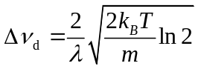 (3)
where k_{B} is the Boltzmann constant, T is the temperature and m is the mass of the CO molecule. Figure S2(f) shows the absorption linewidth of CO molecules from R(5) to R(9) absorption lines under different pressures. It can be seen that different absorption lines have similar absorption linewidth, and are similar to the results measured in the experiment.
b. The absorption and emission cross section
The absorption cross section (σ_{ij}) and emission cross section (σ_{ji}) of CO molecules can be expressed as:
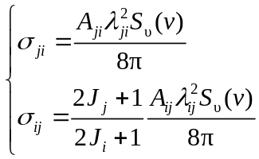 (4)
where A_{ij/ji} and J_{i/j} are the Einstein A-coefficient and rotational quantum number of the corresponding energy level, respectively. The A-coefficients for the relevant (2,0) and (2,1) band transitions are presented in Table. S1 and S2².
Table. S1 CO (2,0) band transition wavelength and A-coefficients²
Transition | Wavelength  (nm) | A-Coeff.  (s⁻¹) | Transition | Wavelength  (nm) | A-Coeff.  (s⁻¹)
 |  |  | R(0) | 2345.305 | 0.3487
P(1) | 2349.504 | 1.0300 | R(1) | 2343.269 | 0.4218
P(2) | 2351.667 | 0.6813 | R(2) | 2341.275 | 0.4554
P(3) | 2353.873 | 0.6084 | R(3) | 2339.323 | 0.4760
P(4) | 2356.121 | 0.5749 | R(4) | 2337.413 | 0.4906
P(5) | 2358.413 | 0.5546 | R(5) | 2335.544 | 0.5020
P(6) | 2360.747 | 0.5402 | R(6) | 2333.717 | 0.5115
P(7) | 2363.125 | 0.5291 | R(7) | 2331.932 | 0.5198
P(8) | 2365.546 | 0.5200 | R(8) | 2330.188 | 0.5273
P(9) | 2368.011 | 0.5121 | R(9) | 2328.485 | 0.5342
P(10) | 2370.519 | 0.5051 | R(10) | 2326.823 | 0.5407
P(11) | 2373.071 | 0.4988 | R(11) | 2325.203 | 0.5468
P(12) | 2375.668 | 0.4929 | R(12) | 2323.623 | 0.5527
P(13) | 2378.308 | 0.4874 | R(13) | 2322.085 | 0.5585
P(14) | 2380.993 | 0.4822 | R(14) | 2320.587 | 0.5641
P(15) | 2383.723 | 0.4772 | R(15) | 2319.13 | 0.5695
P(16) | 2386.498 | 0.4725 | R(16) | 2317.714 | 0.5749
P(17) | 2389.318 | 0.4678 | R(17) | 2316.338 | 0.5803
P(18) | 2392.183 | 0.4634 | R(18) | 2315.003 | 0.5855
P(19) | 2395.093 | 0.459 | R(19) | 2313.708 | 0.5907
P(20) | 2398.05 | 0.4548 | R(20) | 2312.454 | 0.5959

Table. S2 CO (2,1) band transition wavelength and A-coefficients²
Transition | Wavelength  (nm) | A-Coeff.  (s⁻¹) | Transition | Wavelength  (nm) | A-Coeff.  (s⁻¹)
 |  |  | R(0) | 4715.722 | 22.52
P(1) | 4732.65 | 66.830 | R(1) | 4707.42 | 27.18
P(2) | 4741.278 | 44.310 | R(2) | 4699.225 | 29.27
P(3) | 4750.015 | 39.650 | R(3) | 4691.136 | 30.52
P(4) | 4758.863 | 37.540 | R(4) | 4683.154 | 31.38
P(5) | 4767.822 | 36.300 | R(5) | 4675.276 | 32.04
P(6) | 4776.893 | 35.430 | R(6) | 4667.504 | 32.56
P(7) | 4786.077 | 34.770 | R(7) | 4659.835 | 33.01
P(8) | 4795.374 | 34.240 | R(8) | 4652.27 | 33.39
P(9) | 4804.786 | 33.790 | R(9) | 4644.807 | 33.74
P(10) | 4814.312 | 33.400 | R(10) | 4637.447 | 34.05
P(11) | 4823.955 | 33.040 | R(11) | 4630.189 | 34.35
P(12) | 4833.714 | 32.700 | R(12) | 4623.032 | 34.62
P(13) | 4843.591 | 32.400 | R(13) | 4615.976 | 34.89
P(14) | 4853.586 | 32.110 | R(14) | 4609.02 | 35.14
P(15) | 4863.701 | 31.83 | R(15) | 4602.163 | 35.38
P(16) | 4873.935 | 31.57 | R(16) | 4595.406 | 35.61
P(17) | 4884.291 | 31.31 | R(17) | 4588.748 | 35.84
P(18) | 4894.769 | 31.07 | R(18) | 4582.188 | 36.05
P(19) | 4905.37 | 30.82 | R(19) | 4575.726 | 36.27
P(20) | 4916.094 | 30.59 | R(20) | 4569.361 | 36.48
P(21) | 4926.944 | 30.35 | R(21) | 4563.093 | 36.68
P(22) | 4937.919 | 30.12 | R(22) | 4556.922 | 36.88
P(23) | 4949.021 | 29.89 | R(23) | 4550.847 | 37.07
P(24) | 4960.251 | 29.66 | R(24) | 4544.867 | 37.27
P(25) | 4971.61 | 29.45 | R(25) | 4538.983 | 37.46
P(26) | 4983.098 | 29.22 | R(26) | 4533.194 | 37.64
P(27) | 4994.718 | 29.01 | R(27) | 4527.5 | 37.83

S3. The mid-infrared laser output power when the pump absorption lines were R(5), R(6), R(8) and R(9)
The mid-infrared laser output power characteristics under the R (5), R (6), R (8) and R (9) absorption lines near their respective preferred pressures are shown in Fig. S3.
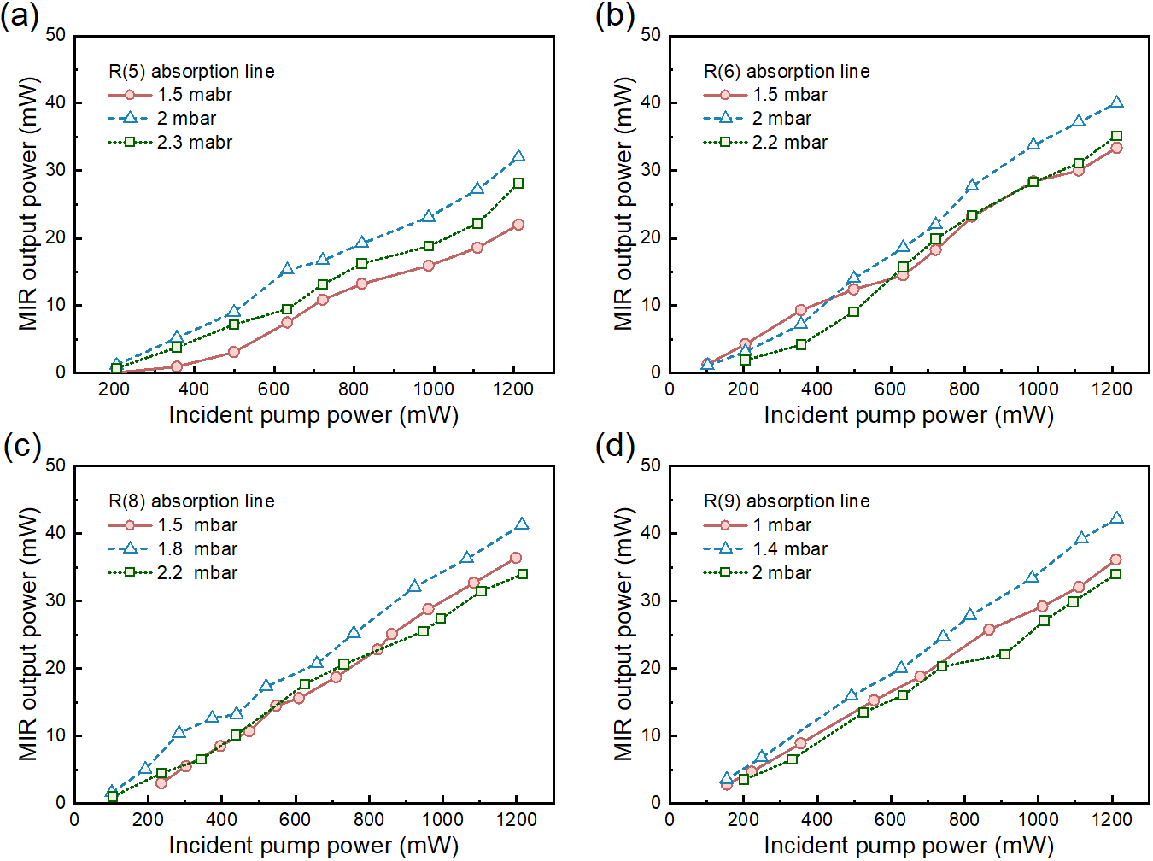
Fig. S3. Measured CO output power for different absorption lines. (a) R(5) absorption line; (b) R(6) absorption line; (c) R(8) absorption line; (d) R(9) absorption line.
References
1. J. E. McCord, H. C. Miller, G. Hager, A. I. Lampson, & P. G. Crowell. Experimental investigation of an optically pumped mid-infrared carbon monoxide laser. IEEE J. Quantum Electron. 35, 1602–1612 (1999).
2. HITRAN spectroscopic database. https://hitran.iao.ru/bands/simlaunch?mol=5.

