Supplementary Information

High-ambition climate action in all sectors can achieve 65% greenhouse gas emissions reduction in the United States by 2035

Authors: Alicia Zhao^{a,f}, Kowan T.V. O’Keefeª, Matthew Binsted^{b}, Haewon McJeon^{c}, Adriana Bryantª, Claire Squireª, Mengqi Zhangª, Steven J. Smith^{b}, Ryna Cuiª, Yang Ou^{d,e}, Gokul Iyer^{b}, Shannon Kennedyª, and Nate Hultmanª

Affiliations:
ª Center for Global Sustainability, University of Maryland, College Park, Maryland, USA
^{b} Joint Global Change Research Institute, Pacific Northwest National Laboratory, College Park, Maryland, USA
^{c} Graduate School of Green Growth & Sustainability, Korea Advanced Institute of Science and Technology, Daejeon, Korea
^{d} College of Environmental Sciences and Engineering, Peking University, Beijing, China
^{e} Institute of Carbon Neutrality, Peking University, Beijing, China
^{f} Corresponding author

Table of Contents

1 Introduction 3
2 Scenario Development 3
2.1 Current climate policy landscape in the U.S. 3
2.2 Current Policies scenario 4
2.3 Enhanced Ambition scenario 4
2.5 State tiering 5
3 Economy-Wide Analysis 7
3.1 Overview of GCAM-USA-CGS 7
3.2 Overview of modeling approach 8
3.3 Modeled IRA provisions 9
3.4 Core model assumptions 10
3.5 Electricity modeling assumptions 10
3.6 Transportation sector modeling assumptions 12
3.7 Building sector modeling assumptions 15
3.8 Industry and other sectors modeling assumptions 17
3.9 Calibrating to EPA inventory 19
3.10 Global Warming Potential 19
3.11 Model validation 20
3.12 Sensitivity analysis 21
4 Bottom-up Aggregation Analysis 22
4.1 Overview of approach 22
4.2 Electricity 22
4.2.1 Renewable Portfolio Standards 22
4.2.2 Coal 23
4.2.3 Nuclear 24
4.3 Transportation 24
4.3.1 Zero Emission Vehicle Standards 24
4.3.2 Vehicle Miles Traveled 26
4.4 Buildings 27
4.4.1 Efficiency 27
4.4.2 Electrification 29
4.5 Land Use, Land-use Change, and Forestry 30
5 Supplementary Figures 31

1 Introduction
We use an enhanced version of GCAM-USA in this analysis to estimate the magnitude of potential economy-wide emissions reductions in the United States through 2035. The analysis centers around two scenarios: Current Policies and Enhanced Ambition. The Current Policies scenario includes the climate and energy provisions of the Inflation Reduction Act (IRA), the Bipartisan Infrastructure Legislation (BIL), and several other federal and non-federal climate policy actions. The Enhanced Ambition scenario assumes enhanced action from non-federal actors – states, cities, and businesses – with additional federal regulatory actions to achieve an ambitious new 2035 emissions reduction target. Both scenarios include top-down and bottom-up policy representation, with the latter building on previously developed methodology for aggregating non-federal actions to the state-level for implementation in GCAM-USA.^{1–5} We provide a detailed description of our methodology in the following sections.

2 Scenario Development

2.1 Current climate policy landscape in the U.S.
Recent federal action in the United States has strengthened emissions reduction potential. Together, the Inflation Reduction Act (IRA) and Bipartisan Infrastructure Law (BIL) provide over a trillion in funds toward clean energy tax credits, electrification and energy efficiency measures, methane emissions reductions, and the expansion of electric vehicle charging infrastructure. ^{6,7} Existing executive actions include the Corporate Average Fuel Economy (CAFE) standards, which mandate the fuel efficiency of passenger cars and light duty trucks, and New Source Performance Standards (NSPS) under the sections 111(b) and (d) of the Clean Air Act (CAA), which set pollution limits on fossil fuel electricity generation. Additionally, proposed rules would strengthen oil and gas methane regulations and phase down coal- and gas-fired electricity generation.^{8,9}

Across sectors, subnational policies have the capability to build upon federal actions. States and cities are setting their own economy-wide emissions reductions goals and formulating policies to help them achieve their targets.^{10,11} Within the power sector, state-level clean energy targets and local zoning ordinances can accelerate decarbonization of electricity, such as Maryland’s renewable portfolio standard (RPS), which mandates that electricity suppliers must procure 50% of their electricity from renewable sources by 2030, and the city of Austin’s target of carbon-free electricity by 2035.^{12,13} Building sector mitigation can be hastened through state and city-level appliance standards and efficiency targets, such as legislation passed in the San Francisco Bay Area that bans new sales of nitric oxide (NO) and nitrogen dioxide (NO2)-emitting space heaters and water heaters, beginning with water heaters in 2027.¹⁴ Transportation decarbonization measures include sales targets and incentives for phaseout of combustion engines, such as California’s Advanced Clean Trucks (ACT) rule, which an increasing number of states are adopting, and investment in public transportation like the Indianapolis Public Transportation Corporation’s (IndyGo) expansion of public bus routes and rollout of hybrid and electric buses.^{15,16} Mandates for more stringent management of fugitive methane and hydrofluorocarbon (HFC) emissions alongside incentives for carbon capture utilization and storage (CCUS), like New Mexico’s 2022 legislation limiting venting and flaring at oil and gas sites, can similarly use subnational levers for industrial emissions reductions.^{3,17}

2.2 Current Policies scenario
The Current Policies scenario includes existing federal policies – including several climate and energy provisions from the BIL and the IRA – and non-federal policies. Altogether, we find that these current policies can reduce emissions 45% below 2005 levels by 2035 (see Table S1 for a sectoral breakdown of emissions reductions). Existing state-level RPS, CAFE standards, and several tax credits from the IRA for renewable electricity generation, zero-emissions vehicles (ZEVs), and carbon capture and storage (CCS) are among the key policy drivers in this scenario. Detailed modeling assumptions for representation in GCAM-USA-CGS 6.0 for these and all other policies in the Current Policies scenario are shown in Tables S2-S6.

2.3 Enhanced Ambition scenario
The IRA, along with additional policies and actions from Congress, the federal government, states, cities, and businesses, collectively provide a major boost to climate action in the United States. Yet these existing policies will not be enough on their own for the United States to meet its 2030 climate target and achieve ambitious reductions through 2035 and beyond. Thus, our Enhanced Ambition scenario models greenhouse gas (GHG) emissions reductions achievable under a comprehensive, “all-in” climate strategy that builds upon the policy framework in the Current Policies scenario with enhanced non-federal and federal action. Altogether, these actions have the potential to deliver a 52% reduction in GHG emissions from 2005 levels by 2030, thus fulfilling its 2030 NDC, and a 65% reduction by 2035. A sector-by-sector breakdown of the results for this scenario is shown in Table S1 alongside results from our Current Policies scenario. Some of the additional policy actions modeled in this scenario include a full phaseout of unabated coal-fired electricity generation by 2030, accelerated adoption of ZEV in light-duty vehicle, bus, and freight truck markets, ramped up electric appliance standards, more stringent standards and oil and gas methane, as well as extensions of the existing IRA tax credits beyond their legislated sunset dates. The modeling assumptions underlying implementation of all policy representation in GCAM-USA-CGS in this scenario are listed in Tables S2-S6.

Table S1. Results by Sector
Sector/GHG | Emissions 2005 (MMTCO₂e) | Emissions 2020 (MMTCO₂e) | Emissions 2035 (MMTCO₂e) |  | Change from 2005 to 2035 (MMTCO₂e) |  | Change relative to 2005 (%) |  | Contribution to total reductions relative to 2005 (%)
Sector/GHG | Emissions 2005 (MMTCO₂e) | Emissions 2020 (MMTCO₂e) | Current Policies | Enhanced Ambition | Current Policies | Enhanced Ambition | Current Policies | Enhanced Ambition | Current Policies | Enhanced Ambition
Electricity CO₂ | 2,417 | 1,457 | 629 | 86 | -1,788 | -2,331 | -74% | -96% | 60% | 53%
Transport CO₂ | 1,869 | 1,581 | 1061 | 815 | -808 | -1,054 | -43% | -56% | 27% | 24%
Industry CO₂ | 1,193 | 1,106 | 1149 | 974 | -44 | -219 | -4% | -18% | 1% | 5%
Buildings CO₂ | 586 | 542 | 456 | 335 | -130 | -251 | -22% | -43% | 4% | 6%
Other CO₂ | 67 | 32 | 28 | 21 | -40 | -47 | -59% | 69% | 1% | 1%
CH₄ | 852 | 807 | 766 | 570 | -86 | -282 | -10% | -33% | 3% | 6%
N₂O | 427 | 400 | 409 | 402 | -18 | -25 | -4% | -6% | 1% | 1%
F-Gases | 138 | 180 | 111 | 92 | -28 | -46 | -20% | -33% | 1% | 1%
Direct Air Capture | 0 | 0 | 0 | -31 | 0 | -31 | 0 | N/A | 0% | 1%
Land sink | -854 | -853 | -882 | -926 | -28 | -73 | 3% | 8% | 1% | 2%
Net GHG Total | 6,697 | 5,252 | 3,728 | 2,339 | 2,969 | 4,357 | 44% | 65% | 100% | 100%

2.5 State tiering
State-level climate action in the United States varies considerably from across the country. For example, some states aim to achieve 100% ZEV sales in light duty vehicle (LDV) markets by 2035, while other states have less ambitious ZEV sales targets, and some lack ZEV sales targets entirely. Therefore, to account for the unequal ambition and urgency with which states implement policies and actions to reduce emissions, and to facilitate our scenario analysis, we group states into three different tiers. State-level tiering reflects the propensity of a state to take further climate action based on the strength of their past and current climate policies. Tier 1 states have been leading the way on climate action in the United States, while Tier 2 states have some policies in place, but tend to move slower. The rest of the states, categorized as Tier 3, have taken limited steps to advance climate action, and are assumed to be least likely to enact ambitious climate legislation.
- Tier 1 states: California, Colorado, Connecticut, Delaware, the District of Columbia, Hawaii, Illinois, Maine, Maryland, Massachusetts, Minnesota, New Hampshire, New Jersey, New Mexico, New York, Oregon, Pennsylvania, Rhode Island, Vermont, and Washington
- Tier 2 states: Arizona, Iowa, Michigan, Missouri, Nevada, North Carolina, Ohio, Virginia, and Wisconsin
- Tier 3 states: Alabama, Alaska, Arkansas, Florida, Georgia, Idaho, Indiana, Kansas, Kentucky, Louisiana, Mississippi, Montana, Nebraska, North Dakota, Oklahoma, South Carolina, South Dakota, Tennessee, Texas, Utah, West Virginia, and Wyoming

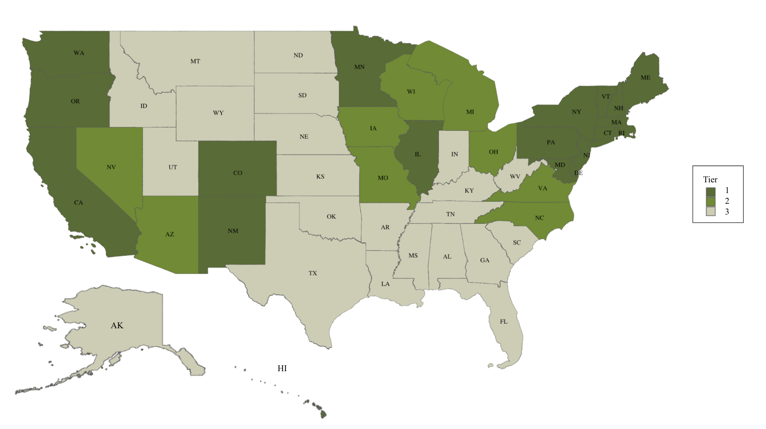
Fig. S1: State tiers used in the Enhanced Ambition scenario.

3 Economy-Wide Analysis

3.1 Overview of GCAM-USA-CGS
Our analysis uses a version of the open-source Global Change Analysis Model (GCAM) to estimate the aggregate impact of federal and non-federal climate policies and actions on economy-wide emissions reductions in the United States. Specifically, we use GCAM-USA, a state-level version of GCAM. We refer to the version of GCAM-USA used in this study as GCAM-USA-CGS.

GCAM is an integrated assessment model (IAM) that covers the energy, land, water, climate, and socioeconomic systems. The global version of GCAM groups the world’s countries into 32 geopolitical regions with representation of the energy and socioeconomic systems for each region. The United States is one of the 32 regions. GCAM represents the global climate system, and uses 235 water basins and 384 land regions to represent global water and land systems. GCAM tracks emissions and sinks of carbon dioxide (CO₂), 16 other GHGs, and several air pollutants.

The state-level version of GCAM used in this analysis, GCAM-USA, disaggregates the U.S. energy and economy components into 50 states and the District of Columbia while maintaining the same level of detail as GCAM for water and land sectors. The energy system in GCAM-USA has representations of depletable primary sources such as coal, gas, oil, and uranium, in addition to renewable resources such as biomass, hydropower, solar, wind, and geothermal. Energy transformation processes like oil refining and electricity generation are represented at the state-level in GCAM-USA. These energy carriers, in turn, are used to deliver services to state-level end users in the buildings, transportation, and industrial sectors. The electric power sector includes representations of a range of power generation technologies, including those fueled by fossil fuels and bioenergy (with and without CCS), renewables, and nuclear power.

GCAM-USA is a market equilibrium model. The model solves for equilibrium in each period by finding a set of market prices such that supplies and demands are equal to one another in all markets as the actors in the model adjust the quantities of the commodities they buy and sell. GCAM operates in 5-year time-increments, with each new period starting from the conditions that emerged in the last, with most technologies vintaged such that a portion of existing stocks at any point carry over into future time periods.

GCAM-USA-CGS is based on the open-source release of GCAM-USA 6.0.¹⁸ GCAM-USA-CGS has been updated for the purposes of this study to reflect changes such as the most recent estimates of future renewable energy costs.¹⁹ The model is also calibrated to the latest non-CO₂ marginal abatement cost curves from the U.S. Environmental Protection Agency (EPA).²⁰

3.2 Overview of modeling approach
Policy representation in our modeled scenarios builds upon bottom-up aggregation tools and data analysis to evaluate and quantify the impacts of policies and climate actions in isolation and within specific sectors. Throughout, we took care to avoid potential double counting of potential emissions reduction drivers from nested governance levels. We then used this information in GCAM-USA-CGS to estimate the economy-wide implications of associated policies. We use a modeling approach consistent with previous analyses, including Accelerating America’s Pledge (2019), An All-In Climate Strategy Can Cut U.S. Emissions by 50% by 2030 (2021), Blueprint 2030 (2021), and An All-In Pathway to 2030 (2023).^{1,2,4,21,22}

All modeled policies in GCAM-USA-CGS are implemented at the state and/or national levels. Therefore, policies and actions from city governments, businesses, and institutions were aggregated to the state-level or assumed to be embedded within or supportive of the state and/or national level policy representation in the model, and therefore not explicitly modeled to remove risk of double counting potential emissions reductions. Detailed descriptions of policy representation in GCAM-USA-CGS can be found in Tables S2-S6 and documentation of the bottom-up aggregation processes across different sectors can be found in Section 4 of this supplementary document.

Model parameters in GCAM-USA-CGS varied according to information from our bottom-up aggregation analysis or changed directly for policy drivers where bottom-up aggregation was either not feasible or not necessary in the case of small-scale potential impacts. The purpose of this analysis is to assess the national emissions reduction potential in the United States for the policies modeled in our scenarios. Accordingly, non-federal policies and actions are only modeled to the extent that doing so would have a meaningful impact on the national-level emissions outcome. In some policy areas, we did not specify state-level variation in policy implementation – for example, with bus electrification – as assessment of the national-level emissions impact does not require state-level precision.

The policies and actions described below were compiled up until August 2023. Nor or changed policies and actions taken after this point are not included in this analysis.

3.3 Modeled IRA provisions
Both scenarios include over 20 IRA provisions, which are listed below. Detailed assumptions for these policies are described in Tables S2-S6.

Electricity
- Section 13101: Production tax credit (PTC)
- Section 13102: Investment tax credit (ITC) extension
- Sections 13701 & 13702: New clean electricity PTC and ITC
- Section 13302: Residential clean energy credit
- Section 13015: PTC for existing nuclear
- Section 50144: Energy infrastructure reinvestment financing
- Section 13104 – 45Q: Extension of credits for captured CO₂

Transportation
- Section 13401 – 30D: Clean vehicle credit
- Section 13404: Alternative refueling property credit
- Section 13403 – 45W: Commercial clean vehicle credit
- Sections 13201, 13202, and 13203: Extension of incentives for biofuels

Buildings
- Section 13303: Energy efficient commercial building deduction
- Sections 13301 – 25C, 13304, and 50121: Energy efficient home improvement credit, Energy efficient home credit, and Home energy efficiency credit
- Section 51022: High efficiency home rebate program

Industry and other sectors
- Section 13104 – 45Q: Extension of credits for captured CO₂
- Section 13204 – 45V: Production credit for clean hydrogen
- Section 13501 – 48C: Manufacturing investment tax credit for advanced energy projects
- Section 50161: Advanced industrial facilities deployment program
- Section 60113: Methane emissions reduction program

3.4 Core model assumptions
The results of this study depend on many assumptions about how the U.S. and the world might evolve in the future. This study uses a set of core assumptions for drivers including economic growth, population growth, fossil fuel prices, demand impacts of the COVID-19 pandemic, and technology costs (Table S2). Our core assumptions draw from a set of data sources that are referenced in other parts of this appendix, for example U.S. Energy Information Agency (EIA)’s Annual Energy Outlook (AEO)²³ and Rhodium Group.²⁴ Economic impacts associated with COVID-19 in 2020 and subsequent recovery in the following years have also been incorporated into these assumptions.

Table S2. Core Assumptions for GCAM-USA-CGS Analysis
Drivers | Scenario assumptions
Economic Growth | Overall gross domestic product (GDP) decreases by 3.5% year-on-year on average in 2020, then increases by 2.1% per year on average through 2035.
Population Growth | Population grows by 0.61% per year on average through 2035.
Fuel Prices | Gas price is assumed to drop by 19.5% year-on-year in 2020, increase by 89% in 2021, then decrease at an average rate of 7.1% per year through 2025. Prices increase 0.1% on average between 2025 and 2035.  Oil price is assumed to drop by 33.9% year-on-year in 2020, increase by 78.4% in 2021. Prices increase at an average rate of 0.7% per year between 2021 and 2035.
Transportation Energy Demand | Transport sector energy demand is assumed to decrease by 6.9% from 2015 levels in 2020, with recovery through 2030.
Industry Energy Demand | Industry sector energy demand is assumed to decrease by 3.1% from 2015 levels in 2020, with recovery through 2030.
Buildings Energy Demand | Buildings sector energy demand is assumed to decrease by 1.9% from 2015 levels in 2020, with recovery through 2030.
Technology Costs | Technology costs are updated with the National Renewable Energy Laboratory (NREL) Annual Technology Baseline 2022 assumptions.¹⁹

3.5 Electricity modeling assumptions
In this and subsequent sections the modeling assumptions are provided in tables that identify the type of policy, the specific portion of the policy (where relevant), and column with a description of the assumptions used in the Current Policies scenario, followed by a description (where different) of how the policy is modeled in the Enhanced Ambition scenario.

Table S3. Implementation of Policy Assumptions for the Electricity Sector in GCAM-USA-CGS
Type of Policy | Modeled Policy | Current Policies Scenario | Enhanced Ambition Scenario
Federal – IRA | Section 13101: PTC | Modeled as a $26/MWh subsidy for solar, wind and geothermal technologies through 2024. We assume that all projects pay prevailing wages. A 7.5% reduction in the credit value is assumed due to the transferability provision.
Federal – IRA | Section 13102: ITC extension | Modeled as a 30% subsidy for offshore wind and storage technologies through 2024, with the simplifying assumption that all projects pay prevailing wages. A 7.5% reduction in the credit value is assumed due to the transferability provision.
Federal – IRA | Sections 13701 and 13702: New clean electricity PTC and ITC | Modeled in the same way as sections 13101 and 13102 through 2030, with phasedown after 2030. | In addition to the assumptions under Current Policies, the subsidies are extended through 2035.
Federal – IRA | Section 13302: Residential clean energy credit | Modeled by updating the rooftop ITC, which results in an additional 0.7GW/yr increase in electricity generation from rooftop solar photovoltaic (PV) on the lifetime of the credit through 2035.
Federal – IRA | Section 13015: PTC for existing nuclear | Modeled as a $15/MWh subsidy for nuclear technologies through 2030, with the simplifying assumption that all projects pay prevailing wages.  We assume that these incentives, in combination with non-federal incentives and ZEV credits, prevent the economic retirement of nuclear plants. As such, we model Georgia Vogtle units 3&4 coming online by 2025, and maintain nuclear capacity at today’s levels.
Federal – IRA | Section 50144: Energy infrastructure reinvestment financing | Modeled as $250 billion in loans and guarantees used to accelerate the retirement of coal-fired power generation and fund the construction of renewable electricity-generating capacity. We estimate this to accelerate the retirement of 38 GW of additional coal-fired capacity beyond already-scheduled retirements by 2030.
Federal – IRA | Section 13104 - 45Q: Extension of credits for captured CO₂ | Credits for CO₂ captured by projects that commence construction between 2023 and 2032 are applied to CCS technologies at a value of $51/ton. These credits assume that half of projects meet prevailing wage and apprenticeship requirements, but do not assume that all projects meet these requirements and receive the full credit value available ($85/ton). CCS technology deployment endogenously responds to these subsidies. | Credits for CO₂ captured by projects that commence construction between 2023 and 2032 are applied to CCS technologies at a value of $68/ton.These credits assume that half of projects meet prevailing wage and apprenticeship requirements, but do not assume that all projects meet these requirements and receive the full credit value available ($85/ton). CCS technology deployment endogenously responds to these subsidies.
Federal – Regulations | CAA section 111(b) Standards for New Stationary Combustion Turbines | Not explicitly modeled in this scenario. | New proposed federal standards under CAA section 111(b) require at least 90% CCS for any new baseload natural gas builds in all states by 2035. This was modeled by reducing new baseload natural gas power plants without CCS starting in 2025 and eliminating new baseload natural gas power plants without CCS by 2030. This reflects an expectation that investors will change their behavior in anticipation of the 2035 policy target, especially in light of the 111(d) emissions guidelines described below. Retention and investment in low capacity factor peaking plants were assumed to be supportive of these measures and were not explicitly modeled.
Federal – Regulations | CAA section 111(d) Emission Guidelines for Existing Fossil Fuel-Fired Sources | Not explicitly modeled in this scenario. | New proposed federal standards under CAA section 111(d) for large, frequently used combustion turbines include two pathways: 96% low-GHG hydrogen in 2038 or 90% CCS in 2035. This was modeled by mandating that all high-capacity factor natural gas power plants either retrofit with CCS by 2035 or cease operating (as determined by the economics of retrofitting). EPA is taking comment on standards for lower capacity factor other stationary combustion turbines, so low capacity factor peaking plants were not subject to the retrofit requirements.
Non-federal | RPS | Current state-level RPS targets are modeled. City- and utility-level goals were assumed to be supportive of these state-level targets and additional only in cases where a higher percentage is targeted. These were implemented by setting a minimum % of total electricity load to be met by renewable generation. | RPS targets of at least 75% by 2035 for high ambition states and 55% for moderate ambition states are assumed.  City- and utility-level goals were assumed to be supportive of these state-level targets and additional only in cases where a higher percentage is targeted. These were implemented by setting a minimum % of total electricity load to be met by renewable generation.
Non-federal | Cap and Trade | The Regional Greenhouse Gas Initiative (RGGI) is modeled as a 30% reduction in power sector emissions below 2020 levels by 2030 in participating states.
Coal phaseout |  | Not explicitly modeled in this scenario | Coal is phased out by 2030 due to a combination of market forces, state coal-exit policies, and regulatory compliance costs.This was modeled by setting a national constraint on coal power to reach zero by 2030, and by prohibiting the buildout of new coal plants in all states.

3.6 Transportation sector modeling assumptions
Table S4. Implementation of Policy Assumptions for the Transportation Sector in GCAM-USA-CGS
Type of Policy | Modeled Policy | Current Policies Scenario | Enhanced Ambition Scenario
Federal – IRA | Section 13401 - 30D: Clean vehicle credit | This tax credit has a maximum value of $7,500 with an EV being eligible for half of the credit if its battery meets domestic assembly requirements and other half of the credit is contingent upon a specific share of the minerals used in the battery being sourced for North American or other free trade countries. We assume that the U.S. auto manufacturing sector will reorient itself so that all new EVs produced by 2030 will meet these requirements, and that by 2025, half of EVs sold will meet these requirements. If the car meets the battery assembly and mineral sourcing requirements, a consumer can receive the full value of the tax credit provided that their income does not exceed the income eligibility threshold and that the sales price of the car does not exceed manufacturer's suggested retail price (MSRP) eligibility thresholds. We find that 89% of Americans meet the income requirement and further assume that they would only purchase EVs that meet the MSRP threshold. Altogether, this yields an EV tax credit with an effective value of $6,673, implemented as a capital cost reduction. We assume that for the 2031-2035 model period that the tax credit takes on a value 40% of the 2030 value because it is scheduled to expire in 2032. | In addition to the assumptions under Current Policies, the tax credit is extended to be available through 2035.
Federal – IRA | Section 13404: Alternative refueling property credit | This credit is assumed to be a $1,000 property credit available for LDV charging infrastructure for individuals in rural and low-income census tracts. Based on census data, 17.4% of Americans live in counties that are either rural or low-income, so the $1,000 property credit is modeled as a weighted average national subsidy of $174 for capital infrastructure cost for EVs. We assume that for the 2031-2035 model period that the tax credit takes on a value 40% of the 2030 value because it is scheduled to expire in 2032. | In addition to the assumptions under Current Policies, the tax credit is extended to be available through 2035.
Federal – IRA | Section 13403 - 45W: Commercial clean vehicle credit | This tax credit is modeled as a $40,000 capital cost reduction for electric heavy duty freight trucks, and a $7,500 capital cost reduction for electric medium duty and light duty freight trucks. We assume that for the 2031-2035 model period that the tax credit takes on a value 40% of the 2030 value because it is scheduled to expire in 2032. | In addition to the assumptions under Current Policies, the tax credit is extended to be available through 2035.
Federal – IRA | Sections 13201, 13202, and 13203: Extension of incentives for biofuels | Implemented as subsidies in 2025 for biodiesel, cellulosic ethanol, Fischer Tropsch (FT) biofuels, cellulosic ethanol with CCS, and FT biofuels with CCS. We assume that jet fuel is the first market for FT biofuel, and FT biofuels therefore receive the aviation fuel credit. | In addition to the assumptions under Current Policies, the tax credit is extended to be available through 2035.
Federal – BIL | Section 11401 and 11403: Grants from charging and fueling infrastructure, Carbon reduction program, and National Electric Vehicle Formula Program | BIL’s $10.7 billion investment in LDV EV charging infrastructure is implemented as an $802 reduction in per vehicle charging infrastructure cost, based on modeled vehicle fleet size in GCAM-USA-CGS 6.0, for model periods 2025 and 2030.
Federal – BIL | Section 11115 and 11403: Congestion mitigation and air quality improvement program, and Carbon reduction program | BIL’s $4.24 billion investment in medium- and heavy-duty truck EV charging infrastructure is implemented as a $9,211 reduction in per vehicle charging infrastructure cost, based on fleet size in GCAM-USA-CGS 6.0, for model periods 2025 and 2030.
Federal – BIL | Sections 71101 and 30018: Clean school bus program and Grants for buses and bus facilities | BIL’s $5 billion investment in school bus electrification is implemented as a $25,000 reduction in per vehicle purchase cost for model periods 2025 and 2030. A $2.625 billion investment in transit bus electrification is implemented as a $29,167 reduction in per vehicle purchase cost for model periods 2025 and 2030.
Federal – Regulations | CAFE standards for LDVs | Internal combustion engine GHG performance standards are modeled to reflect efficiency improvement rates from recently updated CAFE so that nationally, fuel efficiency reaches 166 gCO₂/mi for new passenger cars and 219 gCO₂/mi for new SUVs by 2030. Note: these are based on the National Highway Traffic Safety Administration (NHTSA) minimum standard and are not inclusive of ZEVs. | Federal internal combustion engine GHG performance standards are improved so that nationally, fuel efficiency reaches 143 gCO₂/mi for new passenger cars and 193 gCO₂/mi for new SUVs by 2030.
Federal – Regulations | GHG emissions standards for freight trucks | Internal combustion engine GHG performance standards are modeled to reflect efficiency improvement rates existing GHG emissions standards for heavy duty gasoline- and diesel-powered engines. | Same as in the Current Policies scenario through 2025. Efficiency is assumed to improve further by 5% from 2026-2030 and again from 2031-2035.
Federal – Regulations | Accelerated retirement of old, inefficient LDVs | Not explicitly modeled in this scenario. | Modeled as a “cash-for-clunkers” style program that accelerates the retirement of LDVs produced in 2015 and prior, effectively reducing the share of the 2015 and prior vintage cars remaining on the road in 2030 from 28% to 18%.
Non-federal | LDV ZEV sales mandates and targets | California and the 10 other states that have adopted ZEV sales targets consistent with California's Advanced Clean Cars (ACC) II legislation are assumed to achieve their passenger car sales target of 68% electric in 2030 and 100% in 2035. Additionally, the 5 states that have only adopted legislation consistent with California’s ACC I legislation are modeled to have ZEV sales reach 22% in 2025. | Tier 1 states are assumed to achieve ZEV sales shares equivalent to targets set by California. Tier 2 and Tier 3 states are assumed to achieve these sales shares but on a delayed schedule, 3 years later (Tier 2 states) and 6 years later (Tier 3 states) than Tier 1 states.
Non-federal | LDV ZEV incentives | Major existing incentives for LDV ZEVs at the state-, utility-, and district-level from the Alternative Fuels Data Center are modeled at the state-level as reductions in per vehicle capital cost. Altogether, these are equivalent to a national average capital cost reduction for LDV EVs of $826 per vehicle.
Non-federal | Freight truck ZEV sales mandates and targets | California and 12 other states are assumed to achieve sales targets for electric trucks through 2035 consistent with California’s ACT legislation. | Tier 1 states are assumed to achieve ZEV sales shares equivalent to targets set by California. Tier 2 and Tier 3 states are also assumed to achieve these sales shares but on a delayed schedule, 3 years later (Tier 2 states) and 6 years later (Tier 3 states) than Tier 1 states.
Non-federal | Bus ZEV incentives and sales targets | Not explicitly modeled in this scenario. | A combination of federal and non-federal investments and fleet procurement targets lead to 100% electrification of new bus sales in 2030. This was modeled by raising the national-level sales shares to reach 100% electric by 2030.
Non-federal | Vehicle miles traveled (VMT) reductions | Not explicitly modeled in this scenario. | Federal investment, state and local planning lead to annual average per capita passenger transportation demand reductions ranging from 0.75% to 1.25% in all states from 2025-2035 (consistent with current ambition in Tier 1 states). Annual average per capita VMT reductions were modeled as state-level service demand reduction rates for passenger mode transit.

3.7 Building sector modeling assumptions
Table S5. Implementation of Policy Assumptions for the Buildings Sector in GCAM-USA-CGS
Type of Policy | Modeled Policy | Current Policies Scenario | Enhanced Ambition Scenario
Federal – IRA | Section 13303: Energy efficient commercial building deduction | This provision is estimated to reduce commercial HVAC costs by 3%. This was modeled as a 3% subsidy for commercial high-efficiency heating and cooling technologies in 2025 and 2030. | In addition to the assumptions under Current Policies, the subsidies are extended through 2035.
Federal – IRA | Sections 13301 - 25C and 13304 and 50121: Energy efficient home improvement credit, Energy efficient home credit, and Home energy efficiency credit | Modeled by improving shell efficiency in residential buildings based on the AEO 2022 “Alternative Policies – Extended Credit” case.²⁵
Federal – IRA | Section 51022: High efficiency home rebate program | Modeled as a subsidy to high-efficiency technologies in residential buildings in 2025 and 2030. Two-thirds of consumers are assumed to be eligible for this credit, so this was implemented as a weighted average across all consumers with the effective value of the credit modeled to be 66% of each of the following: $1,750 to electric heat pump water heaters, $4,000 to electric heat pumps for space heating, $420 to electric ovens, $420 to electric heat pump clothes dryers, $1,600 for high-efficiency air conditioning. | In addition to the assumptions under Current Policies, the subsidies are extended through 2035.
Non-federal | Energy efficiency standards (EERS) | Current state-level EERS were modeled by reducing state-level building service demands. However, the energy savings yielded are insignificant at the national level. | Heightened EERS and building codes were modeled by reducing state-level building service demands. This leads to national energy savings of up to 7% for residential buildings and up to 10.7% for commercial buildings by 2035. See Section 5 for more details.
Non-federal | Electrification incentives | Not explicitly modeled in this scenario. | Zero emissions appliance standards were modeled by driving space heating and water heating sales to 100% electric by 2030 in Tier 1 states and 2035 in Tier 2 states. The residential and commercial buildings sectors each achieve 67% electrification by 2035. See Section 5 for more details.

3.8 Industry and other sectors modeling assumptions
Table S6. Implementation of Policy Assumptions for Industry and Other Sectors in GCAM-USA-CGS
Type of Policy | Modeled Policy | Current Policies Scenario | Enhanced Ambition Scenario
Federal - IRA | Section 13104 - 45Q: Extension of credits for captured CO₂ | Credits for CO₂ captured by projects that commence construction between 2023 and 2032 are applied to relevant technologies at a value of $51/ton for CCS. These credits assume that half of projects meet prevailing wage and apprenticeship requirements, but do not assume that all projects meet these requirements and receive the full credit value available ($85/ton). Existing credits for captured CO₂ at $85/ton is implemented as a subsidy for cement and ethanol CCS respond to these subsidies endogenously, resulting in 9 MtCO₂ annual sequestration by 2035. | As a result of this subsidy, it is assumed that all states with cement production install CCS capability for 40% of cement produced by 2035, consistent with California’s 40% goal.²⁶ This subsidy is also assumed to result in sequestration levels from ethanol CCS consistent with Rhodium Group’s analysis by 2035.²⁷ A small amount of CCS in the paper and pulp industry is modeled, well below the U.S. share of global potential identified in the literature.²⁸ Sequestration was exogenously specified across various industrial sectors, resulting in 85 MtCO₂ annual sequestration.
Federal - IRA | Section 13204 - 45V: Production credit for clean hydrogen | Modeled as different subsidies to hydrogen technologies depending on their carbon intensities. Fossil hydrogen without CCS is assumed to claim 45Q instead. 50% of projects are assumed to pay prevailing wages.
Federal - IRA | Section 13501 - 48C: Manufacturing investment tax credit for advanced energy projects | Designates $10 billion for industrial and manufacturing facilities aiming to equip themselves with technology to curtail GHG emissions. This was modeled by specifying electrification rates aligned with an Energy Innovation analysis on low-temperature heating in the industrial sector.²⁹
Federal - IRA | Section 50161 - Advanced industrial facilities deployment program | Designates $5.8 billion towards advanced industrial technology at energy intensive industrial and manufacturing facilities. This was assumed to result in faster equipment stock turnover for fossil fuels, modeled by shortening the average lifetime of existing industrial facilities. | In addition to the assumptions under Current Policies, we assume that new coal is not used as a fuel source in all industries.
Federal - IRA | Section 60113: Methane emissions reduction program | This provision has a fee of $1,500/tCH₄ ($60/tCO₂e) on fugitive methane, modeled to reduce 2.92 MtCH₄ (73 MTCO₂e) in the oil and gas sector, using the EPA’s MAC curves for methane.²⁰ Because this fee only applies to sources covered under the EPA’s GHG Reporting Program, only 39% of the emissions reductions are assumed to be achieved ³⁰, resulting in a reduction of 2.04 MtCH₄ (51 MtCO₂e) below 2020 levels by 2030. This reduction is also inclusive of the recently finalized oil and gas methane regulations that we assume delivers all reductions achievable from the EPA’s MAC’s curves at a cost below $0/tCO₂e for this sector. | An economy-wide methane fee of $1,500/tCH₄ ($60/tCO₂e) was modeled, using the EPA’s MAC curves for methane and the activity reduction drivers for oil & gas, coal, and waste as calculated in our previous report on methane emissions reduction potential in the U.S.³¹ This resulted in methane reductions of 8.72 MtCH₄ (212 MtCO₂e) below 2020 levels by 2035.
HFCs |  | National HFC phasedown is implemented consistent with the American Innovation and Manufacturing (AIM) Act, reducing emissions up to 47% below 2020 levels by 2035 (consistent with analysis and modeling results developed by California Air and Resources Board (CARB)). | National HFC phasedown is implemented consistent with the AIM Act. Tier 1 states achieves additional reductions through more comprehensive measures including Significant New Alternatives Policy (SNAP) and Refrigerant Management Programs (RMP) programs, reducing emissions up to 54% below 2020 levels by 2035 (consistent with analysis and modeling results developed by CARB).¹²
Land use, land-use change and forestry (LULUCF) |  | LULUCF emissions for CO₂ and N₂O are specified exogenously and adapted from America Is All In’s forthcoming lands sector report.³² Current Policies assumes full implementation of roughly $42 billion of current state and federal policies in agriculture and forestry practices, including BIL and IRA. This results in a carbon sink of 765 MtCO₂e from forestry and 31 MtCO₂e from agriculture, which increases sequestration potential by 30 MtCO₂e from 2020 levels. For CH₄ emissions assumptions, please see Section 60113: Methane emissions reduction program above. | LULUCF emissions for CO₂ and N₂O are specified exogenously and adapted from America Is All In’s forthcoming lands sector report.³² Enhanced Ambition assumes an increase of $160 billion in investments in climate-smart policies resulting from enhanced state-level action. This results in a carbon sink of 778 MtCO₂e from forestry and a carbon sink of 62 MtCO₂e from agriculture, which increases sequestration potential by 74 MtCO₂e from 2020 levels. For CH₄ emissions assumptions, please see Section 60113: Methane emissions reduction program above.
Economy-wide GHG targets |  | Not explicitly modeled in this scenario. | Tier 1 states are assumed to achieve their near- and long-term economy-wide GHG targets. Economy-wide GHG constraints were modeled for states that were more than 1 MtCO₂e away from their target in 2035, including California, Washington, and New Jersey.
Direct air carbon capture and storage (DACCS) |  | Not explicitly modeled in this scenario. | DACCS is included as an additional mitigation option, resulting in 31 MtCO₂ of annual removals by 2035. This level of removal is consistent with announced DACCS facilities in the United States.³³

3.9 Calibrating to EPA inventory

For both scenarios, we calibrated emission results through the year 2020 to historical GHG emissions from the 1990-2021 EPA inventory report.³⁴ 2020 is a model year in GCAM-USA-CGS, which operates in 5-year time steps. However, we note that net GHG emissions from the 1990-2021 EPA inventory report increased by 6.4% between 2020 and 2021, so the reductions needed relative to 2021 will be somewhat higher than reductions relative to 2020, which is the base-year used in the paper.

3.10 Global Warming Potential
We use the 100-year global warming potential (GWP) from the IPCC Fifth Assessment Report (AR5) to convert non-CO₂ GHGs into CO₂ equivalents, as this is aligned with the latest EPA inventory, and will be required by the end of 2024 for UNFCCC reporting to reflect updated science .³⁵ However, GWP values from the Fourth Assessment Report (AR4) are commonly used to make these conversions. While there is slight variation in total emissions reductions if we use AR4 instead of AR5, these variations do not make a significant difference in our conclusions. Table S7 below compares the reductions achieved under different GWPs under AR5 and AR4.

Table S7. Economy-wide GHG emissions under Current Policies and Enhanced Ambition using AR4 and AR5 GWP values
Scenario | GWP | 2005 Emissions (MtCO₂e) | 2035 Emissions  (MtCO₂e) | Emissions reduction from 2005 levels | Emissions reduction from 2005 levels (%)
Current Policies | AR5 | 6,697 | 3,728 | 2,969 | 44.3%
Current Policies | AR4 | 6,666 | 3,691 | 2,975 | 44.6%
Enhanced Ambition | AR5 | 6,697 | 2,339 | 4,357 | 65.1%
Enhanced Ambition | AR4 | 6,666 | 2,327 | 4,339 | 65.1%

3.11 Model validation
To validate the emissions estimates used in our Current Measures scenario, we compared our results with values found in previous studies that include the impact of the IRA on future energy emissions in the electricity, buildings, industry, and transportation sectors (Fig. S2). We used emissions estimates from five economy-wide models (EPS-EI, MARKAL-NETL, NEMS-RHG, REGEN-EPRI, and RIO-REPEAT) used in Bistline et al.’s 2023 multi-model comparison paper and the reference case projection in the EIA’s 2023 Annual Energy Outlook.^{25,36} In 2030, other projections estimate that emissions in these sectors will range from 3,311 - 4,011 Mt-CO₂e/yr, similar to our Current Measures total of 3,598 Mt-CO₂e/yr. Similarly, our 2035 emissions estimate of 3,314 Mt-CO₂e/yr falls between the other model projections, which range from 2,653 - 3,903 Mt-CO₂e/yr.

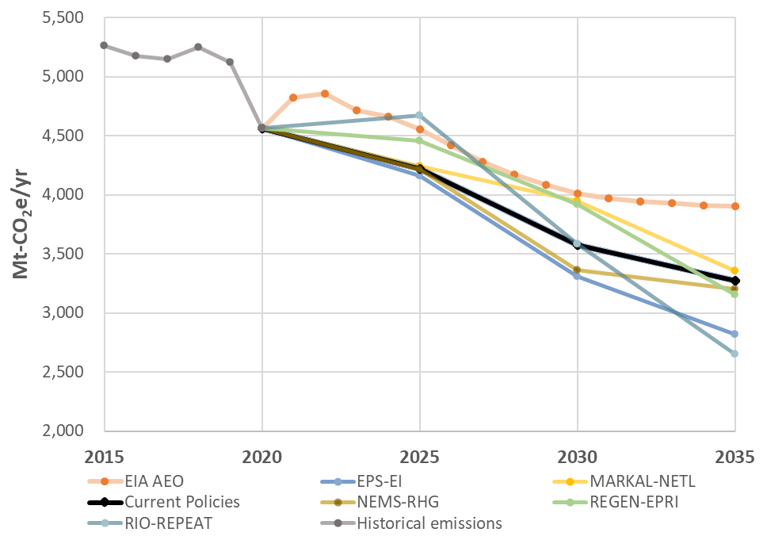
Fig. S2: Energy CO₂ emissions through 2035. Historical data from the EIA is used through 2020. This study’s Current Policies scenario (in black) is compared against EIA AEO’s baseline projection and Bistline et al.’s 2023 multi-model comparison paper on the IRA.

3.12 Sensitivity analysis
We also assessed emissions projections from the two scenarios by varying assumptions on a few important drivers, including GDP, population growth, oil and gas prices, solar and wind costs, and the land sink carbon sequestration potential. See Table S8 for our sensitivity assumptions, and Section 3.4 for the sources for our core assumptions.

Table S8. Assumptions under sensitivity scenarios
Driver | Core Assumptions | Sensitivities
GDP | GDP is assumed to grow by 2.1% per year on average from 2020 through 2035. | High: GDP is assumed to grow by 3.2% per year on average through 2035.  Low: GDP grows by 1% per year on average through 2035.
Population | Population is assumed to grow by 0.61% per year on average from 2020 through 2035. | High: Grows by 0.73% per year on average through 2035.  Low: Grows by 0.48% per year on average through 2035.
Fuel prices | Gas prices are assumed to decrease at an average rate of 7.1% per year from 2021 through 2025. Prices increase 0.1% on average between 2025 and 2035. | High: Gas prices are assumed to increase at an average rate of 1.1% per year from 2021 through 2025, and continue to increase at 3.2% per year on average between 2025 and 2035.  Low: Gas prices are assumed to decrease at an average rate of 12.9% per year from 2021 through 2025, then increase at 2.1% per year on average between 2025 and 2035.
Fuel prices | Oil prices are assumed to increase at an average rate of 0.7% per year between 2021 and 2035. | High: Oil prices are assumed to increase at an average rate of 2.1% per year from 2021 through 2035.  Low: Oil prices are assumed to decrease at an average rate of 3.7% per year from 2021 through 2035.
Solar power | Utility solar PV capital costs are assumed to decrease by 35% from 2022 to 2035. | High: Utility solar PV capital costs are assumed to decrease by 47% from 2022 to 2035.  Low:Utility solar PV capital costs are assumed to decrease by 10% from 2021 to 2035.
Wind power | Land-based wind and offshore wind capital costs are assumed to decrease by 34% and 20%, respectively, from 2022 to 2035. | High: Land-based wind and offshore wind capital costs are assumed to decrease by 50% and 23%, respectively, from 2022 to 2035.  Low: Land-based wind and offshore wind capital costs are assumed to decrease by 29% and 13%, respectively, from 2022 to 2035.
LULUCF | LULUCF sector is assumed to sequester 926 MtCO₂ and 858 MtCO₂ by 2035 under Enhanced Ambition and Current Policies, respectively. | High: LULUCF sector is assumed to sequester 926 MtCO₂ sequestration by 2035.  Low: LULUCF sector is assumed to sequester 762 MtCO₂ sequestration by 2035.

4 Bottom-up Aggregation Analysis

4.1 Overview of approach
Our approach to assess bottom-up actions is built upon a previously developed methodology. For a more detailed description of the aggregation and overall modeling methodology, please see the Accelerating America’s Pledge Technical Appendix (2019)¹ and Hultman, et al. (2020)² along with its accompanying supplementary information. In this analysis, we focus on state-level action, with the assumption that additional policies from cities and businesses will also be needed to achieve enhanced state-level action.

The scope of non-federal climate actions considered in this analysis is not limited to explicit climate policies. Rather, it is inclusive of actions taken to induce cost savings, promote economic growth, and deliver health impacts, among others, but which all have the potential to drive greenhouse gas emissions reductions in the United States. The goal of the bottom-up aggregation analysis is to estimate the overall economy-wide emissions reductions resulting from a combination of climate actions by a wide range of actors.

The process involves collecting climate actions across sectors at the state level. To accomplish this, we collected data to quantify the relative impact of a set of high-impact non-federal climate actions against a no-policy case, taking care to avoid any double counting of potential emissions reductions. For example, when examining energy efficiency measures, we made sure to account for efficiency improvements already embedded in projected years. The resulting state-level impacts of these non-federal climate actions were then represented in GCAM-USA-CGS to estimate potential emissions reductions across the entire economy.

4.2 Electricity

4.2.1 Renewable Portfolio Standards
We assessed legally binding state-level renewable portfolio standards (RPS), differentiating between policies that include hydroelectric and non-hydroelectric sources, in 29 U.S. states and the District of Columbia. We assume all future renewable energy demand driven by the goals is satisfied by non-hydroelectric generation.

As a first step, we collected state-level electricity load forecasts and effective RPS demand rates (representing the actual percentage of a state’s electricity load needed to meet RPS requirements for a specific year) derived from Lawrence Berkeley Lab to estimate the renewable electricity generation driven by RPS legislation.³⁷ We then projected state-level electricity load by coupling historical state-level electricity sales data from the EIA³⁸ with the annual growth rates sourced from GCAM-USA-CGS’s state-level electricity demand outputs.

We assumed that all legally binding state-level RPS would be achieved in the Current Policies scenario. In the Enhanced Ambition scenario, we assumed that Tier 1 states would reach 75% renewable energy generation by 2035, which is in line with leading states such as California and New York. Tier 2 states lag but still achieve 55% renewable by 2035. Meanwhile, Tier 3 states achieve 20% renewable energy by 2035. If hydroelectric generation surpasses the RPS target, we will assume a 0% of demand is satisfied by renewable energy.

4.2.2 Coal
Under both scenarios, we assumed that no new coal-fired power plants without CCS would be constructed in the United States. This is consistent with the lack of new planned coal plants.³⁹ To represent Current Policies, we collected announced retirement dates for all existing coal power plants in the United States and applied these to the historical electricity generation from each of these plants in 2020 to construct a future trajectory for electricity generation from all coal power plants. These plant-level trajectories were then aggregated to the state level to produce an upper bound on electricity generation from coal in the absence of any changes in policy or economic conditions that would further accelerate the decline of coal in the power sector. The resulting state-level upper bounds on electricity generation from coal were implemented at the state level in GCAM-USA-CGS. Announced retirement dates were collected from 3 sources: EIA-860 (2021)⁴⁰, Global Energy Monitor’s Global Coal Plant Tracker (July 2022)³⁹, and the EPA National Electric Energy Data System (NEEDS) database (October 2022).⁴¹ For plants in which retirement dates differ between these sources, the earliest retirement date was used. Finally, we implemented the impact of the IRA’s energy community reinvestment financing program as a further reduction in total electricity generation from coal in the United States, with resultant coal plant retirements occurring in the states where economics drive faster retirements according to state-level profit-shutdown parameters.

In the Enhanced Ambition scenario, we assumed full phase-out of coal-fired electricity generation by 2030. Although this would be affected by a combination of bottom-up actions by utility companies, state governments, changes in consumer demand, and federal spending from the IRA, we implement this as a national constraint on coal generation reaching zero by 2030.

4.2.3 Nuclear
Under both scenarios, we assumed that a combination of federal and state policy actions allow for any nuclear power plants at risk of retiring to stay online through 2035. We also account for Vogtle units 3&4 in Georgia coming online and operating at full capacity by 2025 as these are the only new nuclear power stations scheduled to come online in the United States by 2035. The results of these modeling assumptions is that nuclear power generation in each model period is exogenously specified in GCAM-USA-CGS.

4.3 Transportation

4.3.1 Zero Emission Vehicle Standards
California has become a model state for electric vehicle adoption by passing emission reduction regulations and setting ZEV sales targets. California’s Advanced Clean Cars (ACC) I requires vehicle manufacturers to sell increased shares of zero-emission passenger cars and light-duty trucks starting in model year 2017 and ending in model year 2025. Under 2012 amendments, state manufacturers can opt to comply with California’s enhanced standards over the EPA’s GHG regulations.⁴² In 2022, California passed ACC II, which extends light-duty vehicle (LDV) sales targets after 2025 with an ultimate goal of 100% sales of ZEVs by 2035.⁴³ Since then, a growing number of states have announced their adoption of ACC II over the less stringent EPA regulations.

As states slowly adopt ACC I and ACC II regulations aimed at LDVs, there has been concurrent movement towards the electrification of medium and heavy-duty vehicles. California’s Advanced Clean Trucks (ACT) program sets ZEV sale stargets for medium and heavy-duty vehicles through 2035, which has been adopted by other states as well.⁴⁴

In Current Policies, we assumed that the states that have either implemented or have announced their plan to implement ACC I, ACC II and ACT achieve the sales targets. See Table S9 and Fig. S3 below for a list of states that achieve these sales targets.

In Enhanced Ambition, we assumed wider adoption of California’s ACC II and ACT regulations. For LDV electrification, Tier 1 states follow California and achieve ZEV sales targets on the same timeframe as mandated by ACC II, with ZEVs making up 25% of LDV sales by 2026, increasing to 68% in 2030, and maxing out at 100% in 2035.⁴³ We assumed a three-year time lag for Tier 2 states and a six year time lag for Tier 3 states for achieving ACC II targets.

For medium and heavy-duty vehicle electrification, ACT stipulates the following ZEV sales targets between 2024 to 2035: 55% for Class 2b-3 trucks, 75% for Class 4-8 straight truck sales, and 40% for truck tractor sales. Under Enhanced Ambition, Tier 1 states follow California and achieve ZEV sales targets on the same timeframe as mandated by ACT. We assumed a three-year time lag for Tier 2 states and a six year time lag for Tier 3 states for achieving ACT targets.

Across both scenarios, we took care to ensure that we were not double counting electrification in the transportation sector. We first accounted for other transportation sector policies, like CAFE, IRA tax credits for EVs, and state-level EV tax credits. If states met or exceeded their specified sales targets with these policies, we did not model additional electrification. If states did not achieve their sales targets, we modeled additional electrification that would allow them to meet the targets.

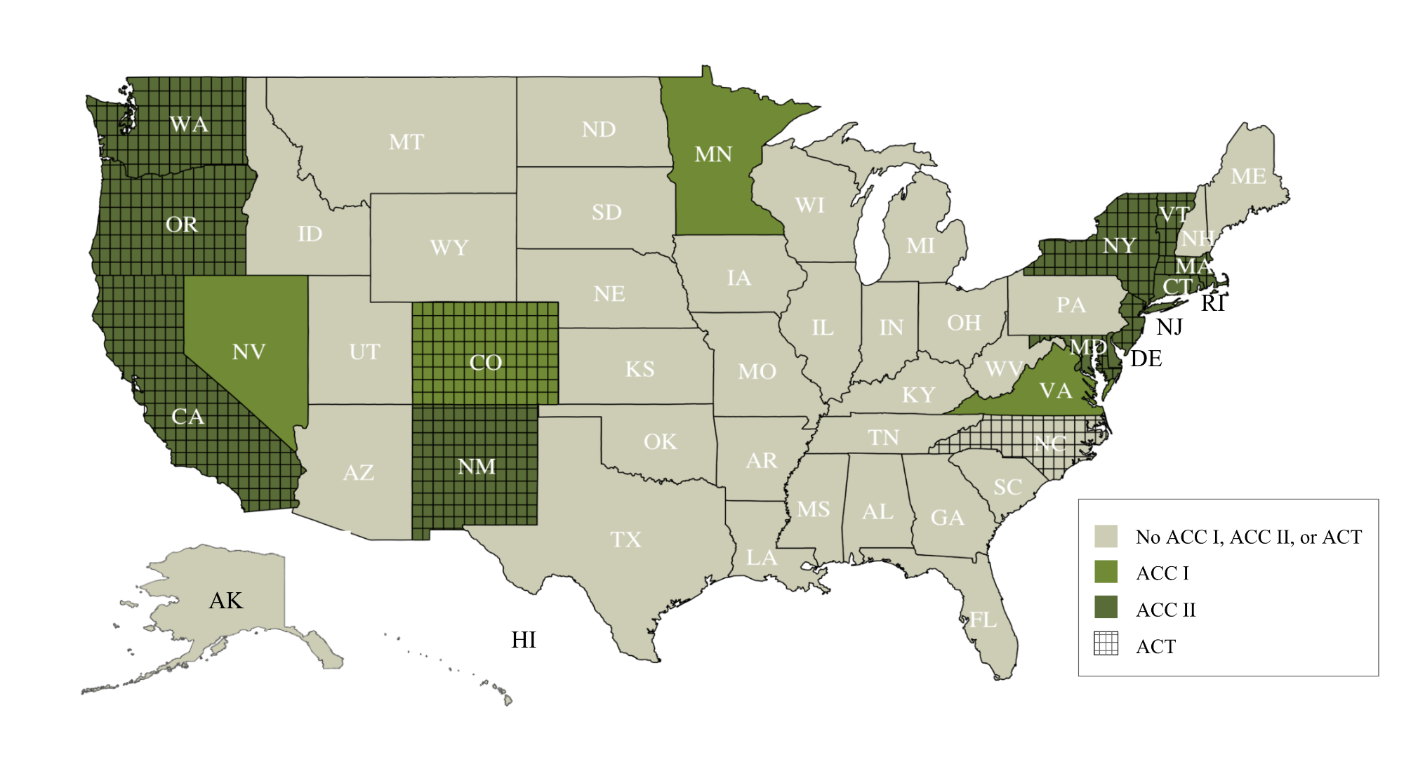
Fig. S3: Status of ACC I, ACC II, and ACT across all states.

Table S9. States that have implemented or have announced plans to implement ACC I, ACC II, and ACT.
ACC I | ACC II | ACT
Colorado | California | California
Minnesota | Connecticut * | Colorado
Nevada | Delaware * | Connecticut *
Virginia | Maryland * | Maryland *
 | Massachusetts | Massachusetts
 | New Jersey * | New Jersey
 | New Mexico * | New Mexico *
 | New York | New York
 | Oregon | North Carolina *
 | Rhode Island * | Rhode Island *
 | Vermont | Oregon
 | Washington | Vermont
 |  | Washington

*States that are in various stages of governor announcement and implementation of ACC II/ ACT, but have yet to make targets official

4.3.2 Vehicle Miles Traveled
Though most current climate-related transportation policies focus on vehicle emission standards and ZEV sales targets, an increasing number of states and other local actors have begun implementing vehicle miles traveled (VMT) reduction policies as a strategy for achieving GHG reduction goals. According to the U.S. Department of Transportation, VMT per capita measures “ the total annual miles of vehicle travel divided by the total population in a state or in an urbanized area.”⁴⁵

Total VMT in the U.S. have been steadily increasing since the mid-20th century, while VMT per capita has been relatively constant since about 2005 (excluding the months following the outbreak of Covid-19, during which lockdowns hampered mobility).^{46,47} The Federal Highway Administration (FHWA) projected a 0.6% annual average growth rate in national VMT between 2019 and 2049, with LDVs increasing at a 1.8% annual average rate and single unit truck increasing by the same average annual rate.⁴⁸ Though LDVs currently account for the majority of total VMT, FHWA projects that their growth will taper off to 0.5% annually by the 2040s. In contrast, single-unit trucks are expected to average 1.8% annual growth over the entire forecast period.⁴⁸

California’s 2022 Scoping Plan for Achieving Carbon Neutrality proposed a statewide VMT per capita reduction of 25% below 2019 levels by 2030 and 30% by 2045.⁴⁹ The scoping plan notes that this reduction target is in line with the goals of SB 375, which aims to “reduce demand for fossil transportation fuels and GHGs, and improve air quality.”⁴⁹ Three other states - Connecticut, Minnesota, and Washington - have passed legislation with varying VMT reduction targets spanning both near- and long-term policy implementation.

Since there is little precedent for VMT reduction targets, we included them only in the Enhanced Ambition scenario. Additionally, we assumed VMT reduction targets are applied to LDVs only. To create a baseline case, we collected 2015 LDV VMT data from the FHWA Highway Statistics Series Publications for each state and applied VMT growth rates from GCAM-USA-CGS through 2035.⁵⁰ We then created the Enhanced Ambition scenario by applying an annualized reduction target between 2026-2035 on top of the baseline. As an upper bound, we looked at California’s current VMT target, which we estimated to have an annual per capita reduction of 1.75% between 2026 and 2030.⁴⁹ The Enhanced Ambition scenario includes a more conservative annualized per capita reduction rate of 1.25% for Tier 1 states, 1.00% for Tier 2 states, and 0.75% for Tier 3 states.

We implemented VMT reductions as a percentage reduction in total passenger service demand in the model. The resulting decline in passenger service was predominantly from road vehicles, but a small amount was from rail and short-haul aircraft.

4.4 Buildings

4.4.1 Efficiency
State-level Energy Efficiency Resources Standards (EERS) mandate efficiency in delivery of residential, commercial, and industrial electricity and gas by setting energy savings targets for utilities. These policies vary in scope and ambition by state; Maryland’s EERS covers all sales within the state, while Arizona’s only covers two large utilities, targets range from 0-2.5% of sales, and electricity standards are more common than than gas targets (data collection found 27 state-level EERS policies for electricity efficiency, and 19 policies for gas).

To calculate EERS savings under Current Policies, we used current state-level standards and applied them to state-level demand projections. We collected current state-level efficiency standards using ACEEE’s EERS documentation,⁵¹ which we cross-checked with individual state websites. Then, to calculate future demand projections, we used historical state-level demand by sector from the EIA for the years 1990-2019^{52,53} and layered on projections of future demand obtained from GCAM-USA-CGS’s state-level electricity and natural gas demand outputs through 2035.

Then, to avoid double counting, we removed embedded energy efficiency savings, or the expected efficiency gains by state in the absence of binding policies, from the calculated EERS savings. This approach allows us to implement only the additional savings that would be achieved from EERS policies. We derived embedded energy efficiency using projections of future demand from a GCAM-USA-CGS baseline scenario along with projected energy efficiency savings reported by EIA’s Annual Electric Power Industry Report.⁴⁰

Under the Enhanced Ambition scenario, states begin to adopt more ambitious standards starting in 2025 (Table S10). Tier 1 states follow New York’s electricity and gas efficiency policies, which mandates annual savings of 3% and 1.3%, respectively, beginning in 2025.^{54,55} Given the aggressive nature of the electricity efficiency goal, each Tier 1 state’s electricity savings rate in 2020 was linearly interpolated to 3% in 2030, allowing states time to gradually reach higher efficiency levels. For Tier 2 states, we implemented electricity efficiency gains of 1.2% annually, based upon an extended version of Virginia’s policy.⁵⁵ We used annual natural gas savings of 0.75%, following efficiency policies currently enacted in Michigan.⁵⁶ We assumed that Tier 3 states implement no additional efficiency targets. If the Current Policies EERS savings in a state is more ambitious than what is assumed under the Enhanced Ambition tiering, we maintained the former savings levels. For states lacking an efficiency standard, we enacted the corresponding Enhanced Ambition target at 50% ambition in 2025, rising to 100% of the goal in 2030. For example, North Carolina, a Tier 2 state, has no gas EERS policy, so under the Enhanced Ambition scenario, we applied a gas target of 0.38% from 2025-2029, and savings of 0.75% from 2030 onwards.

Table S10. Implementation of EERS in the Enhanced Ambition scenario
 | Tier 1 | Tier 2 | Tier 3
Electricity | Linearly interpolate between 2020 savings rate and 2030 goal of 3% annual savings. | 1.2% annual savings beginning in 2025  If no existing EERS:  0.6% beginning in 2025,  1.2% beginning in 2030 | n/a
Natural Gas | 1.3% beginning in 2025  If no existing EERS:  0.65% beginning in 2025,  1.30% beginning in 2030 | 0.75% beginning in 2025  If no existing EERS:  0.38% beginning in 2025,  0.75% beginning in 2030 | n/a
For both technologies and all Tiers, if the Current Policies savings target is higher than the Enhanced Ambition target, maintain the Current Policies target until surpassed by Enhanced Ambition in ambition

4.4.2 Electrification
Though not as widespread as efficiency standards, states throughout the country have enacted policies banning use of combustion-powered appliances or otherwise encouraging electrification. Appliance bans in California⁵⁷, DC⁵⁸, New York⁵⁹, and Washington⁶⁰ prohibit installation of fossil-fuel hookups in new construction or, in California beginning in 2030, all new fossil appliance sales. California’s ban includes fossil-fuel powered space heaters and water heaters, while New York’s and DC’s policies mandate all-of-building electrification. Other state policies include electrification targets (e.g. New Jersey)⁶¹, mandated reductions in emissions or energy use in the building sector (e.g. Maryland and Minnesota)^{62,63}, and electric-ready hookup requirements (e.g. Colorado and Delaware).^{64,65} Electrification mandates, particularly for cookstoves, have encountered fierce opposition: 24 states have laws that prohibit cities from banning natural gas.⁶⁶ However, a large majority of the states with these preemptive bans are listed as Tier 3 in our analysis, and not predicted to enact ambitious electrification policies.

Building electrification under Enhanced Ambition is based on California’s zero-emissions appliance standards, which requires that all new sales of space heaters and gas heaters comply with a zero-NO_{x} standard beginning in 2030.⁵⁷ We assumed that Tier 1 states follow California and pass similarly ambitious appliance turnover mandates that result in 100% electric sales for hot water and space heaters by 2030. Tier 2 states achieve this target by 2035. No enhanced ambition is assumed for Tier 3 states.

4.5 Land Use, Land-use Change, and Forestry
For the land use, land-use change, and forestry (LULUCF) sector, projected CH₄ emissions are estimated based on the EPA’s MAC curves, as described in Table S6. CO₂ and N₂O emissions are estimated based on results from the America Is All In lands sector report, which is under preparation, as described in Table S6.³² This forthcoming report uses the Forest and Agricultural Sector Optimization Model with Greenhouse Gases (FASOMGHG) to assesses the cost-effective combination of different land-based activities to maximize the greenhouse gas mitigation potential of current federal and non-federal policies.⁶⁷ The model accounts for opportunity costs as agriculture and forestry commodity markets adjust in response to GHG reduction investments, and projects subnational land sector dynamics for 11 regions in the United States.

This report examines three scenarios under alternative policy assumptions: A baseline, no climate action scenario, an Existing Policies scenario, and an Enhanced Ambition scenario. The Existing Policies scenario assumes full implementation of current federal and state policies, including $42 billion in investments in climate-smart agricultural practices, conservation policies across the forestry and agriculture sectors, wildfire mitigation, and afforestation and reforestation efforts. The Enhanced Ambition scenario assumes heightened ambition from climate-leading, fast-mover states, leading to an increase of $160 billion in climate-smart policies and incentives for the agriculture and forestry sectors.

The agriculture and forestry emissions projections resulting from these investments under the Existing Policies and Enhanced Ambition scenarios are used in this paper’s Current Policies and Enhanced Ambition scenarios, respectively.

5 Supplementary Figures

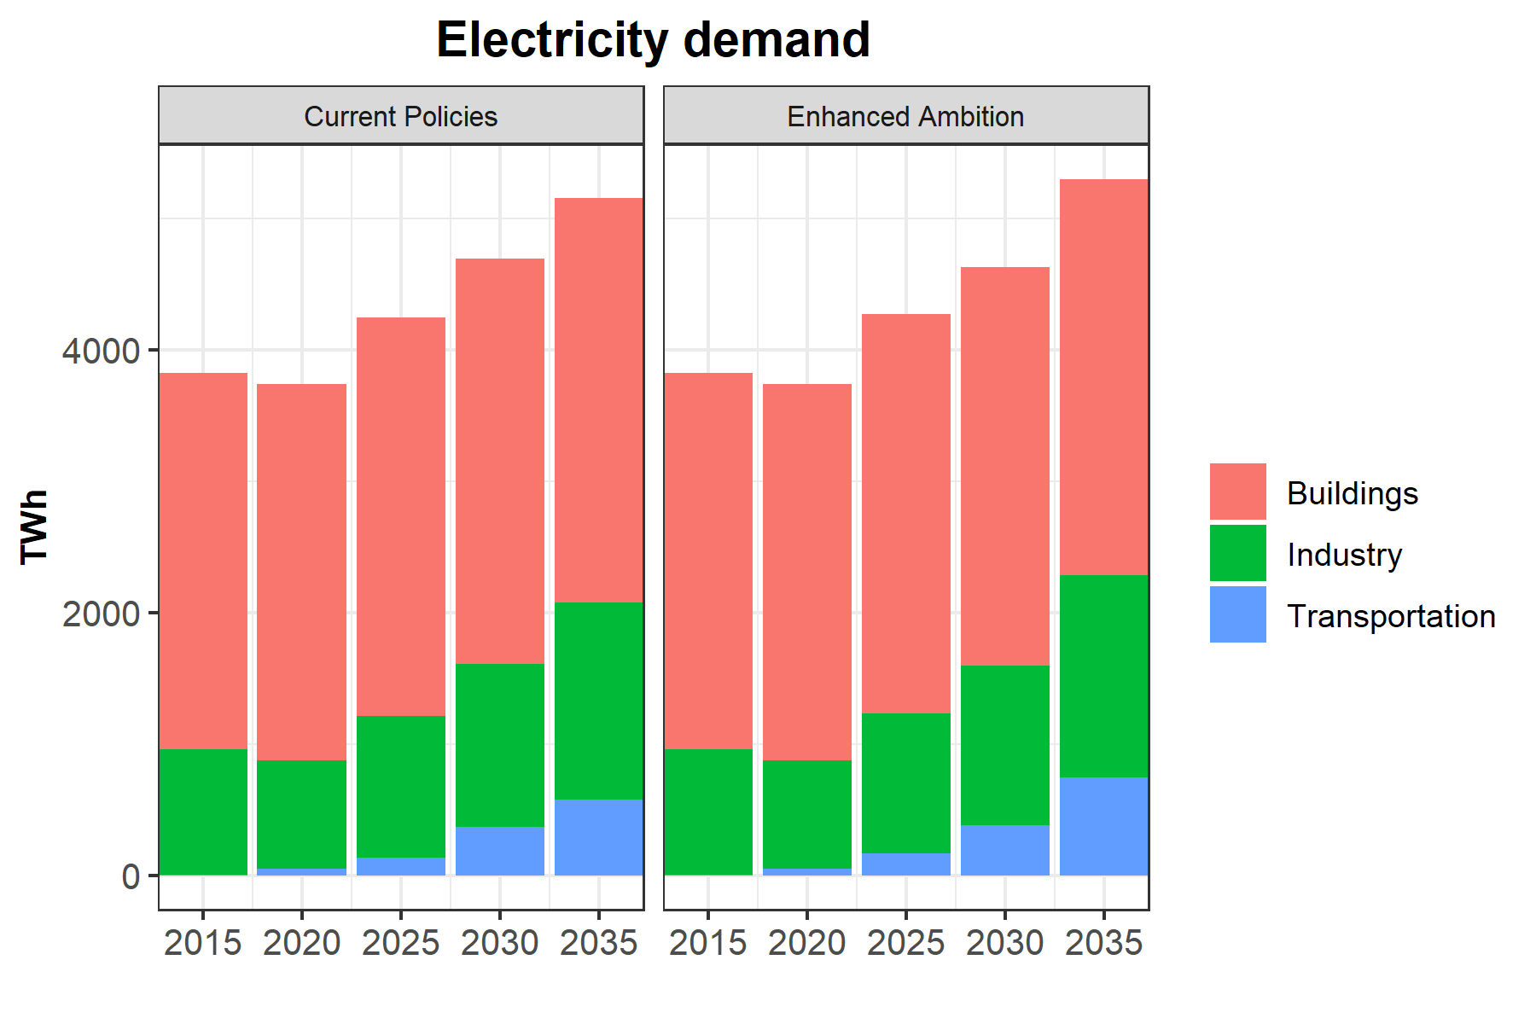
Fig. S4. Electricity demanded by the buildings, industry and transportation sectors in the Current Policies and Enhanced Ambition scenarios, in units of TWh. Electricity demand does not increase dramatically in the Enhanced Ambition scenario due to additional efficiency measures that decrease total demand in the scenario.
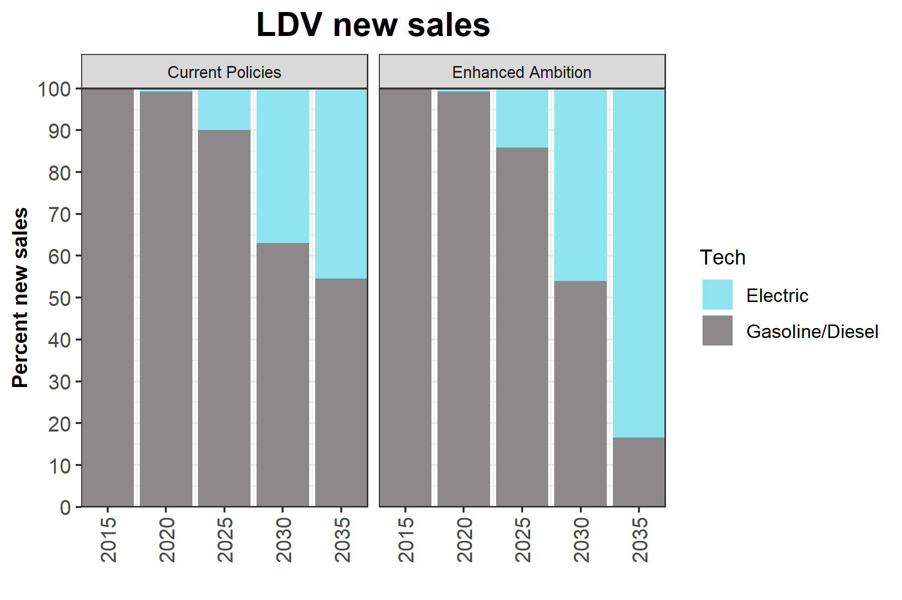
Fig. S5. LDV new sales in the Current Policies and Enhanced Ambition scenarios, in units of percentages. The percentage of new sales from electric vehicles is in blue, and the percentage from gasoline/diesel is in gray. Under the Enhanced Ambition scenario, the share of EV sales increases to 83% in 2035 as a result of additional EV incentives and mandates, compared to 45% under the Current Policies scenario.

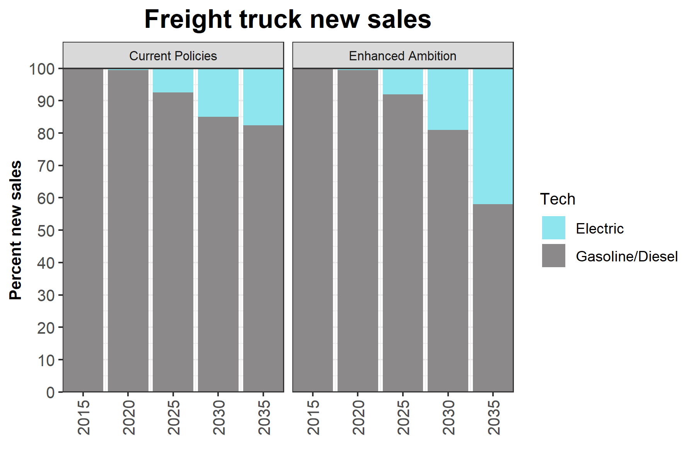
Fig. S6. Freight truck new sales in the Current Policies and Enhanced Ambition scenarios, in units of percentages. The percentage from electric vehicles is in blue, and the percentage from gasoline/diesel service is in gray. Under the Enhanced Ambition scenario, electrification increases to 42% as a result of additional EV incentives and mandates, compared to 18% under the Current Policies scenario.

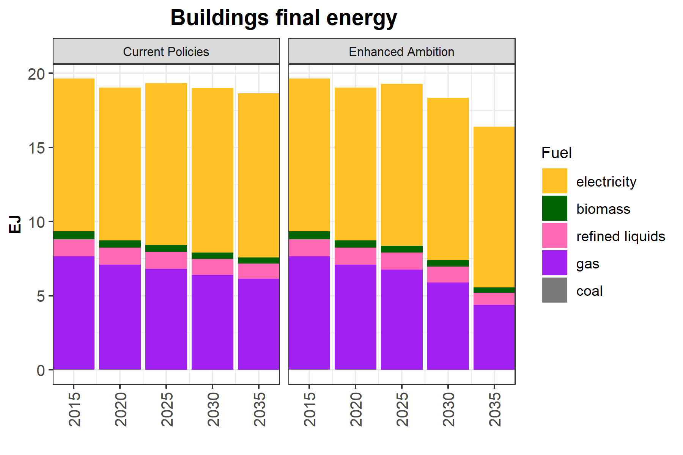Fig. S7. Buildings sector final energy demand in the Current Policies and Enhanced Ambition scenarios, in units of exajoules (EJ). Under the Enhanced Ambition scenario, the share of electricity increases from 54% in 2020 to 66% by 2035 as a result of electrification incentives and mandates, compared to 59% under the Current Policies scenario. Additionally, total demand decreases in the Enhanced Ambition scenario as a result of enhanced energy efficiency measures as well the higher share of electricity, which is more energy efficient than other fuels.

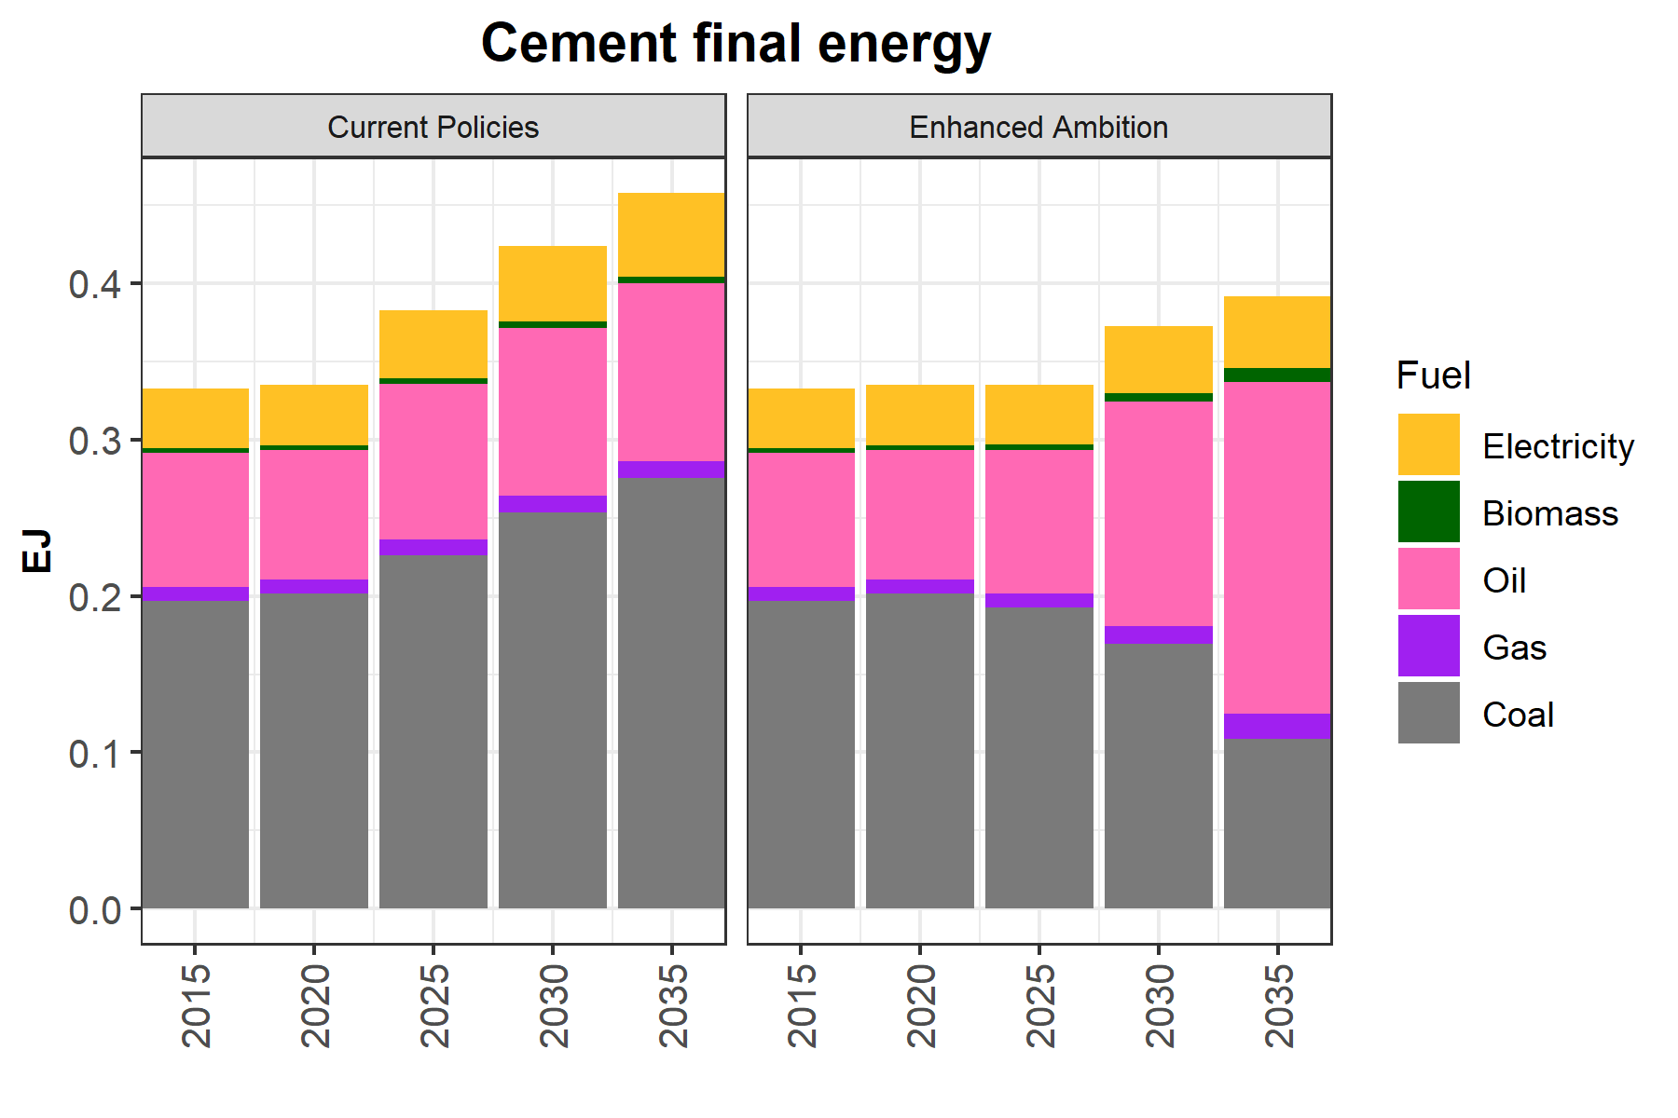
Fig. S8. Cement sector final energy demand in the Current Policies and Enhanced Ambition scenarios, in units of exajoules (EJ).

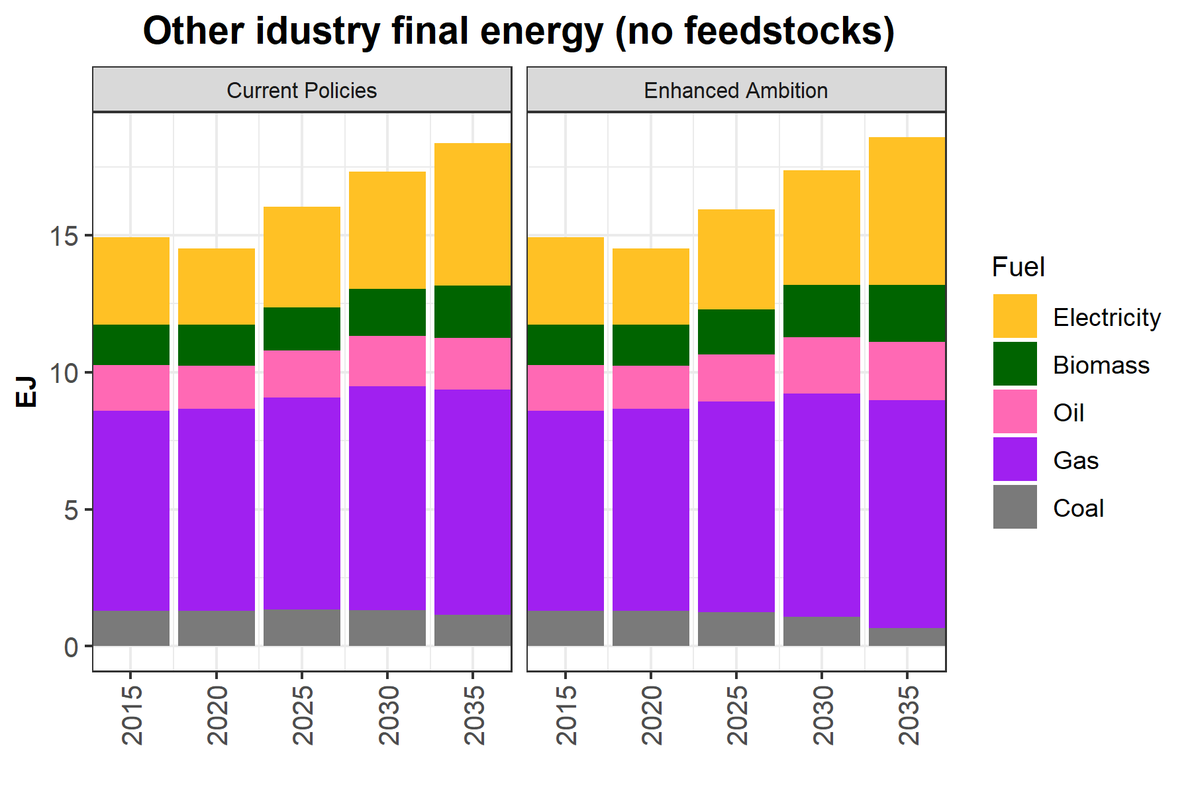
Fig. S9. Other industrial sector final energy in the Current Policies and Enhanced Ambition scenarios, in units of exajoules (EJ).

Bibliography
1. Hultman, N. et al. Accelerating America’s Pledge: Technical Appendix. The America’s Pledge Initiative on Climate Change. 62 (2019).
2. Hultman, N. E. et al. Fusing subnational with national climate action is central to decarbonization: the case of the United States. Nat. Commun. 11, 5255 (2020).
3. Kennedy, K. et al. Blueprint 2030: An All-In Climate Strategy for Faster, More Durable Emissions Reductions. https://www.americaisallin.com/blueprint-2030 (2022).
4. Hultman, N. et al. An All-In climate strategy can cut U.S. emissions by 50% by 2030. https://cgs.umd.edu/research-impact/publications/all-climate-strategy-can-cut-us-emissions-50-2030 (2021).
5. Zhao, A. et al. An “All-In” Pathway To 2030: U.S. Methane Emissions Reduction Potential. https://cgs.umd.edu/research-impact/publications/all-pathway-2030-us-methane-emissions-reduction-potential (2022).
6. Yarmuth, Rep. J. A. Inflation Reduction Act of 2022. (2022).
7. Federal Transit Administration. Bipartisan Infrastructure Law. US Department of Transportation https://www.transit.dot.gov/BIL (2023).
8. US Environmental Protection Agency. EPA Issues Supplemental Proposal to Reduce Methane and Other Harmful Pollution from Oil and Natural Gas Operations. https://www.epa.gov/controlling-air-pollution-oil-and-natural-gas-industry/epa-issues-supplemental-proposal-reduce (2022).
9. US Environmental Protection Agency. EPA Proposes New Carbon Pollution Standards for Fossil Fuel-Fired Power Plants to Tackle the Climate Crisis and Protect Public Health. https://www.epa.gov/newsreleases/epa-proposes-new-carbon-pollution-standards-fossil-fuel-fired-power-plants-tackle (2023).
10. Massachusetts Executive Office of Energy and Environmental Affairs. MA Decarbonization Roadmap. https://www.mass.gov/info-details/ma-decarbonization-roadmap (2020).
11. City of San Diego. Climate Action Plan. https://www.sandiego.gov/sustainability/climate-action-plan (2022).
12. Maryland Public Service Commission. Renewable Energy. Maryland Public Service Commission https://www.psc.state.md.us/electricity/renewable-energy/ (2023).
13. Austin Energy. Renewable Power Generation. https://austinenergy.com/about/environment/renewable-power-generation (2022).
14. Bay Area Air Quality Management District. Air District strengthens building appliance rules to reduce harmful NOx emissions, protect air quality and public health. Bay Area Air Quality Management District https://www.baaqmd.gov/news-and-events/page-resources/2023-news/031523-ba-rules (2023).
15. North Carolina Department of Environmental Quality. Advanced Clean Trucks. North Carolina Department of Environmental Quality https://www.deq.nc.gov/about/divisions/air-quality/motor-vehicles-and-air-quality/advanced-clean-trucks.
16. Dwyer, K. ‘We are full’: IndyGo seeking to borrow $65 million for new buses and garage. The Indianapolis Star https://www.indystar.com/story/news/local/transportation/2021/11/02/indygo-seeks-65-million-loan-purple-line-buses-new-bus-garage-indianapolis-marion-county-indiana/6133660001/ (2021).
17. Maez, M. New Mexico adopts nationally leading oil and gas emissions rule. New Mexico Environment Department https://www.env.nm.gov/wp-content/uploads/2022/04/2022-04-14-COMMS-New-Mexico-adopts-nationally-leading-oil-and-gas-emissions-rule-Final.pdf (2022).
18. Bond-Lamberty, B. et al. GCAM 6.0. (2022) doi:10.5281/ZENODO.6619287.
19. National Renewable Energy Laboratory. 2022 Annual Technology Baseline. https://atb.nrel.gov/electricity/2022/index (2022).
20. US Environmental Protection Agency. Global Non-CO2 Greenhouse Gas Emission Projections & Mitigation Potential: 2015-2050. https://www.epa.gov/global-mitigation-non-co2-greenhouse-gases/global-non-co2-greenhouse-gas-emission-projections (2019).
21. Kennedy, K. et al. Blueprint 2030: An All-In Climate Strategy for Faster, More Durable Emissions Reductions. https://www.americaisallin.com/blueprint-2030 (2022).
22. Zhao, A. et al. An All-In Pathway to 2030: The Beyond 50 Scenario. https://www.americaisallin.com/Beyond50 (2022).
23. Annual Energy Outlook 2023 - U.S. Energy Information Administration (EIA). https://www.eia.gov/outlooks/aeo/index.php.
24. Larsen, K. et al. Taking Stock 2020: The COVID-19 Edition. 18 https://rhg.com/research/taking-stock-2020/ (2020).
25. US Energy Information Administration. Annual Energy Outlook 2023. https://www.eia.gov/outlooks/aeo/tables_ref.php (2023).
26. Josh Becker. Greenhouse gases: cement sector: net-zero emissions strategy. SB-596.
27. Larsen, J., King, B., Hiltbrand, G. & Jones, W. Capturing the Moment: Carbon Capture in the American Jobs Plan. Rhodium Group https://rhg.com/research/carbon-capture-american-jobs-plan/ (2021).
28. Kuparinen, K., Vakkilainen, E. & Tynjälä, T. Biomass-based carbon capture and utilization in kraft pulpmills. Mitig. Adapt. Strateg. Glob. Change 24, 1213–1230 (2019).
29. Rissman, J. Decarbonizing Low-Temperature Industrial Heat in the U.S. https://energyinnovation.org/wp-content/uploads/2022/10/Decarbonizing-Low-Temperature-Industrial-Heat-In-The-U.S.-Report-1.pdf (2022).
30. Jenkins, J. D., Farbes, J., Jones, R. & Mayfield, E. REPEAT Project Section-by-Section Summary of Energy and Climate Policies in the 117th Congress. (2022) doi:doi: 10.5281/zenodo.6993118.
31. Zhao, A. et al. An “All-In” Pathway To 2030: U.S. Methane Emissions Reduction Potential. https://cgs.umd.edu/research-impact/publications/all-pathway-2030-us-methane-emissions-reduction-potential (2022).
32. Kennedy, S. et al. Achieving Land Sector Mitigation Potential in the United States: An all-of-society approach to meeting our climate goals and bolstering the carbon sink by 2035. Preprint at (Forthcoming).
33. Guel, T. et al. Direct Air Capture: A key technology for net zero. https://iea.blob.core.windows.net/assets/78633715-15c0-44e1-81df-41123c556d57/DirectAirCapture_Akeytechnologyfornetzero.pdf (2022).
34. US Environmental Protection Agency. Inventory of U.S. Greenhouse Gas Emissions and Sinks: 1990-2021. Greenhouse Gas Emissions https://www.epa.gov/ghgemissions/inventory-us-greenhouse-gas-emissions-and-sinks-1990-2021 (2023).
35. Stocker, T. F. et al. Climate Change 2013: The Physical Science Basis. Contribution of Working Group I to the Fifth Assessment Report of the Intergovernmental Panel on Climate Change. 1535 https://www.ipcc.ch/report/ar5/wg1/ (2013).
36. Bistline, J. et al. Emissions and energy impacts of the Inflation Reduction Act. Science 380, 1324–1327 (2023).
37. Lawrence Berkeley National Lab. RPS and CES Demand Projections. (2023).
38. US Energy Information Administration. EIA-861 Annual Electric Power Industry Report 2010–2022. Historical State Data https://www.eia.gov/electricity/data/state/ (2022).
39. Global Energy Monitor. Global Coal Plant Tracker. Global Energy Monitor https://globalenergymonitor.org/projects/global-coal-plant-tracker/ (2022).
40. US Energy Information Administration. EIA-860A/860B. (2023).
41. US Environmental Protection Agency. National Electric Energy Data System (NEEDS). Power Sector Modeling https://www.epa.gov/power-sector-modeling/national-electric-energy-data-system-needs (2022).
42. US Department of Energy. Zero Emission Vehicle (ZEV) Production Requirements. Alternative Fuels Data Center https://afdc.energy.gov/laws/4249.
43. California Air Resources Board. Advanced Clean Cars II. https://ww2.arb.ca.gov/our-work/programs/advanced-clean-cars-program/advanced-clean-cars-ii.
44. California Air Resources Board. Advanced Clean Trucks Fact Sheet. ca.gov https://ww2.arb.ca.gov/resources/fact-sheets/advanced-clean-trucks-fact-sheet (2021).
45. US Department of Transportation. VMT Per Capita. transportation.gov https://www.transportation.gov/mission/health/vmt-capita (2015).
46. FRED. Moving 12-Month Total Vehicle Miles Traveled. Federal Reserve Bank of St. Louis https://fred.stlouisfed.org/series/M12MTVUSM227NFWA (2023).
47. Davis, S. C. & Boundy, R. G. Transportation Energy Data Book Edition 40. https://tedb.ornl.gov/wp-content/uploads/2022/03/TEDB_Ed_40.pdf (2022).
48. Office of Highway Policy Information Federal Highway Administration. FHWA Forecasts of Vehicle Miles Traveled (VMT): Spring 2023. (2023).
49. California Air Resources Board. 2022 Scoping Plan for Achieving Carbon Neutrality. 299 https://ww2.arb.ca.gov/sites/default/files/2023-04/2022-sp.pdf (2022).
50. Federal Highway Administration. Highway Statistics Series. (2022).
51. American Council for an Energy-Efficient Economy. Energy Efficiency Resource Standards. https://database.aceee.org/state/energy-efficiency-resource-standards.
52. US Energy Information Administration. Natural Gas Delivered to Consumers. https://www.eia.gov/dnav/ng/ng_cons_sum_a_EPG0_vgt_mmcf_m.htm (2023).
53. US Energy Information Administration. Annual Electric Power Industry Report, Form EIA-861 detailed data files. https://www.eia.gov/electricity/data/eia861/ (2023).
54. NYSERDA. New Efficiency: New York. https://www.nyserda.ny.gov/About/Publications/New-Efficiency (2018).
55. American Council for an Energy-Efficient Economy. Energy Efficiency Resource Standards. https://database.aceee.org/state/energy-efficiency-resource-standards.
56. Michigan Public Service Commission. Energy Waste Reduction. https://www.michigan.gov/mpsc/consumer/ewr.
57. California Air Resources Board. 2022 State Strategy for the State Implementation Plan. (2022).
58. Councilmember Robert C. White, Jr. Greener Government Buildings Amendment Act of 2022. Bill 24-785 vols A24-0755 (2023).
59. State of New York. Enacted Budget Financial Plan. https://www.budget.ny.gov/pubs/archive/fy24/en/fy24en-fp.pdf (2023).
60. Bauer, L. & Braff, P. Building Electrification. Engage Olympia https://engage.olympiawa.gov/building-electrification (2023).
61. Philip D. Murphy. Target To Install Zero-Carbon-Emission Space Heating And Cooling Systems In 400,000 Homes And 20,000 Commercial Properties And Make 10% Of All Low-To-Moderate Income (LMI) Properties Electrification-Ready By 2030. Executive Order 316 (2023).
62. Maryland Department of the Environment. Building Energy Performance Standards. Department of the Environment https://mde.maryland.gov/programs/air/ClimateChange/Pages/default.aspx.
63. Jossi, F. Minnesota lawmakers update commercial building code aimed at energy savings. MinnPost https://www.minnpost.com/environment/2023/05/minnesota-lawmakers-update-commercial-building-code-amid-flurry-of-energy-bills/ (2023).
64. Perkins, H. & Chu, J. New Colorado Building Energy Code Paves Way for More All-Electric Buildings, Widespread Use of EVs. America Is All In https://www.americaisallin.com/new-colorado-building-energy-code-paves-way-more-all-electric-buildings-widespread-use-evs (2023).
65. Delaware General Assembly. County or Municipal Building, Plumbing, Electrical and Other Codes. Code for Energy Conservation. vol. 7602.
66. National Resources Defense Council. Gas Interests Threaten Local Authority. NRDC.org https://www.nrdc.org/bio/alejandra-mejia-cunningham/gas-interests-threaten-local-authority (2021).
67. Darius Adams, Ralph Alig, Bruce A. McCarl, & Brian C. Murray. FASOMGHG Conceptual Structure, and Specification: Documentation. (2005).

Emissions impacts from national and state-level HFC regulations were derived from a short-lived climate pollutant tool developed by CARB and extrapolated to additional states. We used the tool’s Kigali phasedown scenario as a proxy for the impact of the AIM Act.

