Supplementary information
Meteorological conditions during energy droughts
Supplementary Figure 1 and Supplementary Figure 2 show the composite maps of the meteorological anomalies during the winter and summer energy droughts. During summer energy drought windows (EDWs) all countries experience higher than normal temperatures and lower than normal windspeeds. These conditions are the result of long-lasting blocking events, that coincide with little cloud formation and therefor anomalously high solar radiation. During winter EDWs temperatures and windspeeds are low, and negative runoff anomalies are more pronounced.

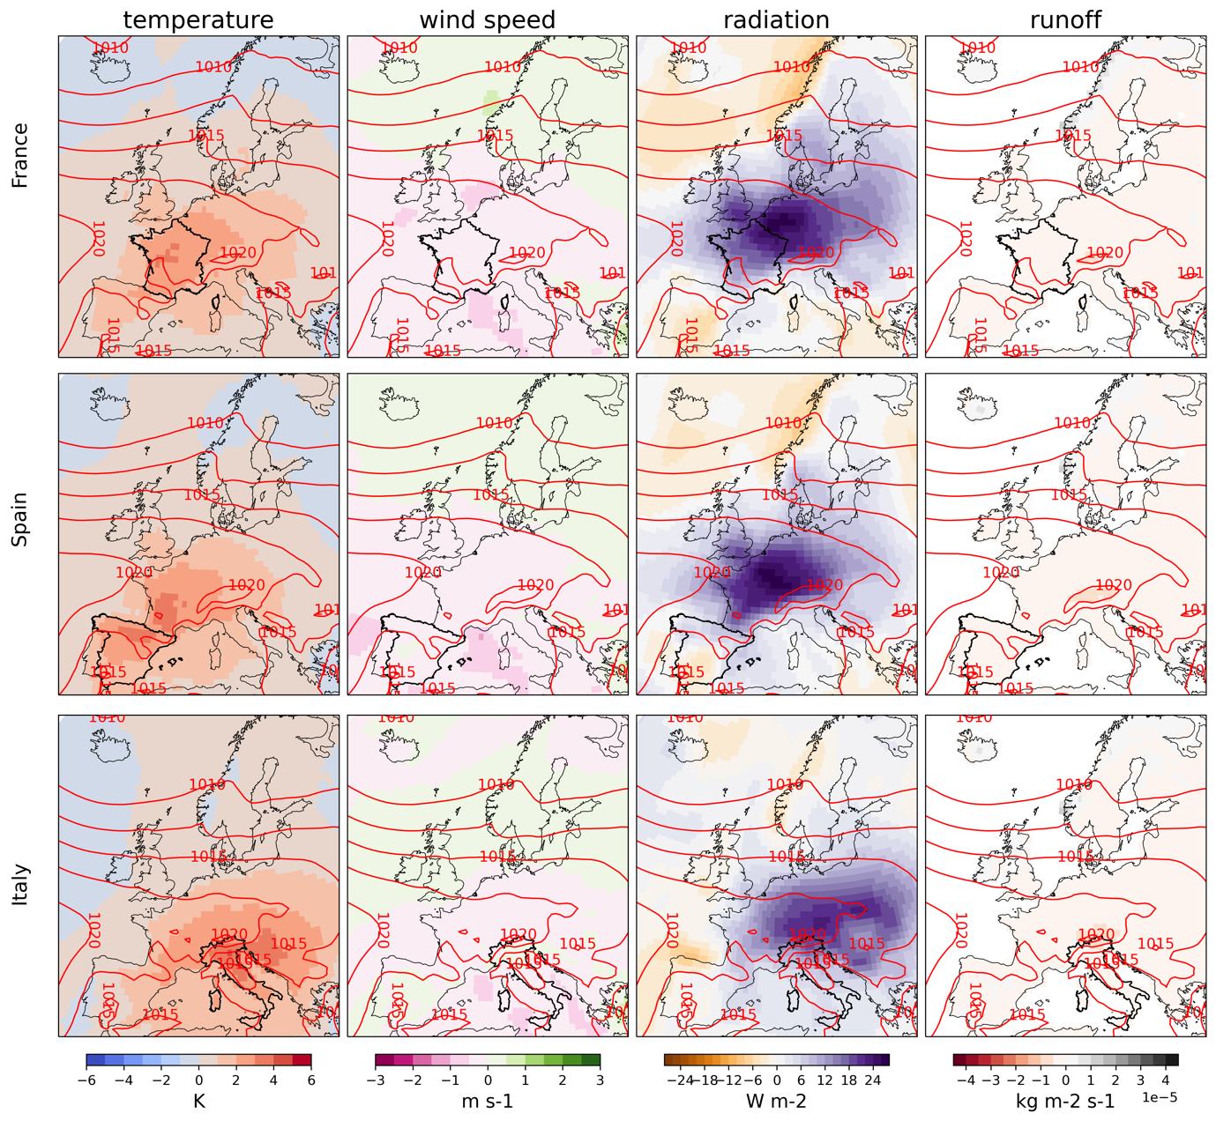
Supplementary Figure 1: Representation of the 30-day summer Energy Drought Windows (EDW) occurring once in 10 years or less for three European countries, organized from top to bottom: France, Spain, and Italy. Horizontally, from left to right, the panels illustrate anomalies in near-surface temperature, near-surface wind speed, solar radiation, and total runoff during these EDWs. Red lines depict the mean sea level pressure patterns concurrent with these events.

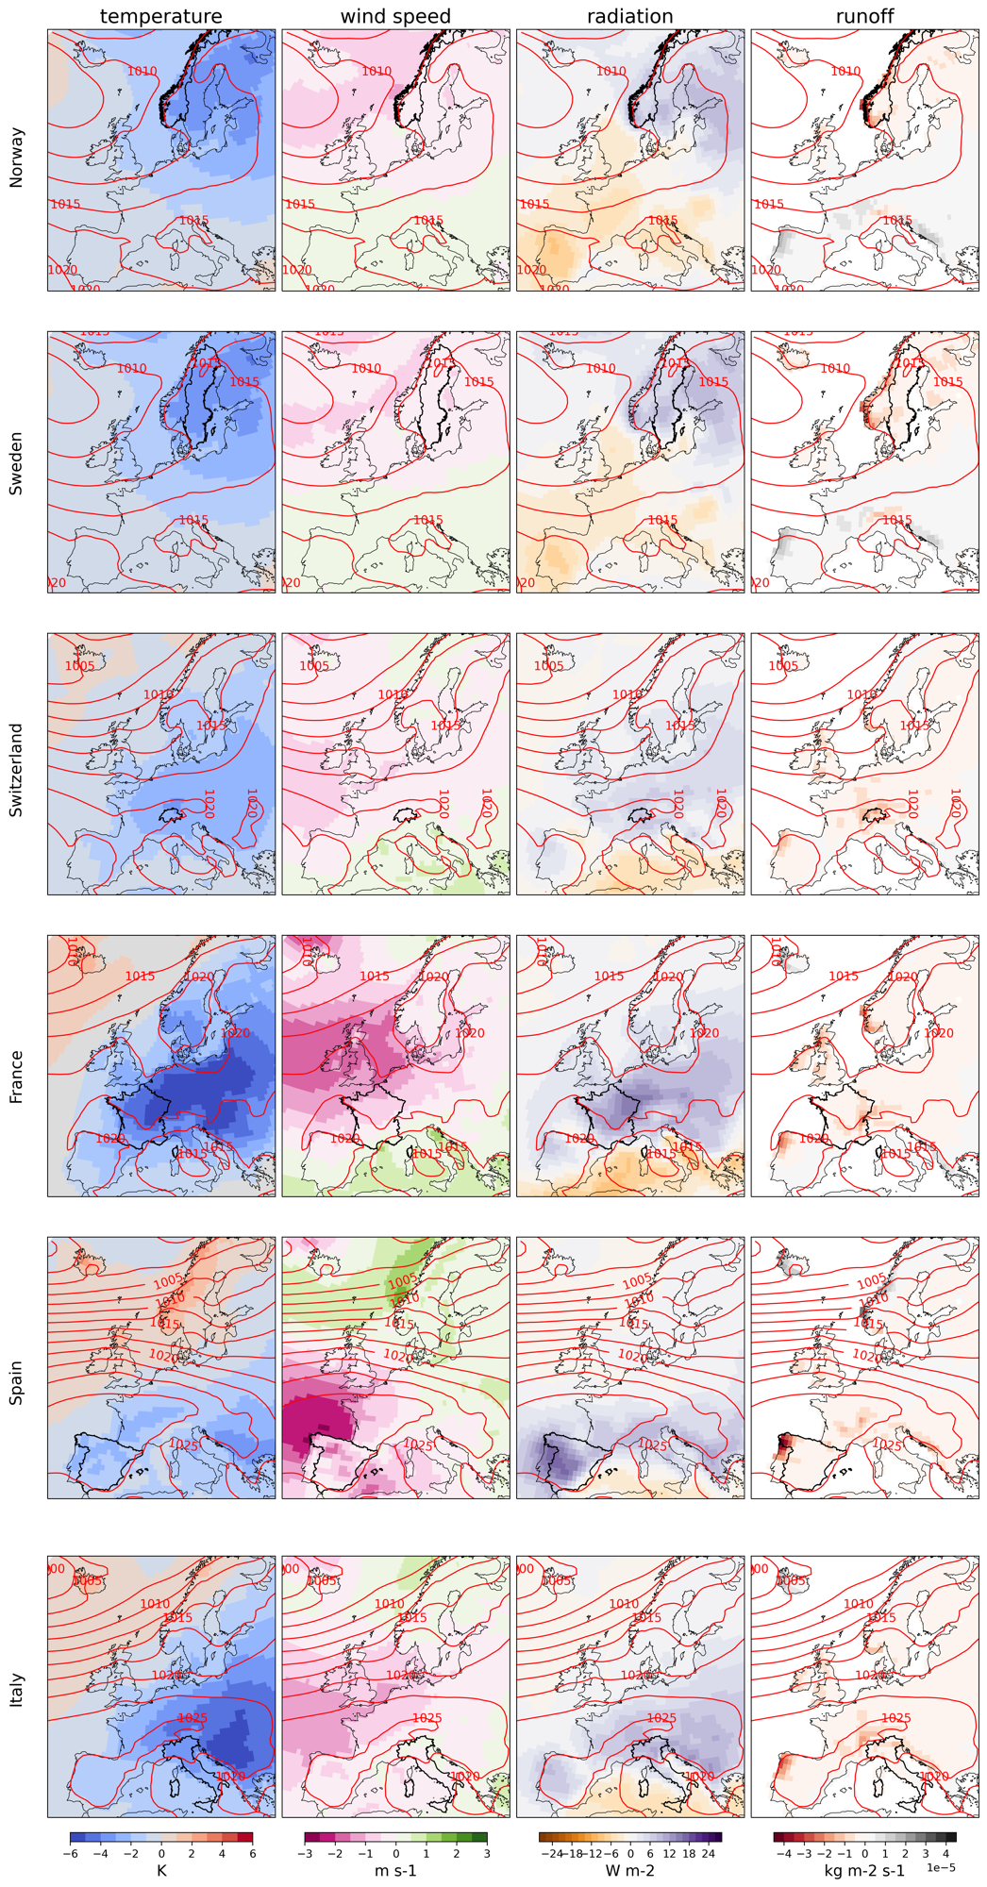
Supplementary Figure 2: Representation of the 30-day winter Energy Drought Windows (EDW) occurring once in 10 years or less for six European countries. Organized from top to bottom: Norway, Sweden, Switzerland, France, Spain, and Italy. Horizontally variables like in Supplementary Figure 1.
Energy production and demand during energy droughts
Supplementary Figure 3 and Supplementary Figure 4 show a timeseries analysis of electricity load, production, and storage during energy drought events across six European countries: Norway, Sweden, Switzerland, France, Spain, and Italy, arranged from top to bottom.
During both winter and summer energy droughts demand is high and in most countries hydropower production is reduced. Additionally, for certain countries, the energy droughts are further intensified by a marked decrease in wind energy production.

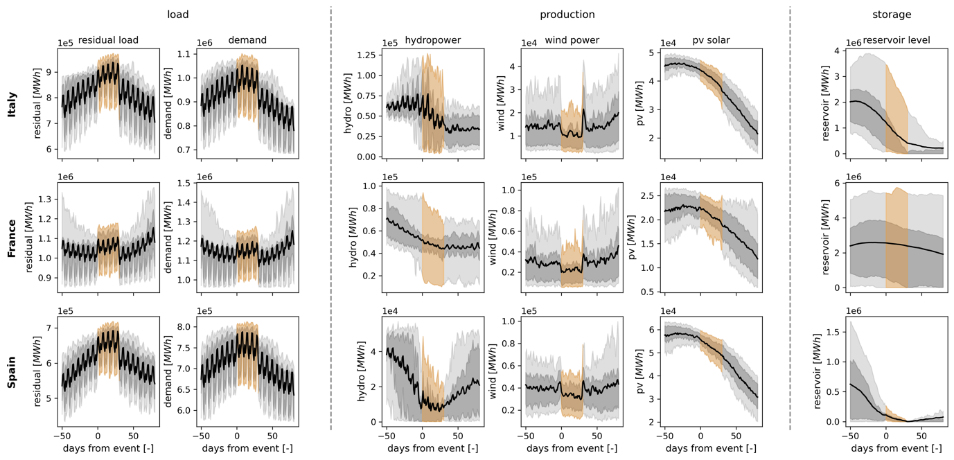
Supplementary Figure 3: Timeseries plots of energy load, production, and storage during 30-day summer energy drought windows (EDWs) that occur once in 10 years or less across three European countries: France, Spain, and Italy, arranged from top to bottom. From left to right, residual load (electricity demand minus renewable electricity production), demand, hydropower production, wind power production, photovoltaic (pv) solar production and the storage levels in the hydropower reservoirs. The grey areas show the 10th-90th and the 25th-75th percentiles and the black line the composite mean over all events. The orange section shows the energy drought window.

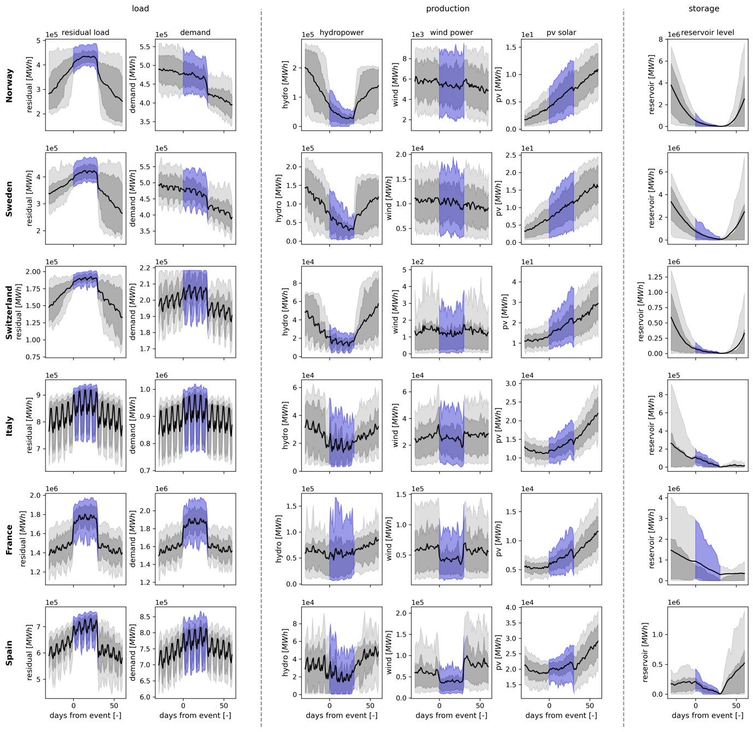
Supplementary Figure 4: Timeseries plots of energy load, production, and storage during 30-day winter energy drought windows (EDWs) that occur once in 10 years or less across six European countries: Norway, Sweden, Switzerland, France, Spain, and Italy, arranged from top to bottom. From left to right, residual load (demand minus renewable production), demand, hydropower production, wind power production, photovoltaic (pv) solar production and the storage levels in the hydropower reservoirs. The grey areas show the 10th-90th and the 25th-75th percentiles and the black line the composite mean over all events. The blue section shows the energy drought window.

Inflow into reservoirs during high demand and low wind and PV production events
Supplementary Figure 5 shows the inflow into reservoirs during instantaneous high residual loads, where instantaneous residual loads are defined as the difference between demand and non-dispatchable renewable energy production (photovoltaic solar and wind). It can be seen that especially in Southern Europe, periods of high demand and low non-dispatchable production coincide with reduced reservoir inflows.
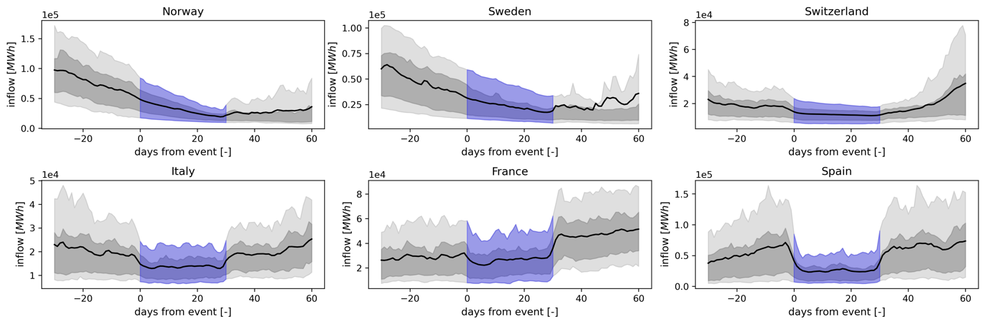
Supplementary Figure 5: Timeseries of daily inflow into hydropower reservoirs around once in 10 years or less high demand and low wind and photovoltaic solar production events for Norway, Sweden, Switzerland, Italy, France and Spain. The grey areas show the 10th-90th and the 25th-75th percentiles and the black line the composite mean over all events. The blue section shows the episodes of high demand and low wind and photovoltaic production.
Timeline analysis of low inflow during spring in Italy
Supplementary Figure 6 shows a timeline overview of the development of low runoff in May and June in Italy preceding summer energy droughts. The low runoff is a combined result of low surface snowmelt and low precipitation. The low surface snowmelt is caused by low snowfall in winter (DJFM) and consequent anomalously low snow deck in April. This is coincided with low soil moisture content, and compounded with low precipitation, all contribution to anomalously low runoff in reservoir filling season.

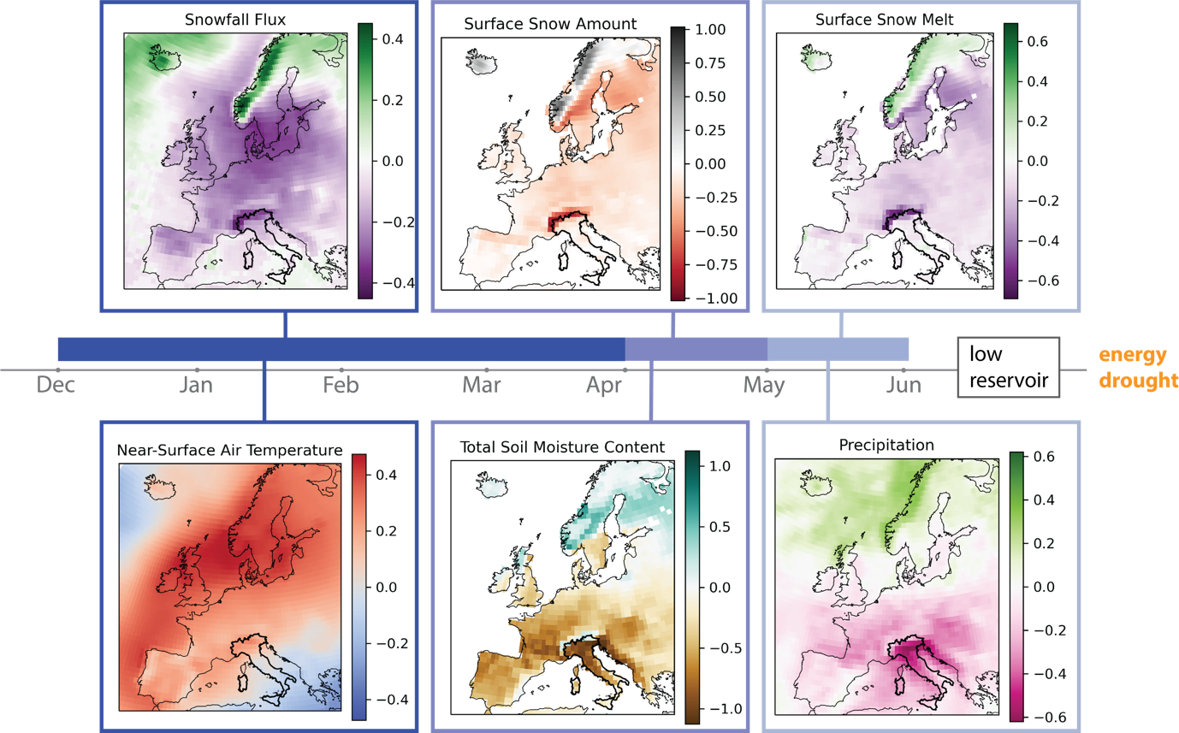
Supplementary Figure 6: A timeline overview of the development of low runoff in May and June in Italy. With the z-scores depicted for six meteorological variables during the months preceding a summer energy drought. From left to right the composite means of periods leading up to summer energy droughts of snowfall flux and near-surface air temperature from December until April, Surface snowmelt and Total Soil Moisture content from April until May, and Surface Snow Melt and Precipitation from May until June.

Comparison of the KNMI-LENTIS data to ERA5 data
Given that our energy modelling framework underwent validation using ERA5 data, we conduct a comparative analysis of meteorological variables between the KNMI-LENTIS model ensemble and ERA5 data. This comparison ensures that the insights gained from our examination of the distribution of energy production and demand modelled with the KNMI-LENTIS ensemble remain consistent and reliable within the context of the model’s established accuracy.

The mean and variance of the climate model are generally well-aligned with the ERA5 reanalysis data. However, as indicated in Supplementary Figure 7, on average, peak discharges in Norway, Sweden, and Switzerland tend to occur slightly earlier in the KNMI-LENTIS dataset compared to ERA5. Additionally, lower discharge levels in Italy are consistently recorded in the KNMI-LENTIS dataset relative to ERA5. Furthermore, Supplementary Figure 7 illustrates that the LENTIS dataset presents a higher temperature variance during the autumn in Southern Europe. In contrast, in Northern Europe, the LENTIS dataset reveals a greater variance in wind speed and runoff when set against ERA5 data.

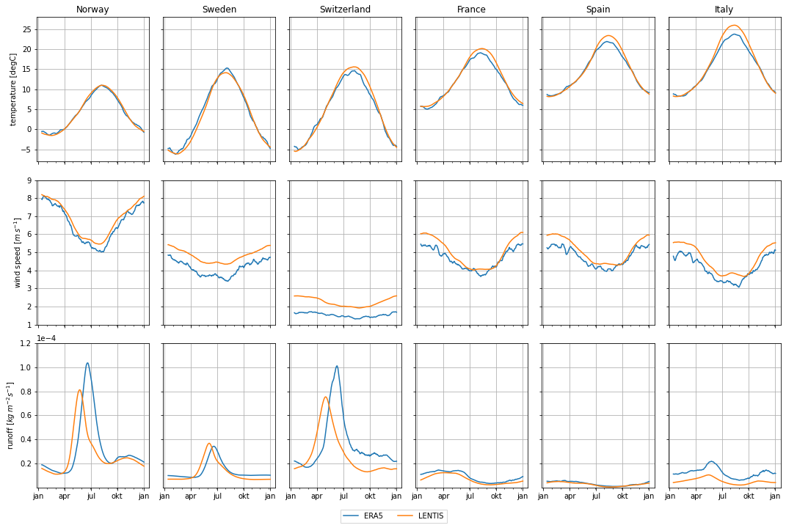
Supplementary Figure 7: The daily 14-day rolling climatological means of the 1600 years of the KNMI-LENTIS dataset (in orange) and the 1990-2021 ERA5 data (in blue), categorized by country. The meteorological variables from top to bottom are near-surface air temperature, near-surface wind speed, and total runoff. The countries depicted, from left to right, are Norway, Sweden, Switzerland, France, Spain, and Italy.
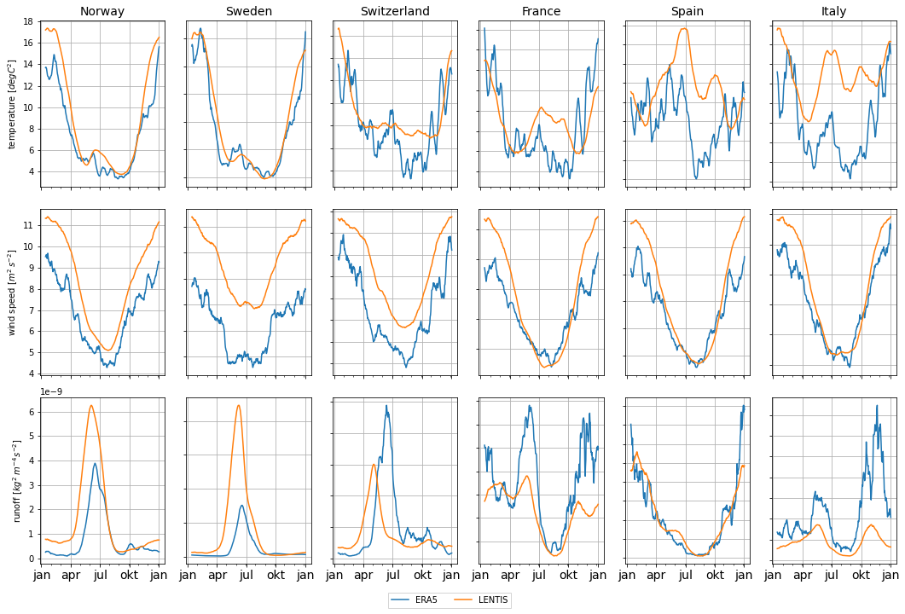
Supplementary Figure 8: The daily 14-day rolling climatological variance of the 1600 years of the KNMI-LENTIS dataset (in orange) and the 1990-2021 ERA5 data (in blue), categorized by country. The meteorological variables from top to bottom are near-surface air temperature, near-surface wind speed, and total runoff. The countries depicted, from left to right, are Norway, Sweden, Switzerland, France, Spain, and Italy.

