Supplemental Table 1. List of 54 myeloid neoplasm-relevant genes studied in targeted NGS sequencing
Gene name | Target region (exon) | Gene name | Target region (exon)
ABL | 4-6 | JAK3 | 13
ASXL1 | 12 | KDM6A | full
ATRX | 8-10, 17-31 | KIT | 2, 8-11, 13, 17
BCOR | full | KRAS | 2, 3
BCORL1 | full | KMT2A | 5-8
BRAF | 15 | MPL | 10
CALR | 9 | MYD88 | 3-5
CBL | 8, 9 | NOTCH1 | 26-28, 34
CBLB | 9, 10 | NPM1 | 12
CBLC | 9, 10 | NRAS | 2, 3
CDKN2A | full | PDGFRA | 12, 14, 18
CEBPA | full | PHF6 | Full
CSF3R | 14-17 | PTEN | 5, 7
CUX1 | full | PTPN11 | 3, 13
DNMT3A | full | RAD21 | Full
ETV6 | full | RUNX1 | Full
EZH2 | full | SETBP1 | 4 (partial)
FBXW7 | 9-11 | SF3B1 | 13-16
FLT3 | 14, 15, 20 | SMC1A | 2, 11, 16, 17
GATA1 | 2 | SMC3 | 10, 13, 19, 23, 25, 28
GATA2 | 2-6 | SRSF2 | 1
GNAS | 8, 9 | STAG2 | full
HRAS | 2, 3 | TET2 | 3-11
IDH1 | 4 | TP53 | 2-11
IDH2 | 4 | U2AF1 | 2, 6
IKZF1 | full | WT1 | 7, 9
JAK2 | 12, 14 | ZRSR2 | full

Supplemental Table 2a. Clinical characteristics of patients with myelodysplastic syndromes, categorized by the 2022 International Consensus Classification
Variables | Del(5q)  (n=4) | Mutated SF3B1  (n=59) | NOS,  SLD  (n=106) | NOS,  MLD  (n=147) | EB  (n=131) | Mutated TP53  (n=23) | P value
Sex |  |  |  |  |  |  | 0.076
Female | 3 (75.0) | 17 (28.8) | 51 (46.4) | 49 (32.7) | 51 (38.9) | 6 (26.1)
Male | 1 (25.0) | 42 (71.2) | 59 (53.6) | 101 (67.3) | 80 (61.1) | 17 (73.9)
Age* | 71 (70-75) | 70 (27-91) | 67 (21-95) | 63 (18-94) | 67 (23-94) | 71 (46-91) | 0.074
Laboratory data*
WBC, ×10⁹ /L | 3.5 (2.0-4.2) | 3.9 (1.8-7.9) | 3.9 (1.1-26.3) | 2.8 (0.8-15.8) | 3.1 (0.7-32.4) | 3.2 (1.1-12.2) | <0.001
ANC, ×10⁹ /L | 1.7 (0.5-2.4) | 2.3 (0.4-5.1) | 2.2 (0.1-12.3) | 1.4 (0-10.8) | 1.4 (0-23.5) | 1.5 (0.2-3.5) | <0.001
Hb, g/dL | 5.7 (3.5-7.5) | 8.1 (5.4-11.7) | 7.9 (3.4-14.4) | 8.3 (4.1-17.1) | 8.3 (3.2-13.7) | 7.1 (4.4-9.7) | 0.035
Platelet, ×10⁹ /L | 214 (82-427) | 194 (6-471) | 106 (4-607) | 52 (3-405) | 71 (1-721) | 65 (1-133) | <0.001
BM blast (%) | 2.4 (0-4.1) | 1.6 (0-4.6) | 1.5 (0-4.8) | 2.0 (0-4.9) | 6.5 (0.6-9.8) | 7.4 (1.4-9.5) | <0.001
PB blast (%) | 0 (0) | 0 (0) | 0 (0) | 0 (0-1) | 0 (0-9) | 2 (0-9) | <0.001
IPSS-R |  |  |  |  |  |  | <0.001
Very low | 0 (0.0) | 7 (11.9) | 9 (8.5) | 6 (4.1) | 0 (0.0) | 0 (0.0) | 0.001
Low | 1 (25.0) | 40 (67.8) | 52 (49.1) | 64 (43.5) | 12 (9.2) | 0 (0.0) | <0.001
Intermediate | 3 (75.0) | 12 (20.3) | 38 (35.8) | 55 (37.4) | 47 (35.9) | 0 (0.0) | 0.001
High | 0 (0.0) | 0 (0.0) | 5 (4.7) | 17 (11.6) | 50 (38.2) | 2 (8.7) | <0.001
Very high | 0 (0.0) | 0 (0.0) | 2 (1.9) | 5 (3.4) | 22 (16.8) | 21 (91.3) | <0.001
IPSS-M |  |  |  |  |  |  | <0.001
Very low | 0 (0.0) | 2 (3.4) | 5 (4.7) | 9 (6.1) | 2 (1.5) | 0 (0.0) | 0.412
Low | 0 (0.0) | 39 (66.1) | 41 (38.7) | 44 (29.9) | 8 (6.1) | 0 (0.0) | <0.001
Moderate low | 0 (0.0) | 13 (22.0) | 29 (27.4) | 31 (21.1) | 16 (12.2) | 0 (0.0) | 0.009
Moderate high | 2 (50.0) | 4 (6.8) | 19 (17.9) | 31 (21.1) | 26 (19.8) | 0 (0.0) | 0.025
High | 1 (25.0) | 1 (1.7) | 10 (9.4) | 23 (15.6) | 50 (38.2) | 0 (0.0) | <0.001
Very high | 1 (25.0) | 0 (0.0) | 2 (1.9) | 9 (6.1) | 29 (22.1) | 23 (100) | <0.001
Treatment
HMA | 1 (25.0) | 4 (6.8) | 2 (1.9) | 9 (6.1) | 54 (41.2) | 11 (47.8) | <0.001
Intensive chemotherapy | 0 (0.0) | 1 (1.8) | 1 (1.0) | 1 (0.7) | 6 (4.6) | 0 (0.0) | 0.204
Clinical trial | 0 (0.0) | 0 (0.0) | 6 (5.8) | 5 (3.4) | 7 (5.4) | 1 (4.5) | 0.600
HSCT | 0 (0.0) | 6 (10.2) | 3 (2.8) | 16 (10.9) | 39 (29.8) | 2 (8.7) | <0.001
Supportive care | 3 (75.0) | 35 (62.5) | 63 (61.2) | 88 (59.9) | 39 (30.0) | 9 (40.9) | <0.001
Other treatment† | 0 (0.0) | 16 (28.6) | 31 (30.1) | 43 (29.3) | 22 (16.9) | 2 (9.1) | 0.033
AML transformation | 2 (50.0) | 3 (5.1) | 8 (7.5) | 13 (8.8) | 41 (31.3) | 11 (47.8) | <0.001
Death | 2 (50.0) | 15 (25.4) | 35 (33.0) | 55 (37.4) | 80 (61.1) | 19 (82.6) | <0.001
Early mortality§ | 2 (50.0) | 6 (10.2) | 7 (6.6) | 16 (10.9) | 13 (9.9) | 5 (21.7) | 0.036
No patients qualify for the diagnosis of MDS, NOS without dysplasia. P values of <0.05 are statistically significant
*Median (range).
†Other treatment: include low-dose cytarabine, rabbit-derived anti-thymocyte globulin (rATG), cyclosporine, danazol, eltrombopag, erythropoietin-stimulating agents (ESA), thalidomide, steroid, venetoclax-based therapy and oral chemotherapy.
§Death within 3 months of diagnosis.
Abbreviations: ANC, absolute neutrophil count; AML, acute myeloid leukemia; BM, bone marrow; del, deletion; EB, excess blasts; Hb, hemoglobin; HMA, hypomethylation agent; HSCT, allogeneic hematopoietic stem cell transplantation; IPSS-R, revised international prognosis scoring system; IPSS-M, Molecular International Prognosis Scoring System; MLD, multilineage dysplasia; NOS, not otherwise specified; PB, peripheral blood; SLD, single lineage dysplasia

Supplemental Table 2b. Clinical characteristics of patients with myelodysplastic syndromes/acute myeloid leukemia, categorized by the 2022 International Consensus Classification
Variables | Mutated TP53  (n=37) | MDS-related gene mutations  (n=93) | MDS-related cytogenetics  (n=12) | NOS  (n=20) | P value
Sex |  |  |  |  | 0.231
Female | 16 (43.2) | 26 (28.0) | 6 (50.0) | 7 (35.0)
Male | 21 (56.8) | 67 (72.0) | 6 (50.0) | 13 (65.0)
Age* | 68 (27-85) | 67 (26-91) | 65 (46-86) | 59 (30-76) | 0.043
Laboratory data*
WBC, ×10⁹ /L | 3.3 (0.6-17.5) | 3.1 (0.6-30.3) | 2.8 (0.9-11.1) | 2.3 (0.8-14.9) | 0.646
ANC, ×10⁹ /L | 1.1 (0.1-11.7) | 1.1 (0.1-13.9) | 1.1 (0.4-3.8) | 1.3 (0-6.5) | 0.788
Hb, g/dL | 7.9 (5.3-11.9) | 8.2 (2.6-14.6) | 8.1 (6.9-11.7) | 8.3 (55.7-12.7) | 0.900
Platelet, ×10⁹ /L | 46 (7-460) | 78 (4-931) | 83 (8-206) | 96 (14-295) | 0.133
BM blast (%) | 14.2 (10.2-19.5) | 13.0 (5.0-19.4) | 13.6 (10.2-17.2) | 12.0 (10.0-18.6) | 0.286
PB blast (%) | 2 (0-17) | 1 (0.0-19) | 1 (0-16) | 2 (0-18) | 0.018
IPSS-R |  |  |  |  | <0.001
Very low | 0 (0.0) | 0 (0.0) | 0 (0.0) | 0 (0.0) | -
Low | 0 (0.0) | 0 (0.0) | 0 (0.0) | 0 (0.0) | -
Intermediate | 0 (0.0) | 7 (7.5) | 0 (0.0) | 4 (20.0) | 0.027
High | 0 (0.0) | 51 (54.8) | 3 (25.0) | 8 (40.0) | <0.001
Very high | 37 (100) | 35 (37.6) | 9 (75.0) | 8 (40.0) | <0.001
IPSS-M |  |  |  |  | <0.001
Very low | 0 (0.0) | 0 (0.0) | 0 (0.0) | 0 (0.0) | -
Low | 0 (0.0) | 0 (0.0) | 0 (0.0) | 0 (0.0) | -
Moderate low | 0 (0.0) | 3 (3.2) | 0 (0.0) | 1 (5.0) | 0.574
Moderate high | 0 (0.0) | 2 (2.2) | 1 (8.3) | 5 (25.0) | <0.001
High | 0 (0.0) | 18 (19.4) | 3 (25.0) | 8 (40.0) | 0..002
Very high | 37 (100) | 70 (75.3) | 8 (66.7) | 6 (30.0) | <0.001
Treatment
HMA | 16 (43.2) | 41 (44.1) | 8 (66.7) | 5 (25.0) | 0.143
Intensive chemotherapy | 1 (2.7) | 5 (5.4) | 0 (0.0) | 3 (15.0) | 0.196
Clinical trial | 2 (5.4) | 5 (5.4) | 0 (0.0) | 1 (5.0) | 0.878
HSCT | 3 (8.1) | 21 (22.6) | 2 (16.7) | 6 (30.0) | 0.171
Supportive care | 14 (37.8) | 24 (25.8) | 3 (25.0) | 6 (30.0) | 0.579
Other treatment† | 5 (13.5) | 14 (15.1) | 0 (0.0) | 5 (25.0) | 0.286
AML transformation | 13 (35.1) | 43 (46.2) | 3 (25.0) | 10 (50.0) | 0.346
Death | 26 (70.3) | 62 (66.7) | 8 (66.7) | 9 (45.0) | 0.253
Early mortality§ | 16 (43.2) | 10 (10.8) | 4 (33.3) | 1 (5.0) | <0.001
P values of <0.05 are statistically significant
*Median (range).
†Other treatment: include low-dose cytarabine, rabbit-derived anti-thymocyte globulin (rATG), cyclosporine, danazol, eltrombopag, erythropoietin-stimulating agents (ESA), thalidomide, steroid, venetoclax-based therapy and oral chemotherapy.
§Death within 3 months of diagnosis.
Abbreviations: ANC, absolute neutrophil count; AML, acute myeloid leukemia; BM, bone marrow; Hb, hemoglobin; HMA, hypomethylation agent; HSCT, allogeneic hematopoietic stem cell transplantation; IPSS-R, revised international prognosis scoring system; IPSS-M, Molecular International Prognosis Scoring System; NOS, not otherwise specified; PB, peripheral blood

Supplemental Table 3a. Comparison of gene alterations, grouped by functional categories, among patients with different subtypes of myelodysplastic syndromes, categorized by the 2022 International Consensus Classification
Genes | Del(5q)  (n=4) | Mutated SF3B1  (n=59) | NOS,  SLD  (n=106) | NOS,  MLD  (n=147) | EB  (n=131) | Mutated TP53  (n=23) | P value
Epigenetics modifiers | 3 (75) | 30 (51) | 27 (26) | 46 (31) | 77 (59) | 9 (39) | <0.001
DNA methylation | 2 (50) | 26 (44) | 16 (15) | 26 (18) | 34 (26) | 7 (30) | <0.001
DNMT3A | 1 (25) | 10 (17) | 5 (5) | 7 (5) | 14 (11) | 2 (9) | 0.021
TET2 | 1 (25) | 20 (34) | 11 (10) | 18 (12) | 12 (9) | 6 (26) | <0.001
IDH1 | 0 (0) | 0 (0) | 0 (0) | 0 (0) | 0 (0) | 0 (0) | -
IDH2 | 0 (0) | 1 (2) | 3 (3) | 2 (1) | 7 (5) | 0 (0) | 0.434
WT1 | 0 (0) | 0 (0) | 0 (0) | 2 (1) | 5 (4) | 0 (0) | 0.236
Chromatin modifiers | 1 (25) | 7 (12) | 17 (16) | 29 (20) | 62 (47) | 2 (9) | <0.001
ASXL1 | 0 (0) | 5 (9) | 12 (11) | 19 (13) | 46 (35) | 1 (4) | <0.001
EZH2 | 1 (25) | 1 (2) | 1 (1) | 4 (3) | 10 (8) | 0 (0) | 0.024
MLL | 0 (0) | 1 (2) | 0 (0) | 3 (2) | 1 (1) | 1 (4) | 0.287
SETBP1 | 0 (0) | 0 (0) | 2 (2) | 3 (2) | 7 (5) | 0 (0) | 0.347
BCOR | 0 (0) | 1 (2) | 3 (3) | 7 (5) | 10 (8) | 0 (0) | 0.417
BCORL1 | 0 (0) | 1 (2) | 1 (1) | 2 (1) | 1 (1) | 0 (0) | 0.948
PHF6 | 0 (0) | 0 (0) | 0 (0) | 0 (0) | 4 (3) | 0 (0) | 0.095
Activated signaling | 1 (25) | 3 (5) | 4 (4) | 8 (5) | 21 (16) | 0 (0) | 0.001
FLT3-ITD | 0 (0) | 0 (0) | 1 (0.9) | 0 (0) | 0 (0) | 0 (0) | 0.409
FLT3-TKD | 0 (0) | 0 (0) | 0 (0) | 0 (0) | 1 (1) | 0 (0) | 0.687
KIT | 0 (0) | 0 (0) | 0 (0) | 0 (0) | 2 (2) | 0 (0) | 0.382
KRAS | 0 (0) | 0 (0) | 1 (1) | 1 (1) | 1 (1) | 0 (0) | >0.999
NRAS | 0 (0) | 0 (0) | 0 (0) | 3 (2) | 6 (5) | 0 (0) | 0.165
PTPN11 | 0 (0) | 0 (0) | 0 (0) | 1 (1) | 1 (1) | 0 (0) | >0.999
JAK2 | 0 (0) | 1 (2) | 1 (0.9) | 1 (1) | 5 (4) | 0 (0) | 0.387
CBL | 1 (25) | 1 (2) | 0 (0) | 2 (1) | 4 (3) | 0 (0) | 0.062
GNAS | 0 (0) | 0 (0) | 1 (1) | 0 (0) | 1 (1) | 0 (0) | 0.684
Transcription factor | 1 (25) | 2 (3) | 6 (6) | 14 (10) | 36 (28) | 1 (4) | <0.001
RUNX1 | 1 (25) | 0 (0) | 5 (5) | 12 (8) | 29 (22) | 0 (0) | <0.001
GATA2 | 0 (0) | 1 (2) | 0 (0) | 2 (1.4) | 1 (0.8) | 0 (0) | 0.701
ETV6 | 0 (0) | 1 (2) | 3 (3) | 0 (0) | 6 (5) | 0 (0) | 0.107
IKZF1 | 0 (0) | 0 (0) | 0 (0) | 0 (0) | 0 (0) | 1 (4) | 0.057
Spliceosome-complex | 3 (75) | 59 (100) | 14 (13) | 31 (21) | 51 (39) | 4 (17) | <0.001
U2AF1 | 1 (25) | 2 (3) | 4 (4) | 10 (7) | 15 (12) | 1 (4) | 0.103
SRSF2 | 0 (0) | 2 (3) | 6 (6) | 13 (9) | 17 (13) | 1 (4) | 0.242
ZRSR2 | 0 (0) | 0 (0) | 4 (4) | 5 (3) | 10 (8) | 1 (4) | 0.212
SF3B1 | 2 (50) | 59 (100) | 0 (0) | 3 (2) | 12 (9) | 1 (4) | <0.001
Cohesin complex | 1 (25) | 1 (2) | 6 (6) | 13 (9) | 28 (21) | 1 (4) | <0.001
RAD21 | 0 (0) | 0 (0) | 0 (0) | 1 (1) | 2 (2) | 0 (0) | 0.800
SMC1A | 0 (0) | 0 (0) | 0 (0) | 0 (0) | 1 (1) | 0 (0) | 0.687
SMC3 | 0 (0) | 0 (0) | 0 (0) | 0 (0) | 1 (1) | 0 (0) | 0.687
STAG2 | 1 (25) | 1 (2) | 6 (6) | 13 (9) | 24 (18) | 1 (4) | 0.002
Tumor suppressor | 0 (0) | 0 (0) | 0 (0) | 2 (1) | 6 (5) | 23 (100) | <0.001
TP53 | 0 (0) | 0 (0) | 0 (0) | 1 (1) | 1 (1) | 23 (100) | <0.001
CUX1 | 0 (0) | 0 (0) | 0 (0) | 1 (1) | 5 (4) | 0 (0) | 0.156
Data are presented as n (%). P values of <0.05 are statistically significant
Abbreviations: SLD, single lineage dysplasia; MLD, multilineage dysplasia; EB, excess blasts; NOS, not otherwise specified

Supplemental Table 3b Comparison of gene alterations, grouped by functional categories, among patients with myelodysplastic neoplasms, categorized by the 2022 World Health Organization classification
Genes | 5q  (n=4) | SF3B1 (n=62) | LB+RS (n=16) | LB  (n=140) | MDS-h  (n=94) | biTP53  (n=46) | IB1  (n=100) | IB2  (n=149) | MDS-f  (n=24) | P  value
Epigenetics modifiers | 3 (75) | 32 (52) | 5 (31) | 46 (33) | 20 (21) | 16 (35) | 57 (57) | 105 (71) | 12 (50) | <0.001
DNA methylation | 2 (50) | 26 (42) | 4 (25) | 29 (21) | 9 (10) | 12 (26) | 26 (26) | 57 (38) | 5 (21) | <0.001
DNMT3A | 1 (25) | 10 (16) | 1 (6) | 9 (6) | 2 (2) | 6 (13) | 11 (11) | 17 (11) | 2 (8) | 0.087
TET2 | 1 (25) | 20 (32) | 2 (13) | 20 (14) | 7 (7) | 7 (15) | 10 (10) | 28 (19) | 0 (0) | 0.001
IDH1 | 0 (0) | 0 (0) | 0 (0) | 0 (0) | 0 (0) | 0 (0) | 0 (0) | 5 (3) | 0 (0) | 0.115
IDH2 | 0 (0) | 1 (2) | 2 (13) | 3 (2) | 0 (0) | 0 (0) | 4 (4) | 14 (9) | 3 (13) | 0.001
WT1 | 0 (0) | 0 (0) | 0 (0) | 2 (1) | 0 (0) | 0 (0) | 4 (4) | 3 (2) | 0 (0) | 0.501
Chromatin modifiers | 1 (25) | 9 (15) | 4 (25) | 26 (19) | 14 (15) | 4 (9) | 45 (45) | 79 (53) | 9 (38) | <0.001
ASXL1 | 0 (0) | 6 (10) | 4 (25) | 16 (11) | 10 (11) | 2 (4) | 34 (34) | 57 (38) | 7 (29) | <0.001
EZH2 | 1 (25) | 1 (2) | 0 (0) | 3 (2) | 2 (2) | 0 (0) | 7 (7) | 11 (7) | 2 (8) | 0.036
KMT2A | 0 (0) | 1 (2) | 0 (0) | 3 (2) | 0 (0) | 2 (4) | 1 (1) | 2 (1) | 0 (0) | 0.624
SETBP1 | 0 (0) | 0 (0) | 1 (6) | 3 (2) | 1 (1) | 0 (0) | 5 (5) | 8 (5) | 0 (0) | 0.203
BCOR | 0 (0) | 2 (3) | 0 (0) | 6 (4) | 3 (3) | 0 (0) | 9 (9) | 15 (10) | 1 (4) | 0.124
BCORL1 | 0 (0) | 1 (2) | 0 (0) | 1(0.7) | 2 (2) | 0 (0) | 0 (0) | 7 (5) | 1 (4) | 0.177
PHF6 | 0 (0) | 0 (0.0) | 0 (0) | 0 (0) | 0 (0) | 0 (0) | 4 (4) | 7 (4.7) | 0 (0) | 0.037
Activated signaling | 1 (25) | 3 (5) | 1 (6) | 8 (6) | 2 (2) | 2 (4) | 13 (13) | 30 (20) | 7 (29) | <0.001
FLT3-ITD | 0 (0) | 0 (0) | 0 (0) | 0 (0) | 1 (1) | 1 (2) | 0 (0) | 1 (1) | 0 (0) | 0.459
FLT3-TKD | 0 (0) | 0 (0) | 0 (0) | 0 (0) | 0 (0) | 0 (0) | 1 (1) | 2 (1) | 0 (0) | 0.740
KIT | 0 (0) | 0 (0) | 0 (0) | 0 (0) | 0 (0) | 0 (0) | 2 (2) | 2 (1) | 0 (0) | 0.547
KRAS | 0 (0) | 0 (0) | 0 (0) | 2 (1) | 0 (0) | 0 (0) | 1 (1) | 1 (1) | 0 (0) | 0.926
NRAS | 0 (0) | 1 (2) | 0 (0) | 2 (1) | 0 (0) | 0 (0) | 2 (2) | 14 (9) | 1 (4) | 0.004
PTPN11 | 0 (0) | 0 (0) | 0 (0) | 1 (1) | 0 (0) | 1 (2) | 1 (1) | 4 (3) | 0 (0) | 0.608
JAK2 | 0 (0) | 1 (2) | 1 (6) | 1 (1) | 0 (0) | 0 (0) | 2 (2) | 2 (1) | 2 (8) | 0.095
CBL | 1 (25) | 1 (2) | 0 (0) | 2 (1) | 0 (0) | 0 (0) | 3 (3) | 6 (4) | 1 (4) | 0.097
GNAS | 0 (0) | 0 (0) | 0 (0) | 0 (0) | 1 (1) | 0 (0) | 0 (0) | 1 (1) | 0 (0) | 0.822
Transcription factor | 1 (25) | 4 (7) | 2 (13) | 13 (9) | 5 (5) | 6 (13) | 26 (26) | 56 (36) | 3 (13) | <0.001
RUNX1 | 1 (25) | 2 (3) | 2 (13) | 9 (6) | 4 (4) | 4 (9) | 23 (23) | 37 (25) | 2 (8) | <0.001
GATA2 | 0 (0) | 1 (2) | 0 (0) | 1 (1) | 1 (1) | 0 (0) | 0 (0) | 6 (4) | 0 (0) | 0.346
ETV6 | 0 (0) | 1 (2) | 0 (0) | 3 (2) | 0 (0) | 0 (0) | 3 (3) | 10 (7) | 1 (4) | 0.120
IKZF1 | 0 (0) | 0 (0) | 0 (0) | 0 (0) | 0 (0) | 2 (4) | 0 (0) | 3 (2) | 0 (0) | 0.114
Spliceosome-complex | 3 (75) | 62 (100) | 5 (31) | 33 (24) | 4 (4) | 4 (9) | 37 (37) | 64 (43) | 10 (42) | <0.001
U2AF1 | 1 (25) | 2 (3) | 1 (6) | 12 (9) | 1 (1) | 0 (0) | 11 (11) | 17 (11) | 5 (21) | 0.003
SRSF2 | 0 (0) | 2 (3) | 4 (25) | 13 (9) | 2 (2) | 1 (2) | 12 (12) | 26 (17) | 3 (13) | 0.001
ZRSR2 | 0 (0) | 0 (0) | 0 (0) | 8 (6) | 1 (1) | 3 (7) | 8 (8) | 8 (5) | 1 (4) | 0.177
SF3B1 | 2 (50) | 62 (100) | 0 (0) | 0 (0) | 0 (0) | 1 (2) | 9 (9) | 15 (10) | 1 (4) | <0.001
Cohesin complex | 1 (25) | 1 (2) | 1 (6) | 13 (9) | 5 (5) | 2 (4) | 21 (21) | 42 (28) | 2 (8) | <0.001
RAD21 | 0 (0) | 0 (0) | 0 (0) | 1 (1) | 0 (0) | 0 (0) | 1 (1) | 1 (1) | 0 (0) | >0.999
SMC1A | 0 (0) | 0 (0) | 0 (0) | 0 (0) | 0 (0) | 0 (0) | 1 (1) | 1 (1) | 0 (0) | 0.896
SMC3 | 0 (0) | 0 (0) | 0 (0) | 0 (0) | 0 (0) | 0 (0) | 1 (1) | 0 (0) | 0 (0) | 0.545
STAG2 | 1 (25) | 1 (2) | 1 (6) | 13 (9) | 5 (5) | 2 (4) | 18 (18) | 40 (27) | 2 (8) | <0.001
Tumor suppressor | 0 (0) | 0 (0) | 0 (0) | 2 (1) | 0 (0) | 46 (100) | 5 (5) | 12 (8) | 5 (21) | <0.001
TP53 | 0 (0) | 0 (0) | 0 (0) | 1 (1) | 0 (0) | 46 (100) | 1 (1) | 11 (7) | 4 (17) | <0.001
CUX1 | 0 (0) | 0 (0) | 0 (0) | 1 (1) | 0 (0) | 0 (0) | 4 (4) | 1 (1) | 1 (4) | 0.157
Data are presented as n (%).
P values of <0.05 are statistically significant
Abbreviations: 5q, MDS with low blasts and isolated 5q deletion; biTP53, MDS with biallelic TP53 inactivation; MDS-f, MDS with fibrosis; MDS-h, hypoplastic MDS; IB1, MDS with increased blasts-1; IB2, MDS with increased blasts-2; LB, MDS with low blasts; RS, ring sideroblasts; SF3B1, MDS with low blasts and SF3B1 mutation

Supplemental Table 3c. Comparison of gene alterations, grouped by functional categories, among patients with different subtypes of myelodysplastic syndromes/acute myeloid leukemia, categorized by the 2022 International Consensus Classification
Genes | Mutated TP53  (n=37) | MDS-related gene mutations  (n=93) | MDS-related cytogenetics  (n=12) | NOS  (n=20) | P value
Epigenetics modifiers | 10 (27) | 75 (81) | 6 (50) | 12 (60) | <0.001
DNA methylation | 6 (16) | 37 (40) | 5 (42) | 11 (55) | 0.016
DNMT3A | 4 (11) | 9 (10) | 2 (17) | 5 (25) | 0.249
TET2 | 2 (5) | 20 (22) | 2 (17) | 3 (15) | 0.149
IDH1 | 0 (0) | 3 (3) | 1 (8) | 1 (5) | 0.249
IDH2 | 0 (0) | 11 (12) | 1 (8) | 2 (10) | 0.104
WT1 | 0 (0) | 0 (0) | 0 (0) | 2 (10) | 0.020
Chromatin modifiers | 5 (14) | 65 (70) | 1 (8) | 1 (5) | <0.001
ASXL1 | 4 (11) | 49 (53) | 0 (0) | 0 (0) | <0.001
EZH2 | 0 (0) | 10 (11) | 0 (0) | 0 (0) | 0.024
MLL | 1 (3) | 1 (1) | 1 (8) | 0 (0) | 0.201
SETBP1 | 0 (0) | 6 (7) | 0 (0) | 0 (0) | 0.379
BCOR | 0 (0) | 14 (15) | 0 (0) | 0 (0) | 0.009
BCORL1 | 0 (0) | 7 (8) | 0 (0) | 0 (0) | 0.267
PHF6 | 0 (0) | 6 (7) | 0 (0) | 1 (5) | 0.386
Activated signaling | 3 (8) | 22 (24) | 0 (0) | 3 (15) | 0.060
FLT3-ITD | 1 (3) | 0 (0) | 0 (0) | 0 (0) | 0.426
FLT3-TKD | 0 (0) | 1 (1) | 0 (0) | 1 (5) | 0.408
KIT | 1 (3) | 1 (1) | 0 (0) | 0 (0) | 0.672
KRAS | 0 (0) | 1 (1) | 0 (0) | 0 (0) | >0.999
NRAS | 0 (0) | 10 (19) | 0 (0) | 1 (5) | 0.137
PTPN11 | 1 (3) | 4 (4) | 0 (0) | 0 (0) | >0.999
JAK2 | 0 (0) | 1 (1) | 0 (0) | 0 (0) | >0.999
CBL | 0 (0) | 5 (5) | 0 (0) | 1 (5) | 0.554
GNAS | 0 (0) | 0 (0) | 0 (0) | 0 (0) | -
Transcription factor | 5 (14) | 44 (47 | 0 (0) | 4 (20) | <0.001
RUNX1 | 4 (11) | 32 (34) | 0 (0) | 0 (0) | <0.001
GATA2 | 0 (0) | 4 (4) | 0 (0) | 1 (5) | 0.668
ETV6 | 0 (0) | 7 (8) | 0 (0) | 1 (5) | 0.318
IKZF1 | 1 (3) | 1 (1) | 0 (0) | 2 (10) | 0.090
Spliceosome-complex | 3 (8) | 57 (61) | 0 (0) | 0 (0) | <0.001
U2AF1 | 0 (0) | 17 (18) | 0 (0) | 0 (0) | 0.002
SRSF2 | 2 (5) | 22 (24) | 0 (0) | 0 (0) | 0.003
ZRSR2 | 2 (5) | 7 (8) | 0 (0) | 0 (0) | 0.722
SF3B1 | 0 (0) | 13 (14) | 0 (0) | 0 (0) | 0.017
Cohesin complex | 3 (8) | 34 (37) | 0 (0) | 1 (5) | <0.001
RAD21 | 0 (0) | 0 (0) | 0 (0) | 0 (0) | -
SMC1A | 0 (0) | 0 (0) | 0 (0) | 1 (5) | 0.198
SMC3 | 0 (0) | 0 (0) | 0 (0) | 0 (0) | -
STAG2 | 3 (8) | 34 (37) | 0 (0) | 0 (0) | <0.001
Tumor suppressor | 37 (100) | 2 (2) | 0 (0) | 0 (0) | <0.001
TP53 | 37 (100) | 1 (1) | 0 (0) | 0 (0) | <0.001
CUX1 | 0 (0) | 1 (1) | 0 (0) | 0 (0) | >0.999
Data are presented as n (%). P values of <0.05 are statistically significant
Abbreviations: NOS, not otherwise specified

Supplemental Table 4. Time-dependent Cox regression subgroup analysis for the impact of allogeneic hematopoietic stem cell transplantation on leukemia-free survival and overall survival.
ICC | LFS |  | OS
ICC | HR (95% CI) | P value | HR (95% CI) | P value
MDS with mutated SF3B1 | 0.702 (0.084-5.859) | 0.743 | 1.514 (0.312-7.350) | 0.607
MDS, NOS with SLD | 1.053 (0.136-8.163) | 0.960 | 2.028 (0.452-9.092) | 0.359
MDS, NOS with MLD | 0.489 (0.148-1.617) | 0.241 | 0.665 (0.233-1.900) | 0.446
MDS with EB | 0.262 (0.135-0.510) | <0.001 | 0.354 (0.195-0.642) | 0.001
MDS with mutated TP53 | 0.590 (0.063-5.515) | 0.643 | 0.504 (0.057-4.485) | 0.539
MDS/AML with MDS-related genes | 0.225 (0.029-1.765) | 0.156 | 0.859 (0.234-3.159) | 0.819
MDS/AML with MDS-related cytogenetics | 0.490 (0.227-1.059) | 0.069 | 0.684 (0.364-1.285) | 0.238
MDS/AML, NOS | 4.498 (0.800-25.271) | 0.088 | 4.419 (0.790-24.708) | 0.091
AML with CEBPA | 0.686 (0.122-3.855) | 0.668 | 0.856 0.189-3.874) | 0.840
P values of <0.05 are statistically significant.
Abbreviations: AML, acute myeloid leukemia; CI, confidence interval; EB, excess blasts; HR, hazard ratios; ICC, International Consensus Classification; LFS, leukemia-free survival; MDS, myelodysplastic syndromes; NOS, not otherwise specified; OS, overall survival

Supplemental Table 5. Time-dependent Cox regression subgroup analysis for the impact of allogeneic hematopoietic stem cell transplantation on leukemia-free survival and overall survival.
WHO-2022 classification | LFS |  | OS
WHO-2022 classification | HR (95% CI) | P value | HR (95% CI) | P value
MDS-SF3B1 | 0.672 (0.081-5.546) | 0.712 | 1.442 (0.302-6.894) | 0.647
MDS-LB | 0.633 (0.148-2.700) | 0.536 | 1.319 (0.455-3.823) | 0.610
MDS-h | 0.648 (0.145-2.902) | 0.571 | 0.628 (0.141-2.807) | 0.543
MDS-IB1 | 0.239 (0.109-0.527) | <0.001 | 0.350 (0.178-0.691) | 0.002
MDS-IB2 | 0.537 (0.289-0.997) | 0.049 | 0.603 (0.350-1.039) | 0.068
MDS-f | 0.305 (0.081-1.144) | 0.078 | 0.443 (0.136-1.449) | 0.178
MDS-biTP53 | 0.361 (0.081-1.608) | 0.181 | 1.058 (0.367-3.045) | 0.917
P values of <0.05 are statistically significant.
Abbreviations: biTP53, biallelic TP53 inactivation; CI, confidence interval; f, fibrosis; h, hypoplastic; HR, hazard ratios; IB1, increased blasts-1; IB2, increased blasts-2; LB, low blasts; LFS, leukemia-free survival; MDS, myelodysplastic neoplasms; OS, overall survival; WHO, World Health Organization

Supplemental Table 6. Case allocation from the 2022 International Consensus Classification to the 2022 World Health Organization classification of 635 patients with myelodysplastic syndromes/neoplasms
WHO-2022 | n=635 | ICC | n (%)
MDS with low blasts and isolated 5q deletion | 4 | MDS with del(5q) | 4 (100)
MDS with low blasts and SF3B1 mutation | 62 | MDS with mutated SF3B1 | 59 (95.2)
MDS with low blasts and SF3B1 mutation | 62 | MDS, NOS, with MLD | 3 (4.8)
MDS with low blasts and RS | 16 | MDS, NOS, with SLD | 9 (56.3)
MDS with low blasts and RS | 16 | MDS, NOS, with MLD | 7 (43.8)
MDS with biallelic TP53 inactivation | 46 | MDS with mutated TP53 | 17 (37.0)
MDS with biallelic TP53 inactivation | 46 | MDS/AML with mutated TP53 | 29 (63.0)
MDS with low blasts | 140 | MDS, NOS, with SLD | 58 (41.4)
MDS with low blasts | 140 | MDS, NOS, with MLD | 82 (58.6)
MDS, hypoplastic | 94 | MDS, NOS, with SLD | 39 (41.5)
MDS, hypoplastic | 94 | MDS, NOS, with MLD | 55 (58.5)
MDS with increased blasts-1 | 100 | MDS with EB | 99 (99.0)
MDS with increased blasts-1 | 100 | MDS with mutated TP53 | 1 (1.0)
MDS with increased blasts-2 | 149 | MDS with EB | 19 (12.8)
MDS with increased blasts-2 | 149 | MDS with mutated TP53 | 1 (0.7)
MDS with increased blasts-2 | 149 | MDS/AML with mutated TP53 | 8 (5.4)
MDS with increased blasts-2 | 149 | MDS/AML with MDS-related gene* | 87 (58.4)
MDS with increased blasts-2 | 149 | MDS/AML with MDS-related cytogenetics† | 12 (8.1)
MDS with increased blasts-2 | 149 | MDS/AML, NOS | 19 (12.8)
MDS with increased blasts-2 | 149 | AML with CEBPA | 3 (2.0)
MDS with fibrosis | 24 | MDS with EB | 13 (54.2)
MDS with fibrosis | 24 | MDS with mutated TP53 | 4 (16.7)
MDS with fibrosis | 24 | MDS/AML with MDS-related gene* | 6 (25.0)
MDS with fibrosis | 24 | MDS/AML, NOS | 1 (4.2)
Abbreviations: AML, acute myeloid leukemia; EB, excess blasts; ICC, International Consensus Classification; MDS, myelodysplastic syndromes/neoplasms; MLD, multilineage dysplasia; NOS, not otherwise specified; RS, ring sideroblasts; SLD, single lineage dysplasia; WHO, World Health Organization
*MDS-related gene mutations: ASXL1, BCOR, EZH2, RUNX1, SF3B1, SRSF2, STAG2, U2AF1, or ZRSR2
†MDS-related cytogenetic abnormalities: complex (>3 clones) karyotype (in the absence of a TP53 mutation), del(5q)/t(5q)/add(5q), -7/del(7q), +8, del(12p)/t(12p)/add(12p), i(17q), -17/add(17p) or del(17p), del(20q), and/or idic(X)(q13) clonal abnormalities

Supplemental Table 7. Univariable Cox regression analysis for leukemia-free survival and overall survival.
Variables | LFS |  | OS
Variables | HR (95% CI) | P value | HR (95% CI) | P value
Age* | 1.026 (1.018-1.033) | <0.001 | 1.028 (1.020-1.036) | <0.001
Female | 0.668 (0.527-0.848) | 0.001 | 0.659 (0.518-0.838) | 0.001
Refined system |  | <0.001 |  | <0.001
MDS-h | Reference | - | Reference | -
Low-risk MDS† | 1.382 (0.902-2.119) | 0.137 | 1.386 (0.904-2.127) | 0.135
MDS with EB‡ | 3.068 (1.978-4.760) | <0.001 | 2.953 (1.903-4.583) | <0.001
MDS/AML§ | 5.754 (3.770-8.782) | <0.001 | 4.895 (3.194-7.501) | <0.001
Mutated TP53¶ | 18.757 (11.411-30.832) | <0.001 | 22.380 (13.505-37.086) | <0.001
IPSS-M |  | <0.001 |  | <0.001
Very low/low | Reference | - | Reference | -
Moderate low | 1.856 (1.156-2.982) | 0.011 | 1.869 (1.164-3.003) | 0.010
Moderate high | 2.576 (1.656-4.005) | <0.001 | 2.382 (1.520-3.732) | <0.001
High | 3.949 (2.644-5.899) | <0.001 | 3.921 (2.625-5.857) | <0.001
Very high | 11.304 (7.732-16.526) | <0.001 | 10.238 (6.993-14.990) | <0.001
IPSS-R |  | <0.001 |  | <0.001
Very low/low | Reference | - | Reference | -
Intermediate | 1.754 (1.248-2.465) | 0.001 | 1.663 (1.179-2.345) | 0.004
High | 3.557 (2.557-4.947) | <0.001 | 3.410 (2.449-4.749) | <0.001
Very high | 6.259 (4.519-8.667) | <0.001 | 6.028 (4.340-8.373) | <0.001
HSCT | 0.790 (0.549-1.135) | 0.202 | 1.080 (0.792-1.473) | 0.627
Note: Only 17 patients (2.7%) were categorized as IPSS-M very low risk and there was no inter-group difference between IPSS-M very low and low risk subgroups in both OS and LFS; accordingly, we put IPSS-M very low and low groups together.
P values of <0.05 are statistically significant.
*As continuous variables analysis.
†Low-risk MDS included MDS-LB, MDS-LB and RS
‡According to our results, we excluded patients with blast percentage ≥ 5% in peripheral blood.
§MDS/AML with MDS-related gene mutations, MDS-related cytogenetic abnormalities, or not otherwise specified. Patients with blast percentage ≥ 5% in peripheral blood were included in this group.
¶MDS or MDS/AML with mutated TP53
Abbreviations: CI, confidence interval; HR, hazard ratio; HSCT, allogeneic hematopoietic stem cell transplantation; h, hypoplastic; IPSS-M, Molecular International Prognostic Scoring System; IPSS-R, Revised International Prognostic Scoring System; LFS, leukemia-free survival; MDS, myelodysplastic neoplasm; OS, overall survival.

Supplemental Figure 1. Distribution of IPSS-R and IPSS-M based on the 2022 World Health Organization classification or International Consensus Classification of myelodysplastic syndromes/neoplasms
(a) Distribution of IPSS-R based on the International Consensus Classification
(b) Distribution of IPSS-M based on the International Consensus Classification
(c) Distribution of IPSS-R based on the 2022 World Health Organization classification
(d) Distribution of IPSS-M based on the 2022 World Health Organization classification
(a)
(b)
(c)
MDS-biTP53
MDS-SF3B1
(d)
MDS-SF3B1
MDS-biTP53
Abbreviations: EB, excess blasts; IPSS-R, Revised International Prognosis Scoring System; IPSS-M, Molecular International Prognosis Scoring System; MDS, myelodysplastic syndromes/neoplasms; MDS-5q, MDS with low blasts and isolated 5q deletion; MDS-LB and RS, MDS with low blasts and ring sideroblasts; MDS-LB, MDS with low blasts; MDS-h, hypoplastic MDS; MDS-IB1, MDS with increased blasts-1; MDS-IB2, MDS with increased blasts-2; MDS-f, MDS with fibrosis; MDS-biTP53, MDS with biallelic TP53 inactivation; MLD, multilineage dysplasia; NOS, not otherwise specified; SLD, single lineage dysplasia

Supplemental Figure 2. Kaplan-Meier curves for leukemia-free survival and overall survival in patients with myelodysplastic syndromes based on the International Consensus Classification
(a) Leukemia-free survival for patients with myelodysplastic syndromes
(b) Overall survival for patients with myelodysplastic syndromes
(c) Leukemia-free survival for patients with myelodysplastic syndromes/acute myeloid leukemia
(d) Overall survival for patients with myelodysplastic syndromes/acute myeloid leukemia
(a) | (b)
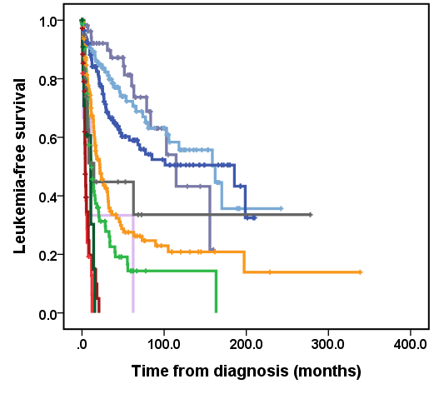  P<0.001 | 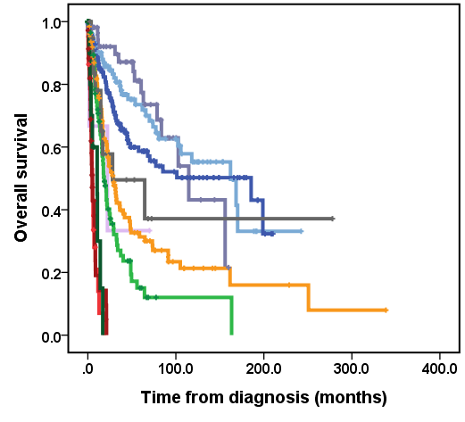  P<0.001
MDS with mutated SF3B1, n=59
MDS with del(5q), n=4
MDS, NOS with MLD, n=147
MDS with EB, n=131
MDS with mutated TP53, n=23
MDS/AML with MDS-related cytogenetics abnormalities, n=12
MDS/AML with mutated TP53, n=37
MDS/AML with MDS-related gene mutations, n=93
MDS, NOS with SLD, n=106
MDS/AML, NOS, n=20

Abbreviations: AML, acute myeloid leukemia; EB, excess blasts; MDS, myelodysplastic syndromes; MLD, multilineage dysplasia; NOS, not otherwise specified; SLD, single lineage dysplasia

Supplemental Figure 3. Kaplan-Meier curves for leukemia-free survival and overall survival in patients with myelodysplastic syndromes (MDS), not otherwise specified with single/multilineage dysplasia, classified according to the 2022 World Health Organization (WHO) classification
(a) Leukemia-free survival for patients with hypoplastic MDS (MDS-h) and MDS with low blasts (MDS-LB), classified according to the 2022 WHO classification
(b) Overall survival for patients with MDS-h and MDS-LB, classified according to the 2022 WHO classification
(a) | (b)
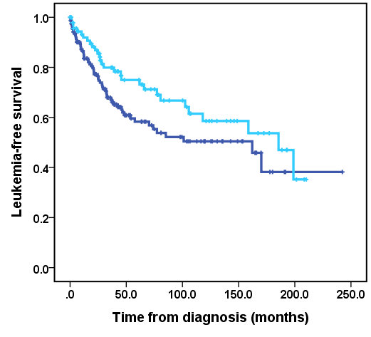  P=0.075  MDS-h , n=94  MDS-LB , n=156 | 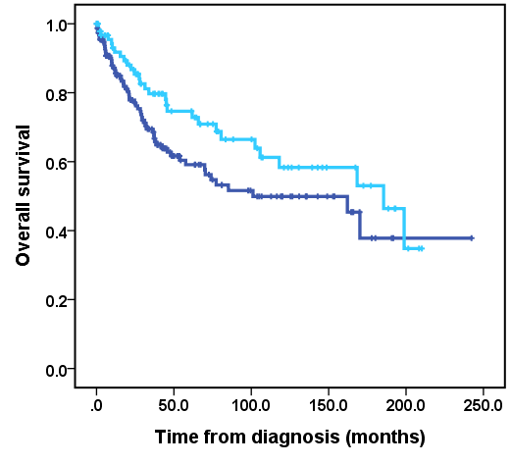  MDS-LB , n=156  MDS-h , n=94  P=0.070

Supplemental Figure 4. Kaplan-Meier curves for leukemia-free survival and overall survival in patients with myelodysplastic syndromes (MDS), with excess blasts, classified according to the 2022 World Health Organization (WHO) classification
(a) Leukemia-free survival for patients with MDS with increased blasts-1 (MDS-IB1), MDS with increased blasts-2 (MDS-IB2) and MDS with fibrosis (MDS-f), classified according to the 2022 WHO classification
(b) Overall survival for patients with MDS-IB1, MDS-IB2 and MDS-f, classified according to the 2022 WHO classification
(a) | (b)
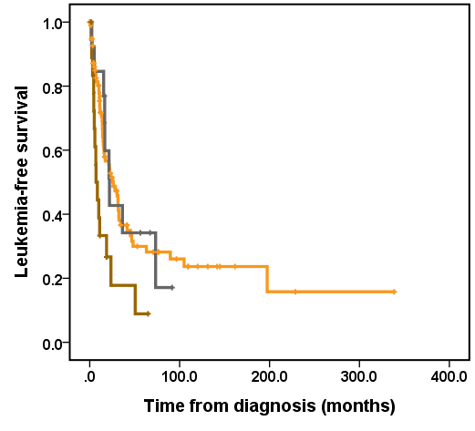  MDS-IB2, n=19  MDS-f, n=13  MDS-IB1, n=99  P=0.004  P=0.042  P=0.883 | 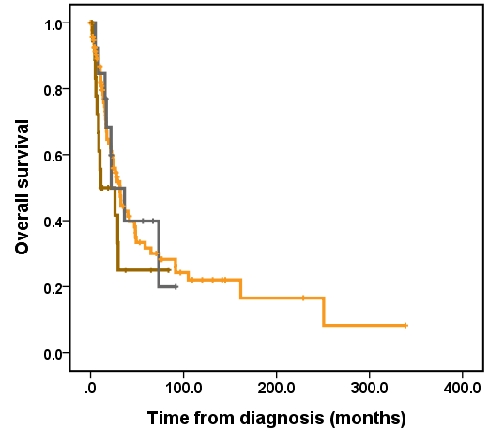  MDS-IB2, n=19  MDS-f, n=13  MDS-IB1, n=99  P=0.123  P=0.333  P=0.887

Supplemental Figure 5. Kaplan-Meier curves for leukemia-free survival and overall survival in patients with myelodysplastic syndromes (MDS) with mutated TP53, classified according to the 2022 World Health Organization (WHO) classification
(a) Leukemia-free survival for patients with MDS with biallelic TP53 inactivation (MDS-biTP53), MDS with increased blasts (MDS-IB), and MDS with fibrosis (MDS-f), classified according to the 2022 WHO classification
(b) Overall survival for patients with MDS-biTP53, MDS-IB, and MDS-f, classified according to the 2022 WHO classification
(a) | (b)
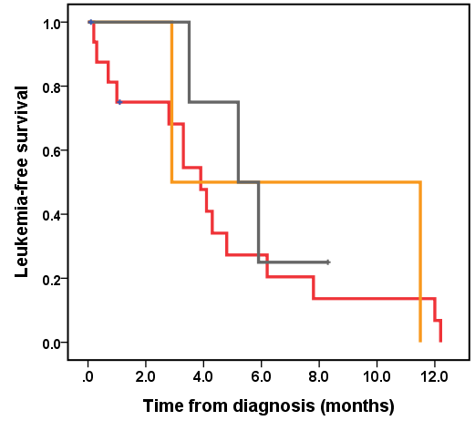  MDS-IB, n=2  MDS-f, n=4  MDS-biTP53, n=17  P=0.817  P=0.896  P=0.388 | 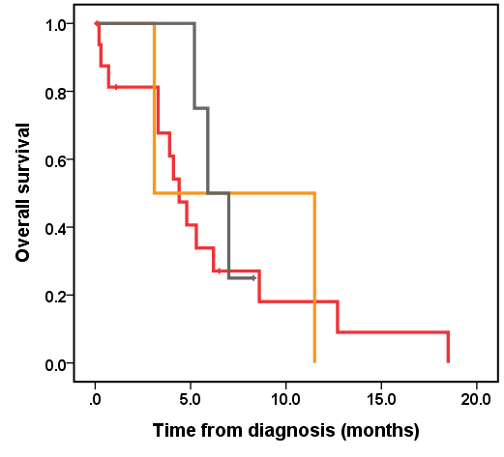  MDS-IB, n=2  MDS-f, n=4  MDS-biTP53, n=17  P=0.981  P=0.896  P=0.472

Supplemental Figure 6. Kaplan-Meier curves for leukemia-free survival and overall survival in patients with myelodysplastic syndromes/acute myeloid leukemia (MDS/AML) with MDS-related gene mutations, classified according to the 2022 World Health Organization classification
(a) Leukemia-free survival for patients with MDS with increased blasts-2 (MDS-IB2), and MDS with fibrosis (MDS-f), classified according to the 2022 WHO classification
(b) Overall survival for patients with MDS-IB2, and MDS-f, classified according to the 2022 WHO classification
(a) | (b)
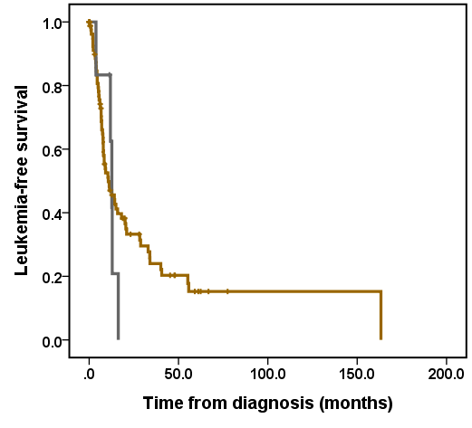  P=0.630  MDS-f, n=6  MDS-IB2, n=87 | 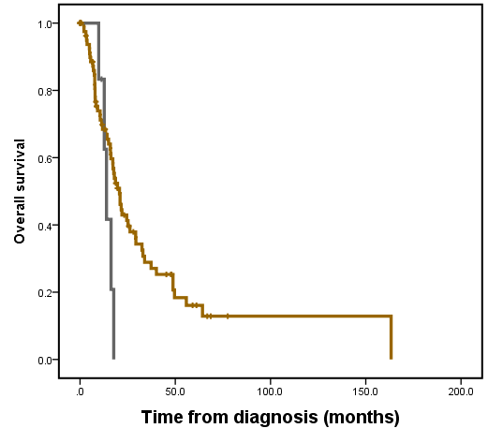  P=0.126  MDS-f, n=6  MDS-IB2, n=87

Supplemental Figure 7. Kaplan-Meier curves for leukemia-free survival and overall survival in patients with myelodysplastic neoplasms (MDS) with low blasts, classified according to the International Consensus Classification (ICC)
(a) Leukemia-free survival for patients with MDS, not otherwise specified with single lineage dysplasia (MDS, NOS with SLD), and MDS, NOS with multilineage dysplasia (MLD), classified according to the ICC
(b) Overall survival for patients with myelodysplastic syndromes for patients with MDS, NOS with SLD and MDS, NOS with MLD, classified according to the ICC
(a) | (b)
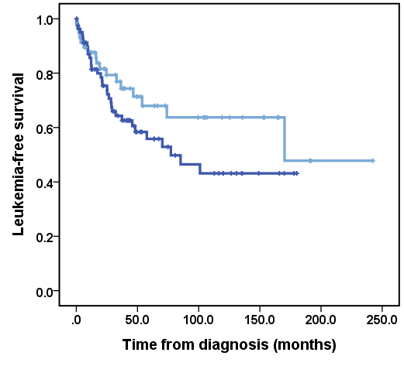  P=0.153  MDS, NOS with MLD, n=82  MDS, NOS with SLD, n=58 | 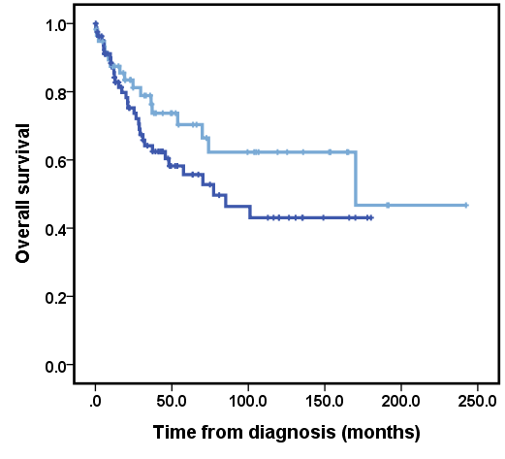  P=0.140  MDS, NOS with MLD, n=82  MDS, NOS with SLD, n=58

Supplemental Figure 8. Kaplan-Meier curves for leukemia-free survival and overall survival in patients with myelodysplastic neoplasms (MDS) with biallelic TP53 inactivation, classified according to the International Consensus Classification (ICC)
(a) Leukemia-free survival for patients with MDS/acute myeloid leukemia (AML) with mutated TP53 and MDS with mutated TP53, classified according to the ICC
(b) Overall survival for patients with MDS/AML with mutated TP53 and MDS with mutated TP53, classified according to the ICC
(a) | (b)
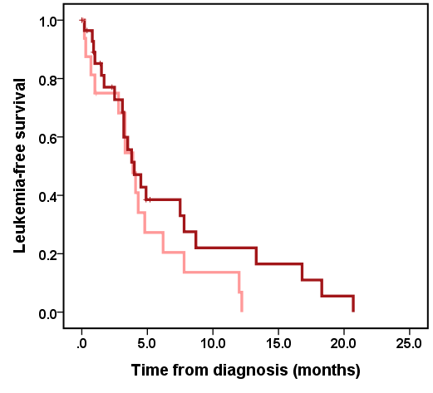  MDS with mutated TP53, n=17  P=0.211  MDS/AML with mutated TP53, n=29 | 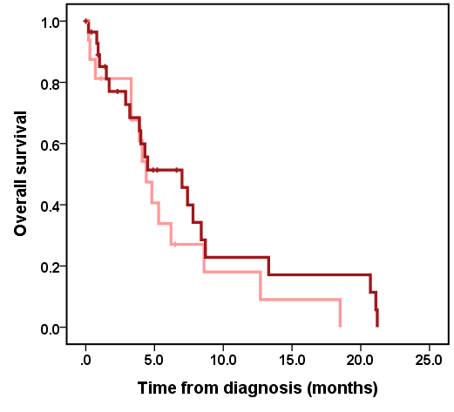  MDS/AML with mutated TP53, n=29  MDS with mutated TP53, n=17  P=0.293

Supplemental Figure 9. Kaplan-Meier curves for leukemia-free survival and overall survival in patients with myelodysplastic neoplasms (MDS) with increased blasts-2, classified according to the International Consensus Classification (ICC)
(a) Leukemia-free survival for patients with MDS/acute myeloid leukemia (AML), not otherwise specified (NOS), MDS/AML with MDS-related gene mutations, MDS with excess blasts (EB), MDS/AML with MDS-related cytogenetics abnormalities, and MDS/AML with mutated TP53, classified according to the ICC
(b) Overall survival for patients with MDS/AML-NOS, MDS/AML with MDS-related gene mutations, MDS with EB, MDS/AML with MDS-related cytogenetics abnormalities, and MDS/AML with mutated TP53, classified according to the ICC
(a)
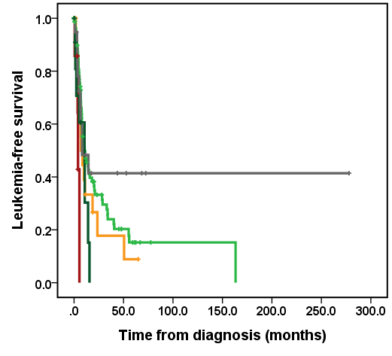
MDS with EB, n=19
MDS/AML with MDS-related cytogenetics abnormalities, n=12
MDS/AML with mutated TP53, n=8
MDS/AML with MDS-related gene mutations, n=87
MDS/AML-NOS, n=19
P=0.043
P=0.004
P=0.052
P=0.301
P=0.310
P=0.399
P=0.240

(b)
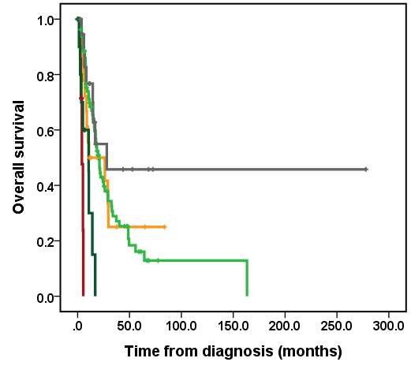
MDS with EB, n=19
MDS/AML with MDS-related cytogenetics abnormalities, n=12
MDS/AML with mutated TP53, n=8
MDS/AML with MDS-related gene mutations, n=87
MDS/AML-NOS, n=19
P<0.001
P<0.001
P<0.001
P=0.123
P=0.864
P=0.131
P=0.058

Supplemental Figure 10. Kaplan-Meier curves for leukemia-free survival and overall survival in patients with myelodysplastic neoplasms (MDS) with fibrosis, classified according to the International Consensus Classification (ICC)
(a) Leukemia-free survival for patients with MDS with excess blasts (EB), MDS/acute myeloid leukemia (AML) with MDS-related gene mutations, and MDS with mutated TP53, classified according to the ICC
(b) Overall survival for patients with MDS with EB, MDS/AML with MDS-related gene mutations, and MDS with mutated TP53, classified according to the ICC
(a)
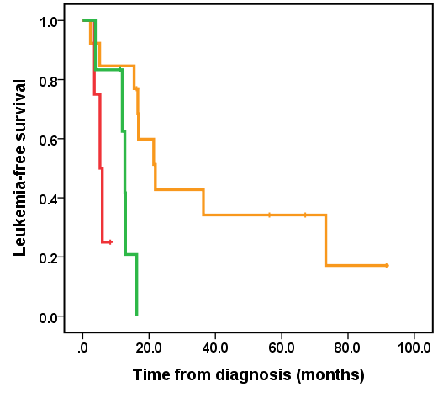
MDS/AML with MDS-related gene mutations n=6
MDS with mutated TP53, n=4
MDS with EB, n=13
P=0.005
P=0.091
P=0.032

(b)
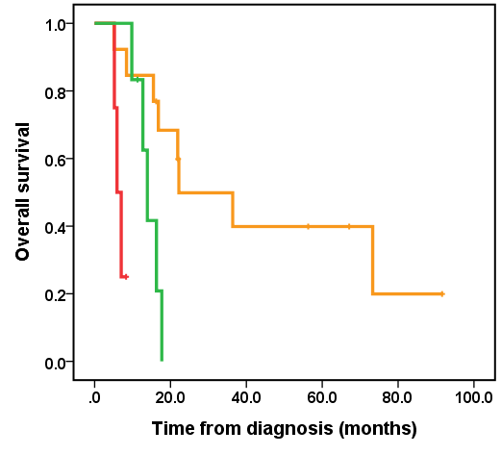
MDS/AML with MDS-related gene mutations n=6
MDS with mutated TP53, n=4
MDS with EB, n=13
P=0.015
P=0.012
P=0.007

