Supplementary Information

One-pot microfluidic fabrication of micro ceramic particles
Chenchen Zhou^{1,2}, Shuaishuai Liang³, Bin Qi³, Chenxu Liu², Nam-Joon Cho^{1,}*
¹School of Materials Science and Engineering, Nanyang Technological University, 639798 Singapore, Singapore
²Department of Mechanical Engineering, Tsinghua University, Beijing 100084, P.R. China
³School of Mechanical Engineering, University of Science and Technology Beijing, Beijing 100083, P.R. China

Table of Contents
S1 “Groove & tongue” assembling for gear-shaped MC fabrication 5
S2 Rheological test 9
S3 Sliding assembling for MCs fabrication 10
S4 Characterizations of MP green bodies 12
S5 Scratch tests 17
S6 Characterization of MP’s corner 20
S7 Assessment of our OPMF system 21
References 24

S1 “Groove & tongue” assembling for gear-shaped MC fabrication
The standard parameters of micro gear are selected as follows: module m = 0.1, pitch diameter d = 1 mm, outer diameter D_{o} = 1.2 mm, root diameter D_{r} = 0.75 mm. The cross-section area a_{g} and length of the gear outer contour l_{g} are calculated as 0.7557 mm² and 6.1370 mm, respectively. The assembled MC is divided into ten pieces, according to which a convex metal mold is designed (Supplementary Fig. 1a). To ensure the precision of the MC fabrication, a reverse molding strategy (Supplementary Fig. 2) is presented. An additional concave PDMS reverse mold demolded from the metal mold serves as an intermediary MC features transferer (Supplementary Fig. 1b), which is to ensure the convex feature of the initial machined metal mold so as to get rid of influences from the non-negligible diameter of machining wires as much as possible, therefore avoiding the rounded features in PDMS substrate that will lead to wedge-shaped channel conners consequently. The obtained MC substrate is cut into ten pieces (Supplementary Figs. 1c,d,3a). The partially enlarged views of a single MC piece (Supplementary Fig. 1e) schematically show an intact contour of a gear tooth and intermediate groove and tongue. The separated MC pieces are assembled one by one and finally form an MC with a closed gear-shaped cross-section (Supplementary Figs. 1f−h). The outer contour of MC is a regular decagon, and the distance between MC’s inner surface and outer surface is too thick for efficient heat transfer. Thus, the peripheral part of MC is cut to form a square outer shape, and the scratches caused by the cutting process are eliminated by coating a thin layer of PDMS, therefore, the top view of the straight gear-shaped MC can be observed (Supplementary Fig. 3b).
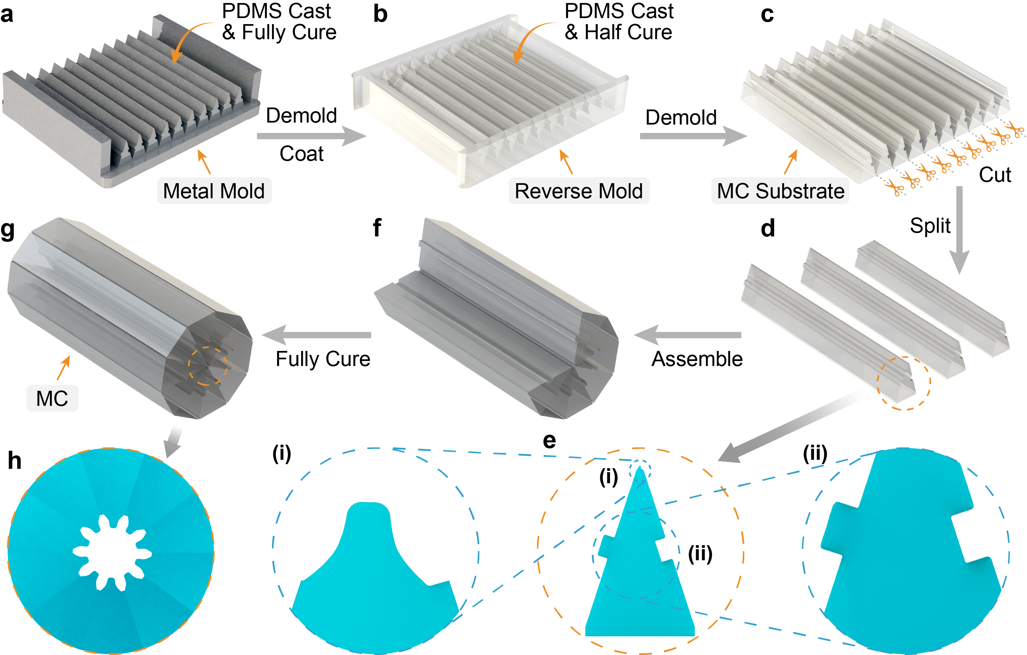

Supplementary Fig. 1 | Fabrication of gear-shaped MCs based on precise “groove & tongue” assembling. a, Liquid PDMS prepolymer was cast and fully cured over the metal mold with designed structures. b, PDMS reverse mold was peeled off and coated with the releasing agent, followed by casting and half-curing of the new batch of PDMS prepolymer. c, MC substrate was demolded and cut into pieces. d, The split MC piece each has an entire profile of e-i, one gear tooth on the tip and e-ii, groove & tongue structures at the side walls. f, The split MC pieces were assembled subsequently and fully cured to form g, a closed MC with h, a gear-shaped cross-section.

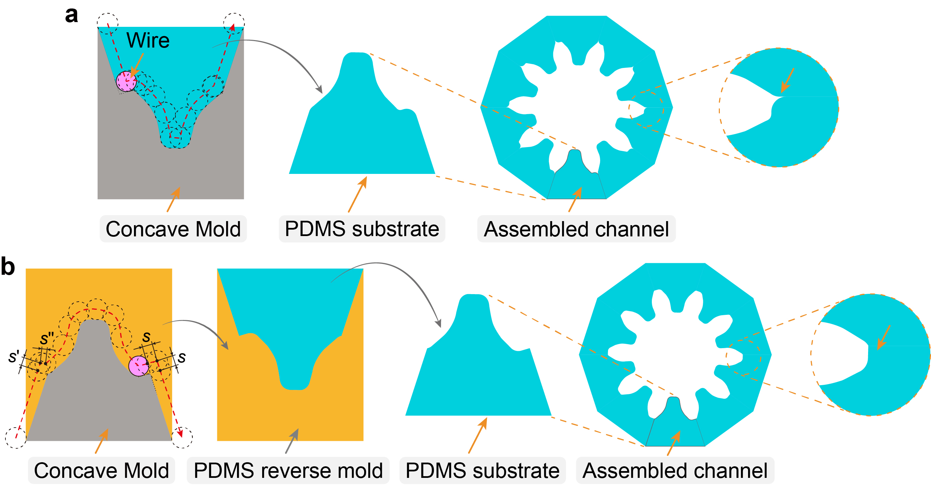

Supplementary Fig. 2 | Comparison between traditional direct molding and novel reverse molding strategies for gear-shaped MCs fabrication. a, Traditional direct molding: The concave edge of the wire-cut metal mold is roundly shaped with a corner radius that equals the wire’s radius instead of being sharp, which causes wedge-shaped defects in the channel. b, Novel reverse molding: An additional PDMS reverse mold is introduced as an intermediary MC features transferer to remove the influences from the non-negligible thickness of the machining wire to the utmost extent. Once the cutting wire meets the convex edges, two spare moving distances are additionally incorporated into the processing path of the wire. The wire trace is denoted as the red dotted line with an arrow. The sharpness of the convex edge is well-defined, contributing to fabricating assembled MCs with high precision.

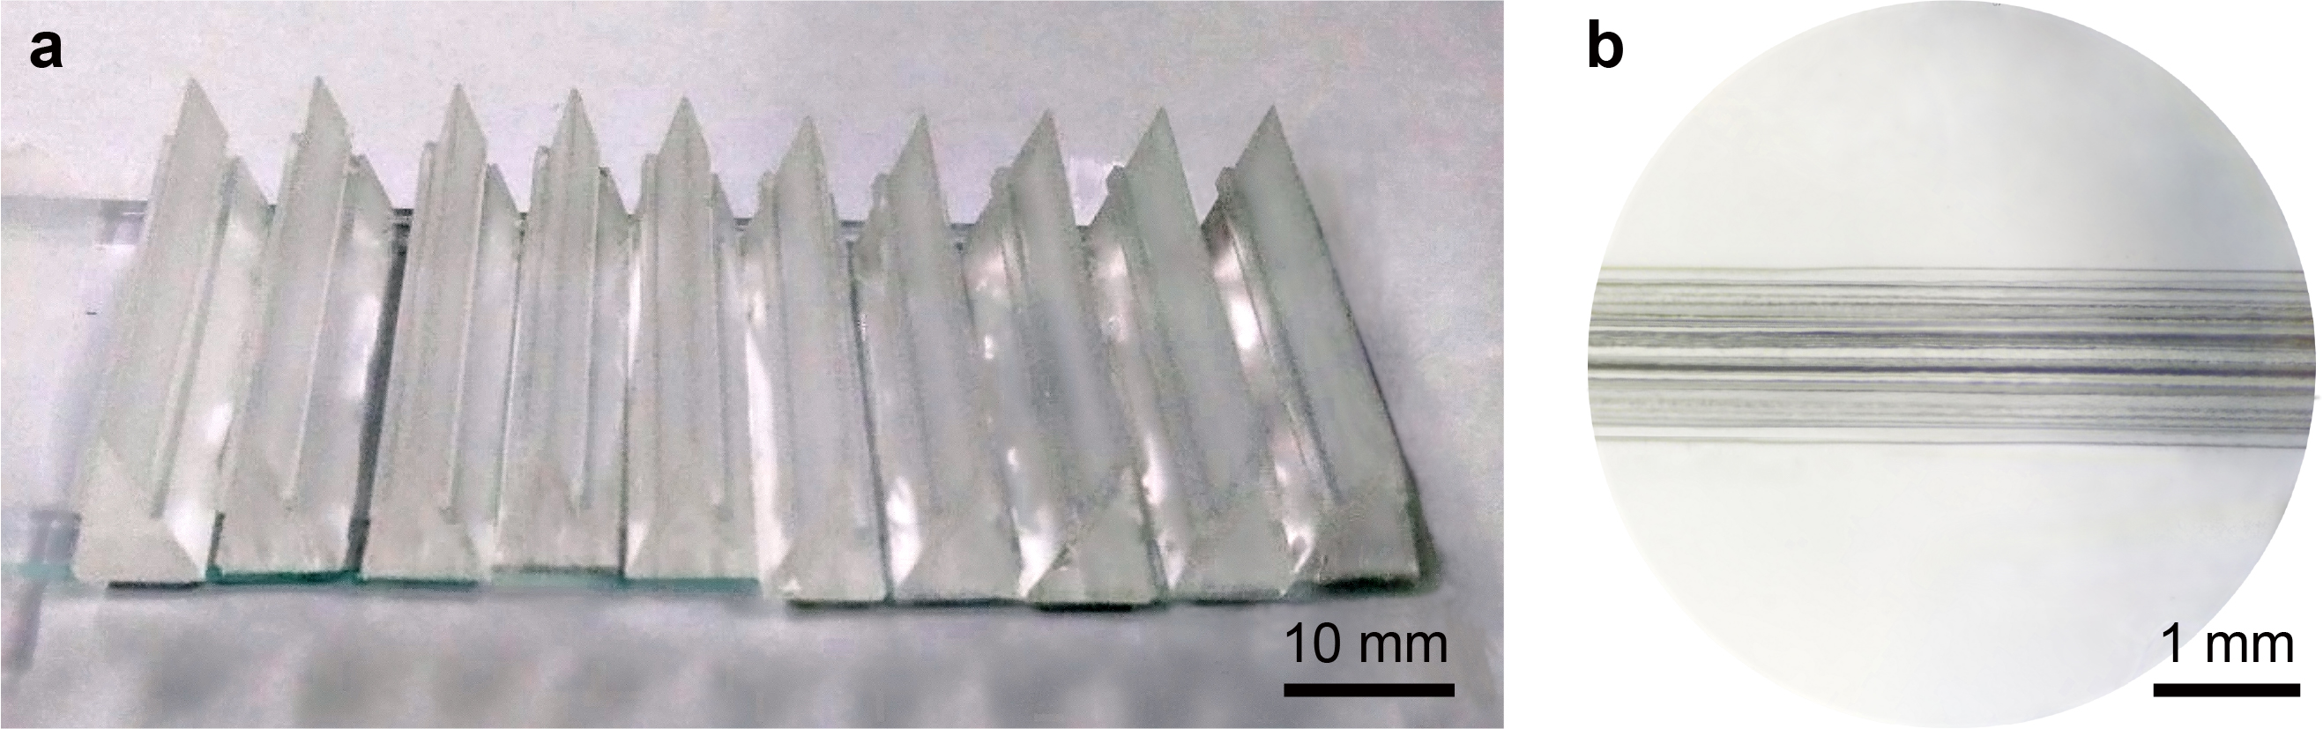

Supplementary Fig. 3 | Structural characterizations of the gear-shaped MC. a, Optical image of the precisely assembled gear-shaped MC substrate after cutting the thin layer of PDMS joints between adjacent pieces. b, Optical image of the gear-shaped MC from the top view. The gear-shaped MCs were first peeled peripherally to form a square outer shape, and then the peeling scratches were smoothed by applying a thin layer of PDMS coating.

S2 Rheological test
The modulus variation of the mixing precursor as temperature increases is imitated in a rheometer set-up with constant humidity (Supplementary Fig. 4). BS is initially filled in the gap between the spindle bottom and the substrate base. The temperature of this set-up is raised from 20 to 70 ℃ at a rate of 6.49 ℃/min. Proportionate CS is added into BS at room temperature (RT, 25 ℃).
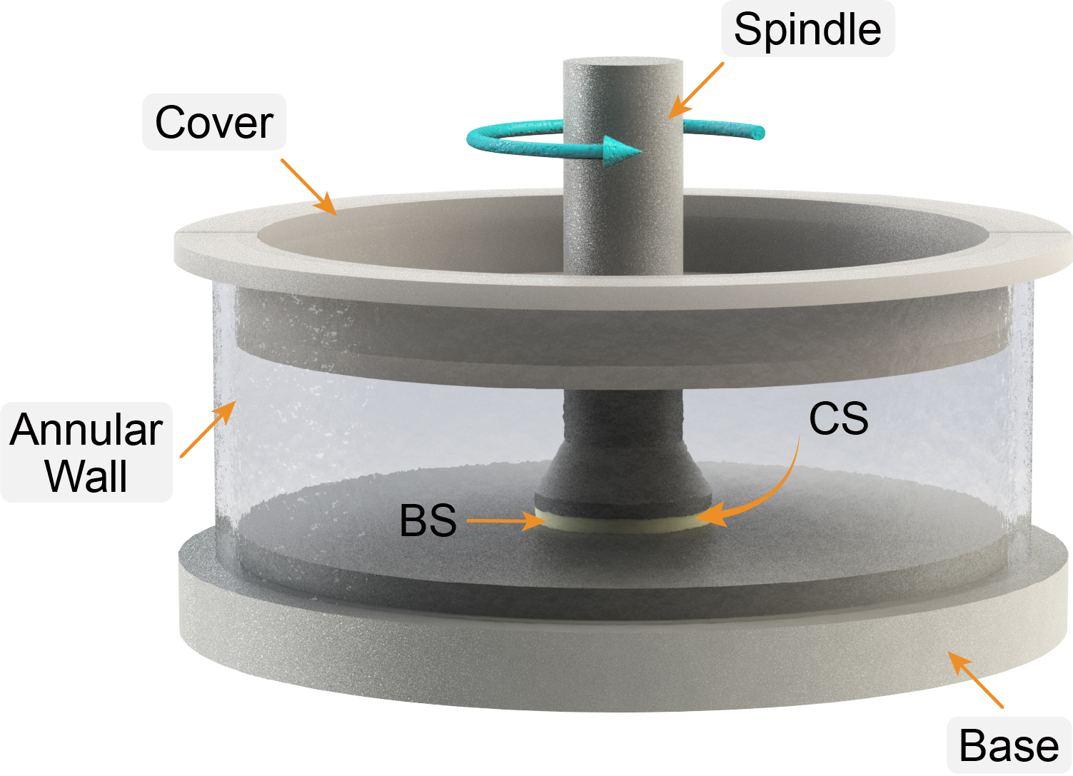

Supplementary Fig. 4 | Rheological measurement setup. Modulus change of the precursor is imitated and monitored during the curing process inside MC.

S3 Sliding assembling for MCs fabrication
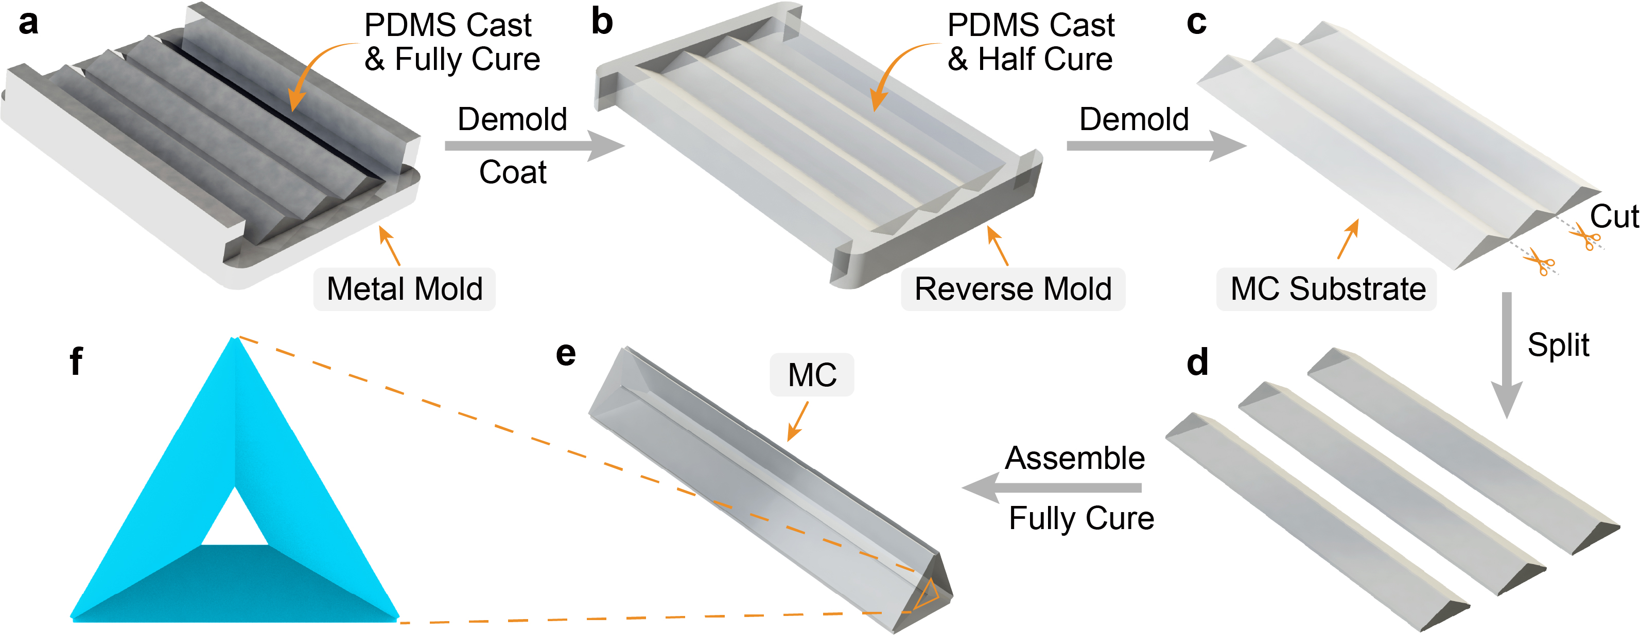

Supplementary Fig. 5 | Fabrication of triangular MCs based on sliding assembling. a, Liquid PDMS prepolymer was cast and fully cured over the metal mold with designed structures. b, PDMS reverse mold was peeled off and coated with the releasing agent, followed by casting and half-curing of the new batch of PDMS prepolymer. c, MC substrate was demolded and cut into pieces along the seams. d, The split MC pieces were assembled and fully cured to form g, a closed MC with f, a regular triangular cross-section.

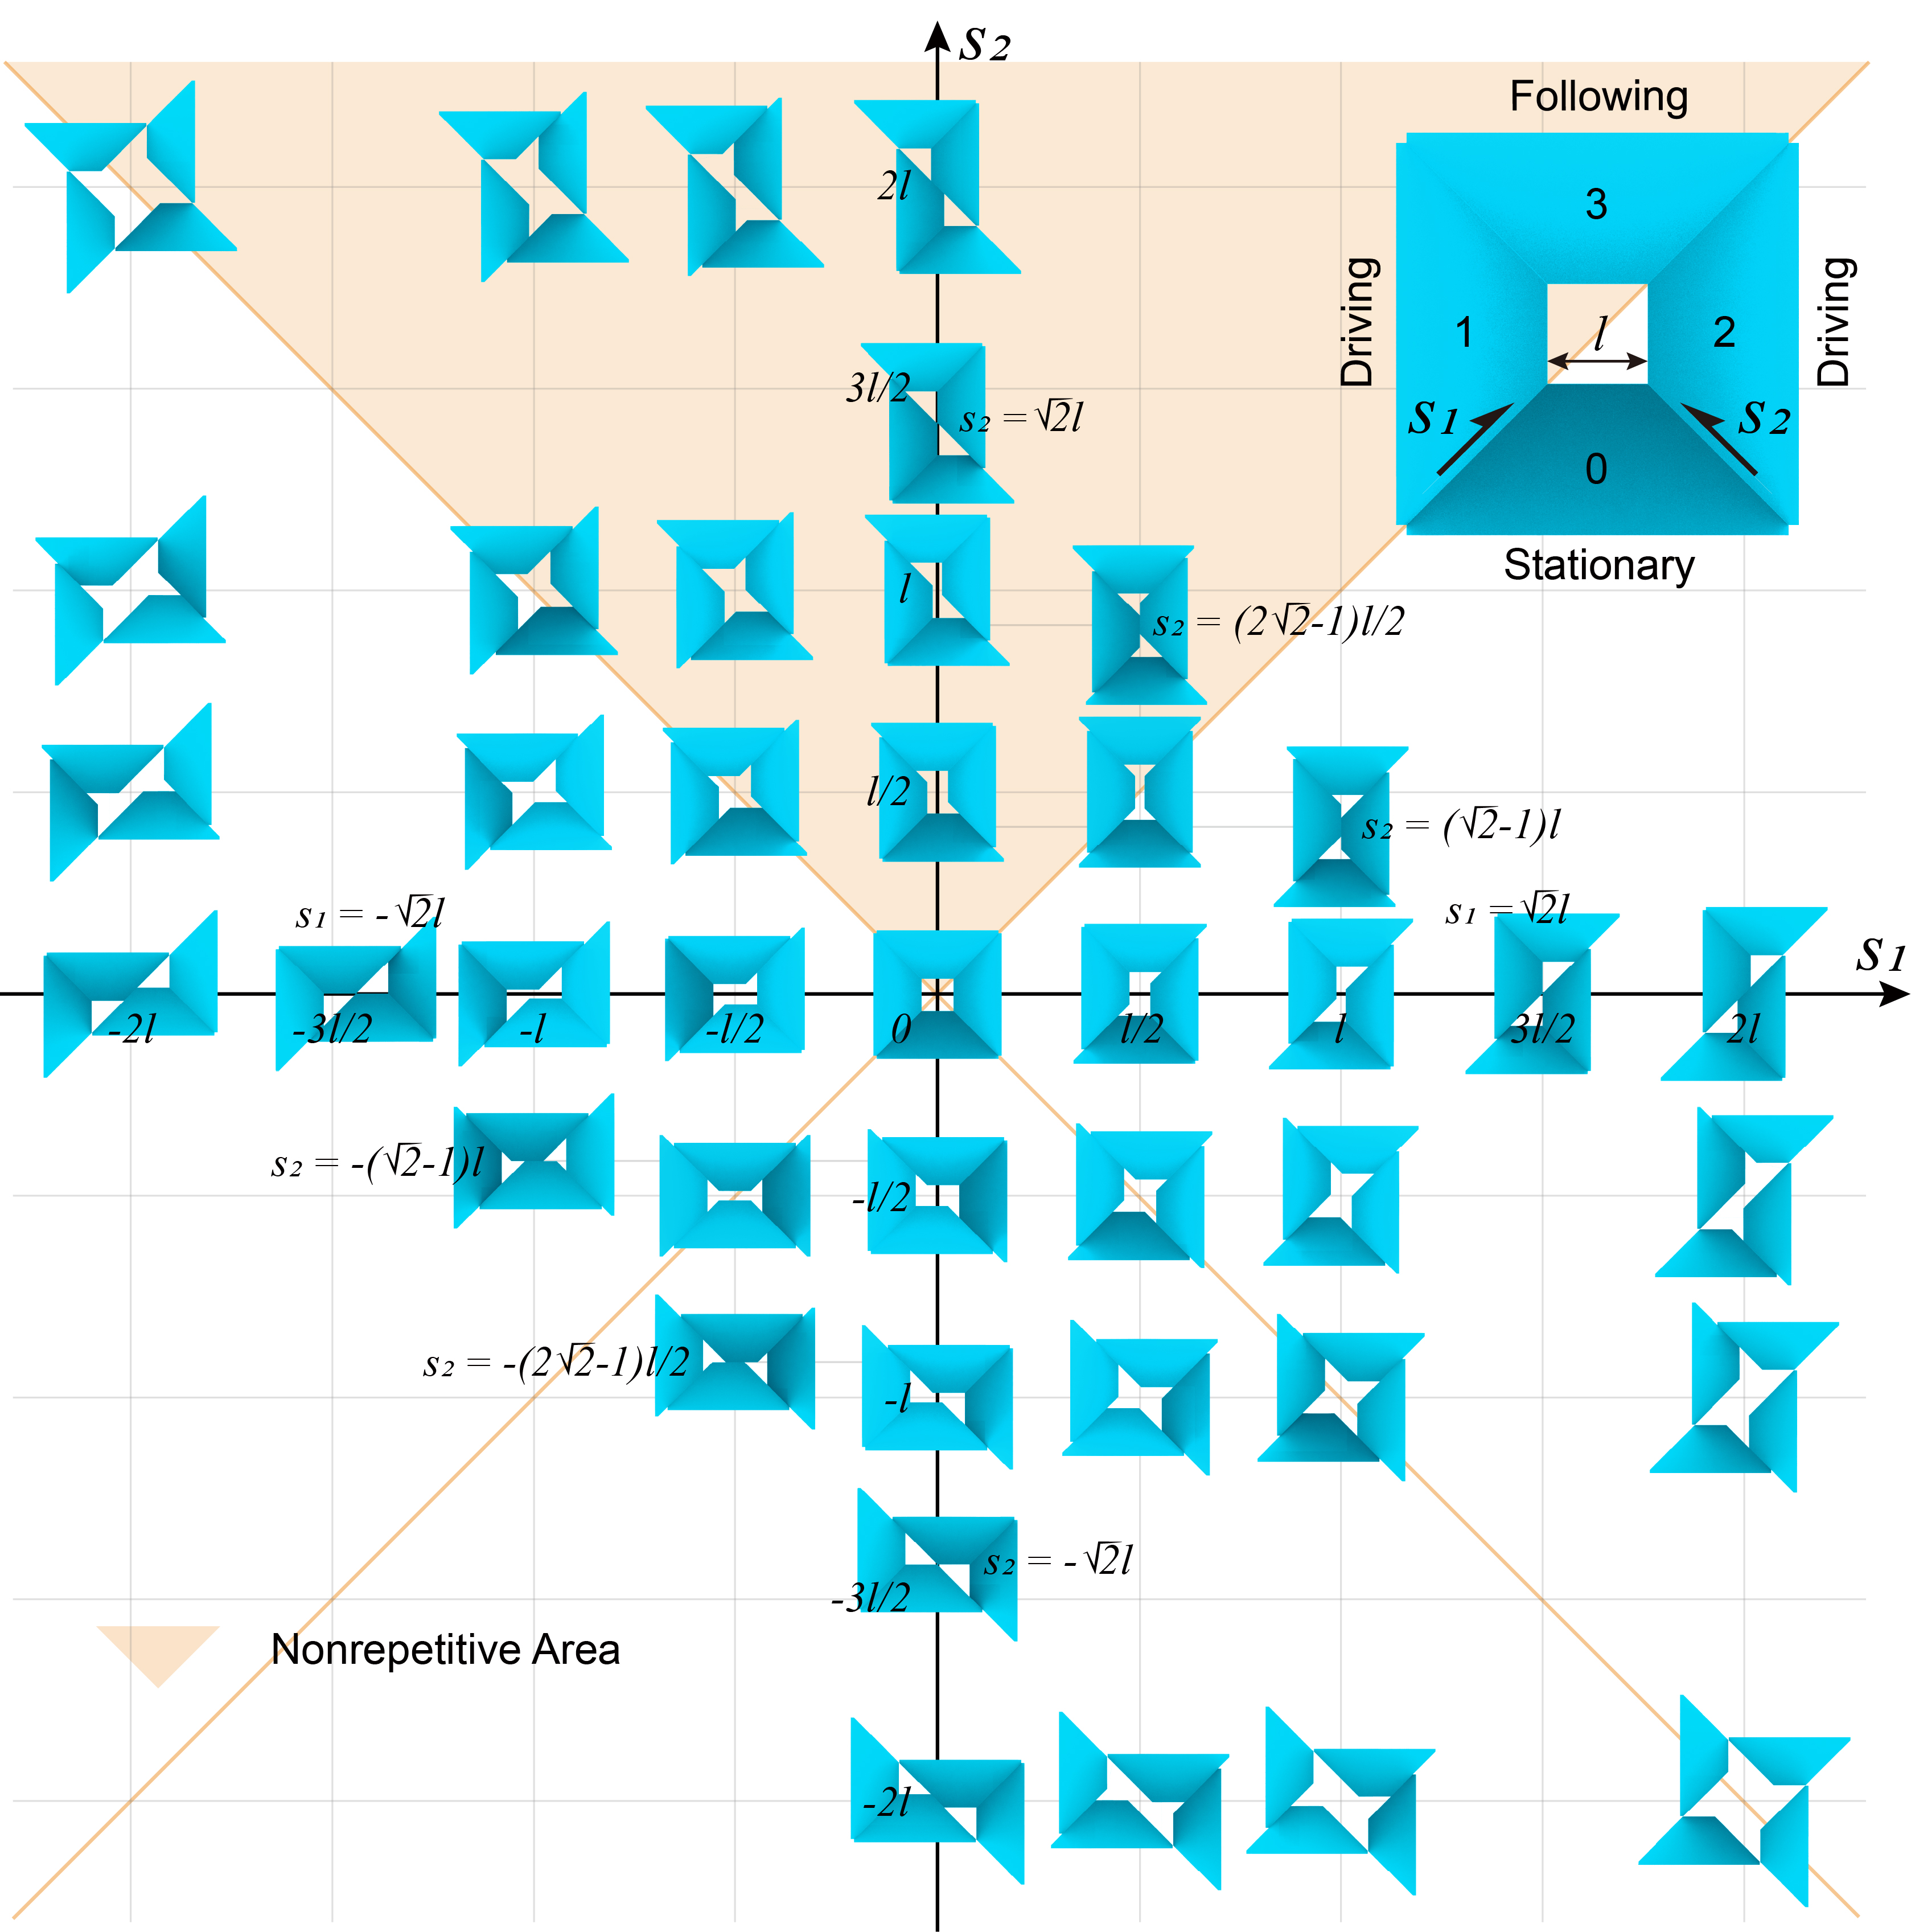

Supplementary Fig. 6 | Schematic illustrations of the intact map for square MC sliding assembling. The cross-sections of MC transform through tuning the sliding distance s₁ and s₂.

S4 Characterizations of MP green bodies
The compositions and structures of the obtained MP green bodies and a pure polyacrylamide (PAM) control sample are characterized by Fourier transform infrared (FTIR) spectroscopy (Supplementary Fig. 7). The absorption peaks at 3348 and 3190 cm⁻¹ are attributed to the asymmetric and symmetric stretching vibration of −NH₂ groups, respectively. The absorption peak at 2924 cm⁻¹ is associated with the stretching vibration of −CH₂ groups included in macromolecular chains and crosslinking bridges, while 2853 cm⁻¹ is assigned to −N−CH₂− bonds from the crosslinking bridges. The absorption peak associated with the stretching vibration of C=O red shifts (from ~1700 to 1647 cm⁻¹) due to the conjugation effect with −NH₂ and −NH− groups¹. Deformation vibrations corresponding to −NH− appear at 1536 cm⁻¹ ². The absorption peak at 1448 cm⁻¹ is for −CH₂− bending vibration¹. These FT-IR analysis results indicate the major functional groups of PAM are detected, while the intensity of the individual absorption peak varies with the sample species. The absorption peaks of SiO₂+PAM samples at 1050 and 794 cm⁻¹ are detected to be assigned to the asymmetric and symmetric stretching vibration of Si−O−Si, respectively³. For Al₂O₃+PAM samples, the absorption peak at 713 cm⁻¹ is assigned to Al–O stretching mode in tetrahedron⁴. The absorption band of Si₃N₄+PAM samples, assigned to Si−N stretching vibration, centers at 852 cm⁻¹ ⁵.
XPS is further used to characterize the compositions of MP green bodies (Supplementary Fig. 8). The broad-spectrum scan reveals the elemental compositions of all the samples. Compared with pure PAM, SiO₂+PAM and Al₂O₃+PAM have additional Si and Al elements, respectively, while the Si₃N₄+PAM sample not only has Si but also contains Al and Y elements, which come from the sintering aids. The peaks from high-resolution XPS spectra of each element at different binding energies correspond to the characteristic compositions of samples. The superimposed curve from three individual intensity peaks corresponding to C−C, C−N, and N−C=O aligns well with the signal spectrum curve. Similarly, the characteristic peaks of CONH₂ and N−C−N can also be split from the spectrum of N 1s. Notably, another peak at 397.1 eV is detected in the Si₃N₄+PAM sample, which is assigned to compound Si₃N₄. In O 1s spectrum, the peaks at binding energy of 533.0, 531.3, and 531.1 eV are attributed to SiO₂, Al₂O₃, and Al₂O₃, respectively in SiO₂+PAM, Al₂O₃+PAM, and Si₃N₄+PAM samples, and Si 2p, Al 2p, Si 2p XPS tests show the characteristic peaks corresponding to SiO₂, Al₂O₃, and Si₃N₄ in these samples. Peaks for sintering additive Y₂O₃ are detected in Y 3d and 3p spectra, while Al₂O₃ is testified in Al 2p spectrum.
The EDX mapping images of three MP green body samples show that the compositional elements of each sample are well-mixed and distributed uniformly (Supplementary Fig. 9), indicating the homogeneous mixing effect of our OPMF system.

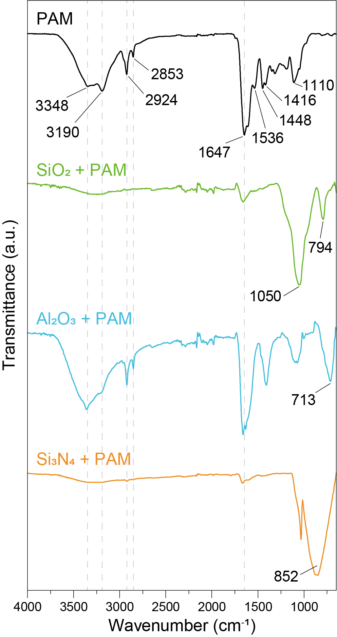

Supplementary Fig. 7 | FTIR spectra for composition identification of SiO₂/Al₂O₃/Si₃N₄ MP green bodies. A pure PAM sample is compared here as a control sample.

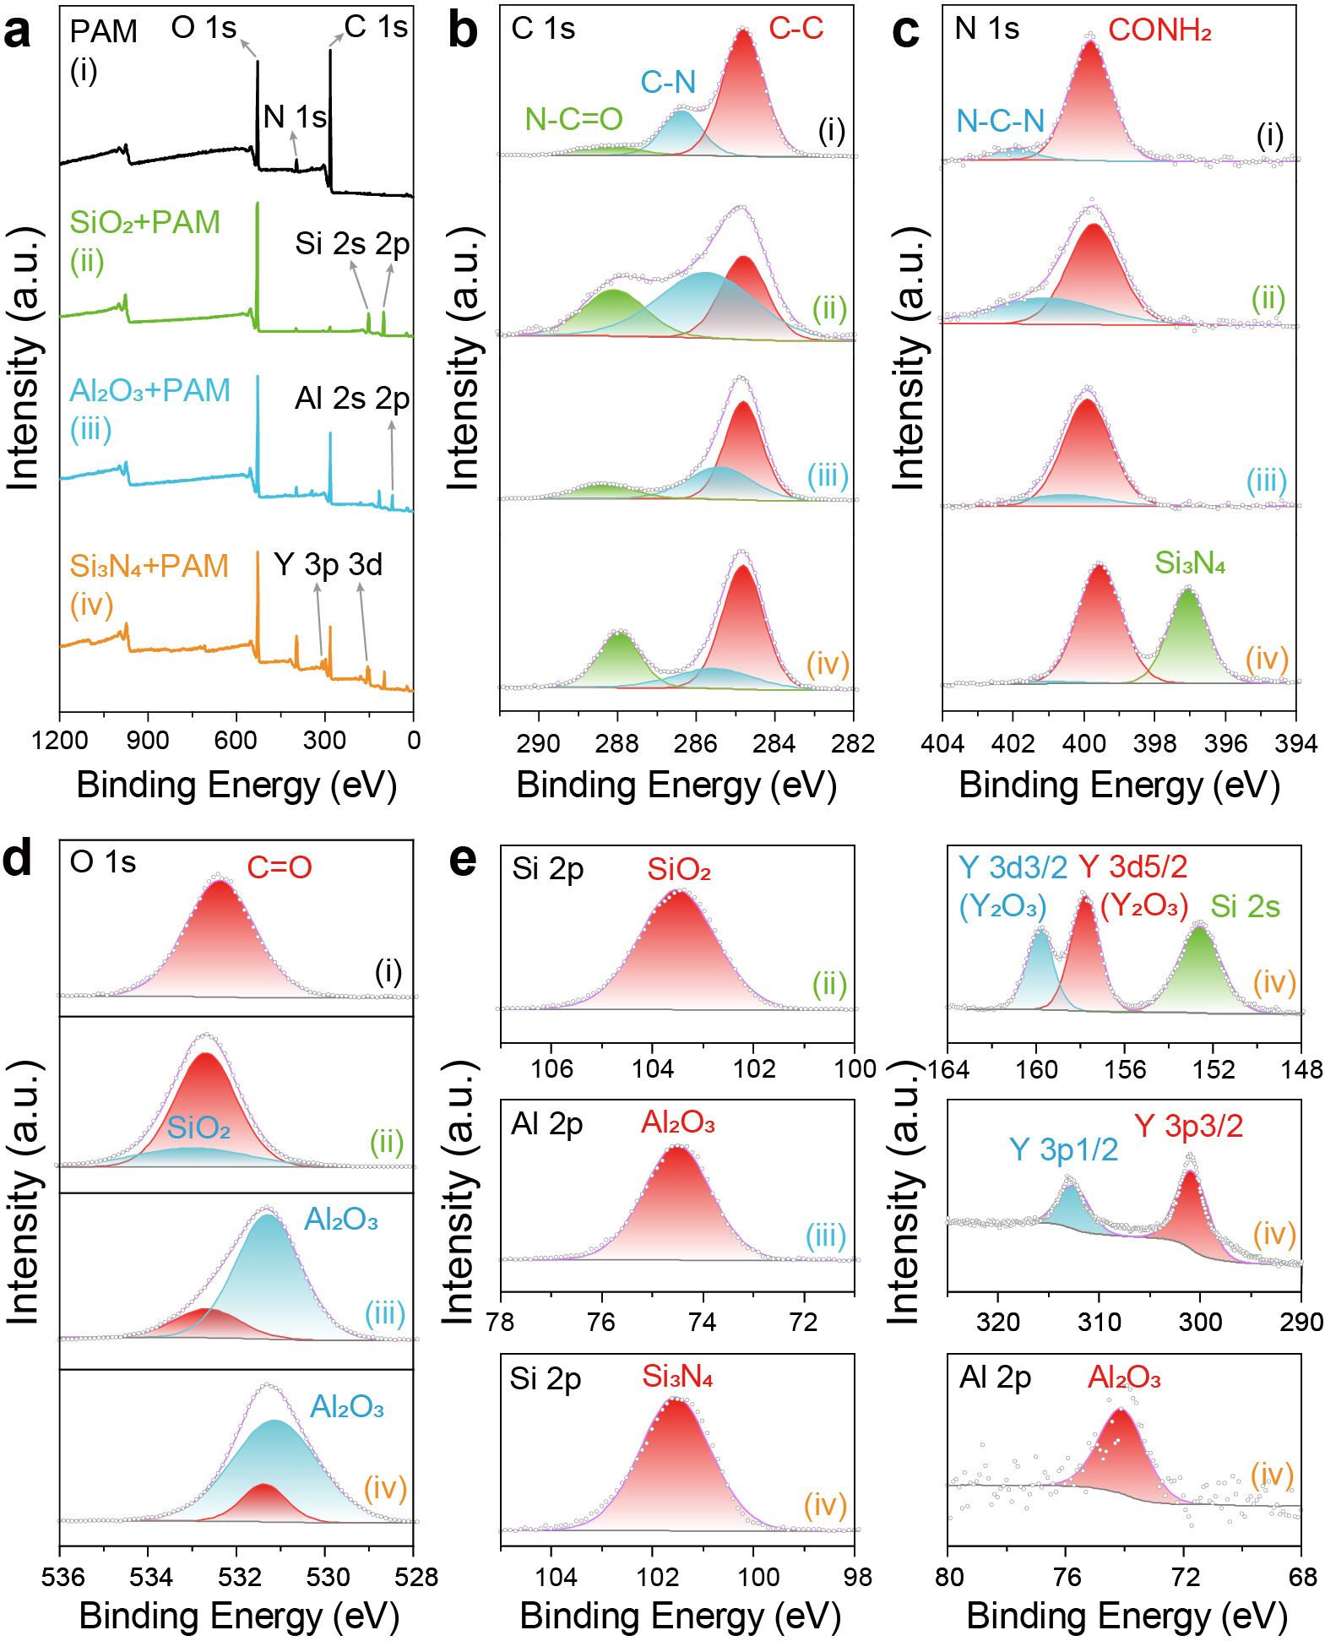

Supplementary Fig. 8 | XPS spectra for composition identification of SiO₂/Al₂O₃/Si₃N₄ MP green bodies. a, full scan, b, C 1s, c, N 1s, d, O 1s, e, other typical elemental XPS spectra of different samples. A pure PAM sample is compared here as a control sample.

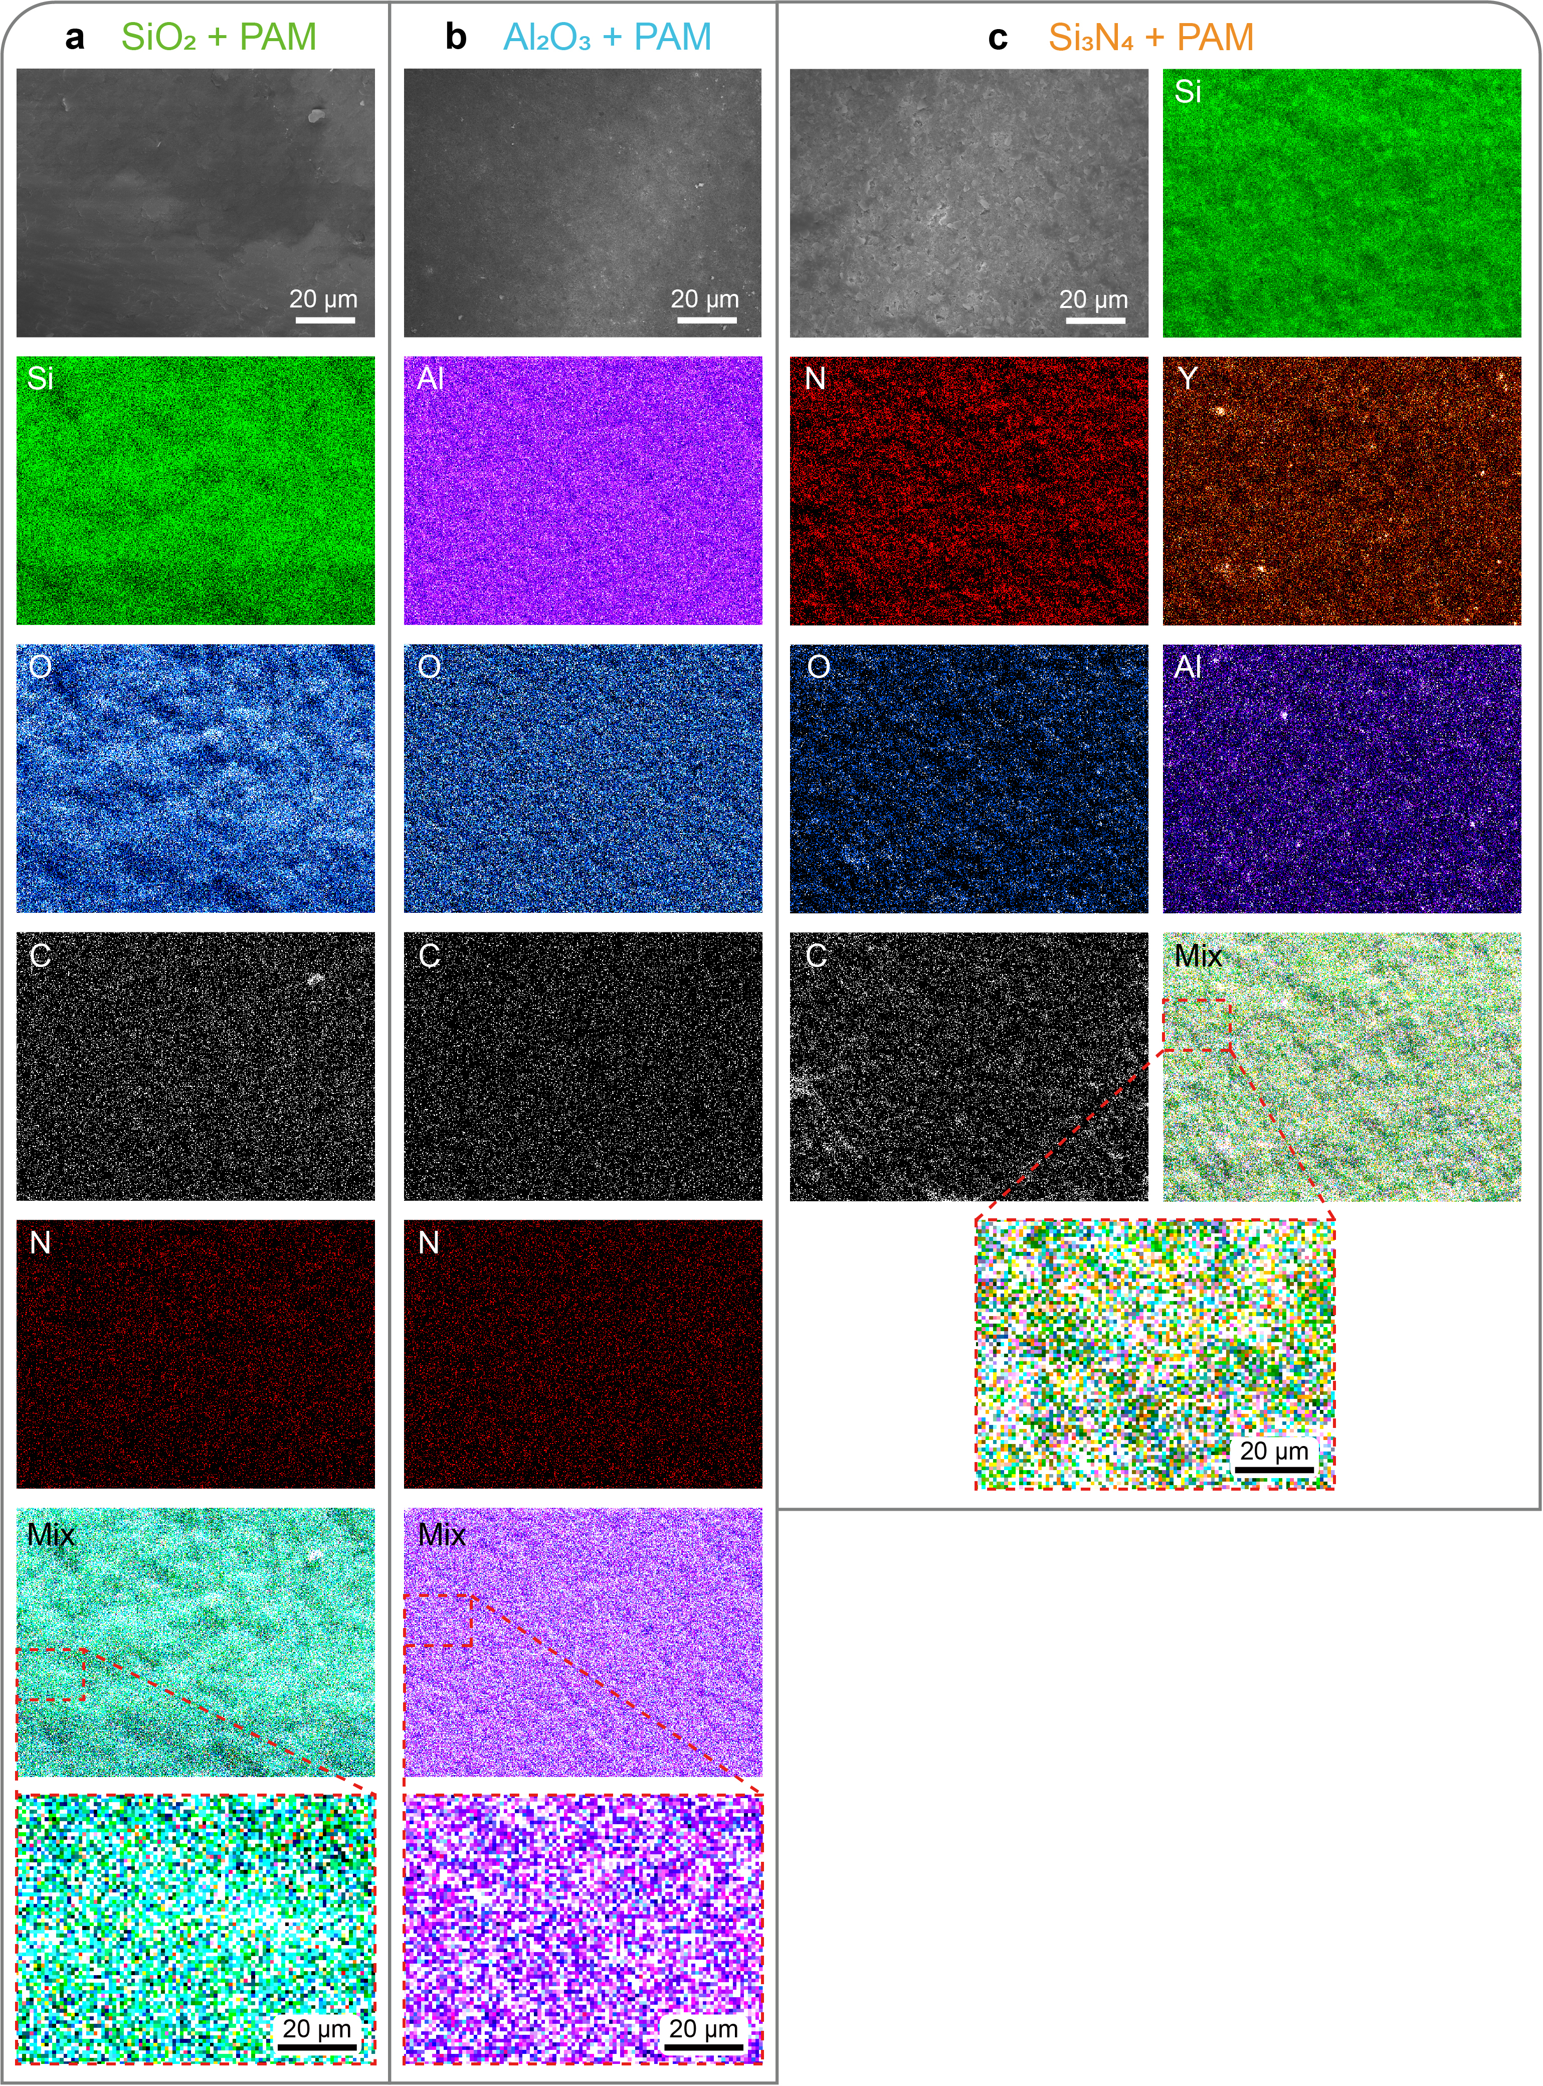

Supplementary Fig. 9 | EDX mapping results showing the individual channels for specific elements distribution. a, SiO₂, b, Al₂O₃ and c, Si₃N₄ MP green bodies’s surface.

S5 Scratch tests
Scratches from the MPs of S-Al₂O₃, T/S-SiO₂, and T/S-Si₃N₄ are characterized in a similar way as the Scratches caused by T-Al₂O₃ MPs (Supplementary Figs. 10−12).

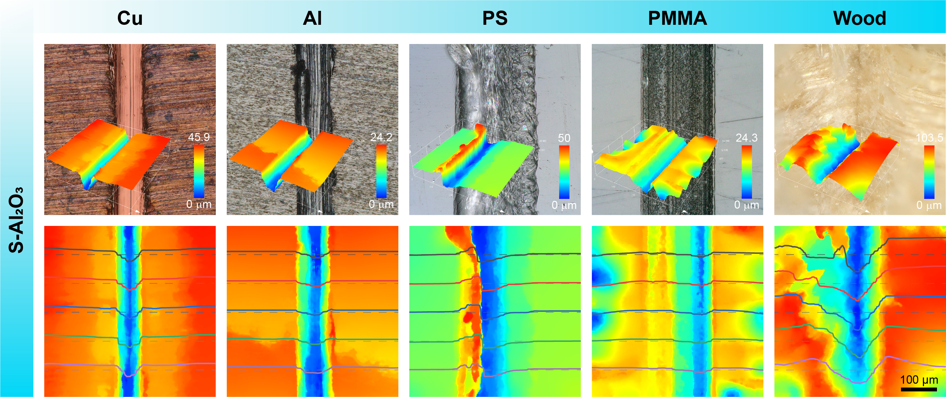

Supplementary Fig. 10 | Scratch test results of star-shaped Al₂O₃ MPs on substrates made of different materials, including Cu, Al, PS, PMMA, and wood.

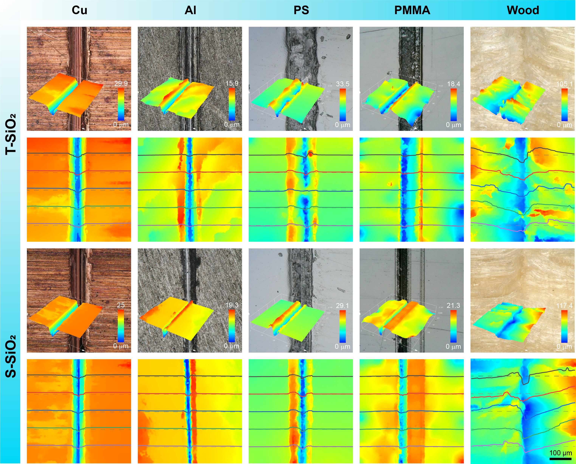

Supplementary Fig. 11 | Scratch test results of isosceles triangular and star-shaped SiO₂ MPs on substrates made of different materials, including Cu, Al, PS, PMMA, and wood.

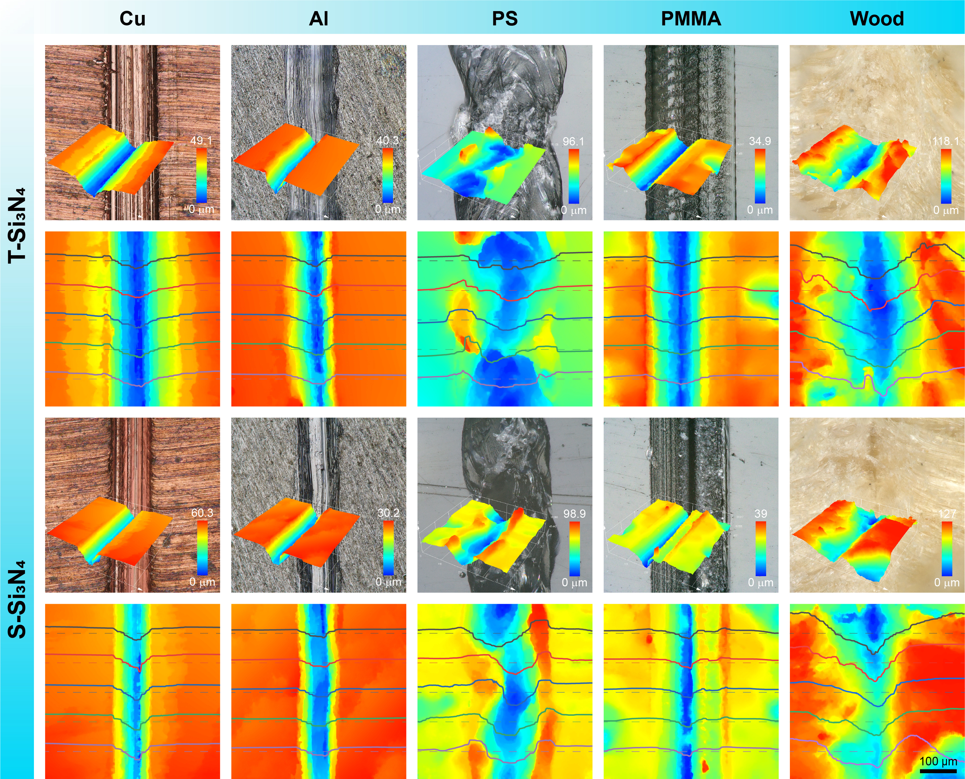

Supplementary Fig. 12 | Scratch test results of isosceles triangular and star-shaped Si₃N₄ MPs on substrates made of different materials, including Cu, Al, PS, PMMA, and wood.

S6 Characterization of MP’s corner
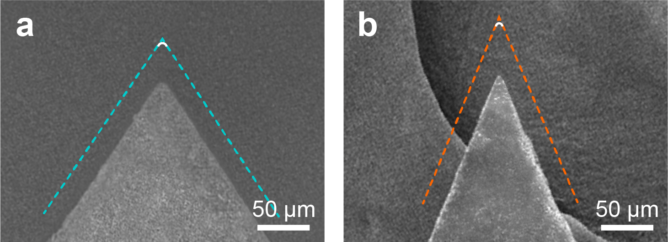

Supplementary Fig. 13 | SEM images of a, triangular and b, star-shaped Al₂O₃ MPs’ corners. The edge radiuses are about 4.78 and 1.32 μm, respectively.

S7 Assessment of our OPMF system

Supplementary Table 1 | Literature investigations on various methods for microtools manufacture have been reported so far.
Method | D_{c} (μm) | L (μm) | Cross-section shape | N | Processing rate (μm³/min) | Precision (μm) | Material | Ref.
µWEDM | 100 | 100 | D shape | 2 | 8726.64626 | R_{a} 0.06, R_{z} 0.1, R_{max} 0.3 | WC | 2004⁶
µWEDM | 50 | 500 | Circle | 1 | 15387.89505 | R_{a} 0.15 | Tungsten | 2004⁷
µWEDM | 50 | 500 | Circle | 1 | 14024.9672 | R_{a} 0.26 | Tungsten | 2004⁷
µWEDM | 50 | 500 | Circle | 1 | 4095.735103 | R_{a} 0.45 | Tungsten | 2004⁷
µWEDM | 50 | 135 | Circle | 1 | N.A. | R_{a} 0.06, 0.13, 0.53, 0.78 | PCD | 2004⁸
µWEDM | 80 | 525 | Circle | 1 | N.A. | R_{a} 0.12 | X38CrMoVS_1 steel | 2005⁹
µWEDM | 47.8 | 400 | Rectangle | 4 | N.A. | R_{a} 0.12 | X38CrMoVS_1 steel | 2005⁹
µWEDM | 1000 | 6000 | Gear | 32 | N.A. | R_{a} 0.12 | X38CrMoVS_1 steel | 2005⁹
µWEDM | 500 | 6000 | Gear | 32 | N.A. | R_{a} 0.12 | X38CrMoVS_1 steel | 2005⁹
µWEDM | 1000 | 10000 | Gear | 32 | N.A. | N.A. | SiSiC ceramic | 2005⁹
µWEDM | 110 | N.A. | Circle | 1 | N.A. | N.A. | WC | 2005¹⁰
µWEDM | 163 | N.A. | Triangle | 3 | N.A. | N.A. | WC | 2005¹⁰
µWEDM | 178 | N.A. | Square | 4 | N.A. | N.A. | WC | 2005¹⁰
µWEDM | 100 | 135 | Round square | 4 | N.A. | Dimensional error <1 | WC | 2007¹¹
µWEDM | 1000 | 600 | Hex-polygon (3D, 2-flute cutter) | 6 | N.A. | N.A. | PCD | 2008¹²
µWEDM | 200 | 200 | Hex-polygon (3D, 6-flute cutter) | 6 | N.A. | N.A. | PCD | 2008¹²
µWEDM | 207.4 | 335 | Circle (3D, hemisphere) | 1 | N.A. | Radius variation ±2.0 | PCD | 2009¹³
µWEDM | 135 | 1445 | Circle | 1 | 172362.9901 | X, Y, Z motion resolutions 0.1 | Brass | 2010¹⁴
µWEDM | 135 | 1445 | Circle | 1 | 86181.49503 | X, Y, Z motion resolutions 0.1 | Steel | 2010¹⁴
µWEDM | 99 | 750 | Square | 4 | 30628.125 | X, Y, Z motion resolutions 0.1 | Brass | 2010¹⁴
µWEDM | 450 | 267 | Circle | 1 | N.A. | N.A. | PCD | 2011¹⁵
µWEDM | 800 | 300 | Square | 2 | N.A. | N.A. | PCD | 2011¹⁵
µWEDM | 350 | 200 | Triangle | 3 | N.A. | N.A. | PCD | 2011¹⁵
µWEDM | 400 | 400 | D shape | 4 | N.A. | N.A. | PCD | 2011¹⁵
µWEDM | 500 | 500 | Quadrilateral | 4 | N.A. | R 6.7, R_{a} ~ 0.265 | PCD | 2013¹⁶
µWEDM | 864.8 | ~800 | Circle (3D, hemisphere) | 1 | N.A. | N.A. | PCD | 2013¹⁷
µWEDM | 781.2 | ~800 | D shape (3D, quarter sphere) | 2 | N.A. | R 1.8, R_{a} 0.186, R_{z} 0.824 | PCD | 2013¹⁷
µWEDM | 282.9 | 67 | Square (3D, pyramid) | 4 | 15761820.9 | R_{a} 0.12 | PCD | 2016¹⁸
µWEDM | 346.4 | 200 | Square (3D, pyramid) | 4 | 8191204.86 | R_{a} 0.12 | PCD | 2016¹⁸
µWEDM | 1200 | 2200 | Gear | 40 | N.A. | R_{a} 0.9, X/Y resolution 0.1 | X153CrMoV12 | 2018¹⁹
µWEDM | 796.6 | 2085 | Round square (3D, helix) | 4 | N.A. | Position resolution 0.1 | Cemented carbide | 2022²⁰
µWEDM | 713.6 | 2000 | Round square (3D, helix) | 4 | N.A. | Position resolution 0.1 | Cemented carbide | 2022²⁰
µWEDM | 878.3 | 2000 | Round square (3D, helix) | 4 | N.A. | Position resolution 0.1 | Cemented carbide | 2022²⁰
µIM | 1188 | 2460 | Rectangle | 4 | N.A. | R_{z} < 0.05 | ZrO₂ | 2001²¹
µIM | 170 | 1700 | Cogwheel | 49 | N.A. | R_{max} 2–3 | ZrO₂ | 2001²¹
µIM | 1295 | 166 | Gearwheel | 41 | N.A. | N.A. | Al₂O₃ | 2002²²
µIM | 1215 | 155 | Gearwheel | 41 | N.A. | N.A. | ZrO₂ | 2002²²
µIM | 8.36 | 24 | Circle | 1 | N.A. | R_{a} 0.25, R_{max} 2 | Iron | 2002²³
µIM | 81.3 | 160 | Circle | 1 | N.A. | R_{a} 0.25, R_{max} 2 | Iron | 2002²³
µIM | 413.9 | 600 | Circle | 1 | N.A. | R_{a} 0.25, R_{max} 2 | Iron | 2002²³
µIM | 834.8 | 700 | Circle | 1 | N.A. | R_{a} 0.25, R_{max} 2 | Iron | 2002²³
µIM | 300 | ~150 | Gear | 49 | N.A. | R_{a} 0.6, R_{max} 4.5 | 316L stainless steel | 2002²³
µIM | 200 | 8.06 | Circle (3D, Dome-like shape) | 1 | 3844858.901 | Absolute height deviation ~0.1, R_{a} 2.315 (PS), 1.606 (PMMA), 3.025 (PC) nm | PS, PMMA, PC | 2004²⁴
µIM | 300 | 17.21 | Circle (3D, Dome-like shape) | 1 | 7360488.705 | Absolute height deviation ~0.1, R_{a} 2.315 (PS), 1.606 (PMMA), 3.025 (PC) nm | PS, PMMA, PC | 2004²⁴
µIM | 500 | 20.81 | Circle (3D, Dome-like shape) | 1 | 62052593.67 | Absolute height deviation ~0.1, R_{a} 2.315 (PS), 1.606 (PMMA), 3.025 (PC) nm | PS, PMMA, PC | 2004²⁴
µIM | 85 | 170 | Circle | 1 | N.A. | N.A. | 316 L stainless steel | 2004²⁵
µIM | 50 | 50 | Circle | 1 | N.A. | N.A. | 316 L stainless steel | 2006²⁶
µIM | 100 | 350 | Circle | 1 | N.A. | N.A. | PP, POM, ABS | 2007²⁷
µIM | 150 | 400 | Circle | 1 | N.A. | N.A. | PP, POM, ABS | 2007²⁷
µIM | 850 | 300 | Gear | 24 | N.A. | N.A. | PP, POM, ABS | 2007²⁷
µIM | 60 | 250 | Circle | 1 | 14137166.94 | N.A. | PP | 2008²⁸
µIM | 90 | 250 | Circle | 1 | 31808625.62 | N.A. | PP | 2008²⁸
µIM | 110 | 250 | Circle | 1 | 47516588.89 | N.A. | PP | 2008²⁸
µIM | 130 | 250 | Circle | 1 | 66366144.81 | N.A. | PP | 2008²⁸
µIM | 60 | 191 | Circle | 1 | N.A. | N.A. | 316L stainless steel | 2011²⁹
µIM | 100 | 200 | Circle | 1 | N.A. | N.A. | 316L stainless steel | 2011²⁹
µIM | 28 | 100 | Square | 4 | N.A. | N.A. | Pb(Mg, Nb)O₃–Pb(Zr, Ti)O₃ | 2016³⁰
µIM | 56.6 | 400 | Square | 4 | N.A. | N.A. | Pb(Mg, Nb)O₃–Pb(Zr, Ti)O₃ | 2016³⁰
µIM | 205 | 80 | Circle | 1 | 1671207.991 | N.A. | PC, PP | 2018³¹
µIM | 0.407 | 5 | Circle | 1 | 0.411710191 | N.A. | PC, PP | 2018³¹
µIM | 608 | 57.12 | Gear | 36 | 47914467.1 | N.A. | PP | 2018³²
Micro grinding | 500 | 2500 | Centrosymmetric irregular shape (3D, helix) | 8 | N.A. | N.A. | TiAIN-coated cemented carbide | 2005³³
Micro grinding | 100 | 1000 | Centrosymmetric irregular shape (3D, helix) | 8 | N.A. | N.A. | TiAIN-coated cemented carbide | 2005³³
Wire electrodischarge grinding | 20 | 25 | Circle | 1 | 5492.294849 | R_{a} 0.06–0.065 | WC | 2006³⁴
Wire electrodischarge grinding | 20 | 50 | Circle | 1 | 10984.5897 | R_{a} 0.06–0.065 | WC | 2006³⁴
Wire electrodischarge grinding | 20 | 90 | Circle | 1 | 19772.26146 | R_{a} 0.06–0.065 | WC | 2006³⁴
Micro grinding | 20 | 30 | D shape | 2 | N.A. | N.A. | WC | 2012³⁵
Micro grinding | 10 | 20 | D shape | 2 | 78.53981634 | N.A. | WC | 2012³⁵
Micro grinding | 44 | 140 | Circle | 1 | N.A. | N.A. | WC & Co | 2017³⁶
Laser-induced graphitization & micro grinding | 2040 | 2000 | Rectangle | 4 | 40000000 | R 2.3, R_{a} 0.053, S_{a} 0.177 | CVD diamond | 2019³⁷
Micro grinding | 1000 | 4000 | Centrosymmetric irregular shape (3D, helix) | 10 | N.A. | R 3–3.5 | TiAlN-WC | 2019³⁸
Micro grinding | 500 | N.A. | Centrosymmetric irregular shape (3D, helix) | 8 | N.A. | R 0.2 | AlTiN coated carbide | 2019³⁹
Micro grinding | 777 | N.A. | Centrosymmetric irregular shape (3D, helix) | 6 | N.A. | R 1.64–2.45 | Ti(C7N3)-based cermet | 2019⁴⁰
Micro grinding | 500 | 1000 | Centrosymmetric irregular shape (3D, helix) | 8 | N.A. | N.A. | WC | 2020⁴¹
Micro grinding | 469 | 1000 | Centrosymmetric irregular shape (3D, helix) | 6 | N.A. | N.A. | WC | 2020⁴¹
Micro grinding | 500 | N.A. | Centrosymmetric irregular shape (3D, helix) | 8 | N.A. | R 2.1 | Alloy | 2020⁴²
Micro grinding | 993 | N.A. | Centrosymmetric irregular shape (3D, helix) | 6 | N.A. | R 3.57 | Ti(C7N3)-based cermet | 2020⁴³
Focused ion beam | 20 | 25 | Two-flute circle variation | 4 | 38.75 | N.A. | WC | 2006³⁴
Focused ion beam | 20 | 50 | Two-flute circle variation | 4 | 77.5 | N.A. | WC | 2006³⁴
Focused ion beam | 20 | 90 | Two-flute circle variation | 4 | 139.5 | N.A. | WC | 2006³⁴
Femtosecond pulsed laser | 1025 | 513 | D shape (3D, quarter sphere) | 2 | 7048232.659 | R 0.8; R_{a} 0.022 | PCD | 2016⁴⁴
Microfludics | 835.9 | N.A. | Gear | 40 | 4056314840 | N.A. | Al₂O₃ | This work
Microfludics | 183.4 | N.A. | Regular triangle | 3 | 2038246156 | N.A. | SiO₂ | This work
Microfludics | 270.5 | N.A. | Isosceles triangle | 3 | 4056314840 | N.A. | Al₂O₃ | This work
Microfludics | 290.4 | N.A. | Regular triangle | 3 | 6040446487 | N.A. | Si₃N₄ | This work
Microfludics | 262.5 | N.A. | Isosceles triangle | 3 | 2038246156 | R_{a} 0.391 | SiO₂ | This work
Microfludics | 378 | N.A. | Regular triangle | 3 | 4056314840 | R 4.78; R_{a} 0.255 | Al₂O₃ | This work
Microfludics | 431.6 | N.A. | Isosceles triangle | 3 | 6040446487 | R_{a} 0.754 | Si₃N₄ | This work
Microfludics | 316.8 | N.A. | Trapezoid | 4 | 2038246156 | N.A. | SiO₂ | This work
Microfludics | 462.9 | N.A. | Trapezoid | 4 | 4056314840 | N.A. | Al₂O₃ | This work
Microfludics | 538.9 | N.A. | Trapezoid | 4 | 6040446487 | N.A. | Si₃N₄ | This work
Microfludics | 481.7 | N.A. | Square_i | 4 | 4056314840 | N.A. | Al₂O₃ | This work
Microfludics | 168.8 | N.A. | Hexagon | 6 | 2038246156 | N.A. | SiO₂ | This work
Microfludics | 257.6 | N.A. | Hexagon | 6 | 4056314840 | N.A. | Al₂O₃ | This work
Microfludics | 273.8 | N.A. | Hexagon | 6 | 6040446487 | N.A. | Si₃N₄ | This work
Microfludics | 384.7 | N.A. | Regular triangle_ii | 6 | 4056314840 | N.A. | Al₂O₃ | This work
Microfludics | 401.9 | N.A. | Regular triangle_iii | 6 | 4056314840 | N.A. | Al₂O₃ | This work
Microfludics | 423.5 | N.A. | Regular triangle_iv | 6 | 4056314840 | N.A. | Al₂O₃ | This work
Microfludics | 716.6 | N.A. | Square_ii | 8 | 4056314840 | N.A. | Al₂O₃ | This work
Microfludics | 706.5 | N.A. | Square_iii | 8 | 4056314840 | N.A. | Al₂O₃ | This work
Microfludics | 679 | N.A. | Square_iv | 8 | 4056314840 | N.A. | Al₂O₃ | This work
Microfludics | 893.8 | N.A. | Square_v | 8 | 4056314840 | R 1.32; R_{a} 0.255 | Al₂O₃ | This work
Microfludics | 632.11 | N.A. | Square_v | 8 | 2038246156 | R_{a} 0.391 | SiO₂ | This work
Microfludics | 1039.3 | N.A. | Square_v | 8 | 6040446487 | R_{a} 0.754 | Si₃N₄ | This work

Abbreviation Explanation:
µWEDM: Micro-wire electrical discharge machining |  | PCD: Polycrystalline diamond
µIM: Micro injection molding |  | PMMA: Polymethyl methacrylate
ABS: Acrylonitrilebutadiene-styrene |  | POM: Polyoxymethylene
CVD: Chemical vapor deposited |  | PP: Polypropylene
D_{c}: Circumcircle diameter |  | PS: Polystyrene
L: Length |  | R: Edge radius
N: Edge number of the cross-section |  | R_{a}: Average roughness
N.A.: Not applicable |  | R_{max}: Maximum roughness depth
PC: Polycarbonate |  | R_{z}: Average maximum surface height

References
1. Liu, Y. et al. Synthesis of a cationic polyacrylamide by a photocatalytic surface-initiated method and evaluation of its flocculation and dewatering performance: nano-TiO₂ as a photo initiator. RSC Adv. 8, 28329-28340 (2018).
2. Dumitrescu, A. M. et al. Ni ferrite highly organized as humidity sensors. Mater. Chem. Phys. 156, 170-179 (2015).
3. Guo, H. et al. Realization of high-percentage addition of fly ash in the materials for the preparation of geopolymer derived from acid-activated metakaolin. J. Clean Prod. 285, 125430 (2021).
4. Du, X., Wang, Y., Su, X. & Li, J. Influences of pH value on the microstructure and phase transformation of aluminum hydroxide. Powder Technol. 192, 40-46 (2009).
5. Liu, Y. C. et al. In-situ infrared reflective absorption spectroscopy characterization of SiN films deposited using sputtering-type ECR microwave plasma. Appl. Surf. Sci. 121-122, 233-236 (1997).
6. Fleischer, J., Masuzawa, T., Schmidt, J. & Knoll, M. New applications for micro-EDM. J. Mater. Process. Technol. 149, 246-249 (2004).
7. Vallance, R. R., Morgan, C. J., Shreve, S. M. & Marsh, E. R. Micro-tool characterization using scanning white light interferometry. J. Micromech. Microeng. 14, 1234-1243 (2004).
8. Morgan, C. J., Vallance, R. R. & Marsh, E. R. Micro machining glass with polycrystalline diamond tools shaped by micro electro discharge machining. J. Micromech. Microeng. 14, 1687-1692 (2004).
9. Schoth, A., Förster, R. & Menz, W. Micro wire EDM for high aspect ratio 3D microstructuring of ceramics and metals. Microsyst. Technol. 11, 250-253 (2005).
10. Liu, H.-S., Yan, B.-H., Huang, F.-Y. & Qiu, K.-H. A study on the characterization of high nickel alloy micro-holes using micro-EDM and their applications. J. Mater. Process. Technol. 169, 418-426 (2005).
11. Chern, G.-L., Wu, Y.-J. E., Cheng, J.-C. & Yao, J.-C. Study on burr formation in micro-machining using micro-tools fabricated by micro-EDM. Precis. Eng. 31, 122-129 (2007).
12. Cheng, X. et al. Development of ultra-precision machining system with unique wire EDM tool fabrication system for micro/nano-machining. CIRP Ann. 57, 415-420 (2008).
13. Cheng, X., Wang, Z. G., Nakamoto, K. & Yamazaki, K. Design and development of a micro polycrystalline diamond ball end mill for micro/nano freeform machining of hard and brittle materials. J. Micromech. Microeng. 19, 115022 (2009).
14. Peng, Z., Wang, Z., Dong, Y. & Chen, H. Development of a reversible machining method for fabrication of microstructures by using micro-EDM. J. Mater. Process. Technol. 210, 129-136 (2010).
15. Perveen, A., San, W. Y. & Rahman, M. Fabrication of different geometry cutting tools and their effect on the vertical micro-grinding of BK7 glass. Int. J. Adv. Manuf. Technol. 61, 101-115 (2011).
16. Gao, C., Zhan, Z., Wang, S., He, N. & Li, L. Research on WEDM process optimization for PCD micro milling tool. Procedia CIRP 6, 209-214 (2013).
17. Zhang, Z., Peng, H. & Yan, J. Micro-cutting characteristics of EDM fabricated high-precision polycrystalline diamond tools. Int. J. Mach. Tools Manuf. 65, 99-106 (2013).
18. Oliaei, S. N. B. & Karpat, Y. Fabrication of PCD mechanical planarization tools by using μ-wire electrical discharge machining. Procedia CIRP 42, 311-316 (2016).
19. Wang, Y., Chen, X., Wang, Z. & Dong, S. Fabrication of micro gear with intact tooth profile by micro wire electrical discharge machining. J. Mater. Process. Technol. 252, 137-147 (2018).
20. Sun, Y. et al. Experimental evaluation of surface generation and force time-varying characteristics of curvilinear grooved micro end mills fabricated by EDM. J. Manuf. Process. 73, 799-814 (2022).
21. Piotter, V., Bauer, W., Benzler, T. & Emde, A. Injection molding of components for microsystems. Microsyst. Technol. 7, 99-102 (2001).
22. Merz, L. et al. Feedstock development for micro powder injection molding. Microsyst. Technol. 8, 129-132 (2002).
23. Rota, A., Duong, T. V. & Hartwig, T. Micro powder metallurgy for the replicative production of metallic microstructures. Microsyst. Technol. 8, 323-325 (2002).
24. Lee, B. K., Kim, D. S. & Kwon, T. H. Replication of microlens arrays by injection molding. Microsyst. Technol. 10, 531-535 (2004).
25. Fu, G., Loh, N. H., Tor, S. B., Murakoshi, Y. & Maeda, R. Replication of metal microstructures by micro powder injection molding. Mater. Des. 25, 729-733 (2004).
26. Zauner, R. Micro powder injection moulding. Microelectron. Eng. 83, 1442-1444 (2006).
27. Sha, B., Dimov, S., Griffiths, C. & Packianather, M. S. Investigation of micro-injection moulding: factors affecting the replication quality. J. Mater. Process. Technol. 183, 284-296 (2007).
28. Lu, Z. & Zhang, K. F. Morphology and mechanical properties of polypropylene micro-arrays by micro-injection molding. Int. J. Adv. Manuf. Technol. 40, 490-496 (2009).
29. Liu, L. et al. Preparation and characterization of micro components fabricated by micro powder injection molding. Mater. Charact. 62, 615-620 (2011).
30. Han, J. S., Gal, C. W., Kim, J. H. & Park, S. J. Fabrication of high-aspect-ratio micro piezoelectric array by powder injection molding. Ceram. Int. 42, 9475-9481 (2016).
31. Zhou, M., Xiong, X., Jiang, B. & Weng, C. Fabrication of high aspect ratio nanopillars and micro/nano combined structures with hydrophobic surface characteristics by injection molding. Appl. Surf. Sci. 427, 854-860 (2018).
32. Oshima, K. & Kunieda, M. Attempts to fabricate micro injection molding tools and assemble molded micro parts on same EDM machine. CIRP Ann. 67, 213-216 (2018).
33. Uhlmann, E. & Schauer, K. Dynamic load and strain analysis for the optimization of micro end mills. CIRP Ann. 54, 75-78 (2005).
34. Ali, M. Y. & Ong, A. S. Fabricating micromilling tool using wire electrodischarge grinding and focused ion beam sputtering. Int. J. Adv. Manuf. Technol. 31, 501-508 (2006).
35. Aurich, J. C., Reichenbach, I. G. & Schüler, G. M. Manufacture and application of ultra-small micro end mills. CIRP Ann. 61, 83-86 (2012).
36. Arrabiyeh, P. A. et al. Experimental analysis for the use of sodium dodecyl sulfate as a soluble metal cutting fluid for micromachining with electroless-plated micropencil grinding tools. Inventions 2, (2017).
37. Zhao, G. et al. Fabrication and performance of CVD diamond cutting tool in micro milling of oxygen-free copper. Diam. Relat. Mat. 100, 107589 (2019).
38. K, V. & Mathew, J. Wear behavior of TiAlN coated WC tool during micro end milling of Ti-6Al-4V and analysis of surface roughness. Wear 424-425, 165-182 (2019).
39. Alhadeff, L. L., Marshall, M. B., Curtis, D. T. & Slatter, T. Protocol for tool wear measurement in micro-milling. Wear 420-421, 54-67 (2019).
40. Wang, Y., Zou, B. & Huang, C. Tool wear mechanisms and micro-channels quality in micro-machining of Ti-6Al-4V alloy using the Ti(C₇N₃)-based cermet micro-mills. Tribol. Int. 134, 60-76 (2019).
41. Khaliq, W., Zhang, C., Jamil, M. & Khan, A. M. Tool wear, surface quality, and residual stresses analysis of micro-machined additive manufactured Ti–6Al–4V under dry and MQL conditions. Tribol. Int. 151, 106408 (2020).
42. Zhang, X., Yu, T., Dai, Y., Qu, S. & Zhao, J. Energy consumption considering tool wear and optimization of cutting parameters in micro milling process. Int. J. Mech. Sci. 178, 105628 (2020).
43. Wang, Y., Zou, B., Wang, J., Wu, Y. & Huang, C. Effect of the progressive tool wear on surface topography and chip formation in micro-milling of Ti–6Al–4V using Ti(C₇N₃)-based cermet micro-mill. Tribol. Int. 141, 105900 (2020).
44. Ogawa, Y. et al. A study on machining of binder-less polycrystalline diamond by femtosecond pulsed laser for fabrication of micro milling tools. CIRP Ann. 65, 245-248 (2016).

