Graphical Abstract

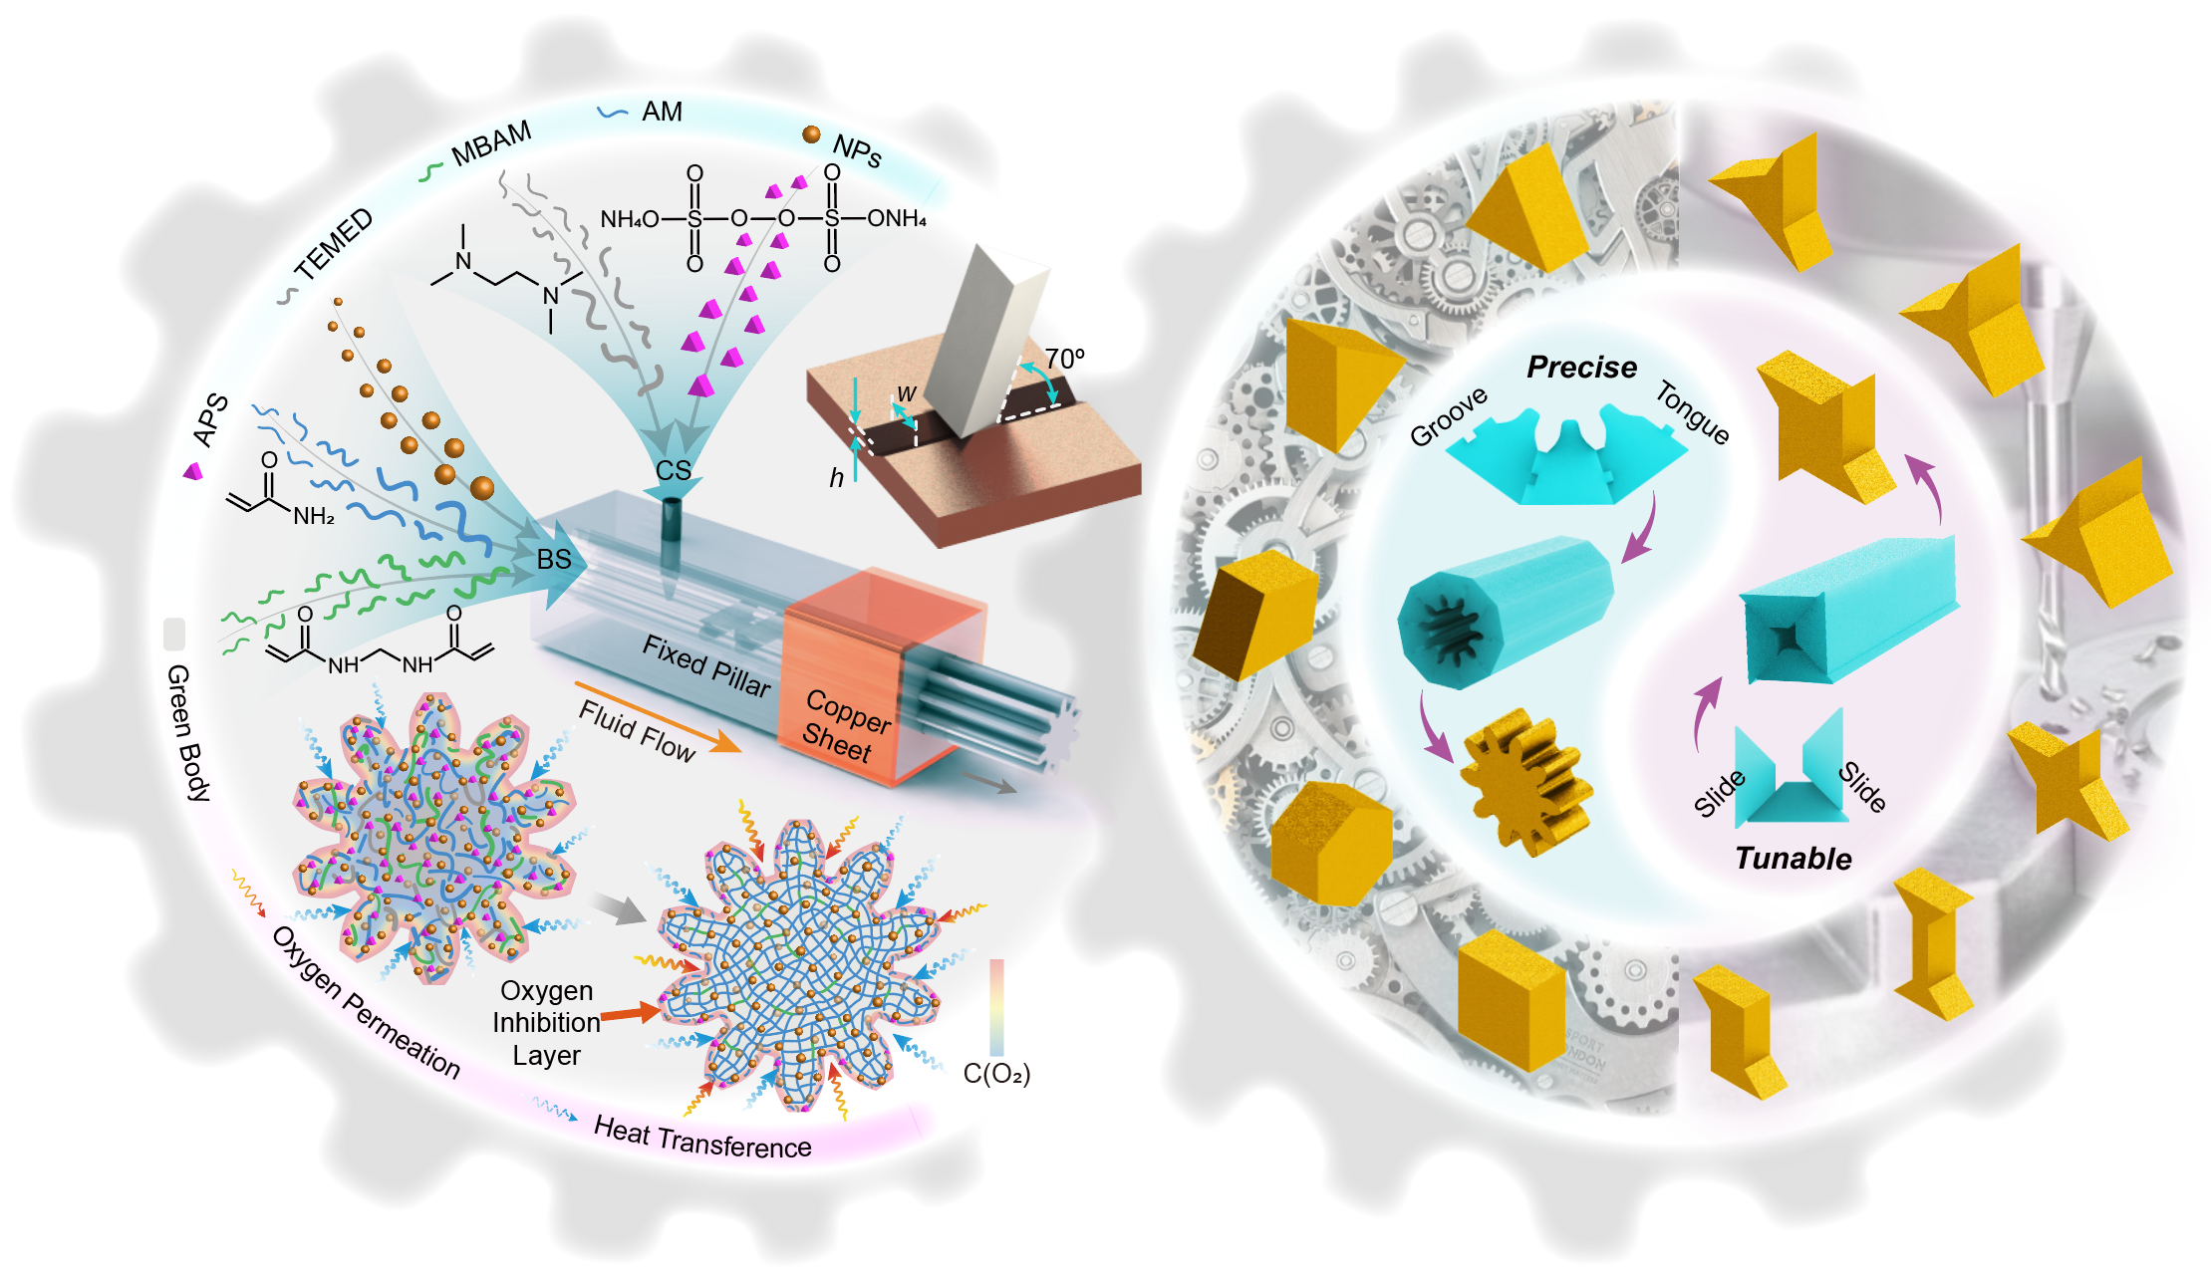
One-pot microfluidic fabrication systems for precise fabrication of both transparent and nontransparent sharp-edged ceramic microblocks with diverse shapes and materials at a high production rate.

