Mapping competition between domestic and distant water fishing fleets in West Africa
Supplementary materials

Table 1. West Africa and its regional and DWF fleets.
Study Region | Regional Fishing Fleet | DWF in the Study Region
West Africa | Benin, Cameroon, Côte d'Ivoire, The Gambia, Ghana, Guinea, Guinea-Bissau, Liberia, Nigeria, Senegal, Sierra Leone and Togo | China, Spain, the Russian Federation, South Korea, France, Ukraine, Germany, Belize and Greece, USA and Malta.

Table 2. Selected common and scientific names of assessed species in West Africa.
Common name | Scientific name
Marine fishes nei | Marine fishes not identified
Jacks, horse mackerels | Trachurus
Yellow tuna | Thunnus Albacares
Blue shark | Prionace glauca
Flatfishes | Pleuronecttiformes
Threadfins | Polynemidae
West African goatfish | Pseudupeneus prayensis
Senegalese hake | Merluccius senegalensis
Frigate tuna | Auxis thazard
Bullet and frigate tunas | Auxis
Bullet tuna | Auxis rochei

Table 3. Total average annual catches (tonnes) in the EEZs of West African nations obtained from the SAU database (Pauly, Zeller and Palomares 2021) for the period 2014–2018, expressed as percent regional (domestic + regional catch) and as percent DWF. Definition of the regional countries are found in Table 1.
EEZ | Total  annual  mean  catch | Total  annual  mean  catch | Regional catch  (%) | DWF | DWF catch  (%)
Benin | 86,970 | Benin,  Ghana,  Nigeria | 96 | Belize,  China,  Greece,  Portugal,  United Kingdom | 4
Cameroon | 217,061 | Cameroon | 94 | Belize,  China,  Equatorial Guinea | 6
Côte d'Ivoire | 147,600 | Côte d'Ivoire,  Cape Verde,  Ghana,  Liberia,  Senegal | 56 | Belize,  China,  Curacao,  El Salvador,  France,  Guatemala,  Japan,  Panama,  Portugal,  Spain,  Taiwan | 44
Gambia | 203,724 | Cape Verde,  Côte d'Ivoire,  Gambia,  Guinea,  Senegal,  Sierra Leone | 94 | China,  Comoros,  France,  Greece,  Guatemala,  Italy,  Japan,  Korea (South),  Lithuania,  Mauritania,  Portugal,  Spain,  Taiwan | 6
Ghana | 344,999 | Cape Verde,  Côte d'Ivoire,  Ghana,  Senegal,  Togo | 95 | Belize,  China,  Curacao,  El Salvador,  France,  Guatemala,  Japan,  Korea (South),  Spain,  Taiwan | 5
Guinea | 653,749 | Cape Verde,  Côte d'Ivoire,  Guinea,  Senegal,  Sierra Leone | 43 | Belize,  China,  Comoros,  Curacao,  El Salvador,  France,  Germany,  Guatemala,  Italy,  Japan,  Korea (South),  Malta,  Mauritania,  Panama,  Portugal,  Russian Federation,  Spain,  Taiwan,  Ukraine,  USA | 57
Senegal | 561,133 | Cape Verde,  Côte d'Ivoire,  The Gambia,  Guinea,  Senegal | 90 | Belize,  China,  Comoros,  Curacao,  El Salvador,  France,  Guatemala,  Italy,  Japan,  Korea (South),  Mauritania,  Norway,  Panama,  Portugal,  Russian Federation,  Saint Vincent and the Grenadines,  Spain,  Taiwan,  Vanuatu | 10
Togo | 52,200 | Ghana,  Guinea,  Togo | 57 | Belize,  China,  Greece,  Italy,  Spain | 43
Source: SAU

Table 4: Populations of exploited fish species occurring in Senegal with Sea Around Us stock assessments based on marine ecoregion reconstructed catch data (1950-2018) and model priors (from FishBase and/or based on literature including official assessments) fitted with a Bayesian Schaefer model (see Froese et al. 2017). Status is defined as: Healthy if the %difference (%Diff={MSY Senegal-Mean Annual Catch Senegal}/MSY Senegal) between maximum sustainable yield (MSY) and mean catch is >0.8; Exploited if %Diff is >0.4 and <0.8; and Overexploited if %Diff <0.4. Note that MSY is ideally at about 50% of the carrying capacity of a fish population in order to remain at sustainable levels. MSY and catch are in 1000 tonnes. Mean annual catch for the region and for the Senegal EEZ were obtained for the period 2014-2018 and expressed in 1000 tonnes.

Region | Scientific name | MSY Region | Mean Annual Catch Region | MSY Senegal | Mean Annual Catch Senegal | %Difference | Status
Atlantic Ocean | Acanthocybium solandri | 13.3 | 17.3 | 0.2 | 0.3 | -0.3 | Overexploited
Sahelian Upwelling | Argyrosomus regius | 8.0 | 7.0 | 2.4 | 2.1 | 0.1 | Overexploited
Atlantic Ocean | Auxis thazard | 23.1 | 21.3 | 1.5 | 1.4 | 0.1 | Overexploited
Sahelian Upwelling | Campogramma glaycos | 0.5 | 0.2 | 0.2 | 0.1 | 0.5 | Exploited
Saharan Upwelling, Sahelian Upwelling, Gulf of Guinea West and Gulf of Guinea Upwelling | Caranx rhonchus | 74.2 | 30.8 | 71.3 | 29.6 | 0.6 | Exploited
Atlantic Ocean | Coryphaena hippurus | 33.3 | 27.0 | 0.9 | 0.7 | 0.2 | Overexploited
Eastern Central Atlantic | Decapterus macarellus | 5.0 | 3.0 | 0.6 | 0.4 | 0.4 | Exploited
Sahelian Upwelling | Dicentrarchus punctatus | 1.1 | 0.4 | 0.5 | 0.2 | 0.7 | Exploited
Sahelian Upwelling | Elops lacerta | 1.8 | 2.0 | 0.1 | 0.1 | -0.1 | Overexploited
Saharan Upwelling, Sahelian Upwelling, Gulf of Guinea West, Gulf of Guinea Upwelling, Gulf of Guinea Central, Gulf of Guinea Islands, Gulf of Guinea South, Angolan, Namib, Namaqua and Angulhas Bank | Engraulis encrasicolus | 242.2 | 123.5 | 14.2 | 7.2 | 0.5 | Exploited
Sahelian Upwelling | Epinephelus caninus | 0.3 | 0.0 | 0.9 | 0.1 | 0.8 | Healthy
Sahelian Upwelling | Ethmalosa fimbriata | 76.9 | 88.6 | 67.9 | 78.2 | -0.2 | Overexploited
Azores Canaries Madeira, Saharan Upwelling, Cape Verde, Sahelian Upwelling and Gulf of Guinea West | Euthynnus alletteratus | 10.6 | 6.7 | 49.0 | 31.2 | 0.4 | Overexploited
Sahelian Upwelling | Farfantepenaeus notialis | 5.4 | 3.8 | 15.5 | 11.0 | 0.3 | Overexploited
Eastern Atlantic Ocean | Istiophorus albicans | 3.1 | 1.8 | 5.3 | 3.1 | 0.4 | Exploited
Eastern Atlantic Ocean | Katsuwonus pelamis | 332.4 | 253.0 | 138.7 | 105.5 | 0.2 | Overexploited
Sahelian Upwelling | Lagocephalus laevigatus | 0.5 | 0.2 | 8.1 | 2.7 | 0.7 | Exploited
Sahelian Upwelling | Lichia amia | 2.0 | 1.5 | 3.0 | 2.2 | 0.3 | Overexploited
Sahelian Upwelling | Lithognathus mormyrus | 4.0 | 2.0 | 11.8 | 5.9 | 0.5 | Exploited
Atlantic Ocean | Makaira nigricans | 5.5 | 5.4 | 0.6 | 0.6 | 0.0 | Overexploited
Sahelian Upwelling | Mugil cephalus | 8.2 | 11.4 | 3.0 | 4.2 | -0.4 | Overexploited
Sahelian Upwelling | Mullus surmuletus | 2.0 | 1.2 | 10.3 | 6.1 | 0.4 | Exploited
Sahelian Upwelling | Mustelus mustelus | 1.5 | 0.9 | 0.1 | 0.0 | 0.4 | Overexploited
Sahelian Upwelling | Octopus vulgaris | 14.2 | 7.1 | 31.6 | 15.7 | 0.5 | Exploited
Sahelian Upwelling | Parapenaeus longirostris | 1.7 | 0.5 | 2.5 | 0.7 | 0.7 | Exploited
Sahelian Upwelling | Plectorhinchus mediterraneus | 3.9 | 4.8 | 3.8 | 4.7 | -0.2 | Overexploited
Sahelian Upwelling | Pomadasys incisus | 0.5 | 0.5 | 0.8 | 0.7 | 0.1 | Overexploited
Sahelian Upwelling | Pomadasys jubelini | 6.0 | 2.3 | 0.0 | 0.0 | 0.6 | Exploited
Sahelian Upwelling | Pomatomus saltatrix | 11.8 | 8.3 | 1.1 | 0.7 | 0.3 | Overexploited
Sahelian Upwelling | Psettodes belcheri | 0.3 | 0.5 | 0.6 | 0.8 | -0.4 | Overexploited
Sahelian Upwelling | Pseudotolithus senegalensis | 5.7 | 3.1 | 9.2 | 5.0 | 0.5 | Exploited
Sahelian Upwelling | Pseudupeneus prayensis | 1.2 | 0.7 | 6.8 | 3.8 | 0.4 | Exploited
Saharan Upwelling, Sahelian Upwelling and Gulf of Guinea West | Rachycentron canadum | 165.7 | 170.4 | 180.8 | 185.9 | 0.0 | Overexploited
Northeast Atlantic and Eastern Central Atlantic | Sarda sarda | 40.7 | 30.6 | 21.5 | 16.2 | 0.2 | Overexploited
Saharan Upwelling and Sahelian Upwelling | Sardina pilchardus | 941.0 | 1194.7 | 15.3 | 19.4 | -0.3 | Overexploited
Saharan Upwelling and Sahelian Upwelling | Sardinella aurita | 376.2 | 442.5 | 360.9 | 424.5 | -0.2 | Overexploited
Saharan Upwelling and Sahelian Upwelling | Sardinella maderensis | 178.2 | 237.1 | 236.3 | 314.4 | -0.3 | Overexploited
Azores Canaries Madeira, Saharan Upwelling and Sahelian Upwelling | Scomber colias | 73.0 | 49.8 | 3.5 | 2.4 | 0.3 | Overexploited
Azores Canaries Madeira, Saharan Upwelling, Sahelian Upwelling, Gulf of Guinea West, Gulf of Guinea Upwelling, Gulf of Guinea Central, Gulf of Guinea Islands, Gulf of Guinea South, Angolan and Namib | Scomberomorus tritor | 13.8 | 8.0 | 12.3 | 7.1 | 0.4 | Exploited
Azores Canaries Madeira, Saharan Upwelling, Cape Verde, Sahelian Upwelling, Gulf of Guinea Upwelling, Gulf of Guinea West, Gulf of Guinea Central, Gulf of Guinea Islands, Gulf of Guinea South, Angolan, Namib, Namaqua and Agulhas Bank | Selar crumenophthalmus | 4.2 | 2.2 | 0.1 | 0.0 | 0.5 | Exploited
Sahelian Upwelling | Sepia officinalis | 2.4 | 2.4 | 28.7 | 28.1 | 0.0 | Overexploited
Sahelian Upwelling | Sparus aurata | 2.4 | 0.9 | 0.4 | 0.2 | 0.6 | Exploited
Atlantic Ocean | Sphyrna zygaena | 14.3 | 10.4 | 27.7 | 20.2 | 0.3 | Overexploited
Sahelian Upwelling | Spondyliosoma cantharus | 2.3 | 0.8 | 7.5 | 2.7 | 0.6 | Exploited
Sahelian Upwelling | Stromateus fiatola | 1.6 | 1.0 | 3.6 | 2.2 | 0.4 | Overexploited
Northern and Central Atlantic Ocean | Thunnus alalunga | 36.4 | 24.8 | 0.0 | 0.0 | 0.3 | Overexploited
Atlantic Ocean | Thunnus albacares | 154.5 | 150.2 | 23.5 | 22.8 | 0.0 | Overexploited
Atlantic Ocean | Thunnus obesus | 86.0 | 87.2 | 6.9 | 7.0 | 0.0 | Overexploited
Eastern Atlantic and the Mediterranean | Thunnus thynnus | 43.6 | 24.1 | 0.1 | 0.0 | 0.4 | Exploited
Sahelian Upwelling | Trachinotus ovatus | 0.3 | 0.0 | 1.6 | 0.2 | 0.9 | Healthy
Saharan Upwelling, Sahelian Upwelling, Gulf of Guinea West and Gulf of Guinea Upwelling | Trachurus trachurus | 63.0 | 83.8 | 7.5 | 10.0 | -0.3 | Overexploited
Saharan Upwelling, Sahelian Upwelling, Gulf of Guinea West, Gulf of Guinea Upwelling, Gulf of Guinea Central, Gulf of Guinea Islands, Gulf of Guinea South, Angolan and Namib | Trachurus trecae | 395.0 | 283.9 | 103.1 | 74.1 | 0.3 | Overexploited
Northern and Central Atlantic Ocean | Xiphias gladius | 17.3 | 7.6 | 2.8 | 1.2 | 0.6 | Exploited
Sahelian Upwelling | Zeus faber | 19.7 | 4.6 | 78.6 | 18.5 | 0.8 | Exploited
Source: Authors estimates based on SAU database

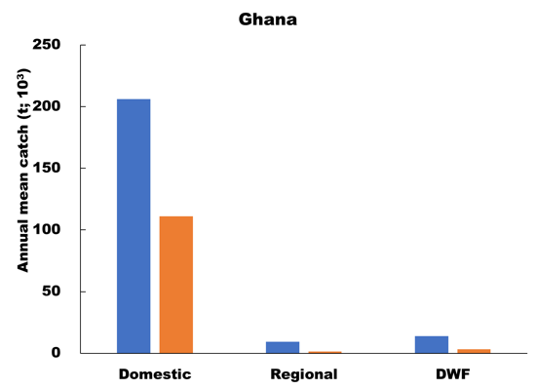 | 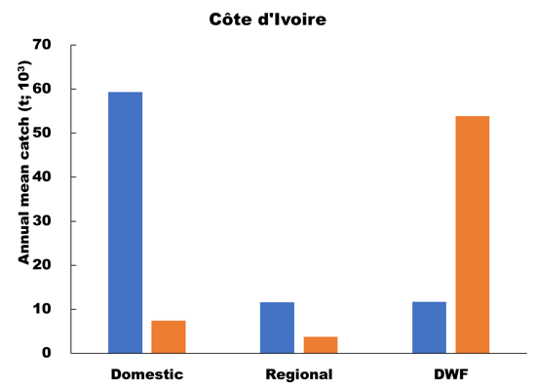
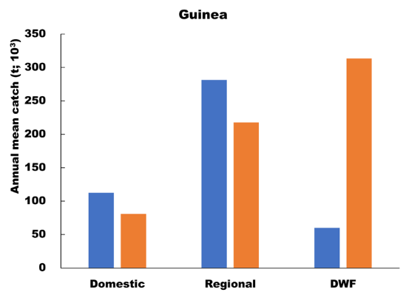 | 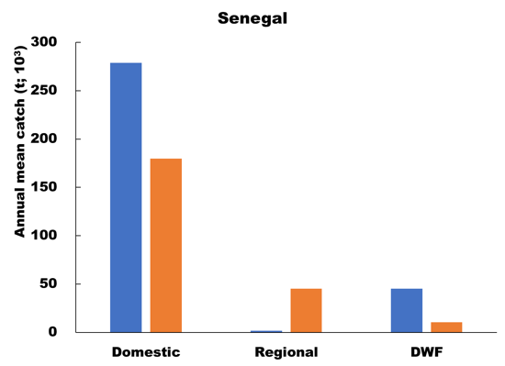
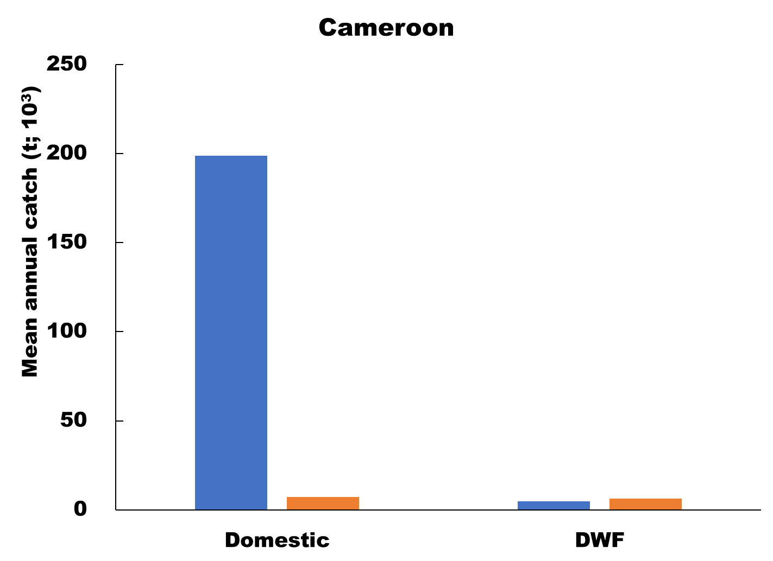 | 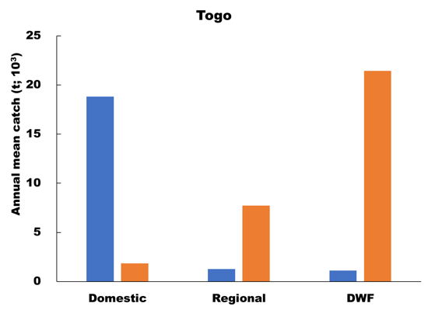
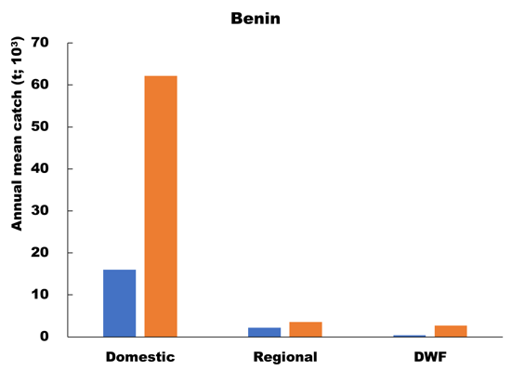 | 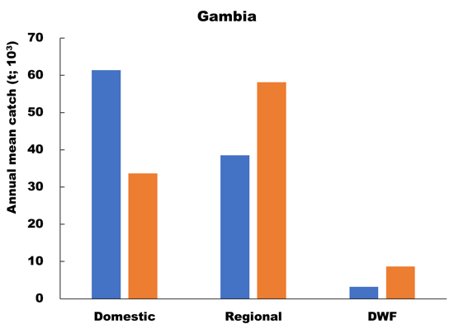
Fig. 1. Mean annual catch in West African EEZs presented by fleet and by reporting status for the period 2014–2018 based on the reconstructed catch landings of the Sea Around Us (Version 2021).

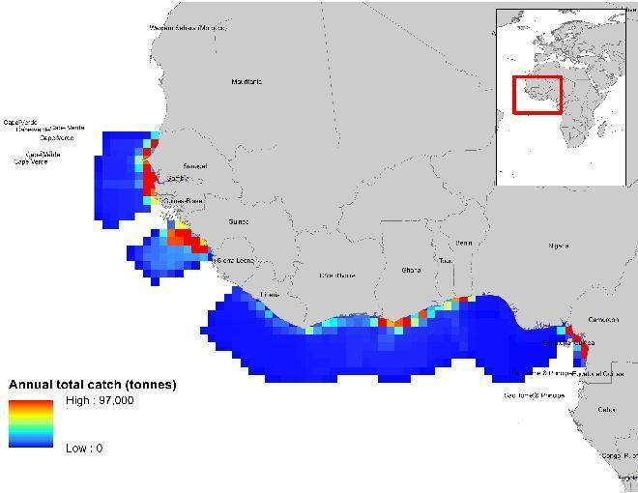 | 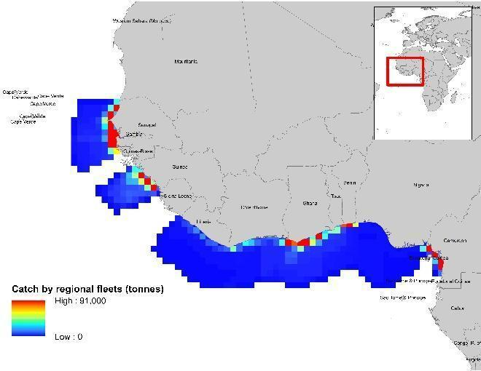
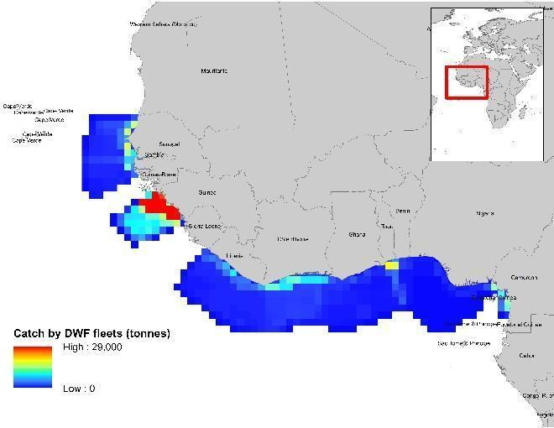
Fig. 2. Supplementary spatial maps: Catch by half degree cells in the West Africa Region. Top left panel: Total average annual catch (t). Top right panel: Average annual catch of regional (plus domestic) fleets (t). See Table 1 for definitions of regional fleets. Bottom left panel: Average annual catch of DWFs. All countries not identified in Table 1 are considered DWFs
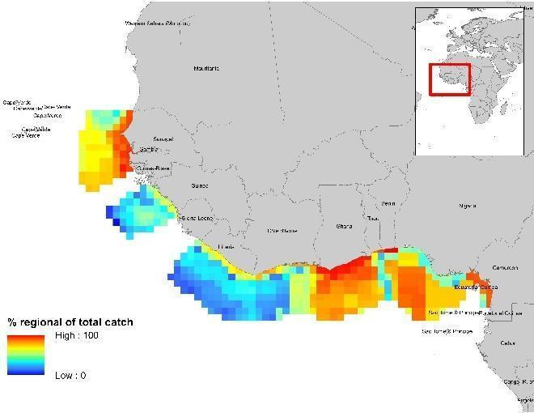 | 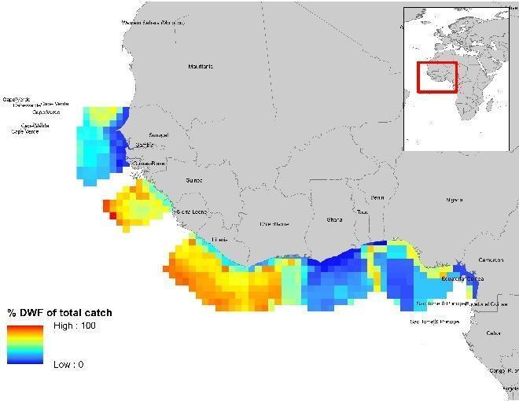
Figure 3. Catch by half degree cells in the West Africa Region. Left panel: Average annual catch (t) of regional fleets expressed as percent of total average annual catch. Right panel: Average annual catch (t) of DWFs expressed as percent of total average annual catch. See the method section for the definitions of regional fleets and all countries in West Africa considered for the DWFs analysis.

