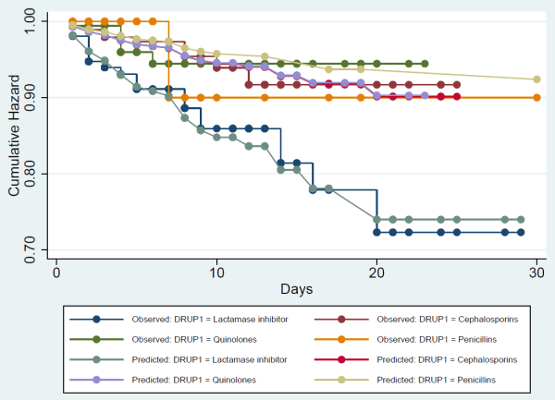
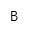
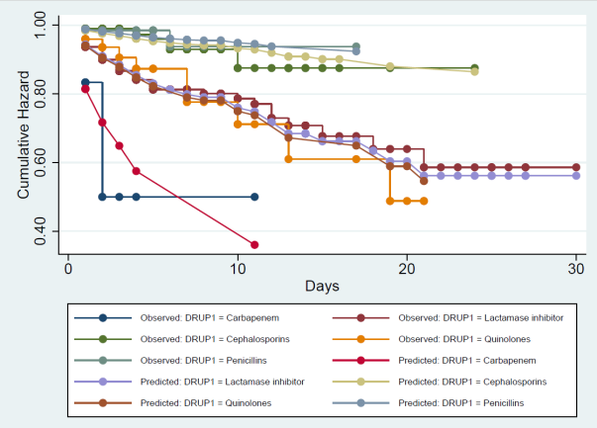
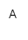
Figure S1 The predicted survival probability diagram: (A) In the Cox proportional hazard model of CRKP, the curve of cumulative hazard observation value was basically consistent with the curve of predicted value; (B) In the Cox proportional hazard model of CREC, the curve of cumulative hazard observation value was basically consistent with the curve of predicted value.

