Supporting Information

Gas-induced modulation of the surface structure of a Ni/Al₂O₃-CeO₂ catalyst in CO methanation

Xinli Li¹, Zhihui Fan¹, Xiaonan Zhang¹, Shaokang Zhang¹, Zhenzhou Zhang^{1,2}, Weifeng Tu ^{1,2}*, Yi-Fan Han^{1,2,3}*

¹State Key Laboratory of Coking Coal Green Exploitation, Zhengzhou University, Zhengzhou 450001, China
²Engineering Research Center of Advanced Functional Material Manufacturing, Ministry of Education, Zhengzhou University, Zhengzhou 450001, China
³State Key Laboratory of Chemical Engineering, East China University of Science and Technology, Shanghai 200237, China

* Corresponding author phone: (+86)21-64251928; fax: (86)21-64251928;
E-mail: yifanhan@ecust.edu.cn ; weifengtu@zzu.edu.cn

SUPPLEMENTARY INFORMATION CONTENTS

CATALYST ACTIVITY ASSESSMENT 3
COMPARISON OF CATALYST ACTIVITY 3
Stability of the catalyst during rate testing 4
Examination of the reversibility of activity enhancement by induction treatments 5
Effect of changes in CO and H₂ concentrations in the induced gas on the rate of methane production 6
Characterisation results 9
IN situ X-ray polycrystalline diffractometer 9
HAADF-STEM and distribution of Ni particles 11
In situ Raman spectroscopy 13
Chemical-molecule titration 14
X-Ray Photoelectron Spectroscopy semi-quantitative analysis 16

CATALYST ACTIVITY ASSESSMENT

COMPARISON OF CATALYST ACTIVITY
Supplementary Figure 1. Catalytic performance of CO methanation of 10Ni/Al_{x}Ce_{1-x} catalysts at 753 K with 5%CO-70%H₂-Ar, 1 MPa, 60000 mL g⁻¹ h⁻¹ (a) CO conversion, (b) CH₄ selectivity.

Stability of the catalyst during rate testing
Supplementary Figure 2. (a) The CH₄ formation rate and (b) conversion of CO and CH₄ selective from CO-H₂ at 753 K with 5%CO-70%H₂-Ar over the 10Ni/7Al3Ce catalyst as a function of time on stream.

Examination of the reversibility of activity enhancement by induction treatments
Supplementary Figure 3. The CH₄ formation rate from CO-H₂ over the 10Ni/7Al3Ce catalyst at 753K before (initial process) and after (reaction process) the induction process, as well as after treatments with 10%H₂-Ar at 873 K for 4 h (re-reduction) and then 5%CO-70%H₂-Ar at 753 K for 7 h.

Effect of changes in CO and H₂ concentrations in the induced gas on the rate of methane production
Supplementary Figure 4. Effect of the variation of CO content (x%CO-8%H₂-Ar, x=0, 1.6, 2, 2.6, 4 and 8) in the induced gases on the rate of CH₄ formation over the 10Ni/7Al3Ce catalyst.

Supplementary Figure 5. Effect of the variation of H₂ content (2.6%CO-y%H₂-Ar, y=2.6, 5.2, 10.4 and 13) in the induced atmosphere on the rate of CH₄ formation over the 10Ni/7Al3Ce catalyst.

Supplementary Figure 6. Effect of induced atmosphere with different CO and H₂ contents at H₂/CO ratio of 3 on the rate of CH₄ formation over the 10Ni/7Al3Ce catalyst.

Characterisation results

IN situ X-ray polycrystalline diffractometer
Supplementary Figure 7. In-situ XRD patterns of the 10Ni/7Al3Ce catalyst during (a) reduction process (10%H₂-Ar, 873 K, 1 atm), (b) initial process (5%CO-70%H₂-Ar, 753 K, 101 kPa), (c) induction process (2.6%CO-8%H₂-Ar, 753 K, 101 kPa).

Supplementary Figure 8. In situ XRD patterns of the 10Ni/7Al3Ce catalyst in the treatment of induction process (x%CO-8%H₂-Ar, 2.6%CO-y%H₂-Ar, 101 kPa total pressure, 753 K for 12 h) with different (a) CO contents (x=0, 1.6, 2, 4, 8) and (b) H₂ contents (y= 2.6, 5.2, 8, 10.4, 13).

HAADF-STEM and distribution of Ni particles
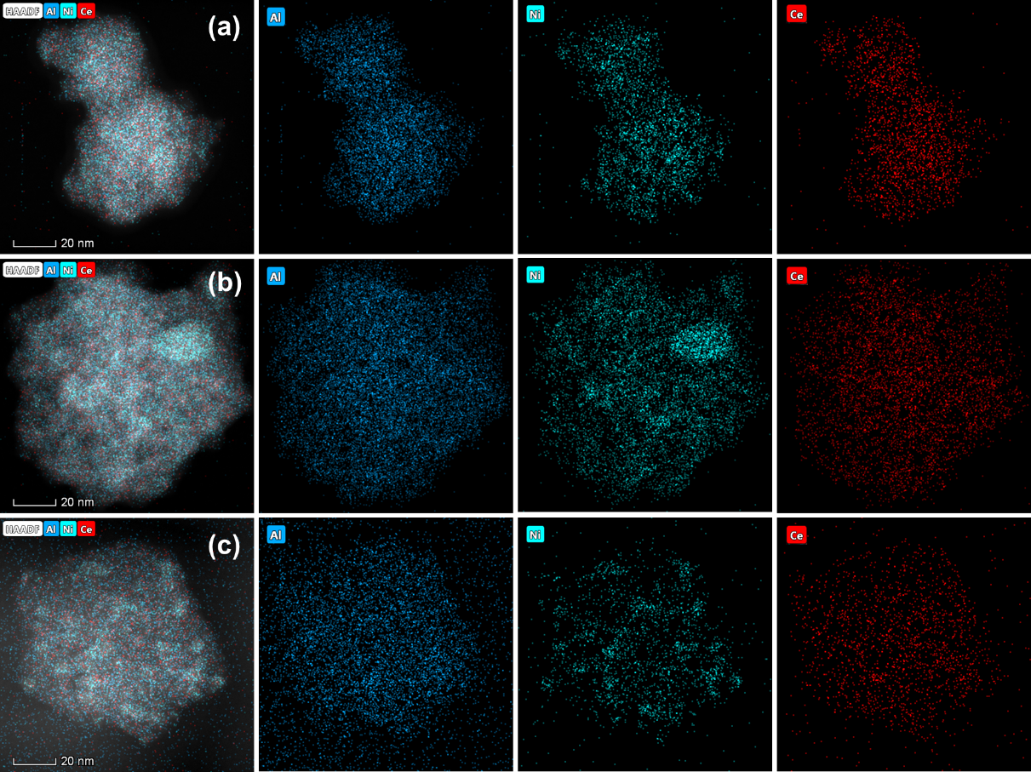

Supplementary Figure 9. HAADF-STEM images with EDX elemental mapping of the (a) reduced 10Ni/7Al3Ce catalyst, (b) after reaction in 5%CO-70%H₂-Ar at 753 K for 5 h, and (c) after reaction in 2.6%CO-8%H₂-Ar at 753 K for 12 h. (blue: Al, cyan: Ni and red: Ce).

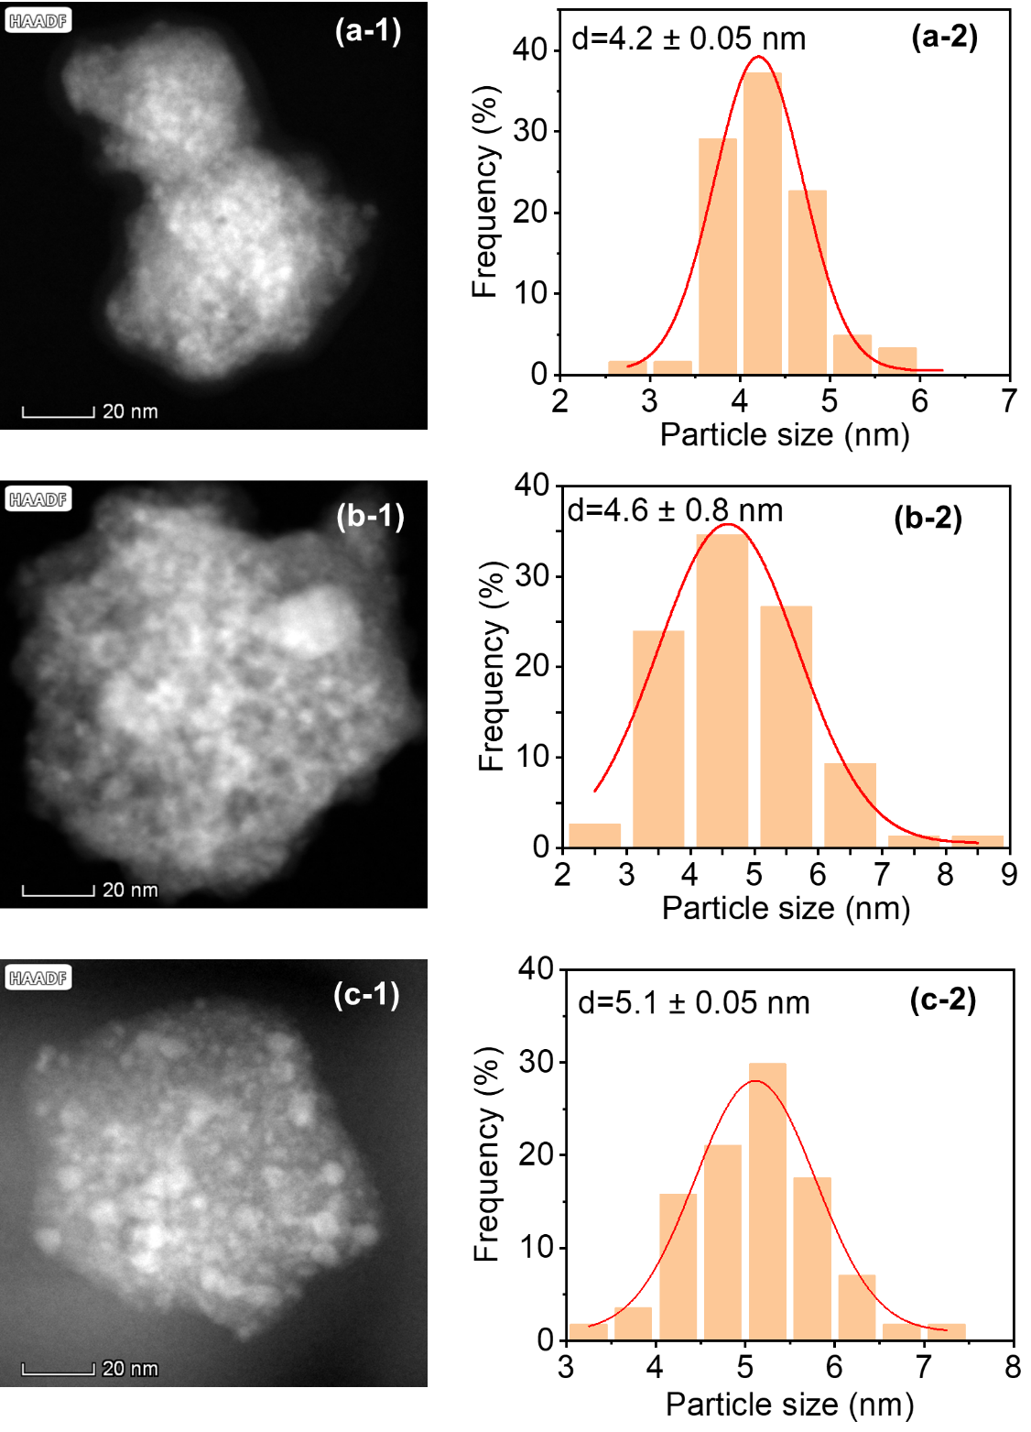
Supplementary Figure 10. TEM images of the 10Ni/7Al3Ce catalyst (a) after reduction at 873 K for 4 h, (b) after reaction in 5%CO-70%H₂-Ar at 753 K for 5 h and (c) after reaction in 2.6%CO-8%H₂-Ar at 753 K for 12 h.

In situ Raman spectroscopy
Supplementary Figure 11. In situ Raman spectra of the 10Ni/7Al3Ce catalyst in the treatment of induction process (x%CO-8%H₂-Ar, 2.6%CO-y%H₂-Ar, 101 kPa total pressure, 753 K for 12 h) with different (a) CO (x=0, 1.6, 2, 4, 8) and (b) H₂ contents (y= 2.6, 5.2, 8, 10.4, 13).

Chemical-molecule titration
Supplementary Figure 12. H₂ chemisorption isotherms and H₂ uptake for the 10Ni/7Al3Ce catalyst treated with induced gases of different (a, c) CO (x = 0, 1.6, 2, 4, 8) and (b, d) H₂ (y = 2.6, 5.2, 8, 10.4, 13) contents.

Supplementary Figure 13. H₂ chemisorption isotherms and H₂ uptake for reduced 10Ni/7Al3Ce catalyst and after initial reaction.

X-Ray Photoelectron Spectroscopy semi-quantitative analysis
Supplementary Figure 14. Atomic ratio of surface (a) Ni⁰/(Ni⁰+Ni²⁺) and (b) Ce³⁺/(Ce³⁺+Ce⁴⁺) over the 10Ni/7Al3Ce catalyst in the induction process.

Compared with other reported catalyst activity
Supplementary Table 1
Catalysts | H₂/CO | Pressure (MPa) | T/℃ | WHSV/  (L g⁻¹h⁻¹) | Ni dispersion/% | TOF_{CH4} (s⁻¹) | Ref.
10Ni/7Al3Ce | 3 | 0.1 | 200 | 30 | 21.83 | 0.0095 | This work
10Ni/7Al3Ce | 14 | 1 | 200 | 60 | 21.83 | 0.0288 | This work
10Ni/7Al3Ce | 14 | 1 | 480 | 29520 | 21.83 | 3.6611 | This work
10Ni/7Al3Ce (induction 12h) | 14 | 1 | 480 | 29520 | 19.6 | 11.8405 | This work
Ni/mBN | 3 | 0.1 | 350 | 720 | 18 | 0.1101 | 1
Ni/Al₂O₃ | 3 | 3 | 305 | 30 | 5.8 | 0.1179 | 2
20Ni-5V-Al | 3 | 0.1 | 260 | 120 | 17.9 | 0.0363 | 3
10Ni/ST5 | 3 | 1 | 250 | 15 | 35.6 | 0.0083 | 4
NiCo/SiO₂-U | 3 | 0.1 | 340 | 60 | 4.1 | 0.7892 | 5
10Ni/Al₂O₃ | 3 | 0.1 | 300 | 30 | 6.1 | 0.0322 | 6
10Ni/Al₂O₃-M | 3 | 0.1 | 250 | 15 | 3.8 | 0.0141 | 7
Ni/CeO₂ | 50 | 0.1 | 200 | 6 | 3.5 | 0.0020 | 8
10Ni/BHA | 3 | 3 | 300 | 30 | 3.1 | 0.0816 | 9
10Ni-2Fe-OMA | 3 | 0.1 | 300 | 60 | 13.0 | 0.0605 | 10
20Ni-5M/20A-W | 3 | 0.1 | 260 | 30 | 18.3 | 0.0118 | 11
10Ni-3V-OMA | 3 | 0.1 | 300 | 90 | 15.3 | 0.0728 | 12
20NiCr2-OMA | 3 | 0.1 | 300 | 60 | 9.1 | 0.0694 | 13
2Ni/13Ni-OMA | 3 | 0.1 | 300 | 60 | 13.1 | 0.0711 | 14
10Ni-5V/SBA-15 | 3 | 1 | 225 | 15 | 21.3 | 0.0062 | 15

1. Sheng J, et al. Surface Borate-Derived Highly Dispersed and Stable Metal Nanoparticles on Nitrogen-Vacancy Boron Nitride Support Promoting CO Methanation. ACS Catal. 13, 9201-9212 (2023).
2. Gao J, et al. Ni/Al₂O₃ catalysts for CO methanation: Effect of Al₂O₃ supports calcined at different temperatures. J Energy Chem. 22, 919-927 (2013).
3. Liu Q, et al. Enhanced catalytic performances of Ni/Al₂O₃ catalyst via addition of V₂O₃ for CO methanation. Appl Catal A. 488, 37-47 (2014).
4. Ren J, et al. Silica/titania composite-supported Ni catalysts for CO methanation: Effects of Ti species on the activity, anti-sintering, and anti-coking properties. Appl Catal B. 201, 561-572 (2017).
5. Zhao B, et al. Bimetallic Ni-Co nanoparticles on SiO₂ as robust catalyst for CO methanation: Effect of homogeneity of Ni-Co alloy. Appl Catal B. 278, (2020).
6. Gao J, Jia C, Zhang M, Gu F, Xu G, Su F. Effect of nickel nanoparticle size in Ni/α-Al₂O₃ on CO methanation reaction for the production of synthetic natural gas. Catal Sci Technol. 3, (2013).
7. Yan X, et al. A Ni-based catalyst with enhanced Ni–support interaction for highly efficient CO methanation. Catal Sci Technol. 8, 3474-3483 (2018).
8. Le TA, Kim TW, Lee SH, Park ED. Effects of Na content in Na/Ni/SiO₂ and Na/Ni/CeO₂ catalysts for CO and CO₂ methanation. Catal Today. 303, 159-167 (2018).
9. Gao J, et al. Nickel Catalysts Supported on Barium Hexaaluminate for Enhanced CO Methanation. Ind Eng Chem Res. 51, 10345-10353 (2012).
10. Liu Q, Qiao Y, Tian Y, Gu F, Zhong Z, Su F. Ordered Mesoporous Ni–Fe–Al Catalysts for CO Methanation with Enhanced Activity and Resistance to Deactivation. Ind Eng Chem Res. 56, 9809-9820 (2017).
11. Lu X, et al. Ni–MnO_{x} Catalysts Supported on Al₂O₃-Modified Si Waste with Outstanding CO Methanation Catalytic Performance. Ind Eng Chem Res. 54, 12516-12524 (2015).
12. Liu Q, et al. One-pot synthesis of ordered mesoporous Ni–V–Al catalysts for CO methanation. J Catal. 326, 127-138 (2015).
13. Liu Q, et al. CO methanation on ordered mesoporous Ni–Cr–Al catalysts: Effects of the catalyst structure and Cr promoter on the catalytic properties. J Catal. 337, 221-232 (2016).
14. Xiao Y-S, et al. Balancing free and confined metallic Ni for an active and stable catalyst—A case study of CO methanation over Ni/Ni–Al₂O₃. J Energy Chem. 50, 73-84 (2020).
15. Li H, Ren J, Qin X, Qin Z, Lin J, Li Z. Ni/SBA-15 catalysts for CO methanation: effects of V, Ce, and Zr promoters. RSC Adv. 5, 96504-96517 (2015).

