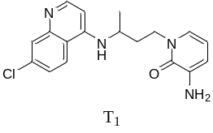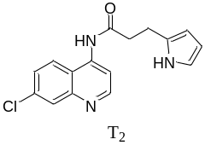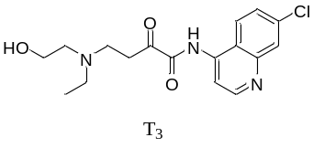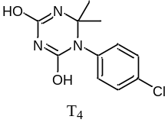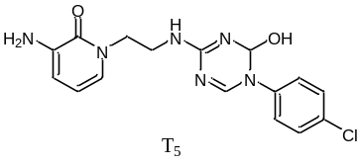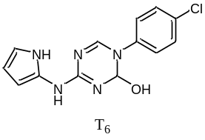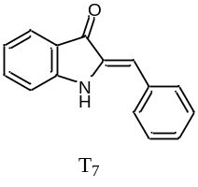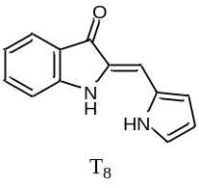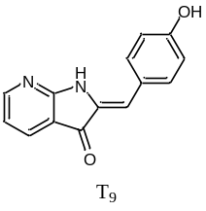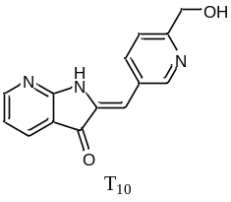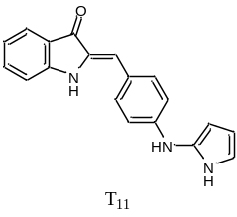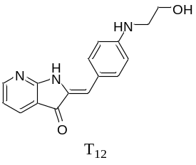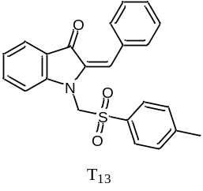
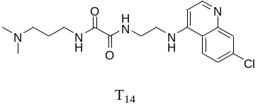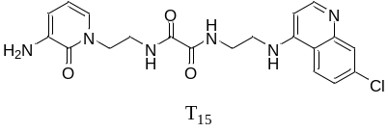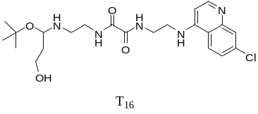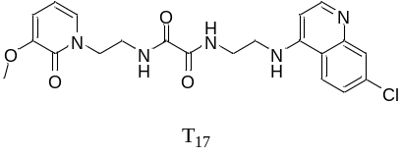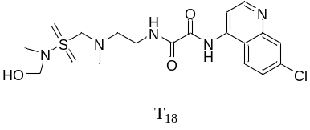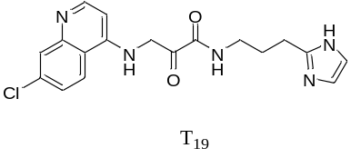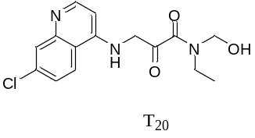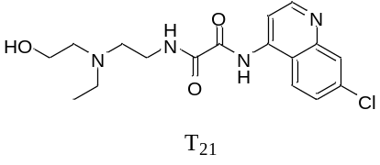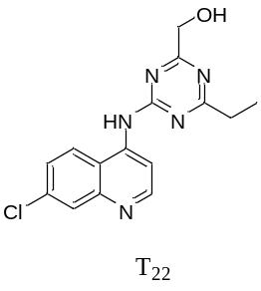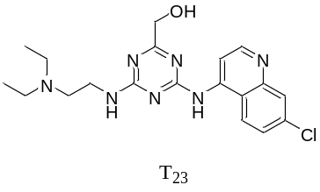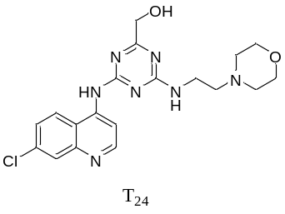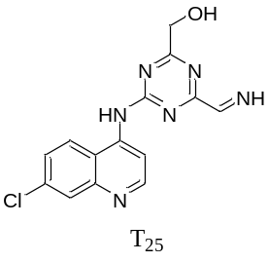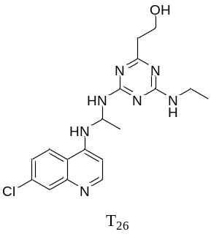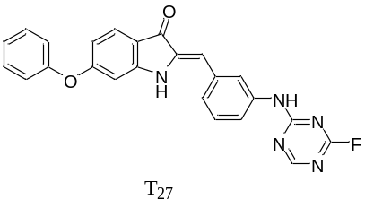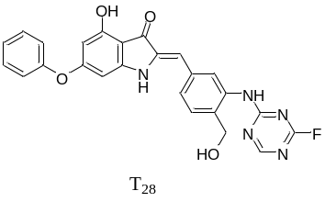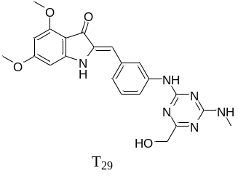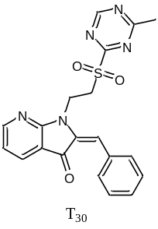
Fig.1. All the molecules used in molecular docking

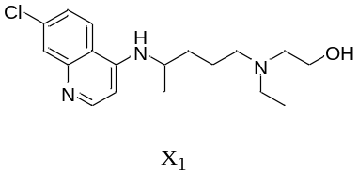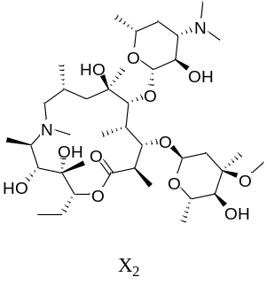
Fig. 2. Structure of hydroxychloroquine (X₁) and azithromycin (X₂)

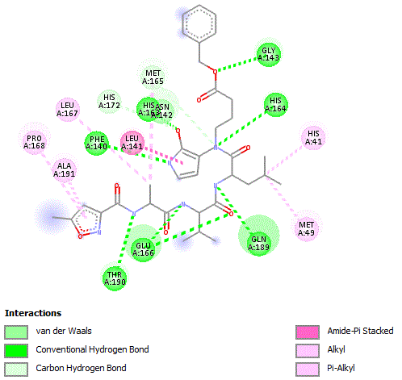
Fig. 3. 2D visualization showing interactions of the crystallographic ligand pose with the SARS-CoV-2 protein protease.
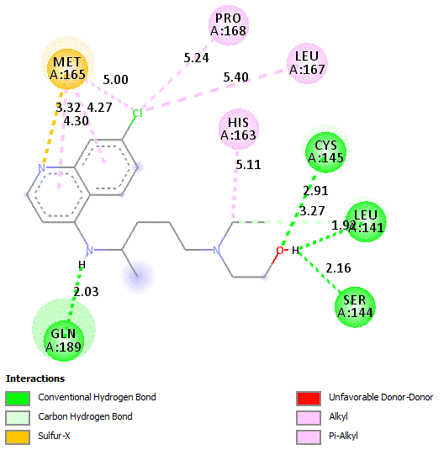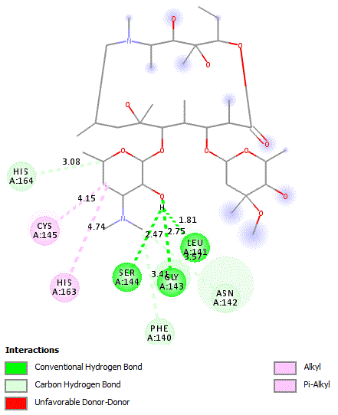
X₁ X₂
Fig. 4. 2D docking poses showing interactions of compounds X₁ and X₂ in the binding sites of SARS-CoV-2 protein protease.. (a) Compound X₁: (binding energy -7.51 kcal/mol). (b) Compound X₂: (binding energy -6.13 kcal/mol)
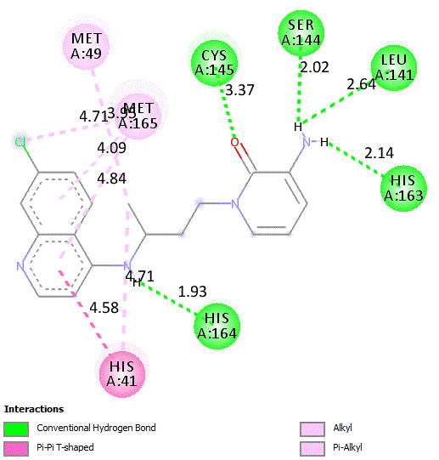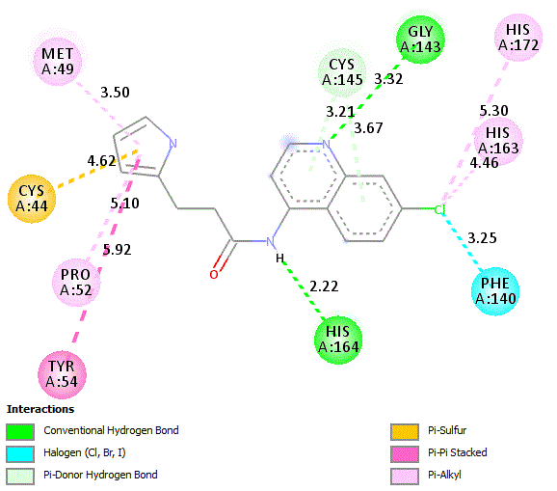
T₁= -9.22 kcal/mol T₂= -9 kcal/mol
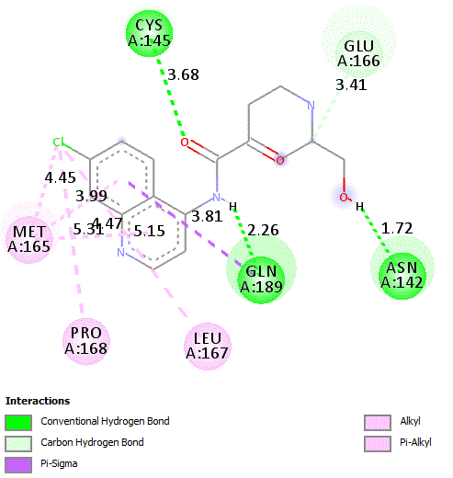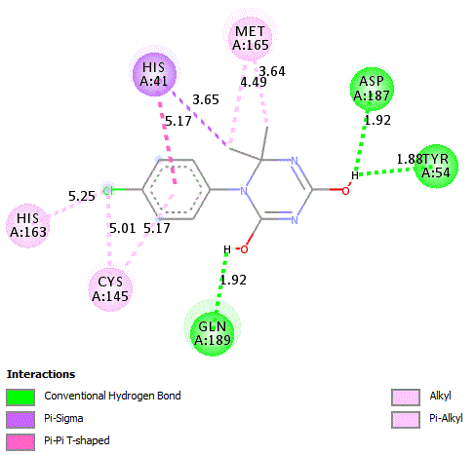
T₃= -7.87 kcal/mol T₄= -7.06 kcal/mol
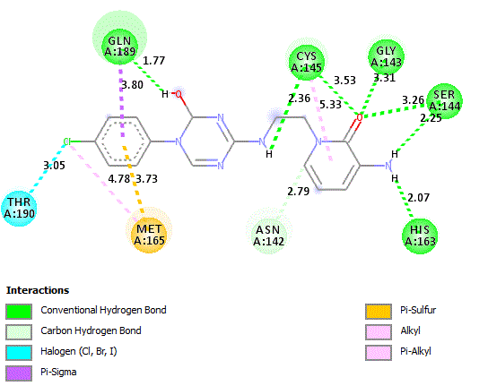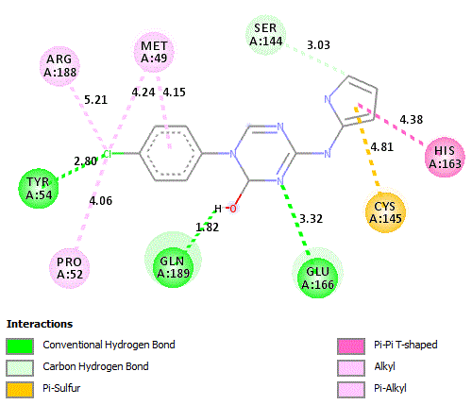
T₅= -8.49 kcal/mol T₆= -7.82 kcal/mol
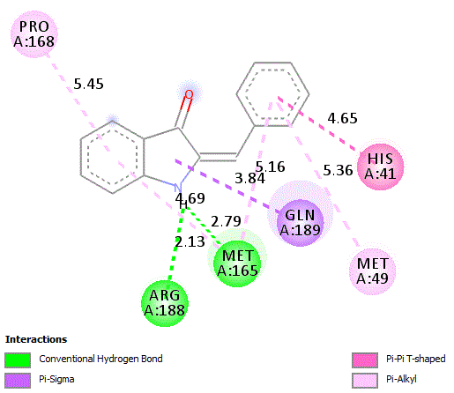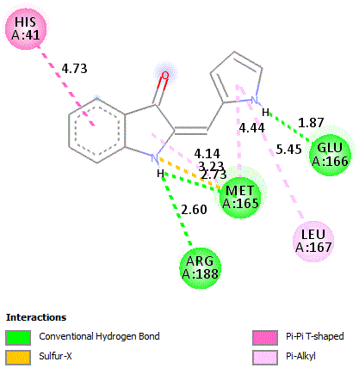
T₇ = -8.17 kcal/mol T₈ =-7.41 kcal/mol
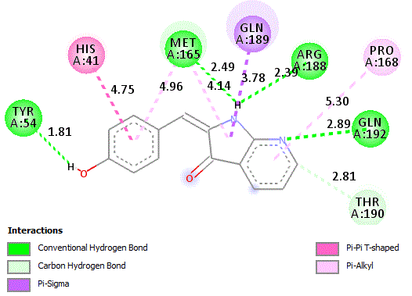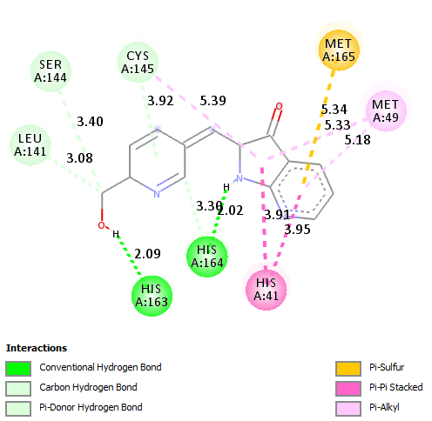
T₉= -7.88kcal/mol T₁₀= -7.86 kcal/mol

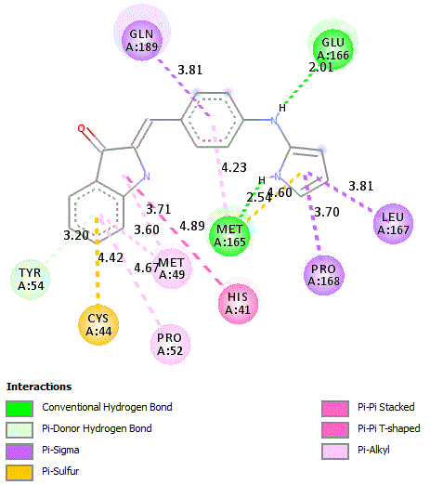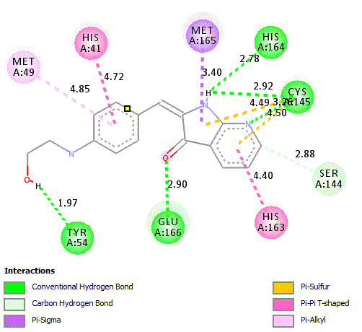
T₁₁ =-8.87 kcal/mol T₁₂= -8.27 kcal/mol
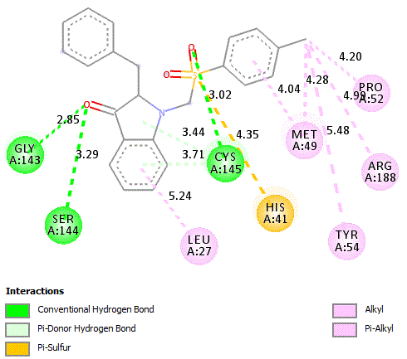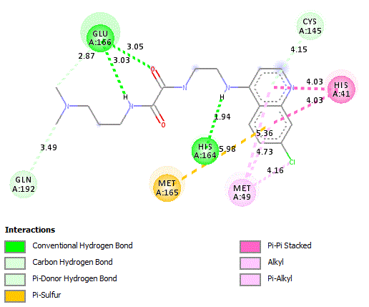
T₁₃= -11.76 kcal/mol T₁₄= --8.76 kcal/mol

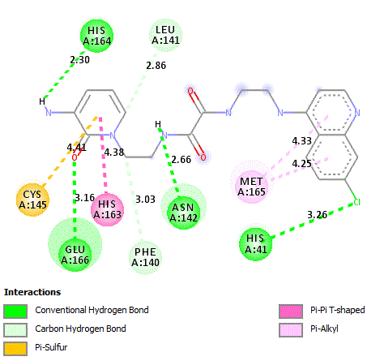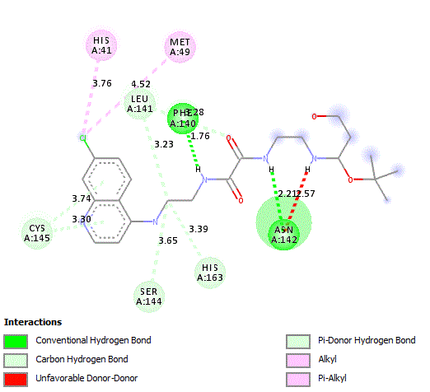
T₁₅= -9.44 kcal/mol T₁₆₌ -8.77 kcal/mol
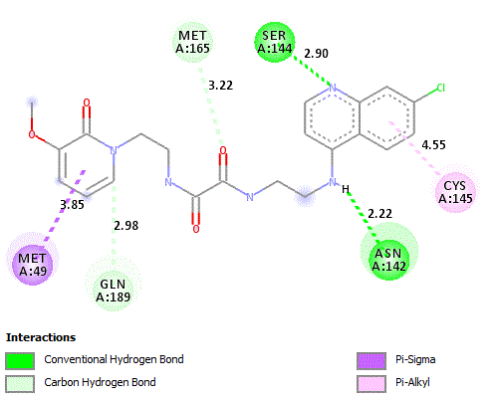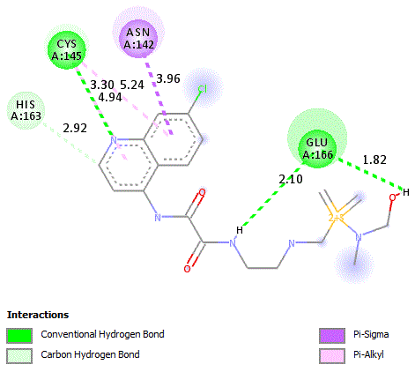
T₁₇= -9.83 kcal/mol T₁₈₌ -8.36 kcal/mol
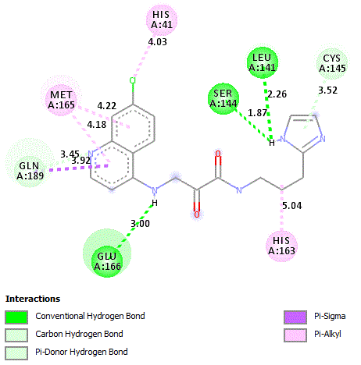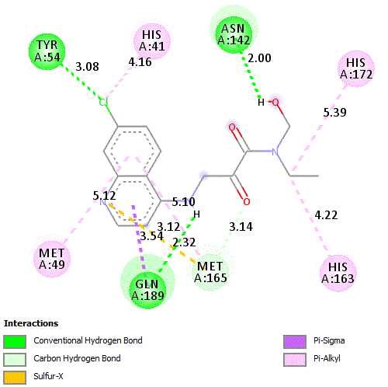
T₁₉= -8.75 kcal/mol T₂₀= -7.57 kcal/mol
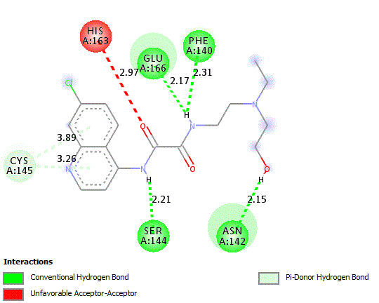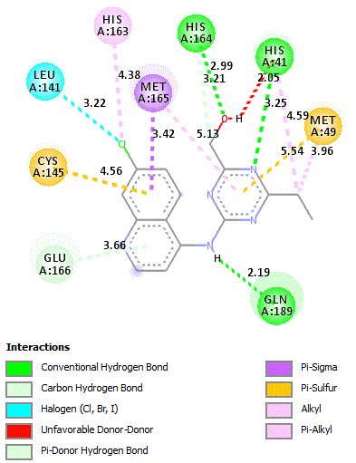
T₂₁= -7.66 kcal/mol T₂₂= -9.22 kcal/mol
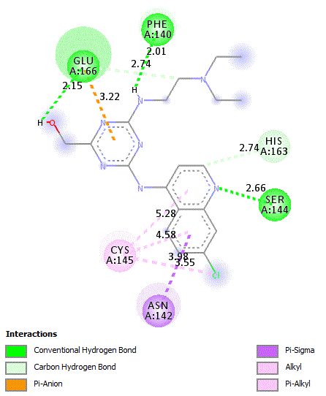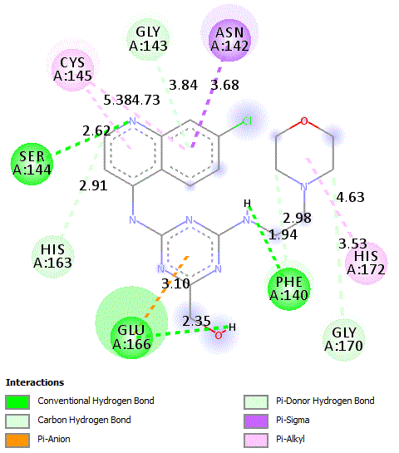
T₂₃= -8.56 kcal/mol T₂₄= -9.04 kcal/mol
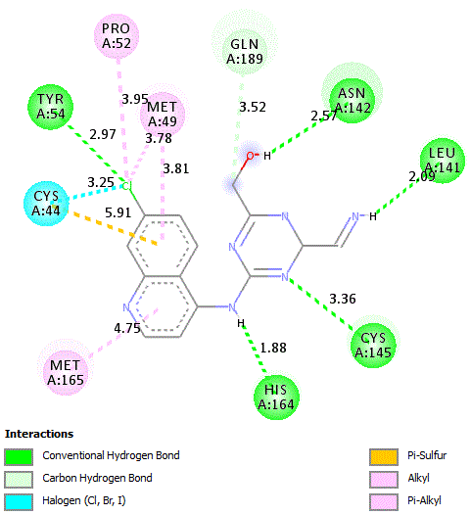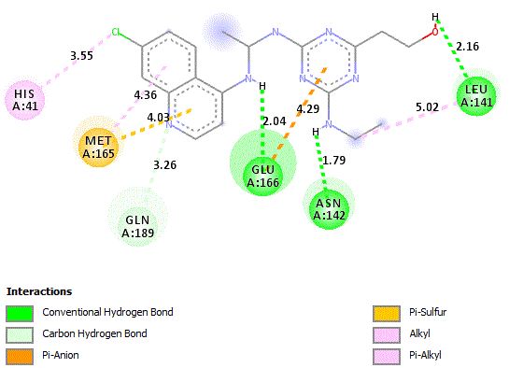
T₂₅= -8.29 kcal/mol T₂₆= -7.61 kcal/mol
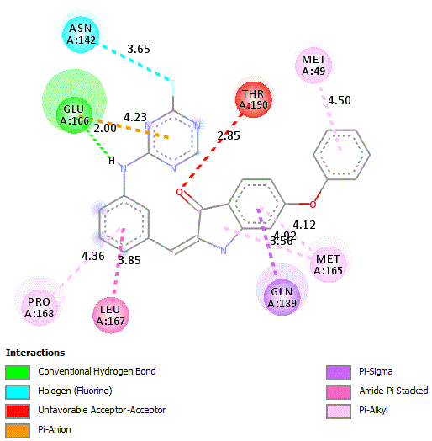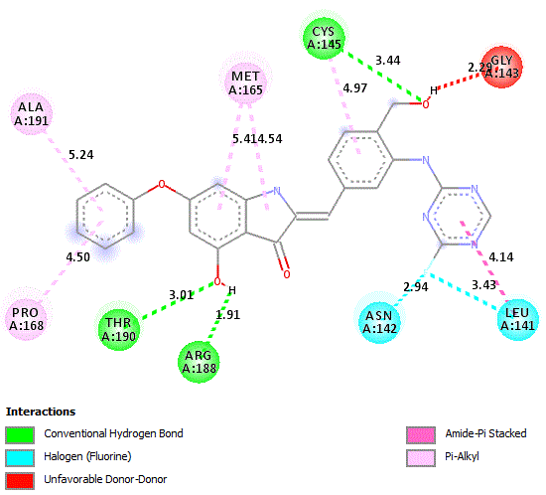
T₂₇= -10.28 kcal/mol T₂₈= -10.02 kcal/mol
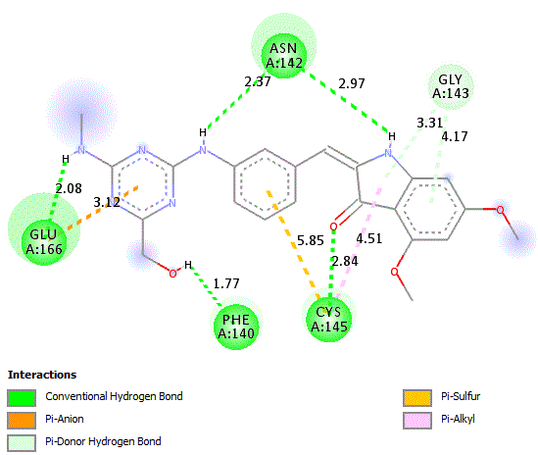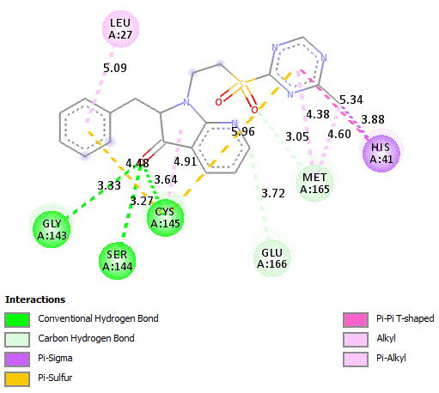
T₂₉= -9.65 kcal/mol T₃₀= -9.88 kcal/mol
Fig. 5. 2D visualization of the distances and interaction modes with the active site of SARS-CoV-2 protein protease.

Table 1. In silico ADMET prediction of new designed compounds (T₁-T₃₀).
Compounds | Absorption | Distribution |  |  | Metabolism |  |  |  |  |  |  |  | Excretion | Toxicity
Compounds | Intestinal  absorption  (human) | VDss  (human) | BBB permeability | CNS permeability | Substrate |  |  | Inhibitor |  |  |  |  | Total  Clearance | AMES  toxicity
 |  |  |  |  | CYP |  |  |  |  |  |  |  | Total  Clearance | AMES  toxicity
 |  |  |  |  | 2D6 | 3A4 |  | 1A2 | 2C19 | 2C9 | 2D6 | 3A4 | Total  Clearance | AMES  toxicity
Compounds | Numeric (%  Absorbed) | Numeric  (Log L/kg) | Numeric (Log BB) | Numeric (Log PS) | Categorical (Yes/No) |  |  |  |  |  |  |  | Numeric (Log  ml/min/kg) | Categorical (Yes/No)
T₁ | 91.469 | 0.116 | -0.413 | -2.182 | No | Yes | Yes |  | Yes | No | No | No | -0.186 | No
T₂ | 90.249 | 0.147 | 0.171 | -2.021 | No | Yes | Yes |  | Yes | No | No | No | 0.012 | No
T₃ | 93.283 | 0.836 | -1.414 | -3.047 | No | No | No |  | No | No | No | No | 1.136 | Yes
T₄ | 87.827 | -0.175 | -0.361 | -2.905 | No | Yes | No |  | No | No | No | No | -0.024 | No
T₅ | 73.942 | 0.357 | -0.824 | -3.02 | No | Yes | No |  | No | No | No | No | 0.454 | No
T₆ | 84.525 | 0.68 | -0.632 | -2.931 | No | Yes | Yes |  | No | No | No | No | 0.464 | No
T₇ | 92.382 | 0.359 | 0.237 | -0.597 | Yes | Yes | Yes |  | Yes | No | No | No | 0.096 | Yes
T₈ | 92.837 | 0.623 | 0.369 | -2.145 | No | Yes | Yes |  | Yes | No | No | No | 0.266 | Yes
T₉ | 91.848 | 0.256 | 0.095 | -2.048 | No | No | Yes |  | No | No | No | No | 0.223 | No
T₁₀ | 94.007 | 0.131 | -0.204 | -2.949 | No | No | Yes |  | No | No | No | No | 0.239 | No
T₁₁ | 89.911 | 0.049 | 0.158 | -1.649 | Yes | Yes | Yes |  | Yes | No | Yes | Yes | 0.076 | No
T₁₂ | 91.661 | 0.311 | -0.824 | -2.453 | No | No | Yes |  | No | No | No | No | 0.162 | No
T₁₃ | 96.865 | -0.294 | 0.031 | -1.796 | No | Yes | No |  | Yes | Yes | No | Yes | 0.516 | No
T₁₄ | 95.078 | 0.585 | -1.253 | -3.424 | No | Yes | No |  | No | No | No | No | 0.878 | No
T₁₅ | 64.529 | -0.53 | -1.48 | -3.466 | No | Yes | No |  | No | No | No | No | -0.296 | Yes
T₁₆ | 61.948 | 0.162 | -1.756 | -3.411 | No | Yes | No |  | No | No | No | No | 0.904 | No
T₁₇ | 65.617 | -0.689 | -1.599 | -3.411 | No | Yes | No |  | No | No | No | Yes | -0.114 | No
T₁₈ | 61.489 | 0.447 | -1.512 | -3.529 | No | Yes | No |  | No | No | No | No | 0.811 | No
T₁₉ | 76.967 | -0.079 | -1.209 | -3.403 | No | No | No |  | No | No | Yes | No | 1.286 | No
T₂₀ | 94.725 | -0.141 | -1.138 | -3.383 | No | Yes | Yes |  | Yes | No | No | No | 0.288 | No
T₂₁ | 67.724 | 0.839 | -1.441 | -3.125 | No | Yes | No |  | No | No | No | No | 0.896 | No
T₂₂ | 93.821 | 0.214 | -0.619 | -2.962 | No | Yes | Yes |  | No | No | No | No | 0.105 | No
T₂₃ | 69.132 | 1.725 | -1.601 | -3.158 | No | No | Yes |  | No | No | No | No | 0.932 | No
T₂₄ | 67.276 | 1.584 | -1.602 | -3.239 | No | No | No |  | No | No | No | No | 0.993 | No
T₂₅ | 79.189 | 0.458 | -1.231 | -3.096 | No | No | Yes |  | No | No | No | No | 0.195 | No
T₂₆ | 82.331 | 0.25 | -1.494 | -3.484 | No | No | Yes |  | Yes | No | No | No | 0.184 | No
T₂₇ | 91.361 | -0.61 | -0.472 | -2.816 | No | Yes | Yes |  | Yes | Yes | No | Yes | -0.328 | No
T₂₈ | 80.028 | -0.704 | -1.975 | -3.497 | No | Yes | No |  | Yes | Yes | No | Yes | -0.39 | No
T₂₉ | 75.471 | 0.247 | -1.558 | -3.533 | No | Yes | No |  | No | Yes | No | Yes | -0.177 | No
T₃₀ | 76.774 | -0.625 | -1.289 | -3.374 | No | Yes | Yes |  | No | No | No | v | 0.674 | No
Table 2. Drug likeness prediction of the compounds (T₁-T₃₀) basing on lipinski, Ghose ,veber, Egan and Muegge, and their synthetic accessibility.
Compounds | Druglikeness
Compounds | Lipinski | Ghose | Veber | Egan | Muegge | Synthetic accessibility
T₁ | Yes | Yes | Yes | Yes | Yes | 3.04
T₂ | Yes | Yes | Yes | Yes | Yes | 2.09
T₃ | Yes | Yes | Yes | Yes | Yes | 2.32
T₄ | Yes | Yes | Yes | Yes | Yes | 3.40
T₅ | Yes | Yes | Yes | Yes | Yes | 4.12
T₆ | Yes | Yes | Yes | Yes | Yes | 3.95
T₇ | Yes | Yes | Yes | Yes | Yes | 2.50
T₈ | Yes | Yes | Yes | Yes | Yes | 2.66
T₉ | Yes | Yes | Yes | Yes | Yes | 2.61
T₁₀ | Yes | Yes | Yes | Yes | Yes | 2.88
T₁₁ | Yes | Yes | Yes | Yes | Yes | 2.94
T₁₂ | Yes | Yes | Yes | Yes | Yes | 2.92
T₁₃ | Yes | Yes | Yes | Yes | Yes | 3.68
T₁₄ | Yes | Yes | No | Yes | Yes | 2.58
T₁₅ | Yes | Yes | Yes | Yes | Yes | 2.94
T₁₆ | Yes | Yes | No | Yes | Yes | 3.83
T₁₇ | Yes | Yes | No | Yes | Yes | 3.10
T₁₈ | Yes | Yes | No | Yes | Yes | 3.50
T₁₉ | Yes | Yes | Yes | Yes | Yes | 2.47
T₂₀ | Yes | Yes | Yes | Yes | Yes | 2.17
T₂₁ | Yes | Yes | Yes | Yes | Yes | 2.47
T₂₂ | Yes | Yes | Yes | Yes | Yes | 2.61
T₂₃ | Yes | Yes | Yes | Yes | Yes | 3.2
T₂₄ | Yes | Yes | Yes | Yes | Yes | 3.19
T₂₅ | Yes | Yes | Yes | Yes | Yes | 2.6
T₂₆ | Yes | Yes | Yes | Yes | Yes | 3.59
T₂₇ | Yes | Yes | Yes | Yes | No | 3.37
T₂₈ | Yes | Yes | Yes | Yes | No | 3.63
T₂₉ | Yes | Yes | Yes | Yes | Yes | 3.66
T₃₀ | Yes | Yes | Yes | Yes | Yes | 3.49

