Additional file
Table 1 ORs (95%CI) of adverse pregnancy outcomes based on age and BMI according to the quartiles of urea nitrogen (BUN)
 | BUN(mmol/L) |  |  |  | P _{trend} | P-interaction
 | Q1 | Q2 | Q3 | Q4 | P _{trend}
Second trimester of pregnant
PROM
Age (years)
<35 | 1 (reference) | 1.17 (0.76,1.78) | 0.11 (0.75,1.64) | 1.01 (0.65,1.58) | 0.903 | 0.677
≥35 | 1 (reference) | 1.74 (0.87,3.48) | 0.95 (0.46,1.97) | 1.19 (0.59,2.40) | 0.952
Macrosomia
Age (years)
<35 | 1 (reference) | 0.91 (0.47,1.76) | 0.65 (0.33,1.26) | 0.73 (0.36,1.48) | 0.218 | 0.358
≥35 | 1 (reference) | 0.84 (0.26,2.70) | 1.05 (0.34,3.19) | 0.58 (0.17,1.97) | 0.483
SGA
Age (years)
<35 | 1 (reference) | 1.01 (0.41,2.46) | 1.28 (0.59,2.79) | 1.82 (0.83,3.99) | 0.119 | 0.798
≥35 | 1 (reference) | 0.54 (0.10,3.06) | 0.67 (0.14,3.21) | 0.46 (0.08,2.62) | 0.422
LGA
Age (years)
<35 | 1 (reference) | 0.72 (0.46,1.14) | 0.70 (0.46,1.08) | 0.75 (0.47,1.20) | 0.157 | 0.994
≥35 | 1 (reference) | 1.73 (0.79,3.80) | 0.85 (0.36,2.00) | 0.75 (0.32,1.79) | 0.265
Third trimester of pregnant
PROM
Age (years)
<35 | 1 (reference) | 0.78 (0.53,1.17) | 0.58 (0.38,0.90) | 0.76 (0.50,1.15) | 0.082 | 0.315
≥35 | 1 (reference) | 1.38 (0.67,2.86) | 1.11 (0.52,2.39) | 1.44 (0.68,3.04) | 0.513
Macrosomia
Age (years)
<35 | 1 (reference) | 0.85 (0.46,1.56) | 0.51 (0.25,1.05) | 0.42 (0.19,0.92) | 0.011 | 0.813
≥35 | 1 (reference) | 0.74 (0.25,2.16) | 0.90 (0.29,2.74) | 0.31 (0.07,1.29) | 0.163
SGA
Age (years)
<35 | 1 (reference) | 0.90 (0.33,2.47) | 2.60 (1.10,6.14) | 2.95 (1.25,6.94) | 0.001 | 0.482
≥35 | 1 (reference) | 3.83 (0.43,34.15) | 1.84 (0.16,21.24) | 2.75 (0.28,27.56) | 0.702
LGA
Age (years)
<35 | 1 (reference) | 0.92 (0.61,1.39) | 0.78 (0.50,1.21) | 0.36 (0.21,0.62) | 0.000 | 0.545
≥35 | 1 (reference) | 0.43 (0.19,0.96) | 0.88 (0.41,1.91) | 0.28 (0.11,0.73) | 0.059
Abbreviations: PROM: premature rupture of membranes; SGA: small for gestational age; LGA: large for gestational age. Logistic regression models adjusted for age, pre-pregnancy BMI, education, smoking status, alcohol status, conception method, parity and history of miscarriage.

Table 2 ORs (95%CI) of adverse pregnancy outcomes based on age and BMI the quartiles of creatinine (SCr)
 | SCr (mmol/L) |  |  |  | P _{trend} | P-interaction
 | Q1 | Q2 | Q3 | Q4 | P _{trend}
Second trimester of pregnant
PROM
Age (years)
<35 | 1 (reference) | 0.99 (0.64,1.52) | 1.13 (0.74,1.74) | 1.24 (0.82,1.90) | 0.249 | 0.410
≥35 | 1 (reference) | 1.43 (0.62,3.33) | 2.52 (1.15,5.50) | 2.51 (1.14,5.53) | 0.008
Macrosomia
Age (years)
<35 | 1 (reference) | 1.19 (0.61,2.35) | 1.19 (0.60,2.37) | 0.86 (0.41,1.80) | 0.738 | 0.198
≥35 | 1 (reference) | 0.45 (0.13,1.60) | 0.48 (0.15,1.47) | 0.57 (0.19,1.72) | 0.236
SGA
Age (years)
<35 | 1 (reference) | 1.67 (0.78,3.57) | 0.49 (0.17,1.36) | 1.57 (0.73,3.39) | 0.709 | 0.056
≥35 | 1 (reference) | 2.68 (0.27,26.56) | 2.03 (0.20,20.44) | 3.13 (0.34,28.92) | 0.390
LGA
Age (years)
<35 | 1 (reference) | 1.17 (0.76,1.82) | 0.91 (0.57,1.45) | 0.80 (0.50,1.29) | 0.248 | 0.698
≥35 | 1 (reference) | 0.83 (0.36,1.93) | 0.46 (0.19,1.10) | 0.88 (0.40,1.96) | 0.557
Third trimester of pregnant
PROM
Age (years)
<35 | 1 (reference) | 1.13 (0.73,1.76) | 1.28 (0.84,1.95) | 1.23 (0.81,1.87) | 0.284 | 0.588
≥35 | 1 (reference) | 0.90 (0.43,1.87) | 1.51 (0.74,3.10) | 1.17 (0.56,2.46) | 0.368
Macrosomia
Age (years)
<35 | 1 (reference) | 0.74 (0.38,1.45) | 0.86 (0.46,1.60) | 0.38 (0.17,0.84) | 0.032 | 0.331
≥35 | 1 (reference) | 0.68 (0.22,2.09) | 0.52 (0.15,0.83) | 0.69 (0.21,2.27) | 0.688
SGA
Age (years)
<35 | 1 (reference) | 1.49 (0.59,3.81) | 2.60 (1.11,6.13) | 1.91 (0.79,4.63) | 0.085 | 0.724
≥35 | 1 (reference) | 0.75 (0.10,5.56) | 1.33 (0.21,8.32) | 2.05 (0.35,12.02) | 0.297
LGA
Age (years)
<35 | 1 (reference) | 0.66 (0.42,1.05) | 0.73 (0.47,1.12) | 0.57 (0.36,0.89) | 0.022 | 0.333
≥35 | 1 (reference) | 0.92 (0.41,2.06) | 0.62 (0.25,1.51) | 0.75 (0.32,1.79) | 0.365
Abbreviations: PROM: premature rupture of membranes; SGA: small for gestational age; LGA: large for gestational age. Logistic regression models adjusted for age, pre-pregnancy BMI, education, smoking status, alcohol status, conception method, parity and history of miscarriage.

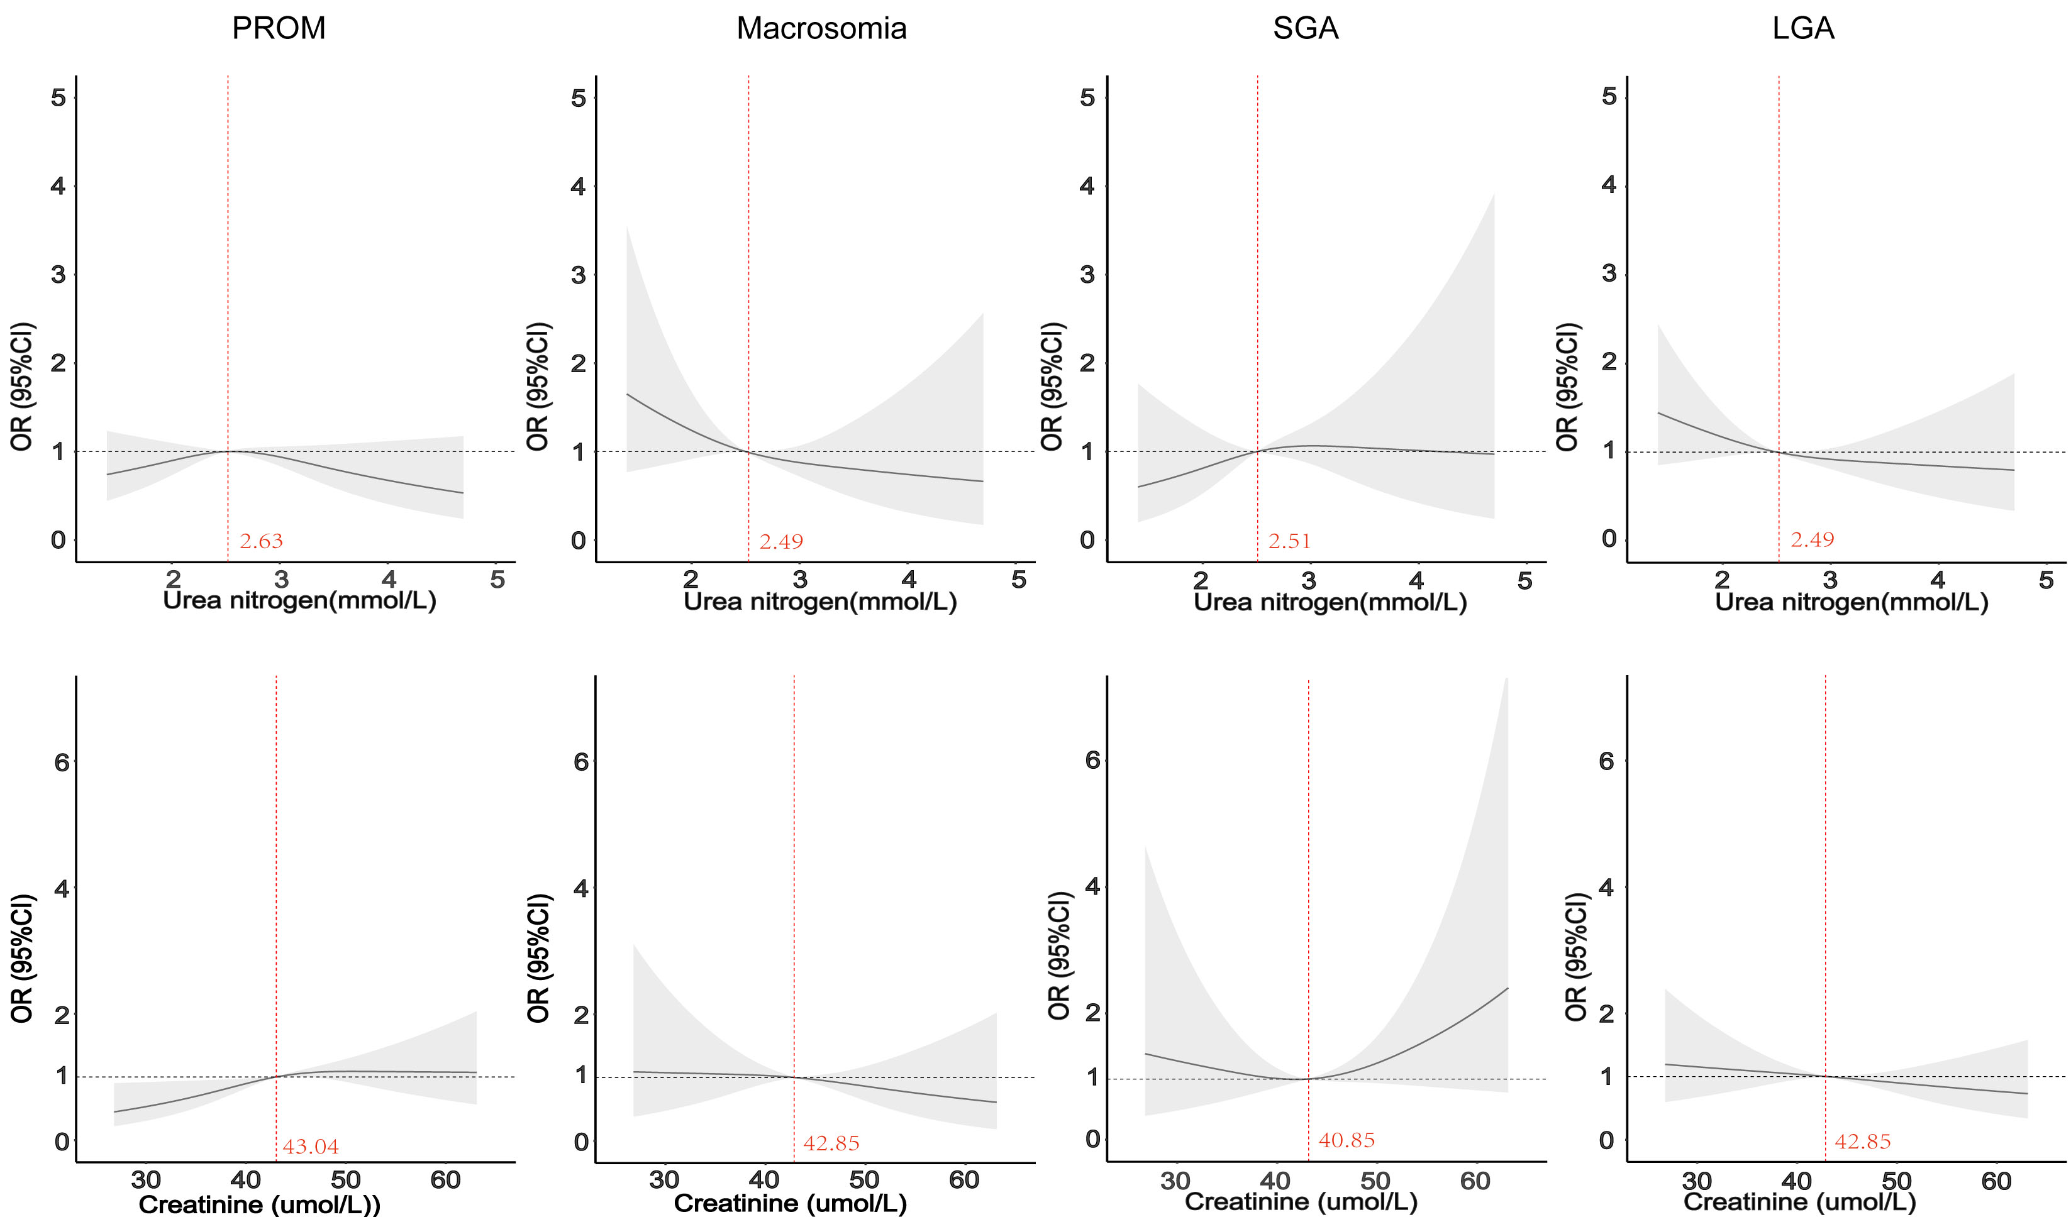

Figure 1 Multivariable adjusted ORs for PROM, Macrosomia, LGA, SGA according to urea nitrogen and creatinine in second trimester of pregnant. The solid lines indicate multivariate adjusted ORs and the shaded area indicate the 95% CIs derived from restricted cubic spline regression. The logistic regression was adjusted for age, pre-pregnancy BMI, education, smoking status, alcohol status, conception method, parity and history of miscarriage.
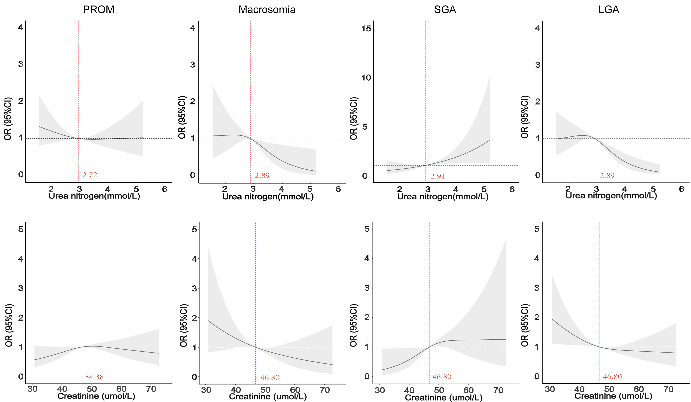

Figure 2 Multivariable adjusted ORs for PROM, Macrosomia, LGA, SGA according to urea nitrogen and creatinine in third trimester of pregnant. The solid lines indicate multivariate adjusted ORs and the shaded area indicate the 95% CIs derived from restricted cubic spline regression. The logistic regression was adjusted for age, pre-pregnancy BMI, education, smoking status, alcohol status, conception method, parity and history of miscarriage.
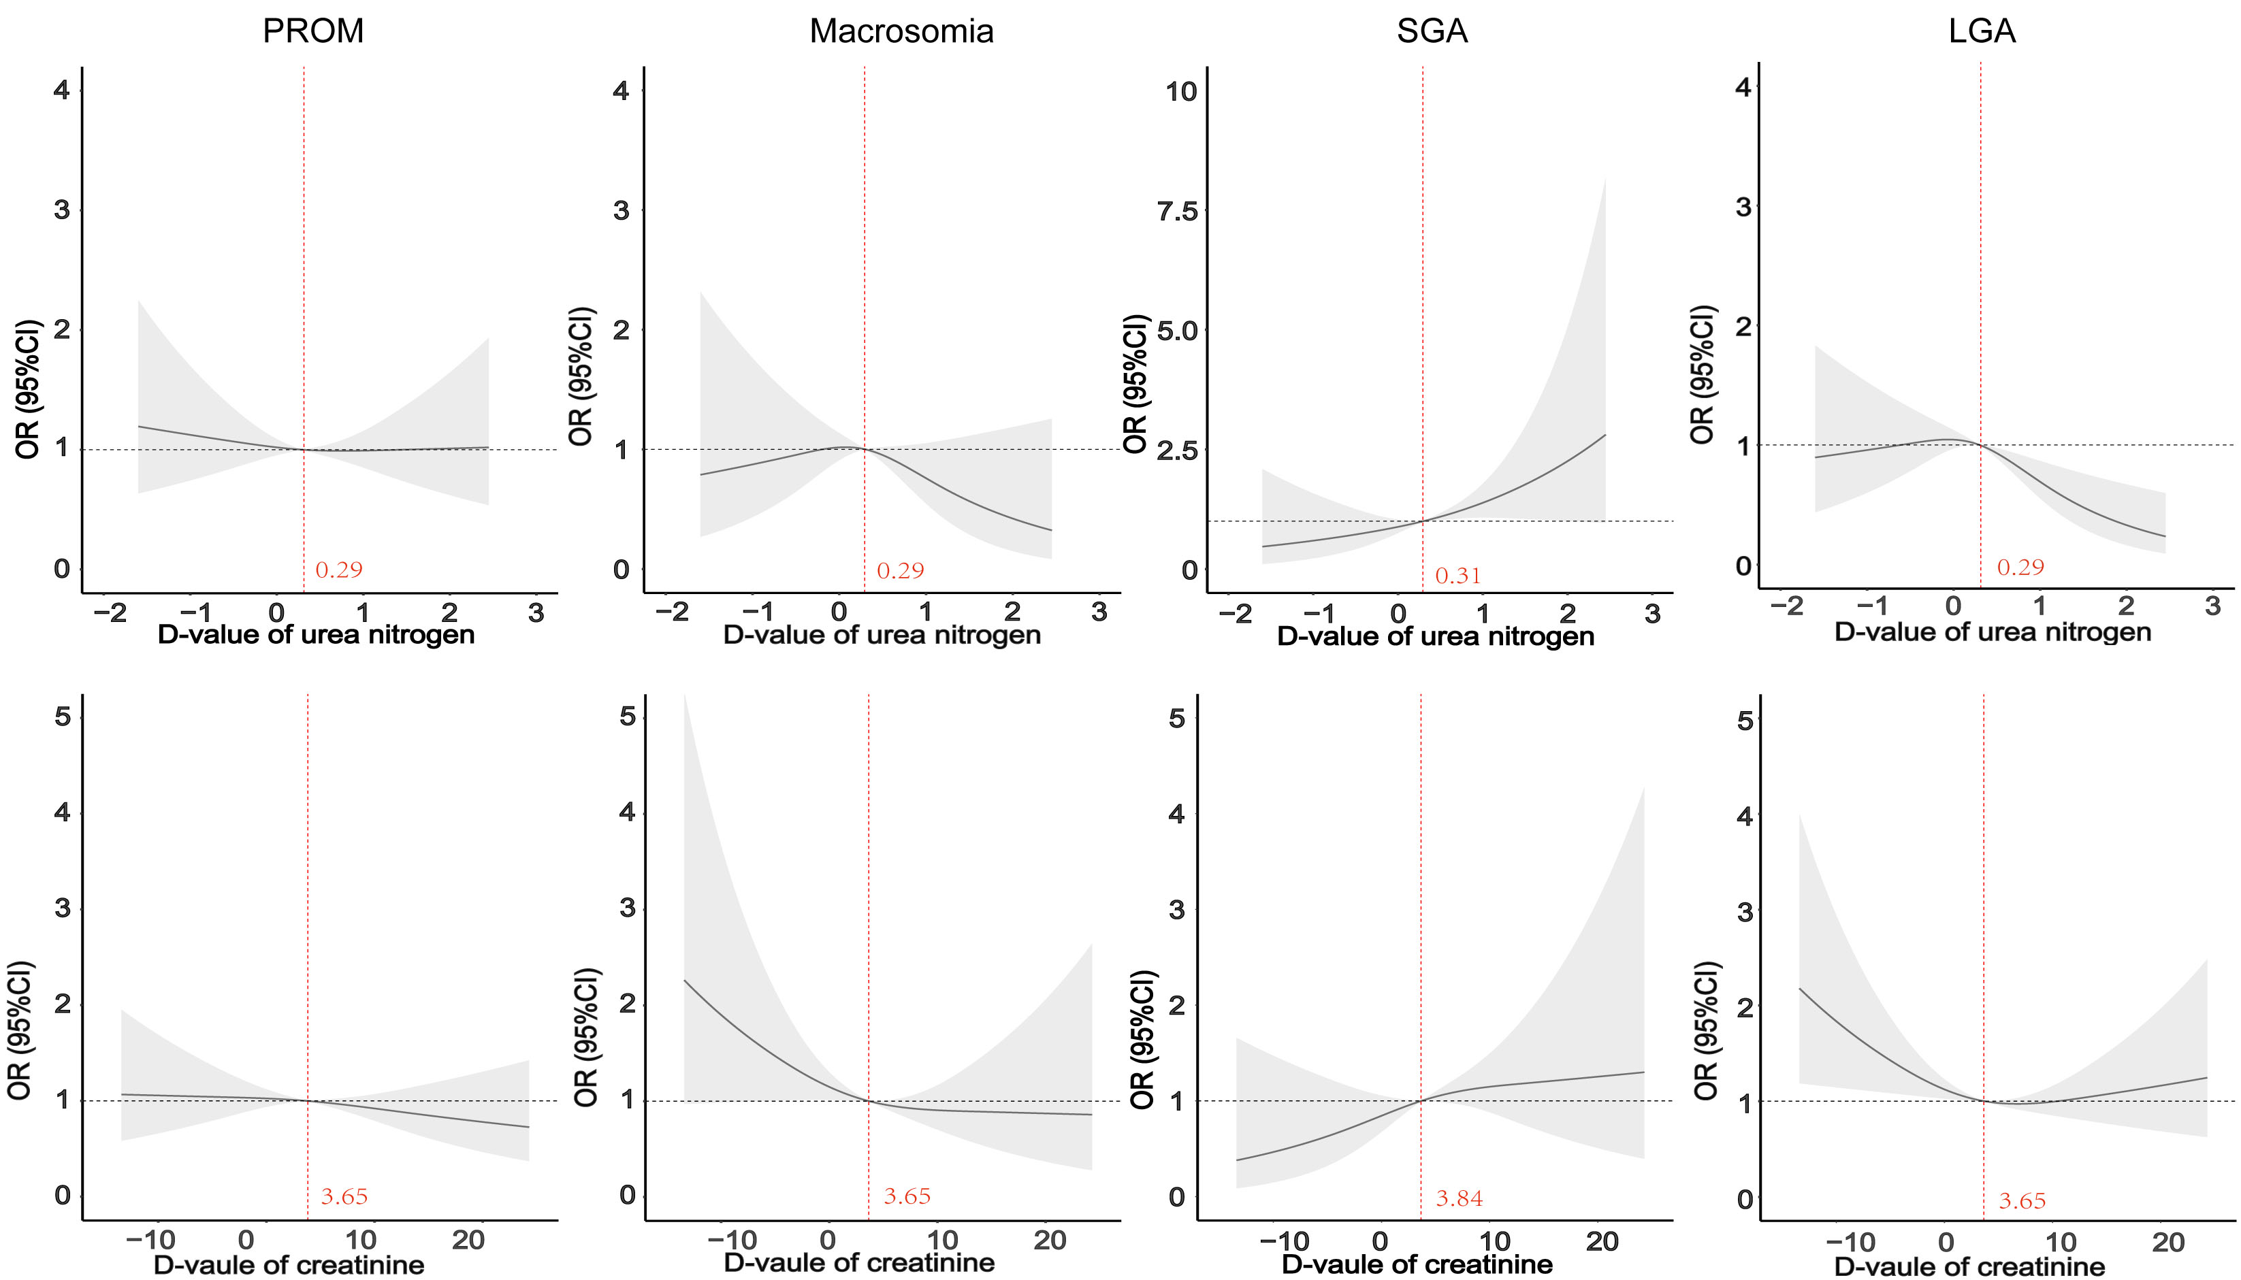

Figure 3 Multivariable adjusted ORs for PROM, Macrosomia, LGA, SGA according to the changes of urea nitrogen and creatinine in second trimester of pregnant. The solid lines indicate multivariate adjusted ORs and the shaded area indicate the 95% CIs derived from restricted cubic spline regression. The logistic regression was adjusted for age, pre-pregnancy BMI, education, smoking status, alcohol status, conception method, parity and history of miscarriage.

