Supplementary Information
Cross-continental shifts of ecological strategy in a global plant invader
Ramona E. Irimia¹, Weihan Zhao^{2,3}, Peipei Cao², Madalin Parepa¹, Zhiyong Liao⁴, Shengyu Wang², Jeannie M. Mounger⁵, Conner Richardson⁵, Fatima Elkott⁵, Xin Zhuang², Jingwen Bi², Yujie Zhao², Elodie Kugler¹, Julia Rafalski¹, Eva Schloter¹, Jihua Wu², Ruiting Ju², Ji Yang², Bo Li^{2, 6,*}, Oliver Bossdorf^{1,*}, Christina L. Richards^{1,5,*}

¹ Plant Evolutionary Ecology, Institute of Evolution & Ecology, University of Tübingen, 72076 Tübingen, Germany
² Ministry of Education Key Laboratory for Biodiversity Science and Ecological Engineering, National Observations and Research Station for Wetland Ecosystems of the Yangtze Estuary, Institute of Biodiversity Science and Institute of Eco-Chongming, School of Life Sciences, Fudan University, 200438 Shanghai, P. R. China
³ Ecology, Department of Biology, University of Konstanz, 78464 Konstanz, Germany
⁴ CAS Key Laboratory of Tropical Forest Ecology, Xishuangbanna Tropical Botanical Garden, Chinese Academy of Sciences, Menglun, Mengla 666303, Yunnan, P.R. China
⁵ University of South Florida, Department of Integrative Biology, 4202 East Fowler Avenue, Tampa, FL 33620, USA
⁶ Ministry of Education Key Laboratory for Transboundary Ecosecurity of Southwest China, Yunnan Key Laboratory of Plant Reproductive Adaptation and Evolutionary Ecology and Centre for Invasion Biology, Institute of Biodiversity, School of Ecology and Environmental Science, Yunnan University, Kunming, Yunnan 650504, P.R. China

* Shared correspondence authors
E-mails: bool@fudan.edu.cn, oliver.bossdorf@uni-tuebingen.de, clr@usf.edu.

Supplementary Figures

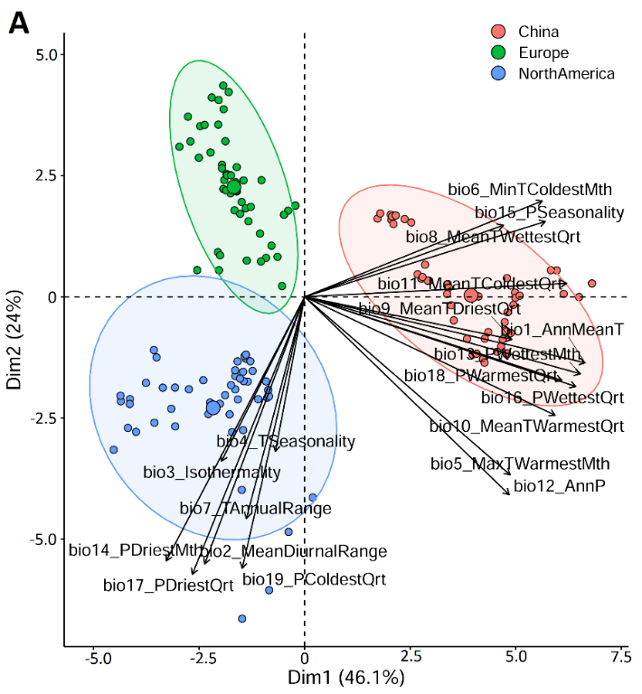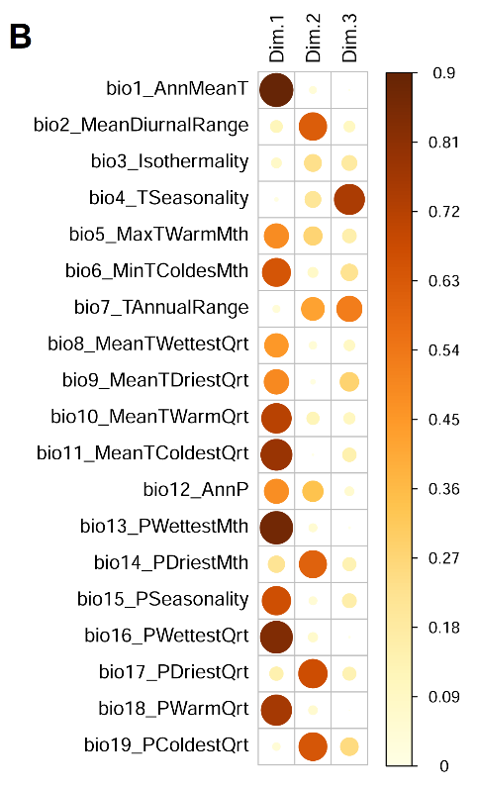
Supplementary Figure 1. A) Principal component analysis (PCA) of climate data across the native (China) and introduced ranges (Europe and USA). B) Variable contribution to each PC.

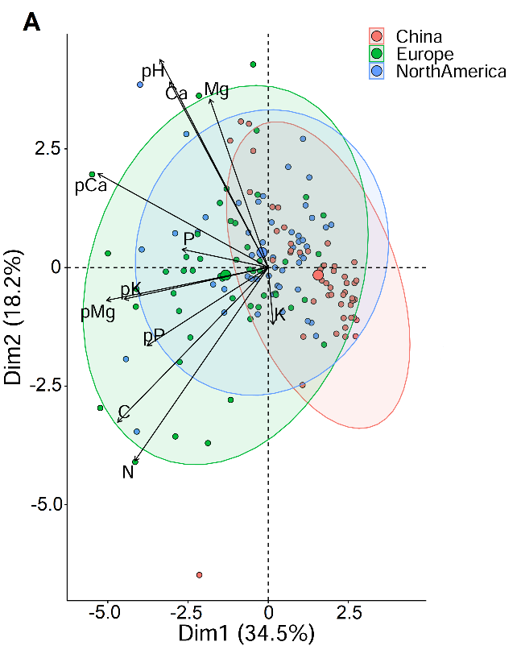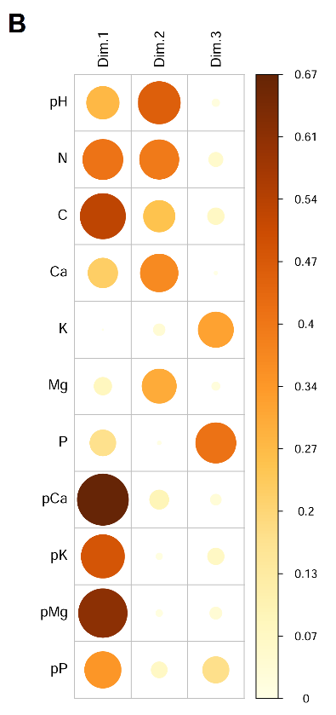

Supplementary Figure 2. A) Principal component analysis (PCA) of soil data across the native (China) and introduced ranges (Europe and USA). B) Variable contribution to each PC.

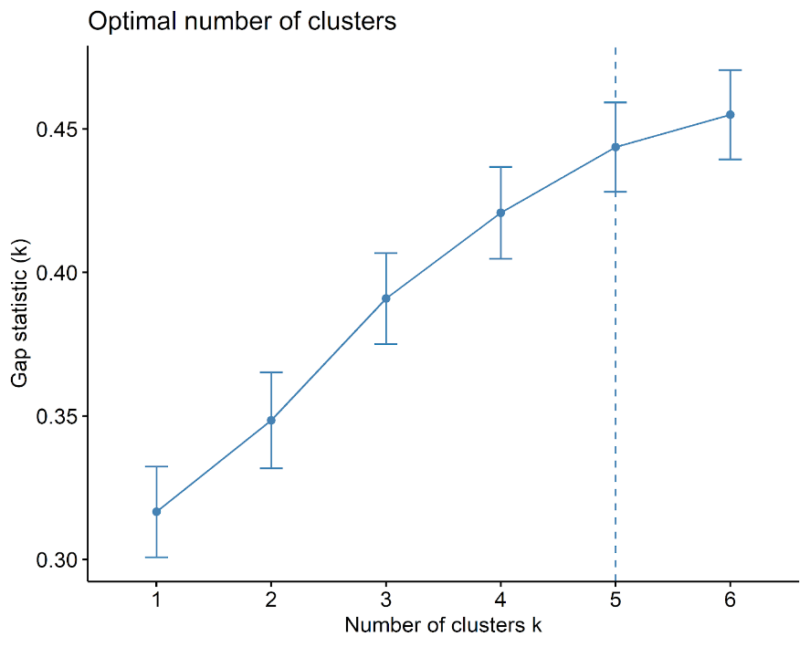
Supplementary Figure 3. Gap statistics to determine the optimal number of clusters for hierarchical cluster analysis. Dashed line shows the optimal number of clusters.

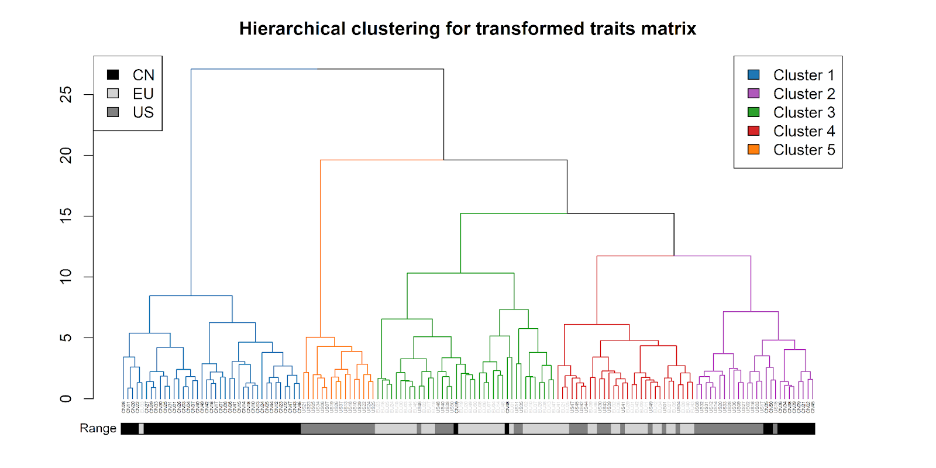
Supplementary Figure 4. Phenogram for 150 knotweed populations generated by hierarchical clustering analysis, indicating the discontinuities between populations based on the performances matrix. Each node represents a population. Branch colors indicate separate clusters (cluster 1 in blue, cluster 2 in purple, cluster 3 in green, cluster 4 in red, cluster 5 in orange). The coloring ribbon under the nodes depicts the origin of each population (populations from CN in black, from USA in dark grey, from EU in light grey).

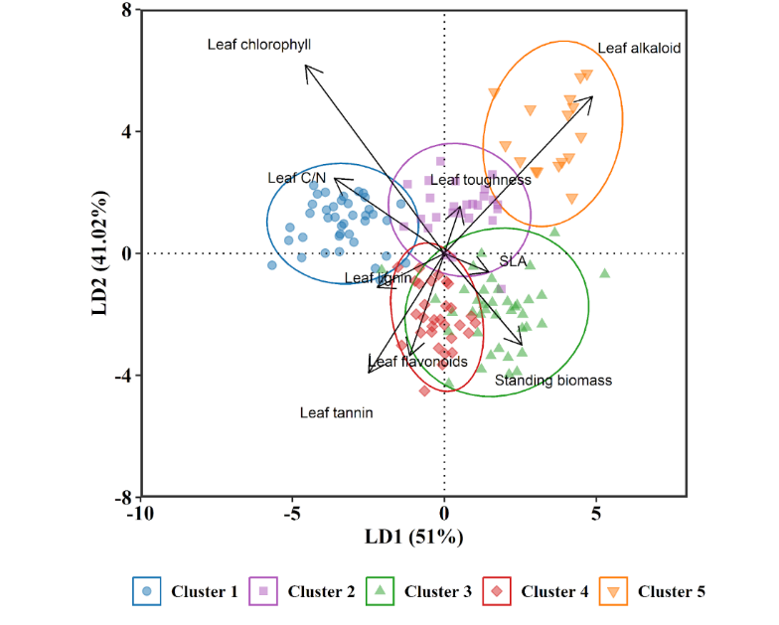
Supplementary Figure 5. Overall variation of performance between clusters defined by the first two discriminators of linear discriminant analysis. Each point represents one of the sampled population. The position of each arrow shows the loading values of LD1 and LD2 for 9 traits. The first two LDs have high discriminatory power (92% in total) to the clusters. Populations are colored with clustering results (cluster 1 in blue, cluster 2 in purple, cluster 3 in green, cluster 4 in red, cluster 5 in orange.

Supplementary Table 1. Geographic locations of the 150 Japanese knotweed populations included in this study. North American and European populations are in the species’ introduced range, Chinese populations in its native range.

Population | Continent | State/country/province | Latitude | Longitude | Elevation [m] | Collection Date
1 | North America | Georgia | 34.243687 | -83.45888 | 244 | 02-06-19
2 | North America | Georgia | 34.582605 | -83.42268 | 455 | 03-06-19
3 | North America | Georgia | 34.909212 | -83.38632 | 655 | 03-06-19
4 | North America | North Carolina | 35.104308 | -83.09636 | 1060 | 03-06-19
5 | North America | North Carolina | 35.46315 | -83.00964 | 845 | 04-06-19
6 | North America | North Carolina | 35.739825 | -82.67967 | 549 | 04-06-19
7 | North America | North Carolina | 36.078762 | -82.34724 | 607 | 05-06-19
8 | North America | North Carolina | 36.213303 | -81.77665 | 811 | 05-06-19
9 | North America | North Carolina | 36.378242 | -81.37687 | 921 | 05-06-19
10 | North America | Virginia | 36.646567 | -80.91819 | 720 | 05-06-19
11 | North America | Virginia | 36.666216 | -80.57397 | 818 | 06-06-19
12 | North America | Virginia | 37.139981 | -80.54223 | 529 | 06-06-19
13 | North America | Virginia | 37.277115 | -80.05605 | 305 | 06-06-19
14 | North America | Virginia | 37.3666 | -79.40806 | 270 | 07-06-19
15 | North America | Virginia | 37.425445 | -79.15961 | 161 | 07-06-19
16 | North America | Virginia | 37.790534 | -79.01639 | 241 | 07-06-19
17 | North America | Virginia | 38.06942 | -78.88527 | 388 | 07-06-19
18 | North America | Virginia | 38.45577 | -78.59494 | 293 | 09-06-19
19 | North America | Virginia | 38.646516 | -78.53521 | 225 | 09-06-19
20 | North America | Virginia | 39.08063 | -78.08574 | 180 | 09-06-19
21 | North America | Maryland | 39.272349 | -77.54727 | 64 | 10-06-19
22 | North America | Maryland | 39.610707 | -76.6827 | 106 | 11-06-19
23 | North America | Pennsylvania | 39.796063 | -76.73519 | 168 | 11-06-19
24 | North America | Pennsylvania | 40.093139 | -76.67698 | 77 | 11-06-19
25 | North America | Pennsylvania | 40.166142 | -76.29577 | 118 | 12-06-19
26 | North America | Pennsylvania | 40.280917 | -75.94827 | 119 | 12-06-19
27 | North America | Pennsylvania | 40.345656 | -75.48387 | 109 | 12-06-19
28 | North America | Pennsylvania | 40.635839 | -75.3936 | 105 | 13-06-19
29 | North America | New Jersey | 40.734003 | -75.08229 | 249 | 13-06-19
30 | North America | New Jersey | 40.802245 | -74.69688 | 205 | 13-06-19
31 | North America | New Jersey | 41.011275 | -74.35119 | 119 | 13-06-19
32 | North America | New York | 41.200219 | -74.19431 | 171 | 13-06-19
33 | North America | New York | 41.414571 | -73.95776 | 4 | 14-06-19
34 | North America | New York | 41.765388 | -73.86471 | 122 | 14-06-19
35 | North America | New York | 41.952163 | -73.51009 | 211 | 14-06-19
36 | North America | Massachusetts | 42.280108 | -73.29808 | 256 | 16-06-19
37 | North America | Massachusetts | 42.38676 | -72.53005 | 60 | 14-06-19
38 | North America | Massachusetts | 42.638961 | -72.91261 | 175 | 16-06-19
39 | North America | Vermont | 42.915838 | -72.76998 | 471 | 16-06-19
40 | North America | Vermont | 43.201889 | -72.45084 | 95 | 17-06-19
41 | North America | Vermont | 43.63969 | -72.32335 | 113 | 17-06-19
42 | North America | Vermont | 43.841038 | -72.18901 | 121 | 17-06-19
43 | North America | New Hampshire | 43.937156 | -71.68359 | 210 | 17-06-19
44 | North America | New Hampshire | 44.116703 | -71.18184 | 185 | 17-06-19
45 | North America | Maine | 44.113167 | -70.68713 | 83 | 18-06-19
46 | North America | Maine | 44.212188 | -70.30963 | 140 | 18-06-19
47 | North America | Maine | 44.527762 | -69.88677 | 76 | 18-06-19
48 | North America | Maine | 44.763763 | -69.5617 | 78 | 18-06-19
49 | North America | Maine | 44.936021 | -68.99148 | 86 | 19-06-19
50 | North America | Maine | 44.946028 | -68.64332 | 40 | 19-06-19
51 | Europe | Italy | 44.88361 | 7.68843 | 230 | 30-05-19
52 | Europe | Italy | 44.74757 | 7.47791 | 258 | 30-05-19
53 | Europe | Italy | 44.67113 | 7.28597 | 586 | 30-05-19
54 | Europe | Italy | 45.1911 | 8.0385 | 159 | 31-05-19
55 | Europe | Italy | 45.38115 | 8.37205 | 135 | 31-05-19
56 | Europe | Italy | 45.63655 | 8.37471 | 308 | 31-05-19
57 | Europe | Italy | 45.79983 | 8.87095 | 336 | 01-06-19
58 | Europe | Switzerland | 46.21338 | 8.74464 | 374 | 01-06-19
59 | Europe | Switzerland | 46.27302 | 8.99511 | 258 | 01-06-19
60 | Europe | Switzerland | 46.51352 | 8.69992 | 1003 | 01-06-19
61 | Europe | Switzerland | 47.15534 | 8.56083 | 720 | 02-06-19
62 | Europe | Germany | 47.62404 | 8.2154 | 344 | 02-06-19
63 | Europe | Germany | 47.81194 | 7.61194 | 240 | 02-06-19
64 | Europe | Germany | 47.9401 | 7.87734 | 633 | 03-06-19
65 | Europe | Germany | 48.2796 | 8.11127 | 298 | 03-06-19
66 | Europe | Germany | 48.3737 | 8.55788 | 575 | 03-06-19
67 | Europe | Germany | 48.46553 | 8.91653 | 419 | 03-06-19
68 | Europe | Germany | 48.56372 | 8.39383 | 513 | 06-06-19
69 | Europe | Germany | 48.78511 | 8.32216 | 193 | 06-06-19
70 | Europe | Germany | 49.47681 | 8.36521 | 95 | 07-06-19
71 | Europe | Germany | 49.58927 | 8.73014 | 169 | 07-06-19
72 | Europe | Germany | 49.90489 | 8.83001 | 145 | 07-06-19
73 | Europe | Germany | 50.07063 | 8.48126 | 107 | 07-06-19
74 | Europe | Germany | 50.23075 | 8.05309 | 230 | 08-06-19
75 | Europe | Germany | 50.31413 | 7.78856 | 130 | 08-06-19
76 | Europe | Germany | 50.54085 | 7.08143 | 205 | 08-06-19
77 | Europe | Germany | 51.14256 | 6.78324 | 42 | 08-06-19
78 | Europe | Germany | 51.42722 | 7.29018 | 77 | 09-06-19
79 | Europe | Germany | 51.86572 | 7.54834 | 64 | 09-06-19
80 | Europe | Germany | 52.15184 | 7.6159 | 40 | 09-06-19
81 | Europe | Germany | 52.38889 | 7.94417 | 49 | 09-06-19
82 | Europe | Germany | 52.72011 | 8.26118 | 29 | 10-06-19
83 | Europe | Germany | 53.01177 | 8.70257 | 8 | 10-06-19
84 | Europe | Germany | 53.22062 | 9.56834 | 34 | 11-06-19
85 | Europe | Germany | 53.4468 | 10.08358 | 2 | 11-06-19
86 | Europe | Germany | 53.98502 | 10.24835 | 39 | 11-06-19
87 | Europe | Germany | 54.30611 | 10.13286 | 11 | 12-06-19
88 | Europe | Denmark | 54.71061 | 11.4508 | 4 | 12-06-19
89 | Europe | Denmark | 55.45565 | 12.18828 | -2 | 13-06-19
90 | Europe | Sweden | 55.68228 | 13.18643 | 14 | 13-06-19
91 | Europe | Sweden | 56.14472 | 13.75752 | 50 | 13-06-19
92 | Europe | Sweden | 56.44507 | 13.60293 | 105 | 14-06-19
93 | Europe | Sweden | 56.83254 | 13.96032 | 150 | 14-06-19
94 | Europe | Sweden | 57.6978 | 14.111 | 188 | 14-06-19
95 | Europe | Sweden | 58.16846 | 14.57616 | 144 | 14-06-19
96 | Europe | Sweden | 58.41322 | 15.65144 | 45 | 15-06-19
97 | Europe | Sweden | 58.66624 | 16.20078 | 9 | 15-06-19
98 | Europe | Sweden | 58.89243 | 17.56211 | 17 | 15-06-19
99 | Europe | Sweden | 59.31895 | 18.01697 | 12 | 16-06-19
100 | Europe | Sweden | 59.94927 | 17.70784 | 51 | 16-06-19
101 | Asia | China / Jiangxi | 29.305139 | 117.85097 | 100 | 08-07-20
102 | Asia | China / Jiangxi | 29.212917 | 117.15264 | 76 | 09-07-20
103 | Asia | China / Jiangxi | 28.709353 | 117.02008 | 106 | 10-07-20
104 | Asia | China / Jiangxi | 28.536197 | 117.0542 | 64 | 10-07-20
105 | Asia | China / Jiangxi | 28.186318 | 116.76129 | 116 | 11-07-20
106 | Asia | China / Jiangxi | 27.86845 | 116.78029 | 100 | 11-07-20
107 | Asia | China / Jiangxi | 27.657717 | 116.67717 | 76 | 12-07-20
108 | Asia | China / Jiangxi | 27.378919 | 116.44771 | 245 | 12-07-20
109 | Asia | China / Jiangxi | 27.077805 | 116.33928 | 225 | 13-07-20
110 | Asia | China / Jiangxi | 26.846733 | 116.37137 | 215 | 14-07-20
111 | Asia | China / Jiangxi | 26.553948 | 116.27197 | 480 | 14-07-20
112 | Asia | China / Jiangxi | 26.271136 | 116.31947 | 338 | 15-07-20
113 | Asia | China / Jiangxi | 26.029378 | 116.16491 | 264 | 15-07-20
114 | Asia | China / Jiangxi | 25.804809 | 115.93752 | 259 | 16-07-20
115 | Asia | China / Jiangxi | 25.528305 | 115.83884 | 302 | 16-07-20
116 | Asia | China / Jiangxi | 25.236142 | 115.73258 | 250 | 17-07-20
117 | Asia | China / Jiangxi | 24.958921 | 115.61321 | 349 | 18-07-20
118 | Asia | China / Guangdong | 24.711662 | 115.8243 | 370 | 18-07-20
119 | Asia | China / Guangdong | 23.824923 | 115.38494 | 785 | 20-07-20
120 | Asia | China / Guangdong | 23.745348 | 115.27247 | 596 | 21-07-20
121 | Asia | China / Guangdong | 23.636976 | 113.83965 | 650 | 22-07-20
122 | Asia | China / Guangdong | 23.291111 | 114.00875 | 1129 | 23-07-20
123 | Asia | China / Guangdong | 23.740442 | 113.9119 | 915 | 24-07-20
124 | Asia | China / Guangdong | 24.438277 | 113.2545 | 397 | 25-07-20
125 | Asia | China / Guangdong | 24.617076 | 113.76008 | 485 | 26-07-20
126 | Asia | China / Jiangxi | 26.102937 | 114.68757 | 272 | 26-07-20
127 | Asia | China / Jiangxi | 29.102245 | 117.12284 | 122 | 01-08-20
128 | Asia | China / Jiangxi | 29.429552 | 117.16421 | 93 | 01-08-20
129 | Asia | China / Jiangxi | 29.638337 | 117.22124 | 171 | 01-08-20
130 | Asia | China / Anhui | 29.810289 | 117.05254 | 244 | 02-08-20
131 | Asia | China / Anhui | 29.984197 | 116.96657 | 184 | 02-08-20
132 | Asia | China / Anhui | 30.183525 | 117.0438 | 82 | 03-08-20
133 | Asia | China / Anhui | 30.441699 | 116.22543 | 102 | 04-08-20
134 | Asia | China / Anhui | 30.685132 | 115.97836 | 296 | 05-08-20
135 | Asia | China / Anhui | 30.822433 | 116.04723 | 362 | 05-08-20
136 | Asia | China / Anhui | 30.92216 | 116.20587 | 431 | 06-08-20
137 | Asia | China / Anhui | 31.090839 | 116.10247 | 558 | 06-08-20
138 | Asia | China / Anhui | 31.205587 | 116.01563 | 336 | 06-08-20
139 | Asia | China / Anhui | 31.395357 | 115.92709 | 297 | 07-08-20
140 | Asia | China / Anhui | 31.580801 | 115.97336 | 225 | 08-08-20
141 | Asia | China / Henan | 31.812995 | 115.84742 | 95 | 08-08-20
142 | Asia | China / Henan | 34.268356 | 115.67621 | 47 | 10-08-20
143 | Asia | China / Jiangsu | 34.720443 | 116.78818 | 40 | 11-08-20
144 | Asia | China / Shandong | 35.055528 | 116.3148 | 37 | 11-08-20
145 | Asia | China / Shandong | 35.521634 | 117.81795 | 204 | 12-08-20
146 | Asia | China / Shandong | 35.743485 | 117.63847 | 267 | 13-08-20
147 | Asia | China / Shandong | 35.99998 | 117.64851 | 192 | 13-08-20
148 | Asia | China / Shandong | 36.379211 | 117.66407 | 328 | 14-08-20
149 | Asia | China / Shandong | 36.866777 | 117.68417 | 80 | 14-08-20
150 | Asia | China / Jiangsu | 32.84518 | 118.43548 | 71 | 16-08-20

Supplementary Table 2. Climatic variable loadings on principal components 1, 2, and 3 (PC1, 2 and 3). PC1 explained 46.1% of the climatic variation and was mainly associated with the annual mean temperature (bio1), the precipitation of the wettest month (bio13), the precipitation of the wettest quarter (bio16), the mean temperature of the coldest quarter (bio11), the precipitation of the warmest quarter (bio18) and the mean temperature of warmest quarter (bio10), all displaying negative loadings on the PC. PC2 explained 24% of the variation and was mainly associated with the precipitation of driest quarter (bio17), the precipitation of the coldest quarter (bio19), precipitation of driest month (bio14) and the mean diurnal range (bio2) all showing positive loadings on the PC. PC3 explained 17.5% of the variation and was mainly associated with temperature seasonality (bio4) and temperature annual range (bio7), both showing negative loadings on the PC. Variables that contribute strongly to the PC are shown in bold. Collectively, the three PCs explained 87.6% of the total variation in climatic data.

 | bio1 | bio2 | bio3 | bio4 | bio5 | bio6 | bio7 | bio8 | bio9 | bio10 | bio11 | bio12 | bio13 | bio14 | bio15 | bio16 | bio17 | bio18 | bio19
PC1 | -0.321 | 0.114 | 0.095 | 0.033 | -0.235 | -0.272 | 0.067 | -0.228 | -0.237 | -0.287 | -0.300 | -0.234 | -0.316 | 0.158 | -0.276 | -0.310 | 0.128 | -0.294 | 0.071
PC2 | 0.091 | 0.369 | 0.227 | 0.214 | 0.246 | -0.132 | 0.306 | -0.099 | 0.059 | 0.164 | -0.019 | 0.273 | 0.106 | 0.365 | -0.104 | 0.124 | 0.383 | 0.115 | 0.375
PC3 | 0.013 | -0.170 | 0.235 | -0.475 | -0.216 | 0.259 | -0.398 | -0.166 | 0.292 | -0.176 | 0.212 | 0.138 | -0.026 | 0.205 | -0.218 | 0.024 | 0.205 | -0.002 | 0.278

Supplementary Table 3. Soil variable loading on the PC. The first principal component explained 34.5% of the variation in soil data and was mainly associated with plant available Ca and Mg, as well as with total soil C, plant available K and total soil N (all showing negative loadings on the PC). The PC2 explained 18.2% of the variation and was mainly associated with soil pH, (positive loading on the PC), total soil N (negative loading) and Ca (positive loading). Finally, PC3 explained 11% of the variation and was mainly associated with total soil P and K (both showing positive loadings on the PC). Variables that contribute strongly to the PC are shown in bold. The three PCs explained 63.7% of the variation in soil data.

 | pH | N | C | Ca | K | Mg | P | pCa | pK | pMg | pP
PC1 | -0.268 | -0.330 | -0.373 | -0.244 | 0.012 | -0.144 | -0.213 | -0.421 | -0.356 | -0.400 | -0.299
PC2 | 0.480 | -0.446 | -0.357 | 0.428 | -0.132 | 0.388 | 0.042 | 0.216 | -0.073 | -0.076 | -0.180
PC3 | -0.109 | -0.207 | -0.242 | -0.051 | 0.515 | 0.118 | 0.587 | -0.157 | 0.240 | -0.175 | 0.384

Supplementary Table 4. Global model selection on phenotypic traits indicating the 95% confidence set of best model(s) based on raw sum of model probabilities. K = the number of parameters in the model, AIC = the information score of the model, Delta_AIC = the difference in AIC score between the best model and the model being compared, AICWt = the proportion of the total amount of predictive power provided by the full set of models, Cum.Wt = the sum of the AIC weights, LL = the log-likelihood, value describing how likely the model is, R² (cond.) = the coefficient of determination for both the fixed and random effects, R² (marg.) = the coefficient of determination for fixed effects.

Dependent variable | 95% confidence set of best model(s) | K | AIC | Delta_AIC | AICWt | Cum.Wt | LL | R² (cond.) | R² (marg.)
Standing biomass | Climate + Soil nutrients + Light availability | 10 | 14232.8 | 0.00 | 0.30 | 0.30 | -7106.4 | 0.404 | 0.185
Standing biomass | Climate + Light availability | 7 | 14233.0 | 0.20 | 0.27 | 0.57 | -7109.5 | 0.404 | 0.170
Standing biomass | Climate + Soil nutrients + Light availability + Range | 11 | 14234.8 | 1.99 | 0.11 | 0.68 | -7106.4 | 0.404 | 0.185
Standing biomass | Climate + Light availability + Range | 8 | 14234.8 | 2.03 | 0.11 | 0.79 | -7109.4 | 0.404 | 0.170
Specific leaf area | Soil nutrients + Light availability + Range | 8 | 5267.64 | 0.00 | 0.65 | 0.65 | -2625.7 | 0.572 | 0.288
Specific leaf area | Climate + Light availability + Range | 8 | 5270.49 | 2.85 | 0.16 | 0.80 | -2627.1 | 0.569 | 0.279
Specific leaf area | Climate + Soil nutrients + Light availability + Range | 11 | 5270.65 | 3.01 | 0.14 | 0.95 | -2624.1 | 0.570 | 0.295
Leaf toughness | Climate + Light availability + Range interactions | 12 | 1845.53 | 0.00 | 0.51 | 0.51 | -910.55 | 0.544 | 0.176
Leaf toughness | Climate + Range interactions | 10 | 1846.69 | 1.16 | 0.28 | 0.79 | -913.19 | 0.541 | 0.166
Leaf chlorophyll | Climate + Soil nutrients + Range interactions | 16 | 4195.35 | 0.00 | 0.46 | 0.46 | -2081.3 | 0.760 | 0.574
Leaf chlorophyll | Climate + Range interactions | 10 | 4195.55 | 0.20 | 0.41 | 0.87 | -2087.6 | 0.760 | 0.555
Leaf C:N ratio | Climate + Soil nutrients + Light availability + Range | 11 | 3794.69 | 0.00 | 0.46 | 0.46 | -1886.1 | 0.718 | 0.481
Leaf C:N ratio | Climate + Soil nutrients + Light availability + Range interactions | 18 | 3794.71 | 0.02 | 0.45 | 0.91 | -1878.8 | 0.717 | 0.506
Leaf tannins | Climate + Light availability + Range interactions | 12 | 599.470 | 0.00 | 0.73 | 0.73 | -287.52 | 0.307 | 0.167
Leaf tannins | Climate + Soil nutrients + Light availability + Range interactions | 18 | 601.490 | 2.02 | 0.27 | 1.00 | -282.27 | 0.307 | 0.185
Leaf alkaloids | Climate + Soil nutrients + Light availability + Range interactions | 18 | 2988.53 | 0.00 | 0.96 | 0.96 | -1476.2 | 0.565 | 0.357
Leaf lignin | Soil nutrients + Light availability + Range | 8 | 6193.52 | 0.00 | 0.40 | 0.40 | -3088.7 | 0.548 | 0.393
Leaf lignin | Light availability + Range | 5 | 6195.04 | 1.51 | 0.19 | 0.58 | -3092.5 | 0.548 | 0.382
Leaf lignin | Light availability + Range interactions | 6 | 6195.25 | 1.72 | 0.17 | 0.75 | -3091.6 | 0.546 | 0.382
Leaf lignin | Climate + Light availability + Range | 8 | 6196.21 | 2.69 | 0.10 | 0.86 | -3090.1 | 0.548 | 0.388
Leaf flavonoids | Climate + Range | 7 | 4489.32 | 0.00 | 0.32 | 0.32 | -2237.6 | 0.506 | 0.076
Leaf flavonoids | Climate | 6 | 4490.46 | 1.14 | 0.18 | 0.50 | -2239.2 | 0.506 | 0.065
Leaf flavonoids | Climate + Light availability + Range | 8 | 4490.89 | 1.57 | 0.15 | 0.65 | -2237.4 | 0.507 | 0.077

Supplementary Table 5. Bioclimatic variable loadings on the PCs: within region analysis*.

Region | PC | bio1 | bio2 | bio3 | bio4 | bio5 | bio6 | bio7 | bio8 | bio9 | bio10 | bio11 | bio12 | bio13 | bio14 | bio15 | bio16 | bio17 | bio18 | bio19
US | PC1 | -0.225 | -0.100 | -0.263 | 0.283 | -0.081 | -0.243 | 0.277 | 0.028 | -0.266 | -0.139 | -0.253 | -0.268 | -0.272 | -0.262 | 0.031 | -0.275 | -0.256 | -0.266 | -0.258
US | PC2 | -0.290 | -0.081 | -0.143 | 0.146 | -0.354 | -0.260 | 0.163 | -0.322 | -0.028 | -0.337 | -0.252 | 0.218 | 0.203 | 0.229 | -0.223 | 0.195 | 0.240 | 0.163 | 0.230
EU | PC1 | -0.050 | -0.103 | -0.197 | 0.192 | 0.001 | -0.103 | 0.084 | -0.015 | -0.020 | 0.024 | -0.105 | -0.358 | -0.332 | -0.374 | 0.100 | -0.338 | -0.374 | -0.344 | -0.348
EU | PC2 | 0.390 | 0.273 | 0.240 | 0.023 | 0.350 | 0.348 | 0.123 | 0.233 | 0.294 | 0.358 | 0.371 | -0.057 | -0.063 | -0.044 | -0.104 | -0.084 | -0.029 | -0.122 | -0.088
EU | PC3 | -0.089 | -0.197 | 0.130 | -0.418 | -0.265 | 0.172 | -0.446 | 0.169 | 0.310 | -0.225 | 0.056 | -0.136 | -0.216 | -0.018 | -0.403 | -0.191 | -0.011 | -0.101 | 0.099
CN | PC1 | -0.254 | 0.232 | -0.083 | 0.250 | -0.032 | -0.277 | 0.253 | 0.200 | -0.272 | -0.072 | -0.268 | -0.281 | -0.251 | -0.241 | 0.214 | -0.273 | -0.236 | -0.180 | -0.266
CN | PC2 | -0.033 | 0.040 | 0.382 | -0.231 | -0.446 | 0.056 | -0.228 | 0.227 | -0.02 | -0.420 | 0.084 | 0.045 | 0.130 | -0.247 | 0.161 | 0.069 | -0.238 | 0.334 | -0.175

* Climate – within region analysis: PCs explained
In the USA, PC1 and PC2 explained 82% of the variation in climatic space. PC1 was mainly associated with the temperature seasonality (bio4) and temperature annual range (bio7) (both showing positive loadings on the PC) and with the precipitation of the wettest quarter (bio16), precipitation of the wettest month (bio13), annual precipitation (bio12), precipitation of the warmest quarter (bio18) and precipitation of the coldest quarter (bio19) (all showing negative loadings on the PC). PC2 was mainly associated with the maximum temperature of the warmest month (bio5), the mean temperature of the warmest quarter (bio10) and the mean temperature of the wettest quarter (bio8) (all showing negative loadings on the PC).
In Europe, the first three principal components explained 87.9% of the variation. PC1 was mainly associated with the precipitation of the driest month (bio14) and driest quarter (bio17), the annual precipitation (bio12), precipitation of the coldest quarter (bio19) and precipitation of the warmest quarter (bio18), all showing negative loadings on the PC. PC2 was mainly associated with the annual mean temperature (bio1), the mean temperature of the coldest quarter (bio11), mean temperature of the warmest quarter (bio10), the maximum temperature of the warmest month (bio5) and the minimum temperature of the coldest month (bio6) (all showing positive loadings on the PC). PC3 was mainly associated with the temperature seasonality (bio4), the temperature annual range (bio7) and the precipitation seasonality (bio15) all showing negative loadings on the PC.
In China, the first two principal components explained 83.2% of variation. PC1 was mainly associated with the annual precipitation (bio12), the precipitation of the wettest quarter (bio16), the mean temperature of the driest quarter (bio9), the minimum temperature of the coldest month (bio6), the mean temperature of the coldest quarter (bio11) and the precipitation of the coldest quarter (bio19) (all showing negative loadings on the PC). The PC2 was mainly associated with the maximum temperature of the warmest month (bio5), the mean temperature of the warmest quarter (bio10) (both showing negative loadings on the PC) and with isothermality (bio3) (which showed a positive loading on the PC).
Supplementary Table 6. Soil nutrient variable loadings on the PCs: within region analysis**.

Region | PC | pH | N | C | Ca | K | Mg | P | pCa | pK | pMg | pP
US | PC1 | 0.203 | 0.469 | 0.440 | 0.218 | 0.023 | 0.024 | 0.288 | 0.394 | 0.206 | 0.397 | 0.240
US | PC2 | -0.471 | 0.152 | 0.027 | -0.451 | 0.217 | -0.318 | 0.301 | -0.312 | 0.290 | 0.010 | 0.360
US | PC3 | -0.186 | -0.115 | -0.136 | 0.420 | 0.679 | 0.201 | 0.306 | 0.172 | -0.162 | -0.294 | 0.142
EU | PC1 | -0.020 | -0.523 | -0.506 | -0.005 | -0.050 | 0.040 | 0.030 | -0.351 | -0.332 | -0.449 | -0.172
EU | PC2 | 0.561 | -0.185 | -0.156 | 0.395 | 0.078 | 0.467 | 0.203 | 0.406 | 0.186 | -0.021 | -0.065
EU | PC3 | -0.188 | -0.020 | -0.081 | 0.092 | 0.088 | 0.028 | 0.418 | -0.246 | 0.458 | -0.255 | 0.657
EU | PC4 | 0.205 | -0.118 | -0.119 | 0.223 | -0.756 | -0.341 | -0.316 | 0.064 | 0.160 | 0.028 | 0.250
CN | PC1 | -0.434 | 0.072 | 0.025 | -0.425 | 0.172 | -0.344 | -0.192 | -0.422 | -0.326 | -0.390 | -0.057
CN | PC2 | 0.114 | -0.650 | -0.641 | -0.030 | 0.087 | -0.062 | -0.240 | 0.013 | -0.041 | 0.017 | -0.285
CN | PC3 | -0.044 | -0.162 | -0.213 | 0.011 | 0.180 | 0.412 | 0.636 | -0.273 | -0.391 | -0.027 | 0.302

** Soil within region analysis: PCs explained
In the USA, the first three PCs explained 65.2% of the variation in the soil nutrients. PC1 was mainly associated with the total soil nitrogen and carbon content as well as to the plant available Mg and Ca (all showing positive loadings on the PC). PC2 was mainly associated with the soil pH and the total soil Ca (both showing negative loading on the PC). Finally, PC3 was mainly associated with the total soil K, which showed a positive loading on the PC.
In Europe, the first four PCs explained 71.9% of the variation in soil nutrients. PC1 was mainly associated with the total soil N and C as well as to the plant available Mg (all showing negative loadings on the PC). PC2 was mainly associated with the soil pH and the total soil Mg (both showing positive loadings on the PC). PC3 was mainly associated with the plant available P and K (both showing positive loadings on the PC). Lastly, PC4 was mainly associated with the total soil K which had a negative loading on the PC.
In China, the first three PCs explained 72.7% of the variation in soil nutrients. PC1 was mainly associated with the soil pH, the soil total Ca and the plant available Ca and Mg (all having negative loadings on the PC). PC2 was mainly associated with the total soil N and C (both showing negative loadings on the PC). Finally, PC3 was mainly associated with the total soil P which showed a positive loading on the PC.

Supplementary Table 7. Tukey post hoc test output for comparison of morphological trait differentiation and enemy pressure across Japanese knotweed regions: China (native), Europe and North America (introduced).

Dependent variable | Groups compared | Estimate | Standard Error | Z value | Pr (>|z|)
Standing biomass | Europe - China | 3981 | 486.9 | 8.048 | < 0.001
Standing biomass | North America - China | 2487 | 487.2 | 5.106 | < 0.001
Standing biomass | North America - Europe | -1430 | 485.6 | -2.946 | 0.008
Specific leaf area | Europe - China | 8.970 | 1.457 | 6.156 | < 0.001
Specific leaf area | North America - China | 12.33 | 1.458 | 8.462 | <0.001
Specific leaf area | North America - Europe | 3.366 | 1.455 | 2.314 | 0.053
Leaf toughness | Europe - China | -0.862 | 0.150 | -5.722 | <0.001
Leaf toughness | North America - China | -0.382 | 0.150 | -2.537 | 0.03
Leaf toughness | North America - Europe | 0.480 | 0.150 | 3.19 | 0.004
Leaf chlorophyll | Europe - China | -11.38 | 0.833 | -13.65 | <1e-10
Leaf chlorophyll | North America - China | -5.779 | 0.833 | -6.93 | <1e-10
Leaf chlorophyll | North America - Europe | 5.605 | 0.832 | 6.733 | <1e-10
Leaf C:N ratio | Europe - China | -7.102 | 0.562 | -12.62 | <1e-04
Leaf C:N ratio | North America - China | -6.643 | 0.563 | -11.8 | <1e-04
Leaf C:N ratio | North America - Europe | 0.458 | 0.561 | 0.816 | 0.693
Leaf tannins | Europe - China | -0.020 | 0.052 | -0.39 | 0.919
Leaf tannins | North America - China | -0.189 | 0.052 | -3.623 | <0.001
Leaf tannins | North America - Europe | -0.168 | 0.052 | -3.245 | 0.003
Leaf alkaloids | Europe - China | 0.559 | 0.338 | 1.655 | 0.223
Leaf alkaloids | North America - China | 2.238 | 0.338 | 6.617 | <1e-04
Leaf alkaloids | North America - Europe | 1.678 | 0.330 | 4.973 | <1e-04
Leaf lignin | Europe - China | -14.20 | 2.240 | -6.342 | 1.09E-09
Leaf lignin | North America - China | -30.15 | 2.242 | -13.44 | <1e-09
Leaf lignin | North America - Europe | -15.94 | 2.235 | -7.136 | <1e-09
Leaf flavonoids | Europe - China | 1.970 | 0.864 | 2.28 | 0.058
Leaf flavonoids | North America - China | -2.155 | 0.864 | -2.493 | 0.033
Leaf flavonoids | North America - Europe | -4.126 | 0.863 | -4.781 | <0.001
Leaf area lost | Europe - China | -0.050 | 0.007 | -6.83 | <1e-05
Leaf area lost | North America - China | -0.050 | 0.007 | -6.53 | <1e-05
Leaf area lost | North America - Europe | 0.002 | 0.007 | 0.3 | 0.95
Pathogens | Europe - China | -0.750 | 0.040 | -16.93 | <1e-04
Pathogens | North America - China | -0.730 | 0.040 | -16.3 | <1e-04
Pathogens | North America - Europe | 0.020 | 0.040 | 0.62 | 0.8

Supplementary Table 8. (a) Mean values of each phenotypic trait to separate clusters of performance across knotweed populations. Figures are the least square mean and SE of trait values for separate clusters, and coefficients of each trait for LD1 (LDA scaling) of linear discriminant analysis. F-values with significant marks were derived from type II ANOVA test. (b) Pair-wise comparisons between clusters for each phenotypic trait across knotweed populations. Figures are the F-values with significant marks. Significant (P < 0.05) differences between clusters are typed in bold.

 | Stem biomass | SLA | Leaf chlorophyll | Leaf toughness | Leaf C/N | Leaf Tannin | Leaf alkaloid | Leaf lignin | Leaf flavonoids
(a) LDA means with emmeans function significant of F-statistics
LD1 scaling | 0.43 | 0.24 | -0.76 | 0.09 | -0.60 | -0.41 | 0.81 | -0.37 | -0.19
Cluster 1 | -0.74 ± 0.13 | -1.07 ± 0.09 | 1.10 ± 0.09 | 0.72 ± 0.13 | 1.24 ± 0.09 | 0.54 ± 0.10 | -0.70 ± 0.09 | 1.08 ± 0.11 | 0.30 ± 0.13
Cluster 2 | -0.35 ± 0.16 | 0.05 ± 0.11 | 0.19 ± 0.12 | 0.24 ± 0.16 | -0.07 ± 0.12 | -0.45 ± 0.13 | 0.28 ± 0.11 | -0.44 ± 0.13 | -0.73 ± 0.16
Cluster 3 | 0.90 ± 0.13 | 0.73 ± 0.09 | -0.72 ± 0.09 | -0.89 ± 0.13 | -0.81 ± 0.09 | -0.04 ± 0.10 | 0.24 ± 0.09 | -0.35 ± 0.11 | 0.71 ± 0.13
Cluster 4 | 0.17 ± 0.15 | -0.34 ± 0.11 | -0.93 ± 0.11 | 0.05 ± 0.15 | -0.01 ± 0.11 | 0.74 ± 0.12 | -0.74 ± 0.10 | 0.15 ± 0.12 | -0.09 ± 0.15
Cluster 5 | -0.14 ± 0.20 | 1.39 ± 0.15 | 0.53 ± 0.15 | -0.07 ± 0.20 | -0.91 ± 0.15 | -1.86 ± 0.16 | 2.05 ± 0.13 | -1.35 ± 0.17 | -1.11 ± 0.20
F values | 22.66 *** | 73.44 *** | 70.76 *** | 19.66 *** | 70.79 *** | 53.13 *** | 92.41 *** | 47.85 *** | 22.67 ***
(b) F statistics with significant mark from testInteractions function
Cluster 1-Cluster 2 | 3.90 | 57.43 *** | 36.72 *** | 5.37 . | 76.15 *** | 36.77 *** | 52.22 *** | 80.78 *** | 26.19 ***
Cluster 1-Cluster 3 | 83.14 *** | 185.49 *** | 185.39 *** | 75.33 *** | 234.25 *** | 15.50 *** | 60.08 *** | 89.18 *** | 5.41 .
Cluster 1-Cluster 4 | 22.36 *** | 26.29 *** | 199.73 *** | 11.13 ** | 75.19 *** | 1.69 | 0.07 | 32.86 *** | 3.91
Cluster 1-Cluster 5 | 6.56 . | 202.00 *** | 10.55 ** | 10.49 ** | 150.58 *** | 156.59 *** | 296.54 *** | 151.04 *** | 35.52 ***
Cluster 2-Cluster 3 | 38.21 *** | 21.19 *** | 37.43 *** | 29.65 *** | 24.63 *** | 6.46 * | 0.09 | 0.29 | 51.82 ***
Cluster 2-Cluster 4 | 5.86 . | 6.32 * | 50.17 *** | 0.70 | 0.15 | 47.74 *** | 49.95 *** | 10.87 ** | 9.27 *
Cluster 2-Cluster 5 | 0.67 | 52.44 *** | 3.22 | 1.39 | 20.36 *** | 47.06 *** | 106.74 *** | 18.68 *** | 2.22
Cluster 3-Cluster 4 | 14.24 ** | 57.34 *** | 2.06 | 22.63 *** | 31.37 *** | 24.73 *** | 56.12 *** | 9.45 ** | 17.19 ***
Cluster 3-Cluster 5 | 19.30 *** | 14.63 *** | 50.94 *** | 11.44 ** | 0.36 | 90.45 *** | 127.87 *** | 25.88 *** | 59.82 ***
Cluster 4-Cluster 5 | 1.57 | 92.31 *** | 63.54 *** | 0.24 | 24.66 *** | 169.56 *** | 279.60 *** | 53.14 *** | 17.35 **
*** P < 0.001, ** P < 0.01, * P < 0.05, . P < 0.1

Supplementary Table 9. Variance partitioning within region based on partR2. The overall marginal R² and confidence intervals of the full model and different classes of predictors is given below, following parametric bootstrapping with 1000 replicates.

Region | Trait | Full model R² | Climate R² | Soil R² | Canopy R² | Residuals | Climate + Soil R² | Climate + Canopy R² | Soil + Canopy R² | Significant predictors
US | Standing biomass | 0.13 (0.07-0.28) | 0.02 (0-0.18) | 0.09 (0.03-0.24) | 0.01 (0-0.17) | 87 | 0.10 (0.04-0.25) | 0.04 (0-0.20) | 0.11 (0.05-0.26) | PC2 (+), PC1s (+)
EU | Standing biomass | 0.05 (0.04-0.20) | 0.01 (0-0.16) | 0.008 (0-0.16) | 0.02 (0.01-0.18) | 95 | 0.02 (0.0-0.17) | 0.04 (0.03-0.19) | 0.03 (0.02-0.19) | none
CN | Standing biomass | 0.15 (0.09-0.29) | 0.11 (0.06-0.26) | 0.05 (0-0.20) | 0.002 (0-0.15) | 85 | 0.15 (0.09-0.29) | 0.11 (0.06-0.26) | 0.05 (0-0.20) | PC1 (+), PC1s (+)
US | Specific leaf area | 0.14 (0.08-0.30) | 0.01 (0-0.18) | 0.09 (0.02-0.25) | 0.03 (0-0.20) | 86 | 0.11 (0.04-0.26) | 0.04 (0-0.20) | 0.12 (0.05-0.28) | PC2s (+), canopy (+)
EU | Specific leaf area | 0.18 (0.12-0.37) | 0.03 (0-0.24) | 0.01 (0-0.22) | 0.12 (0.06-0.32) | 82 | 0.03 (0-0.24) | 0.16 (0.10-0.35) | 0.15 (0.09-0.35) | PC3 (-), canopy (+)
CN | Specific leaf area | 0.17 (0.10-0.33) | 0.02 (0-0.19) | 0.02 (0-0.19) | 0.11 (0.03-0.27) | 83 | 0.05 (0-0.22) | 0.13 (0.06-0.29) | 0.13 (0.06-0.29) | canopy (+)
US | Leaf toughness | 0.05 (0.03-0.20) | 0.01 (0-0.17) | 0.01 (0-0.17) | 0.02 (0.003-0.18) | 95 | 0.03 (0.01-0.19) | 0.03 (0.01-0.18) | 0.03 (0.01-0.19) | none
EU | Leaf toughness | 0.11 (0.08-0.35) | 0.08 (0.04-0.32) | 0.05 (0.00-0.29) | 0 (0-0.25) | 89 | 0.11 (0.08-0.35) | 0.08 (0.04-0.32) | 0.05 (0.00-0.29) | PC3 (+)
CN | Leaf toughness | 0.11 (0.06-0.27) | 0.05 (0-0.21) | 0.04 (0-0.20) | 0.04 (0-0.20) | 89 | 0.07 (0.01-0.23) | 0.09 (0.03-0.24) | 0.09 (0.03-0.24) | PC2 (+), canopy (-)
US | Leaf chlorophyll | 0.49 (0.41-0.63) | 0.28 (0.16-0.44) | 0.03 (0-0.24) | 0.002 (0-0.21) | 51 | 0.46 (0.37-0.60) | 0.29 (0.17-0.45) | 0.04 (0-0.24) | PC1 and PC2 (-), PC1s (+)
EU | Leaf chlorophyll | 0.12 (0.08-0.32) | 0.09 (0.05-0.30) | 0.03 (0-0.24) | 0 (0-0.22) | 82 | 0.12 (0.08-0.32) | 0.09 (0.05-0.30) | 0.03 (0-0.25) | PC2 (+)
CN | Leaf chlorophyll | 0.11 (0.05-0.30) | 0.07 (0.009-0.25) | 0.08 (0.02-0.27) | 0.003 (0-0.18) | 89 | 0.11 (0.05-0.29) | 0.07 (0.009-0.26) | 0.08 (0.02-0.27) | PC1 (+), PC3s (-)
US | Leaf C:N ratio | 0.20 (0.13-0.40) | 0.01 (0-0.23) | 0.09 (0-0.30) | 0.05 (0-0.27) | 80 | 0.12 (0.03-0.33) | 0.08 (0-0.30) | 0.15 (0.06-0.35) | PC1s (-), canopy (-)
EU | Leaf C:N ratio | 0.15 (0.10-0.37) | 0.08 (0.02-0.31) | 0.07 (0.005-0.3) | 0.0001 (0-0.23) | 85 | 0.14 (0.09-0.37) | 0.08 (0.02-0.31) | 0.07 (0.01-0.30) | PC3 (+), PC1s (+)
CN | Leaf C:N ratio | 0.13 (0.07-0.28) | 0.01 (0-0.17) | 0.01 (0-0.17) | 0.04 (0-0.19) | 87 | 0.07 (0.01-0.22) | 0.06 (0-0.21) | 0.05 (0-0.20) | canopy (-)
US | Leaf tannins | 0.24 (0.17-0.39) | 0.11 (0.02-0.27) | 0.03 (0-0.20) | 0.004 (0-0.18) | 76 | 0.22 (0.15-0.37) | 0.12 (0.03-0.28) | 0.04 (0-0.21) | PC2 (+), PC3s (+)
EU | Leaf tannins | 0.08 (0.05-0.19) | 0.03 (0-0.14) | 0.03 (0-0.14) | 0.01 (0-0.13) | 92 | 0.06 (0.03-0.18) | 0.04 (0.00-0.15) | 0.05 (0.01-0.16) | PC1 (+), PC2s (-)
CN | Leaf tannins | 0.11 (0.06-0.24) | 0.01 (0-0.14) | 0.06 (0-0.18) | 0.05 (0-0.18) | 89 | 0.06 (0-0.19) | 0.06 (0.01-0.19) | 0.11 (0.06-0.24) | PC3s (-), canopy (-)
US | Leaf alkaloids | 0.29 (0.20-0.46) | 0.02 (0-0.22) | 0.09 (0-0.28) | 0.07 (0-0.26) | 71 | 0.18 (0.07-0.36) | 0.09 (0-0.29) | 0.18 (0.07-0.36) | PC1s (+), PC3s (-), canopy (+)
EU | Leaf alkaloids | 0.18 (0.12-0.35) | 0.10 (0.03-0.28) | 0.03 (0-0.21) | 0.04 (0-0.22) | 72 | 0.13 (0.05-0.31) | 0.13 (0.06-0.31) | 0.09 (0.02-0.27) | PC1 (-), PC2 (+), PC3 (-), canopy (+)
CN | Leaf alkaloids | 0.19 (0.12-0.35) | 0.0008 (0-0.17) | 0.02 (0-0.19) | 0.11 (0.03-0.27) | 79 | 0.06 (0-0.23) | 0.11 (0.03-0.27) | 0.13 (0.06-0.29) | canopy (+)
US | Leaf lignin | 0.11 (0.06-0.25) | 0.04 (0-0.19) | 0.04 (0-0.19) | 0.01 (0-0.16) | 89 | 0.09 (0.04-0.23) | 0.06 (0-0.20) | 0.06 (0.00-0.20) | PC2 (+), PC2s (-)
EU | Leaf lignin | 0.08 (0.05-0.24) | 0.02 (0-0.18) | 0.01 (0-0.17) | 0.01 (0-0.17) | 92 | 0.05 (0.01-0.21) | 0.04 (0.01-0.20) | 0.04 (0.00-0.20) | none
CN | Leaf lignin | 0.16 (0.10-0.29) | 0.03 (0-0.17) | 0.04 (0-0.18) | 0.08 (0.01-0.22) | 84 | 0.08 (0.01-0.22) | 0.11 (0.04-0.24) | 0.13 (0.06-0.26) | PC1 (+), PC3s (-), canopy (-)
US | Leaf flavonoids | 0.09 (0.04-0.24) | 0.06 (0.02-0.22) | 0.01 (0-0.17) | 0.03 (0-0.16) | 91 | 0.08 (0.04-0.23) | 0.07 (0.02-0.22) | 0.02 (0-0.18) | PC2 (+)
EU | Leaf flavonoids | 0.08 (0.06-0.31) | 0.01(0-0.25) | 0.05(0.02-0.28) | 0.005(0-0.23) | 92 | 0.06 (0.04-0.29) | 0.02(0-0.25) | 0.07(0.04-0.30) | none
CN | Leaf flavonoids | 0.10 (0.04-0.28) | 0.06 (0-0.24) | 0.07 (0.01-0.25) | 0.01 (0-0.20) | 90 | 0.09 (0.03-0.27) | 0.06 (0.01-0.25) | 0.08 (0.03-0.26) | PC3s (-)

