Supporting information
Sulfur/reduced graphite-oxide and dual-anion solid polymer-electrolyte integrated structure for high-loading practical all-solid-state lithium–sulfur battery
En Mei Jin¹, Jinseok Han², Guk-Tae Kim², Huan Li³, Meng Yang Cui³, Kanghwan Park², Dong-Ho Bae^{2,4}, Bo Jin^{3,*}, Sang Mun Jeong^{1,*}, Jae-Kwang Kim^{2,*}
¹ Department of Chemical Engineering, Chungbuk National University, Chungdae-to 1, Seowon-Gu, Cheongju, Chungbuk 28644, Republic of Korea
² Department of Energy Convergence Engineering, Cheongju University, Cheongju, Chungbuk 28503, Republic of Korea
³ Key Laboratory of Automobile Materials, Ministry of Education, and College of Materials Science and Engineering, Jilin University, Changchun 130022, China
⁴ Swemeka Co. Ltd. 39 Odong-ro, Cheongwon-gu, Cheongju, Chungbuk 28353, Republic of Korea

*Corresponding authors: jaekwang@cju.ac.kr (J.-K. Kim), jinbo@jlu.edu.cn (B. Jin), smjeong@chungbuk.ac.kr (S. M. Jeong)

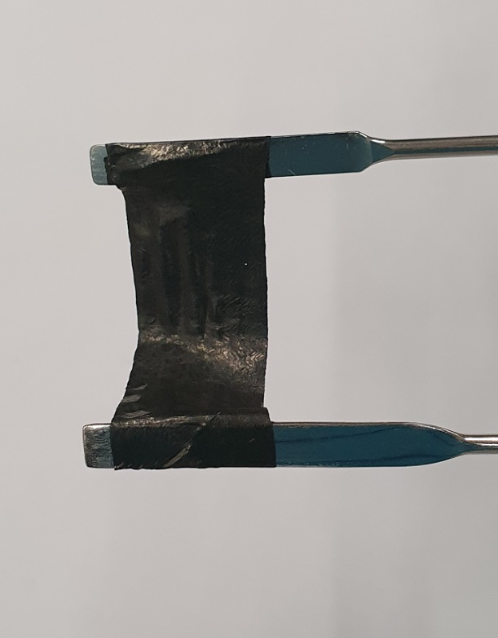

Fig. S1. Photo image of the integrated S/rGO/PE composite cathode blend.

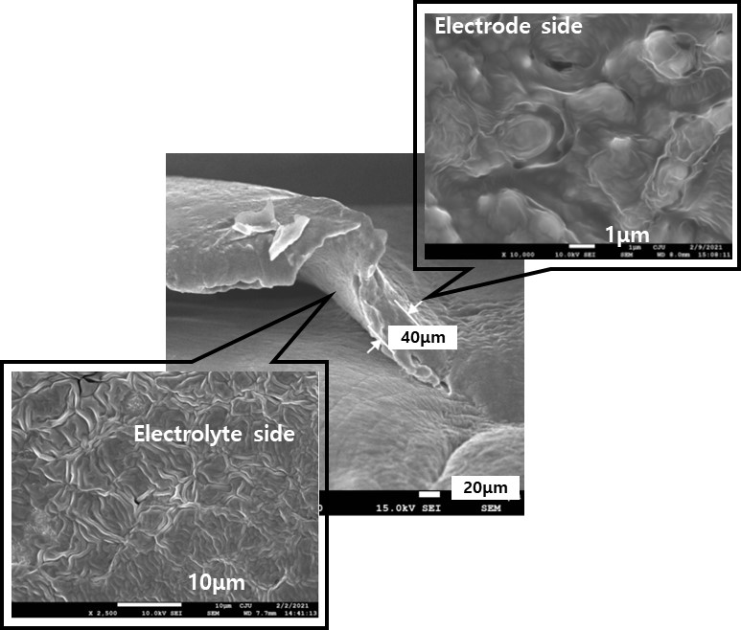

Fig. S2. SEM images of the integrated cathode blend in cathode and electrolytes sides.

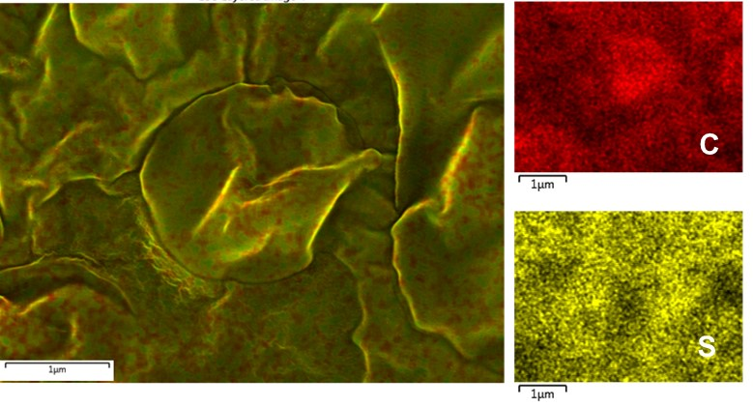

Fig. S3. SEM-EDS image of the surface of electrode side in the integrated cathode blend

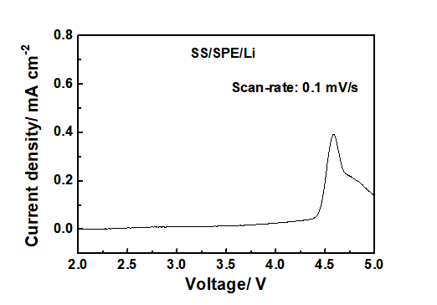

Fig. S4. Linear sweep voltammograms of dual-anions SPE.

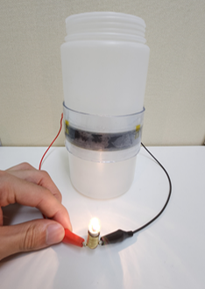

Fig. S5. LED working photo image of integrated electrode and dual-anions SPE using flexible sulfur battery.

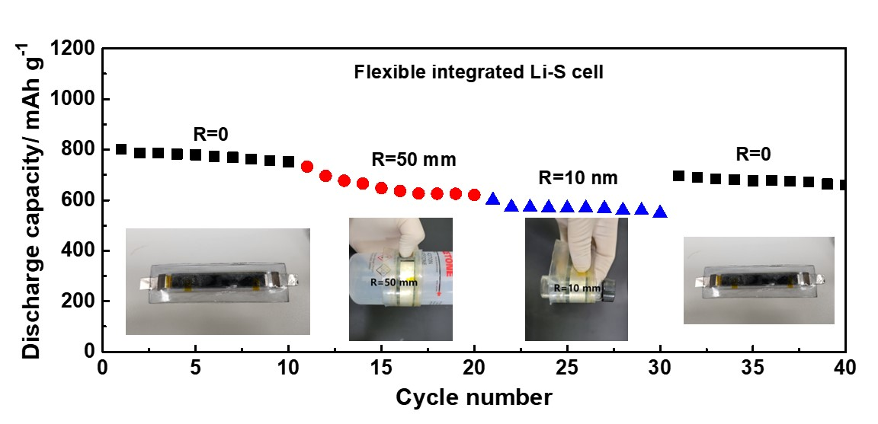

Fig. S6. Cycling performance of the S/rGO-based integrated ASS Li–S batteries in bent (R = 50 and 10 mm) and flat states at 0.2 C.

