Screening Stability, Thermochemistry, and Chemical kinetics of 3-Hydroxy butanoic acid as a bi-functional biodiesel additive
Mohamed A. Abdel-Rahman

Department of Chemistry, Faculty of Science, Suez University, P.O. Box:43221, Suez, Egypt

*Corresponding Author
E-mail: mohammadadel2015@yahoo.com; Mohamed.Abdel Rahman@sci.suezuni.edu.eg (Mohamed A. Abdel-Rahman)

Table S1 optimized geometries of 3-HBA, and transition state using CBS-QB3 method.
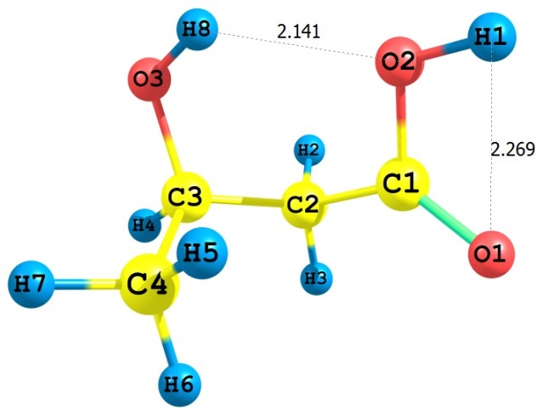
3-HBA
6 -1.265572000 -0.038241000 0.114096000
8 -2.248176000 -0.706300000 -0.062167000
8 -1.088032000 1.158119000 -0.525982000
1 -1.865389000 1.290289000 -1.089846000
6 -0.108200000 -0.367084000 1.027333000
1 -0.151269000 0.314457000 1.882963000
1 -0.273300000 -1.382421000 1.390280000
6 1.294664000 -0.230441000 0.389787000
8 1.659111000 1.130434000 0.200302000
1 2.006194000 -0.605555000 1.130709000
6 1.451731000 -1.044215000 -0.896477000
1 0.773996000 -0.681905000 -1.675655000
1 1.241550000 -2.104653000 -0.728668000
1 2.473002000 -0.945398000 -1.268576000
1 0.976246000 1.537047000 -0.346859000
CBS-QB3 (0 K)= -382.362388
CBS-QB3 Energy= -382.354623
CBS-QB3 Enthalpy= -382.353678
CBS-QB3 Free Energy= -382.394732
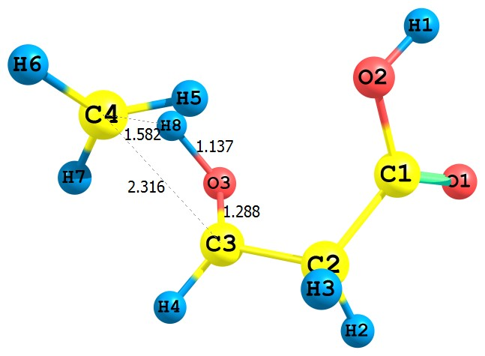

TS1
6 1.358393000 0.114179000 0.094002000
8 2.383582000 -0.211856000 -0.438977000
8 0.904935000 1.390719000 0.099013000
1 1.531642000 1.912526000 -0.424737000
6 0.433275000 -0.814422000 0.854728000
1 0.927269000 -1.793067000 0.881666000
1 0.337049000 -0.469677000 1.888682000
6 -0.933005000 -0.977037000 0.242036000
8 -1.113563000 -0.752758000 -1.027930000
1 -1.624944000 -1.633695000 0.768637000
6 -2.430690000 0.949386000 0.161882000
1 -1.379382000 1.158003000 0.095408000
1 -3.029387000 1.737150000 0.613349000
1 -2.913957000 -0.010536000 0.135368000
1 -1.815765000 0.057824000 -1.131110000
CBS-QB3 (0 K)= -382.218093
CBS-QB3 Energy= -382.210020
CBS-QB3 Enthalpy= -382.209076
CBS-QB3 Free Energy= -382.250916
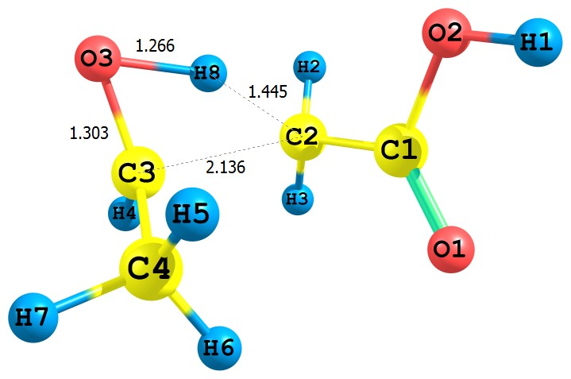
TS2
6 -1.290189000 -0.182232000 0.186232000
8 -0.882135000 -1.313218000 0.503295000
8 -1.952618000 -0.045310000 -1.018591000
1 -1.990772000 -0.943242000 -1.374193000
6 -1.076489000 1.043367000 0.869203000
1 -1.667583000 1.896287000 0.550546000
1 -0.913710000 0.956284000 1.938443000
6 1.543445000 0.295314000 0.272033000
8 1.417109000 1.217354000 -0.615169000
1 1.146086000 0.490591000 1.260591000
6 2.094566000 -0.995937000 -0.091831000
1 1.158903000 -1.602288000 -0.141703000
1 2.699399000 -1.435277000 0.702457000
1 2.593276000 -0.992763000 -1.059909000
1 0.687560000 1.796725000 -0.246343000
CBS-QB3 (0 K)= -382.239624
CBS-QB3 Energy= -382.231296
CBS-QB3 Enthalpy= -382.230351
CBS-QB3 Free Energy= -382.273146
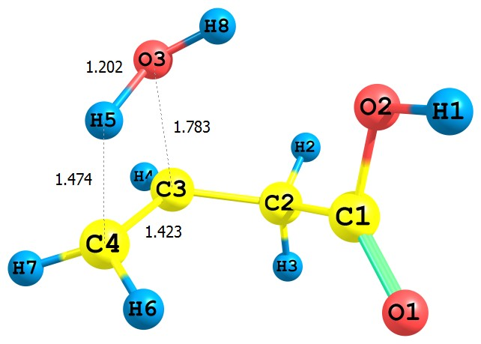
TS3
6 -1.246676000 -0.075304000 0.099906000
8 -2.031113000 -0.859250000 -0.359696000
8 -1.258459000 1.246835000 -0.228568000
1 -1.969378000 1.369111000 -0.876272000
6 -0.145306000 -0.390646000 1.089886000
1 -0.152454000 0.355539000 1.886536000
1 -0.378148000 -1.368140000 1.521121000
6 1.237449000 -0.491278000 0.476125000
8 1.656793000 1.247277000 -0.087394000
1 2.028278000 -0.520871000 1.217078000
6 1.479191000 -1.048659000 -0.811958000
1 1.690880000 0.352771000 -0.968335000
1 0.629582000 -1.432805000 -1.367981000
1 2.410560000 -1.585742000 -0.954623000
1 0.854966000 1.786564000 -0.176020000
CBS-QB3 (0 K)= -382.253068
CBS-QB3 Energy= -382.245234
CBS-QB3 Enthalpy= -382.244290
CBS-QB3 Free Energy= -382.285464
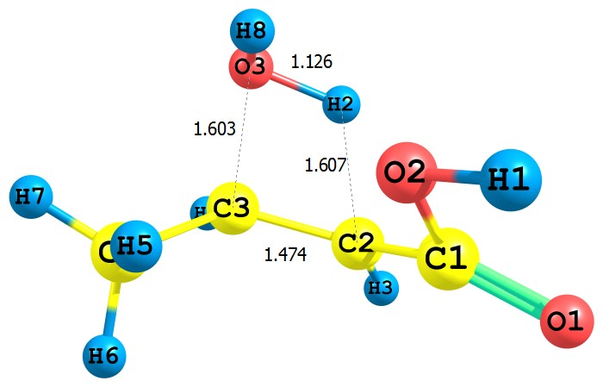

TS4
6 -1.322360000 -0.070081000 -0.075571000
8 -2.482490000 -0.307173000 -0.330038000
8 -1.008270000 0.937825000 0.827446000
1 -1.862693000 1.310157000 1.087233000
6 -0.161014000 -0.801362000 -0.546849000
1 0.576371000 -1.304004000 0.680021000
1 -0.397579000 -1.567386000 -1.274643000
6 1.204340000 -0.270262000 -0.571606000
8 1.661736000 -0.916606000 0.948045000
1 1.859922000 -0.869748000 -1.197026000
6 1.591460000 1.187544000 -0.578381000
1 1.014292000 1.766718000 0.139441000
1 1.371205000 1.580437000 -1.576109000
1 2.660934000 1.311870000 -0.396144000
1 1.535188000 -0.215448000 1.608049000
CBS-QB3 (0 K)= -382.266676
CBS-QB3 Energy= -382.258753
CBS-QB3 Enthalpy= -382.257809
CBS-QB3 Free Energy= -382.299459
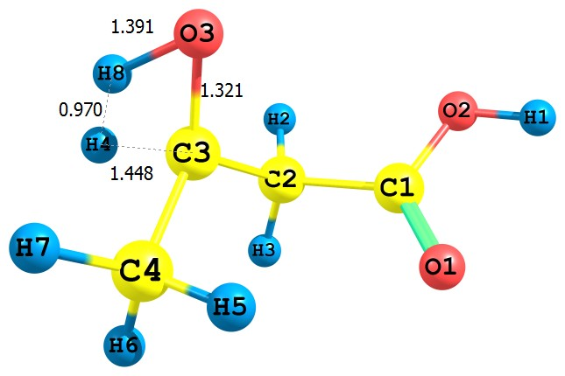
TS5
6 1.227071000 0.199537000 0.079058000
8 1.232975000 1.304699000 -0.399625000
8 2.251797000 -0.665429000 -0.054404000
1 2.922117000 -0.221391000 -0.596719000
6 0.104776000 -0.387206000 0.920725000
1 0.326866000 -1.429590000 1.137664000
1 0.048333000 0.181335000 1.853243000
6 -1.215762000 -0.305949000 0.134102000
8 -1.319342000 -1.109259000 -0.918863000
1 -2.087316000 -0.949463000 1.149594000
6 -1.869543000 1.056315000 0.058581000
1 -1.227135000 1.660751000 -0.587796000
1 -1.944796000 1.544272000 1.032562000
1 -2.851851000 0.965780000 -0.403240000
1 -1.988909000 -1.367955000 0.243031000
CBS-QB3 (0 K)= -382.225354
CBS-QB3 Energy= -382.217591
CBS-QB3 Enthalpy= -382.216647
CBS-QB3 Free Energy= -382.258150
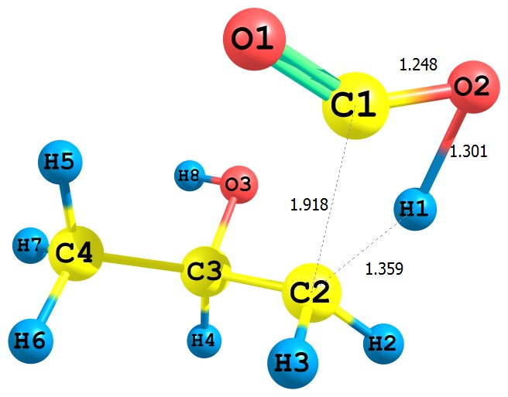
TS6
6 1.429893000 0.269334000 -0.056069000
8 1.339389000 1.397958000 -0.366125000
8 2.140886000 -0.759365000 -0.153889000
1 1.080825000 -1.028617000 0.514327000
6 -0.020693000 -0.395300000 1.086590000
1 0.060420000 -1.372563000 1.605616000
1 0.066823000 0.356245000 1.869536000
6 -1.331112000 -0.350593000 0.308745000
8 -1.084511000 -1.104232000 -0.885687000
1 -2.104704000 -0.861824000 0.901599000
6 -1.826802000 1.061089000 -0.004380000
1 -1.102180000 1.607594000 -0.607214000
1 -2.011365000 1.622324000 0.916294000
1 -2.772507000 1.010376000 -0.553426000
1 -1.891137000 -1.115609000 -1.410444000
CBS-QB3 (0 K)= -382.246360
CBS-QB3 Energy= -382.238111
CBS-QB3 Enthalpy= -382.237167
CBS-QB3 Free Energy= -382.279354
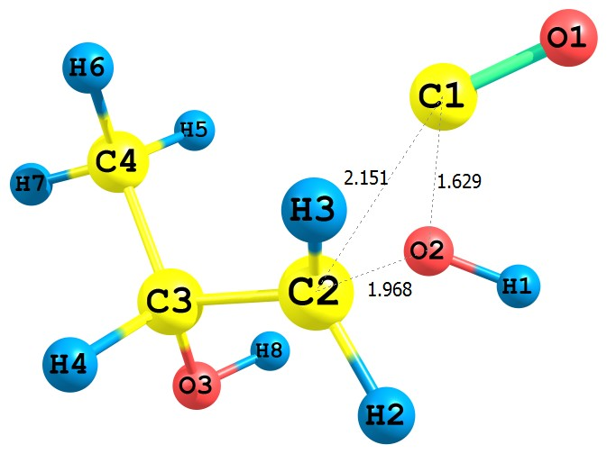

TS7
6 1.660825000 0.472774000 -0.069382000
8 2.817831000 0.389071000 -0.082228000
8 0.838472000 -1.016270000 -0.461587000
1 1.411398000 -1.800190000 -0.362472000
6 -0.179201000 -0.106212000 1.138646000
1 -0.087753000 -1.076719000 1.607622000
1 0.210975000 0.719007000 1.718421000
6 -1.434570000 0.129118000 0.374212000
8 -1.856511000 -1.019663000 -0.319638000
1 -2.167347000 0.276613000 1.192677000
6 -1.441841000 1.387251000 -0.495705000
1 -0.727302000 1.274226000 -1.311627000
1 -1.169506000 2.274361000 0.082604000
1 -2.440466000 1.526187000 -0.912956000
1 -1.059614000 -1.316175000 -0.793269000
CBS-QB3 (0 K)= -382.196116
CBS-QB3 Energy= -382.187199
CBS-QB3 Enthalpy= -382.186254
CBS-QB3 Free Energy= -382.229730

Table S1. Eckart tunneling corrections for the studied chemical reactions over the temperature ranges 600−1700 K at the CBS-QB3 level.
T | R1 | R2 | R3 | R4 | R5 | R6 | R7
600 | 1.26 | 1.04 | 3.31 | 2.16 | 4.68 | 3.4 | 1.16
650 | 1.22 | 1.04 | 2.67 | 1.9 | 3.47 | 2.72 | 1.13
700 | 1.18 | 1.03 | 2.28 | 1.72 | 2.8 | 2.31 | 1.11
750 | 1.16 | 1.03 | 2.02 | 1.6 | 2.39 | 2.04 | 1.1
800 | 1.14 | 1.02 | 1.84 | 1.51 | 2.12 | 1.85 | 1.09
850 | 1.12 | 1.02 | 1.71 | 1.43 | 1.92 | 1.71 | 1.08
900 | 1.11 | 1.02 | 1.6 | 1.38 | 1.78 | 1.61 | 1.07
950 | 1.1 | 1.02 | 1.52 | 1.33 | 1.67 | 1.53 | 1.06
1000 | 1.09 | 1.02 | 1.46 | 1.29 | 1.58 | 1.46 | 1.05
1050 | 1.08 | 1.01 | 1.41 | 1.26 | 1.51 | 1.41 | 1.05
1100 | 1.07 | 1.01 | 1.36 | 1.24 | 1.45 | 1.36 | 1.04
1150 | 1.06 | 1.01 | 1.33 | 1.21 | 1.4 | 1.33 | 1.04
1200 | 1.06 | 1.01 | 1.29 | 1.19 | 1.36 | 1.3 | 1.04
1250 | 1.05 | 1.01 | 1.27 | 1.18 | 1.33 | 1.27 | 1.03
1300 | 1.05 | 1.01 | 1.25 | 1.16 | 1.3 | 1.25 | 1.03
1350 | 1.05 | 1.01 | 1.23 | 1.15 | 1.28 | 1.23 | 1.03
1400 | 1.04 | 1.01 | 1.21 | 1.14 | 1.25 | 1.21 | 1.03
1450 | 1.04 | 1.01 | 1.19 | 1.13 | 1.23 | 1.19 | 1.03
1500 | 1.04 | 1.01 | 1.18 | 1.12 | 1.22 | 1.18 | 1.02
1550 | 1.03 | 1.01 | 1.17 | 1.11 | 1.2 | 1.17 | 1.02
1600 | 1.03 | 1.01 | 1.16 | 1.11 | 1.19 | 1.16 | 1.02
1650 | 1.03 | 1.01 | 1.15 | 1.1 | 1.18 | 1.15 | 1.02
1700 | 1.03 | 1.01 | 1.14 | 1.1 | 1.17 | 1.14 | 1.02

