Supplementary material
Detailed pulmonary implementation program
All of the following demonstration photos for pulmonary rehabilitation program were taken by Shihui Yuan. Novel coronavirus infection is a guide for patients with chronic obstructive pulmonary disease. If the new coronavirus is infected, for patients who were enrolled in this trial wore a mask, and the medical staff must wear protective clothing, N95, protective screen or goggles, latex gloves, working cap and shoe covers.

Bedside breathing exercises
Section 1
Keep feet apart to the width as shoulders. keep hands on the waist as inhale. Raise the right hand, bend the upper body to the right side, and exhale at the same time. Stand straight and inhale. Raise the left hand, bend the upper body to the left, and exhale at the same time, then inhale after completion. Repeat for eight times. Relax and breathe.
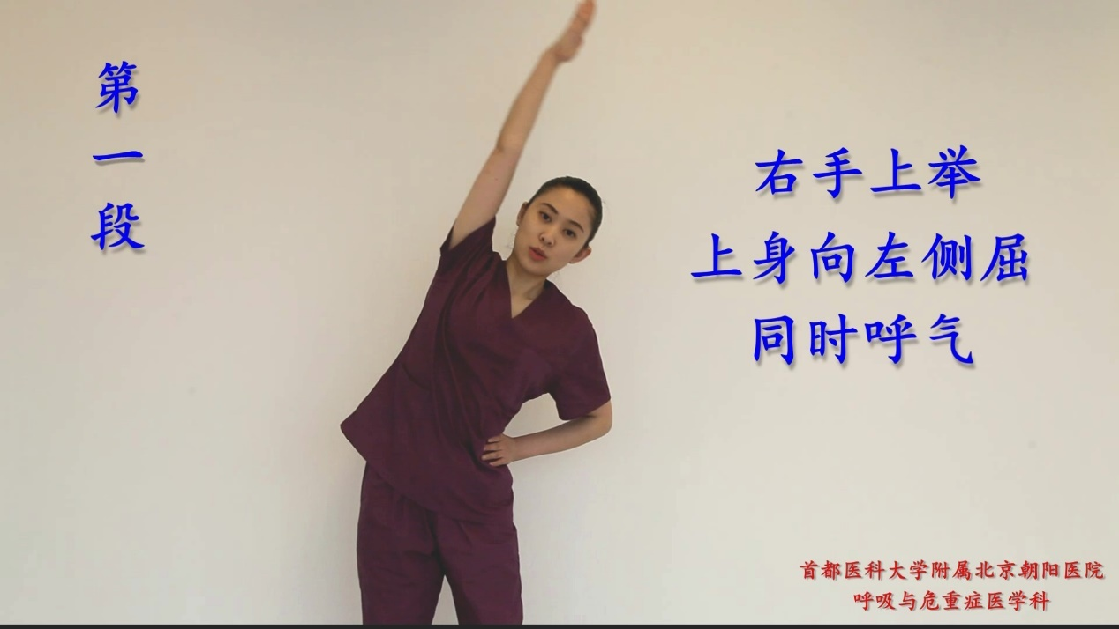
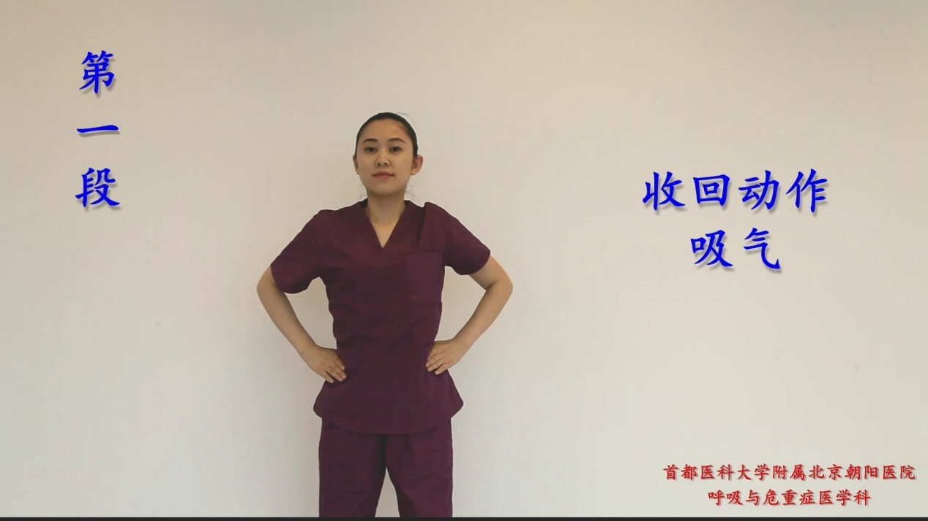
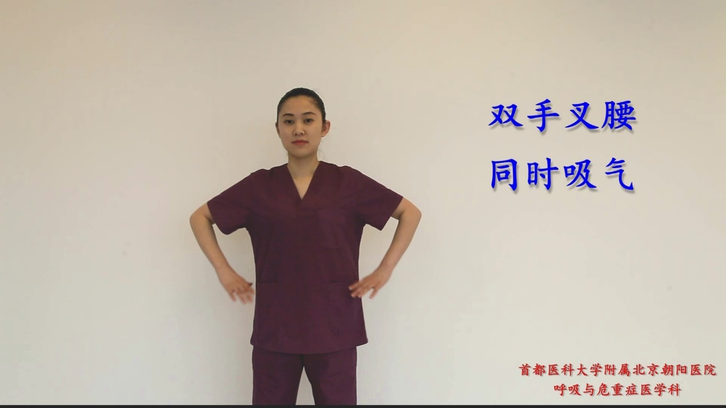
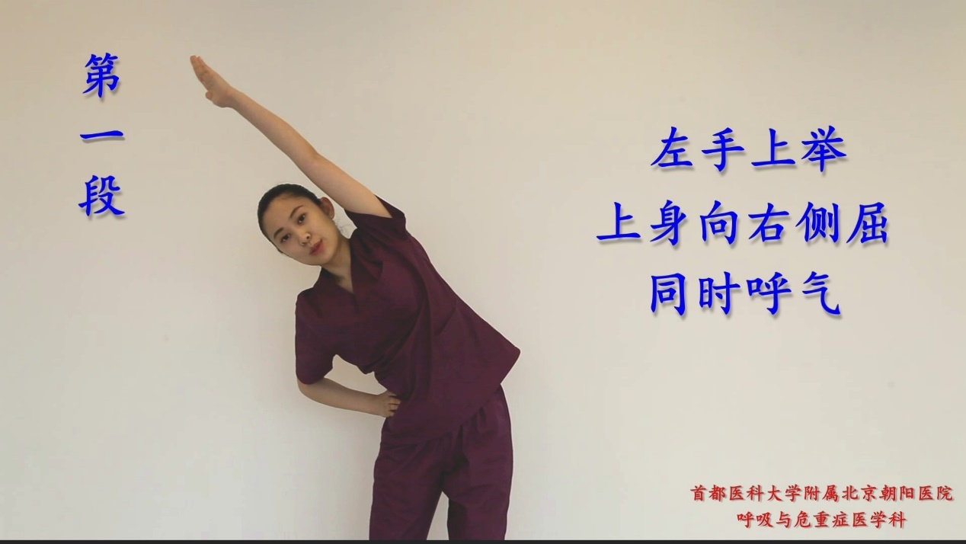

e-Figure 1. Shows the pulmonary rehabilitation of patients in Section 1
Section 2
Extend both upper limbs sideways and inhale at the same time. Turn the upper body to the right and exhale at the same time, then inhale after completion. Turn the upper body to the left and exhale at the same time, Stand straight and inhale. Repeat for eight times. Relax and breathe.
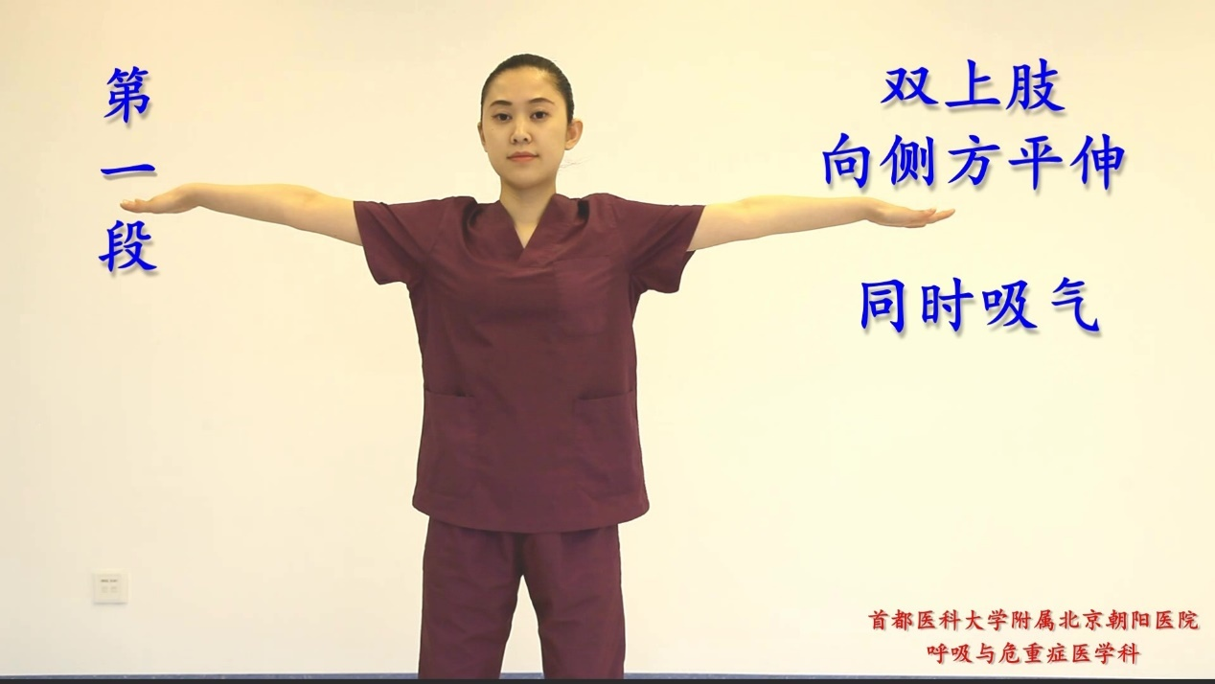
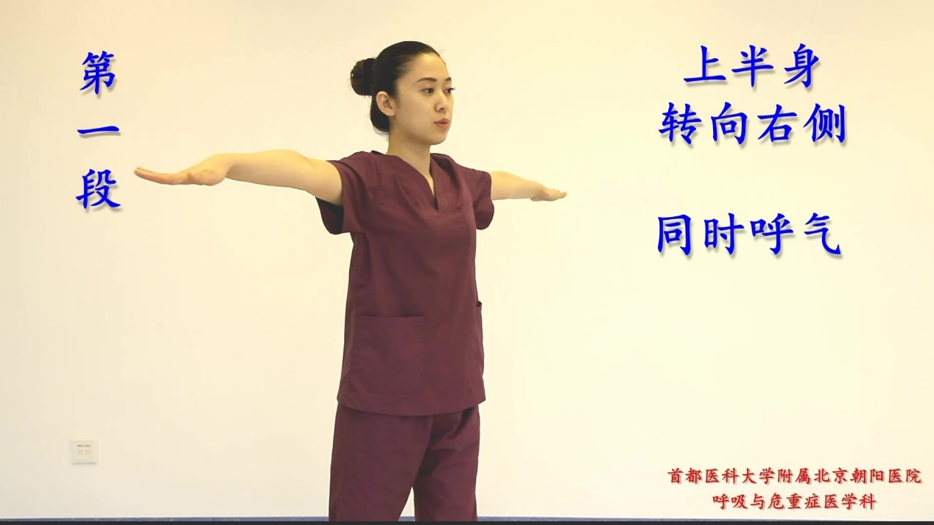
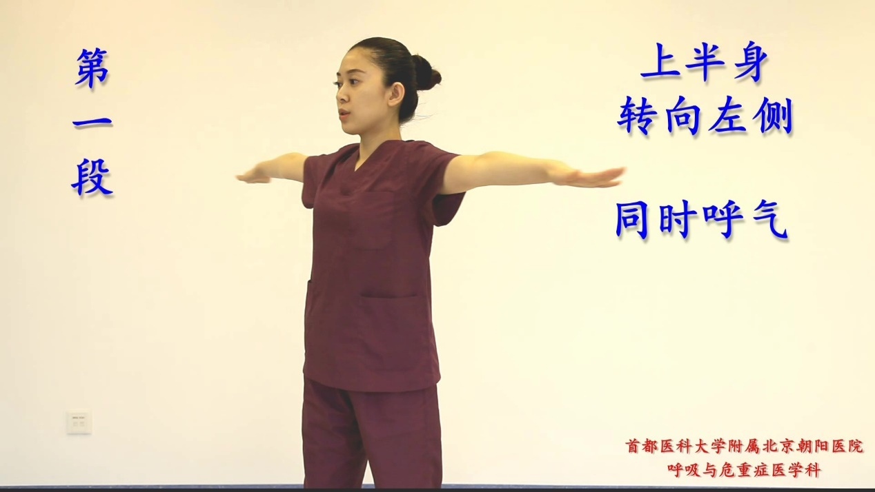

e-Figure 2. Shows the pulmonary rehabilitation of patients in Section 2.
Section 3
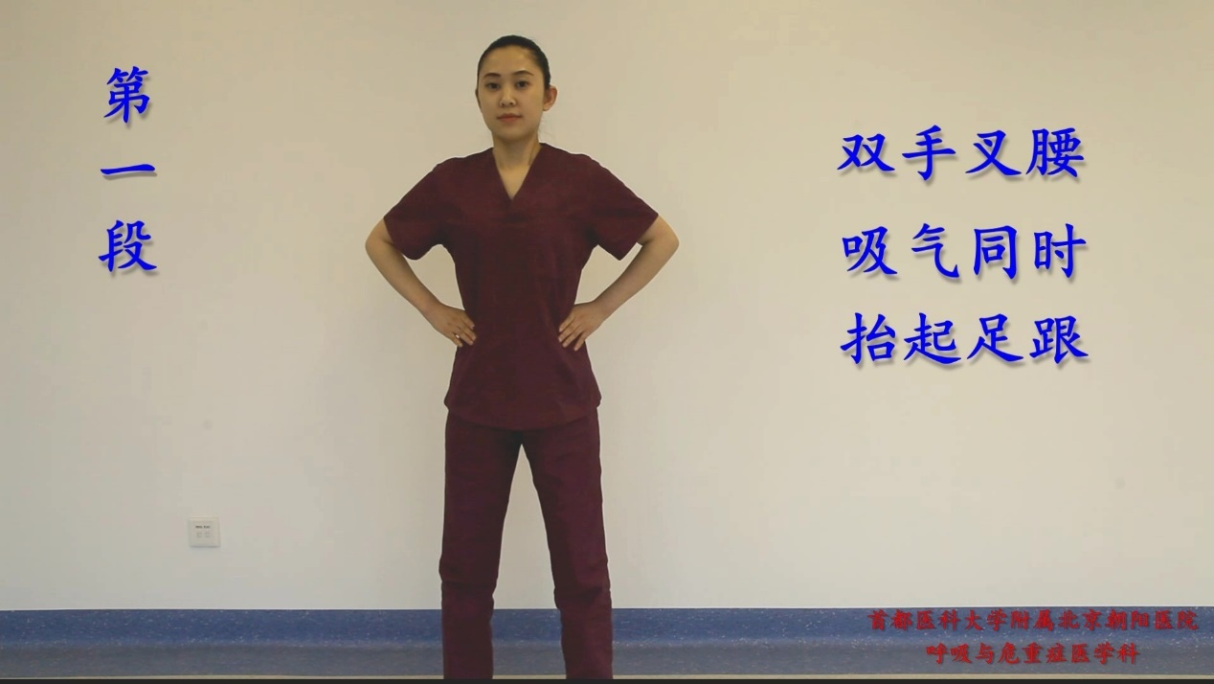
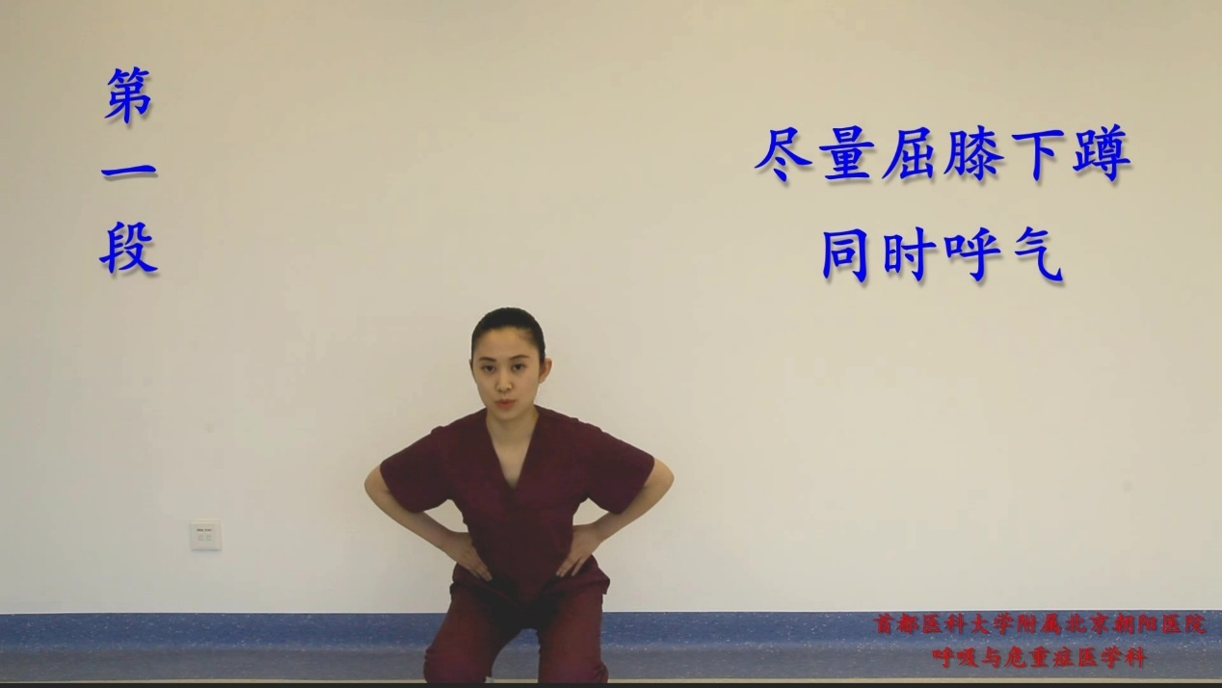
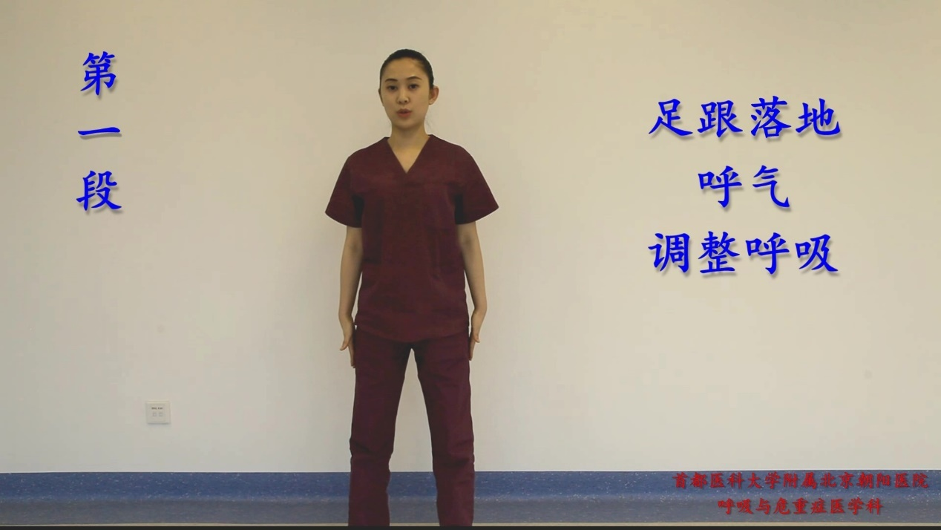
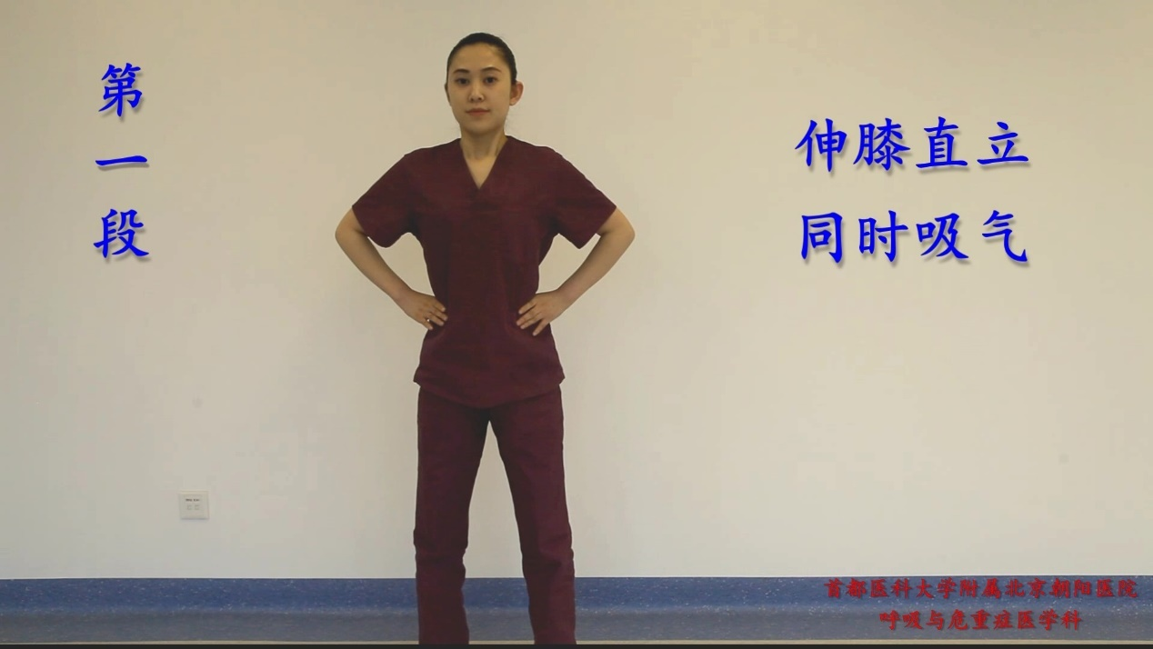
Keep hands on the waist, lift heels when inhale. Try to squat as much as and exhale at the same time. Extend your knees and stand upright, inhale at the same time. Stand up and exhale. Repeat for eight times. Relax and breathe.

e-Figure 3. Shows the pulmonary rehabilitation of patients in Section 3.
Section 4
Sit on the chair, and keep hands behind head and deeply inhale. Turn the upper body to the right, exhale deeply. Turn your upper body to the left, exhale deeply. then inhale after completion. Repeat for six times. Relax and breathe.
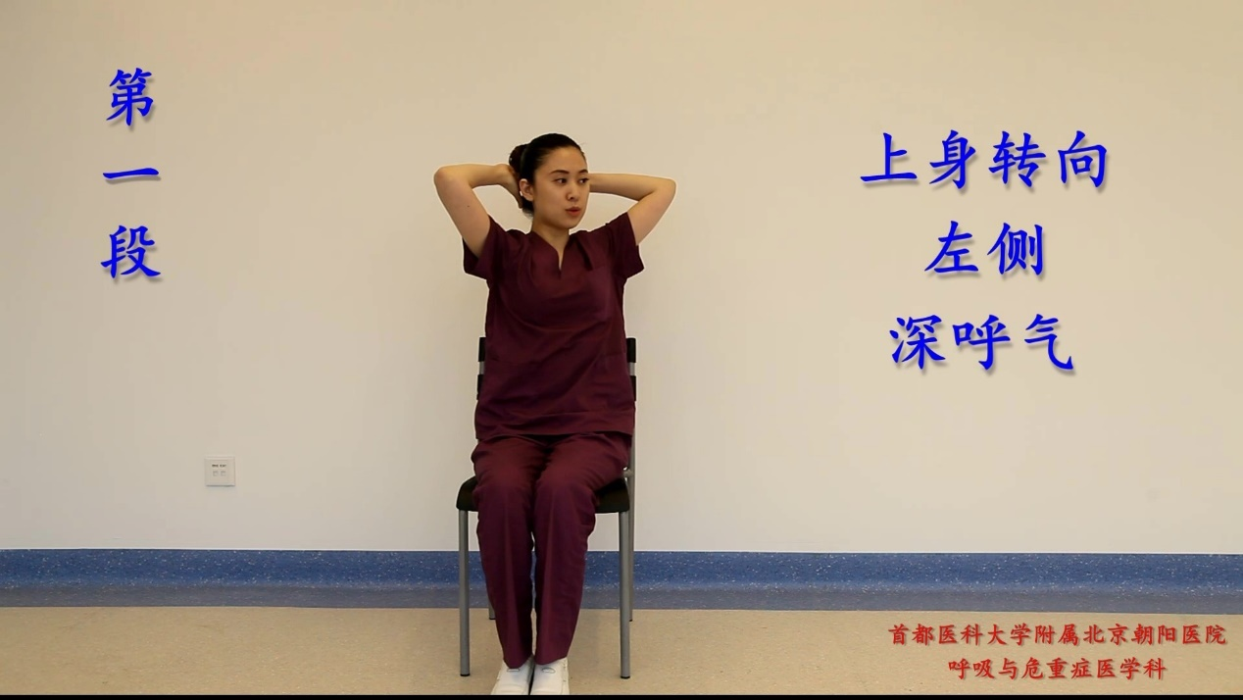
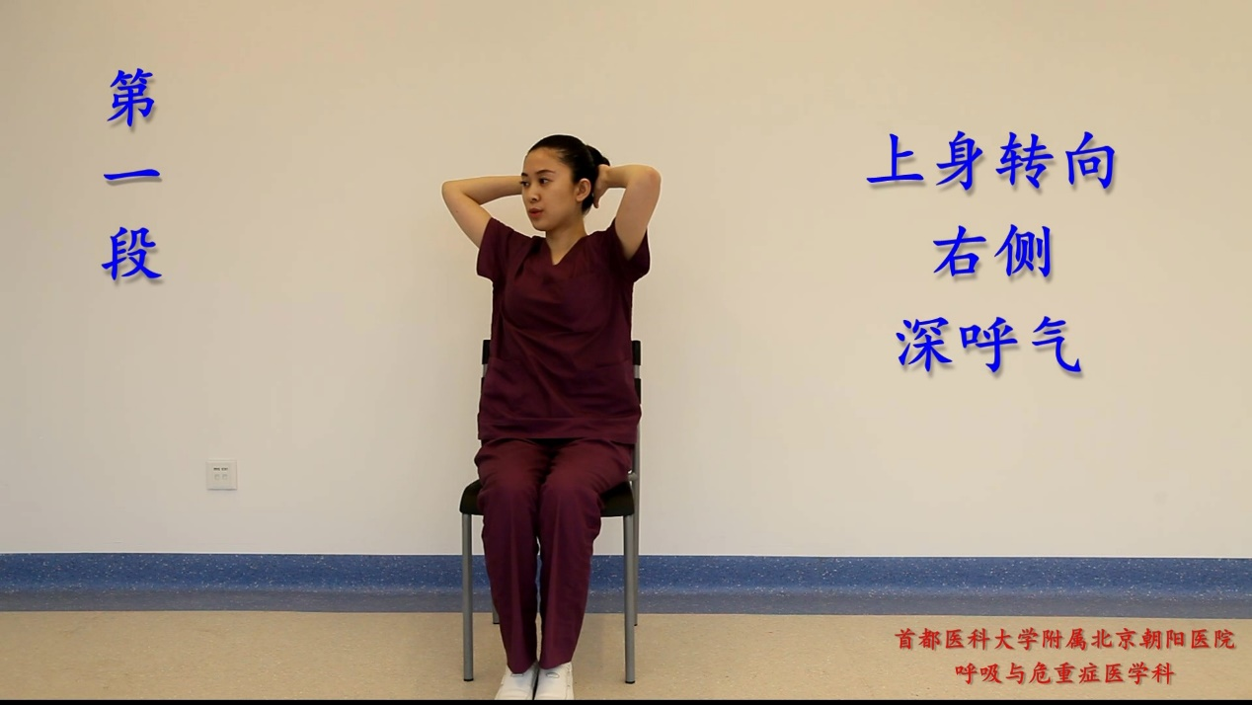
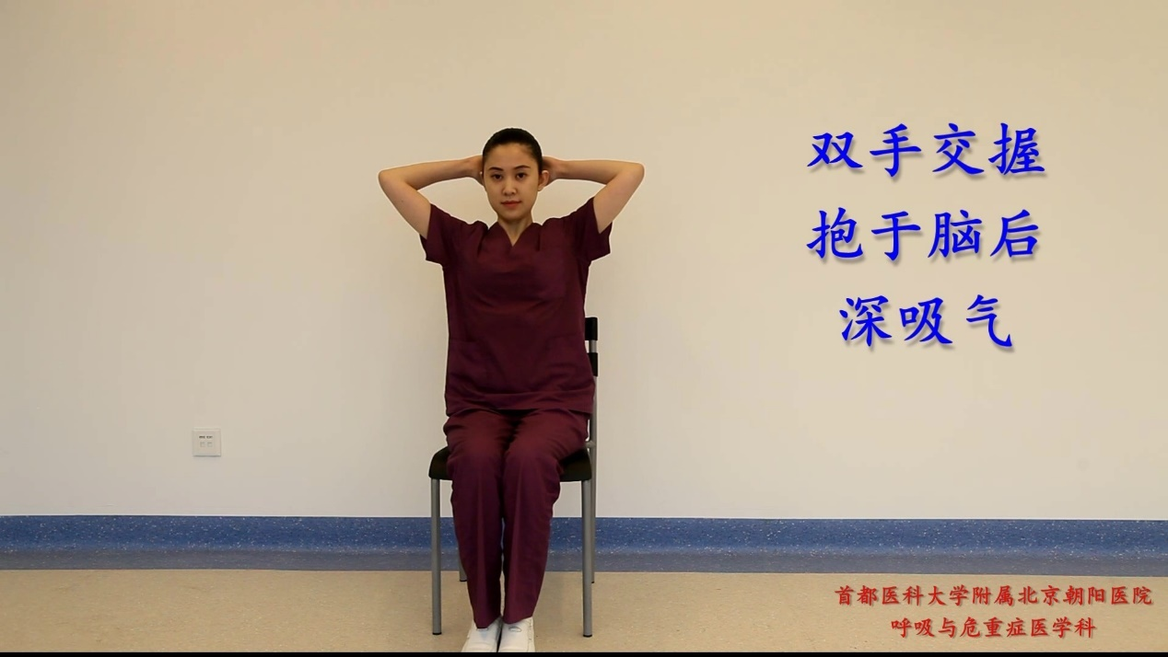

e-Figure 4. Shows the pulmonary rehabilitation of patients in Section 4.
Section 5
Sit on the chair, Put the hands on legs. Inhale and lift the right leg at the same time. Exhale and extend right leg forward and retract. Inhale and lift the left leg at the same time. Exhale and extend left leg forward and retract. Repeat for six times. Relax and breathe.
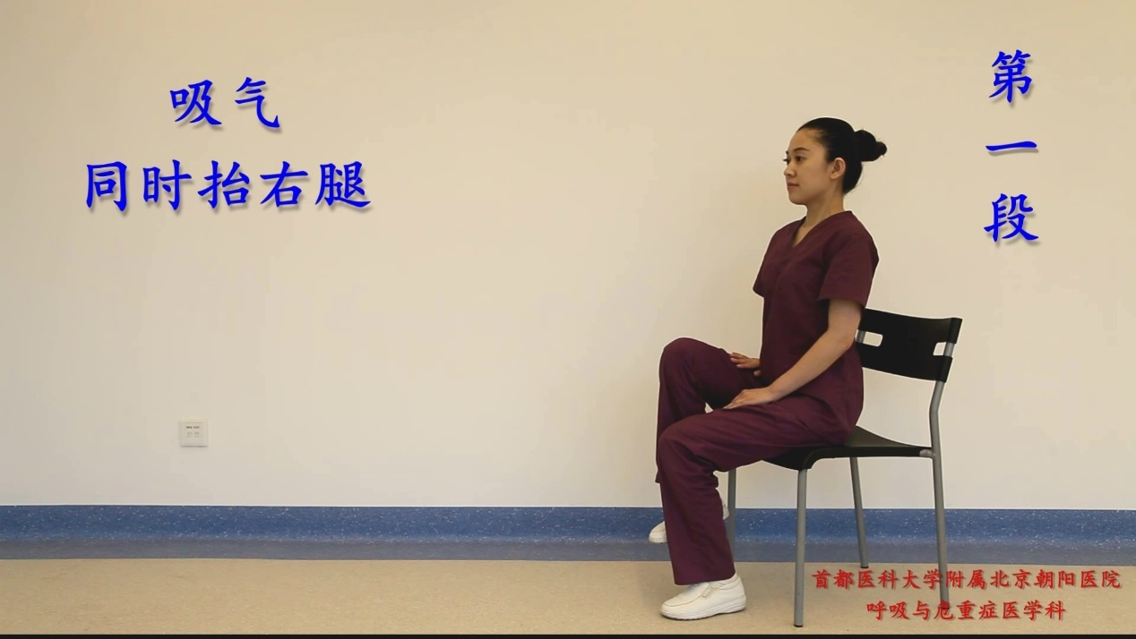
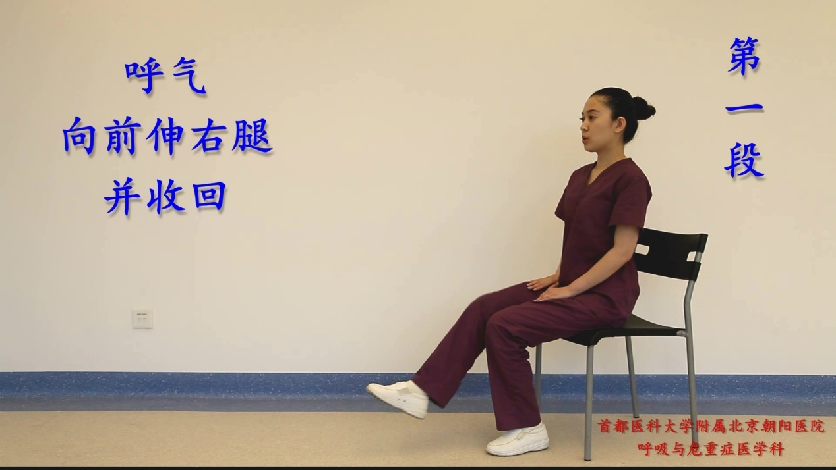
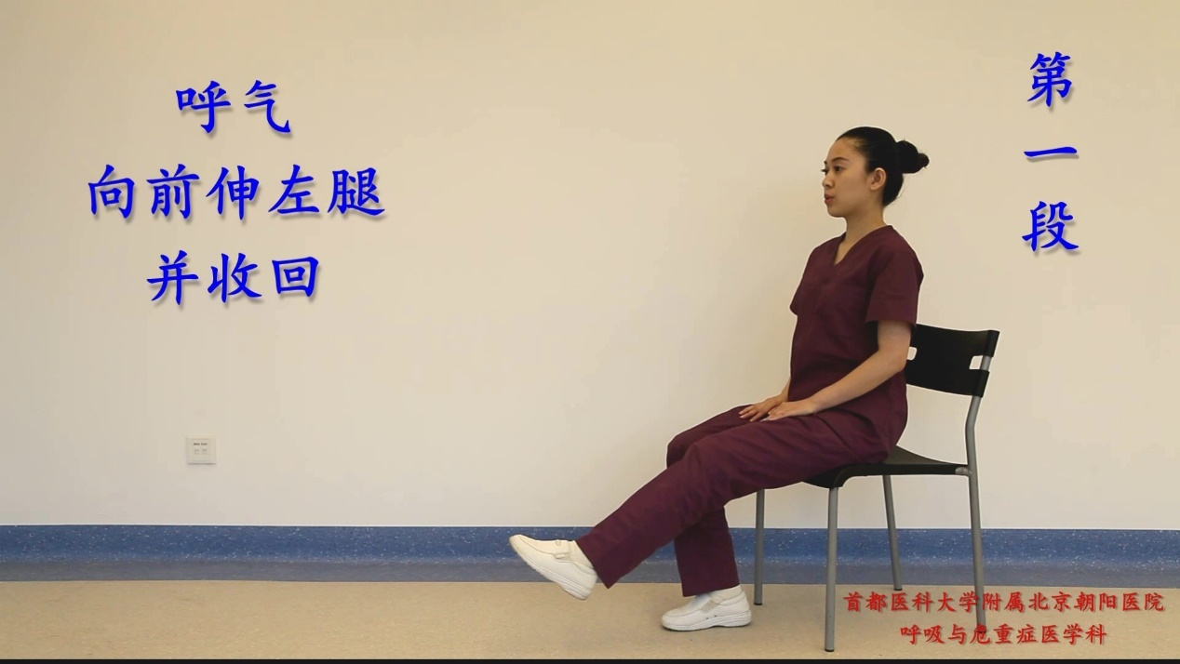
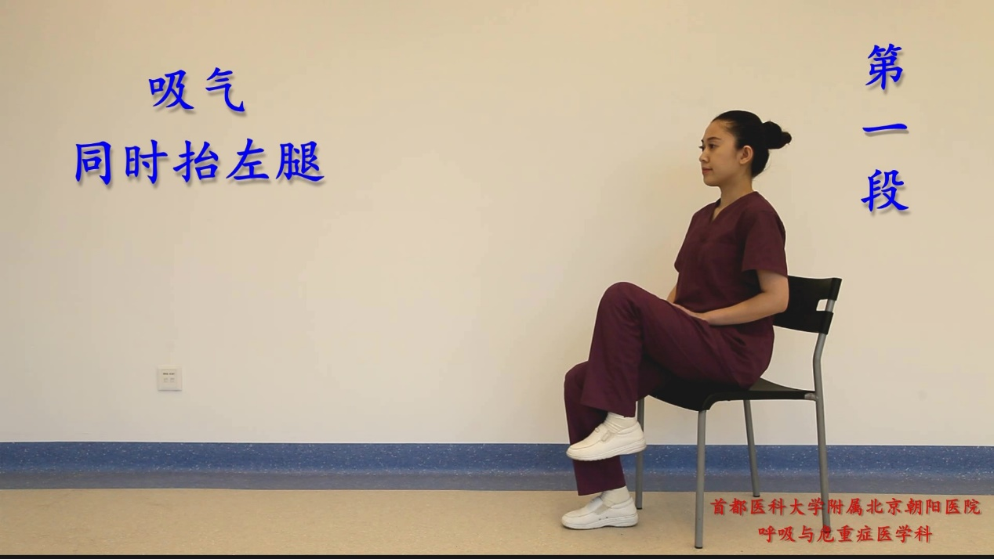

e-Figure 5. Shows the pulmonary rehabilitation of patients in Section 5.
Section 6
Step in place for three minutes

Bed breathing exercises
Section 1 Elbow flexion
Place the patient's hands on both sides of the body, bend the elbow and exhale at the same time. Repeat for 15 times (e-Figure 6A)
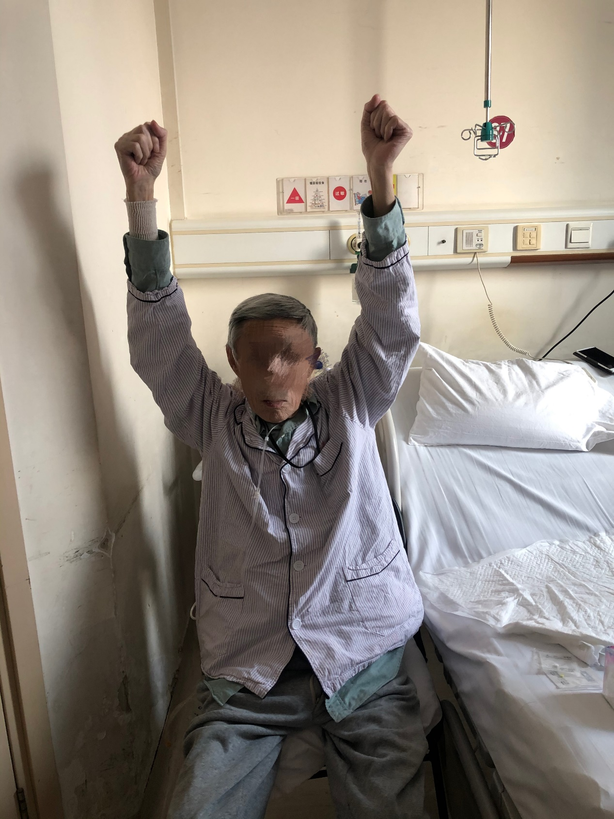
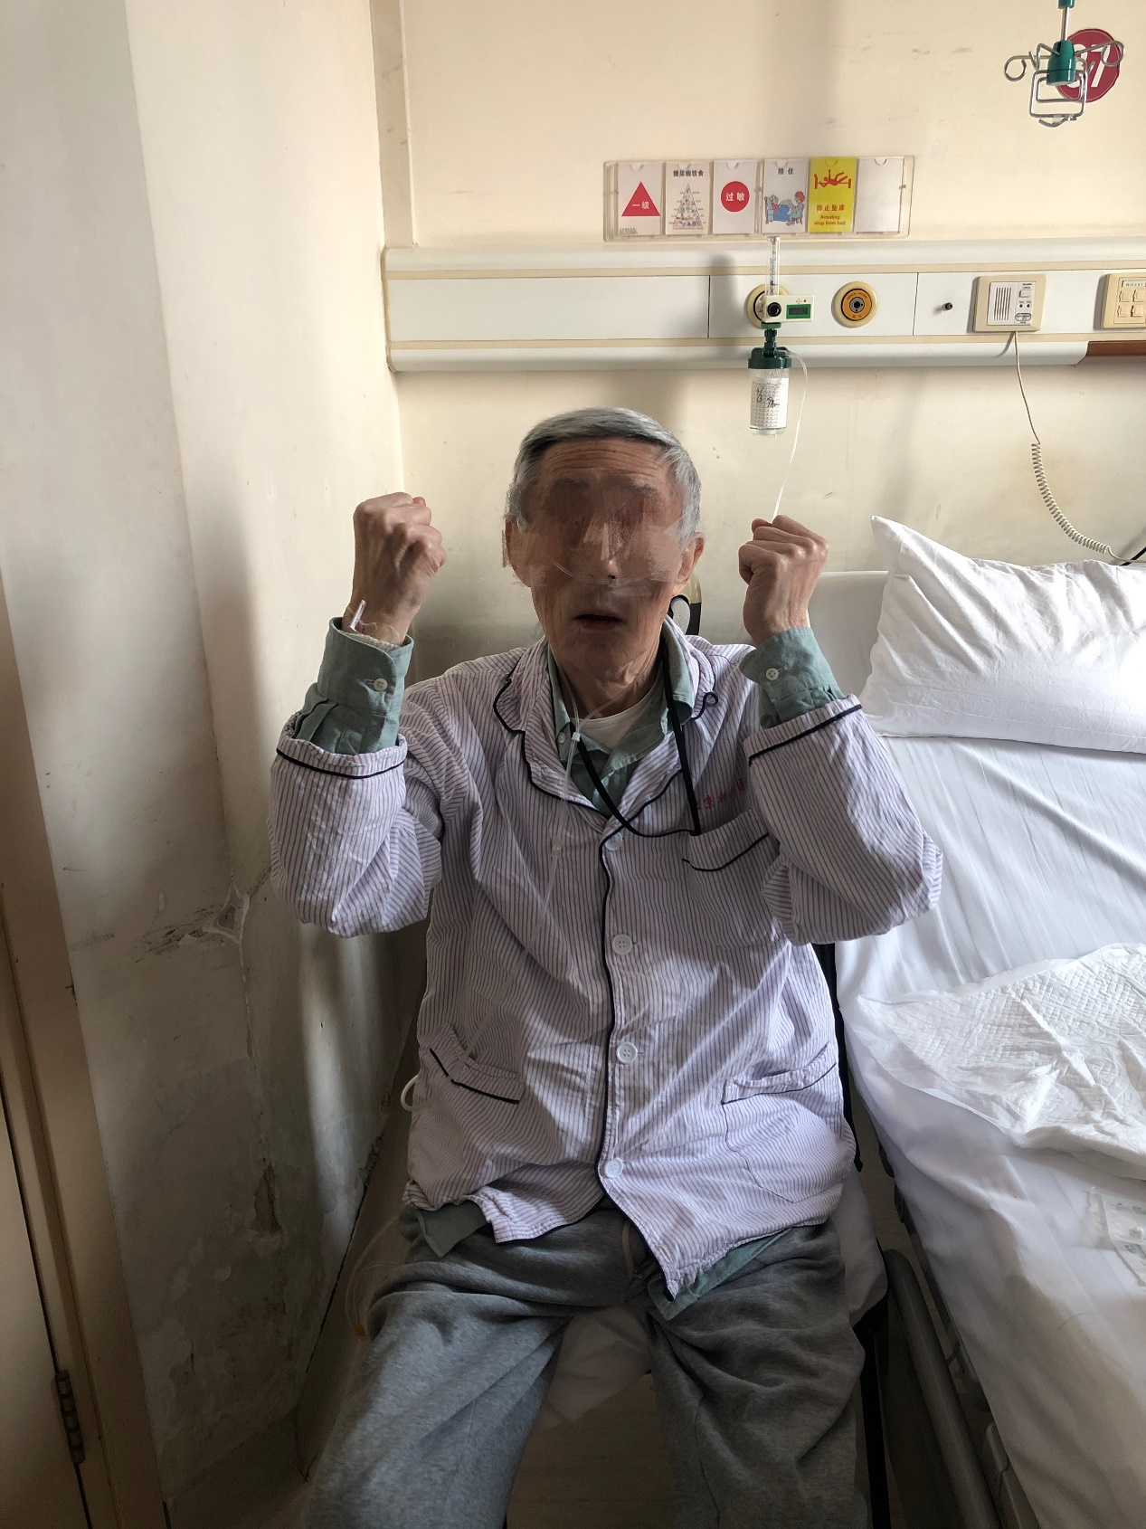
A
B

e-Figure 6. Shows examples of the in-bed pulmonary rehabilitation of patients. A: Elbow flexion; B: Lifting movement.
Section 2 Lifting movement (e-Figure 6 B)
Place the patient's hands on both sides of the body, raise the arms and exhale at the same time. Repeat for 15 times
Section 3 stretching and sitting
The patient holds the bedside with both hands, uses the strength of the upper limbs to pull up to sit straight for 5 seconds, then lies down, and repeats again.
Section 4 bridge movement
The patient took a supine position, with the knee joint flexed, and both feet flat on the bed, and maintained the hip to be about 10-15cm away from the bed for three to five seconds, and repeated again.
Section 5 Aerobike
The patient takes a lying position, bends the knee to raise the lower limbs, and keeps the upper body still, and alternates the two legs in the air like riding bicycle until tired.

