Supporting Information:
Colloidal atomic layer deposition on nanocrystals using ligand-modified precursor
Philippe B. Green¹, Ona Segura Lecina¹, Petru P. Albertini¹, Mark A. Newton¹, Krishna Kumar¹, Coline Boulanger¹, Jari Leemans¹, Paul B.J. Thompson², Anna Loiudice¹ and Raffaella Buonsanti¹*
¹Laboratory of Nanochemistry for Energy (LNCE), Institute of Chemical Sciences and Engineering (ISIC), École Polytechnique Fédérale de Lausanne, CH-1950 Sion, Switzerland.
²XMaS beamline, United Kingdom CRG, European Synchrotron Radiation Facility, 71, avenue des Martyrs, CS 40220, 38043 Grenoble Cedex 9, France
*Corresponding author: raffaella.buonsanti@epfl.ch

Table of Contents
Section 1: Materials & Instruments 3
1.1 Chemicals: 3
1.2 Instrumentation: 3
1.3 Synchrotron based measurements: 4
Section 2: Synthesis and characterization 5
2.1 PbS NCs: 5
2.2 PbS nanocubes: 5
2.3 InP NCs: 5
2.4 CdSe NPLs: 5
2.5 NaGdF₄ NCs: 6
2.6 Surface chemistry of PbS NCs: 9
Section 3: Precursor Surface Interactions 16
3.1 Titrations: 16
3.2 Trimethyl aluminium (TM-Al): 26
3.3 Dimethyl zinc (DM-Zn): 31
3.4 Trimethyl gallium (TM-Ga): 33
3.5 Metal amide precursors (TDMA-Ti and TDMA-Ga): 36
3.6 Structural Characterization of free species: 40
Supplementary Note 1: Discussion on precursor reactivity 45
Section 4: Colloidal Atomic Layer Deposition of hybrid oxide shells 46
4.1 Procedure: 46
Additional Notes: 47
4.2 Characterization: 48
Section 5: Metal-amide based c-ALD for fully inorganic oxide shells 53
5.1 Procedure: 53
Supplementary Note 2: Synthetic details 54
5.2 Tracking the growth: 55
5.3 Characterization: 65
EDX maps: 65
Optical properties: 67
X-ray diffraction (XRD): 68
X-ray absorption (XAS): 69
Principle component analysis: 72
Supplementary Note 3: Alternative methods for the growth of metal oxide shells 74
References: 75

Section 1: Materials & Instruments

1.1 Chemicals:
All chemicals were purchased from Sigma-Aldrich, unless specified. Lead Oxide (99.999%), bis(trimethylsilyl) sulfide (synthesis grade), elemental sulfur (99.998%), indium acetate (99.99, trace metal basis), tris(trimethylsilyl)phosphine (95%), gadolinium acetate hydrate (99.9%), ytterbium acetate hydrate (99.9%), sodium hydroxide (97%), ammonium fluoride (99.99%), cadmium myristate (99.9%), cadmium acetate (99.995%) selenium (99.5%), myristic acid (99%), hexane (95%), octane (anhydrous $≥$99%), oleic acid (OLAC), 1-octadecene (ODE), Zinc Stearate (technical grade), tetramethylethylendiamine (TMEDA), didodecylamine, (97%), acetone (anhydrous 99.8%, ACROS), ethanol (anhydrous 95%), deuterated toluene (99%), deuterated acetone, deuterated acetonitrille, trimethylaluminium (TM-Al, 98% Strem), dimethylzinc (DM-Zn, 98%), trimethylgallium (TM-Ga, 99% Brunschwig), tris(dimethylamido)gallium (TDMA-Ga, 98% abcr), tetrakis(dimethylamido)titanium (TDMA-Ti, 99.999%).

1.2 Instrumentation:
Optical absorption: Measured using a PerkinElmer Lambda 950 spectrophotometer, equipped with a deuterium (ultraviolet range) and tungsten lamp (visible and infrared range). A PMT and InGaAs detector was used.
Time resolved photoluminescence (TRPL): A Horiba Jobin Yvon Fluorolog-3 instrument was employed. A Horiba nanoLED with excitation wavelength of 450 nm was employed.
Fourier transform infrared spectroscopy (FT-IR): FT-IR was carried out using an attenuated total reflectance (ATR) Perkinelmer Two spectrometer. The sample was directly drop-casted on the ATR plate from hexane or octane.
Nuclear magnetic resonance (NMR): A Bruker Avance III 400 MHz spectrometer equipped with a 5mm BBFO Z-gradient SmartProbe was used. ¹H, DOSY, NOESY, ¹H-{¹³C} HSQC, ¹H-{¹³C} HMBC and ¹H{¹H} TOCSY were acquired using standard pulse sequences from the Bruker library. VT was acquired by gradually increasing the temperature from 22$℃$ to 70$℃$ and then back to 22$℃$. A 300s equilibration time was applied between each acquisition. All data was processed using Topspin and Mestrenova.
Transmission electron microscopy (TEM): Bright-field TEM images of NCs were acquired on a Thermo-Fischer Tecnai-Spirit at 120kV. The samples for imaging were prepared by drop casting from hexane or octane on carbon coated copper TEM grids (Ted Pella, Inc). ImageJ was used to calculate the average NC size.
X-ray photoelectron spectroscopy (XPS): XPS was performed using a Kratos Analytical instrument equipped with a monochromated Kα X-ray line of an Al anode. The samples were prepared by drop casting the sample from hexane or octane on a clean silicon substrate. CasaXPS was used to analyze the data. All spectra were referenced at 284.8 eV using the C-C bond of the C 1s orbital.
Energy dispersive X-ray spectroscopy (EDXS) and HAADF-STEM: These measurements where performed using a FEI Tecnai Osiris TEM in scanning mode at an acceleration voltage of 200 kV. This microscope is equipped with a high brightness X-FEG gun, and four windowless Super-X silicon detectors for EDXS. The EDXS data was processed using the Bruker Esprit software (version 1.9).
A diluted NC suspension was drop casted from hexane or octane on a carbon coated copper TEM grid (Ted Pella, Inc.). For the purpose of EDX measurements, additional cleaning was performed to avoid detrimental contamination from leftover organics. We found that the best results were obtained by leaving the NC covered grid in ethanol for up to twenty hours. This method successfully removed most of the contamination and allowed for longer acquisition periods. Simple rinsing of the TEM grid in ethanol or exposing the grid to a one-minute nitrogen plasma still resulted in significant contamination and unreliable data.
Aggregation of smaller particles such as our PbS and InP NCs was observed when the samples were left in ethanol for prolonged periods.

1.3 Synchrotron based measurements:
Beamline setup: HR-XRD and XAS measurements were performed on the BM28 (XmaS) beamline at the European Synchrotron Radiation Facility in Grenoble. The beamline source is a single 0.89 Tesla bending magnet and the x-ray beam conditioned using a LN2 cooled Si <111> monochromator and focused using a Platinum coated 1.4m long toroidal mirror.¹ An additional two plane mirrors, with stripes of Chromium, Platinum and Silicon, positioned at an angle of incidence of 3 mrads, were used to reject harmonics transmitted from the Si <111> monochromator.
The sample was mounted onto a large Huber 6 circle diffractometer for both XRD and XAS measurements. A Pilatus 300K 2D Silicon detector, mounted on the diffractometer two theta arm, some 1169 mm from the sample was used to measure the XRD. To prevent the direct beam exposing and damaging the detector, a motorized tungsten beamstop was placed behind the sample and Helium flight tubes were used to reduce the background from air scatter. Images of the XRD powder rings were taken by moving the 2D camera every degree on the diffractometer two theta arm. These images were processed using the esaProject software developed by EVA Surface Analysis Ltd, to produce 1D diffraction patterns.^{2,3}
XAS was measured in fluorescence using a Ketek 150mm2 Silicon drift diode mounted onto a motorized slide approximately 90 degrees to the incident beam path. The output of the silicon drift diode was fed into a XIA Falcon-X digital signal processor and the fluorescence signal isolated using a 4095 channel multi-channel analyzer. Oken ionization chambers, filled with N2 gas, were used as an X-ray beam monitor to measure the intensity of the incident beam as a function of energy. All of the XAS spectra were recorded in ‘step-scanning’ mode with each scan taking approximately 25 minutes.
The XAS data obtained from the above measurement protocols was reduced and normalized using Prestopronto⁴ and or PAXAS⁵. Explicit analysis of the Ga K-edge EXAFS was achieved using EXCURV.⁶ PCA analysis was conducted using both Prestopronto⁴ and the ITFA package due to Rossberg et al.⁷ The use of two different programs to achieve these analyses was implemented to verify that both returned acceptably similar results in term of the proportions and spectral character of the components to the XAS thus returned.
Sample preparation: All samples were prepared by loading the desired suspensions in glass capillaries. The capillaries had dimensions: Diameter: 1 mm, Wall thickness: 0.01 mm, length: 80 mm. After loading, the capillaries were flame sealed in a nitrogen atmosphere.

Section 2: Synthesis and characterization

2.1 PbS NCs:
PbS NCs were synthesized through a previously published method.⁸ In brief, 0.669 g of PbO was added to a three-neck flask with 25 mL ODE and 5.7 mL OLAC. This reaction was heated to 120$℃$ for 1 hour under a nitrogen atmosphere. The solution was then cooled to 90$℃$. A solution containing 0.09 mL of TMS-S in 1 mL toluene was then swiftly injected. The solution quickly turned black. The reaction was left for 90 seconds. Then a water bath was used to cool the reaction to room temperature. Purification was performed by adding twice the volume of acetone and centrifuging at 6000 rpm (4140 rcf) for 1 minutes. The solution was then redispersed in 5mL hexanes. Four more antisolvent purification with acetone were performed. The sample was then dissolved in the desired solvent and stored in a nitrogen filled glovebox.

2.2 PbS nanocubes:
PbS nanocubes were synthesized by a previously published method.⁹ In brief, 1.11g of PbO was added to a three neck flask with 12.5mL of OLAC and 25mL of ODE. This solution was degassed and heated to 100$℃$ for 30 minutes and then flushed with nitrogen. This solution was then heated to 210$℃$. The sulfur solution was prepared by sonicating 160mg of elemental sulfur in 5 mL OLAM until the solution turned red and no precipitates could be observed. The sulfur solution was rapidly injected into the three-neck flask. The solution was kept around 210$℃$ for 5 minutes until the flask was cooled to room temperature using a water bath. Purification was performed by adding twice the volume of acetone and centrifuging at 6000 rpm (4140 rcf) for 1 minutes. The solution was then redispersed in 5mL hexanes. Four more antisolvent purification with acetone were performed. The sample was then dissolved in the desired solvent and stored in a nitrogen filled glovebox.

2.3 InP NCs:
InP NCs were synthesized by a previously published method.¹⁰ In brief, 1.17g of indium acetate was added to a three neck flask with 4.6mL of OLAC and 5mL of ODE. This solution was degassed and heated to 100$℃$ and left to stir overnight. The solution was then flushed with nitrogen and heated to 315$℃$. The phosphorus solution was prepared by adding 0.58mL of tris(trimethylsilyl)phosphine to 5mL of ODE. The phosphorus solution was rapidly injected and the reaction was left to settle at 300$℃$ for 20 minutes. The reaction was then cooled to room temperature using an ice bath. Multiple purification steps using ethanol and hexane were then performed.

2.4 CdSe NPLs:
CdSe NPLS were synthesized by a previously published method.¹¹ In brief, 0.6g of cadmium myristate was added to a three neck flask with 49mL of ODE. This solution was then degassed at room temperature for one hour. Then 42mg of selenium powder was added to 1mL of ODE and sonicated until a homogenous mixture is obtained. The cadmium myristate suspension was then heated to 240$℃$ under a nitrogen atmosphere. Then the selenium suspension was swiftly injected. After 20 seconds, 211mg of cadmium acetate was introduced as a powder. The suspension was then kept at 240$℃$ for 10 minutes. Then the reaction was slowly cooled down, initial with air flow and then with a water bath. Upon reaching 70$℃$, a solution containing 4mL of oleic acid and 10mL hexane was injected. The mixture was then centrifuged for 1hr at 5000 rpm (2880 rcf). The precipitate was then dispersed in hexane. Two further antisolvent purifications were performed using ethanol. The obtained product was dispersed in octane and stored in a nitrogen filled glovebox.

2.5 NaGdF₄ NCs:
NaGdF₄ NCs were synthesized through a previously published method.¹² In a three neck flask, 66mg of Gd(CH₃CO₂)₃$∙$H₂O and 70mg Yb(CH₃CO₂)₃$∙$H₂O was mixed with 5 mL of OLAC and 5 mL of ODE.¹³ This solution was heated to heated to 150$℃$ for 1 hour and then cooled to room temperature. A solution of 50mg NH₄F and 40mg NaOH in 6mL methanol was then added to the three-neck flask. The flask was heated to 50$℃$under ambient conditions for 1 hour. The flask was then sealed and degassed at 100$℃$for 30 minutes. Then the reaction was rapidly heated to 270$℃$and kept at this temperature for 1 hours. The reaction was then cooled with an air gun. The solution was then purified with twice the volume of ethanol and centrifuged at 6000 rpm (4140 rcf) for 10 minutes. This process was repeated four times. The precipitate was then collected and dissolved in the desired solvent in a nitrogen filled glovebox.

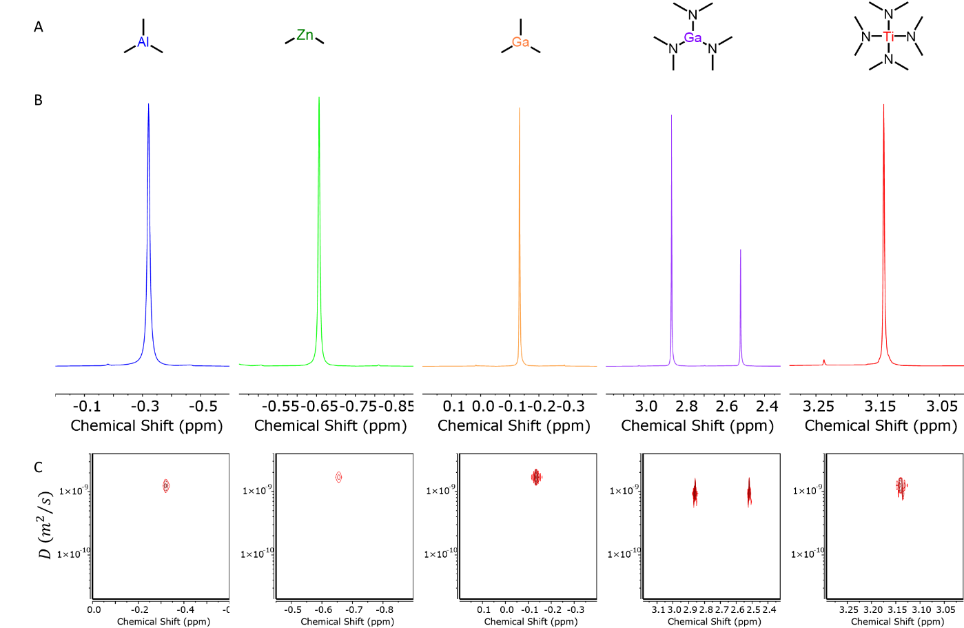
Supplementary Figure 1: NMR characterization of the employed precursors. A) Chemical structure, B) ¹H NMR and C) DOSY of each precursor employed. TM-Al and TDMA-Ga are known to exist as dimers. Consistently, two resonance with integrations of 2:1 are observed for TDMA-Ga and they display equivalent diffusion coefficient. The two distinct resonances arise from the bridging amides between the Ga centers and the amides on the periphery.¹⁴ We do not observe two resonances for the TM-Al dimer, however we note a broader linewidth of $\sim$4 Hz as compared to $<2$ Hz linewidths of the resonances for the other precursor. Further, we note a smaller diffusion coefficient of 1250 µm²/s for TM-Al as compared to 1700 µm²/s for TM-Ga. These observations suggest that the resonance measured for TM-Al is broadened due to its presence as a dimer.

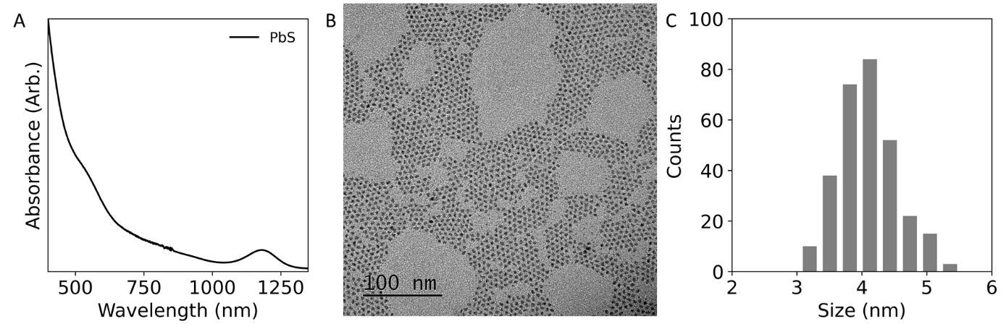
Supplementary Figure 2: Characterization of the PbS NCs. A) Optical absorption spectrum showing a first excitonic peak at 1246 nm, B) representative TEM picture and C) sizing histogram extracted from TEM showing an average size of 4.1 nm for 298 particles measured.
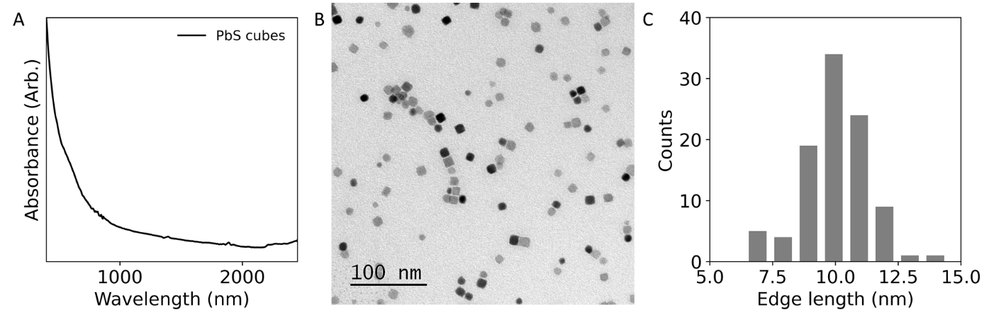
Supplementary Figure 3: Characterization of the PbS nanocubes. A) Optical absorption spectrum showing no distinct excitonic peak, B) representative TEM picture and C) sizing histogram extracted from TEM showing an average size of 10.0 nm for 100 particles measured.
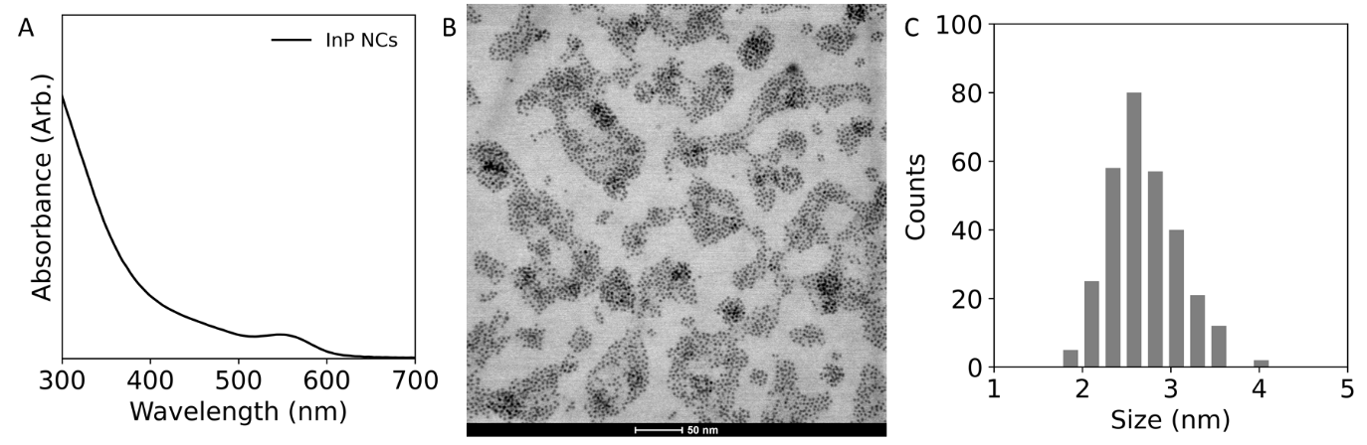
Supplementary Figure 4: Characterization of the InP NCs. A) Optical absorption spectrum showing a first excitonic peak at 546 nm, B) representative STEM picture and C) sizing histogram extracted from STEM showing an average size of 2.7 nm for 300 particles measured.
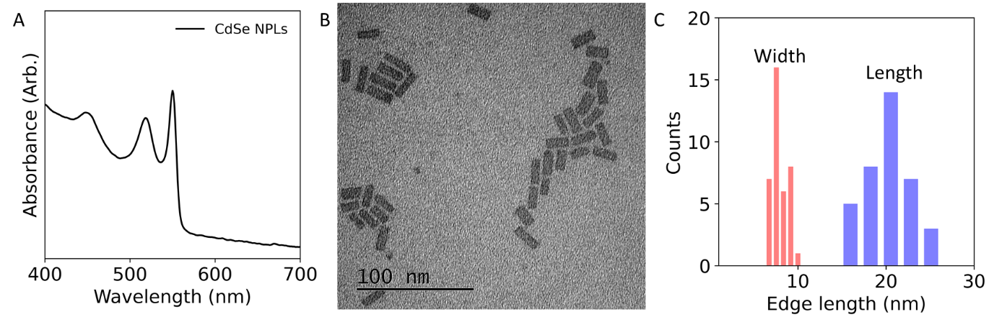
Supplementary Figure 5: Characterization of the CdSe NPLs. A) Optical absorption spectrum showing a first excitonic peak at 550 nm consistent with 5.5 monolayer thick NPLs, B) representative TEM picture and C) sizing histogram extracted from TEM showing an average width of 7.9 nm and length of 20.2 nm for 37 particles measured.
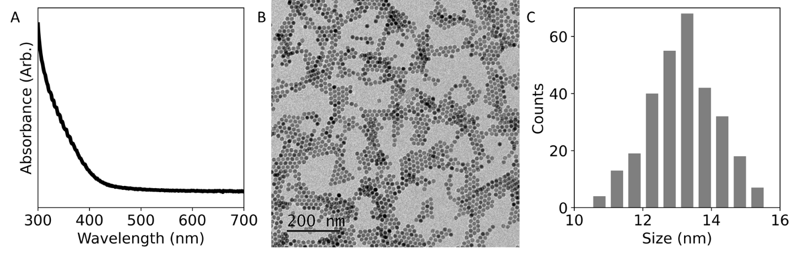
Supplementary Figure 6: Characterization of the NaGdF₄ NCs. A) optical absorption spectrum showing no distinct feature, B) representative TEM picture and C) sizing histogram extracted from TEM showing an average size of 13.2 nm for 300 particles measured.

2.6 Surface chemistry of PbS NCs:
We find it useful to briefly describe the surface of our PbS NCs (See supplemental section 2 for synthetic details). Our NCs are oleate passivated as identified by ¹H NMR. After sufficient anti-solvent purification, we obtained samples with only bound ligands (Supplementary Figure 7). In fact, we observed one single broad ($\sim 45$Hz) alkene resonance at 5.7 ppm (Supplementary Figure 7). We calculate approximately 132 oleates per NC. DOSY revealed a diffusion coefficient ($D$) of 85 µm²/s, corresponding to a solvodynamic diameter of 7.2 nm which is consistent with the size of our NCs (4 nm + ligands) as measured by TEM and estimated by optical absorption spectroscopy (Supplementary Figure 2 and 7).¹⁵ The addition of common additives such as excess oleic acid, zinc stearate or tetramethylethylenediamine (TMEDA) resulted in the appearances of a new, sharper alkene resonance upfield to the bound oleate resonance (Supplementary Figure 8).^{16–20} The new resonance is representative of chemical exchanges through a dynamic interaction of X-type ligands (oleates) or Z-type ligands (zinc-stearate or lead oleate).²¹ In VT-NMR experiments, heating the native PbS NCs from 22 to 70$℃$ results in the emergence of a new upfield resonance, associated with a dynamic equilibrium of charge neutral Z-type lead oleates (Supplementary Figure 9).¹⁷ VT-NMR in the presence of the previously mentioned additives amplifies the observed dynamic behavior (Supplementary Figure 10-12). We consider it likely that hydroxide ligands are also present on the surface as they are a byproduct of the synthesis.²² Therefore, our PbS NCs can be considered to be passivated by oleates. These data will serve as our basis to contrast the perturbations induced when adding the c-ALD precursors.

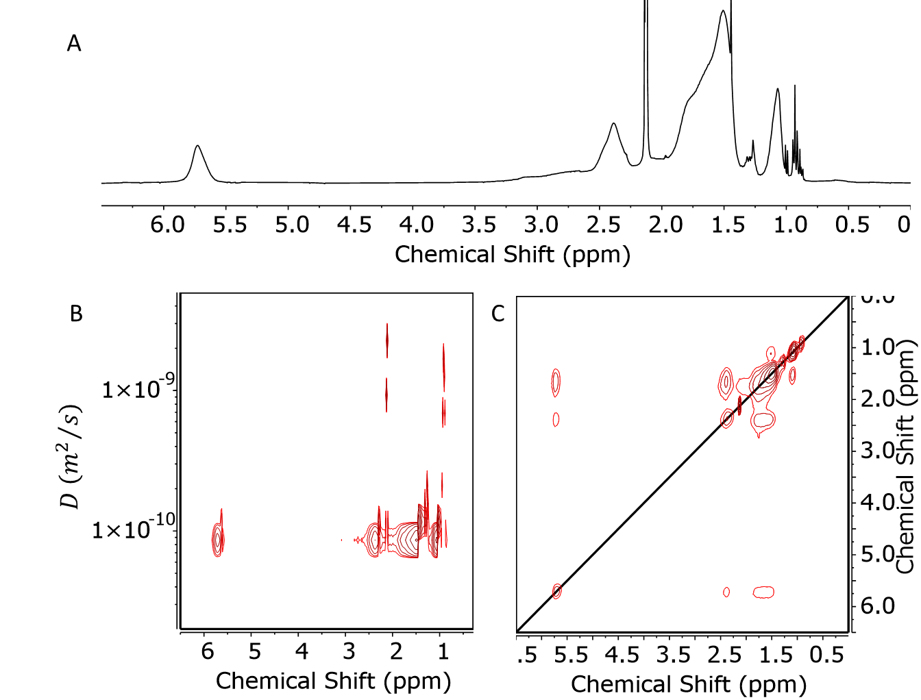
Supplementary Figure 7: NMR characterization of native PbS NCs in toluene-d8. A) ¹H NMR of as prepared NCs showing broadened resonances. The alkene resonance at 5.7 ppm has a linewidth of $\sim$45 Hz, consistent with bound ligands. B) DOSY measurements extract a diffusion coefficient of 85 µm²/s. Using the Stokes-Einstein equation a solvodynamic diameter (NC diameter + ligand length) of 7.2 nm is obtained consistent with the expected value for bound ligands on a 4 nm NC (Supplementary Figure 2). C) 2D NOESY showing negative cross peaks (same sign as the diagonal) further reinforcing that the ligands are bound.

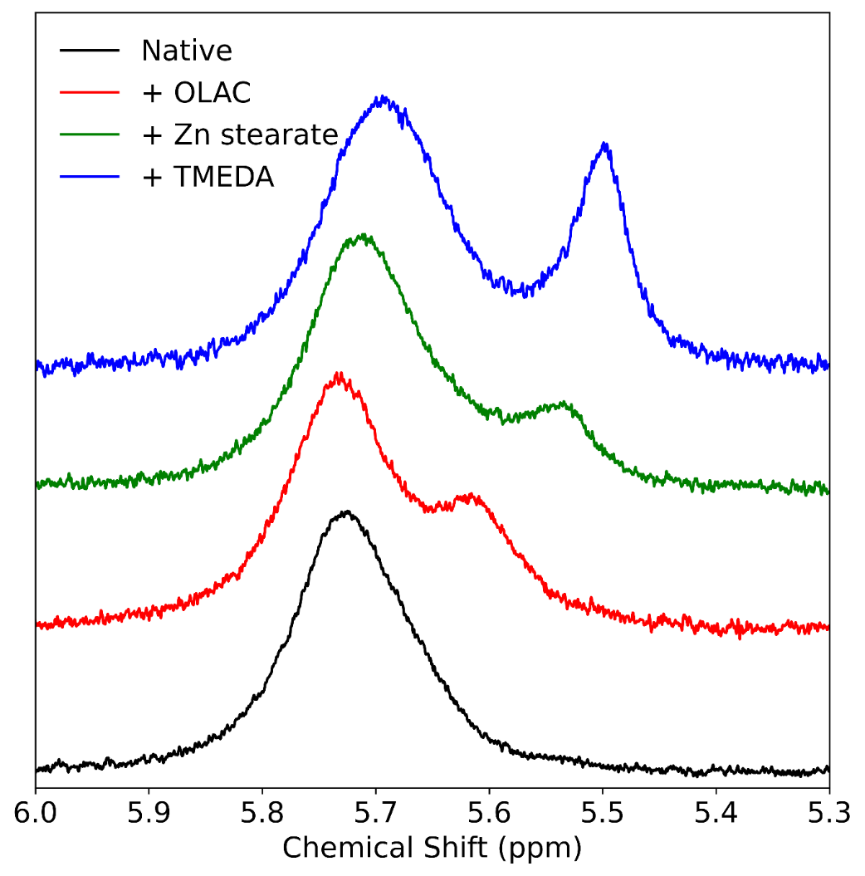
Supplementary Figure 8: Typical ¹H NMR spectra of the alkene resonances of PbS NCs in the presence of various additives. The native sample (black) displays a broad resonance ($\sim 45$Hz) consistent with bound ligands.²³ We then introduced excess OLAC, zinc stearate or TMEDA as common additives that probe various exchanges. The addition of OLAC results in the appearance of a new narrower resonance at lower ppm’s. The appearance of this resonance is associated to a dynamic exchange of carboxylates, known as a X-for-X exchange.¹⁹ Then, the addition of Lewis acidic zinc stearate likely undergoes an exchange with bound lead oleate in what would be a Z-for-Z exchange.²⁴ This exchange also manifested through a narrower resonance at lower ppm. Similarly, TMEDA, a Lewis base, is known to displace Lewis acidic lead oleate through an exchange known as L promoted Z-type ligand displacement.¹⁸ Further characterization of these exchanges is presented in Supplementary Figures 10 to 12 were we report the temperature dependence of the lineshape. These exchanges form the basis of the commonly observed ¹H NMR lineshapes of the OLAC alkene and constitute a reference to contrast the linewidth of our PbS NCs in presence of our c-ALD precursors.

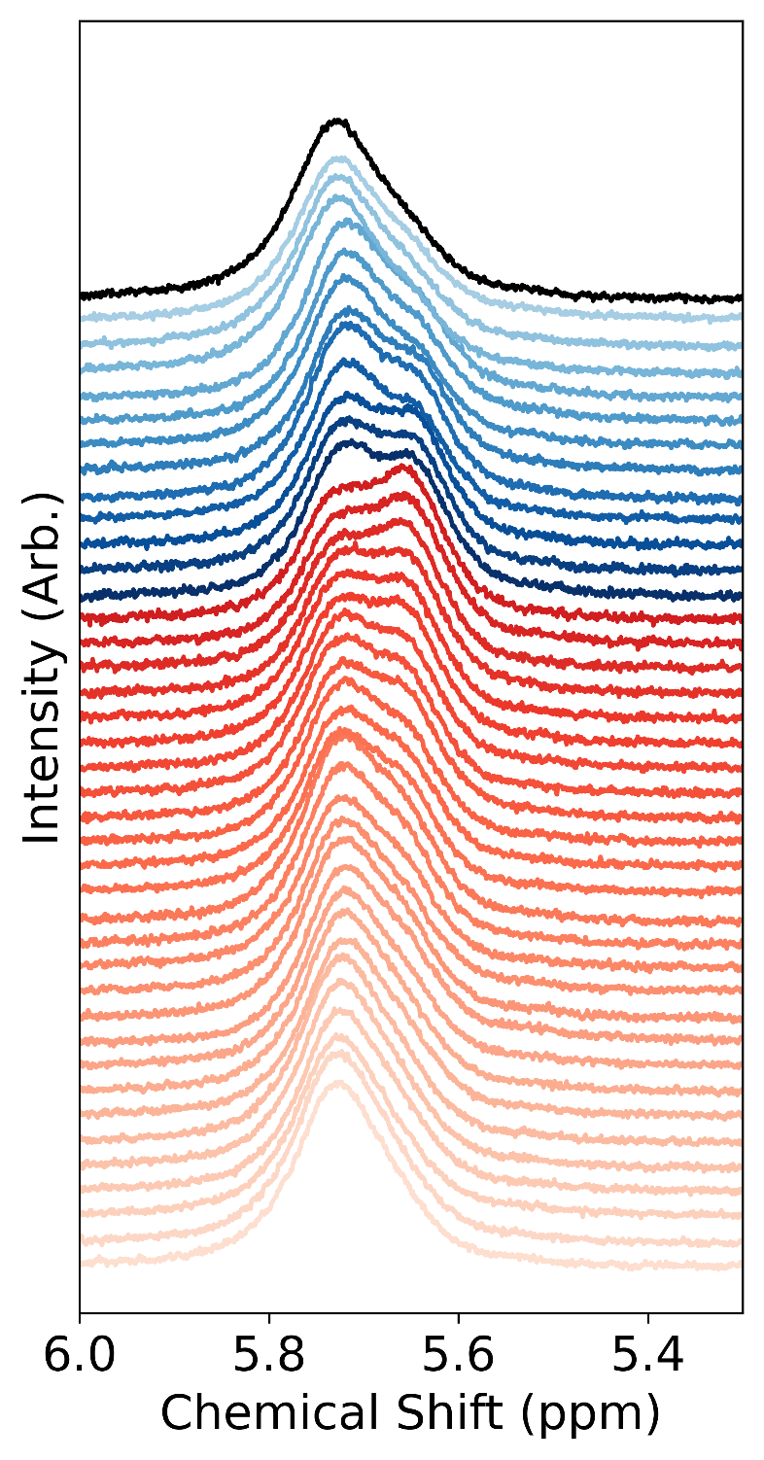
Supplementary Figure 9: VT-NMR of the native sample going from 22$℃$ to 70$℃$ and then back to 22$℃$. A single broad resonance is observed at 22$℃$. Upon heating a new upfield resonances emerges. This resonance is indicative of a dynamic equilibrium by Z-type lead oleate ligands. As the temperature increases, the equilibrium is biased to the release of lead oleate. Upon cooling the sample, the observed resonance is similar to the initial spectrum.
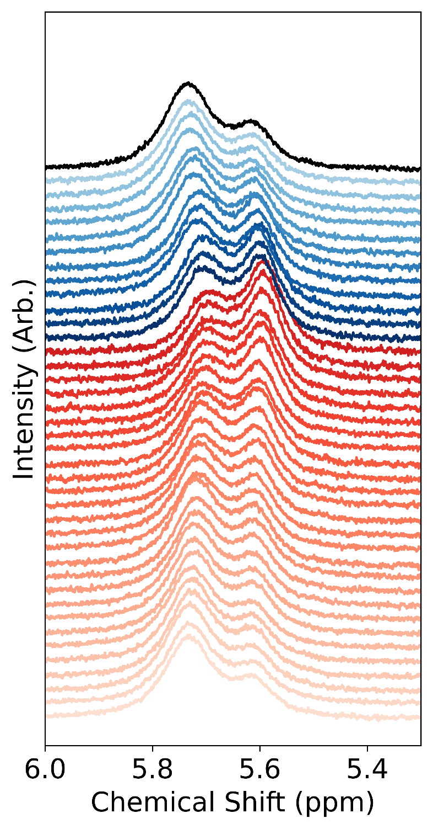
Supplementary Figure 10: VT-NMR of the native sample with additional OLAC going from 22$℃$ to 70$℃$ and then back to 22$℃$. The introduction of OLAC results in the emergence of a second upfield resonances assigned to dynamically interacting OLAC. Heating this sample is likely to release lead oleate which in turn has its oleates in dynamic exchange with the excess OLAC. Consequently, due to the rapid nature of this exchange (with the surface and released lead oleate) only two resonances are observed.
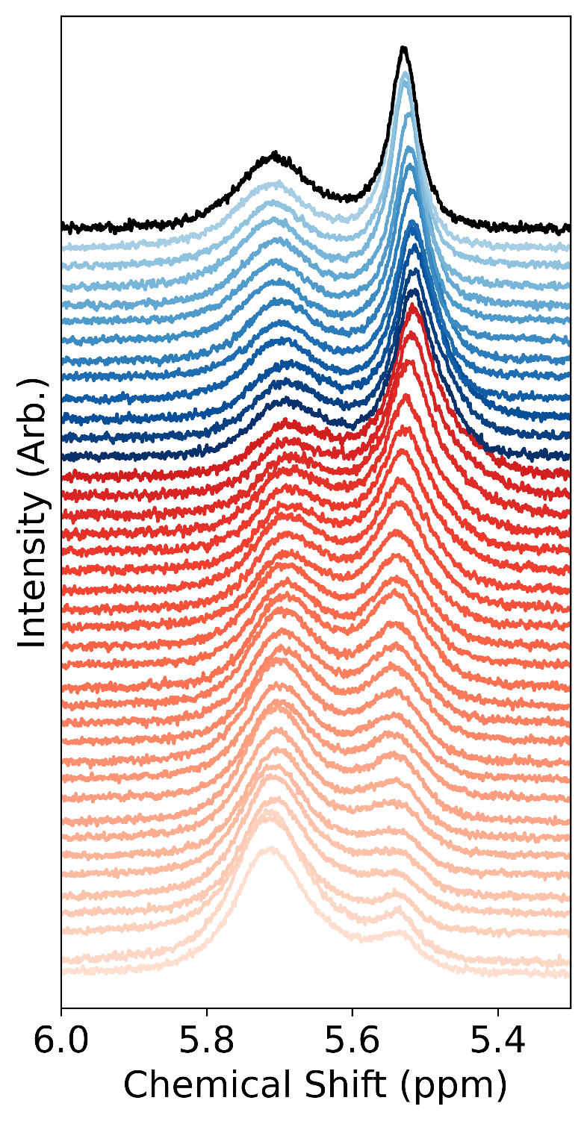
Supplementary Figure 11: VT-NMR of the native sample with additional zinc stearate going from 22$℃$ to 70$℃$ and then back to 22$℃$. The introduction of zinc stearate results in the emergence of a second upfield resonances assigned to dynamically interacting lead oleate. Zinc stearate is a Lewis acid (Z-type ligand). These ligands are likely to substitute bound lead oleates. Further stearates are known to form denser ligand shells due to their fully saturated alkene chain.²⁵ Upon heating, swapping of Z-type lead oleate and zinc stearate is promoted, however we do not observe a reversible equilibrium as the stearates form a more compact ligand shell.
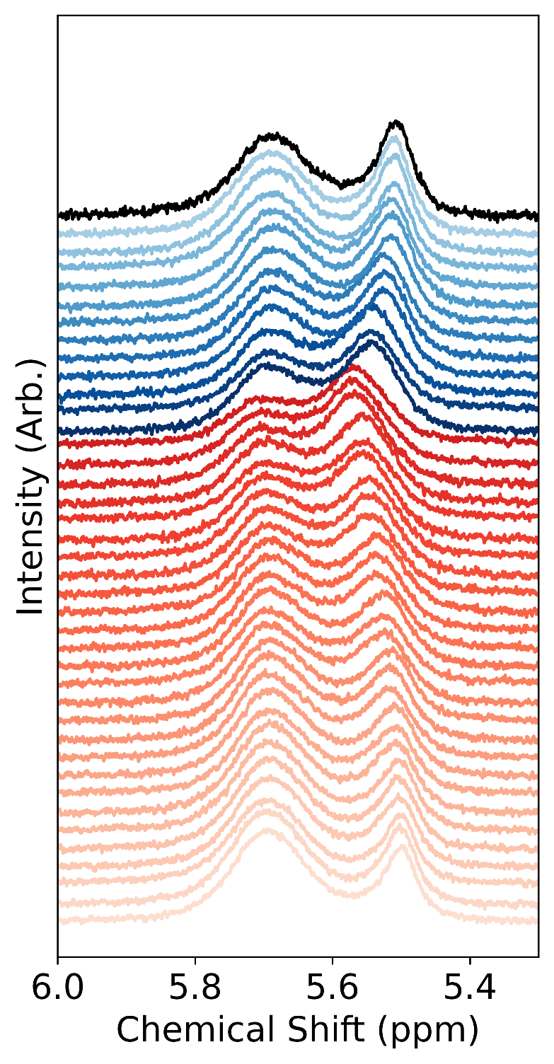
Supplementary Figure 12: VT-NMR of the native sample with additional TMEDA going from 22$℃$ to 70$℃$ and then back to 22$℃$. The introduction of TMEDA results in the emergence of a second upfield resonances assigned to dynamically interacting lead oleate coordinated by TMEDA. TMEDA is a Lewis bases (L-type) ligand and has been shown to promote the release of bound Z-type ligands.

Section 3: Precursor Surface Interactions

3.1 Titrations:
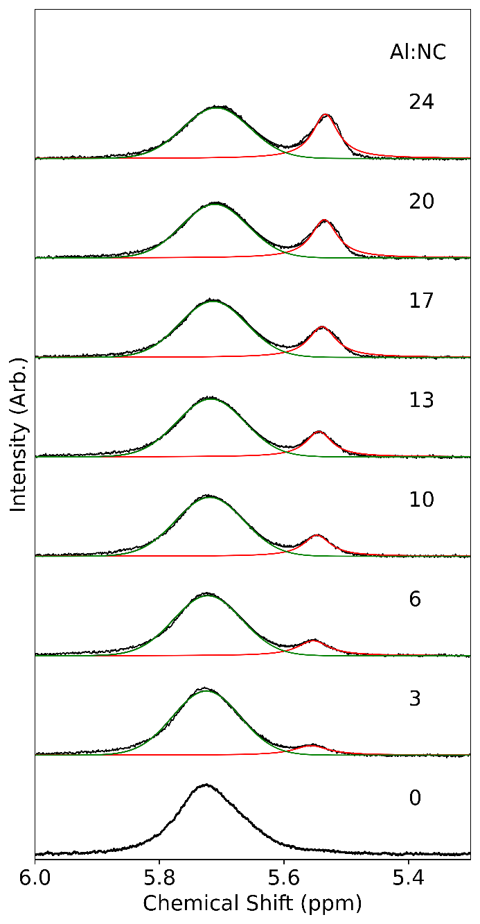
Supplementary Figure 13: Fitted contributions of the alkene resonances during the titration of TM-Al to PbS NCs, reported in terms of Al to NC equivalences. A Gaussian function is employed to account for the bound contribution (green) while a Lorentzian is used for the released component (red). The integrated percentage of released oleate ligands is presented in Supplementary Figure 14.
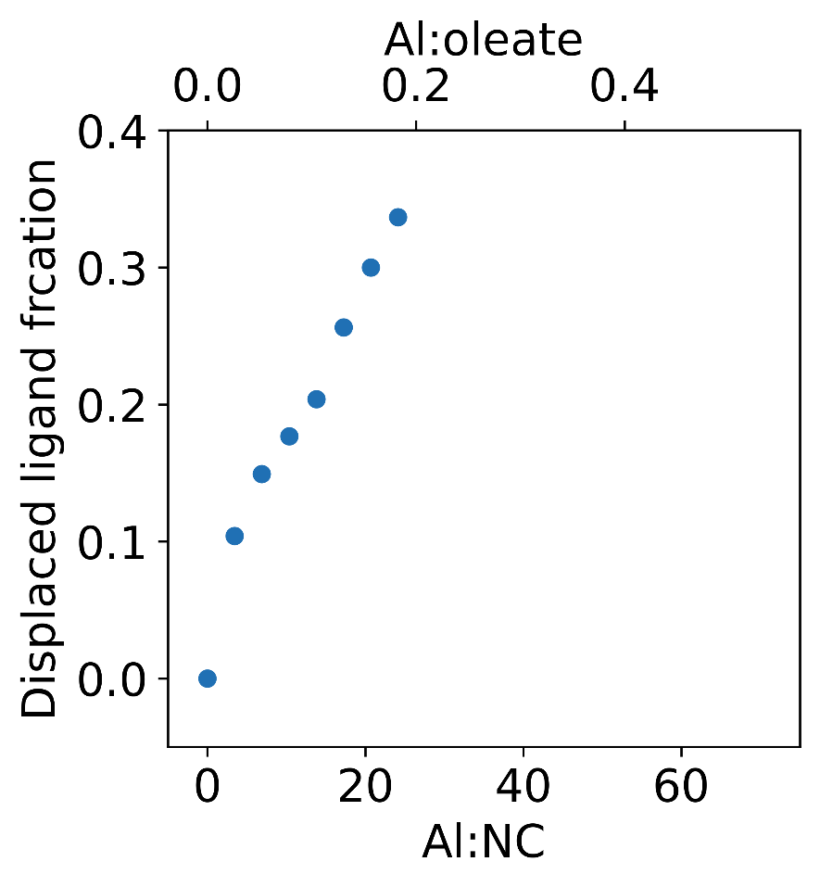
Supplementary Figure 14: Displaced ligand percentage extracted from the TM-Al titration presented in Figure 1 and Supplementary Figure 13.
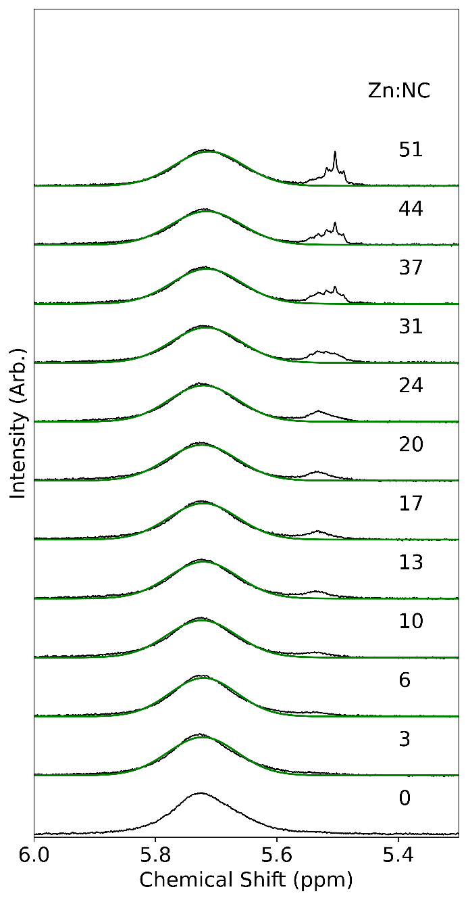
Supplementary Figure 15: Fitted contributions of the alkene resonances during the titration of DM-Zn to PbS NCs, reported in terms of Zn to NC equivalences. The integrated area of the alkene resonances was normalized and a Gaussian function was employed to account for the bound contribution (green). The released fraction was not fit due to its convoluted lineshape. The integrated ratios between free and bound is presented in Supplementary Figure 16.

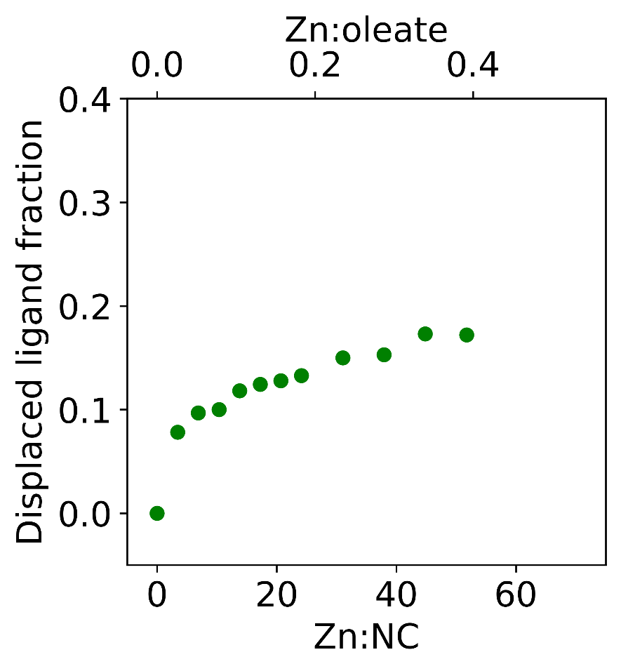
Supplementary Figure 16: Displaced ligand percentage extracted from the DM-Zn titration presented in Figure 1 and Supplementary Figure 15.
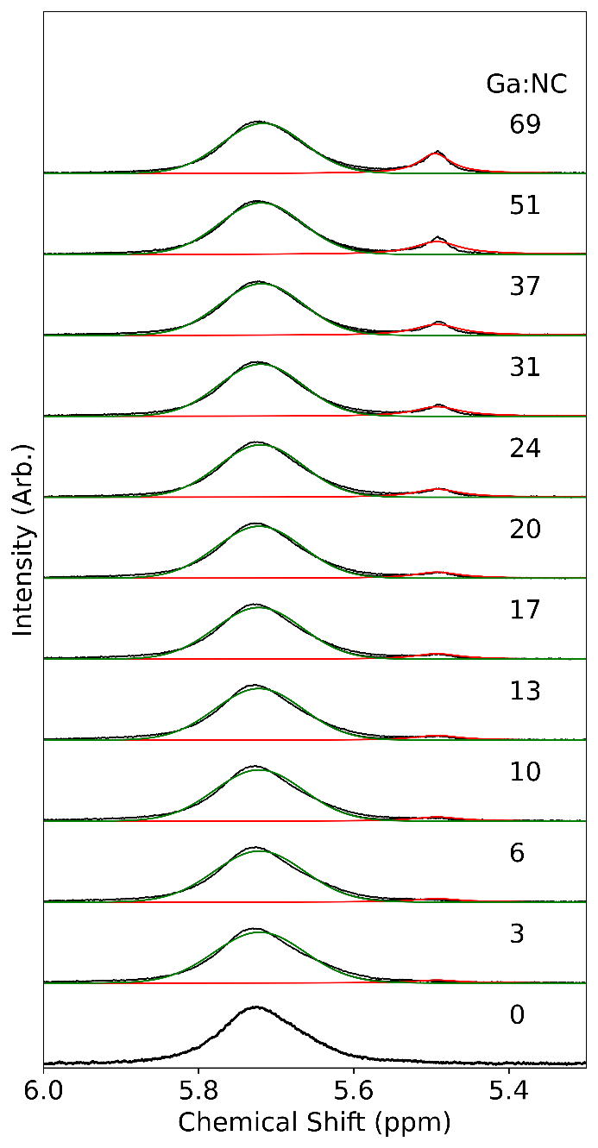
Supplementary Figure 17: Fitted contributions of the alkene resonances during the titration of TM-Ga to PbS NCs, reported in terms of Ga to NC equivalences. A Gaussian function is employed to account for the bound contribution (green) while a Lorentzian is used for the released component (red). The integrated percentage of released oleate ligands is presented in Supplementary Figure 18.
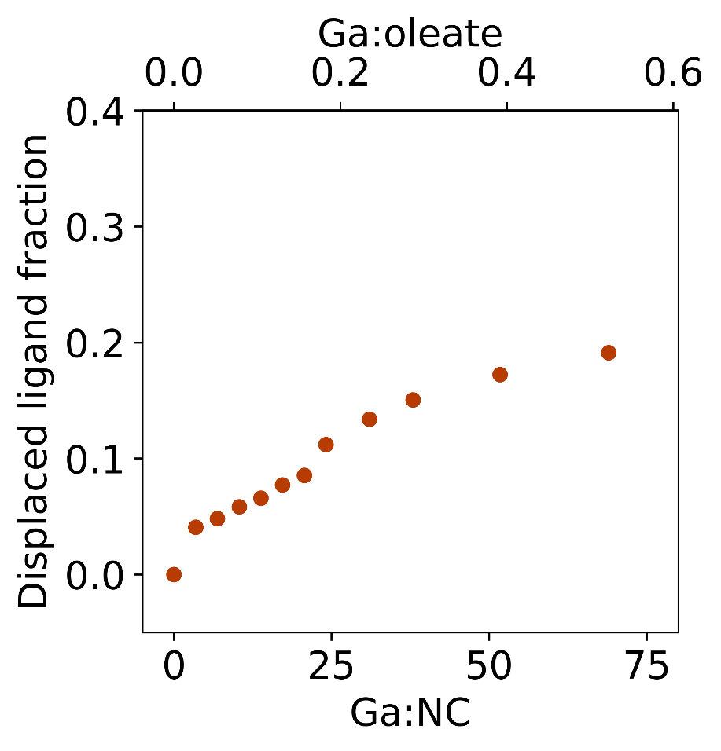
Supplementary Figure S18: Displaced ligand percentage extracted from the TM-Ga titration presented in Figure 1 and Supplementary Figure 17.
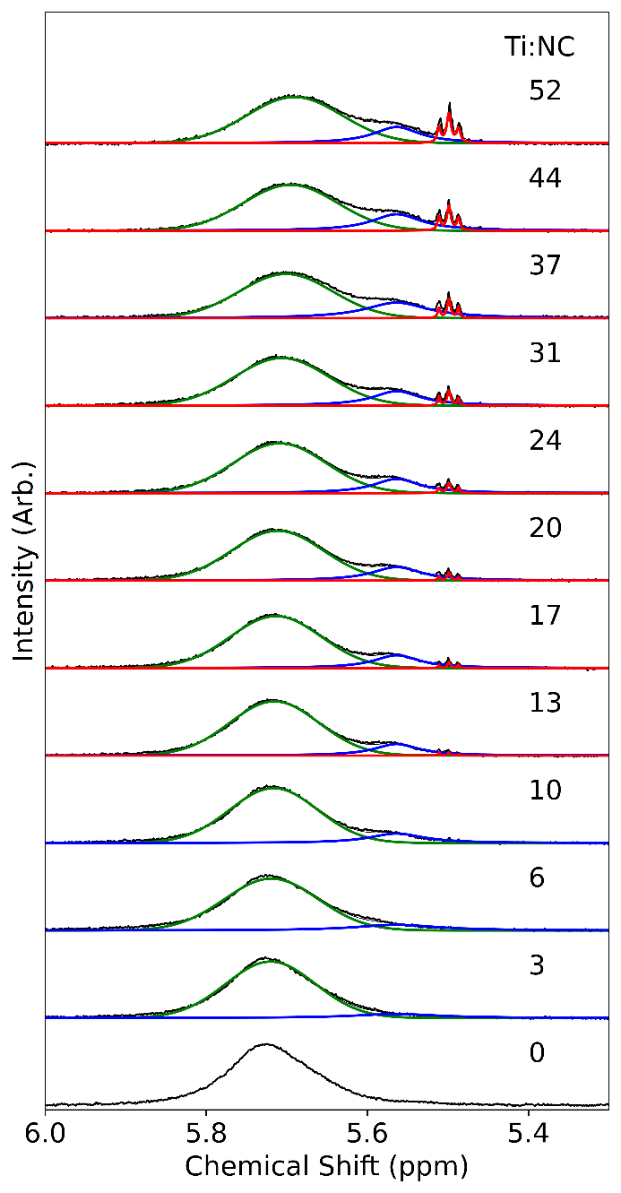
Supplementary Figure 19: Fitted contributions of the alkene resonances during the titration of TDMA-Ti to PbS NCs, reported in terms of Ti to NC equivalences. A Gaussian function is employed to account for the bound contribution (green), a Lorentzian function is used for the released component at 5.5 ppm (blue) and three more Lorentzian functions are used to account for the resonances at 5 ppm (red). The integrated percentage of released oleate ligands is presented in Supplementary Figure 20.
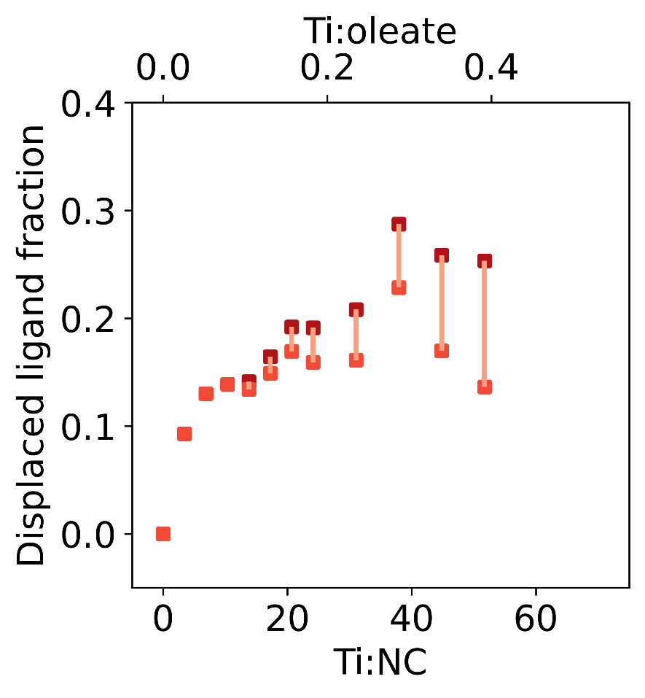
Supplementary Figure 20: Displaced ligand percentage extracted from the TDMA-Ti titration presented in Figure 1 and Supplementary Figure 19. Light red squares indicate the integrated percentage area of the resonance at 5.5 ppm (blue fit in Supplementary Figure 19), while the dark red squares indicate the integrated value of both the 5.5 and 5 ppm resonances (blue and red fits in Supplementary Figure 19). The connecting lines between light and dark squares indicates the respective contributions of both observed resonances. Therefore, the length of the connecting line corresponds to the integrate percentage area of the resonance at 5 ppm.
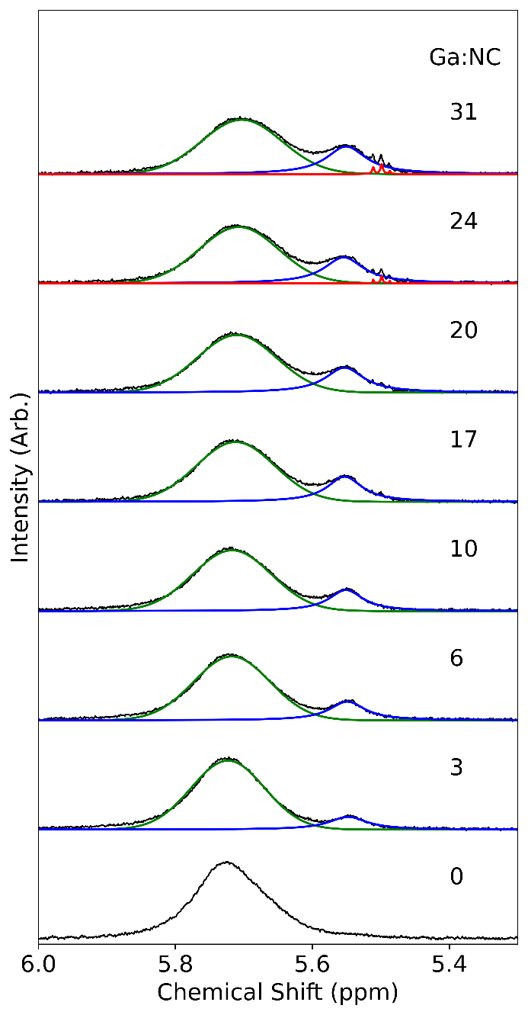
Supplementary Figure 21: Fitted contributions of the alkene resonances during the titration of TDMA-Ga to PbS NCs, reported in terms of Ga to NC equivalences. A Gaussian function is employed to account for the bound contribution (green), a Lorentzian function is used for the released component at 5.5 ppm (blue) and three more Lorentzian functions are used to account for the resonances at 5 ppm (red). The integrated percentage of released oleate ligands is presented in Supplementary Figure 22.
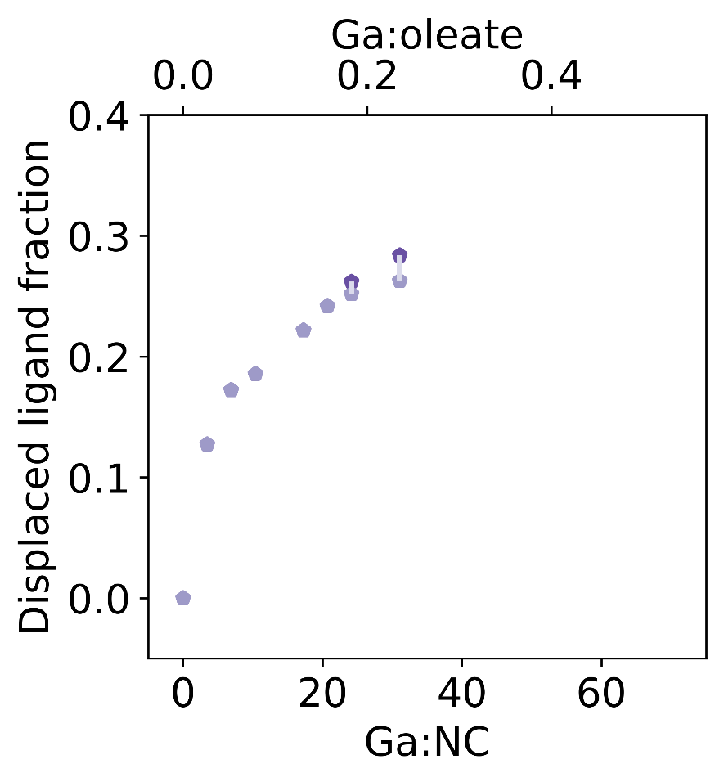
Supplementary Figure 22: Displaced ligand percentage extracted from the TDMA-Ga titration presented in Figure 1 and Supplementary Figure 21. Light purple pentagons indicate the integrated percentage area of the resonance at 5.5 ppm (blue fit in Supplementary Figure 21), while the dark purple pentagons indicate the integrated value of both the 5.5 and 5 ppm resonances (blue and red fits in Supplementary Figure 21). The connecting lines between light and dark squares indicates the respective contributions to of both observed resonances. Therefore, the length of the connecting line corresponds to the integrate percentage area of the resonance at 5 ppm.

3.2 Trimethyl aluminium (TM-Al):
In the titration with TM-Al, two resonances are observed with linewidths of 51 Hz and 21 Hz at 5.7 and 5.5 ppm respectively (Figure 1, Supplementary Figure 13). We associate the resonance at 5.5 ppm to dynamic or free OLAC and observe that it constitutes up to 33% of the OLAC species before gradual precipitation of the NCs occurred (Supplementary Figure 13, 14). Methane was observed at 0.2 ppm as well as a very broad feature at -0.2 ppm. The latter having speculatively been associated to surface bound CH₃.^{26,27} This observation suggests that TM-Al participates in the release of OLAC, potentially as a dynamically interacting species, while TM-Al derivatives are anchored to the surface as a species with remaining methyl ligands.²⁷ DOSY supports this hypothesis as two distinct diffusion coefficients are observed (Supplementary Figure 23). However, VT-NMR (heating from 22 to 70$℃$) is inconsistent with this view (Supplementary Figure 24). Upon heating the sample, the resonance at 5.5 ppm appears unaffected, while that of the bound ligands splits into two. The behavior of the bound OLAC is reminiscent of the native sample which suggests that heating results in the release of Z-type lead oleate (Supplementary Figure 9). This leads us to the conclusion that the produced species with TM-Al do not partake in a chemical equilibrium with the surface as it behaves in a way inconsistent with dynamically interacting OLAC or lead oleate. Thus, these experiments suggest that a new species is formed.
We then extracted the chemical species that are released from the NC surface after the interaction with TM-Al. This extraction was performed by centrifuging a solution of PbS NCs with TM-Al until all NCs precipitated and the supernatant was transparent. ¹H NMR of this transparent solution revealed a broad asymmetric alkene resonance at 5.54 ppm with a linewidth of approximately 30 Hz (Supplementary Figure 25). This resonance in the control experiment matches the chemical shift and peak shape of the resonance observed during the TM-Al titration, suggesting it is the same species. Further, it resembles that of a TM-Al titration to CdSe and CsPbBr₃ NCs passivated by cadmium oleate or ammonium-oleate.^{28,29} Concomitantly we observe a very broad resonance at -0.28 ppm. The remaining peaks between 4 and 0.5 ppm are consistent with the carbon chain of OLAC. All the broad resonances display a similar diffusion coefficient of 1.58 µm²/s corresponding to a solvodynamic diameter of approximately 4 nm as measured by DOSY, a value between that of free OLAC and the PbS NCs (Supplementary Figure 25, 26). The broad resonance at -0.28 ppm is reminiscent of bound methyls²⁷ however, the absence of a quantifiable amount of NCs suggests that this resonance arises from a different species.
We find similarities between the ¹H NMR of this new species and of methylaluminoxanes (MAOs) produced from the controlled hydrolysis of TM-Al in toluene. MAOs are oligomers of the formula [-Al(CH₃)O-]_{n}.³⁰ Consequently, the observed resonance at 5.5 ppm would be consistent with a stable coordination polymer containing a variant of oleic acid and trimethyl aluminium. This assignment agrees with the temperature independent resonance at 5.5 ppm from the titration experiment as oleate chains bound in the MAO coordination polymer would not be expected to dynamically interact with the NC surface. While the formation of MAO is not optimal to obtain AlO_{x} shells as it likely results in heterogeneous alumina nucleation, its presence in our titrations confirms that TM-Al interacts with the NCs and that if used in dilute amounts can be used for the growth of aluminium oxide on carboxylated surfaces

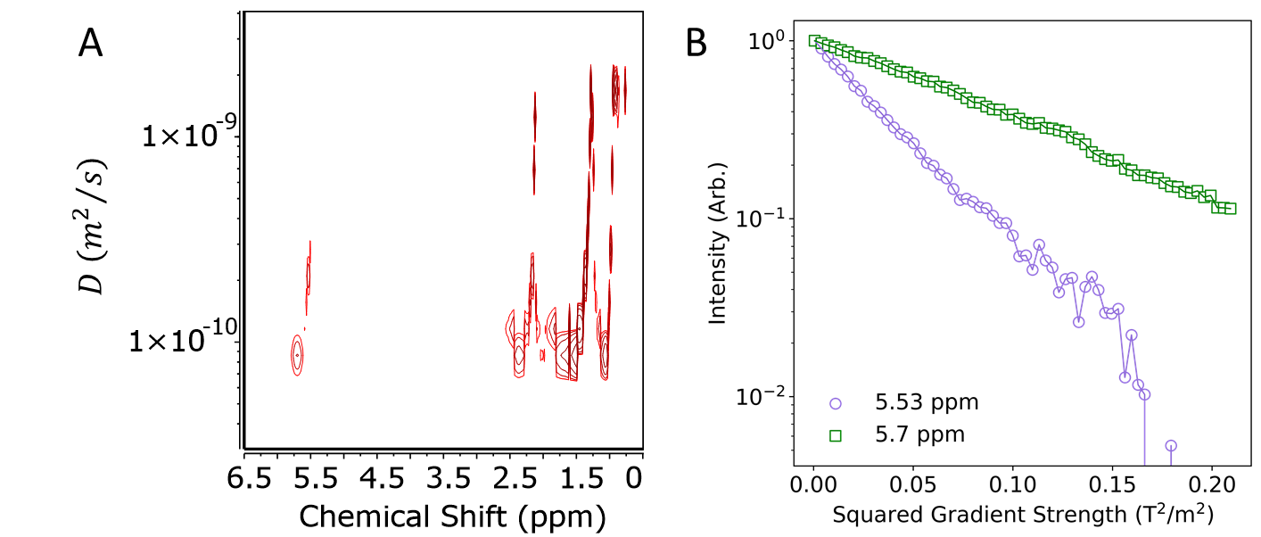

Supplementary Figure 23: DOSY of PbS NCs after the addition of TM-Al. A) 2D DOSY and B) extracted decay for the resonances at 5.53 and 5.7 ppm. These results indicate the presence of at least two distinct species. We calculate a solvodynamic diameter of 7.0 nm and 2.85 nm for the resonances at 5.7 and 5.53 ppm respectively.

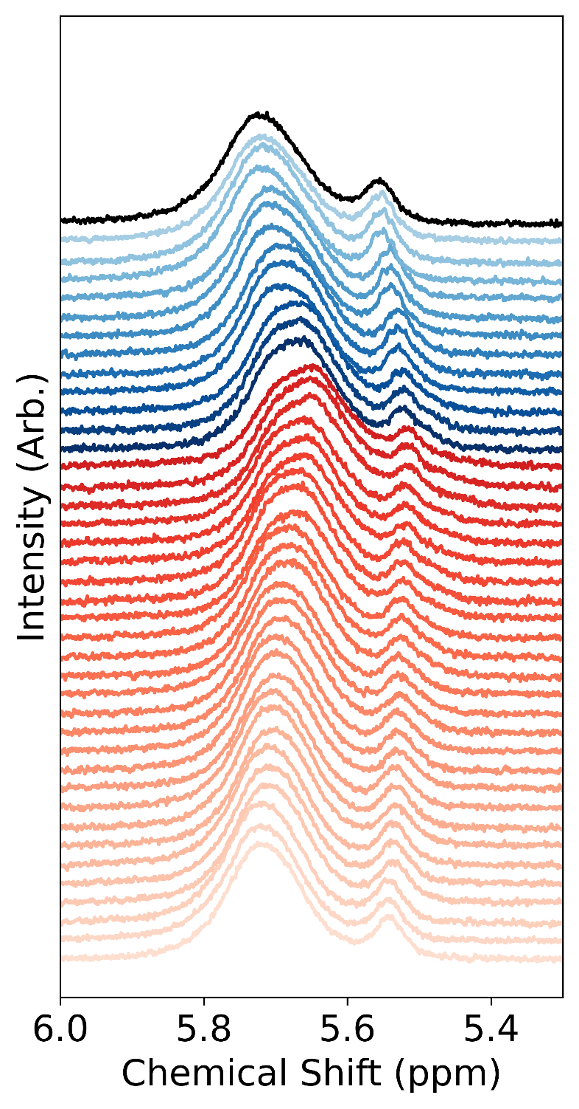
Supplementary Figure 24: VT-NMR of PbS NCs after the introduction of TM-Al. Two resonances are initially observed at 5.7 and 5.5 ppm. These are associated to bound oleates (5.7 ppm) and a byproduct of the interaction with TM-Al (5.5 ppm). Upon heating to 70$℃,$ the resonance at 5.7 splits in two in a manner akin to the native NCs (Supplementary Figure 9). This result suggest the displacement of Z-type lead oleate and indicates that the resonance of 5.5 ppm does not arise from a surface-based equilibrium. This observation suggests that the resonance at 5.5 ppm is neither OLAC or lead oleate, but a distinct specie.

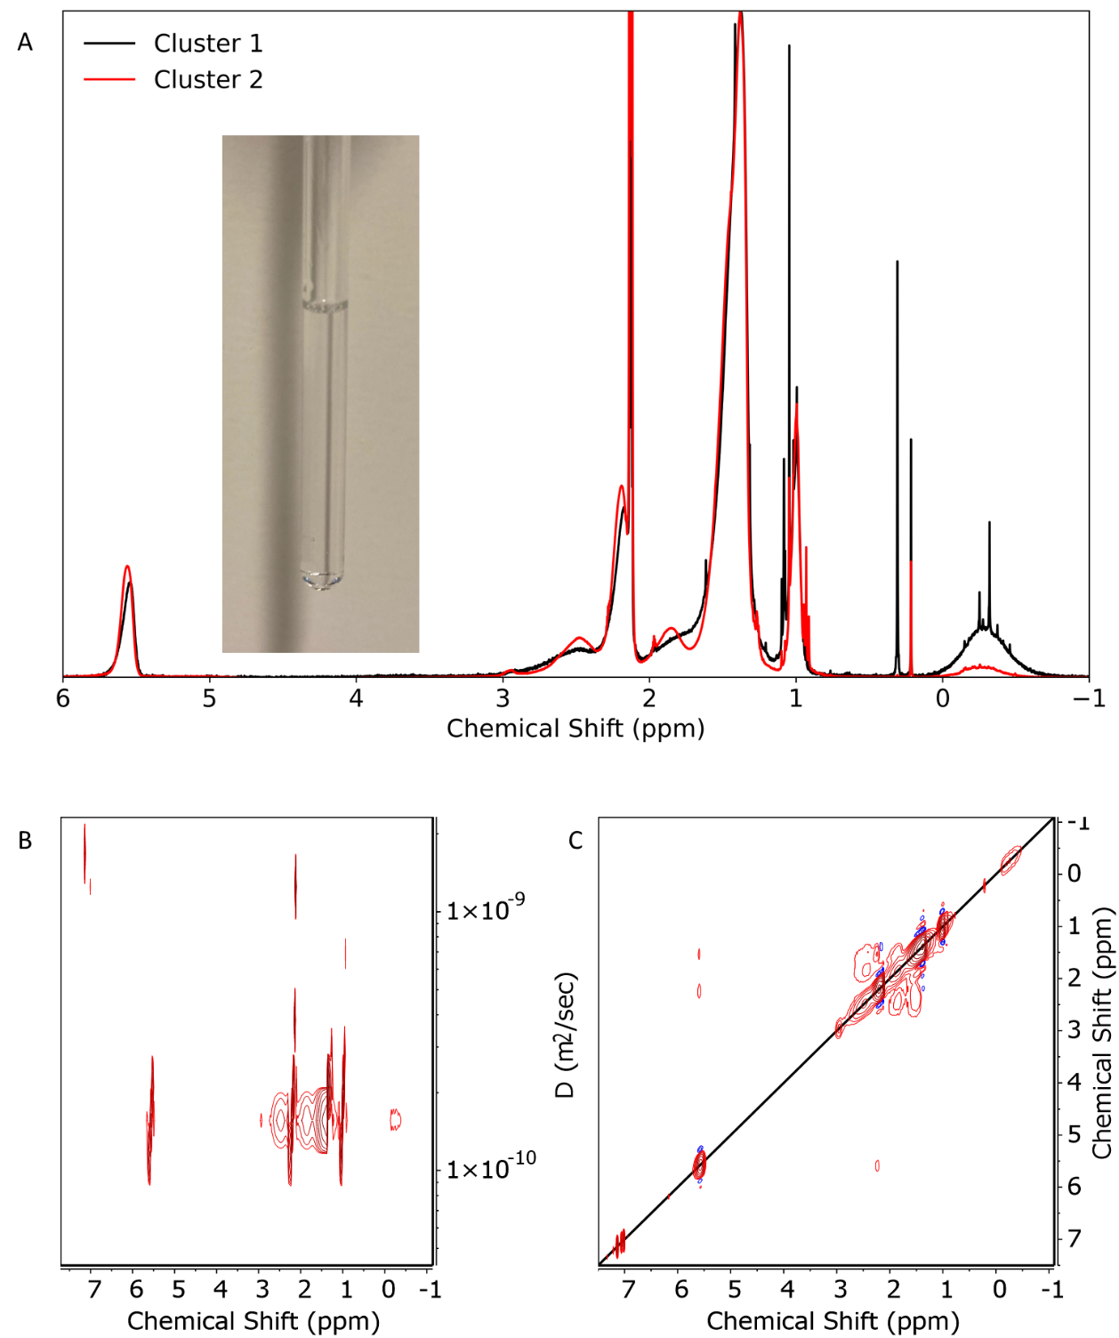
Supplementary Figure 25: ¹H NMR of the isolated byproducts obtained from a TM-Al titration. A) We show two examples of the obtained byproduct. Both have an asymmetric alkene resonance and a very broad resonances around -0.28 ppm. The obtained suspensions are visually clear (inset photo) indicating the absence of a meaningful amount of PbS NCs. B) DOSY of this species indicates a solvodynamic diameter of 4.0 nm. C) 2D NOESY shows negative crosspeaks indicative of the alkene protons not being free species, but part of small particles.
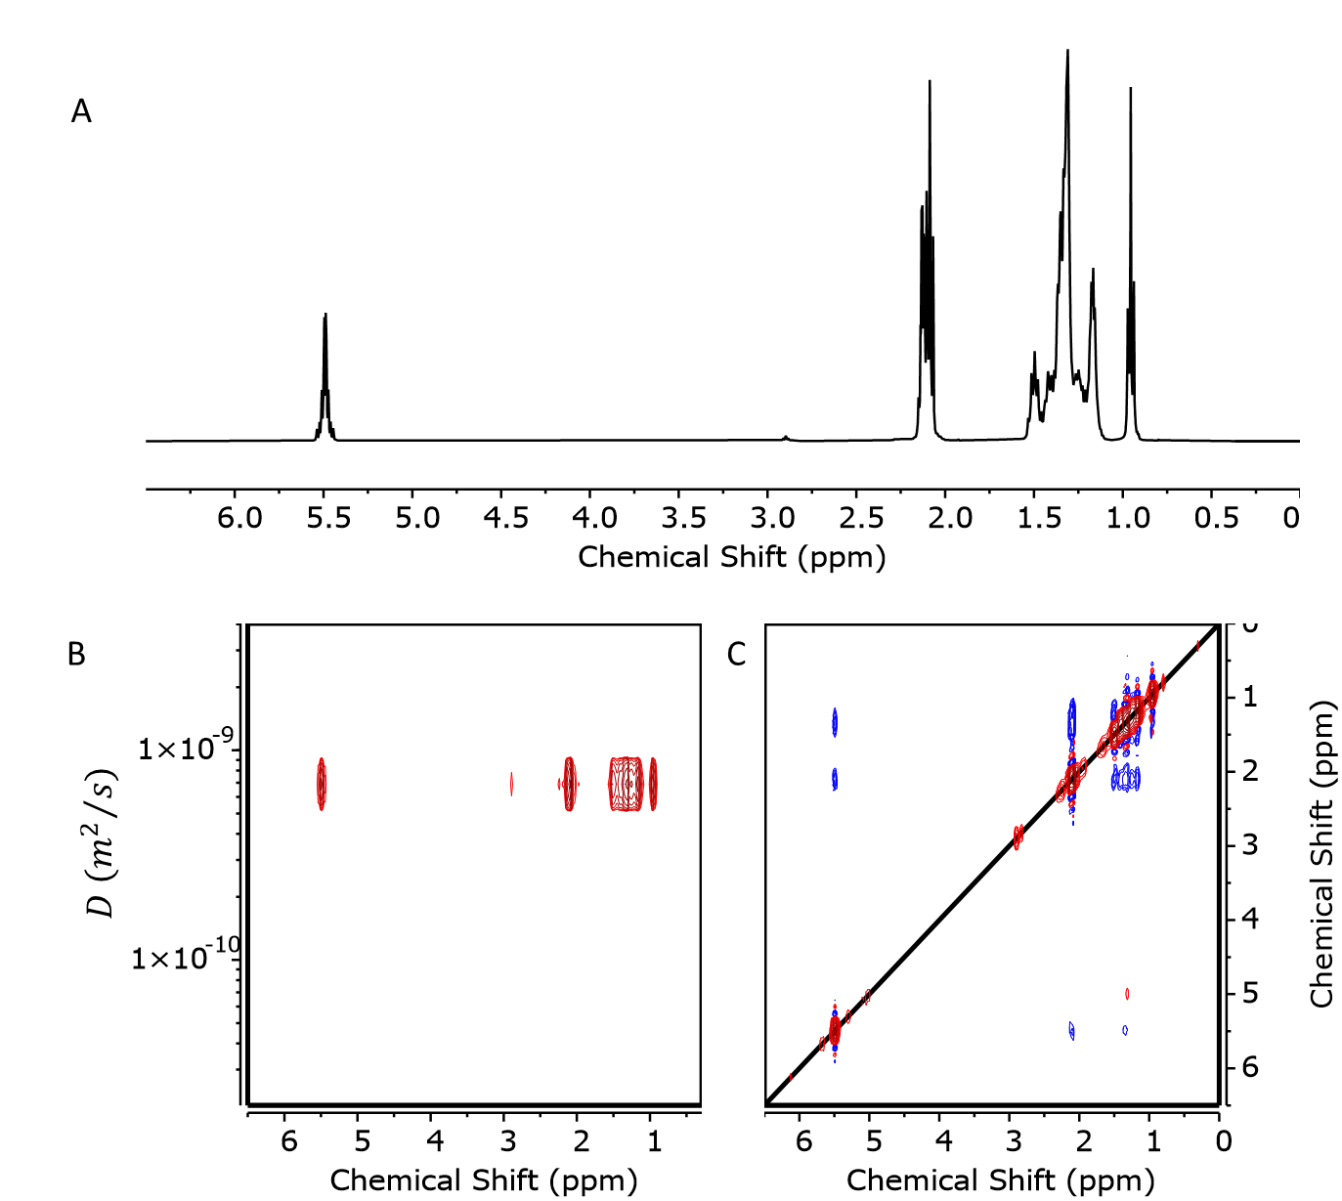
Supplementary Figure 26: A) ¹H NMR of OLAC. B) DOSY of OLAC indicates a solvodynamic diameter of 1.0 nm. C) 2D NOESY shows positive crosspeaks indicative of the alkene protons being free species.

3.3 Dimethyl zinc (DM-Zn):
Similar to experiments with TM-Al, increasing the equivalences of DM-Zn results in the appearance of a new resonance at 5.5 ppm. However, DM-Zn was observed to be less reactive then TM-Al as only 18% of released OLAC is reached at 51 equivalences of DM-Zn per NC (Figure 1, Supplementary Figure 15, 16). Furthermore, the lineshape of the resonance at 5.5 ppm is a convolution of features with linewidths around $\sim$2 and 10 Hz and three diffusion coefficients can be extracted from DOSY (Supplementary Figure 27). We also observed the presence of methane but not of bound methyls. VT-NMR resulted in a significant change in the lineshape of the released OLAC at 5.5 ppm (Supplementary Figure S28). All the resonances of the released OLAC merge into a single symmetric peak with a $\sim$ 17 Hz linewidth at 70$℃$. Narrow features are partially recovered upon cooling. The absence of chemical exchange and the presence of three distinct features indicate that the observed resonances at 5.5 ppm, generated by the addition of DM-Zn, originates from a new species. We consider that Zn₅(oleate)₆Me₄ can form through the DM-Zn titration as it has previously been postulated to form in the titration of diethyl zinc and CdSe NCs and previous VT-NMR experiments (from 20 to 80$℃$) on such structures have revealed a similar broadening of the resonances upon heating.^{27,31–33} Consequently, we postulate that upon excessive additions of DM-Zn, the formation of Zn₅(oleate)₆Me₄ is dominant. The c-ALD conditions should minimize the formation of such a species, yet these experiments indicate to a clear interaction of the precursors with the native oleates.

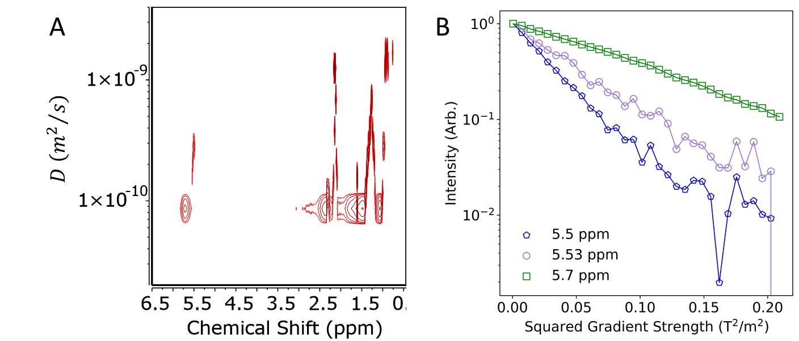
Supplementary Figure 27: DOSY of PbS NCs after the introduction of DM-Zn. A) 2D DOSY and B) extracted decay for the resonances at 5.5, 5.53 and 5.7 ppm. These results indicate the presence of at least two distinct species and possibly a third. We calculate a solvodynamic diameter of 7.2 nm, 3.3 nm and 2.2 nm for the resonances at 5.7 and 5.53 and 5 ppm respectively.

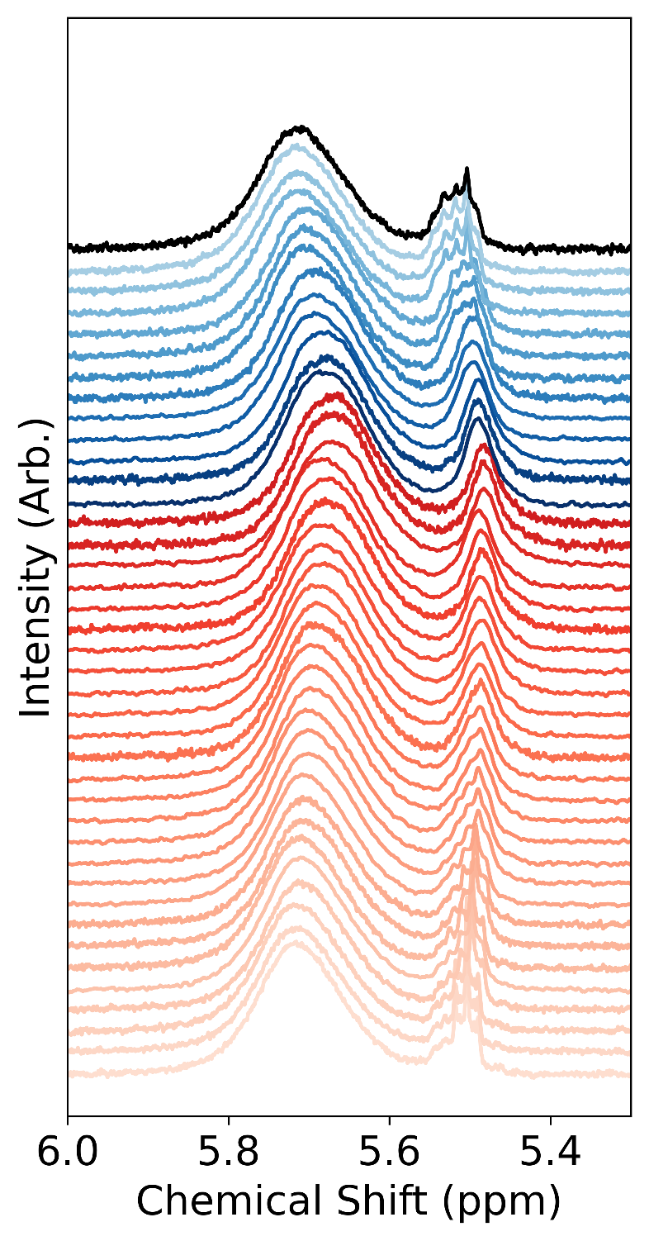
Supplementary Figure 28: VT-NMR of PbS NCs after the introduction of DM-Zn. Three resonances are initially observed at 5.7, 5.53 and 5.5 ppm. These are associated to bound oleates (5.7 ppm) and a byproduct of the interaction with DM-Zn (5.53 and 5.5 ppm). The resonance at 5.7 is marginally affected upon heating to 70$℃$. No surface-based equilibrium is noticeable while a broadening and merging of the resonances around 5 ppm is observed. Narrow features are recovered upon cooling. While it is difficult to clearly assign the nature of these resonances, the VT-NMR experiment strongly suggest that the newly formed species does not interact with the NCs core and is distinct to OLAC and lead oleate.

3.4 Trimethyl gallium (TM-Ga):
Titrations with TM-Ga result in a similar behavior to both previous precursors. However, TM-Ga appeared to be the least reactive towards the NC surface as only 20% of the OLAC was released for 69 equivalences (Figure 1, Supplementary Figure 17, 18). Free TM-Ga was clearly observed to be unreacted at the completion of the titration. DOSY once again yielded two clearly distinct diffusion coefficients (Supplementary Figure 29). VT-NMR was consistent with the other precursors as it appears the released OLAC does not interact with the NC surface (Supplementary Figure 30). Similar to TM-Al, the controlled hydrolysis of TM-Ga can produce polymeric structures.^{34–37} We isolated the biproduct of such a reaction and observed proton resonance consistent with the formation of a cluster like structure (Supplementary Figure 27) Consequently, we hypothesize that the addition of TM-Ga yields networks of Ga and OLAC.

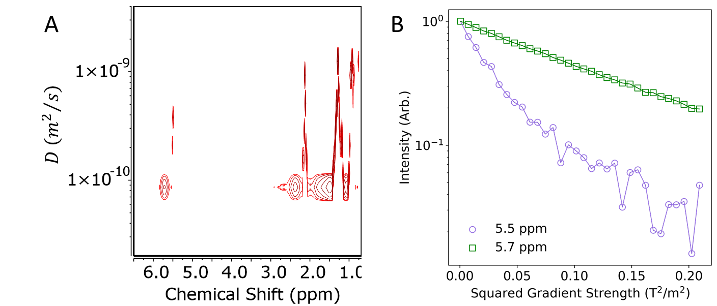
Supplementary Figure 29: DOSY of PbS NCs after the introduction of TM-Ga. A) 2D DOSY and B) extracted decay for the resonances at 5.5 and 5.7 ppm. These results indicate the presence of at least two distinct species. We calculated a solvodynamic diameter of 7.1 nm and 1.8 nm for the resonances at 5.7 and 5.5 ppm, respectively.

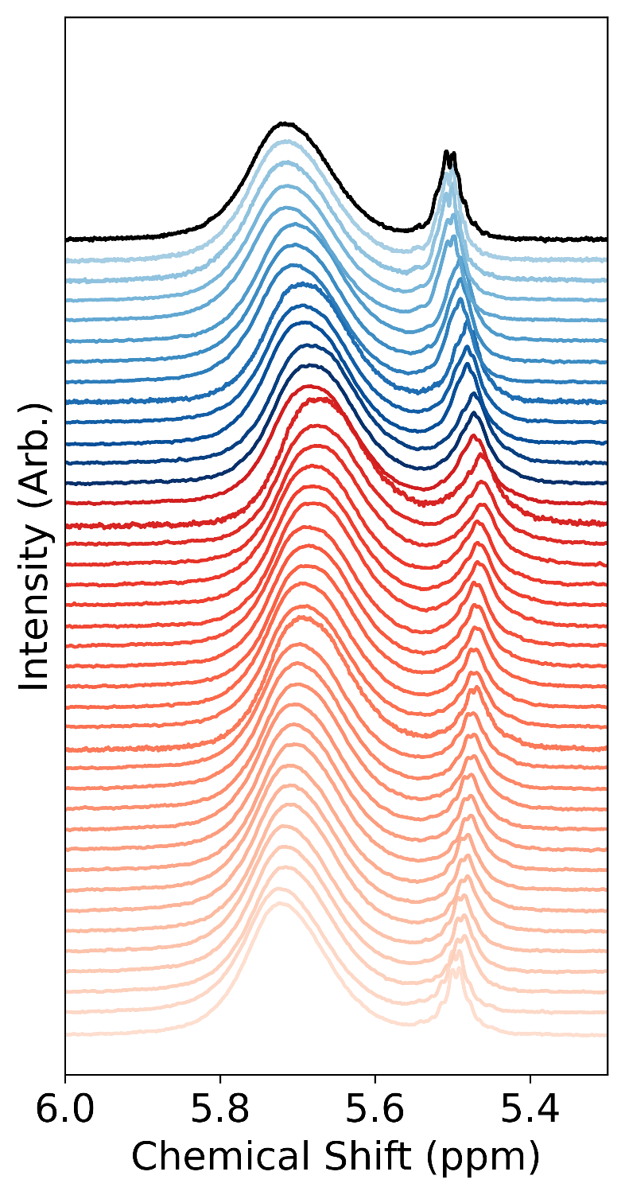
Supplementary Figure 30: VT-NMR of PbS NCs after the introduction of TM-Ga. Two resonances are initially observed at 5.7 and 5.5 ppm. These are associated to bound oleates (5.7 ppm) and a byproduct of the interaction with TM-Ga (5.5 ppm). The resonance at 5.7 is marginally affected upon heating to 70$℃$. No surface-based equilibrium is noticeable while a broadening a merging of the resonances around 5 ppm is observed. Narrow features are recovered upon cooling. While it is difficult to clearly assign the nature of these resonances, the VT-NMR experiment strongly suggest that the newly formed species does not interact with the NCs core and is distinct to oleic acid and lead oleate.

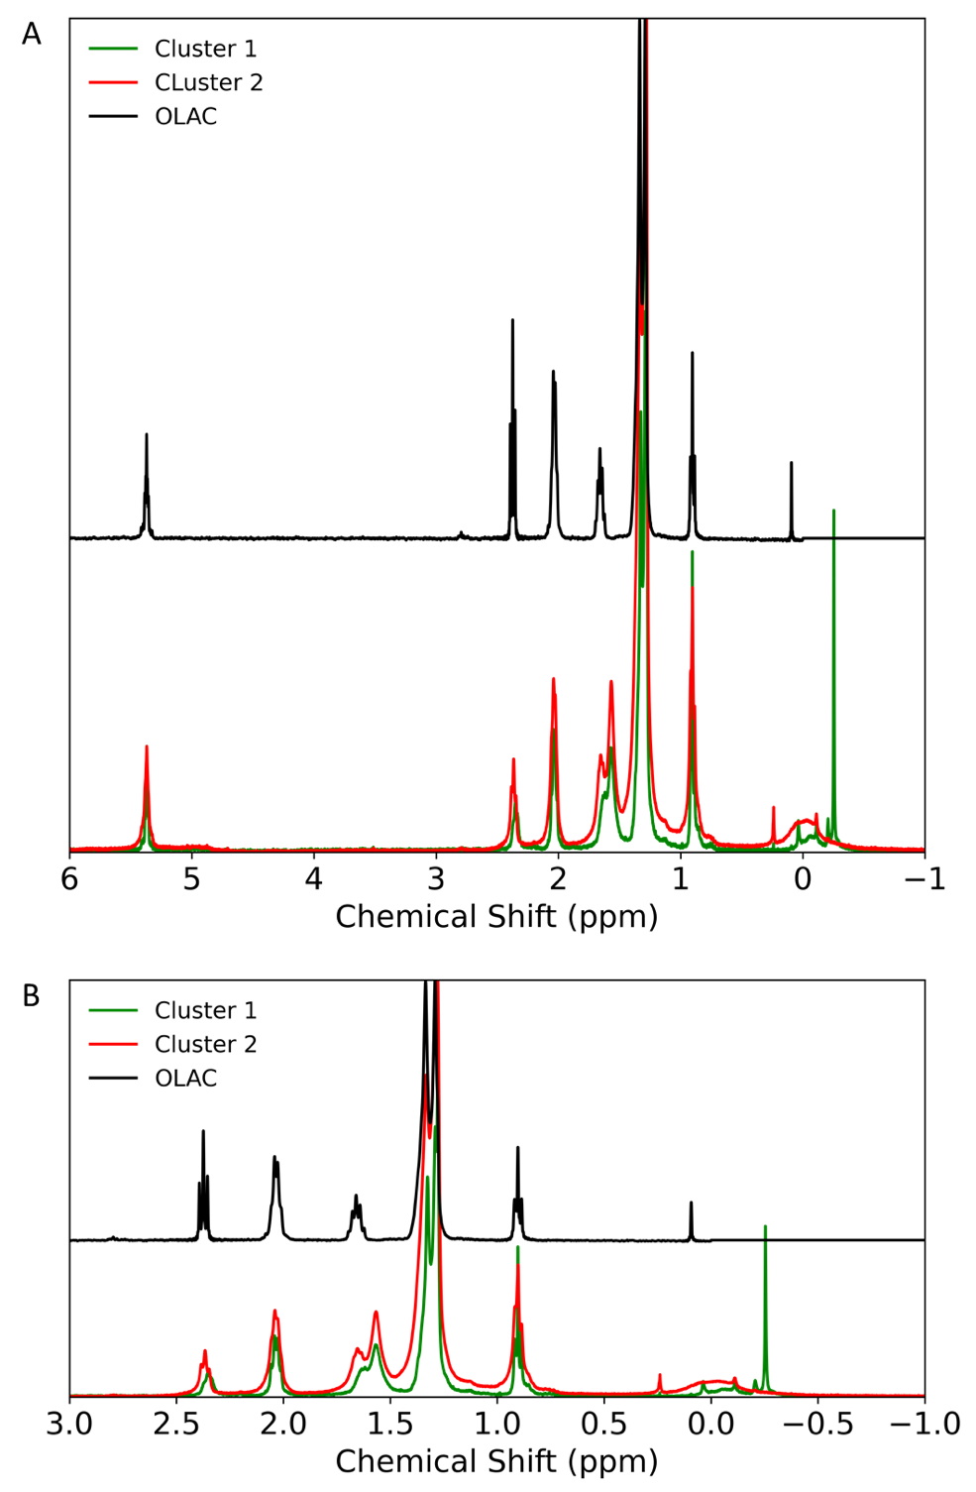
Supplementary Figure 31: ¹H NMR of the isolated byproducts obtained from a TM-Ga titration. A) We show two examples of the obtained byproduct (red and green) and contrast it to free oleic acid (black). B) Zoom into the showing the slightly broadened peaks and the large resonance around 0 ppm.

3.5 Metal amide precursors (TDMA-Ti and TDMA-Ga):
Titration of both precursors is noticeably different from the methyl precursors as two new resonances emerge with added equivalences of the precursor (Figure 1). These resonances are a broader ($\sim$30 Hz) resonance around 5.55 ppm and another with clear multiplicity and linewidths of $\sim$2 Hz (Supplementary Figure 19-22). DOSY revealed three distinct diffusion coefficients for the bound resonances at 5.7 ppm, the resonance at 5.55 ppm and the narrow resonances at 5.5 ppm (Supplementary Figure 32-33). VT-NMR does not reveal any interaction between that of the bound ligands and the resonances at 5 ppm, suggesting that these resonances arise from non-interacting molecules with the NC surface (Supplementary Figure 34-35). This result again suggests that the addition of these precursors results in a chemical reaction on the OLAC.
We isolated this specie and used NMR techniques to reveal its structure. The isolation was performed by precipitating the suspension and collecting the supernatant. ¹H NMR of this solution revealed clear differences with OLAC through the presence of two resonances at 3 and 2.85 ppm with each having an integration of 1.5 (3:2) with reference to the alkene resonance (Figure 1, Supplementary Figure 36-37). Then, a suite of experiments including HSQC, HMBC and TOCSY were employed and this species was identified as being oleamide (Supplementary Figure 38-40). HSQC revealed that both resonances at 3 and 2.85 are consistent with CH₃ units. HMBC confirms that these two resonances correlate with a carbonyl carbon of amides. Finally, TOCSY reveals through bond connectivity of these two resonances with a long carbon chain originally belonging to oleic acid. These measurements confirm the formation of dimethyl-oleamide.

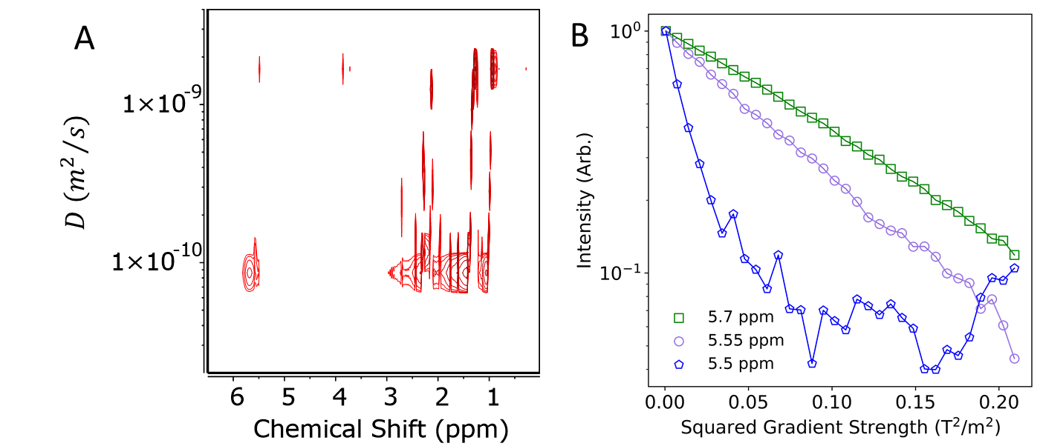
Supplementary Figure 32: DOSY of PbS NCs after the introduction of TDMA-Ti. A) 2D DOSY and B) extracted decay for the resonances at 5.5, 5.55 and 5.7 ppm. These results indicate the presence of at three distinct species. We calculated a solvodynamic diameter of 1.2, 5.2 and 7.2 nm for the 5.5, 5.55 and 5.7 ppm resonances, respectively.

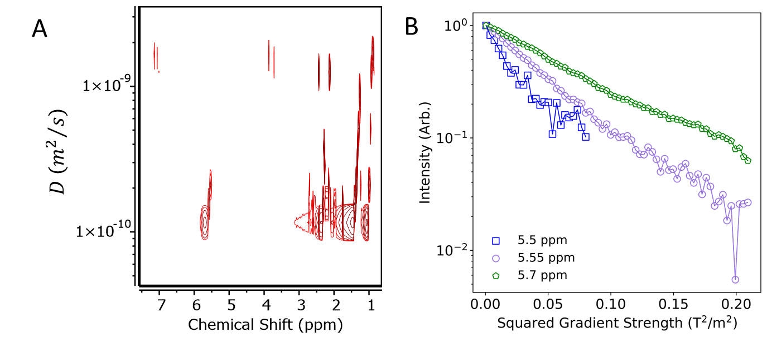
Supplementary Figure 33: DOSY of PbS NCs after the introduction of TDMA-Ga. A) 2D DOSY and B) extracted decay for the resonances at 5.5, 5.55 and 5.7 ppm. These results indicate the presence of at three distinct species. The extracted decay for the resoancne at 5.5 ppm is a convolution with the resonance at 5.55 ppm and therefore is not a reliable metric for the diffusion coefficient of this specie. We calculated a solvodynamic diameter of 5.8 nm and 3.1 nm for the resonances at 5.7 and 5.55 ppm, respectively.

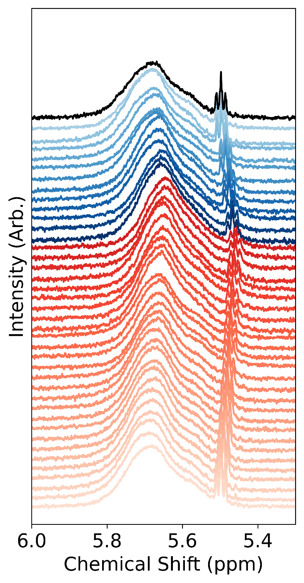
Supplementary Figure 34: VT-NMR of PbS NCs after the introduction of TDMA-Ti. Three resonances are initially observed at 5.7, 5.53 and 5.5 ppm. These are associated to bound oleates (5.7 ppm) and a byproduct of the interaction with TDMA-Ti (5.53 and 5.5 ppm). The resonance at 5.7 appears marginally affected upon heating to 70$℃$. No surface-based equilibrium is noticeable. The resonance at 5 ppm appears unaffected by temperature. While it is difficult to clearly assign the nature of these resonances, the VT-NMR experiment strongly suggest that the newly formed species as 5 ppm does not interact with the NCs core and is distinct to OLAC and lead oleate.

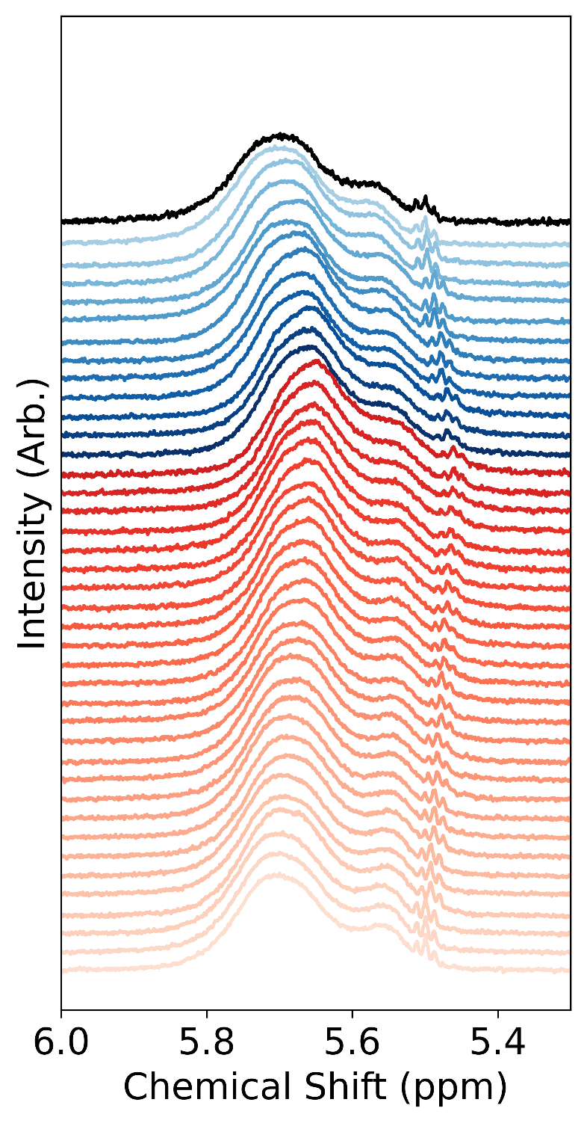
Supplementary Figure 35: VT-NMR of PbS NCs after the introduction of TDMA-Ga. Three resonances are initially observed at 5.7, 5.53 and 5.5 ppm. These are associated to bound oleates (5.7 ppm) and a byproduct of the interaction with TDMA-Ga (5.53 and 5.5 ppm). The resonance at 5.7 appears marginally affected upon heating to 70$℃$. No surface-based equilibrium is noticeable. The resonance at 5 ppm appears unaffected by temperature. While it is difficult to clearly assign the nature of these resonances, the VT-NMR experiment strongly suggest that the newly formed species as 5 ppm does not interact with the NCs core and is distinct to OLAC and lead oleate.

3.6 Structural Characterization of free species:
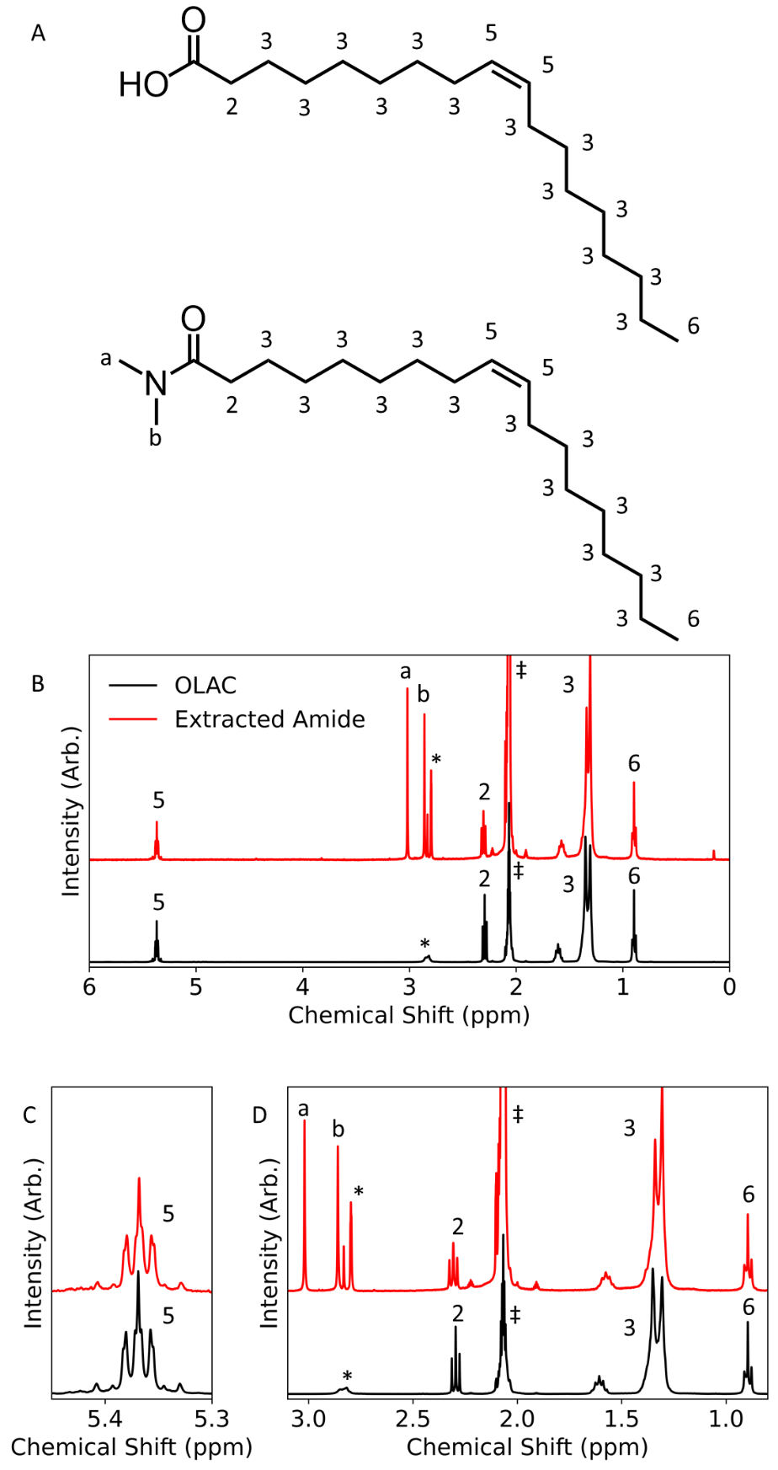
Supplementary Figure 36: (A) Structure of OLAC and the isolated dimethyl-oleamide obtained a TDMA-Ti titration and their corresponding (B) ¹H NMR in deuterated acetone. We identify dimethyl-oleamide from the resonances labeled a and b. The star (*) indicates H₂O and HDO, both are known impurities in deuterated acetone. These peaks are more defined for the dimethyl-oleamide samples as there is no proton for chemical exchange in contrast to OLAC. Zoom in of the alkene (C) and alkane (D) resonances. The alkene resonances are unchanged while the appearance of the peaks labelled a and b are clear indication of dimethyl-oleamide formation. The integration of these two peaks is consistent with dimethyl-oleamide as a ratio of 3:3:2 (a:b:5) with reference to the alkene resonance (peak labelled 5) is obtained.
Supplementary Figure 37: Proposed mechanism for the anchoring of metal amide precursors and the formation of dimethyl oleiamide on a bound oleate surface. TDMA-Ga is used as a representative example. First, a Lewis adduct is formed between the carbonyl of bound oleates and the precursors. Then an amidation reaction occurs through an amide transfer from the precursor to the carbonyl carbon. This eventually results in the release of dimethyl oleiamide and an anchored precursor.
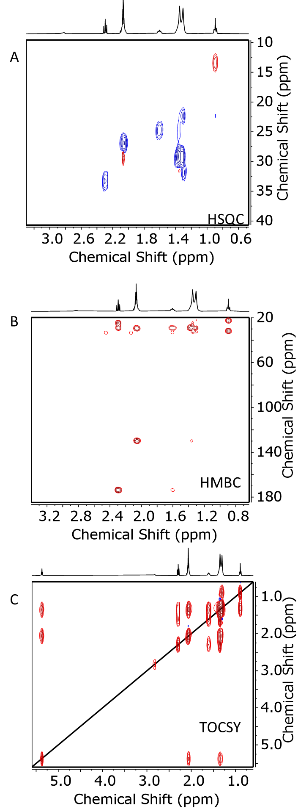
Supplementary Figure 38: 2D NMR characterization of OLAC in deuterated acetone. A) ¹H-{¹³C} HSQC, B) ¹H-{¹³C} HMBC and C) ¹H-{¹H} TOCSY of oleic acid.
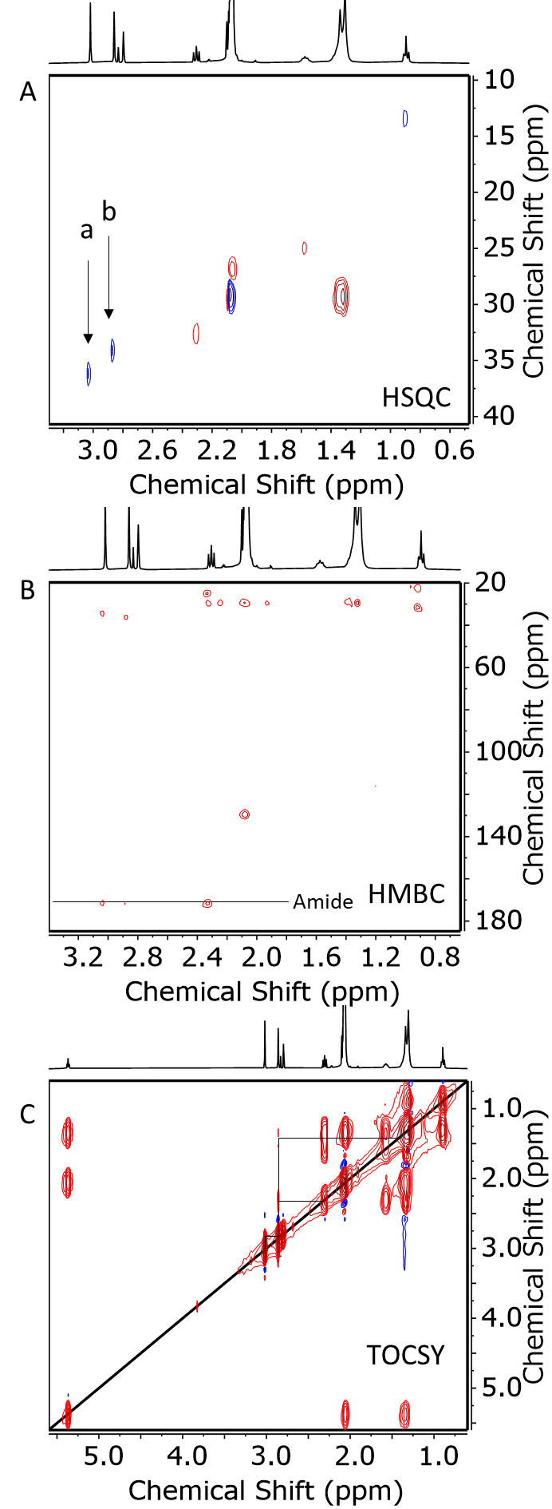
Supplementary Figure 39: 2D NMR characterization of the extracted free species during a titration of TDMA-Ti to PbS NCs. A) ¹H-{¹³C} HSQC, B) ¹H-{¹³C} HMBC and C) ¹H-{¹H} TOCSY of the extracted specie. ¹H-{¹³C} HSQC reveals two new peaks, a and b, labelled with an arrow not present in the ¹H-{¹³C} HSQC of oleic acid (Supplementary Figure 38). The sign of these peaks is the same as the terminal CH₃ protons suggesting that the resonances emanate from CH₃ protons, consistent with our integration. Similarly, ¹H-{¹³C} HMBC reveals that the same two resonance correlate with a carbonyl carbon of an amide (drawn line). Finally, ¹H-{¹H} TOCSY displays connectivity between the a and b proton with the main aliphatic chain. These data strongly suggest the formation of dimethyl-oleamide.

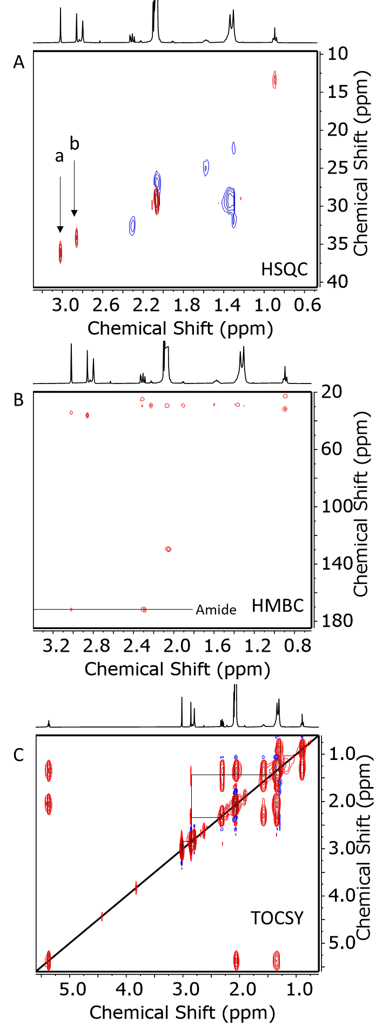
Supplementary Figure 40: 2D NMR characterization of the extracted free species during a titration of TDMA-Ga to PbS NCs. A) ¹H-{¹³C} HSQC, B) ¹H-{¹³C} HMBC and C) ¹H-{¹H} TOCSY of the extracted specie. The same observations as reported in Supplementary Figure 39 are observed here for TDMA-Ga.

Supplementary Note 1: Discussion on precursor reactivity
Herein, we discuss how the nature of the precursor might affect whether nucleation of the metal oxide preferentially occurs heterogeneously on the nanocrystal surface or homogenously as free aggregates. As mentioned previously, we take the fraction of released oleates as a metric for the reactivity of the precursor. In this regard we observe the following trend TM-Al$>$DM-Zn$≥$TM-Ga$<$TDMA-Ga$<$TDMA-Ti. Directly comparing the metal amide and alkyl metal precursors is convoluted due to the distinct interactions occurring with the surface oleates. For the metal amides, we consider the amount of produced dimethyl-oleiamide as the most appropriate metric as it directly correlates the number of anchored precursors accounting for the nucleation of the shell. For alkyl metal, we use the complete amount of displaced oleates as our metric as the chemical nature of the oleate-metal complexes responsible of nucleation remains undetermined.
We use Hard-Soft acid base theory as guiding principles to compare the reactivity of each precursor towards the surface oleates.³⁸ First, TM-Al is expected to be the hardest of the three alkyl-metal precursors as it is considered to be harder than DM-Zn and TM-Ga due to Al’s smaller size and high charge. Comparison between DM-Zn and TM-Ga is subtler as the metal differs both in size and charge state. Our experiments suggest that DM-Zn is slightly more prone to interact with bound oleates.
Then considering the methyl or dimethyl-amide (DMA) ligands we consider that the harder nature of DMA has the net consequence of hardening the precursor. The comparison between TM-Ga and TDMA-Ga suggest that the metal precursors are more reactive when bearing DMA instead of methyls, which we explain by the harder character of the dimethyl-amide compared to the methyl group. Finally, the larger generation of dimethyl-oleiamide with TDMA-Ti compared TDMA-Ga matches well the harder nature of TDMA-Ti.
We consider these trends to be important in predicting whether a precursor is suitable for the growth of metal oxide shells on oleate surfaces.
Our data evidences that precursors with a softer Lewis character (e.g. TM-Ga) are not reactive enough with the surface oleates, in contrast precursors with a harder Lewis character interact favorably with the bound oleates and should form a metal oxide shell in the presence of an appropriate reaction enabling the anchoring of the metal precursor and the nucleation of such a shell.

Section 4: Colloidal Atomic Layer Deposition of hybrid oxide shells

4.1 Procedure:
The procedure follows the same guidelines as in our previous work.³⁹ The procedure is repeated here for convenience.
All stock precursor solutions are prepared in anhydrous octane in a nitrogen filled glovebox. For all precursors, any equipment used to handle them was quenched through dilution with hexane (500x the volume) followed by the addition of isopropanol after use. This step releases methane or dimehtylamine in the glovebox. Extreme care was taken while manipulating all precursor solutions as they are highly pyrophoric. DM-Zn was prepared by diluting a 1.2M solution in toluene. TDMA-Ga is a solid, it was weighed in a nitrogen glovebox and then dissolved in octane.
All solution employed for c-ALD were prepared by mixing the stock precursor solution with anhydrous octane to yield a 20mM solution. A 2.5mM solution was used for the titanium precursor (TDMA-Ti) and 10 mM for TDMA-Ga as more concentrated solutions tended to clog syringes. This solution was then transferred to a gas tight syringe (S.G.E. Gas Tight Luer Lock Syringe 5mL) with a stainless steel 304 syringe from Sigma Aldrich. The syringe was purged with nitrogen before introducing the precursors.
From a nitrogen filled glovebox a 3mL solution of $\sim$34 µM NC in anhydrous octane was prepared from the stock NC solution. This solution was then transferred to a three-neck flask that had been previously purged with nitrogen. The nitrogen was supplied through a three-way valve to ensure the constant renewal of nitrogen and replacement of the introduced O₂ and generated methane or dimethyl amine. The solution was constantly stirred at room temperature for the duration of the experiment.
The general procedure for the growth of the metal oxide shell was performed as follows but can be modified to include more or less equivalences of precursor per cycle. Each precursor additions involved the injection of 50µL (400µL for TDMA-Ti, 100µL for TDMA-Ga) of the precursor solution at a rate of 1mL/hr using a syringe pump (Chemyx Fusion 200 two-channel injection pump). The precursor injection was then followed either by the bubbling of O₂ or the introduction of ligands. The bubbling of O₂ was performed using a mass flow controller at a rate of 1.5 mL/min for 2 min.
OLAC was introduced using a purged needle and directly injected into the three-neck flask. This step was performed after every five cycles. After each step, whether precursor, O₂ or ligands was introduced a minimum 5-minute delay was performed.
After the desired number of cycles, the solution was dried under a constant flow of nitrogen and the NCs were redispersed in the desired anhydrous solvent such as deuterated toluene or octane and stored in a nitrogen filled glovebox.
The gas tight syringe was then washed by flowing 15 mL of anhydrous hexanes to avoid alumina formation and clogging of the syringe. The syringe was then placed in a 60$℃$ oven. If alumina deposits are observed, the syringe was washed with a 1M HCl solution. The syringe was then thoroughly rinsed and stored in the oven.

Additional Notes:
Note: The addition of excess precursor results in the precipitation of the NCs. It was thus useful for us to initially titrate the NC solutions with each precursor until precipitation was visibly observed. We employed a fraction of this amount in each cycle of the growth process using this c-ALD method.
Note: To verify if the growth occurs, we found it helpful to extract aliquots of the solution and to take an FTIR spectrum. If the four bands discussed highlighted in Supplementary Figure 41 were present, we expected the successful growth of a metal oxide shell. These bands can usually be observed after 2 cycles. If the bands were not present, we suspected either the precursor was quenched or growth of a shell was incompatible with the NC surface chemistry.
Note: All glassware was kept at 110$℃$ for at least two hours before c-ALD due to the high sensitivity of all precursors to air and water

4.2 Characterization:

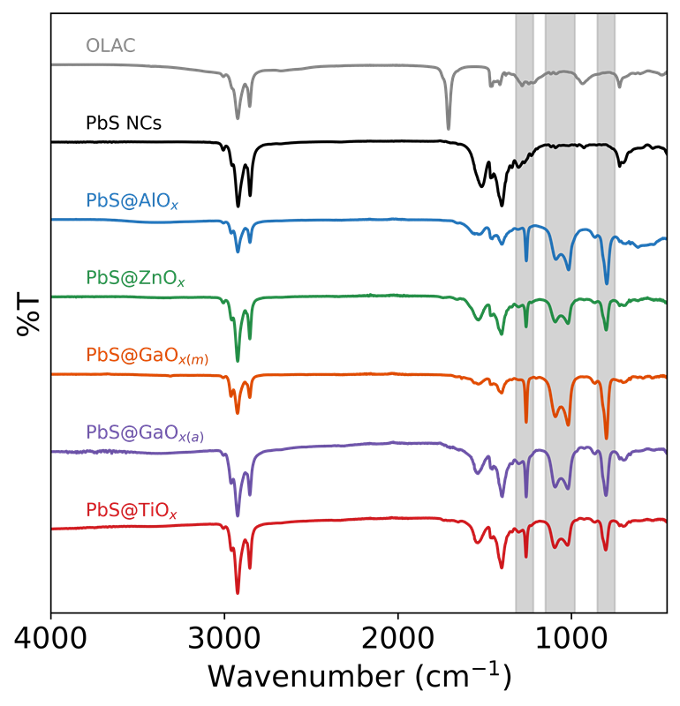
Supplementary Figure 41: FT-IR spectrum of all PbS NCs having undergone four cycles of metal oxide growth. We observe for all precursors the four expected bands (highlighted in grey) for the growth of the metal oxides at 1260,1094, 1023 and 801 cm⁻¹.⁴⁰

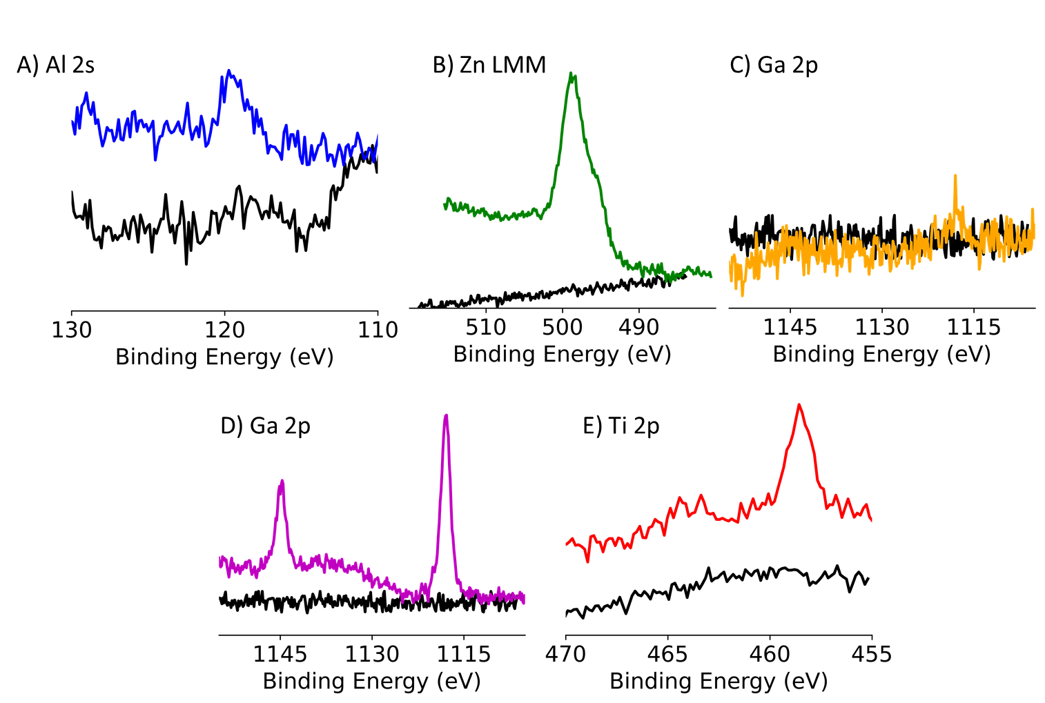
Supplementary Figure 42: XPS of the metal oxide coated PbS NCs. A) Al 2s of PbS coated by aluminium oxide grown by TM-Al, B) Zn LMM of PbS coated by zinc oxide grown by DM-Zn, C) Ga 2p of PbS coated by gallium oxide grown by TM-Ga, E) Ga 2p of PbS coated by gallium oxide grown by TDMA-Ga and E) Ti 2p of PbS coated by titanium oxide grown by TDMA-Ti.
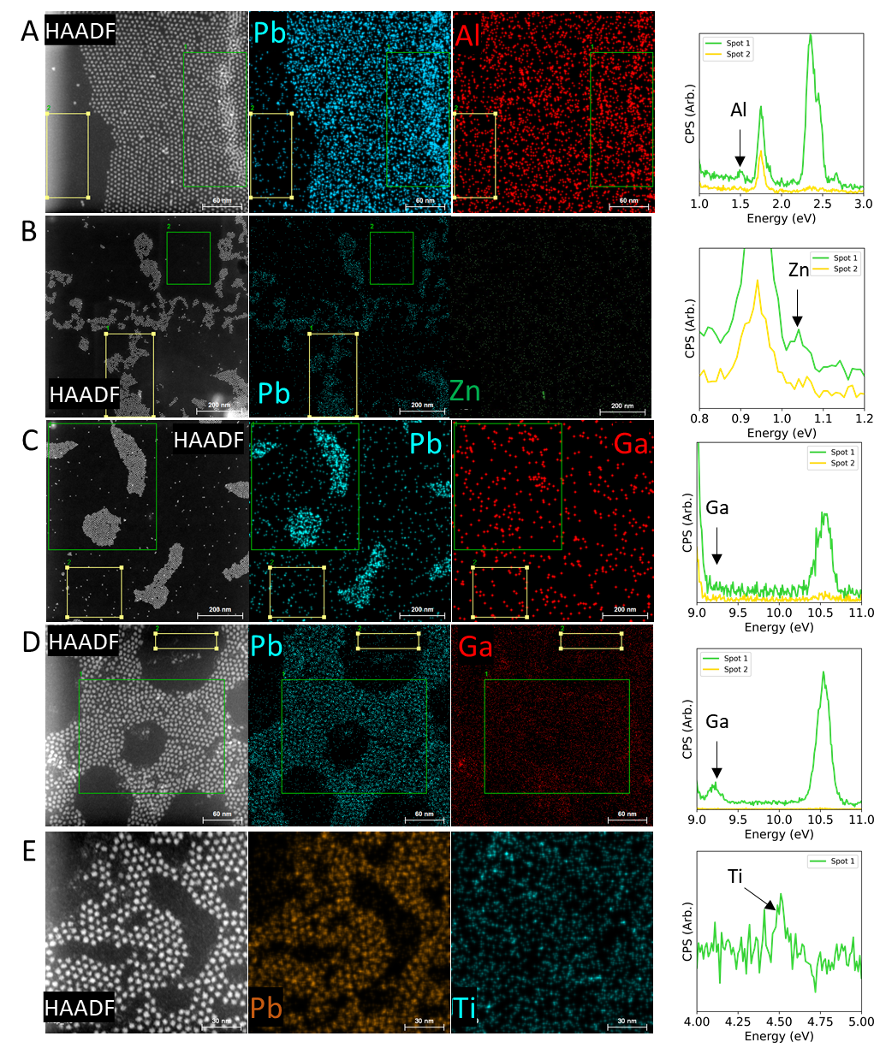
Supplementary Figure 43: HAADF STEM and EDX maps of PbS NCs coated by a metal oxide. HAADF-STEM, EDX elemental maps (Pb and metal oxide) and spectra of PbS NCs coated by a metal oxide using A) TM-Al, B) DM-Zn, C) TM-Ga, D) TDMA-Ga and E) TDMA-Ti.

In order to grow shells with TM-Ga we took inspiration from gas-phase ALD on polymers. In these studies, the low interaction strength of TM-Ga with carbonyls prevents efficient film growth.^{41–44} Consequently, researchers have sought to modify the polymer to mimic surfaces used for ALD on solid state inorganic substrates which are often covered by hydroxyl. The presence of hydroxyls allows for TM-G to readily react as a Bronsted acid with Bronsted base hydroxyls.⁴⁵ This can be achieved by growing an initial layer of alumina. Therefore, we form alumina shells PbS NCs using strongly interacting TM-Al. This step was then followed by four c-ALD cycles using TM-Ga. In contrast, to samples where TM-Ga only was used a strong signal for gallium is observed by XPS (Supplementary Figure 44). Further HAADF-STEM with EDX clearly indicated spatial colocalization of the NC, Al and Ga (Supplementary Figure 45). Thus, the growth of an initial layer of alumina effectively promotes the growth of gallium oxide with TM-Ga.

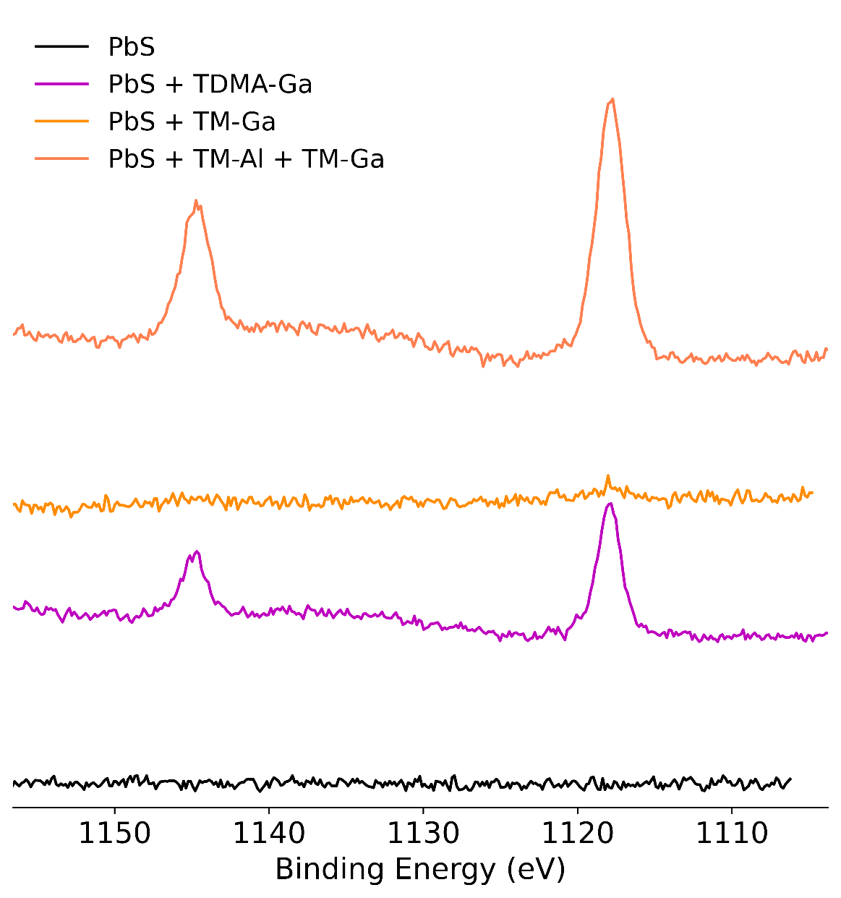
Supplementary Figure 44: Ga 2p XPS of PbS NCs (black), with a gallium oxide grown from TDMA-Ga (purple), from TM-Ga (yellow) and from first using TM-Al then TM-Ga (orange).
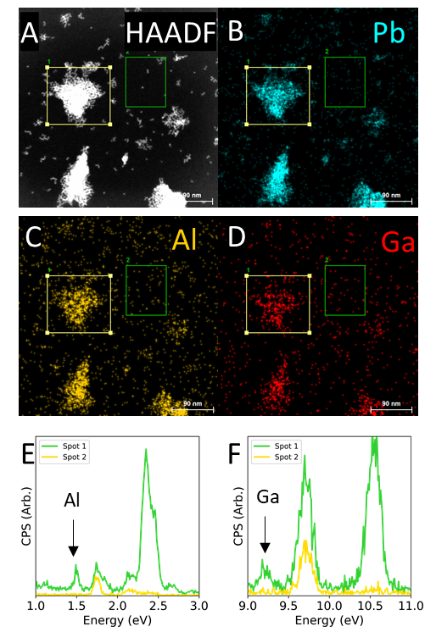
Supplementary Figure 45: A) Representative HAADF-STEM image of PbS NCs having first undergone three cycles of TM-Al/O₂ and then four cycles of TM-Ga/O₂ forming PbS@AlO_{x}@GaO_{x}. EDX colored maps of Pb (B), Al (C) and Ga (D) revealing spatial colocalization of all three elements. E and F) EDX spectra of two representative areas with (1) and without (2) NCs. E) reveals the presence of Al only where there are NC and F) reveals the same for Ga.

Section 5: Metal-amide based c-ALD for fully inorganic oxide shells

5.1 Procedure:
Transamination: The transamidation reactions are performed in a nitrogen filled glove box. In brief, we use a 1:1 molar ratio of the precursor (TDMA-Ga or TDMA-Ti) and didodecylamine. These ratios are selected to avoid over transamination as the latter results in deactivation of the precursor due to steric hindrance. Both the precursor and didodecylamine are mixed in either octane or toluene-d8 and heated at 110$℃$ for one hour. The solution is then left to cool and is used as obtained for the growth of the shell. Typically, a 20mM solution of the precursor is prepared, but concentration up to 110 mM were also tested. The byproduct of the transamidation is the evolution of volatile dimethylamine. For TDMA-Ga, these concentrations are in terms of gallium atoms and not the as purchased gallium dimer.
Concentration of ligands: The ligand concentration in a solution of NCs was calculated by ¹H NMR using dibromomethane as a standard and a relaxation delay of 90 seconds. Bound ligand concentration ranged from 12.5 uM to 90 mM for the stock NC solutions.
Metal-amide based c-ALD: c-ALD is performed in a nitrogen filled glovebox. A solution of NCs is prepared in a 20 mL scintillation vial and constantly stirred. Then, the transamidated precursor is rapidly injected into the solution such that the bound ligand to precursor ratio is 1:1. The reaction is left to stir for 15 minutes and then heated at 70$℃$ for another 15 minutes. Then, oleic acid is injected in a 1:1 ratio with the previously added precursor. The solution is left to stir for another 15 minutes. This step completes the first cycle and results in the growth of the first layer of metal oxide. Repeating these steps results in the growth of an additional layer after each cycle.
Example for PbS cubes: The concentration of ligands in a stock PbS cube solution was estimated to be 88.5mM. 0.5mL of this solution was dissolved in 4.5mL octane. The precursor was prepared by mixing 135mg of TDMA-Ga and 0.236g of didodecylamine and heating at 110$℃$ for an hour. This operation results in a precursor concentration of about 110mM. Then 0.4mL of the precursors was rapidly added to the PbS nanocube solution resulting in a 1:1 solution of both the precursor and bound ligands. If the transamidation is well performed, no precipitates should form. This solution was left to stir for 15 min at room temperature and then heated to 70$℃$ for 15 more minutes. Then, 0.4 ml of a 110mM solution of oleic acid was rapidly injected and the solution was left to stir for 15 minutes. The sum of these steps concludes the first cycle. To continue the growth, the steps concerning the injection of precursor and oleic acid were performed until the desired number of cycles is obtained.

Supplementary Note 2: Synthetic details
2.1 We confirm the presence of alkyl amides by characterizing the byproduct. However, we only isolate dimethyl oleamide and not didodecyl oleamide. Consequently, we postulate that the steric bulk of the solubilizing didodecyl amide does not allow for an amide transfer to the bound oleates. Therefore, partial transamidation of the precursor is needed to assure that the precursor remains highly reactive towards the NC surface while preserving the colloidal stability of the NCs.
2.2 Exposing a NC ensemble to air when the last performed step is the addition of the transamidated precursor results in the precipitation of the NCs. This precipitation is expected as any moisture will remove the solubilizing didodecylamides. Thus, it is beneficial to add an excess oleic acid to fully quench any residual bound amides in the last step of the c-ALD process.
2.3 When drying or purifying highly concentrated samples that have undergone more than 5 cycles a viscous gel is obtained. This gel is likely due to the production of a large excess of dimethyl-oleamide and didodecylamine at each cycle. It might be advantageous to purify the sample at every 2 or 3 cycles to avoid the buildup of these molecules.
2.4 We elected to use didodecylamine for the transamidation, instead of the more commonly employed oleylamine for several reasons. i) The alkene resonance of oleylamine would convolute our NMR experiments. ii) Primary amines, such as oleylamine, are known to be good Z-type ligand displacers¹⁸ whereas secondary amines are not. This consideration is important as displaced Z-type lead oleate could result in the heterogenous nucleation of gallium oxide. iii) Didodecylamine is likely to interact less with the NCs surface and thus not interfere with c-ALD.
2.4 We consider that our c-ALD protocol is fully compatible with the presence of surface hydroxyls. The chosen precursors are known to anchor on the surface in gas phase ALD through a protic exchange with hydroxyls. The anchored precursor should be structurally indistinguishable from those anchored through bound oleates. Further, since our process involves the addition of colloidally solubilizing precursors, c-ALD on hydroxyls will increase the density of ligands per NC. This effect can be greatly useful in solubilizing NC compositions that are poorly colloidally stable due to a low oleate density and/or high hydroxyl coverage.
2.5 In contrast to the previous form of c-ALD the addition of excess precursor does not result in the precipitation of the NCs. Indeed, arbitrary amounts can be added and excess precursor were seen to remain unreacted.

5.2 Tracking the growth:

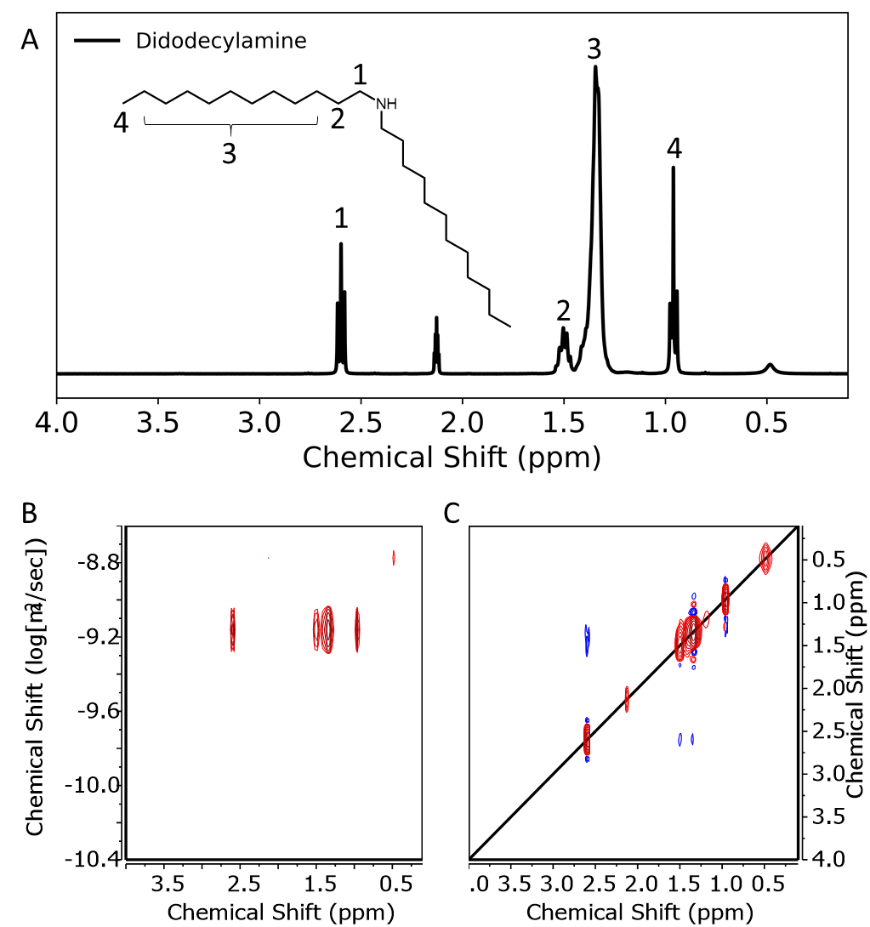
Supplementary Figure 46: NMR characterization of didodecylamine. A) Structure of didodecylamine with labelled numbers indicating the proton resonances found in the ¹H NMR spectrum. B) DOSY reveals a diffusion coefficient of 7.3x10⁻¹⁰ m²/s corresponding to a solvodynamic radius of approximately 1 nm. C) NOESY reveals cross diagonal peaks with sign opposite to the diagonal indicating though space interactions.

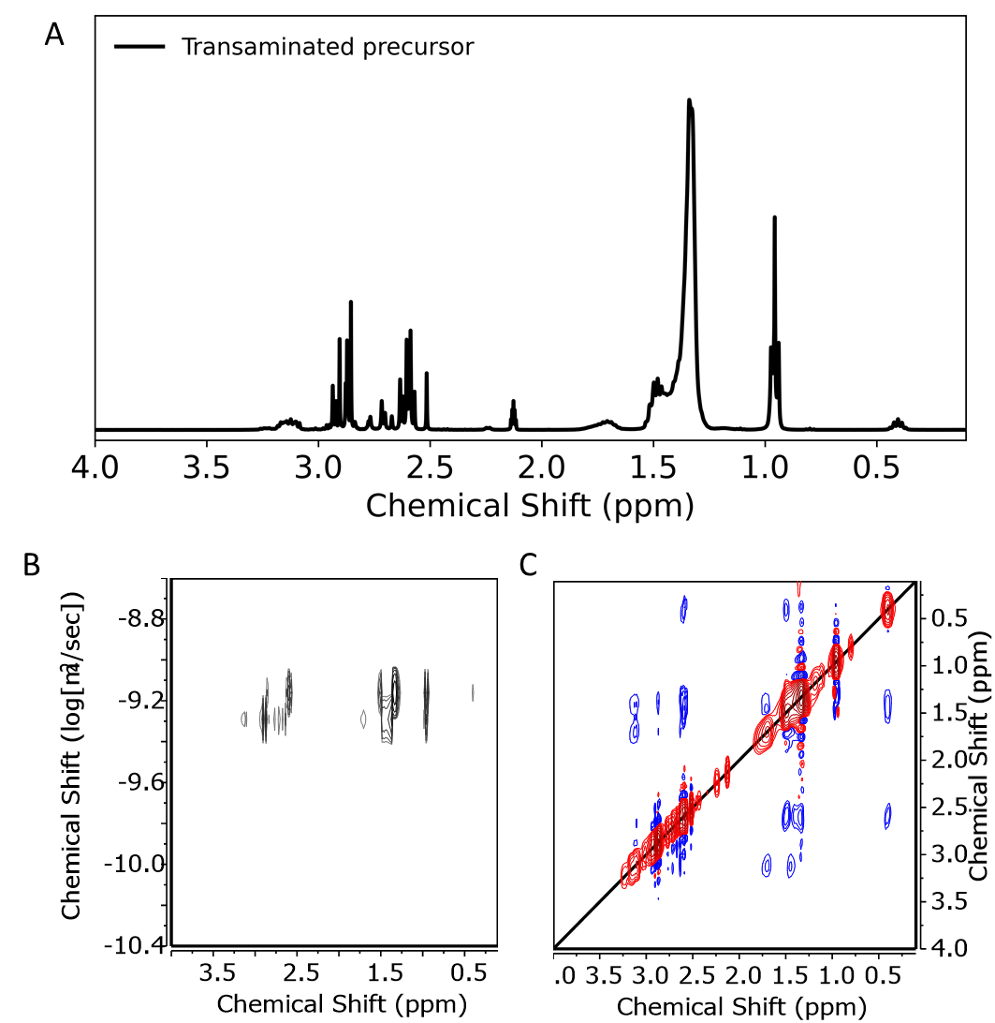
Supplementary Figure 47: A) Upon transamination of TDMA-Ga with didodecylamine several new resonances emerge in the ¹H NMR spectrum associated with gallium didodecylamide. B) DOSY reveals a distribution of diffusion coefficients ranging from 3.5x10⁻¹⁰ m²/s to 10.0x10⁻¹⁰ m²/s corresponding to solvodynamic diameters between 1.8 and 0.6 nm indicative of a distribution in the extent of transamination. C) NOESY reveals additional cross diagonal peaks compared to didodecylamine (Supplementary Figure 46) confirming through space interactions and the formation of transaminated species.

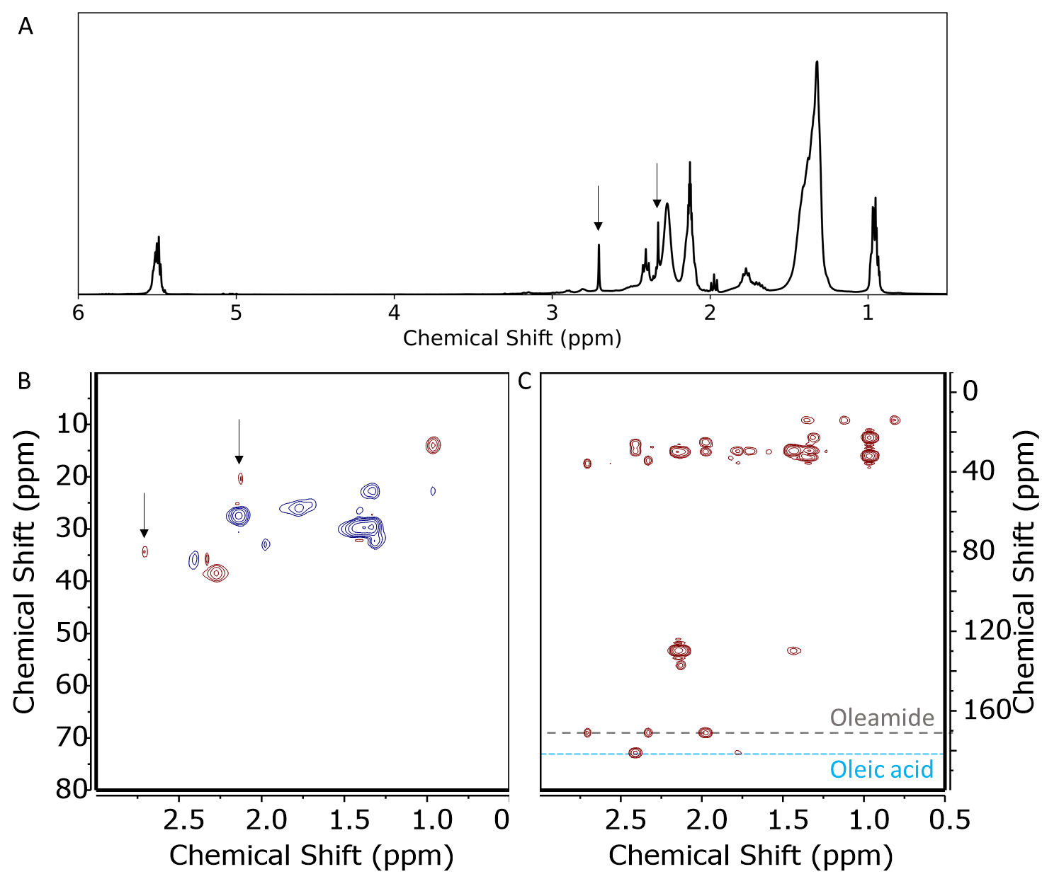
Supplementary Figure 48: NMR characterization of a TDMA-Ga OLAC mixture. A) ¹H NMR spectrum of the mixture, showing the two characteristic peaks of dimethyl-oleiamide (indicated by arrows and labelled a and b in Supplementary Figure 36). A broadening of the oleate resonances are also observed, suggesting the formation of gallium oxide clusters. B) HSQC and C) HMBC are further confirming the formation of dimethyl-oleamide as consistent with Supplementary Figure 39.

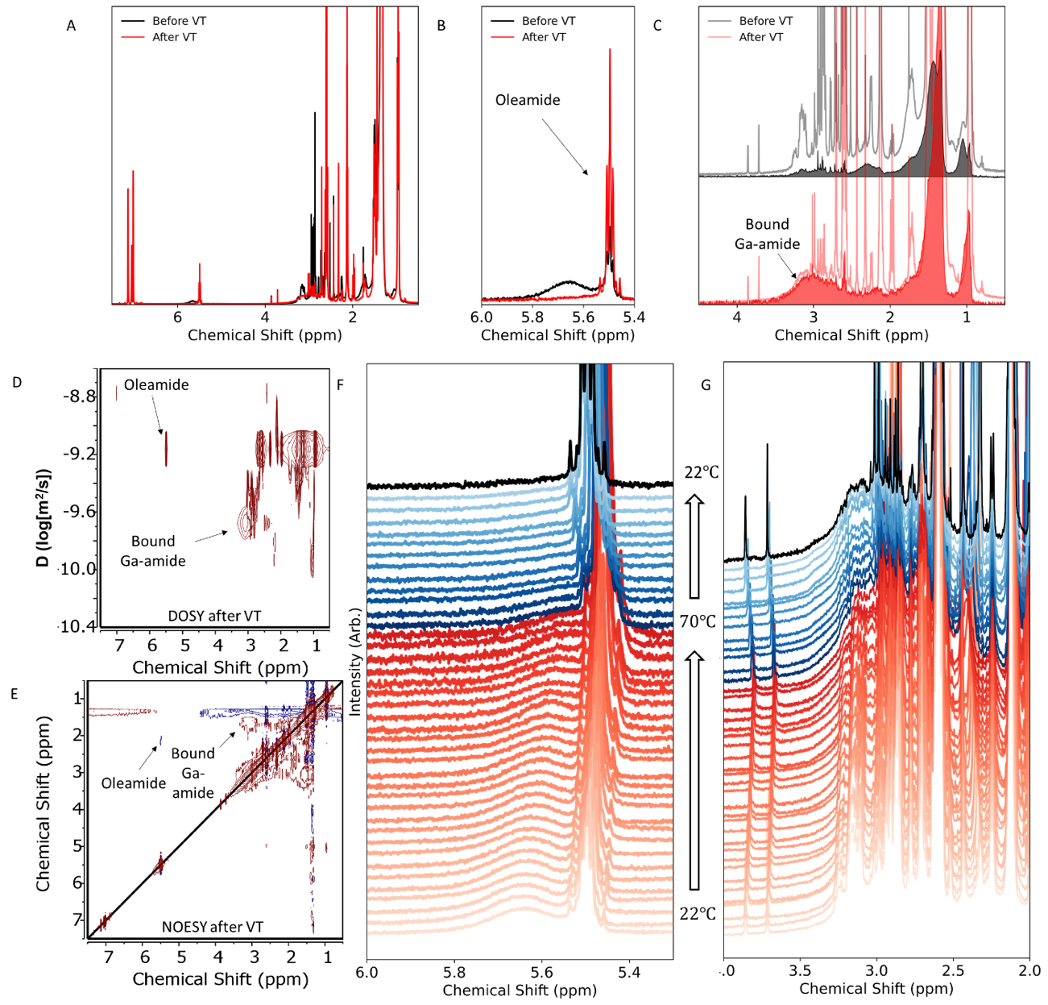
Supplementary Figure 49: Probing the 1st half reaction (n=0.5) using transamidated TDMA-Ga on PbS NCs probed by NMR. A) Full ¹H NMR of a 1:1 mixture of transamidated TDMA-Ga and bound oleates on PbS NCs. The black curve represents the sample after the addition of the precursor and the red curve represents the same sample after undergoing a VT-NMR experiment which involved heating the sample up to 70$℃$. B) Zooming in on the alkene protons, we can see that the simple addition of the precursor results in the partial conversion of the bound oleates to free dimethyl-oleiamide (black). After heating (red), full conversion of the bound oleates is observed. C) Concurrent with the formation of dimethyl-oleiamide, a new resonance emerges, which is associated with bound gallium-amides (anchored precursor). The sample before (pale grey) and after (light red) heating is reported. We superimposed a diffusion filtered spectrum as the black and red curves. The diffusion filtered spectrum highlight the emergence of bound gallium amides through the growth of the resonance around 3 ppm. D) 2D DOSY of the sample after heating. The resonance associated with dimethyl-oleiamide arises from a species that is freely diffusing. Further, the resonance associated with bound gallium-amide diffuses as part of a lager entity, suggesting the gallium amide is bound to the surface of the NC. E) 2D NOESY of the sample after heating, showing the resonance associated with dimethyl-oleiamide having a sign opposite to the diagonal and the resonance associated with bound gallium amide having the same sign as the diagonal. F) and G) VT NMR experiment going from 22$℃$ to 70$℃$ and then back to 22$℃$. F) Zooming in on the alkene resonance, full conversion of bound oleates to dimethyl-oleiamide is observed around 70$℃$. Concurrently, a broad resonance at 3 ppm associated to bound gallium amide emerges at 70$℃ (G).$ These experiments suggest the full replacement of bound oleate ligands on the surface of PbS NCs by gallium amides. This full substitution results in the positioning on the surface of the first Ga-O bond.

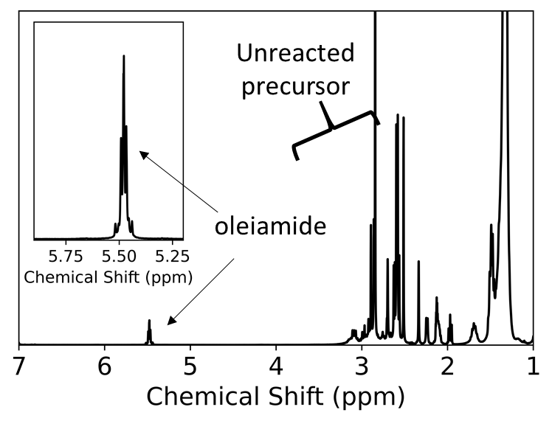
Supplementary Figure 50: Addition of a large excess of transamidated TDMA-Ga. We observe full conversion of the bound oleate to free dimethyl oleiamide. Further unreacted precursor remain as evidences by the multiple resonance around 3 ppm. This suggest the the process is self-limited and no more then one layer can be grown per cycle.

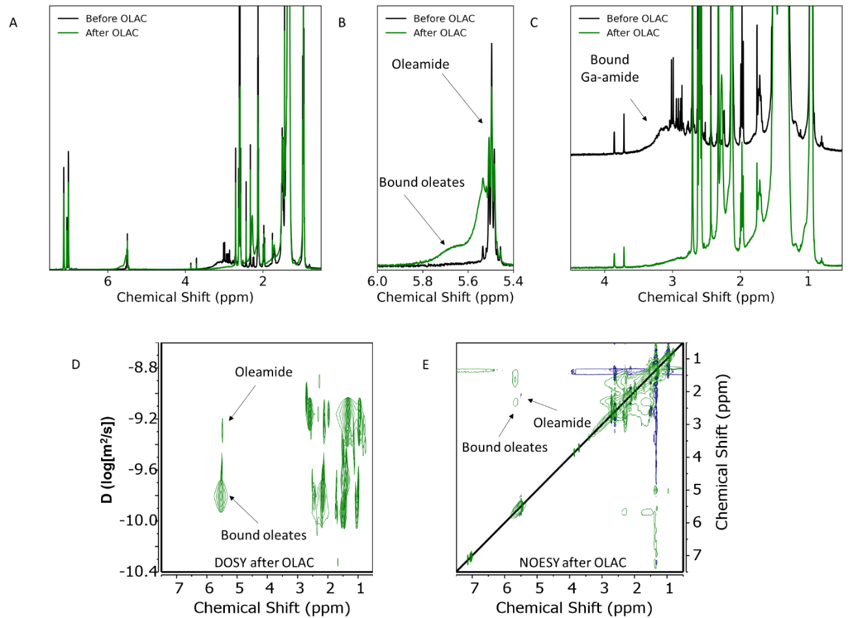
Supplementary Figure 51: Probing the 2nd half reaction (n=1.0) using oleic acid probed by NMR (following the step introduced in Supplementary Figure 49). A) Full ¹H NMR before (black) and after (green) the introduction of oleic acid to the sample passivated by gallium-amide. B) Zooming in on the alkene protons we see that the addition of oleic acid restores a bound oleate contribution (green). C) Concurrently, the resonance associated with bound gallium-amides (anchored precursor) disappears, likely forming bound gallium-oleates. D) 2D DOSY of the sample after adding oleic acid. The resonance associated with dimethyl-oleiamide remains associated to a freely diffusing species. Further, the resonance associated with bound oleates diffuses as part of a lager entity, suggesting the oleate is bound to the surface of the NC. E) 2D NOESY of the sample after adding oleic acid, showing the resonance associated with dimethyl-oleamide having a sign opposite to the diagonal and the resonance associated with bound oleates having the same sign as the diagonal. In both D and E, no signatures of bound gallium amides were detected. These experiments suggest the full replacement of bound gallium-amides on the surface of PbS NCs by the release of secondary amines to form bound gallium-oleates.

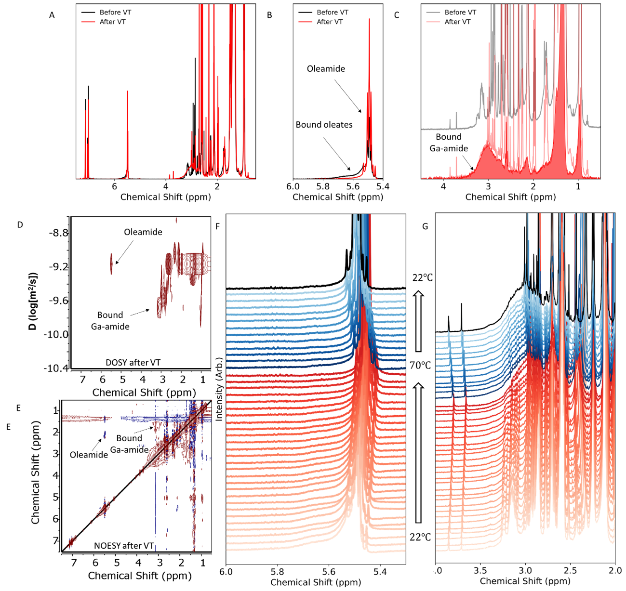
Supplementary Figure 52: Probing the second 1st half reaction (n=1.5) using transamidated TDMA-Ga on PbS NCs probed by NMR. The observations herein are the same as those reported in Supplementary Figure 49, but result in the formation of a second Ga-O bond.

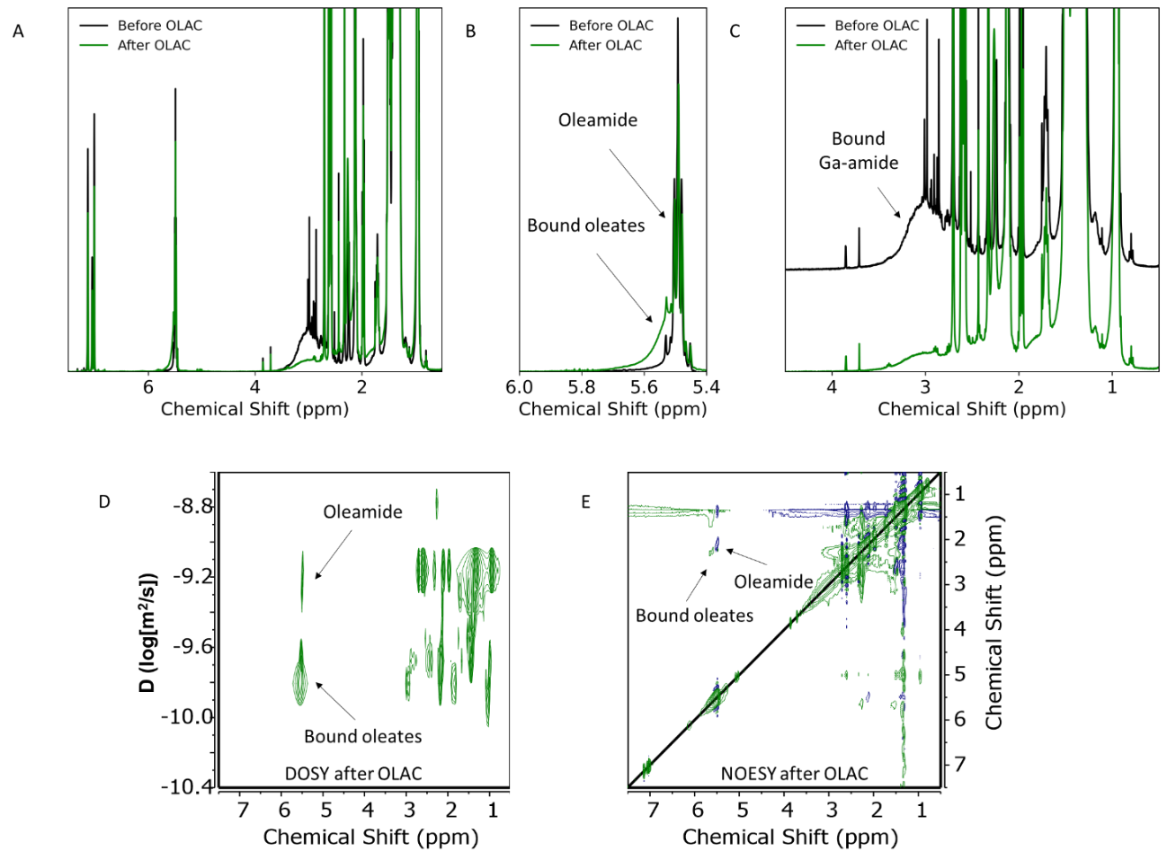Supplementary Figure 53: Probing the second 2nd half reaction (n=2.0) using oleic acid probed by NMR. The observations herein are the same as those reported in Supplementary Figure 51.

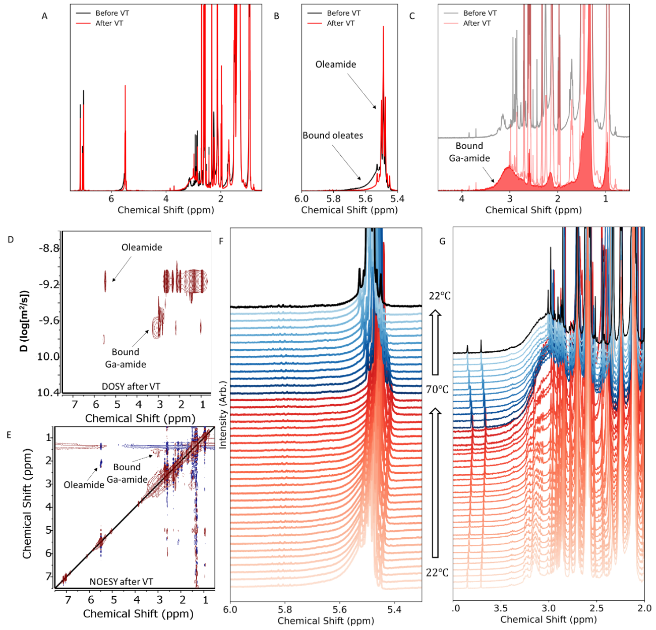
Supplementary Figure 54: Probing the third 1st half reaction (n=2.5) using transamidated TDMA-Ga on PbS NCs probed by NMR. The observations herein are the same as those reported in Supplementary Figure 49, but result in the formation of a third Ga-O bond.

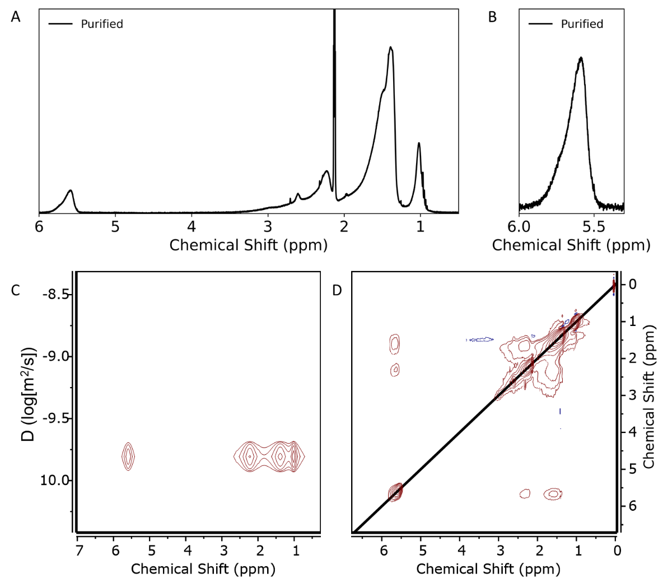
Supplementary Figure 55: Purified PbS NCs after three cycles of c-ALD to grow a gallium oxide shell using transamidated TDMA-Ga and oleic acid. A) Full ¹H NMR and B) zoom in on the alkene protons showing bound oleates. The resonance is asymmetric with a maximum around 5.6 ppm, whereas native PbS NCs have the alkene resonance maximum around 5.7 ppm. Such a shift and asymmetry have been observed in metal-oxide nanoparticles.²³ C) DOSY of the purified sample displaying a single diffusion coefficient and D) 2D NOESY showing negative cross peaks.

5.3 Characterization:

EDX maps:
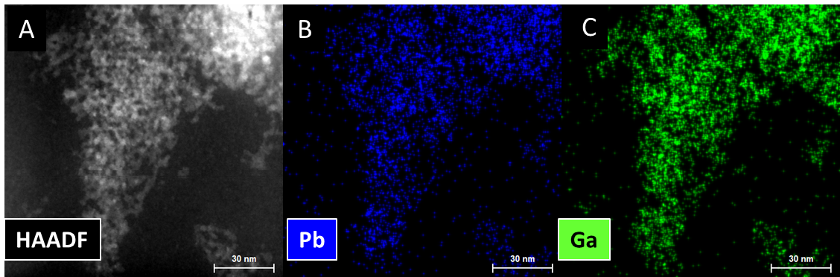
Supplementary Figure 56: A) HAADF-STEM images of PbS NCs with a gallium oxide shell. EDX map of Pb (B) and Ga (C), showing spatial colocalization.
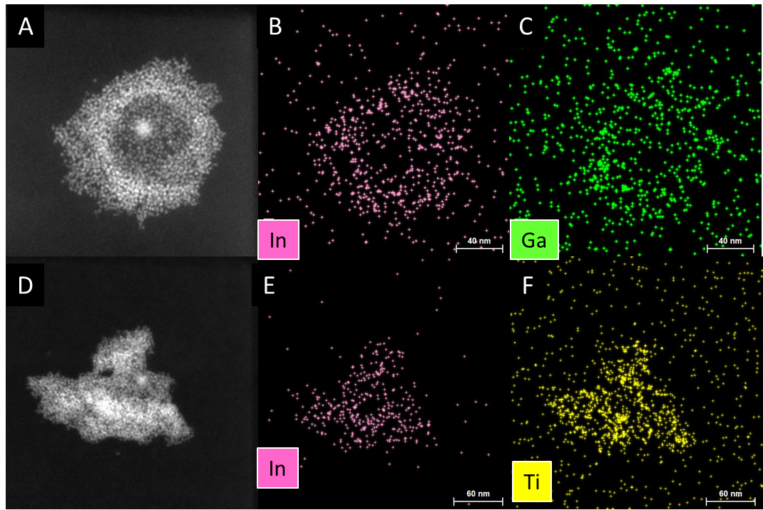
Supplementary Figure 57: HAADF-STEM images of InP NCs with a gallium (A) or titanium (D) oxide shell. EDX map of In (B) and Ga (C), showing spatial colocalization and the formation of gallium oxide shelled InP NCs. EDX map of In (E) and Ti (F), showing spatial colocalization and the formation of titanium oxide shelled InP NCs.

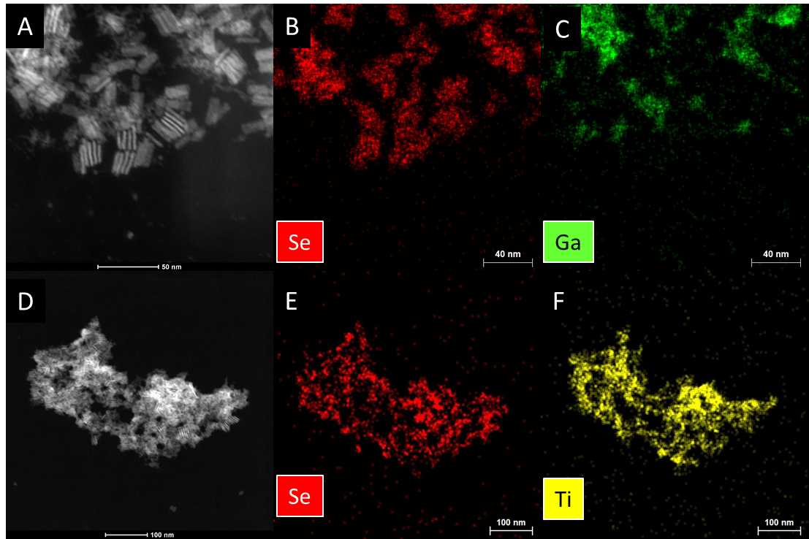
Supplementary Figure 58: HAADF-STEM images of CdSe NPLs with a gallium (A) or titanium (D) oxide shell. EDX map of Cd (B) and Ga (C) and EDX map of Cd (E) and Ti (F). The spatial colocalization of the metal oxide and CdSe NPLs does not appears to exactly correlate, despite the metal oxide only being found in proximity to the NPLs. This observation might suggest that the metal-oxide grows in a core-crown manner.
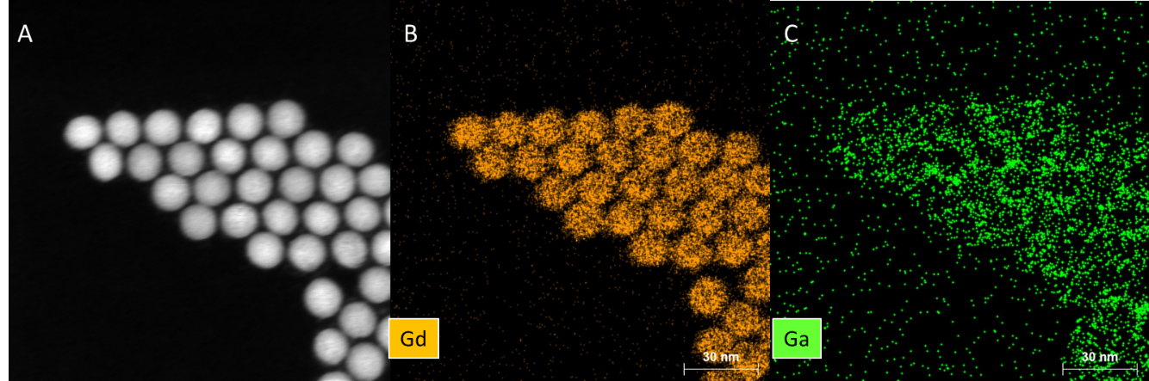
Supplementary Figure 59: A) HAADF-STEM images of NaGdF₄ NCs with a gallium oxide shell. EDX map of Gd (B) and Ga (C), showing spatial colocalization.

Optical properties:
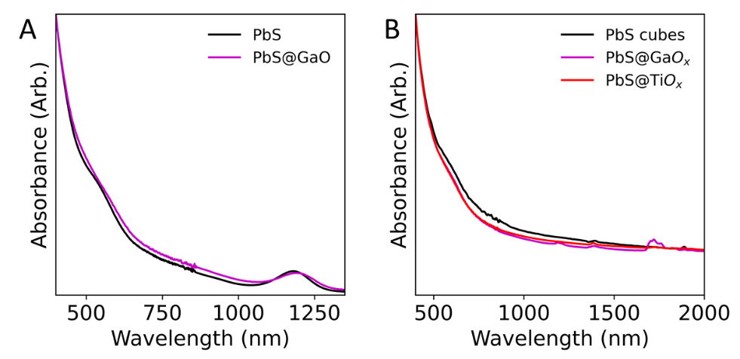
Supplementary Figure 60: Optical absorption of A) PbS NCs and B) PbS nanocubes before and after shelling. No significant differences are observed after 10 cycles.
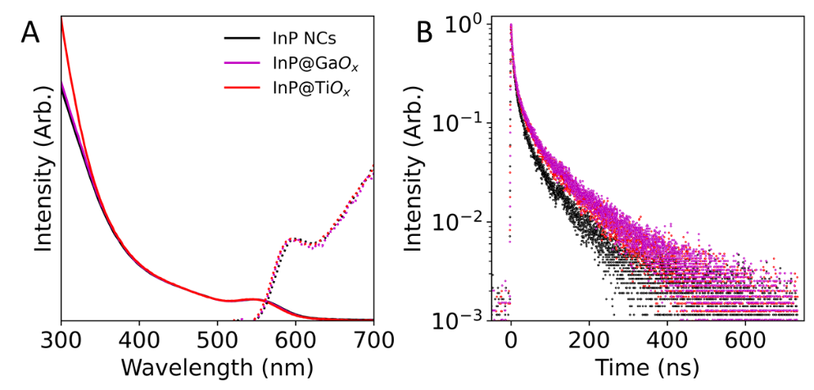
Supplementary Figure 61: A) Optical absorption and photoluminescence and B) time resolved photoluminescence of InP NCs before and after shelling. No significant differences are observed after 10 cycles.
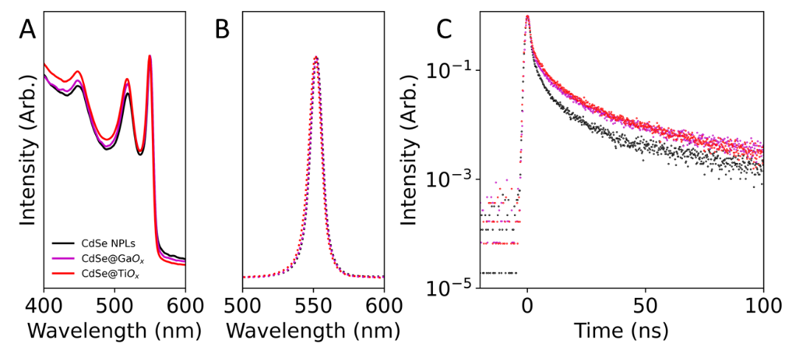
Supplementary Figure 62: A) Optical absorption, B) photoluminescence and C) time resolved photoluminescence of CdSe NPLs before and after shelling. No significant differences are observed after 10 cycles.

X-ray diffraction (XRD):

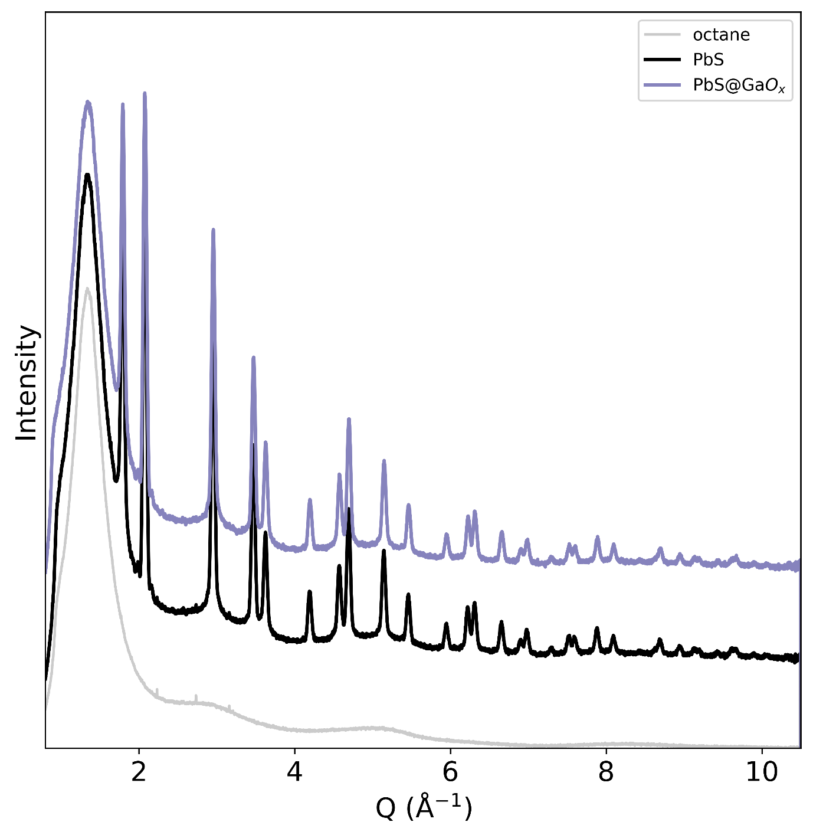
Supplementary Figure 63: High resolution diffraction pattern of octane (grey), PbS nanocubes (black) and PbS nanocubes having undergone five cycles of gallium oxide shell growth (purple). We observe no measurable difference between the diffraction pattern of the native PbS nanocubes and those coated by gallium oxide. Further, no additional reflections associated to a gallium oxide phase are noticeable. These data suggest that the gallium oxide is amorphous and does not impose geometric strain to the PbS core.

X-ray absorption (XAS):

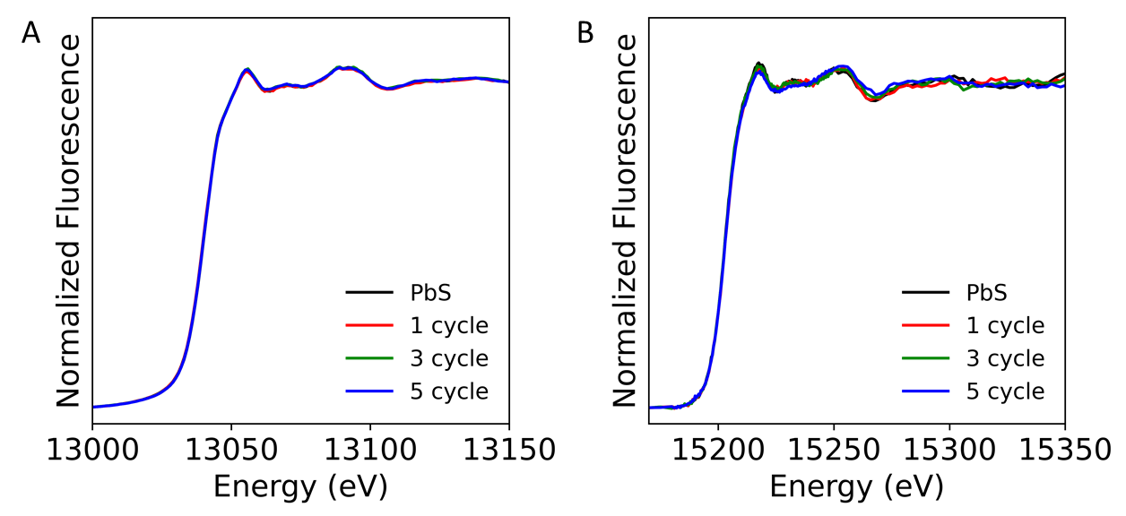
Supplementary Figure 64: Normalized Pb L₃ (A) and L₂ edge fluorescence XANES spectra obtained from PbS nanocubes with zero, one, three and five cycles of gallium oxide growth. No significant difference is observed in both edges suggesting that the Pb coordination is unchanged and no Pb oxidation occurs.

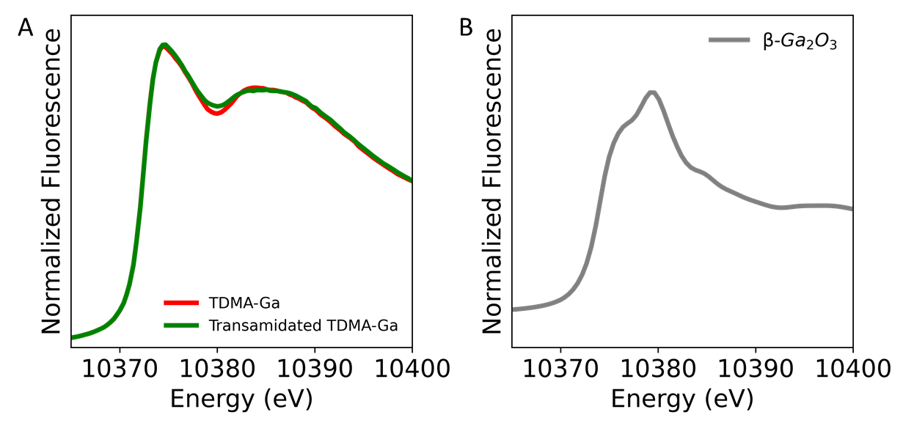
Supplementary Figure 65: Normalized Ga-K edge of the gallium precursors (A) and of $β$-Ga₂O₃ (B). We observe no evidence of TDMA-Ga or the transamidated TDMA-Ga in the final products illustrated in Fig. 5a. In addition, no similarities between the gallium oxide on the surface of the PbS nanocubes and the thermodynamically preferred $β$-Ga₂O₃ phase is observed.

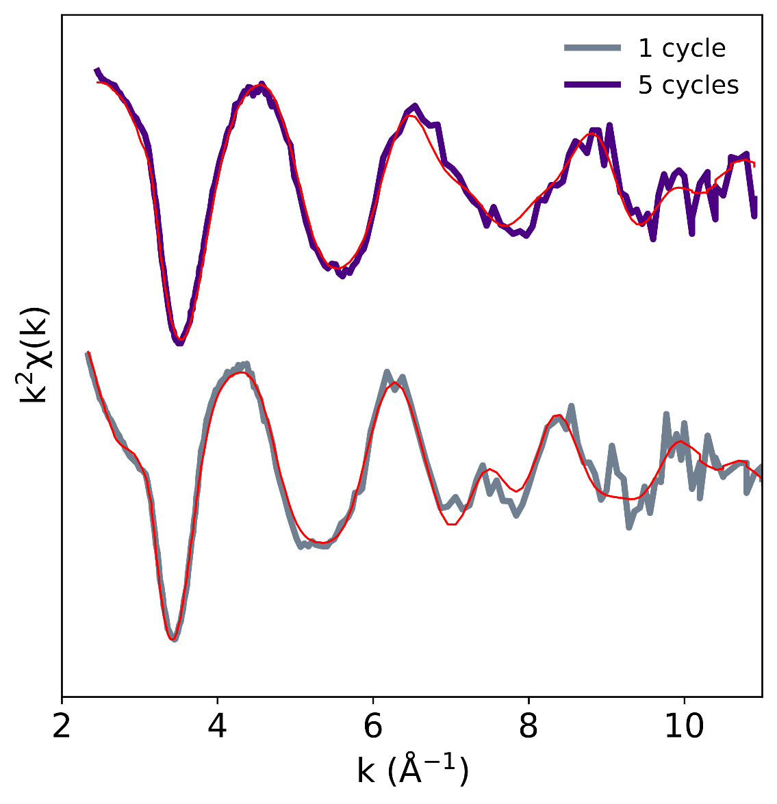
Supplementary Figure 66: k² weighted Ga K-edge EXAFS and their corresponding fits for PbS nanocubes having undergone 1 and 5 cycles of gallium oxide growth. The real space transform of these data is reported in Fig. 5b.
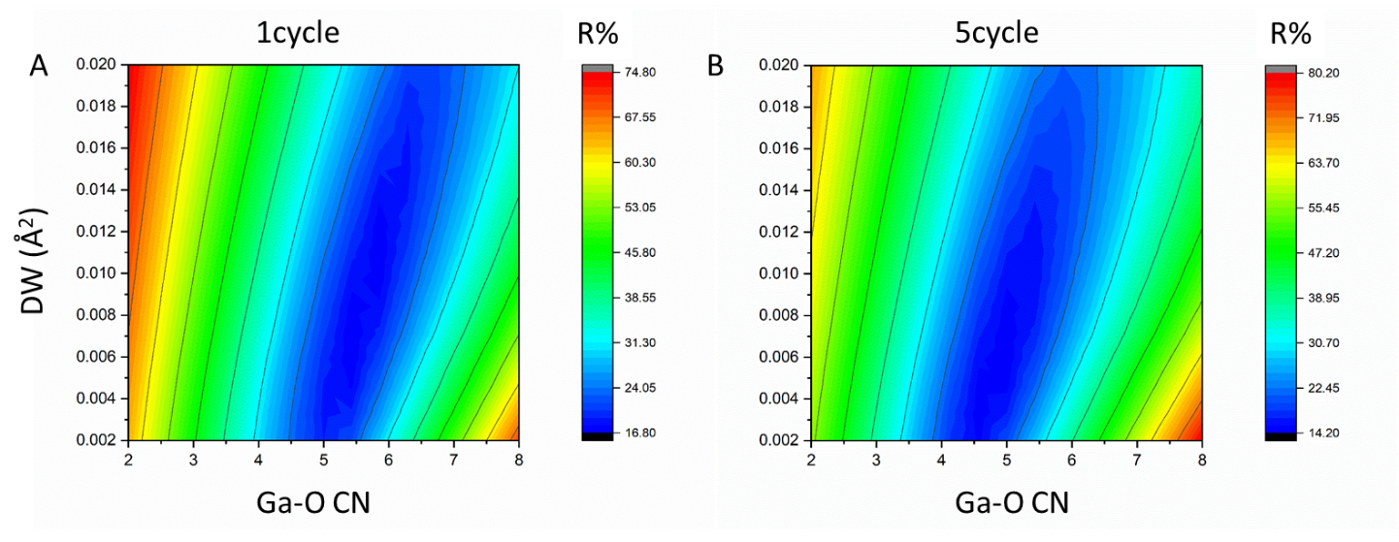
Supplementary Figure 67: Contour maps (most probable values in blue) of the Debye-Waller factor versus the Ga-O coordination number for PbS nanocubes having undergone 1 (A) and 5 (B) cycles of gallium oxide growth. These data are summarized in Table 1.
Supplementary Table 1: Structural and statistical data derived from analysis of Ga K-edge EXAFS. In all cases Kmin = 2.5, K max = 11, AFAC = 0.9
Sample | Scatterer | CNª | r (Å)^{b} | DW (2σ²) (Å⁻²)^{c} | E_{f}^{d} | R (%)^{e} | Chi² (x10⁶)^{f}
1cycle | O | 5.6 | 1.96 | 0.009 | -5.4 | 14.1 | 1.22
 | Ga | 5.0 | 3.01 | 0.023
 | Pb | 3.2 | 3.93 | 0.010
 | O | 4.7 | 3.87 | 0.029
5cycle | O | 5.0 | 1.88 | 0.007 | -3.8 | 13.0 | 0.96
 | Ga | 6.6 | 2.98 | 0.028
 | Ga | 6.4 | 3.24 | 0.030
 | Ga | 3.7 | 3.93 | 0.018
$β$-Ga₂O₃ | O | 4.3 | 1.89 | 0.016 | -4.68 | 32.0 | 2.1
 | O | 1.1 | 2.05 | 0.026
 | Ga | 2.6 | 3.03 | 0.009
 | Ga | 2.2 | 3.35 | 0.012
 | Ga | 8.0 | 4 | 0.031

ª Coordination number, the likely associate errors in which are at least ±10% and in some cases signifcantly larger as a result of the strong correlation of this with DW and the radial proximity to othr shells being fitted (see test)
^{b} Distance of the scattering atom from the central atom (ca. ± 1.5% of stated value).
^{c} Debye−Waller factor; σ is the root mean square internuclear separation (Å).
^{d} Edge position relative to the vacuum zero (Fermi energy, eV).
^{e} R % = (Σ^{Ν}_{ι}(│χ^{T}_{i}(k) − χ^{E}_{i}(k)│)×100 where χ^{T} and χ^{E} are the theoretical and experimental EXAFS and k is the photoelectron wave vector.
^{f} χ² = 2/(Ν_{ind} − p)(Ν_{ind}/Ν) Σ^{Ν}_{ι} (χ^{E}_{i}(k) − χ^{T}_{i}(k))² where p is the number of fitted parameters and N_{ind} given by 2(k_{max} - k_{min})(r_{max}-r_{min})/π.

Principle component analysis:
PCA analysis was performed in order to estimate the contribution of the Pb-Ga scattering as the shell grows. We use these data as supporting evidence to our EXAFS and proposed growth mechanism. These data are not a quantitative representation of the XAS, but should be regarded as a qualitative evidence that supports our claims.
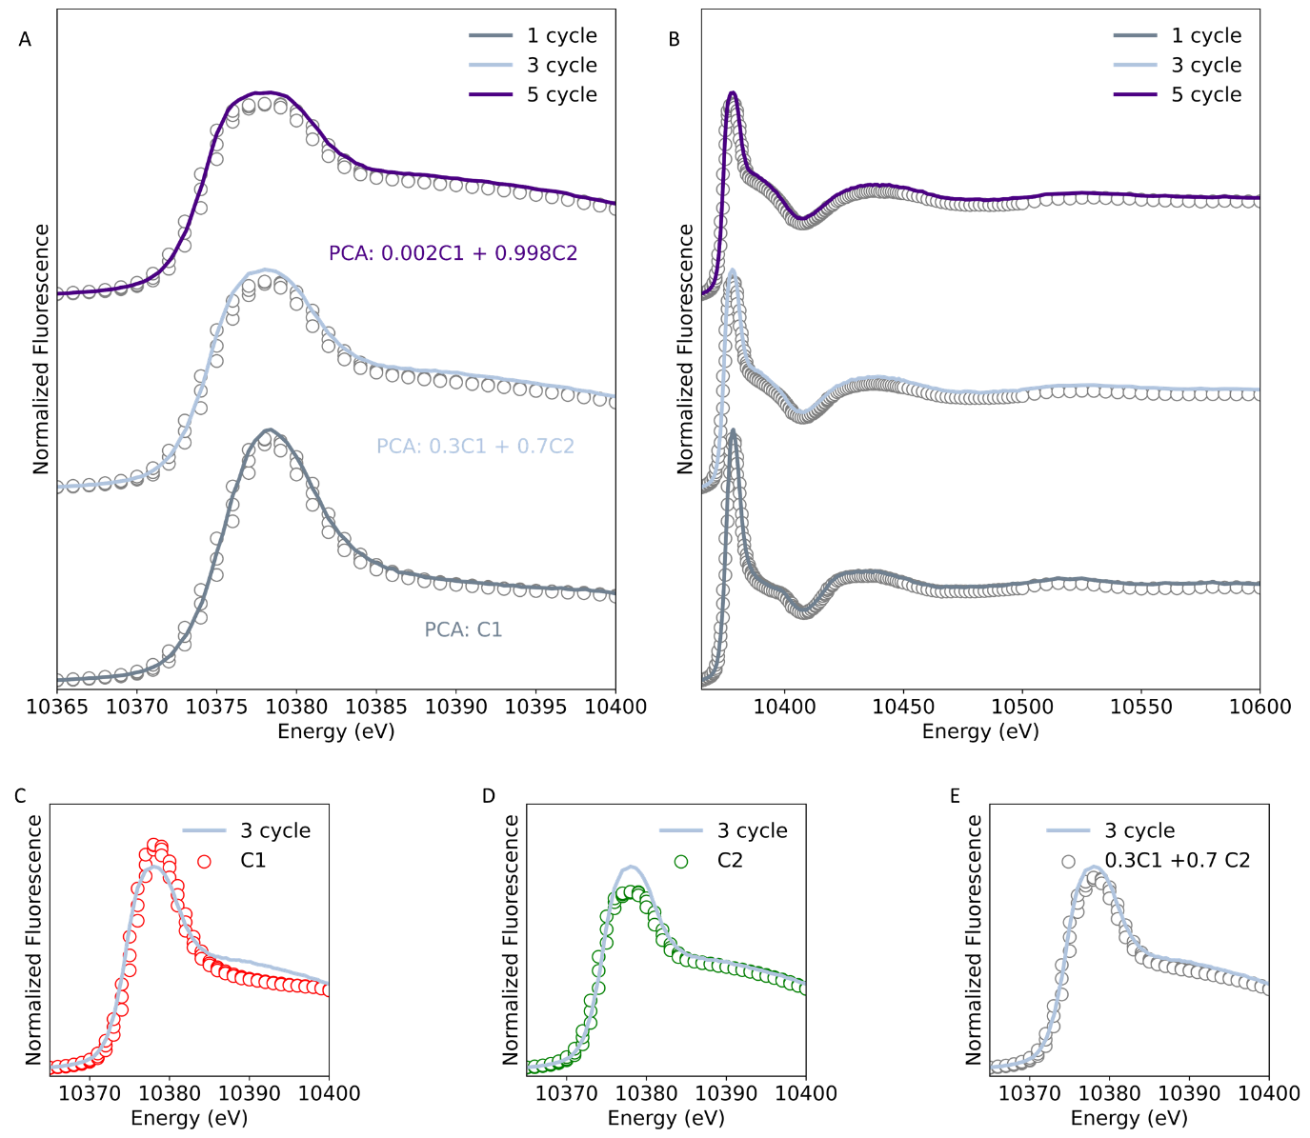
Supplementary Figure 68: Reconstructed XAS spectra from extracted PCA components. A) Ga K-edge XANES for PbS nanocubes having undergone one, three and five cycles of gallium oxide growth by c-ALD. Overlaid is the matched PCA combination of two extracted components. Considering the limits of our dataset, we obtain that the sample having undergone one cycle is ideally represented by the first component (C1), as growth occurs, the fraction of C1 goes from 1 to 0.3 to 0.002 and is replaced by component 2 (C2). B) Wider view of the Ga k-edge XAS. Representing the three cycles sample with C1 (C), with C2 (D) and by 0.3C1+0.7C2 (E). The sample is better represented by the mixed components.
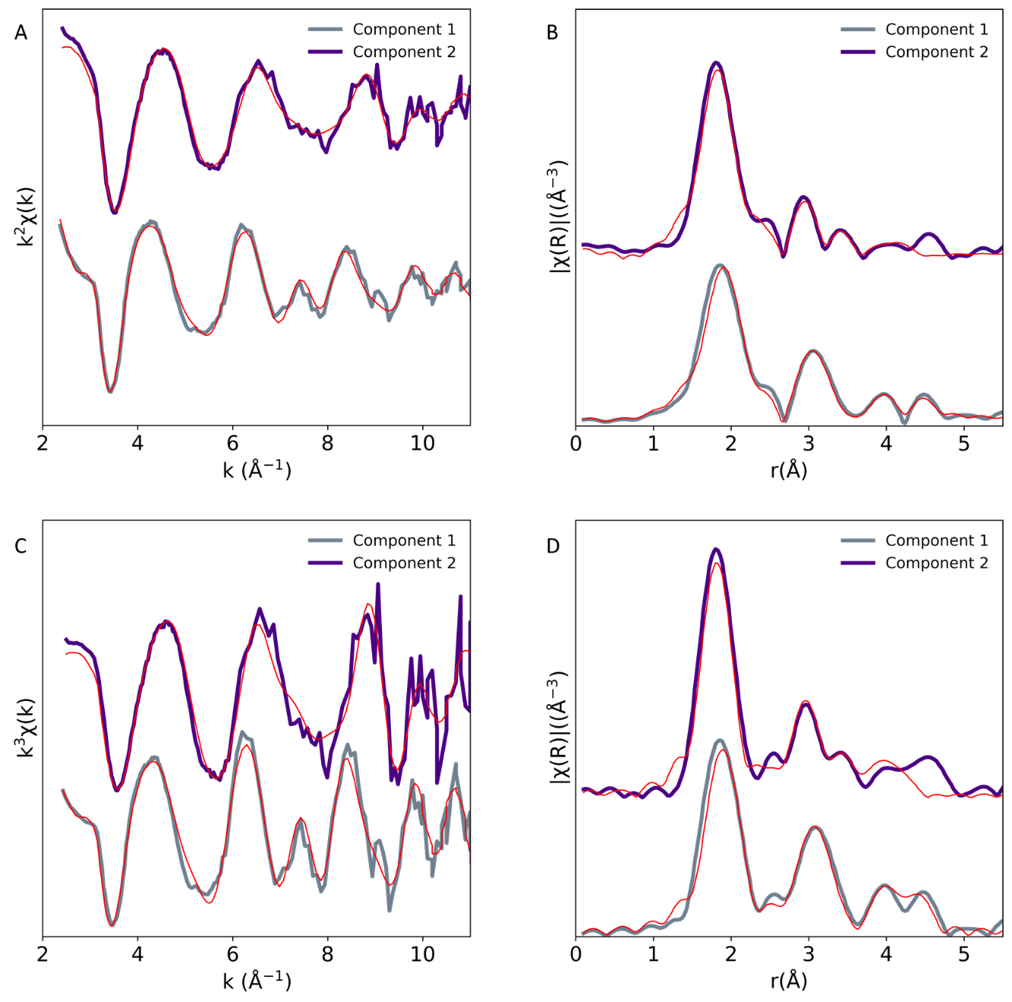
Supplementary Figure 69: EXAFS of PCA components. A) k² weighted Ga K-edge EXAFS and B) their corresponding real-space transform for components 1 and 2 extracted from our PCA analysis. C) and D) are similar but for k³ weighted Ga K-edge EXAFS. The fits are extracted from the models already presented on our experimental data (Fig.5b)

Supplementary Note 3: Alternative methods for the growth of metal oxide shells
A variety of strategies have been developed to grow metal oxide coatings on NCs.^{46,47} We consider that our methodology is an alternative that offers highly desired features that are difficult to attain otherwise.
Historically, sol-gel methods to coat NCs by silica shells have been successfully employed and extended to coat a variety of nanocrystalline composition of various shapes.^{48–52} The reverse microemulsion is one such method that has been useful in coating several semiconductor nanocrystals.⁴⁹ In this method, nanocrystals are entrapped inside an aqueous micelle of a water in oil microemulsion containing the silica precursors (ex: tetraethoxysilane).⁴⁹ A basic environment promotes the hydrolysis and condensation of the silica precursor initiating silica nucleation and growth.⁴⁹ This method yields uniform but rather thick (>2 nm) silica shells. Further, this chemistry is not simply extendable to a variety of metal oxide composition and involves water. Consequently these shells are ideal for biological applications⁵², but face limitations for solid state optoelectronic applications.
Non-hydrolytic sol-gel approaches have also been used.^{53,54},⁵⁵ One recent example involves the growth to alumina, titania or zirconia on CsPbBr₃ NCs.⁵⁵ This method relies on a reaction wherein metal halide and metal alkoxydes to form the metal oxide. While successful, this method is not self-limiting and does not yield fine tuning of the thickness.
Finally, attempt to replicate the precision in shell thickness attained by conventional gas phase ALD on colloids have recently been realized.^{26,28,40,56,57} Our group introduced first a c-ALD methodology to grow metal oxide shells consisting of aluminum oxide.^{56,58} Others and us have more recently expanded the scope to other oxides, including zinc oxide.^{26,57} These reports involve precursors such as TM-Al or DM-Zn and water, O₂ or isopropanol as the oxygen source.^{26,56,57,59}
As mentioned in the main text, this method yields hybrid shells that incorporate the ligands, a trait that is desirable for certain applications but undesirable for solid state devices or systems where full ligand replacement is necessary. Furthermore, this method yields only partial layer growth per cycle as addition of enough precursor to displace all the ligands leads to precipitation of the NCs. This limitation potentially generates a patchy shell.
The currently proposed c-ALD based on ligand-modified precursors overcomes several of these limitations as is described in the main manuscript and summarized here for convenience. Key advantages of our method are its generalizable and scalable nature and ability to grow metal oxide shells with sub-nanometric thickness control (layer-by-layer). Further, the growth is performed in non-coordinating organic solvents and avoids the use oxidizing species such as O₂, O₃ or water, but instead leverages the native surface ligands as a source of oxygen. Finally, all the ligands are displaced at every half-cycle resulting in a high density of metal oxide anchoring points equivalent to that of the native surface ligands. This results in the growth of fully inorganic atomically thin metal oxide layers.

References:
1. Thompson, P. et al. New opportunities for the XMaS beamline arising from the ESRF upgrade program. in 060030 (2019). doi:10.1063/1.5084661.
2. Dowsett, M. G. et al. Synchrotron X-ray diffraction investigation of the surface condition of artefacts from King Henry VIII’s warship the Mary Rose. J Synchrotron Rad 27, 653–663 (2020).
3. Dowsett, M., Adriaens, A., Martin, C. & Bouchenoire, L. The Use of Synchrotron X-rays To Observe Copper Corrosion in Real Time. Anal. Chem. 84, 4866–4872 (2012).
4. Figueroa, S. J. A. & Prestipino, C. PrestoPronto: a code devoted to handling large data sets. J. Phys.: Conf. Ser. 712, 012012 (2016).
5. Binsted, N. PAXAS, Program for the analysis of X-ray absorption spectra. University of Southampton (1998).
6. Gurman, S. J., Binsted, N. & Ross, I. A rapid, exact curved-wave theory for EXAFS calculations. J. Phys. C: Solid State Phys. 17, 143–151 (1984).
7. Rossberg, A., Reich, T. & Bernhard, G. Complexation of uranium(VI) with protocatechuic acid?application of iterative transformation factor analysis to EXAFS spectroscopy. Analytical and Bioanalytical Chemistry 376, 631–638 (2003).
8. Green, P. B. et al. Controlling Cluster Intermediates Enables the Synthesis of Small PbS Nanocrystals with Narrow Ensemble Line Widths. Chem. Mater. 32, 4083–4094 (2020).
9. Calcabrini, M. et al. Exploiting the Lability of Metal Halide Perovskites for Doping Semiconductor Nanocomposites. ACS Energy Lett. 6, 581–587 (2021).
10. Hanrahan, M. P., Stein, J. L., Park, N., Cossairt, B. M. & Rossini, A. J. Elucidating the Location of Cd ²⁺ in Post-synthetically Treated InP Quantum Dots Using Dynamic Nuclear Polarization ³¹ P and ¹¹³ Cd Solid-State NMR Spectroscopy. J. Phys. Chem. C 125, 2956–2965 (2021).
11. Riedinger, A. et al. An intrinsic growth instability in isotropic materials leads to quasi-two-dimensional nanoplatelets. Nature Mater 16, 743–748 (2017).
12. Wang, F., Deng, R. & Liu, X. Preparation of core-shell NaGdF4 nanoparticles doped with luminescent lanthanide ions to be used as upconversion-based probes. Nat Protoc 9, 1634–1644 (2014).
13. Han, S. et al. Lanthanide-doped inorganic nanoparticles turn molecular triplet excitons bright. Nature 587, 594–599 (2020).
14. Waggoner, K. M., Olmstead, M. M. & Power, P. P. STRUCTURAL AND SPECTROSCOPIC CHARACTERIZATION.
15. Moreels, I. et al. Size-Dependent Optical Properties of Colloidal PbS Quantum Dots. ACS Nano 3, 3023–3030 (2009).
16. Kessler, M. L., Starr, H. E., Knauf, R. R., Rountree, K. J. & Dempsey, J. L. Exchange equilibria of carboxylate-terminated ligands at PbS nanocrystal surfaces. Phys. Chem. Chem. Phys. 20, 23649–23655 (2018).
17. Kessler, M. L. & Dempsey, J. L. Mapping the Topology of PbS Nanocrystals through Displacement Isotherms of Surface-Bound Metal Oleate Complexes. Chem. Mater. 32, 2561–2571 (2020).
18. Anderson, N. C., Hendricks, M. P., Choi, J. J. & Owen, J. S. Ligand Exchange and the Stoichiometry of Metal Chalcogenide Nanocrystals: Spectroscopic Observation of Facile Metal-Carboxylate Displacement and Binding. J. Am. Chem. Soc. 135, 18536–18548 (2013).
19. Fritzinger, B., Capek, R. K., Lambert, K., Martins, J. C. & Hens, Z. Utilizing Self-Exchange To Address the Binding of Carboxylic Acid Ligands to CdSe Quantum Dots. J. Am. Chem. Soc. 132, 10195–10201 (2010).
20. Prather, K. V., Stoffel, J. T. & Tsui, E. Y. Z-Type Ligand Coordination at Colloidal Semiconductor Nanocrystals Modifies Surface Electrostatics. Chem. Mater. 34, 3976–3984 (2022).
21. Owen, J. The coordination chemistry of nanocrystal surfaces. Science 347, 615–616 (2015).
22. Zherebetskyy, D. et al. Hydroxylation of the surface of PbS nanocrystals passivated with oleic acid. Science 344, 1380–1384 (2014).
23. De Roo, J. et al. Probing Solvent–Ligand Interactions in Colloidal Nanocrystals by the NMR Line Broadening. Chem. Mater. 30, 5485–5492 (2018).
24. De Roo, J., De Keukeleere, K., Hens, Z. & Van Driessche, I. From ligands to binding motifs and beyond; the enhanced versatility of nanocrystal surfaces. Dalton Trans. 45, 13277–13283 (2016).
25. Calvin, J. J., O’Brien, E. A., Sedlak, A. B., Balan, A. D. & Alivisatos, A. P. Thermodynamics of Composition Dependent Ligand Exchange on the Surfaces of Colloidal Indium Phosphide Quantum Dots. ACS Nano 15, 1407–1420 (2021).
26. Park, N. et al. Colloidal, Room-Temperature Growth of Metal Oxide Shells on InP Quantum Dots. Inorg. Chem. acs.inorgchem.3c00161 (2023) doi:10.1021/acs.inorgchem.3c00161.
27. Chen, P. E., Anderson, N. C., Norman, Z. M. & Owen, J. S. Tight Binding of Carboxylate, Phosphonate, and Carbamate Anions to Stoichiometric CdSe Nanocrystals. J. Am. Chem. Soc. 139, 3227–3236 (2017).
28. Segura Lecina, O. et al. Colloidal-ALD-Grown Hybrid Shells Nucleate via a Ligand–Precursor Complex. J. Am. Chem. Soc. 144, 3998–4008 (2022).
29. Loiudice, A., Saris, S., Oveisi, E., Alexander, D. T. L. & Buonsanti, R. CsPbBr ₃ QD/AlO _{x} Inorganic Nanocomposites with Exceptional Stability in Water, Light, and Heat. Angew. Chem. Int. Ed. 56, 10696–10701 (2017).
30. Imhoff, D. W., Simeral, L. S., Sangokoya, S. A. & Peel, J. H. Characterization of Methylaluminoxanes and Determination of Trimethylaluminum Using Proton NMR. Organometallics 17, 1941–1945 (1998).
31. Brown, N. J. et al. From Organometallic Zinc and Copper Complexes to Highly Active Colloidal Catalysts for the Conversion of CO ₂ to Methanol. ACS Catal. 5, 2895–2902 (2015).
32. Grala, A. et al. Structural Diversity of Ethylzinc Carboxylates. Organometallics 34, 4959–4964 (2015).
33. Orchard, K. L., White, A. J. P., Shaffer, M. S. P. & Williams, C. K. Pentanuclear Complexes for a Series of Alkylzinc Carboxylates. Organometallics 28, 5828–5832 (2009).
34. Lynch, M., Demchuk, A., Simpson, S. & Koplitz, B. On the reactivity of trimethylgallium with H2O, CH3OH, CH3OCH3, and NH3 in a multiple pulsed nozzle environment. Chemical Physics Letters 388, 12–17 (2004).
35. Storre, J. et al. Hydrolysis of Trimesitylgallium and Trimesitylaluminum: Structures Along a Reaction Pathway. J. Am. Chem. Soc. 118, 1380–1386 (1996).
36. Kenney, M. E. & Laubengayer, A. W. Polymeric Dimethylgallium Hydroxide ¹ and its Condensation. J. Am. Chem. Soc. 76, 4839–4841 (1954).
37. Smith, G. S. & Hoard, J. L. The Structure of the Cyclic Tetramer of Dimethylgallium Hydroxide ¹. J. Am. Chem. Soc. 81, 3907–3910 (1959).
38. Ho, T.-L. Hard soft acids bases (HSAB) principle and organic chemistry. Chemical Reviews 75, 1–20 (1975).
39. Green, P. B., Lecina, O. S., Albertini, P. P., Loiudice, A. & Buonsanti, R. Colloidal-ALD-Grown Metal Oxide Shells Enable the Synthesis of Photoactive Ligand/Nanocrystal Composite Materials. J. Am. Chem. Soc. jacs.3c01439 (2023) doi:10.1021/jacs.3c01439.
40. Loiudice, A., Segura Lecina, O., Bornet, A., Luther, J. M. & Buonsanti, R. Ligand Locking on Quantum Dot Surfaces via a Mild Reactive Surface Treatment. J. Am. Chem. Soc. 143, 13418–13427 (2021).
41. Waldman, R. Z. et al. Sequential Infiltration Synthesis of Electronic Materials: Group 13 Oxides via Metal Alkyl Precursors. Chem. Mater. 31, 5274–5285 (2019).
42. Berman, D. & Shevchenko, E. Design of functional composite and all-inorganic nanostructured materials via infiltration of polymer templates with inorganic precursors. J. Mater. Chem. C 8, 10604–10627 (2020).
43. Berman, D. et al. Sequential Infiltration Synthesis for the Design of Low Refractive Index Surface Coatings with Controllable Thickness. ACS Nano 11, 2521–2530 (2017).
44. Azoulay, R., Shomrat, N., Weisbord, I., Atiya, G. & Segal‐Peretz, T. Metal Oxide Heterostructure Array via Spatially Controlled–Growth within Block Copolymer Templates. Small 15, 1904657 (2019).
45. Comstock, D. J. & Elam, J. W. Atomic Layer Deposition of Ga ₂ O ₃ Films Using Trimethylgallium and Ozone. Chem. Mater. 24, 4011–4018 (2012).
46. Ghosh Chaudhuri, R. & Paria, S. Core/Shell Nanoparticles: Classes, Properties, Synthesis Mechanisms, Characterization, and Applications. Chem. Rev. 112, 2373–2433 (2012).
47. Gao, C., Lyu, F. & Yin, Y. Encapsulated Metal Nanoparticles for Catalysis. Chem. Rev. 121, 834–881 (2021).
48. Liz-Marzán, L. M., Giersig, M. & Mulvaney, P. Synthesis of Nanosized Gold−Silica Core−Shell Particles. Langmuir 12, 4329–4335 (1996).
49. Hutter, E. M. et al. Method To Incorporate Anisotropic Semiconductor Nanocrystals of All Shapes in an Ultrathin and Uniform Silica Shell. Chem. Mater. 26, 1905–1911 (2014).
50. Albrecht, W. et al. Morphological and chemical transformations of single silica-coated CdSe/CdS nanorods upon fs-laser excitation. Nanoscale 9, 4810–4818 (2017).
51. Rossi, C. et al. Exploiting the Transformative Features of Metal Halides for the Synthesis of CsPbBr ₃ @SiO ₂ Core–Shell Nanocrystals. Chem. Mater. 34, 405–413 (2022).
52. Bruchez, M., Moronne, M., Gin, P., Weiss, S. & Alivisatos, A. P. Semiconductor Nanocrystals as Fluorescent Biological Labels. Science 281, 2013–2016 (1998).
53. Debecker, D. P. & Mutin, P. H. Non-hydrolytic sol–gel routes to heterogeneous catalysts. Chem. Soc. Rev. 41, 3624 (2012).
54. Danks, A. E., Hall, S. R. & Schnepp, Z. The evolution of ‘sol–gel’ chemistry as a technique for materials synthesis. Mater. Horiz. 3, 91–112 (2016).
55. Guggisberg, D. et al. Colloidal CsPbX ₃ Nanocrystals with Thin Metal Oxide Gel Coatings. Chem. Mater. acs.chemmater.2c03562 (2023) doi:10.1021/acs.chemmater.2c03562.
56. Loiudice, A., Strach, M., Saris, S., Chernyshov, D. & Buonsanti, R. Universal Oxide Shell Growth Enables in Situ Structural Studies of Perovskite Nanocrystals during the Anion Exchange Reaction. J. Am. Chem. Soc. 141, 8254–8263 (2019).
57. Segura Lecina, O. et al. Surface Chemistry Dictates the Enhancement of Luminescence and Stability of InP QDs upon c-ALD ZnO Hybrid Shell Growth. JACS Au 3, 3066–3075 (2023).
58. Albertini, P. P. et al. Hybrid Oxide Coatings Generate Stable Cu Catalyst for CO2 Eelctroreduction. Just accepted Nature Materials (2023) doi:10.21203/rs.3.rs-2873572/v1.
59. Zhou, B. et al. Highly Efficient CsPbBr ₃ Perovskite Nanocrystal Light-Emitting Diodes with Enhanced Stability via Colloidal Layer-by-Layer Deposition. ACS Appl. Electron. Mater. 3, 2398–2406 (2021).

