MOF-Based Nanoagent Enables NIR-Triggered Dual Damage to Mitochondria via Synergistically Reinforced Oxidative Stress and Calcium Overload
Authors: Weier Bao^{1,2}, Ming Liu¹, Jiaqi Meng^{1,2}, Shuang Wang², Rongrong Jia⁴, Yugang Wang⁴, Guanghui Ma^{2,3}* Wei Wei^{2,3}*, Zhiyuan Tian¹*
Affiliations:
¹School of Chemical Sciences, University of Chinese Academy of Sciences, Beijing 100049, P. R. China.
²State Key Laboratory of Biochemical Engineering, Institute of Process Engineering, Chinese Academy of Sciences, Beijing 100190, P. R. China.
³School of Chemical Engineering, University of Chinese Academy of Sciences, Beijing 100049, P. R. China.
⁴Department of Gastroenterology, Shanghai Tongren Hospital, Shanghai Jiao Tong University School of Medicine, Shanghai 200336, P. R. China.
Correspondence and requests for materials should be addressed to Zhiyuan Tian (zytian@ucas.ac.cn) or Wei Wei (weiwei@ipe.ac.cn) or Guanghui Ma (ghma@ipe.ac.cn).
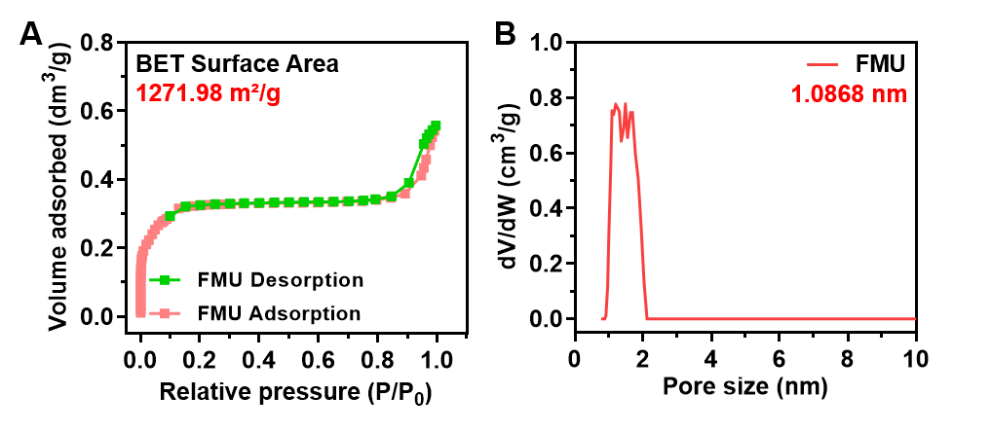
Figure S1. (A) Nitrogen adsorption-desorption isotherms for FMU. (B) Pore size distribution of FMU determined via the Barrett-Joyner-Halenda method.
For the target pristine MOF nanostructures, their Brunauer-Emmet-Teller (BET) surface area of 1271.98 m²/g and mean pore size of 1.0868 nm were confirmed, which enabled efficient loading of photoacid generator components within FMU.
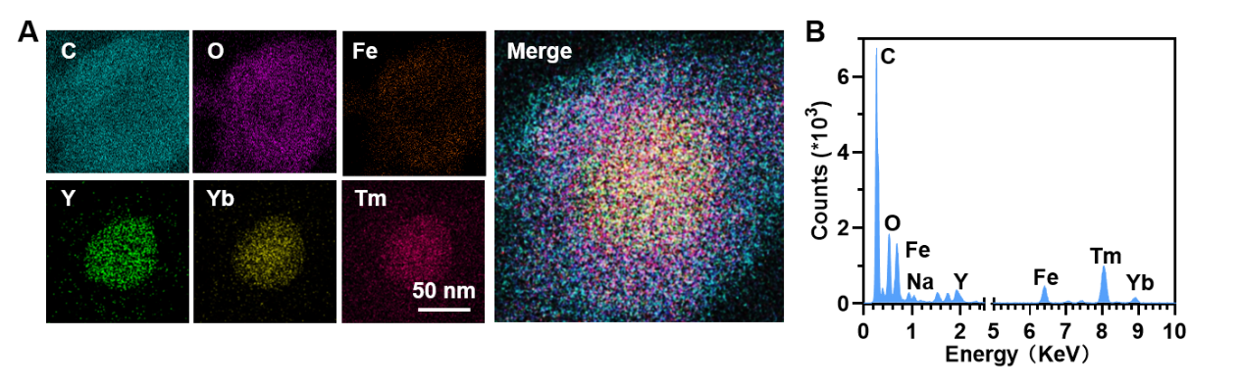
Figure S2. (A) Element mapping images of FMUP (C, O, Fe, Y, Yb, and Tm). (B) Energy dispersive X-ray (EDX) element analysis of FMUP.
The elemental mapping data provided structural information of the core-shell nanostructures regarding the locations and distribution of various active components within the composite nanostructures. Specifically, it was found that the rare earth elements Y, Yb, and Tm mainly resided at the core while the elements C, O, and Fe uniformly distributed throughout the shell of nanostructures, suggesting that the UCNP core was surrounded by the MOF shell and the organic photoacid generator was incorporated into the MOF shell. The EDX element characterization presented further elemental quantitative information of the target composite nanostructures.
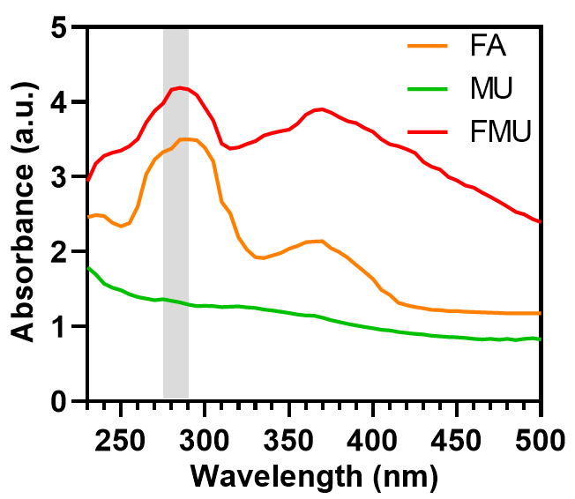
Figure S3. UV/vis absorption spectra of MOFs with and without FA doping.
The characteristic absorption features of FMU at ~280 nm and 375 nm, respectively, definitely originated from FA moiety, which confirmed the involvement of folate component in the target MOF nanostructure.
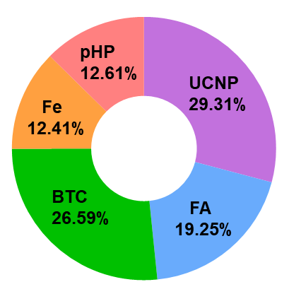
Figure S4. The weight percentage of all functional components in FMUP.

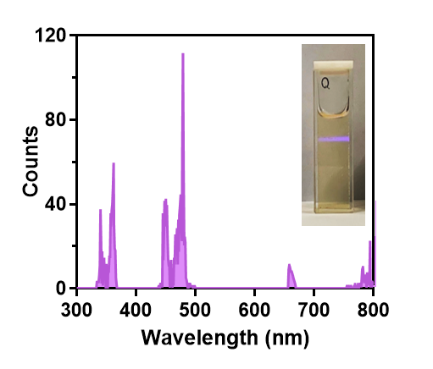
Figure S5. Full-wavelength luminescence emission spectrum and photograph of aqueous FMUP dispersion sample upon excitation of 980-nm laser.
FMUP displayed emission feature in UV region with peak around 365 nm upon excitation of NIR light. Such excitation energy upconversion was expected to play crucial roles in two key processes involved in the anticancer action of FMUP, namely UV-light-mediated reduction of Fe³⁺ to Fe²⁺ and generation of H⁺ from pHP moiety via a photochemical reaction with the former process releasing more efficient reactant (Fe²⁺) for Fenton reaction while the latter bringing about acidification of intracellular milieu.
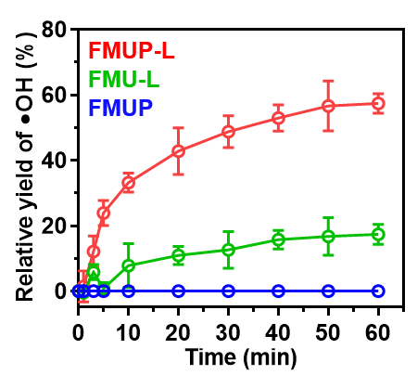
Figure S6. Effects of photoacid generator and NIR light irradiation on in vitro •OH generation efficiency.
The synergistic effect of NIR light-triggered release of Fe²⁺ and acidification of microenvironment on improving the efficiency of generating •OH via Fenton reaction was unequivocally confirmed. Specifically, the group of pHP-encapsulated composite nanostructures with light irradiation (FMUP+L) presented much higher •OH generation yield as compared to the counterparts involved in pHP-free composite nanostructures with light irradiation (FMU+L) and pHP-encapsulated composite nanostructures void of light irradiation (FMUP).
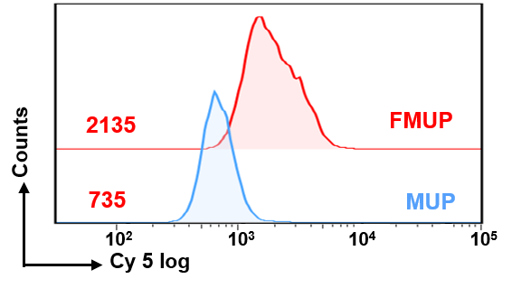
Figure S7. The evaluation of folate-enabled targeting ability of target nanoagents.
To evaluate folate-enabled targeting performance, HeLa cells were incubated with Cy5-labeled core-shell nanostructures with (FMUP) and without (MUP) decoration of folate moiety, respectively, and then examined via flow cytometry analysis. It was found that HeLa cells treated with FMUP presented much stronger red fluorescence as compared to that in the case of cells treated with MUP and the amount of internalized FMUP was ~ 2.9 times than that of MUP, indicating that FMUP was more easily internalized by HeLa tumor cells as compared to its counterpart.
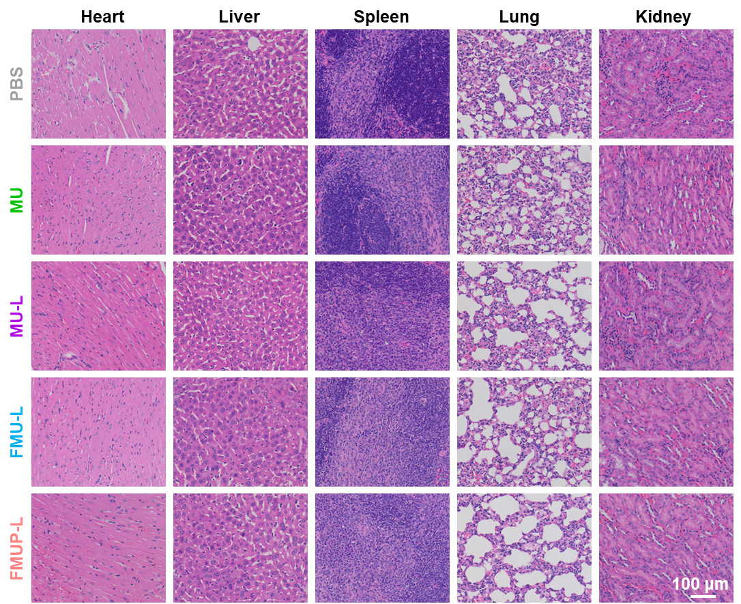
Figure S8. Evaluating the biocompatibility of various treatment protocols in HeLa tumor-bearing mice via H&E-stained slice image analysis of their major organs.
No significant difference was found in the H&E staining of the main organs of heart, liver, spleen, lung, and kidney in all the groups, which further confirmed the biosafety of our FMUP nanoagents.
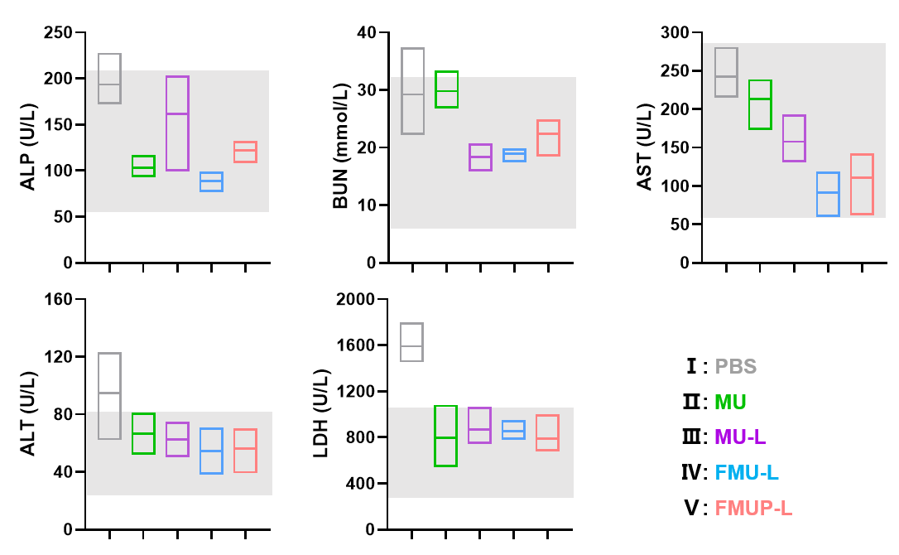
Figure S9. Evaluating the biocompatibility of various treatment protocols in HeLa tumor-bearing mice via blood biochemical analysis of model mice.
Few abnormalities were found in all serum biochemical indicators in model mice upon treatment, indicating the biosafety of our FMUP nanoagents. Gray area in each figure represents the normal range of the indicator.
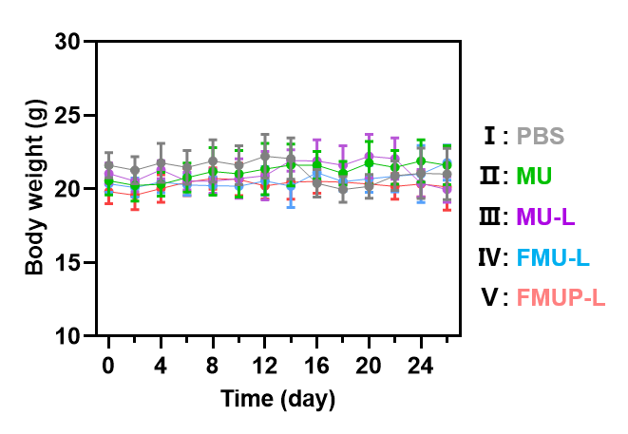
Figure S10. Evaluating the biocompatibility of various treatment protocols in HeLa tumor-bearing mice via monitoring the body weight change of mice upon treatments.
It can be seen that the body weight of model mice in each group nearly kept steady over the treatment period, again confirming the safe use of our doped MOF for combined anticancer therapy. Data represent mean ± SD (n=6)

