Entry for the Table of Contents

((Insert graphic for Table of Contents here (300 DPI resolution: up to 650x532 pixels for single-column format; up to 1358x295 pixels for double-column format). Please ensure your graphic is in one of the two following formats.))
((max. width: 5.5 cm; max. height: 4.5 cm))
650x532 pixels
Please delete this box prior to submission.
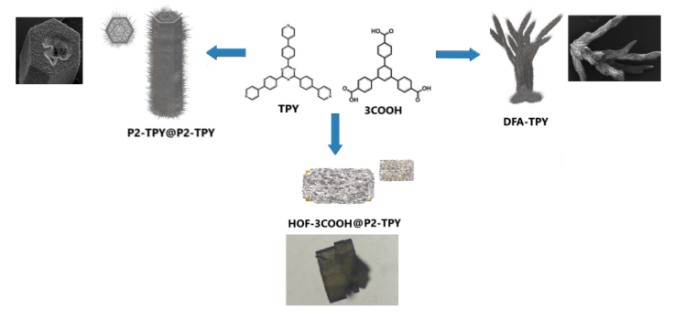
or
((max. width: 11.0 cm; max. height: 2.5 cm))
1358x295 pixels
Please delete this box prior to submission.
A simple strategy for the formation of HOFs with hierarchical superstructures is proposed here. As proof of concept, we have obtained examples of HOF crystals with hierarchical superstructures and the first reported HOF-on-HOF crystals.
Institute and/or researcher Twitter usernames: @LboroScience

