Supporting Information
For
A simple and sequential strategy for the introduction of complexity and hierarchy in hydrogen-bonded organic (HOFs) crystals for environmental applications

Christopher A. Halliwell, Kenny Jolley, Keith Yendall, Mark R. J. Elsegood, Gary N. Parkinson*, Antonio Fernandez*

General Materials and Analysis
Reactants, solvents, and other reagents were all commercially purchased from various suppliers and in all cases, were obtained in 95-100% purity. The molecular precursor, 3COOH, was purchased from Sigma Aldrich. All chemicals were used directly without further purification, unless stated otherwise. The molecular precursor, TPY, was synthesized according to a published procedures [1]. Analytical thin-layer chromatography was used in most syntheses and were performed on 40 mm x 80 mm precoated Machery-Nagel ALUGRAM SIL G/UV₂₅₄ aluminium sheets (Fischer Scientific) and visualised with ultraviolet light (264 nm). Column chromatography was performed using silica gel 60, 40-63 µm mesh (Apollo Scientific). Fourier transform-infrared (FT-IR) studies were recorded by using a Bruker TENSOR-27 spectrophotometer at room temperature. Thermogravimetric analysis was conducted using a Mettler-Toledo model TGA/SDTA851 at a heating rate of 10 °C min⁻¹ under N₂. Single-crystal X-ray crystallography data was obtained from the ESPRC National Crystallographic Service at the University of Southampton and collected on a Rigaku 007FH diffractometer equipped with an AFC11 goniometer and HyPix 6000 detector at 100(2) K using Cu- Kα (λ = 1.54178 Å) radiation from a rotating anode source. The structure for P2-TPY was solved by dual-space iterative methods and refined on F² by full-matrix least squares methods using the SHELXL-2018 software package. H atoms were constrained in a riding model. Refined as a 2-component twin with twin law 0.087 0 –0.913, 0 –1 0, –1.087 0 –0.087 and twin component ratio of 0.0407:0.9593(19). The solvate molecules were treated as diffuse contribution to the overall scattering without specific atom positions by SQUEEZE/PLATON due to severe disorder of these solvate molecules in the lattice. The structure of P2-TPY was close to hexagonal symmetry but is actually monoclinic, and had major and minor merhoedral twin components 1.86:98.84(10)% for twin law 0 0 1 0 -1 0 1 0 0. Due to the resulting poor data quality, restraints were applied to anisotropic displacement parameters and some geometry. The data collection, cell refinement, data reduction for for Hybrid-1 and 2306105 for HOF-3COOH were undertaken using CrysAlisPro 1.171.42.60a [2]. The structures were solved by dual-space iterative methods on F2 and refined on F2 using the olex2.refine software package within Olex2-1.5 [3]. H atoms were constrained in a riding model. Further details are provided in table S1,S2 and S3 and in the deposited cif files CCDC 2304619 for Hybrid-1 and 2306105 for HOF-3COOH that contains the supplementary crystallographic data for this paper. These data can be obtained free of charge from The Cambridge Crystallographic Data Centre via www.ccdc.cam.ac.uk/structures. PXRD patterns were obtained using a Bruker D2 Phaser X-ray diffractometer, fitted with a 1-dimensional Lynxeye detector and a copper X-ray source (Kα = 1.54184 Å) operated at 30 kV and 10 mA. Kβ radiation was suppressed by means of a 0.5 mm thick nickel filter. Patterns were recorded over a range of 4 – 30° (2θ) with a step size of 0.041° and an equivalent step time of 96 seconds per step. Sample rotation was set at 15 rpm. Scanning electron microscopy was carried out on a JEOL JSM-7100F Field Emission Scanning Electron Microscope (FE-SEM). Samples were sputter coated with gold/palladium to provide a 5–10 nm conductive layer to facilitate analysis. Images were collected using an accelerating voltage of 5 kV and an approximate beam current of 120 pA. UV-vis analysis was performed in a Shimadzu UV-1800 UV-Vis Spectrophotometer. CO₂ gas adsorption analysis was performed in a Micromeritics ASAP 2020. All the samples were out-gases at either 80°C or 110°C for 16 hours prior the gas adsorption experiment.
1-General crystallisation conditions
-P2-TPY: TPY (10 mg) in toluene (15 mL) was added into a glass vial. The mixture was heated at 110oC for 10 minutes until complete dissolution. After all the toluene was evaporated at temperature below 18oC for 4 days, hollow crystals of P2-TPY were collected.
-FA-TPY: TPY (19 mg) in toluene (15 mL) were added into a glass vial. The mixture was heated at 110oC for 10 minutes until complete dissolution. After all the toluene was evaporated in 3 days at room temperature, FA-TPY was collected.
-DFA-TPY: FA-TPY crystals in an open vial were submerged in a solution (12 mg in 15 mL of toluene) of TPY in toluene and left to evaporate fast at 50oC (~20 hours), allowing new crystals to grow on FA-TPY.
-P2-TPY@P2-TPY: P2-TPY crystals in an open vial were submerged in a solution of TPY (10 mg in 15 mL of toluene) and left to evaporate at room temperature for 20 minutes, allowing new crystals to grow on P2-TPY. The process was repeated 4 times.
-Hybrid-1: 10 mg of TPY in toluene (35 mL) were added into a glass vial and mixed with 29 mg of 3COOH in ethanol (50 mL). The mixture was left to evaporated slowly at room temperature, and hollow crystals of Hybrid-1 were collected after 15 days.
-P2-TPY@Hybrid-1: Activated P2-TPY crystals were submerged in a solution of 3COOH (1.3mg/mL) in ethanol and left to evaporate at room temperature for 4 days, allowing new crystals of Hybrid-1 to grow on P2-TPY.
-HOF-3COOH: 3COOH (20 mg) in methanol (15 mL) was added into a glass vial. The mixture was heated at 70oC for 10 minutes until complete dissolution. The solution was left undisturbed for 2 weeks until crystals of HOF-3COOH appeared and were collected by filtration.
-HOF-3COOH@P2-TPY: HOF-3COOH crystals were located in a small vial, covering all the bottom of the vial, and a solution of TPY (10 mg in 15 mL of toluene) was added to the vial, enough to cover 1/3 of the vial, and left to evaporate at 58oC for at least 18 hours, allowing crystals of P2-TPY to grow on HOF-3COOH and being collected thereafter.
2-Study for the oil-water adsorption of dyes and microplastic trapping with DFA-TPY crystals:
-Dye mixture: crystals of DFA-TPY were dipped in an emulsion of petroleum ether and water containing Oil Red (OR). After 2 minutes, all the OR was readily adsorbed.
-Microplastic removal: 10 mg of PET of different sizes and diameters, ranging between 10-500 microns were added to 100 mL deionized water. DFA-TPY crystals were used along a vacuum filtration system, as described in Figure 6 in the article. The amount of microplastics was determined by TGA analysis.

a) b)
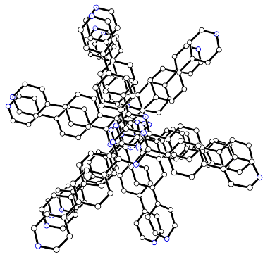
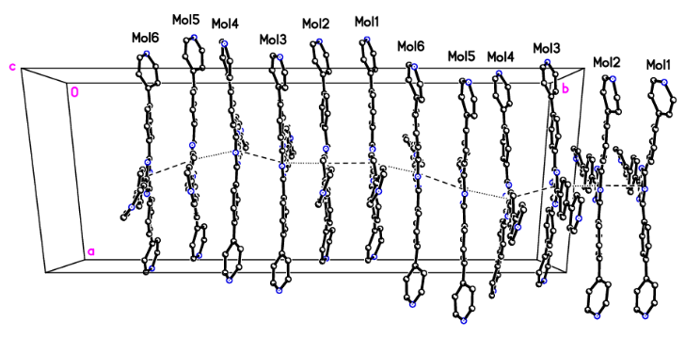
Figure S1. Overview of the crystal packing of P2-TPY (with toluene molecules omitted): a) detailed visualization of the pyridyl molecules arranged in pairs and all six unique molecules form an infinite π∙∙∙π stacked column parallel to b and b) visualization view onto ac plane. Atom colours: black=carbon, blue=nitrogen.

Table S1. Crystallographic data and structure refinement results of P2-TPY toluene solvate.
1-Crystal data
C₃₆H₂₄N₆·1.5(C₇H₈) | F(000) = 4284
M_{r} = 678.81 | D_{x} = 1.275 Mg m⁻³
Monoclinic, P2₁ | Cu Kα radiation, λ = 1.54184 Å
a = 17.4693(5) Å | Cell parameters from 10634 reflections
b = 40.0964(7) Å | θ = 3.1–73.8°
c = 17.4825(5) Å | μ = 0.59 mm⁻¹
β = 119.942(4)° | T = 100 K
V = 10611.3(6) Å³ | Cylinder, colourless
Z’ = 2, Z = 12 | 0.15 × 0.07 × 0.01 mm³

Data collection
Rigaku 007HF diffractometer with HF Varimax confocal mirrors, an UG2 goniometer and HyPix 6000HE detector | 30090 independent reflections
Radiation source: Rotating anode | 29201 reflections with I > 2σ(I)
Detector resolution: 10 pixels mm⁻¹ | R_{int} = 0.032
profile data from ω–scans | θ_{max} = 68.3°, θ_{min} = 2.9°
Absorption correction: multi-scan. CrysAlis PRO 1.171.41.123a (Rigaku Oxford Diffraction, 2022). Empirical absorption correction using spherical harmonics, implemented in SCALE3 ABSPACK scaling algorithm. | h = -17→20
T_{min} = 0.692, T_{max} = 1.000 | k = -48→48
53982 measured reflections | l = -21→20

Refinement
Refinement on F² | Hydrogen site location: inferred from neighbouring sites
Least-squares matrix: full | H-atom parameters constrained
R[F² > 2σ(F²)] = 0.234 | w = 1/[σ²(F_{o}²) + (0.4286P)² + 34.920P]  where P = (F_{o}² + 2F_{c}²)/3
wR(F²) = 0.518 | (Δ/σ)_{max} = 0.082
S = 1.08 | Δρ_{max} = 2.57 e Å⁻³
30090 reflections | Δρ_{min} = -1.64 e Å⁻³
2846 parameters | Extinction correction: SHELXL2018/3 (Sheldrick 2018), Fc*=kFc[1+0.001xFc²λ³/sin(2θ)]^{-1/4}
6345 restraints | Extinction coefficient: 0.104 (7)
Primary atom site location: iterative | Absolute structure: Flack x determined using 9615 quotients [(I+)-(I-)]/[(I+)+(I-)] (Parsons, Flack and Wagner, Acta Cryst. B69 (2013) 249-259).
Secondary atom site location: difference Fourier map | Absolute structure parameter: 0.42 (11); not reliably determined.

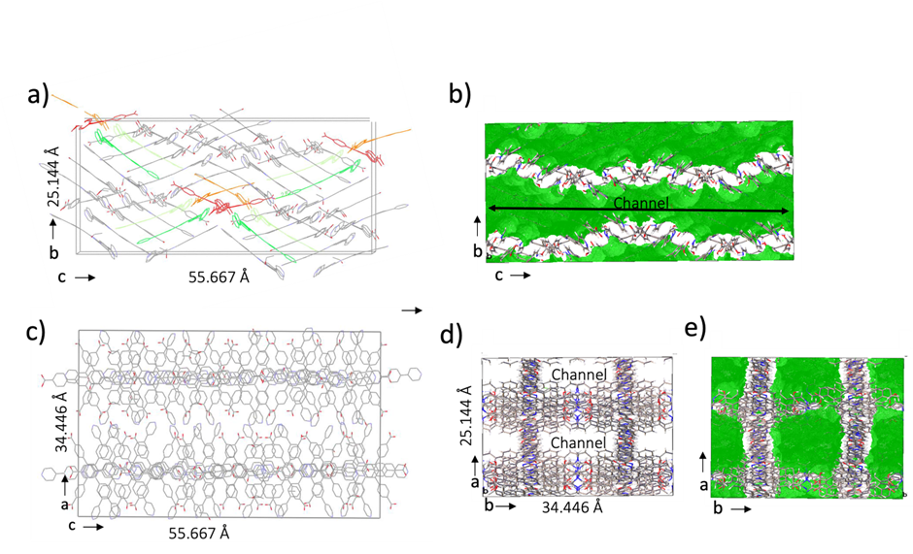
Figure S2. Overview of the crystal packing of Hybrid-1 in the unit cell obtained after crystallisation in a toluene mixture: a) view onto bc plane showing interlocked HOF-3COOH:TPY where green represent HOF-3COOH, red represent TPY, b) view onto ac plane showing the continuous solvent accessible channel that runs through the crystal lattice, as a green contoured surface, c) view onto ac plane showing interlocked HOF-3COOH:TPY, d) view onto ab plane, atom colours grey:carbon, red:oxygen, blue:nitrogen, showing the continuous solvent channel, e) view onto ab plane showing solvent accessible channel as a green contoured surface.

Table S2. Crystallographic data and structure refinement results of Hybrid-1 crystallized in toluene/ethanol mixture.
-Crystal data
(C₃₆H₂₄N₆·(C₂₇H₁₈O₆)) | F(000) = 13944
M_{r} = 979.04 | D_{x} = 1.015 Mg m⁻³
Monoclinic, I 2 | Cu Kα radiation, λ = 1.54178 Å
a = 34.446 (3) Å | Cell parameters from 21550 reflections
b = 25.144 (3) Å | Min D 0.95 max D 9.96
c = 55.667 (6) Å | μ = 0.515 mm⁻¹
β = 90.07 (5)° | T = 100(10) K
V = 48213.15 (83) Å³ | Block, colourless
Z’ = 4 and Z = 28 | 0.13 × 0.08 × 0.05 mm³

Experimental details
Crystal data
Chemical formula | (C₃₆H₂₄N₆·(C₂₆H₁₈O₆))
M_{r} | 979.044
Crystal system, space group | Monoclinic, I 2
Temperature (K) | 100
a, b, c (Å) | 34.446 (3), 25.144 (3), 55.667 (6)
β (°) | 90.07 (3)
V (Å³) | 48213.15 (83)
Z’, Z | 4, 28
Radiation type | Cu Kα
μ (mm⁻¹) | 1.40
Crystal size (mm³) | 0.13 × 0.08 × 0.05
Data collection
Diffractometer | Diffractometer: Rigaku 007HF equipped with Arc)Sec VHF Varimax confocal mirrors and a UG2 goniometer and HyPix 6000HE detector
Absorption correction | CrysAlisPro 1.171.42.60a (Rigaku Oxford Diffraction, 2022) Empirical absorption correction using spherical harmonics, implemented in SCALE3 ABSPACK scaling algorithm.
T_{min}, T_{max} | 0.524, 1.000
No. of measured, independent and  observed [I > 4σ(I)] reflections | 179524, 30203, 22114
R_{int} | 0.073
(sin θ/λ)_{max} (Å⁻¹) | 0.602
Refinement
R[F² > 2σ(F²)], wR(F²), | 0.207, 0.230, 0.533,
No. of reflections (all) | 30203
No. of parameters | 4749
H-atom treatment | H-atom parameters constrained
w = 1/[σ²(F_{o}²) + (0.2046P)² + 13.190P]
where P = (F_{o}² + 2F_{c}²)/3
Δ⟩_{max}, Δ⟩_{min} (e Å⁻³) | 0.8, -0.5

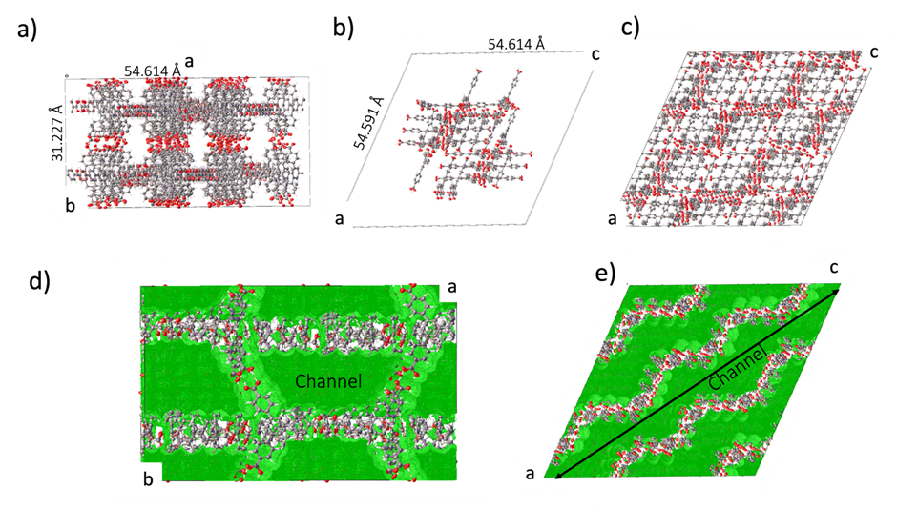 Figure S3. Overview of the crystal packing of HOF-3COOH in the unit cell obtained after crystallisation in a methanol solution: a) view onto ab plane, atom colours grey:carbon, red:oxygen, white:hydrogen, revealing the open channels in the unit cell, b) view onto ac plane showing contents of the ASU and the twenty-eight independent interlocked 3COOH molecules, c) view onto ac plane revealing the herringbone arrangement of the packed molecules within the unit cell, d) view onto ab plane showing solvent accessible channel as a green contoured surface, e) view onto ac plane showing the continuous solvent accessible channel that runs through the crystal lattice, as a green contoured surface.

Table S3. Crystallographic data and structure refinement results of HOF-3COOH crystallized in methanol mixture.
1-Crystal data
(C₂₇H₁₈O₆) | F(000) = 25605.5
M_{r} = 438.428 | D_{x} = 0.962 Mg m⁻³
Monoclinic, Cc | Cu Kα radiation, λ = 1.54178 Å
a = 54.615 (3) Å | Cell parameters from 1160087 reflections
b = 31.227 (11) Å | 2θ = 3.34–153.96°
c = 54.591 (3) Å | μ = 0.564 mm⁻¹
β = 114.604 (6)° | T = 100 K
V = 84656.9 (8) Å³ | Block, colourless
Z’ = 4 and Z = 112 | 0.45 × 0.34 × 0.25 mm³

Experimental details
Crystal data
Chemical formula | (C₂₇H₁₈O₆)
M_{r} | 438.428
Crystal system, space group | Monoclinic, Cc
Temperature (K) | 100
a, b, c (Å) | 54.615 (3), 31.227 (11), 54.591 (3)
β (°) | 114.604 (6)
V (Å³) | 84656.9 (8)
Z’, Z | 4, 112
Radiation type | Cu Kα
μ (mm⁻¹) | 0.564
Crystal size (mm³) | 0.45 × 0.34 × 0.25
Data collection
Diffractometer | Diffractometer: Rigaku 007HF equipped with Arc)Sec VHF Varimax confocal mirrors and a UG2 goniometer and HyPix 6000HE detector
Absorption correction | CrysAlisPro 1.171.42.79a (Rigaku Oxford Diffraction, 2022) Empirical absorption correction using spherical harmonics, implemented in SCALE3 ABSPACK scaling algorithm.
T_{min}, T_{max} | 0.539, 1.000
No. of measured, and independent  observed [I > 2σ(I)] reflections | 1160087, 161203
R_{int} | 11.72
I/ σ(Ι) | 18.6
(sin θ/λ)_{max} (Å⁻¹) | 0.79
Refinement
R[F² > 2σ(F²)], wR(F²), R[F² > all data F²)] | 0.222, 0.5557, 0.2335
No. of reflections | 161203
No. of parameters | 8357
No. of restraints | 3418
H-atom treatment | H-atom parameters constrained riding model
w = 1/[σ²(F_{o}²) + (0.2P)²]
where P = (F_{o}² + 2F_{c}²)/3
Δ⟩_{max}, Δ⟩_{min} (e Å⁻³) | 2.07, -1.18

Figure S4. PXRD patterns for: (a) simulated data from crystal [1], (b) as-synthesized FA-TPY, (c) as-synthesized DFA-TPY and (d) DFA-TPY after activation.

Figure S5. TGA curve under N₂ for the as-synthesized sample DFA-TPY

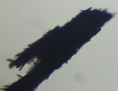
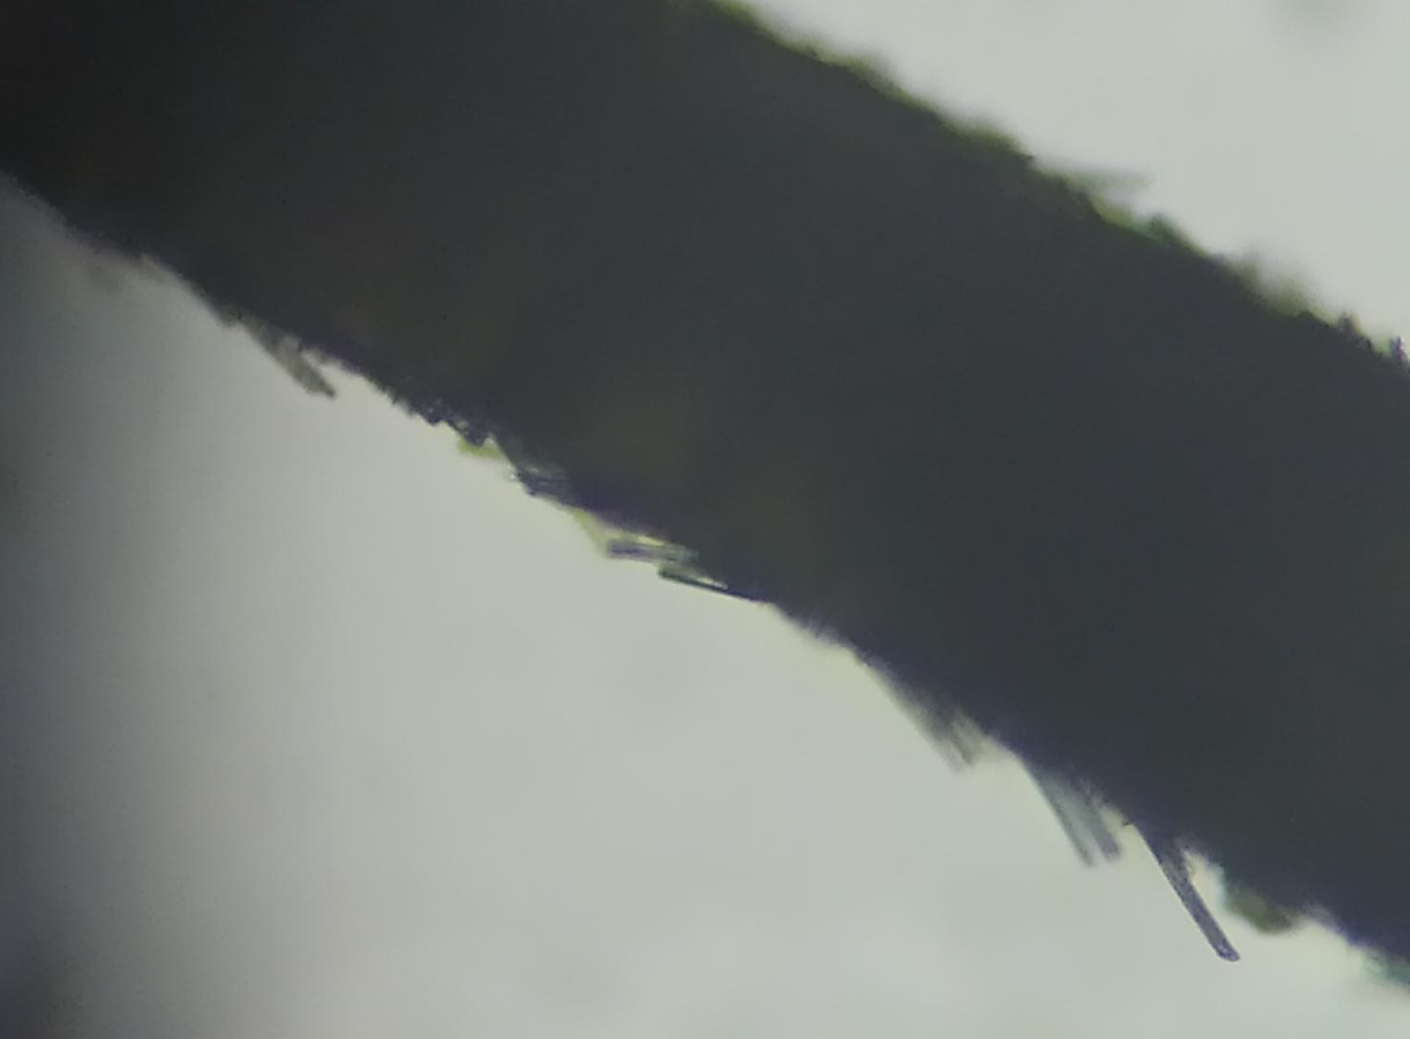

Figure S6. Optical microscopy images of P2-TPY@P2-TPY with seed crystals of millimetre size having a secondary generation of crystals of micrometre scale. Scale bars: 200 microns

Figure S7. PXRD patterns for: a) simulated from crystal data for P2-TPY, b) as-synthesized P2-TPY, and c) single crystal-to-single crystal transformation for P2-TPY@P2-TPY during activation.

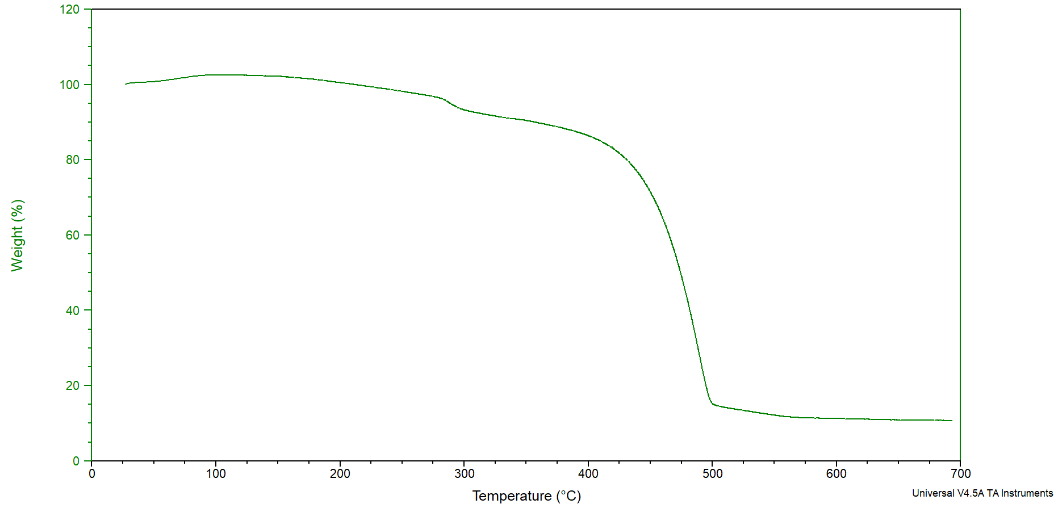

Figure S8. TGA curve under N₂ for the as-synthesized sample P2-TPY@P2-TPY

- b)
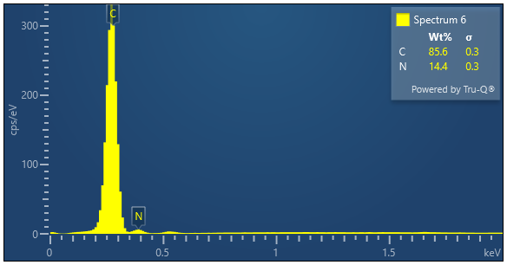
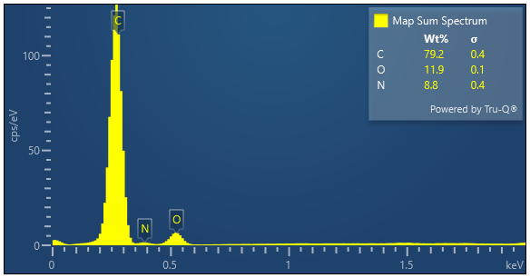

Figure S9. EDX analysis of the evolution C,N and O for during the growth of Hybrid-1 on P2-TPY to obtain P2-TPY@Hybrid-1.

Figure S10. PXRD patterns for: a) Hybrid-1 simulated b) activated P2-TPY and c) P2-TPY@Hybrid-1

Figure S11. PXRD patterns for: a) Hybrid-1 simulated b) activated P2-TPY and c) activated P2-TPY@Hybrid-1

Figure S12. UV-Vis absorbance of the ethanol solution where the P2-TPY crystals were submerged for 3 weeks.

Figure S13. FT-IR spectra of a) P2-TPY, b) 3COOH and c) P2-TPY@Hybrid-1.

Figure S14. FT-IR spectra of a) Hybrid-1 and b) P2-TPY@Hybrid-1.

-Density functional theory (DFT) calculations
All the calculations were done using ORCA version 5.0.3 [4]. The structures of the single molecules and their dimers with various functionals were optimised using initial coordinates in the cif files. This optimises the geometry and calculates the formation energy of the molecule that was used in later calculations. We accounted for the basis set superposition error (BSSE) by following the procedure as given within the ORCA documentation. The BSSE was small accounting for approximately 5% of the interaction energy.

Pi Stacked interaction energy = -27.23073022 kcal/mol
H Bond interaction energy = -11.9443 kcal/mol

See below for some images and the calculation values.

Note: Orca reports energies in Hartrees (Eh)
1 Hartree = 27.2114 Electron Volts
1 Hartree = 627.5 kcal/mol

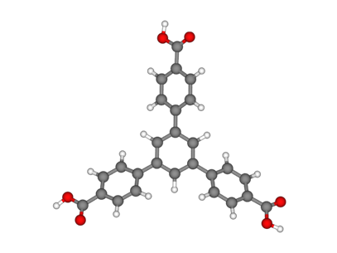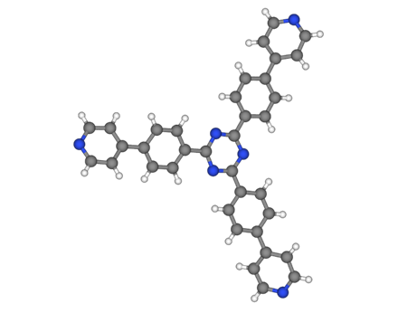
Fig S15. Representation of 3COOH (left) and TPY (right)

a)
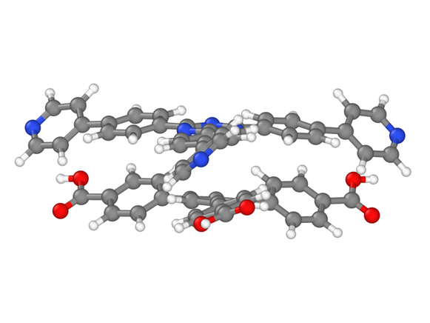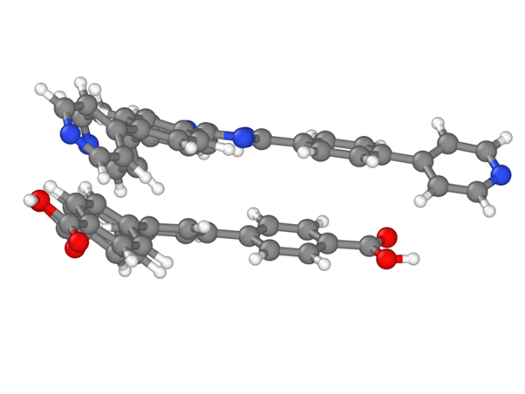
b)
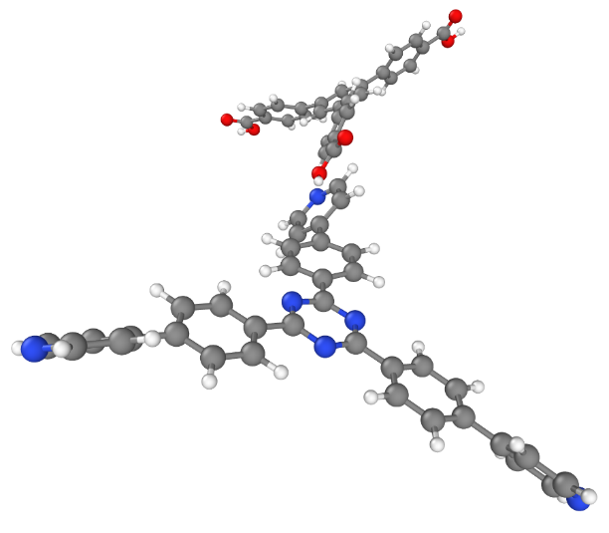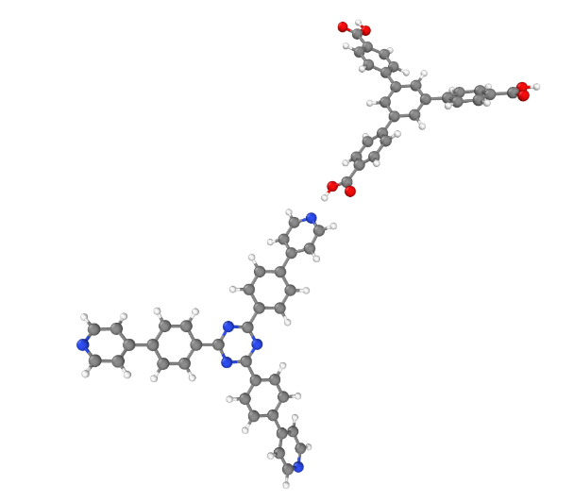
Fig S16. Representation of the stacked dimers in Hybrid-1 used for the DFT calculations: a) views of the π stacked and b) H-bond interactions between dimers

Figure S17.TGA curve under N₂ for P2-TPY@Hybrid-1.

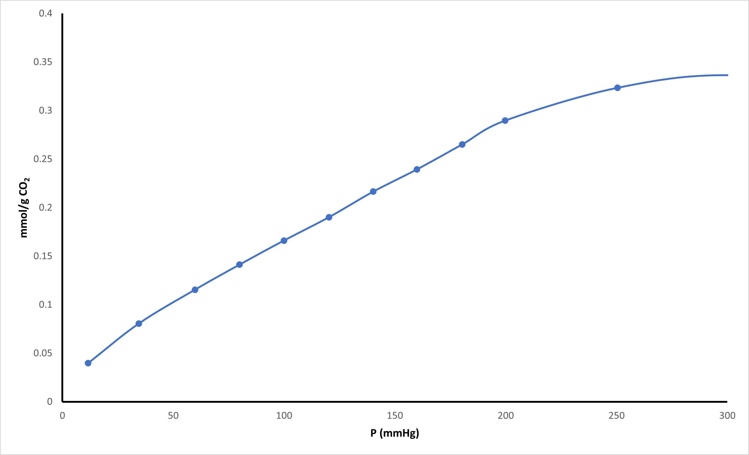

Figure S18. CO₂ adsorption isotherm for P2-TPY@Hybrid-1 at 223 K.

Figure S19. TGA curve under N₂ for HOF-3COOH

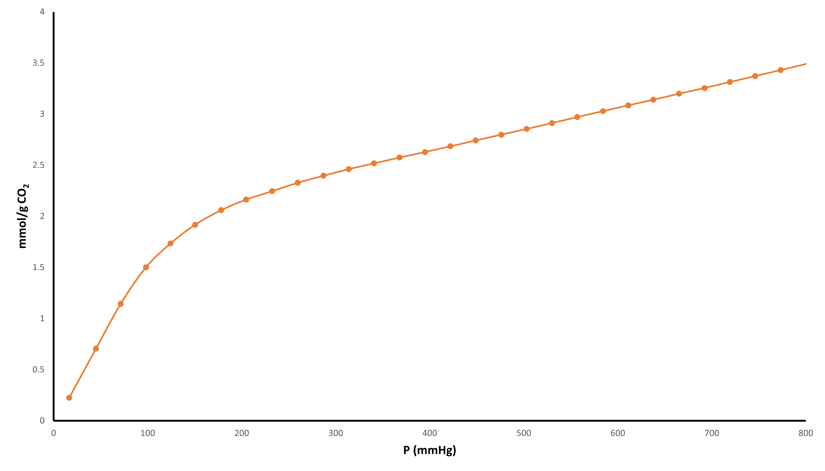

Figure S20. CO₂ adsorption isotherm for HOF-3COOH at 223 K.

- b)
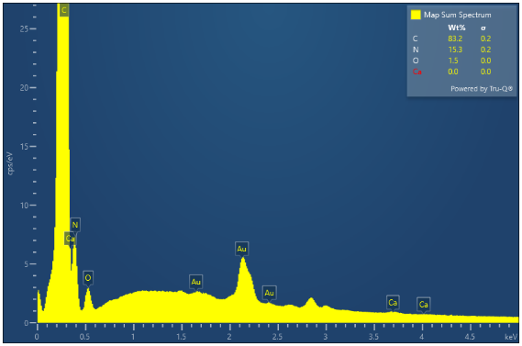
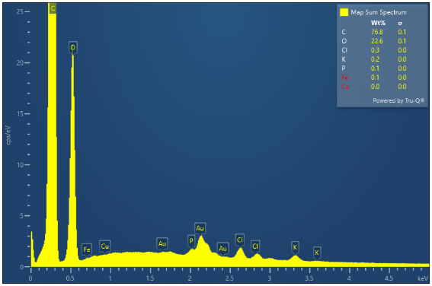

Figure S21. EDX analysis of C,N and O for (a) HOF-3COOH and (b) the shell of HOF-3COOH@P2-TPY

Figure S22. PXRD patterns for: a) simulated from crystal data HOF-3COOH, b) as-synthesized HOF-3COOH and c) activated HOF-3COOH.

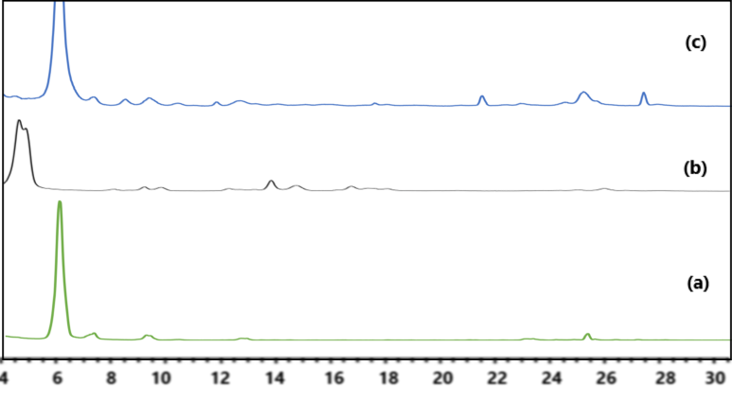

Figure S23. PXRD patterns for: a) as-synthesized HOF-3COOH b) activated P2-TPY and c) activated HOF-3COOH@P2-TPY.

Figure S24. FT-IR spectra of a) HOF-3COOH, b) P2-TPY and c) HOF-3COOH@P2-TPY.

Figure S25. TGA curve under N₂ for HOF-3COOH@P2-TPY.

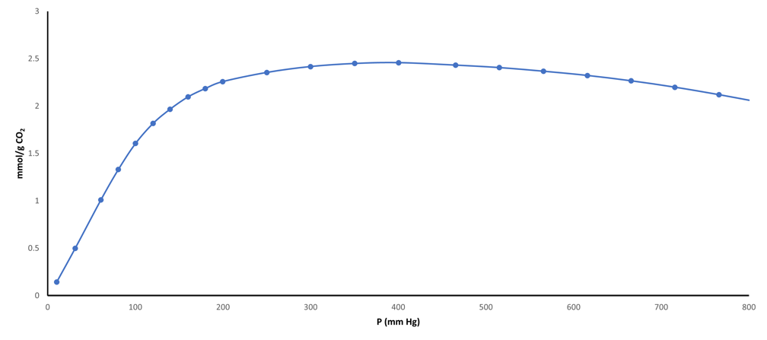

Figure S26. CO₂ adsorption isotherm for HOF-3COOH@P2-TPY at 223 K.

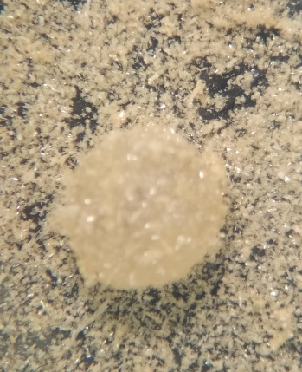
a)
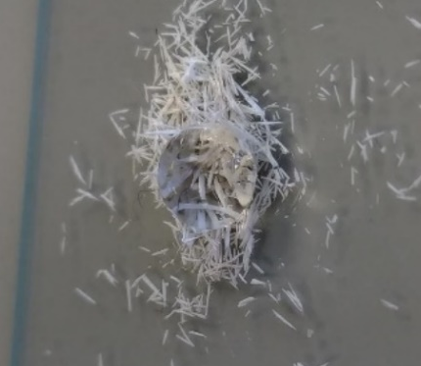
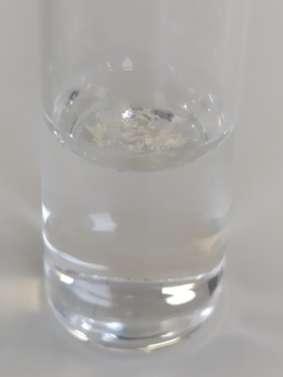

b)
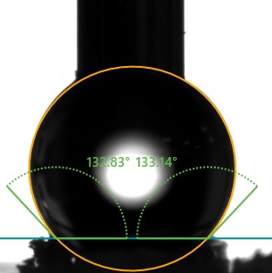
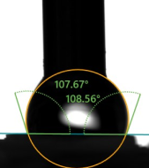

Figure S27 a) Examples of the low wettability in presence of water for DFA-TPY (left), P2-TPY@P2-TPY (centre) and P2-TPY@Hybrid-1 (right). b) Contact angle measurements for P2-TPY (left) and P2-TPY@Hybrid-1 (right).

References:

1- C. A. Halliwell, S. E. Dann, J. Ferrando-Soria, et al. Angew. Chem. Int. Ed., 61, e202208677 (2022).

2- CrysAlisPRO, Oxford Diffraction /Agilent Technologies UK Ltd, Yarnton, England.

3- L. J. Bourhis, O. V.Dolomanov, R. J. Gildea, et al. Acta Cryst. A71, 59-75, (2015).

4-F. Neese, WIREs Comput. Mol. Sci. 12:e1606, (2022).

