Supplementary Information for

Informal recycling sector contribution to plastic pollution mitigation: A systematic scoping review and quantitative analysis of prevalence and productivity
Ed Cook¹, Nathalia Silva de Souza Lima Cano^{2,3}, Costas A. Velis^{1,*}

¹School of Civil Engineering, University of Leeds: Leeds, LS2 9JT, United Kingdom
²Civil and Environmental Engineering, University of Pittsburgh: Pittsburgh, PA, US
³FLUXUS Laboratory, School of Civil Engineering, Architecture, and Urban Design, UNICAMP, Rua Saturnino de Brito, 224, 13083-889, Campinas, Brazil
*Corresponding author. Email: C.Velis@leeds.ac.uk

Contents
S1. Calculation of waste picker prevalence and productivity 2
S2. Systematic review 2
S3. Data analysis 8
S3.1. Prevalence 8
S3.2. Productivity 9
S3.3. Working time 9
S3.1. Composition 10
S3.2. Operating context 10
S4. Results of literature review 10
S5. Supplementary results 14
S5.1. Operating context 22

Calculation of waste picker prevalence and productivity
Based on the assertion by Linzner and Lange (2013) that the IRS represents an average of 0.6% of the global population. If we assume that this only applies to the Global South, which the The World Bank (2023c) estimates the population at 6.68 billion in 2022, there would be approximately 40 million IRS workers worldwide.

Systematic review
Table S1: Preferred Reporting Items for Systematic reviews and Meta-Analyses extension for Scoping Reviews (PRISMA-ScR) checklist; after Tricco et al. (2018).
Section | Item | PRISMA-ScR checklist item | Where reported
Title
Title | 1 | Identify the report as a scoping review. | Title
Abstract
Structured summary | 2 | Provide a structured summary that includes (as applicable): background, objectives, eligibility criteria, sources of evidence, charting methods, results, and conclusions that relate to the review questions and objectives. | Abstract
Introduction
Rationale | 3 | Describe the rationale for the review in the context of what is already known. Explain why the review questions/objectives lend themselves to a scoping review approach. | Section 1
Objectives | 4 | Provide an explicit statement of the questions and objectives being addressed with reference to their key elements (e.g., population or participants, concepts, and context) or other relevant key elements used to conceptualize the review questions and/or objectives. | Section 1 and Table S2
Methods
Protocol and registration | 5 | Indicate whether a review protocol exists; state if and where it can be accessed (e.g., a Web address); and if available, provide registration information, including the registration number. | Not applicable (Optional)
Eligibility criteria | 6 | Specify characteristics of the sources of evidence used as eligibility criteria (e.g., years considered, language, and publication status), and provide a rationale. | Table S5
Information sources* | 7 | Describe all information sources in the search (e.g., databases with dates of coverage and contact with authors to identify additional sources), as well as the date the most recent search was executed. | Section 2.1, Table S3 and Table S4
Search | 8 | Present the full electronic search strategy for at least 1 database, including any limits used, such that it could be repeated. | Section 2.1
Selection of sources of evidence† | 9 | State the process for selecting sources of evidence (i.e., screening and eligibility) included in the scoping review. | Section 2.1
Data charting process‡ | 10 | Describe the methods of charting data from the included sources of evidence (e.g., calibrated forms or forms that have been tested by the team before their use, and whether data charting was done independently or in duplicate) and any processes for obtaining and confirming data from investigators. | Section 2.1 and Table S6
Data items | 11 | List and define all variables for which data were sought and any assumptions and simplifications made. | Section 2.2 and Table S6
Critical appraisal of individual sources of evidence§ | 12 | If done, provide a rationale for conducting a critical appraisal of included sources of evidence; describe the methods used and how this information was used in any data synthesis (if appropriate). | Section 2.3
Synthesis of results | 13 | Describe the methods of handling and summarizing the data that were charted. | Sections 2.2 and 2.3
Results
Selection of sources of evidence | 14 | Give numbers of sources of evidence screened, assessed for eligibility, and included in the review, with reasons for exclusions at each stage, ideally using a flow diagram. | Fig. S1, Table S9, Table ST00a and b
Characteristics of sources of evidence | 15 | For each source of evidence, present characteristics for which data were charted and provide the citations. | Supplementary Data file
Critical appraisal within sources of evidence | 16 | If done, present data on critical appraisal of included sources of evidence (see item 12). | Section 2.3
Results of individual sources of evidence | 17 | For each included source of evidence, present the relevant data that were charted that relate to the review questions and objectives. | Supplementary Data file
Synthesis of results | 18 | Summarize and/or present the charting results as they relate to the review questions and objectives. | Fig. 1-6 and Table 1
Discussion
Summary of evidence | 19 | Summarize the main results (including an overview of concepts, themes, and types of evidence available), link to the review questions and objectives, and consider the relevance to key groups. | Section 4
Limitations | 20 | Discuss the limitations of the scoping review process. | Section 4
Conclusions | 21 | Provide a general interpretation of the results with respect to the review questions and objectives, as well as potential implications and/or next steps. | Section 5
Funding
Funding | 22 | Describe sources of funding for the included sources of evidence, as well as sources of funding for the scoping review. Describe the role of the funders of the scoping review. | Funding section

Table S2: Detailed research questions.
No | Research question
1 | How many primary collectors work in the informal recycling sector?
2 | What proportion of informal recycling sector primary collectors are men, women and children?
3 | What is the composition of the materials collected by the informal recycling sector and what types of plastics do they collect?
4 | What is the productivity of informal recycling sector primary collectors and how does this vary with worker’s characteristics?
5 | How much time do primary collectors spend at work each day, week, month, and year?
6 | What operating context to informal recycling sector workers carry out activities in (Dumpsites, transfer stations, door-to-door collection, ‘street picking’ or non-collection roles (sorting, trade, and transport)?

Table S3: Terms used to search Scopus database.
Database | Search terms
Scopus | TITLE-ABS-KEY ("Waste picker*" OR "Waste collector*" OR "Informal recycler*" OR "Informal recycling sector" OR "Inclusive recycling" OR "Collective recycling" OR "Garbage picker*" OR "Rag picker*" OR "trash picker*" OR "refuse collector*" OR "waste worker*" OR "landfill scavenger*" OR "trash picking" OR "garbage-comber*" OR "waste salvager*" OR "subsistence waste collector*"

Table S4: Details of sites searched, search terms and number of papers selected during structured grey literature search.
Organisation | Main website | Search terms | DL | Incl.
China National Knowledge Infrastructure (CNKI) | https://oversea.cnki.net/index/ | 拾荒 - pick waste; 拾荒者 - waste picker; 非正规回收 - informal recycling; 捡破烂 – scavenger; 收废品 - collect scrap; 收破烂 - collect garbage; 拾破烂 - pick garbage; 拾荒大军 - scavenging army | 31 | 8
WIEGO | https://www.wiego.org/ | "waste pick" site:https://www.wiego.org/  "garbage pick" site:https://www.wiego.org/ | 15 | 4
WIEGO | https://www.wiego.org/wiego-briefs#Statistical%20Briefs | Screened full list | 12 | 4
WIEGO | https://www.wiego.org/peer-reviewed-publications | Screened full list | 1 | 4
ILO | https://www.ilo.org/global/lang--en/index.htm | "waste pick" site:https://www.ilo.org  "garbage pick" site:https://www.ilo.org | 11 | 0
International Alliance of Waste Pickers | https://globalrec.org/ | Browsed | 0 | 0
The Alliance of Indian Waste Pickers (AIW) | https://aiw.globalrec.org/ | Browsed | 0 | 0
Ikatan Pemulung Indonesia (Indonesia Waste-pickers Union- IPI) | https://si-ipi.com/ | Browsed | 0 | 0
South African Waste Pickers Association (SAWPA) | https://wastepickers.org.za/ | Browsed | 0 | 0
Groundwork | https://groundwork.org.za/ | "waste pick" site:https://groundwork.org.za/ | 1 | 0
UNEP | https://www.unep.org/ | "recycling" site:https://www.unep.org  (Google search did not yield, so searched the publications page) | 3 | 0
GIZ | https://www.giz.de/de/html/index.html | "waste pick" site:https://www.giz.de  "informal waste" site:https://www.giz.de | 3 | 1
IGES | https://www.iges.or.jp/en | Screened publications page for waste picker and selected 'circular economy' (https://www.iges.or.jp/en/pub/list?f%5B0%5D=pub_topic_s_%3A25) | 37 | 0
UNDP | https://www.undp.org/ | "waste pick" site:https://www.undp.org/  "informal waste" site:https://www.undp.org/  Also browsed | 1 | 1
Abbreviations: DL=downloaded; Incl. = Included in study |  | Total | 115 | 14

Table S5: Inclusion / exclusion criteria. Adapted from Cook et al. (2023).
Detail | Included | Excluded
Relevance | Data relevant to research questions detailed in Table S2 | No relevant data
Scope | Informal recycling sector | Formal sector activities that do not include informal elements (for example informal elements include skimming by formal waste collectors)  Informal recycling sector activities unrelated to primary or secondary collection
Study type | Cross‐sectional; prospective cohort; retrospective cohort; case‐control studies; longitudinal; material flow analysis; expert interviews; passive observation; census; panel survey; supra-national surveys; modelling  literature reviews; analysis of secondary survey or census data | Anecdotal qualitative information or qualitative survey data that has not been coded  Secondary data where the original data were able to be located
Quality | All quantitative data | Method not clear enough for confidence that results reported on correct basis  Duplicated work  Evidence of errors and typos which cannot be plausibly corrected
Languages | English; Portuguese; Chinese; languages which could be machine translated into English effectively | Languages which could not be machine translated into English effectively
Temporal scope | Initial searching included studies published between 2000 and 2020, however later snowball searching included some studies outside this window | Published before 2000
Type | Peer reviewed articles  Books and chapters  Grey literature  Journalism | Web-pages*
* Two exceptions (Li, 2003; Yu, 2019) were made in the case of data points from China which were included as it was judged that they had sufficient reliability in the context of other data which were included.

Table S6: Data charting (variables and categories recorded) according to definition proposed by Peters et al. (2020).
Category | Variables | Categories
Identification of study | Title  Authors  Language  Year of publication  Journal | As reported
Characteristics of study | Location of study (country)  Location of study (city)  Study period | As reported
Methods | Study design | Cross sectional survey; material flow analysis; expert interviews; passive observation; targeted census (complete enumeration of sector within a geographical area); general population census (complete enumeration of an entire population within a geographical area); panel survey; supra-national surveys; modelling; literature reviews; analysis of secondary survey or census data.
Methods | Sample selection | Complete enumeration, probability, non-probability
Methods | Sample size determination | Method used to determine sample size
Methods | Stratification | Age; area; population; location; socioeconomics
Methods | Representativeness as claimed by original author | Yes/no
Methods | Representatives as assessed in this study | Yes/no
Variables related to research questions | Population of study area | Number
Variables related to research questions | Number of informal recycling sector participants | Number
Variables related to research questions | Source of information | Source of information, for example: secondary, present study, author estimation, hearsay
Variables related to research questions | Sample size | Number & type
Variables related to research questions | Gender proportions and number of children in primary collector population | Men, women, children
Variables related to research questions | Composition of materials collected including types of plastics | Paper (including cardboard); metal, glass; plastic; others.  Plastic type, for example: HDPE; PET; ‘shoes’.
Variables related to research questions | Operational context | Land disposal, streets, door-to-door, transfer stations, non-collection roles, itinerant buyer, sorting.
Variables related to research questions | Transport modality | Bicycle, tricycle, foot, mixed modality, van, cart
Variables related to research questions | Productivity | Amount of waste collected each time period
Variables related to research questions | Time spent working by different primary collectors | Hours per day; days per week; months per year

Table S7: Modified United Nations (UN) regions. To simplify reporting, we merged UN global Intermediate regions as shown here.
Modified UN region | UN Intermediate region
E. Asia | Eastern Asia
E. Europe & Cen. W. Asia | Central Asia
E. Europe & Cen. W. Asia | Eastern Europe
E. Europe & Cen. W. Asia | Western Asia
Lat. Am & Carrib. | Latin America and the Caribbean
N. Africa | Northern Africa
N. America | Northern America
N.W. Europe | Northern Europe
N.W. Europe | Western Europe
Oceania | Australia and New Zealand
Oceania | Melanesia
Oceania | Micronesia
Oceania | Polynesia
S Asia | Southern Asia
S. Europe | Southern Europe
S.E. Asia | South-eastern Asia
Sub-S. Africa | Sub-Saharan Africa

Data analysis

Prevalence
Data on the number of IRS participants operating at multi-source locations were presented at national and administrative area (including metropolitan city, city, municipality, district, and neighbourhood) level. Where more than one data point existed for a particular area or country, we calculated the mean prevalence and related it to a mean year of study. Prevalence of the IRS was presented in absolute numbers, and as a proportion of the population reported in the source article or, in its absence, using data from census or supra-national organisations (Table ST01b).
Where three or more data points were presented for a country or administrative area, we presented the data as a time series. Two sources (The Economist Intelligence Unit, 2017; UAESP, 2012) reported prevalence in Bogota in 2012, so we calculated the mean of these.
Using OriginPro (Origin Labs, version 2023b) statistical software package, the Levenberg-Marquardt iteration algorithm for convergence (Levenberg, 1944) was used to fit models between the proportion of primary collectors in the population (dependent variable) and the following socioeconomic indicators (independent variables): Gross National Income (GNI) per capita, purchasing power parity (PPP) (constant 2017 international $) (The World Bank, 2023b); Social Progress Index (SPI-0) (Social Progress Imperative, 2022); Social Progress Index Opportunity (SPI-3); Gross Domestic Product (GDP) per capita, PPP (constant 2017 international $) (The World Bank, 2023a); and Human Development Index (HDI) (UNDP, 2023). We chose these explanatory variables on the basis of research by Velis et al. (2023), who established that such socioeconomic indicators were able to paltry explain (I.e. model) the variability of several waste and resources management indicators.
Linear, Bradley, Gaussian, Power, 2nd and 3rd order polynomial curves (8) were fitted between IRS prevalence and each socioeconomic indicator. Goodness-of-fit was assessed according to the Akaike Information Criterion (AIC) Test score (Akaike, 1974); BIC, Adjusted R², Residual Sum of Squares and Reduced Chi-Square metrics were also reported for completeness (full details in Table ST07a). Given the relatively poor fitting results for all curves in most of the correlations tested, in the diagrams one of the best fitting curves was used for indicative visualisation purposes, also after visual inspection.
Table S8: Formulas for the models used to fit pairs of dependent (prevalence, composition, working hours) and independent variables (socioeconomic indicators).
Name of model | Formula | Prevalence | Working hours | Composition
Linear | $$y=A+Bx$$ | Y |  | Y
Second order polynomial (parabola) | $$y=A+Bx+Cx^{2}$$ | Y | Y | Y
Third order polynomial (cubic) | $$y=A+Bx+Cx^{2}+Dx^{3}$$ | Y | Y
Bradley (logarithm) | $$y=aln\left(-bln\left(x\right)\right)$$
Power | $$y=x^{A}$$ | Y | Y
Gaussian | $$y=y_{0}+\left(\frac{A}{w\sqrt{π/2}}\right)e^{-2\left(\frac{{\left(x-x_{c}\right)}^{2}}{w^{2}}\right)}$$ |  | Y

Productivity
Productivity data were normalised to kg·d⁻¹ and summarised according to whether they were: related to single-or multi-source collection; the context of the collection; and the mode of transport employed. Many of the papers did not provide sufficient contextual information to ascertain the context in which the IRS collectors were working (n=21) and the transport used (n=25). For these studies we made assumptions based on other peripheral information in the paper (Table ST02a). To simplify presentation of the data, we merged several transport modalities and contexts as detailed in Table ST02b.

Working time
The sources we reviewed reported data for working time both categorically and as means, medians or as a non-specified averages (averaged data). Averaged data which differentiated between the working time for men and women were presented in bar charts.
For the remaining non-gendered data, we presented the averaged data as boxplots to show the central tendency and spread. But to increase the dataset, we also calculated a mean of the values for the gendered data (men and women), weighted by the proportion in the sample population, to provide an approximate average working time from those studies.
The categorical values reported in studies of daily working time (n=11) and days worked per week (n=3) were incongruously reported (Table ST04a). Therefore, we distributed the proportion in each group uniformly to harmonize the number of hours worked each day (Table ST04b). For the daily working time, we fitted Gaussian, 2nd and 3rd order polynomials (8) which were then assessed according to the Akaike Information Criterion (AIC) Test score (Akaike, 1974). For the days worked per week we fitted, 2nd, 3rd and 4th order polynomials. Full details of the ranking are shown in Table ST07b.

Composition
The composition of material collected for recycling by informal recycling sector primary collectors was categorised according to five main (basic) groups: plastics, paper, metals, glass and other. Where data were available, plastics were further classified according to the polymer. We have presented the data in its raw format, as a mean of sub-national administrative areas where more than one are reported; as a mean of all data points within a country; and as a mean of all; data points. The proportion of each of the basic groups was plotted against the year of reporting using a linear model (8), the results of which are shown in Table ST07c.

Operating context
The eleven data points identified were normalised to include only ‘primary collectors’.

Results of literature review
Scopus
(1,665)
Titles screened
(1,665)
Grey
(115)
Snowball
(40)
Abstracts screened
(985)
Rejected
(680)
Full articles screened
(364)
Rejected
(621)
Rejected
(291)
Included
(74)
Total included
(122)
Full articles screened
(155)
Included
(48)
Rejected
(107)
Identification
Screening
Eligibility
Inclusion
Fig. S1: Decision flowchart for systematic review.

Table S9: List of sources included in study.
Citation | Study (relevant) period | Country
Abledu and Amfo-Otu (2018) | 2017 | GHA
Adebola (2006) | 2006 | NGA
Afon (2012) | 2012 | NGA
Agarwal et al. (2005) | 2000 | IND
Ahn et al. (2020) | 2019 | KOR
Al-Khatib et al. (2020) | 2019 | PSE
Andrade et al. (2020) | 2016 | BRA
Andrianisa et al. (2016) | 2014 | CIV
Asim et al. (2012) | 2009 | PAK
Baah-Boateng and Vanek (2020) | 2015 | GHA
Hamidul Bari et al. (2012) | 2012 | BGD
Becerra et al. (2020) | 2018 | ARG
Bermudez et al. (2019) | 2018 | COL
Besen and Fracalanza (2016) | 2010 | BRA
Black et al. (2019) | 2009 | NPL
Bonini-Rocha et al. (2021) | 2017 | BRA
Borongan and Okumura (2010) | 2010 | IDN
Botello-Álvarez et al. (2018) | 2015 | MEX
Bouvier and Dias (2021) | 2002 | BRA
Burneo et al. (2020) | 2016 | ECU
Cajamarca Cajamarca et al. (2019) | 2018 | ECU
Chandramohan et al. (2010) | 2010 | IND
Chen et al. (2018) | 2015 | CHN
Chikarmane (2014) | 2012 | IND
CHINTAN (2005) | 2005 | KHM
CHINTAN (2009) | 2009 | IND
Conke (2018) | 2012 | BRA
Cruvinel et al. (2020) | 2017 | BRA
Di Gregorio (1994) | 1994 | VNM
Diaz and Otoma (2014) | 2008 | COL
Do Carmo and Puppim de Oliveira (2010) | 2010 | BRA
DRZ (2016) | 2015 | BRA
Espinoza et al. (2011) | 2010 | Multiple
Evergreen Social Ventures (2020) | 2020 | VNM
Ferronato et al. (2020) | 2008 | BOL
Fulwani et al. (2020) | 2020 | IND
Fuss et al. (2021) | 2014 | BRA
GIZ (2018) | 2016 | Multiple
Godfrey and Oelofse (2017) | 2013 | ZAF
Guo et al. (2007) | 1998 | CHN
Gutberlet and Baeder (2008) | 2005 | BRA
Gutberlet et al. (2020) | 2012 | BRA
Hartmann (2018) | 2009 | NIC
Hayami et al. (2006) | 2003 | IND
IRR (2015) | 2015 | ECU
Kamran et al. (2015) | 2012 | PAK
Jaligot et al. (2016) | 2015 | EGY
Karki et al. (2018) | 2017 | NPL
Kaseva and Gupta (1996) | 1996 | TZA
Kashyap et al. (2010) | 2010 | IND
Kasinja and Tilley (2018) | 2018 | MWI
King and Gutberlet (2013) | 2010 | BRA
Koolwal (2022) | 2019 | SEN
Kumar et al. (2018) | 2015 | MEX
Li (2003) | 2003 | CHN
Li (2013) | 2013 | CHN
Li (2002) | 2002 | CHN
Lino and Ismail (2012) | 2013 | BRA
Linzner and Lange (2013) | 2005 | Multiple
Linzner and Salhofer (2014) | 2010 | CHN
López de Munain et al. (2021) | 2019 | ARG
Marques et al. (2021) | 2017 | BRA
Masocha (2006) | 2006 | ZWE
Masood and Barlow (2013) | 2005 | PAK
Medina (2005) | 2005 | MEX
Medina (2007) | 1997 | IND
Miranda et al. (2020) | 2020 | BRA
Mitchell (2008) | 2006 | VNM
Mkhize et al. (2014) | 2012 | ZAF
Mo et al. (2009) | 2009 | CHN
Moniruzzaman et al. (2011) | 2011 | BGD
Mrkajić et al. (2018) | 2015 | SRB
Nandy et al. (2015) | 2015 | IND
Navarrete-Hernandez and Navarrete-Hernandez (2018) | 2005 | CHL
Nzeadibe and Iwuoha (2008) | 2007 | NGA
Nzeadibe (2009) | 2009 | NGA
Oduro-Appiah et al. (2021)* | 2021 | GHA
Ogwueleka and BP (2021) | 2021 | NGA
Oteng-Ababio (2012) | 2010 | GHA
Parra (2020) | 2019 | COL
Paul et al. (2012) | 2012 | PHL
Practical Action (2021) | 2021 | IND
Putri et al. (2018) | 2015 | IDN
Rockson et al. (2013) | 2009 | GHA
Romero et al. (2010) | 2002 | COL
Rutkowski (2020) | 2020 | BRA
Sabedot and Pereira Neto (2017) | 2012 | BRA
Sant’Ana and Metello (2016) | 2013 | BRA
Sasaki and Araki (2014) | 2005 | CHN
Sasaki et al. (2020) | 2018 | IDN
Scheinberg et al. (2011); Scheinberg et al. (2010) | 2010 | Multiple
Scheinberg et al. (2016); Scheinberg et al. (2011) | 2010 | Multiple
Scheinberg et al. (2016) | 2015 | Multiple
Schenck and Blaauw (2011) | 2010 | ZAF
Schenck et al. (2019) | 2016 | ZAF
Sembiring and Nitivattananon (2010) | 2010 | IDN
Silva de Souza Lima and Mancini (2017) | 2015 | BRA
Silva et al. (2013) | 2010 | BRA
Sim et al. (2013) | 2011 | KGZ
Simatele et al. (2017) | 2015 | ZAF
Singh and Chari (2010) | 2010 | IND
Steuer et al. (2017) | 2013 | CHN
Talyan et al. (2008) | 2008 | IND
The Economist Intelligence Unit (2017) | 2015 | ARG
UAESP (2012) | 2012 | COL
Uddin et al. (2020) | 2017 | BGD
Vaccari and Perteghella (2016) | 2016 | BIH
Vaccari et al. (2012) | 2016 | CHN
Valderrama et al. (2020) | 2017 | COL
Valenzuela-Levi (2020) | 2017 | COL
van Beukering et al. (1999) | 1996 | IND
Viljoen et al. (2019) | 2018 | ZAF
Wilson et al. (2012) | 2010 | Multiple
Wittmer (2021) | 2018 | IND
Yepes Palacio et al. (2008) | 2005 | COL
Yu (2019) | 2015 | CHN
Yu et al. (2020) | 2017 | ZAF
Zhang (2007) | 2005 | CHN
Zhang and Wen (2014) | 2011 | CHN
Zhou and Xiong (2010) | 2007 | CHN
Zia and Devadas (2008) | 2002 | IND
Zia et al. (2008) | 2004 | IND
* Results from this article were supplemented with additional, unpublished information provided directly by its author.

Supplementary results
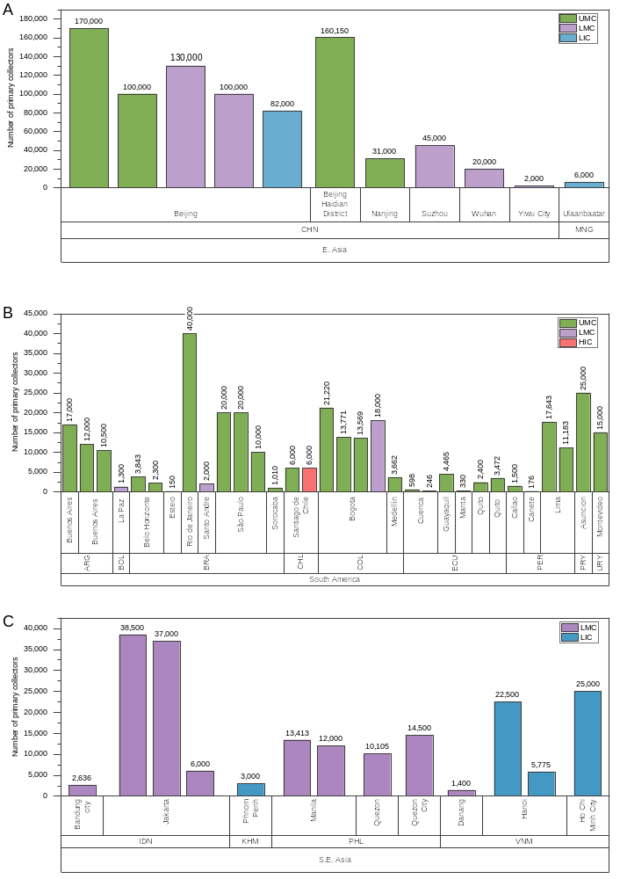
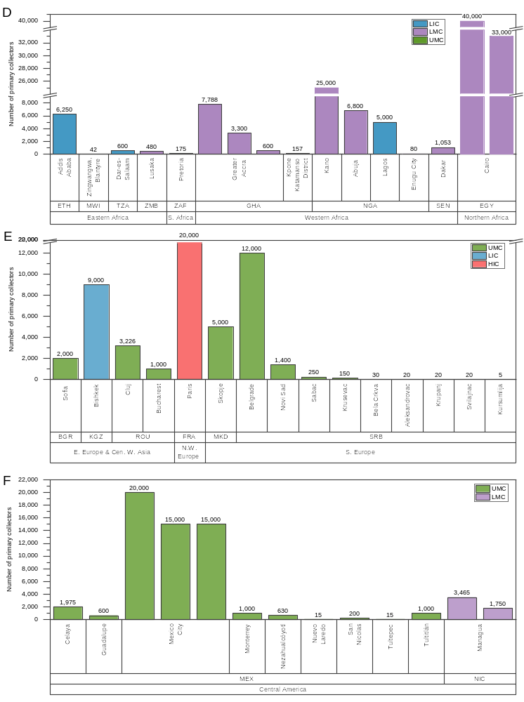
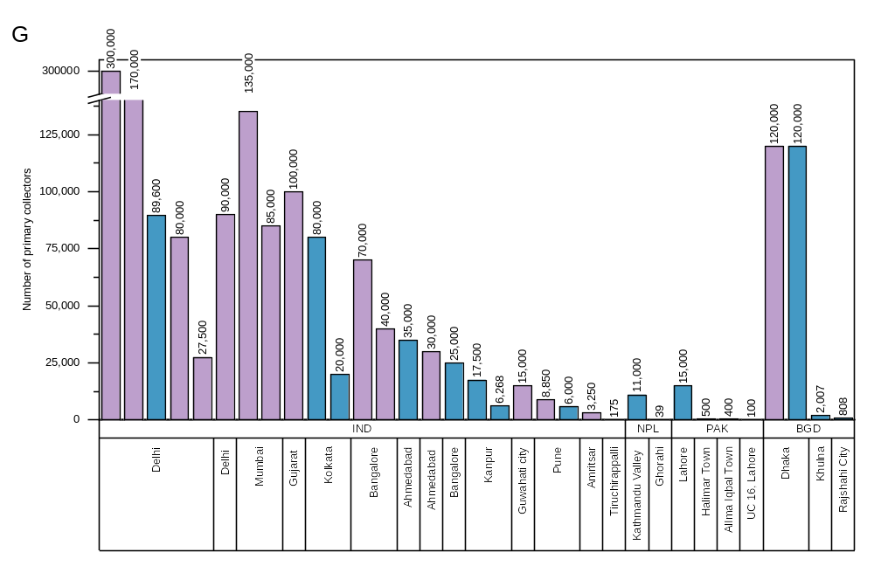Fig. S2: Absolute number of primary collectors reported in sub-national administrative areas in (A) Eastern Asia; (B) South America; and (C) Southeast Asia; (D) Africa; (E) Europe and Central and Western Asia; (F) Central America; and (G) Southern Asia (source data Table ST01d).

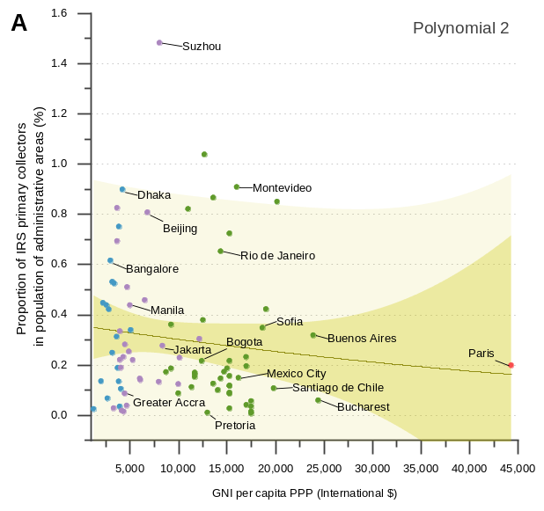 | 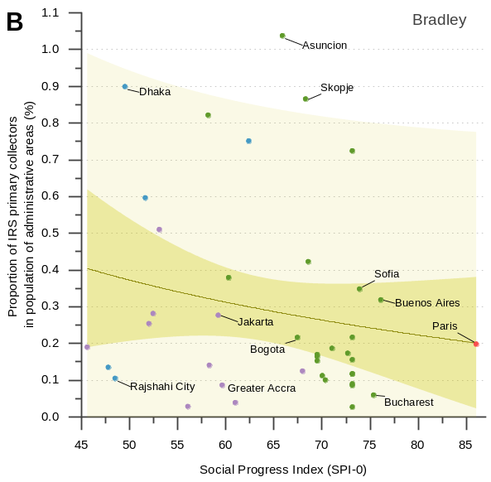
Fig. S3: Correlation between (A) GNI per capita, PPP (constant 2017 international $) and proportion of IRS primary collectors in subnational administrative areas – version includes Paris. Dark green line is fitted 2nd order polynomial curve; and (B) Social progress Index (SP-0) with proportion of IRS primary collectors in subnational administrative areas. Dark green line is fitted Bradley model (Table ST01e).

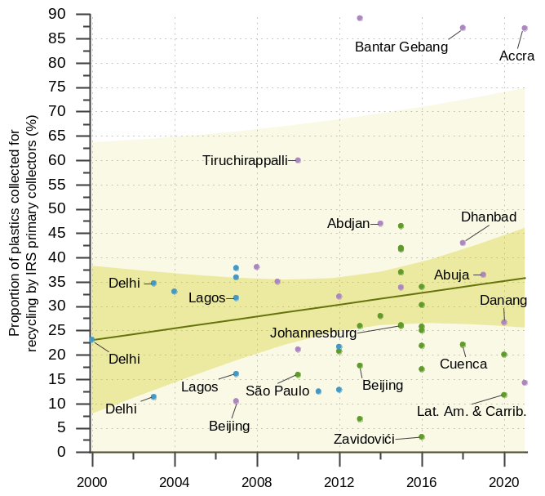
Fig. S4: Change in plastics composition reported in national and sub-national administrative areas. This alternative analysis of dataset presented in Figure 5B in main manuscript shows the effect on the regression line with the datapoint for Hanoi excluded. Green line is fitted linear model (Table ST03a).
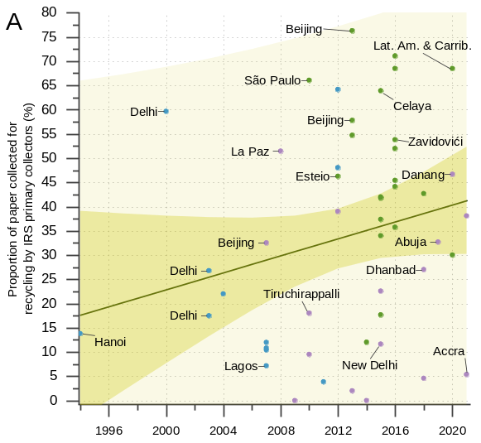 | 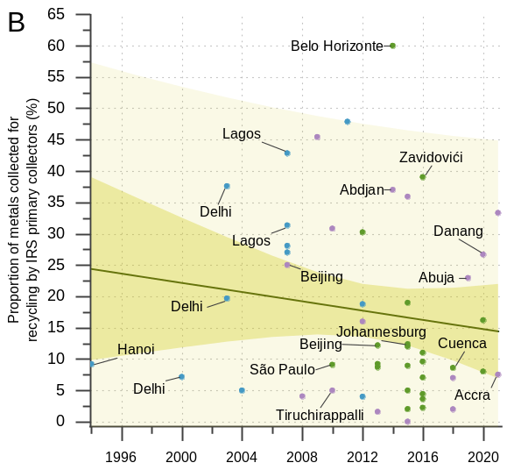
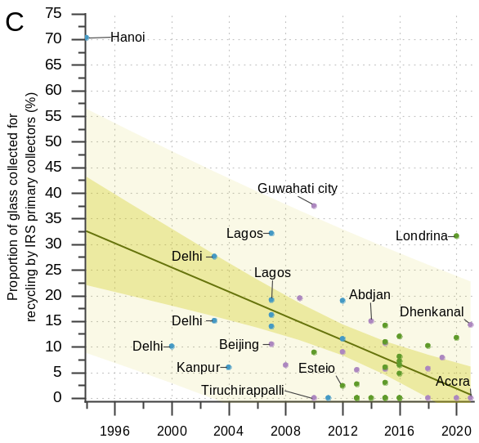 | 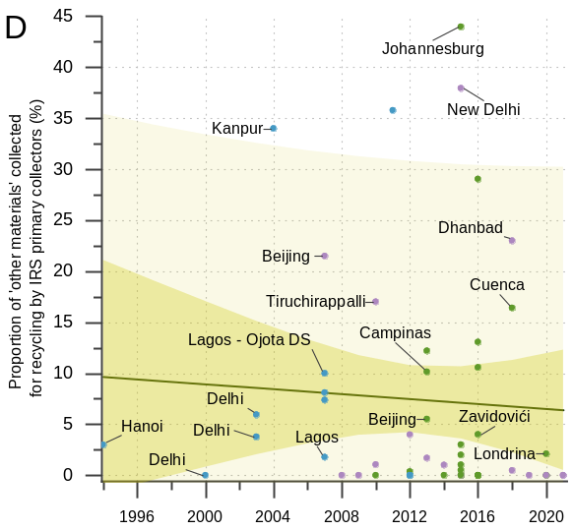
Fig. S5: Change in composition of (A) Paper; (B) Metals; (C) Glass; and (D) Other materials, reported in national and sub-national administrative areas. Green lines are fitted linear models (Table ST03a).

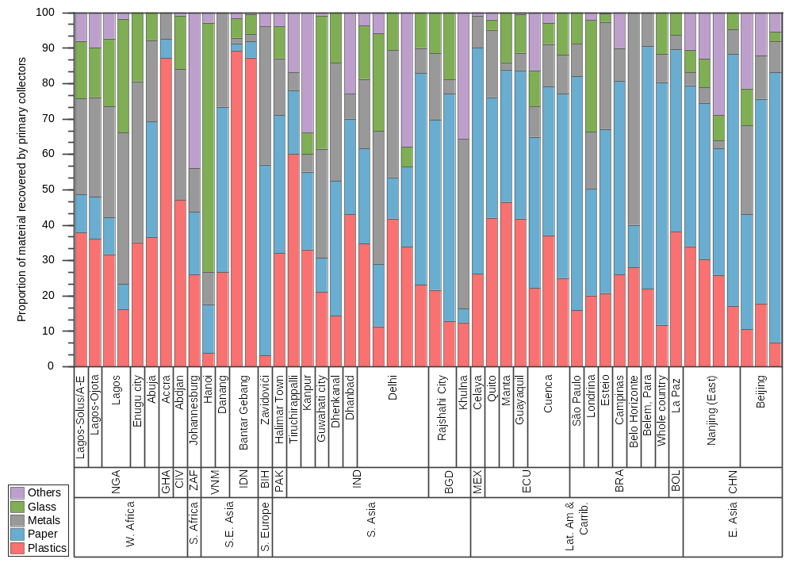
Fig. S6: Basic composition of waste collected for recycling by informal recycling sector primary collectors in sub-national administrative areas worldwide (Table ST_03b). Proportions are calculated as a mean where data were found for more than one sub-national administrative area.

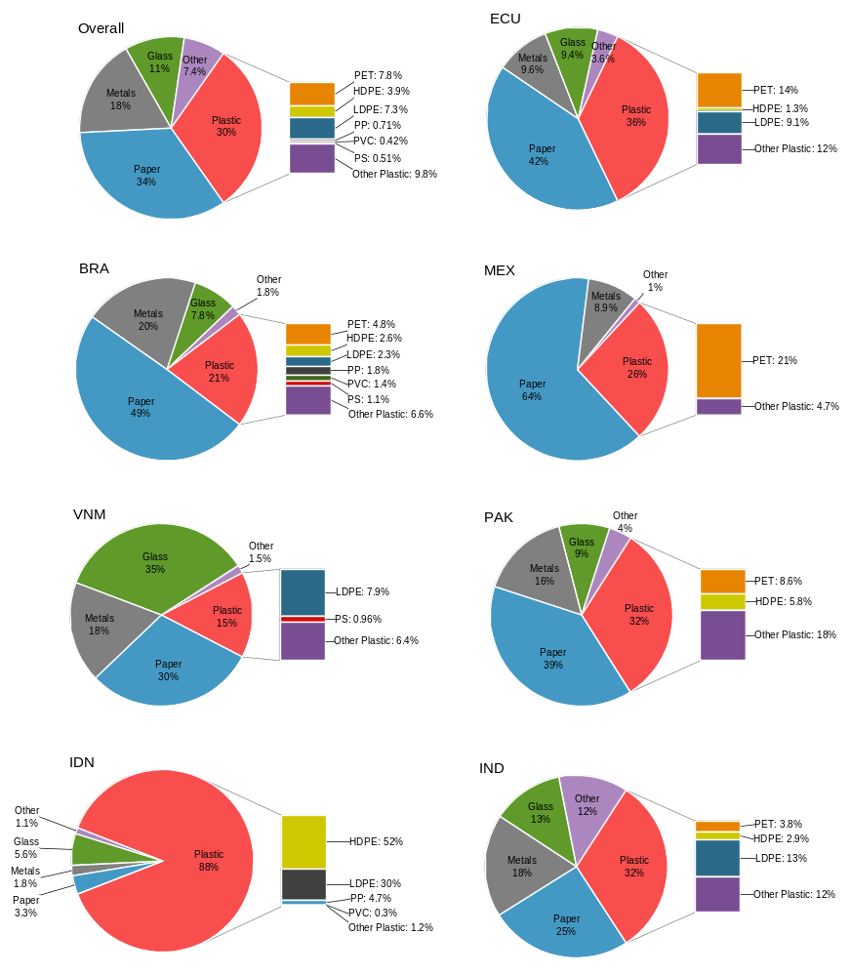
Fig. S7: Detailed composition of material collected for recycling by informal recycling sector primary collectors. Proportions are the mean of studies calculated for each country (Table ST03g).

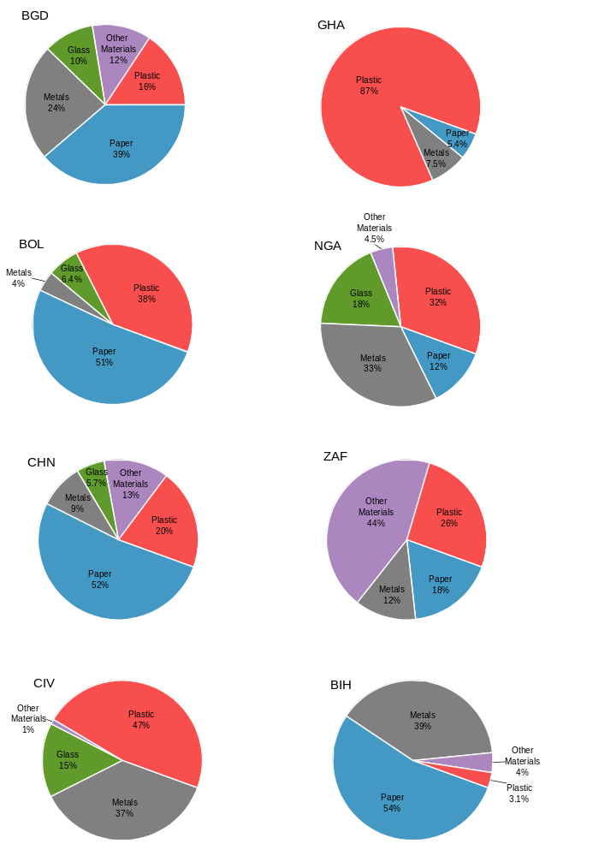
Fig. S8: Detailed composition of material collected for recycling by informal recycling sector primary collectors. Proportions are the mean of studies calculated for each country. Source data in Table ST_03g.

Operating context
Though many of the sources reviewed reported the proportion of IRS primary collectors working in different contexts, we rejected most as they appeared to erroneously refer to their own sample rather than the whole population. Four studies were included, which referred to the waste picker populations in 14 locations (Fig. S9). Eleven are from Espinoza et al. (2011) whose supra-national survey of Latin American countries was based on a stratified sample of municipalities across the region. Overall, approximately 50% (arithmetic mean) of primary collectors work in the urban environment (streets), with a large between-country variation between 5% and 97% in the countries and sub-national administrative areas reviewed.
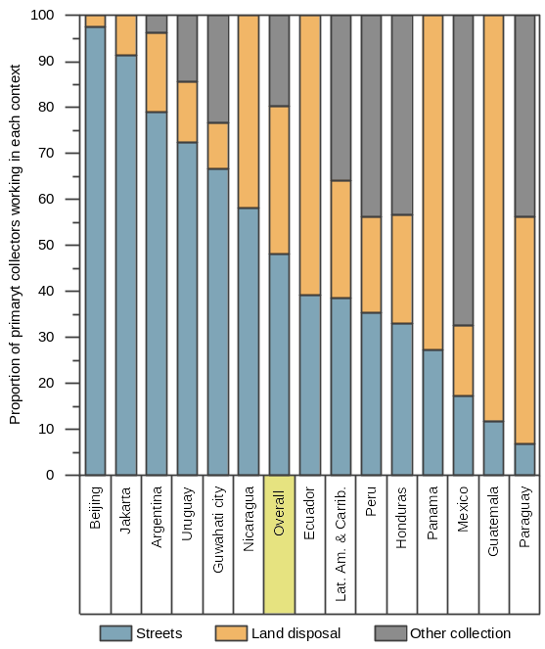
Fig. S9: Proportion of primary collectors working in different contexts in countries and sub-nation al administrative areas (Table ST05b). Bar for ‘Overall’ is the arithmetic mean of all data points. ‘Other collection’ includes cooperatives, ‘other places’ and other types of collaborative collection activities.

Author contributions
E.C.: Conceptualization; Methodology; Validation; Formal analysis; Investigation; Data Curation; Writing - Original Draft; Writing - Review & Editing; Visualization. N.S.S.LC.: Conceptualization; Methodology; Validation; Formal analysis; Investigation; Data Curation. C.A.V.: Conceptualization; Methodology; Validation; Formal analysis; Investigation; Data Curation; Writing - Original draft; Writing - Review & Editing; Visualization; Supervision; Resources; Funding acquisition.
Acknowledgements
We would like to thank: Xue Mei for assistance with searching and screening data in Chinese; Josh W. Cottom for assistance with data analysis; Kwaku Oduro-Appiah, David C. Wilson and Remi Jaligot for their assistance with clarification of findings in their research.
Funding
This work was partly supported by GRID-Arendal and NORAD under project number 205275, with additional in-kind support by the University of Leeds; and the University of Leeds Visiting Researcher Fund supporting Nathalia Silva de Souza Lima Cano’s research placement in Leeds. The views expressed in this article are those of the authors’ alone and do not necessarily represent the views or policies of GRID-Arendal or NORAD.
Declaration of Competing Interest
The authors declare that they have no known competing financial interests or personal relationships that could have appeared to influence the work reported in this paper.
Data availability statement
All data relating to this study are available in the main text and supplementary information and supplementary data file.

References
Abledu, E.S., Amfo-Otu, R., 2018. Contribution of Informal Sector Recycling Workers to Sustainable Landfill Management: The Case of Kpone Landfill Site in the Greater Accra Region. PUCG Appl. Res. J. 4, 1-11.
Adebola, O.O., "The roles of informal private sector in integrated solid waste management in the achievement of the millennium development goals (MDGS) in Lagos, Nigeria " in Solid Waste, Health & Millennium Development Goals, CWG- WASH Workshop (Richbol Environmental Services Ltd, 2006).
Afon, A., 2012. A survey of operational characteristics, socioeconomic and health effects of scavenging activity in Lagos, Nigeria. Waste Manage. Res. 30(7), 664-671.
Agarwal, A., Singhmar, A., Kulshrestha, M., Mittal, A.K., 2005. Municipal solid waste recycling and associated markets in Delhi, India. Resour. Conserv. Recycl. 44(1), 73-90.
Ahn, J., Lee, J., Park, H., Kang, Y., Kang, C., You, Y.J., Kang, M.Y., 2020. The Health Status of Informal Waste Collectors in Korea. International Journal of Environmental Research and Public Health 17(15).
Akaike, H., 1974. A new look at the statistical model identification. IEEE Transactions on Automatic Control 19(6), 716-723.
Al-Khatib, I.A., Al-Sari’, M.I., Kontogianni, S., 2020. Assessment of Occupational Health and Safety among Scavengers in Gaza Strip, Palestine. Journal of Environmental and Public Health 2020, 3780431.
Andrade, A.A., Braga, R.M.Q.L., Fernandes, L.L., Gomes, R.R.K.d.A., 2020. Evaluation of recyclable waste management of a waste pickers’ association in Belém, Brazil. 173(2), 28-39.
Andrianisa, H.A., Brou, Y.O.K., Séhi bi, A., 2016. Role and importance of informal collectors in the municipal waste pre-collection system in Abidjan, Côte d'Ivoire. Habitat. Int. 53, 265-273.
Asim, M., Batool, S.A., Chaudhry, M.N., 2012. Scavengers and their role in the recycling of waste in Southwestern Lahore. Resour. Conserv. Recycl. 58, 152-162.
Baah-Boateng, W., Vanek, J., 2020. Statistical Brief No 21 - Informal Workers in Ghana: A Statistical Snapshot, WIEGO, Manchester, UK https://www.wiego.org/sites/default/files/publications/file/WIEGO_Statistical_Brief_N21_0.pdf.
Becerra, L., Carenzo, S., Juarez, P., 2020. When Circular Economy Meets Inclusive Development. Insights from Urban Recycling and Rural Water Access in Argentina. Sustainability 12(23).
Bermudez, J.F., Montoya-Ruiz, A.M., Saldarriaga, J.F., 2019. Assessment of the Current Situation of Informal Recyclers and Recycling: Case Study Bogotá. Sustainability 11(22).
Besen, G.R., Fracalanza, A.P., 2016. Challenges for the sustainable management of municipal solid waste in Brazil. Disp 52(2), 45-52.
Black, M., Karki, J., Lee, A.C.K., Makai, P., Baral, Y.R., Kritsotakis, E.I., Bernier, A., Fossier Heckmann, A., 2019. The health risks of informal waste workers in the Kathmandu Valley: a cross-sectional survey. Public Health 166, 10-18.
Bonini-Rocha, A.C., de Oliveira, R.A.C., Bashash, M., do Couto Machado, G., Cruvinel, V.R.N., 2021. Prevalence of musculoskeletal disorders and risk factors in recyclable material waste pickers from the dump of the structural city in Brasília, Brazil. Waste Manage. 125, 98-102.
Borongan, G., Okumura, S., 2010. Municipal Waste Management Report: Status-quo and Issues in Southeast and East Asian Countries, AIT/UNEP Regional Resource Center for Asia and the Pacific (RRC.AP), Pathumthani, Thailand https://digital.library.unt.edu/ark:/67531/metadc226662/m2/1/high_res_d/Municipal%20Waste%20Report.pdf.
Botello-Álvarez, J.E., Rivas-García, P., Fausto-Castro, L., Estrada-Baltazar, A., Gomez-Gonzalez, R., 2018. Informal collection, recycling and export of valuable waste as transcendent factor in the municipal solid waste management: A Latin-American reality. J Clean Prod 182, 485-495.
Bouvier, M., Dias, S., 2021. Statistical Brief No 29 - Waste Pickers in Brazil: A Statistical Profile, WIEGO, Manchester, UK https://www.wiego.org/sites/default/files/publications/file/WIEGO_Statistical_Brief_N29_Brazil_WPs.pdf.
Burneo, D., Cansino, J.M., Yñiguez, R., 2020. Environmental and socioeconomic impacts of urban waste recycling as part of circular economy. The case of Cuenca (Ecuador). Sustainability 12(8), 3406.
Cajamarca Cajamarca, E.S., Bueno Sagbaicela, W.R., y Jimbo Días, J.S., 2019. De cero a dinero: La basura como fuente principal para un negocio inclusivo de reciclaje en Cuenca (Ecuador). Retos Revista de Ciencias de la Administración y Economía 9(17), 71-87.
Chandramohan, A., Ravichandran, C., Sivasankar, V., 2010. Solid waste, its health impairments and role of rag pickers in Tiruchirappalli city, Tamil Nadu, Southern India. 28(10), 951-958.
Chen, F., Luo, Z., Yang, Y., Liu, G.J., Ma, J., 2018. Enhancing municipal solid waste recycling through reorganizing waste pickers: A case study in Nanjing, China. Waste Manage. Res. 36(9), 767-778.
Chikarmane, P., 2014. Informal Economy Monitoring Study: Waste Pickers in Pune, India, WIEGO, Manchester, UK https://www.wiego.org/sites/default/files/publications/files/IEMS-Pune-Waste-Pickers-City-Report.pdf.
CHINTAN, 2005. Informal-Formal: Creating opportunities for the informal sector in Asia, Chintan Environmental Research and Action Group, Delhi, India https://tinyurl.com/y6gaqwvn.
CHINTAN, 2009. Carving opportunities: A manual to facilitate children wastepickers access education, Group, C.E.R.a.A., New Delhi, India https://www.chintan-india.org/index.php/node/239.
Conke, L.S., 2018. Barriers to waste recycling development: Evidence from Brazil. Resour. Conserv. Recycl. 134, 129-135.
Cook, E., Derks, M., Velis, C.A., 2023. Plastic waste reprocessing for circular economy: A systematic scoping review of risks to occupational and public health from legacy substances and extrusion. Sci. Total Environ. 859, 160385.
Cruvinel, V.R.N., Zolnikov, T.R., Takashi Obara, M., Oliveira, V.T.L.d., Vianna, E.N., Santos, F.S.G.d., Oliveira, K.C.d., Scott, J.A., 2020. Vector-borne diseases in waste pickers in Brasilia, Brazil. Waste Manage. 105, 223-232.
Di Gregorio, M., 1994. Urban harvest: Recycling as a peasant industry in Northern Vietnam, East-WEst Center, Honolulu, USA https://scholarspace.manoa.hawaii.edu/bitstream/10125/21620/1/ENVop017UrbanHarvest1994%5Bpdfa%5D.PDF.
Diaz, R., Otoma, S., 2014. Cost–benefit analysis of waste reduction in developing countries: a simulation. J. Mater. Cycles Waste Manage. 16(1), 108-114.
Do Carmo, M.S., Puppim de Oliveira, J.A., 2010. The Semantics of Garbage and the organization of the recyclers: Implementation challenges for establishing recycling cooperatives in the city of Rio de Janeiro, Brazil. Resour. Conserv. Recycl. 54(12), 1261-1268.
DRZ, 2016. Plano de Coleta Seletiva [in portugees], Prefeitura Municipal de Sorocaba sp, Sorocaba https://servicospublicos.sorocaba.sp.gov.br/wp-content/uploads/2016/10/planocoletaseletiva.pdf.
Espinoza, P.T., Arce, E.M., Daza, D., Faure, M.S., Terraza, H., 2011. Regional Evaluation on Urban Solid Waste Management in Latin America and the Caribbean: 2010 Report, Pan American Health Organization (PAHO), Inter-American Development Bank (IDB), Inter-American Association of Sanitary and Environmental Engineering (AIDIS) https://publications.iadb.org/en/regional-evaluation-urban-solid-waste-management-latin-america-and-caribbean-2010-report.
Evergreen Social Ventures, 2020. Mapping Informal Waste Sector in Da Nang: Understanding the informal waste sector, its workers & dynamic during COVID - Da Nang Case Study, UNDP https://www.undp.org/sites/g/files/zskgke326/files/migration/vn/UNDP-Mapping-Informal-Waste-Sector-in-Da-Nang_FINAL.pdf.
Ferronato, N., Preziosi, G., Gorritty Portillo, M.A., Guisbert Lizarazu, E.G., Torretta, V., 2020. Assessment of municipal solid waste selective collection scenarios with geographic information systems in Bolivia. Waste Manage. 102, 919-931.
Fulwani, D., Banda, D., Shah, H., Chandel, D., 2020. Women rag pickers at a dump in Ahmedabad: Genotoxicity and oxidative stress. Mutation Research/Genetic Toxicology and Environmental Mutagenesis 858-860, 503254.
Fuss, M., Barros, R.T.V., Poganietz, W.R., 2021. The role of a socio-integrated recycling system in implementing a circular economy – The case of Belo Horizonte, Brazil. Waste Manage. 121, 215-225.
GIZ, 2018. Inclusion of informal collectors into the evolving waste management system in Serbia: A Roadmap for Integration, GIZ, Belgrade, Serbia https://www.giz.de/de/downloads/inclusion-of-informal-collectors-into-the-evolving-waste-management.pdf.
Godfrey, L., Oelofse, S., 2017. Historical Review of Waste Management and Recycling in South Africa. Resources 6(4).
Guo, S., Zhang, H., Minghui, Z., Lin, A.Y., 2007. 京城十万拾荒族忐忑面 对被“收编 http://www.mbtsg.com/periodical/9e7d9fc1baa9b966e4c452bb5b598c9c.html.
Gutberlet, J., Baeder, A.M., 2008. Informal recycling and occupational health in Santo André, Brazil. Int. J. Environ. Health Res. 18(1), 1-15.
Gutberlet, J., Besen, G.R., Morais, L., 2020. Participatory solid waste governance and the role of social and solidarity economy: Experiences from São Paulo, Brazil. 13, 167-180.
Hamidul Bari, Q., Mahbub Hassan, K., Ehsanul Haque, M., 2012. Solid waste recycling in Rajshahi city of Bangladesh. Waste Manage. 32(11), 2029-2036.
Hartmann, C., 2018. Waste picker livelihoods and inclusive neoliberal municipal solid waste management policies: The case of the La Chureca garbage dump site in Managua, Nicaragua. Waste Manage. 71, 565-577.
Hayami, Y., Dikshit, A.K., Mishra, S.N., 2006. Waste pickers and collectors in Delhi: Poverty and environment in an urban informal sector. The Journal of Development Studies 42(1), 41-69.
IRR, 2015. Avances en el reciclaje y en la inclusión de recicladores básicos en el Ecuador: Diagnóstico en las ciudades de Quito, Guayaquil, Cuenca y Manta, Regional Initiative for Inclusive Recycling https://latitudr.org/wp-content/uploads/2016/04/Reciclaje-Inlcusivo-y-Recicladores-de-base-en-EC.pdf.
Jaligot, R., Wilson, D.C., Cheeseman, C.R., Shaker, B., Stretz, J., 2016. Applying value chain analysis to informal sector recycling: A case study of the Zabaleen. Resour. Conserv. Recycl. 114, 80-91.
Kamran, A., Chaudhry, M.N., Batool, S.A., 2015. Role of the informal sector in recycling waste in eastern lahore. Pol. J. Environ. Stud. 24(2), 537-543.
Karki, J., Pohl, G., Baral, Y.R., Makai, P., Black, M., Lee, A.C., Kritsotakis, E., Fossier-Heckmann, A., Poudel, S., Bernier, A., 2018. Health status and occupational risks in informal waste workers in Nepal: Results from a cross-sectional study conducted in the Kathmandu Valley, Médecins du Monde https://www.medecinsdumonde.org/app/uploads/2022/04/MDM-Nepal_Waste_Workers_web.pdf.
Kaseva, M.E., Gupta, S.K., 1996. Recycling — an environmentally friendly and income generating activity towards sustainable solid waste management. Case study — Dar es Salaam City, Tanzania. Resour. Conserv. Recycl. 17(4), 299-309.
Kashyap, A., Kalita, J., Kalita, S., Mazumdar, K., 2010. Present scenario of solid waste with special reference to plastic and other non-biodegradable solid waste and its management for the sustainable urban poor development in Guwahati City, Assam, India. NeBIO 0976-3597 1, 18-26.
Kasinja, C., Tilley, E., 2018. Formalization of informal waste pickers' cooperatives in Blantyre, Malawi: A feasibility assessment. Sustainability (Switzerland) 10(4).
Kaza, S., Yao, L., Bhada-Tata, P., Woerden, F.V., 2018. What a Waste 2.0: A Global Snapshot of Solid Waste Management to 2050., Washington, DC.
King, M.F., Gutberlet, J., 2013. Contribution of cooperative sector recycling to greenhouse gas emissions reduction: A case study of Ribeirão Pires, Brazil. Waste Manage. 33(12), 2771-2780.
Koolwal, G., 2022. Statistical Brief No 31 - Informal Workers in Senegal:
A Statistical Profile, WIEGO, Manchester, UK https://www.wiego.org/sites/default/files/publications/file/WIEGO_Statistical_BriefN31_Senegal.pdf.
Kumar, A., Samadder, S.R., Kumar, N., Singh, C., 2018. Estimation of the generation rate of different types of plastic wastes and possible revenue recovery from informal recycling. Waste Manage. 79, 781-790.
Levenberg, K., 1944. A METHOD FOR THE SOLUTION OF CERTAIN NON-LINEAR PROBLEMS IN LEAST SQUARES. Quarterly of Applied Mathematics 2(2), 164-168.
Li, S., 2002. Junk-buyers as the linkage between waste sources and redemption depots in urban China: the case of Wuhan. Resour. Conserv. Recycl. 36(4), 319-335.
Li, X., 2013. Analysis of the reasons and ways of scavengers and their scavenging (in Chinese). Manage. Engin., (5), 58-61.
Li, Y., 2003. 城市拾荒者 [Urban Scavengers]. http://www.chinatoday.com.cn/china/2003/0305/03.htm. 20 July 2022).
Lino, F., Ismail, K., 2012. Analysis of the potential of municipal solid waste in Brazil. Environ Dev 4, 105-113.
Linzner, R., Lange, U., 2013. Role and size of informal sector in waste management – a review. Proceedings of the Institution of Civil Engineers - Waste and Resource Management 166(2), 69-83.
Linzner, R., Salhofer, S., 2014. Municipal solid waste recycling and the significance of informal sector in urban China. Waste Manage. Res. 32(9), 896-907.
López de Munain, D., Castelo, B., Ruggerio, C.A., 2021. Social metabolism and material flow analysis applied to waste management: A study case of Autonomous City of Buenos Aires, Argentina. Waste Manage. 126, 843-852.
Marques, C.P., Zolnikov, T.R., Noronha, J.M.d., Angulo-Tuesta, A., Bashashi, M., Cruvinel, V.R.N., 2021. Social vulnerabilities of female waste pickers in Brasília, Brazil. Archives of Environmental & Occupational Health 76(3), 173-180.
Masocha, M., 2006. Informal waste harvesting in Victoria Falls town, Zimbabwe: Socio-economic benefits. Habitat. Int. 30(4), 838-848.
Masood, M., Barlow, C.Y., 2013. Framework for integration of informal waste management sector with the formal sector in Pakistan. Waste Manage. Res. 31(10_suppl), 93-105.
Medina, M., 2005. Serving the unserved: informal refuse collection in Mexico. Waste Manage. Res. 23(5), 390-397.
Medina, M., 2007. Waste picker cooperatives in developing countries, in: Chen, M., Jhabvala, R., Kanbur, R., Richards, C. (Eds.), Membership Based Organizations of the Poor (Routledge Studies in Development Economics). Routledge, Oxon, UK, pp. 125-141.
Miranda, I.T., Fidelis, R., de Souza Fidelis, D.A., Pilatti, L.A., Picinin, C.T., 2020. The integration of recycling cooperatives in the formal management of municipal solid waste as a strategy for the circular economy: The case of Londrina, Brazil. Sustainability 12(24), 10513.
Mitchell, C.L., 2008. Altered landscapes, altered livelihoods: The shifting experience of informal waste collecting during Hanoi's urban transition. Geoforum 39(6), 2019-2029.
Mkhize, S., Dube, G., Quazi, T., 2014. Informal Economy Monitoring Study: Waste Pickers in Durban, South Africa, WIEGO, Manchester, UK https://www.wiego.org/sites/default/files/publications/files/Mkhize-IEMS-Durban-City-Report-Waste-Pickers.pdf.
Mo, H., Wen, Z., Chen, J., 2009. China's recyclable resources recycling system and policy: A case study in Suzhou. Resour. Conserv. Recycl. 53(7), 409-419.
Moniruzzaman, S.M., Bari, Q.H., Fukuhara, T., 2011. Recycling practices of solid waste in Khulna City, Bangladesh. J. Solid Waste Technol. Manage. 37(1), 1-15.
Mrkajić, V., Stanisavljevic, N., Wang, X., Tomas, L., Haro, P., 2018. Efficiency of packaging waste management in a European Union candidate country. Resour. Conserv. Recycl. 136, 130-141.
Nandy, B., Sharma, G., Garg, S., Kumari, S., George, T., Sunanda, Y., Sinha, B., 2015. Recovery of consumer waste in India – A mass flow analysis for paper, plastic and glass and the contribution of households and the informal sector. Resour. Conserv. Recycl. 101, 167-181.
Navarrete-Hernandez, P., Navarrete-Hernandez, N., 2018. Unleashing waste-pickers’ potential: Supporting recycling cooperatives in Santiago de Chile. World Devel. 101, 293-310.
Nzeadibe, C., Iwuoha, H.C., 2008. Informal waste recycling in Lagos, Nigeria. Communications in Waste & Resource Management 9, 24-30.
Nzeadibe, T.C., 2009. Solid waste reforms and informal recycling in Enugu urban area, Nigeria. Habitat. Int. 33(1), 93-99.
Oduro-Appiah, K., Scheinberg, A., Afful, A., de Vries, N., 2021. The contribution of participatory engagement strategies to reliable data gathering and inclusive policies in developing countries: Municipal solid waste management data in the Greater Accra Metropolitan Area of Ghana. Afr J Sci Technol In 13(6), 735-746.
Ogwueleka, T.C., BP, N., 2021. Activities of informal recycling sector in North-Central, Nigeria. Energy. Nex. 1, 100003.
Oteng-Ababio, M., 2012. The role of the informal sector in solid waste management in The Gama, Ghana: Challenges and opportunities. Tijdschrift voor economische en sociale geografie 103(4), 412-425.
Parra, F., 2020. The Struggle of Waste Pickers in Colombia: From being considered trash, to being recognised as workers. Anti-Trafficking Review 10.14197/atr.201220157(15), 122-136.
Paul, J.G., Arce-Jaque, J., Ravena, N., Villamor, S.P., 2012. Integration of the informal sector into municipal solid waste management in the Philippines - What does it need? Waste Manage. 32(11), 2018-2028.
Peters, M.D.J., Marnie, C., Tricco, A.C., Pollock, D., Munn, Z., Alexander, L., McInerney, P., Godfrey, C.M., Khalil, H., 2020. Updated methodological guidance for the conduct of scoping reviews. JBI evidence synthesis 18(10), 2119-2126.
Practical Action, 2021. Managing our waste 2021: View from the Global South, Practical Action Publishing, Rugby, UK https://doi.org/10.3362/9781788530989.
Putri, A.R., Fujimori, T., Takaoka, M., 2018. Plastic waste management in Jakarta, Indonesia: evaluation of material flow and recycling scheme. J. Mater. Cycles Waste Manage. 20(4), 2140-2149.
Rockson, G.N.K., Kemausuor, F., Seassey, R., Yanful, E., 2013. Activities of scavengers and itinerant buyers in Greater Accra, Ghana. Habitat. Int. 39, 148-155.
Romero, D.H.A., Oudin, A., Strömberg, U., Karlsson, J.-E., Welinder, H., Sequeira, G., Blanco, L., Jiménez, M., Sánchez, F., Albin, M., 2010. Respiratory symptoms among waste-picking child laborers: a cross-sectional study. Int. J. Occup. Environ. Health. 16(2), 120-131.
Rutkowski, J.E., 2020. Inclusive packaging recycling systems: Improving sustainable waste management for a circular economy. Detritus 13, 29-46.
Sabedot, S., Pereira Neto, T., 2017. Desempenho ambiental dos catadores de materiais recicláveis em Esteio (RS). Engenharia Sanitaria e Ambiental 22, 103-109.
Sant’Ana, D.d., Metello, D., 2016. Capítulo 1: Reciclagem e inclusão social no Brasil: Balanço e desafios [Chapter 1: Recycling and social inclusion in Brazil: Balance and challenges], in: Pereira, B.C.J., Goes, F.L. (Eds.), Recyclable Material Collectors: A national meeting. IPEA - Instituto de Pesquisa Econômica Aplicada, Brasília.
Sasaki, S., Araki, T., 2014. Estimating the possible range of recycling rates achieved by dump waste pickers: The case of Bantar Gebang in Indonesia. Waste Manage. Res. 32(6), 474-481.
Sasaki, S., Watanabe, K., Lee, K., Widyaningsih, N., Baek, Y., Araki, T., 2020. Recycling contributions of dumpsite waste pickers in Bantar Gebang, Indonesia. J. Mater. Cycles Waste Manage. 22(5), 1662-1671.
Scheinberg, A., Nesić, J., Savain, R., Luppi, P., Sinnott, P., Petean, F., Pop, F., 2016. From collision to collaboration – Integrating informal recyclers and re-use operators in Europe: A review. Waste Manage. Res. 34(9), 820-839.
Scheinberg, A., Spies, S., Simpson, M.H., Mol, A.P.J., 2011. Assessing urban recycling in low- and middle-income countries: Building on modernised mixtures. Habitat. Int. 35(2), 188-198.
Scheinberg, A., Wilson, D.C., Rodic-Wiersma, L., 2010. Solid waste management in the world's cities, Earthscan, London, UK https://unhabitat.org/solid-waste-management-in-the-worlds-cities-water-and-sanitation-in-the-worlds-cities-2010-2.
Schenck, C.J., Blaauw, P.F., Swart, E.C., Viljoen, J.M.M., Mudavanhu, N., 2019. The management of South Africa’s landfills and waste pickers on them: Impacting lives and livelihoods. Devel. Southern Africa 36(1), 80-98.
Schenck, R., Blaauw, P.F., 2011. The work and lives of street waste pickers in Pretoria—a case study of recycling in South Africa’s urban informal economy, Urban Forum. Springer, p. 411.
Sembiring, E., Nitivattananon, V., 2010. Sustainable solid waste management toward an inclusive society: Integration of the informal sector. Resour. Conserv. Recycl. 54(11), 802-809.
Silva de Souza Lima, N., Mancini, S.D., 2017. Integration of informal recycling sector in Brazil and the case of Sorocaba City. Waste Manage. Res. 35(7), 721-729.
Silva, S.P., Goes, F.L., Alvarez, A.R., 2013. Situação Social das Catadoras e dos Catadores de Material Reciclável e Reutilizável: Brasil [Social Situation of Recyclable and Reusable Material Waste Pickers: Brazil], IPEA - Instituto de Pesquisa Econômica Aplicada, Brasília, Brazil https://www.ipea.gov.br/portal/images/stories/PDFs/situacao_social/131219_relatorio_situacaosocial_mat_reciclavel_brasil.pdf.
Sim, N.M., Wilson, D.C., Velis, C.A., Smith, S.R., 2013. Waste management and recycling in the former Soviet Union: The City of Bishkek, Kyrgyz Republic (Kyrgyzstan). Waste Manage. Res. 31(10 SUPPL.), 106-125.
Simatele, D.M., Dlamini, S., Kubanza, N.S., 2017. From informality to formality: Perspectives on the challenges of integrating solid waste management into the urban development and planning policy in Johannesburg, South Africa. Habitat. Int. 63, 122-130.
Singh, R., Chari, K.R., "Socio-economic issues in waste management by informal sector in india" in Proceedings of the International Expert Conference on the Project TransWaste, Going Green – Care Innovation 2010 (2010).
Social Progress Imperative, Social progress index 2022. The Social Progress Imperative (2022); https://www.socialprogress.org/download/.
Steuer, B., Ramusch, R., Part, F., Salhofer, S., 2017. Analysis of the value chain and network structure of informal waste recycling in Beijing, China. Resour. Conserv. Recycl. 117, 137-150.
Talyan, V., Dahiya, R.P., Sreekrishnan, T.R., 2008. State of municipal solid waste management in Delhi, the capital of India. Waste Manage. 28(7), 1276-1287.
The Economist Intelligence Unit, 2017. Progress and Challenges for Inclusive Recycling: An Assessment of 12 Latin American and Caribbean Cities, EIU, New York, USA https://latitudr.org/wp-content/uploads/2017/05/EIU_Inclusive-Recycling_report-ENGLISH.pdf.
The World Bank, GDP per capita, PPP (constant 2017 international $). (2023a); https://databank.worldbank.org/.
The World Bank, GNI per capita, PPP (constant 2017 international $). (2023b); https://databank.worldbank.org/.
The World Bank, Population, Total. (2023c); https://api.worldbank.org/v2/en/indicator/SP.POP.TOTL?downloadformat=excel.
Tricco, A.C., Lillie, E., Zarin, W., O'Brien, K.K., Colquhoun, H., Levac, D., Moher, D., Peters, M.D.J., Horsley, T., Weeks, L., Hempel, S., Akl, E.A., Chang, C., McGowan, J., Stewart, L., Hartling, L., Aldcroft, A., Wilson, M.G., Garritty, C., Lewin, S., Godfrey, C.M., Macdonald, M.T., Langlois, E.V., Soares-Weiser, K., Moriarty, J., Clifford, T., Tunçalp, Ö., Straus, S.E., 2018. PRISMA Extension for Scoping Reviews (PRISMA-ScR): Checklist and Explanation. Annals of Internal Medicine 169(7), 467-473.
UAESP, 2012. Informe final censo de recicladores, bogotá humana 2012: Informe final revisado y ajustado, Unidad administrativa especial de servicios públicos, Bogotá, Colombia https://www.anrcolombia.org/index.php?option=com_phocadownload&view=category&download=133:uaesp-informe-final-censo-de-recicladores-bogota-2012&id=27:formalizacion-censo-recicladores&Itemid=148.
Uddin, S.M.N., Gutberlet, J., Ramezani, A., Nasiruddin, S.M., 2020. Experiencing the Everyday of Waste Pickers: A Sustainable Livelihoods and Health Assessment in Dhaka City, Bangladesh. Journal of International Development 32(6), 833-853.
UNDP, Table 1: Human Development Index and components. United Nations Development Programme (UNDP) (2023); https://hdr.undp.org/sites/default/files/2021-22_HDR/HDR21-22_Statistical_Annex_HDI_Table.xlsx.
Vaccari, M., Perteghella, A., 2016. Resource recovery from waste by Roma in the Balkans: A case study from Zavidovici (BiH). Waste Manage. Res. 34(9), 866-874.
Vaccari, M., Torretta, V., Collivignarelli, C., 2012. Effect of improving environmental sustainability in developing countries by upgrading solid waste management techniques: A case study. Sustainability 4(11), 2852-2861.
Valderrama, C., Ortiz, J.D., Usa, M.M., Borrero, O.I., 2020. Analysis of the Recycling Sector in Intermediate Cities, Study Case - Neiva, Colombia %J Ingeniería y competitividad. 22.
Valenzuela-Levi, N., 2020. Waste Political Settlements in Colombia and Chile: Power, Inequality and Informality in Recycling. Dev. Change. 51(4), 1098-1122.
van Beukering, P., Sehker, M., Gerlagh, R., Kumar, V., 1999. Analysing Urban Solid Waste in Developing Countries: a Perspective on Bangalore, India, International Institute for Environment and Development (IIED), Amsterdam, The Netherlands https://www.academia.edu/download/100429222/creed24e.pdf.
Velis, C.A., Wilson, D.C., Gavish, Y., Grimes, S.M., Whiteman, A., 2023. Socio-economic development drives solid waste management performance in cities: A global analysis using machine learning. Sci. Total Environ. 872, 161913.
Viljoen, J., Blaauw, D., Schenck, C., 2019. The opportunities and value-adding activities of buy-back centres in South Africa's recycling industry: A value chain analysis. Local Economy 34(3), 294-315.
Wilson, D.C., Rodic, L., Scheinberg, A., Velis, C.A., Alabaster, G., 2012. Comparative analysis of solid waste management in 20 cities. Waste Manage. Res. 30(3), 237-254.
Wittmer, J., 2021. “We live and we do this work”: Women waste pickers’ experiences of wellbeing in Ahmedabad, India. World Devel. 140, 105253.
Yepes Palacio, D.L., Vélez Guzmán, P.A., Gómez Salazar, W.M., 2008. Factors that affect the productivity of the informal recycler. Medellin Case. Gestion y Ambiente 11, 85–96.
Yu, D., Blaauw, D., Schenck, R., 2020. Waste pickers in informal self-employment: Over-worked and on the breadline. Devel. Southern Africa 37(6), 971-996.
Yu, Q.H., 2019. 深度 | 拾荒江湖兴衰—北京可回收垃圾的底层真相 [The rise and fall of scavenging rivers and lakes - the underlying truth of Beijing's recyclable waste]. https://huanbao.bjx.com.cn/news/20190915/1007057-1.shtml https://huanbao.bjx.com.cn/news/20190915/1007057-1.shtml
Zhang, D., 2007. 城市拾荒者的透视与思考 [Perspective and Thinking of Urban Scavengers]. Journal of Hebei Youth Administrative Cadre College, http://caod.oriprobe.com/articles/12175414/On_Those_Glean_and_Collect_Scraps.htm(2), 8-12.
Zhang, H., Wen, Z.-G., 2014. The consumption and recycling collection system of PET bottles: A case study of Beijing, China. Waste Manage. 34(6), 987-998.
Zhou, Y., Xiong, H., 2010. 北京市垃圾拾荒者的资源贡献及其经济价值估测. Ecol. Econom., (6), 168-171.
Zia, H., Devadas, V., 2008. Urban solid waste management in Kanpur: Opportunities and perspectives. Habitat. Int. 32(1), 58-73.
Zia, H., Devadas, V., Shukla, S., 2008. Assessing informal waste recycling in Kanpur City, India. Manage. Environ. Qual. 19(5), 597-612.

