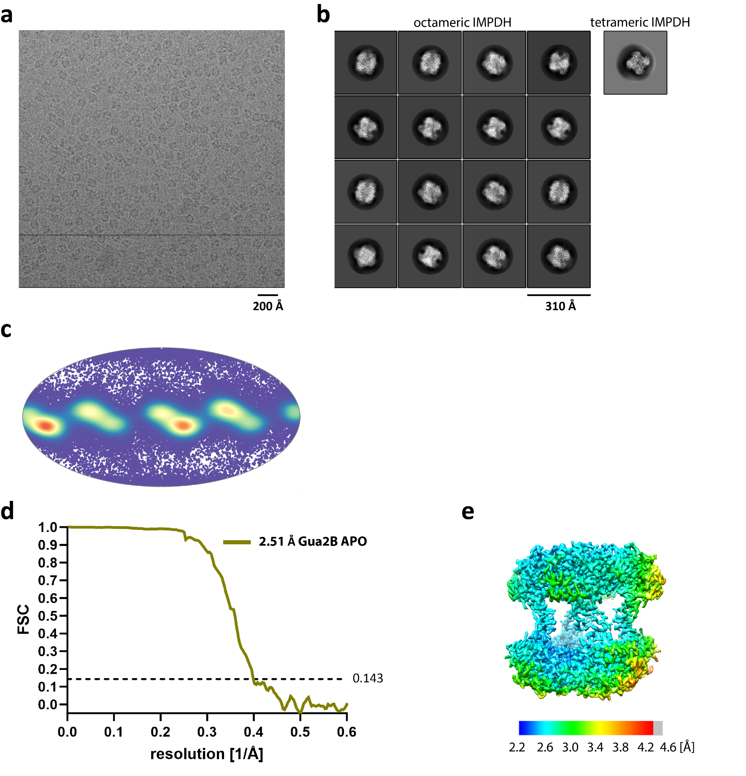Figure EM-1: Cryo-EM of the Gua2B APO form complex
a, Micrograph of the Gua2B APO form complexes in free standing ice after MotionCor2¹ correction at defocus of ~2.5 µm. b, 2D-class averages of the Gua2B APO form complex. c, Angular distribution for particles of the Gua2B APO form complex visualized on a globe-like plane. d, Fourier shell correlation (FSC) curves for the Gua2B APO form complex. The plot of the FSC between two independently refined half-maps shows the overall resolution of the two maps as indicated by the gold standard FSC 0.143 cut-off criteria². e, Surface representation of local resolution distribution of the Gua2B APO form complex. The map is colored according to the local resolution calculated within the RELION 4.0³ software package. Resolution is as indicated in the color bar.
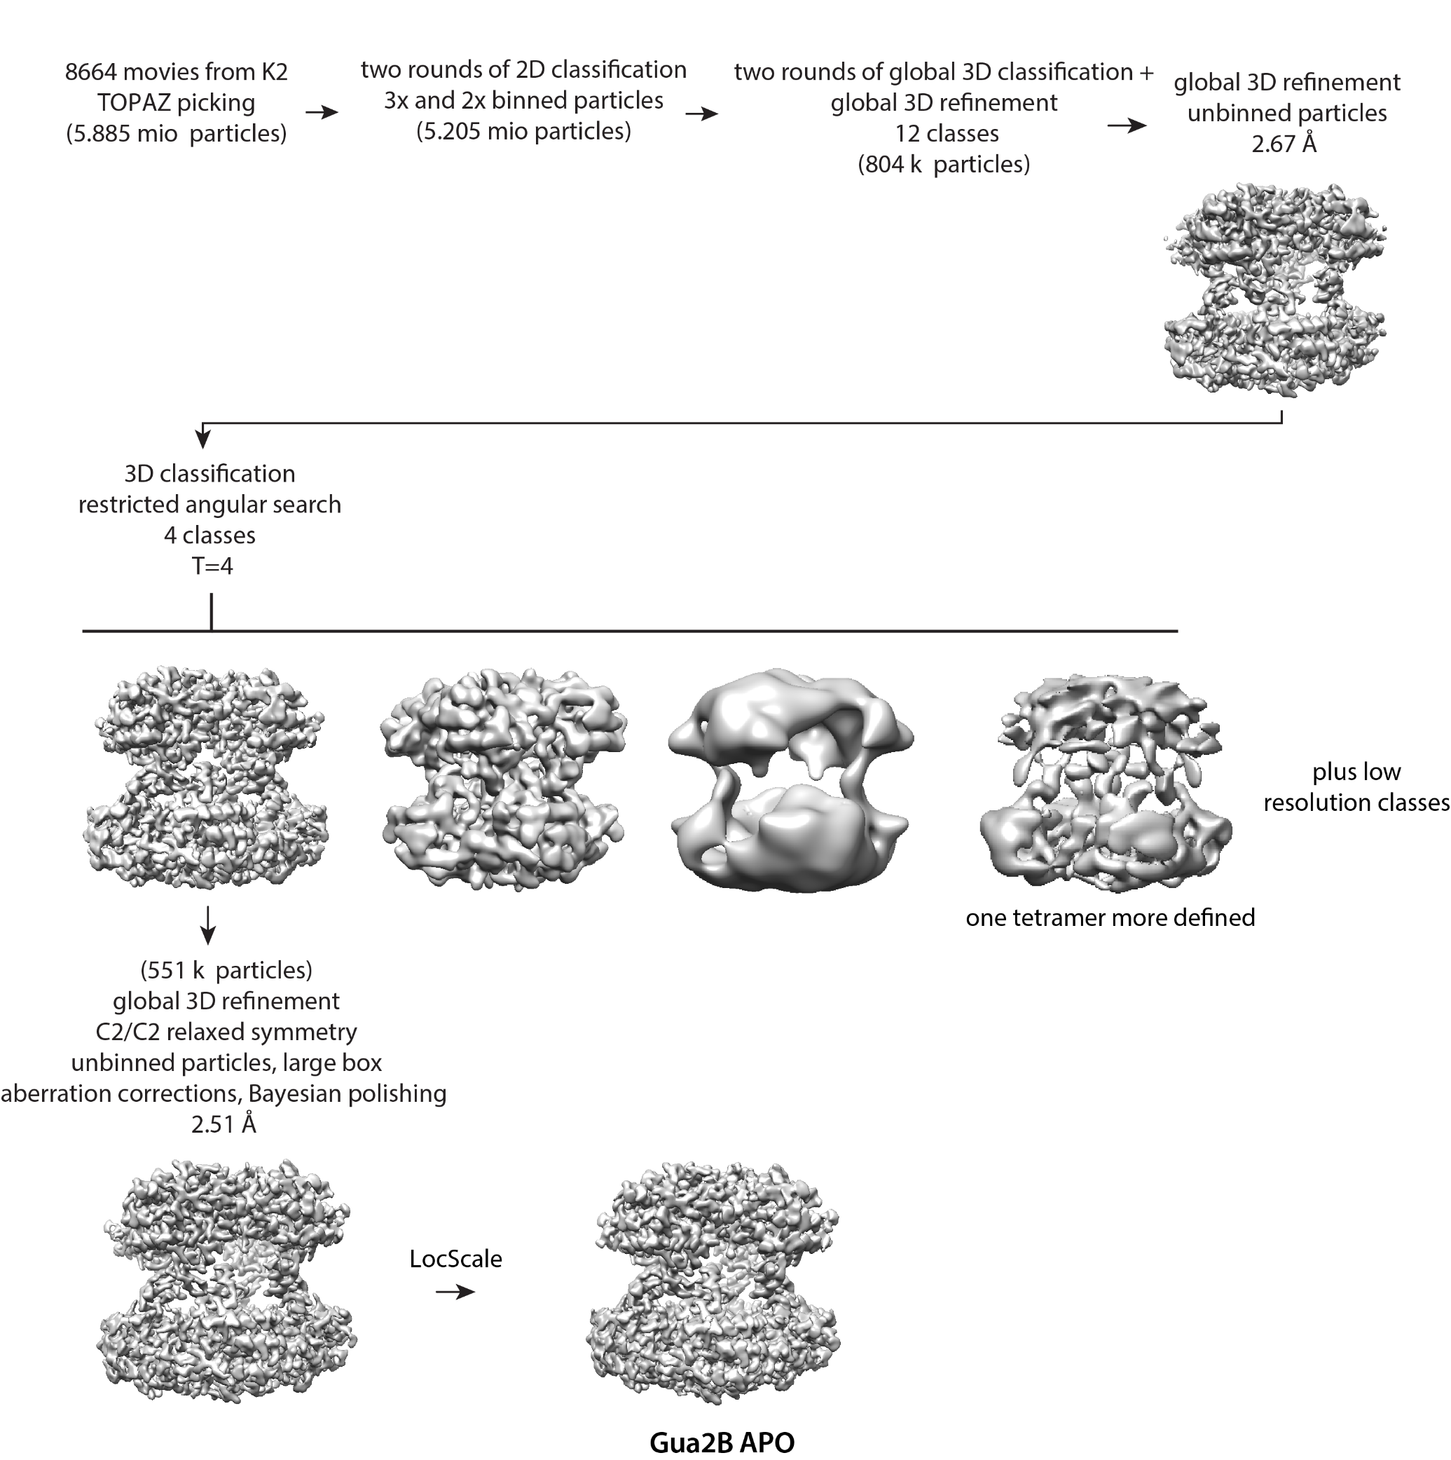
Figure EM-2: Cryo-EM data 3D classification and refinement scheme of the Gua2B APO form complex
Final cryo-EM map was refined and post-processed with a respective mask in RELION 4.0³ and filtered by LocScale⁴.

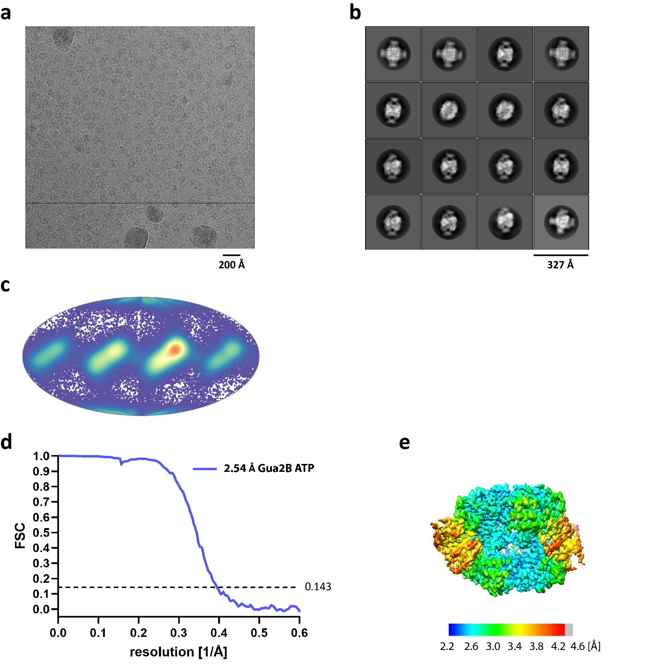Figure EM-3: Cryo-EM of the Gua2B ATP-bound complex
a, Micrograph of the Gua2B ATP-bound complex in free standing ice after MotionCor2¹ correction at defocus of ~2.5 µm. b, 2D-class averages of the Gua2B ATP-bound complex. c, Angular distribution for particles of the Gua2B ATP-bound complex visualized on a globe-like plane. d, FSC curves for the Gua2B ATP-bound complex. The plot of the FSC between two independently refined half-maps shows the overall resolution of the two maps as indicated by the gold standard FSC 0.143 cut-off criteria². e, Surface representation of local resolution distribution of the Gua2B ATP-bound complex. The map is colored according to the local resolution calculated within the RELION 4.0³ software package. Resolution is as indicated in the color bar.
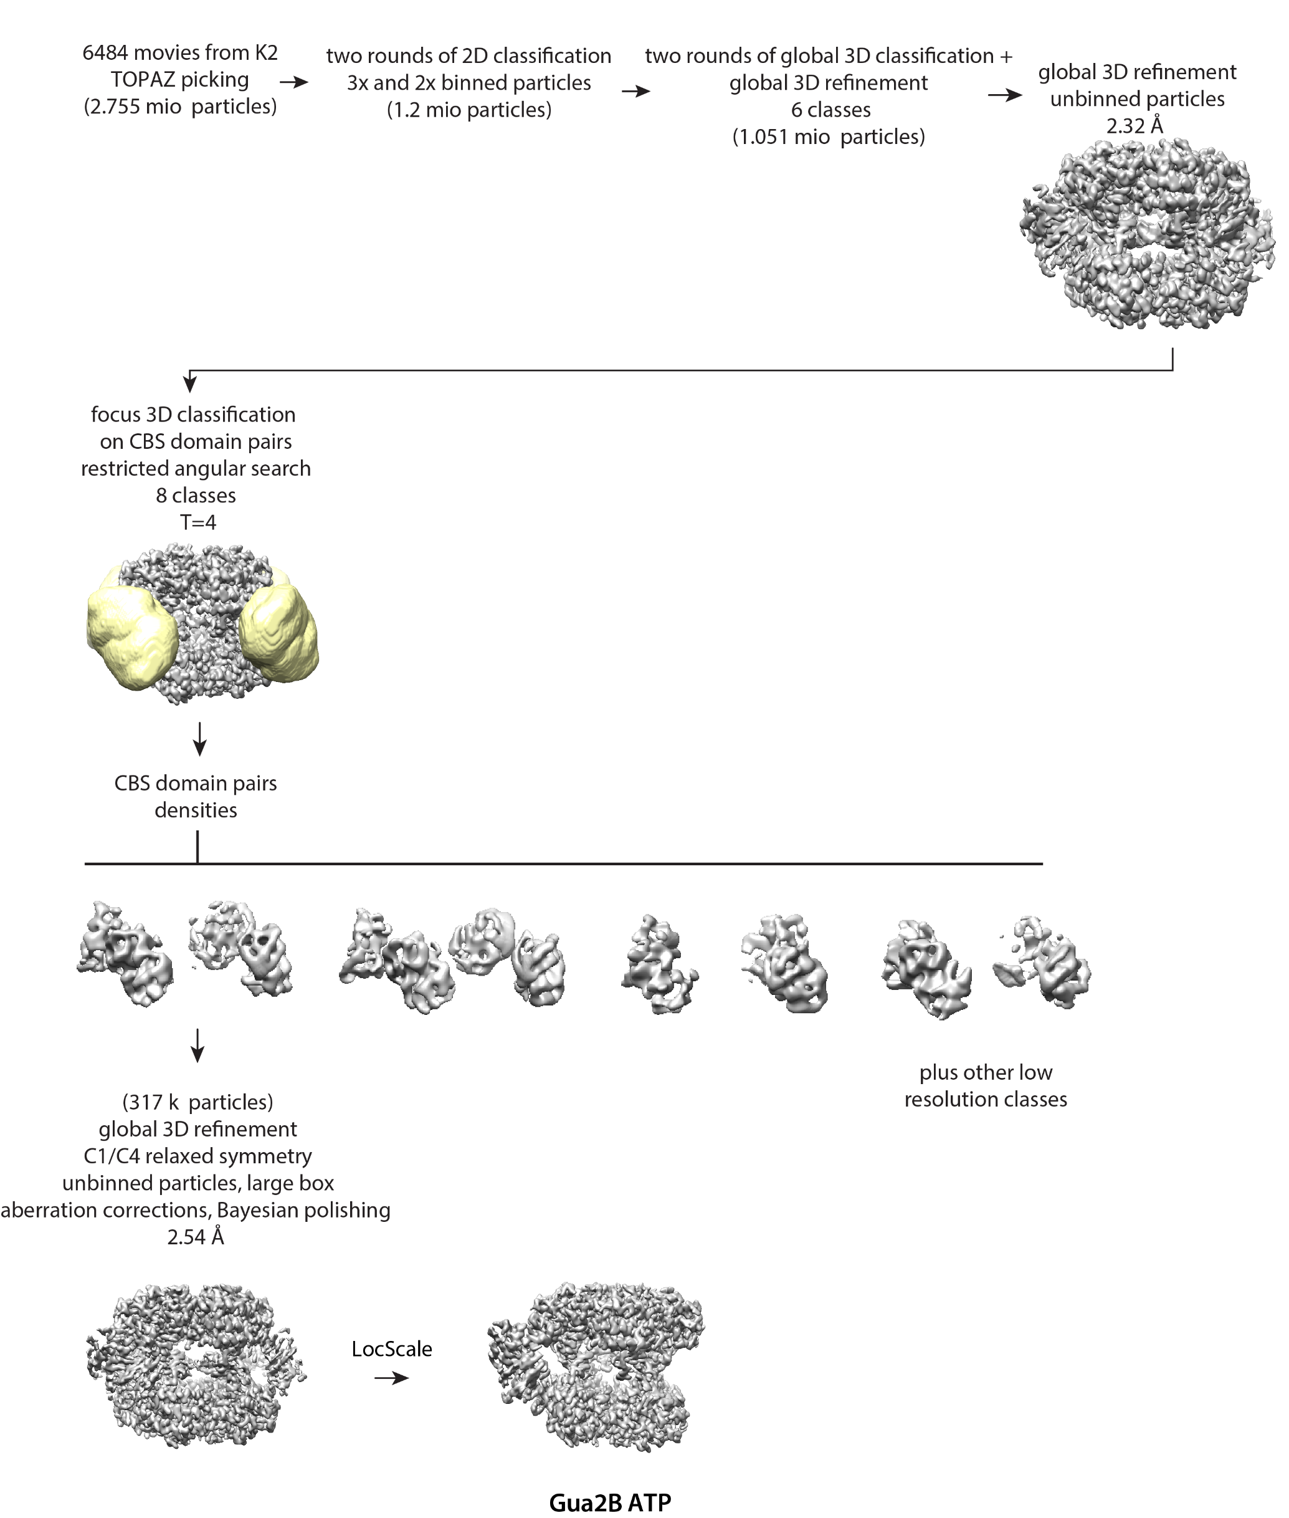Figure EM-4: Cryo-EM data 3D classification and refinement scheme of the Gua2B ATP-bound complex
Final cryo-EM map was refined and post-processed with a respective mask in RELION 4.0³ and filtered by LocScale⁴.
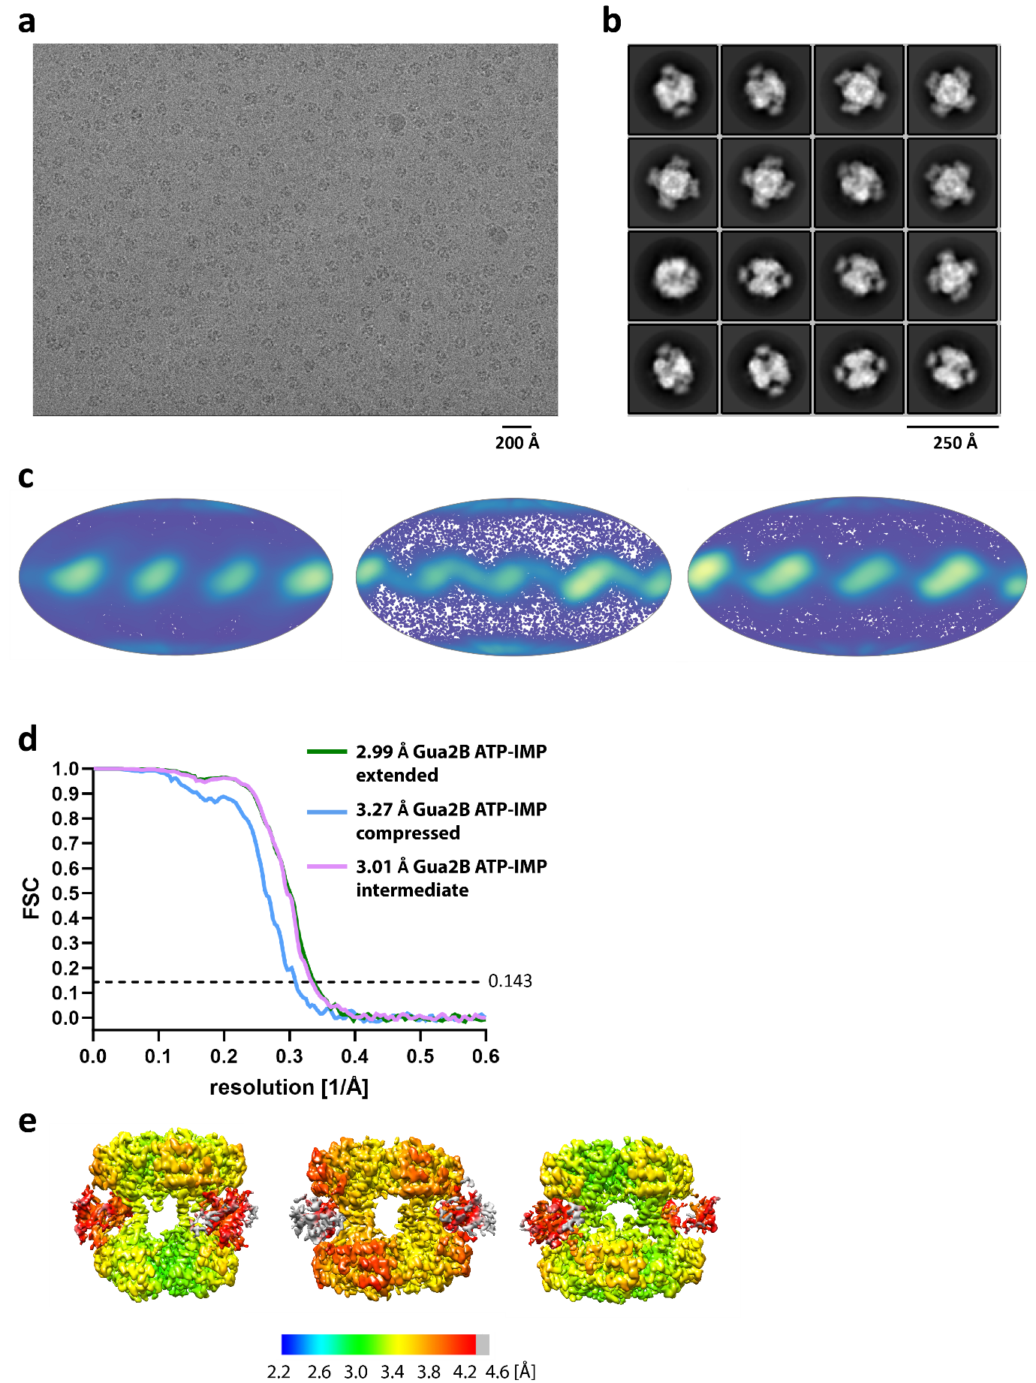
Figure EM-5: Cryo-EM of the Gua2B ATP-IMP-bound complexes
a, Micrograph of the Gua2B ATP-IMP-bound complexes in free standing ice after MotionCor2¹ correction at defocus of ~2.5 µm. b, 2D-class averages of the Gua2B ATP-IMP-bound complexes. c, Angular distribution for particles of the Gua2B ATP-IMP bound complexes in extended, compressed and intermediate form, respectively, visualized on a globe-like plane. d, FSC curves for the Gua2B ATP-IMP-bound complexes. The plot of the FSC between two independently refined half-maps shows the overall resolution of the two maps as indicated by the gold standard FSC 0.143 cut-off criteria². e, Surface representation of local resolution distribution of the Gua2B ATP-IMP-bound complexes in extended, compressed and intermediate form, respectively. The maps are colored according to the local resolution calculated within the RELION 4.0³ software package. Resolution is as indicated in the color bar.

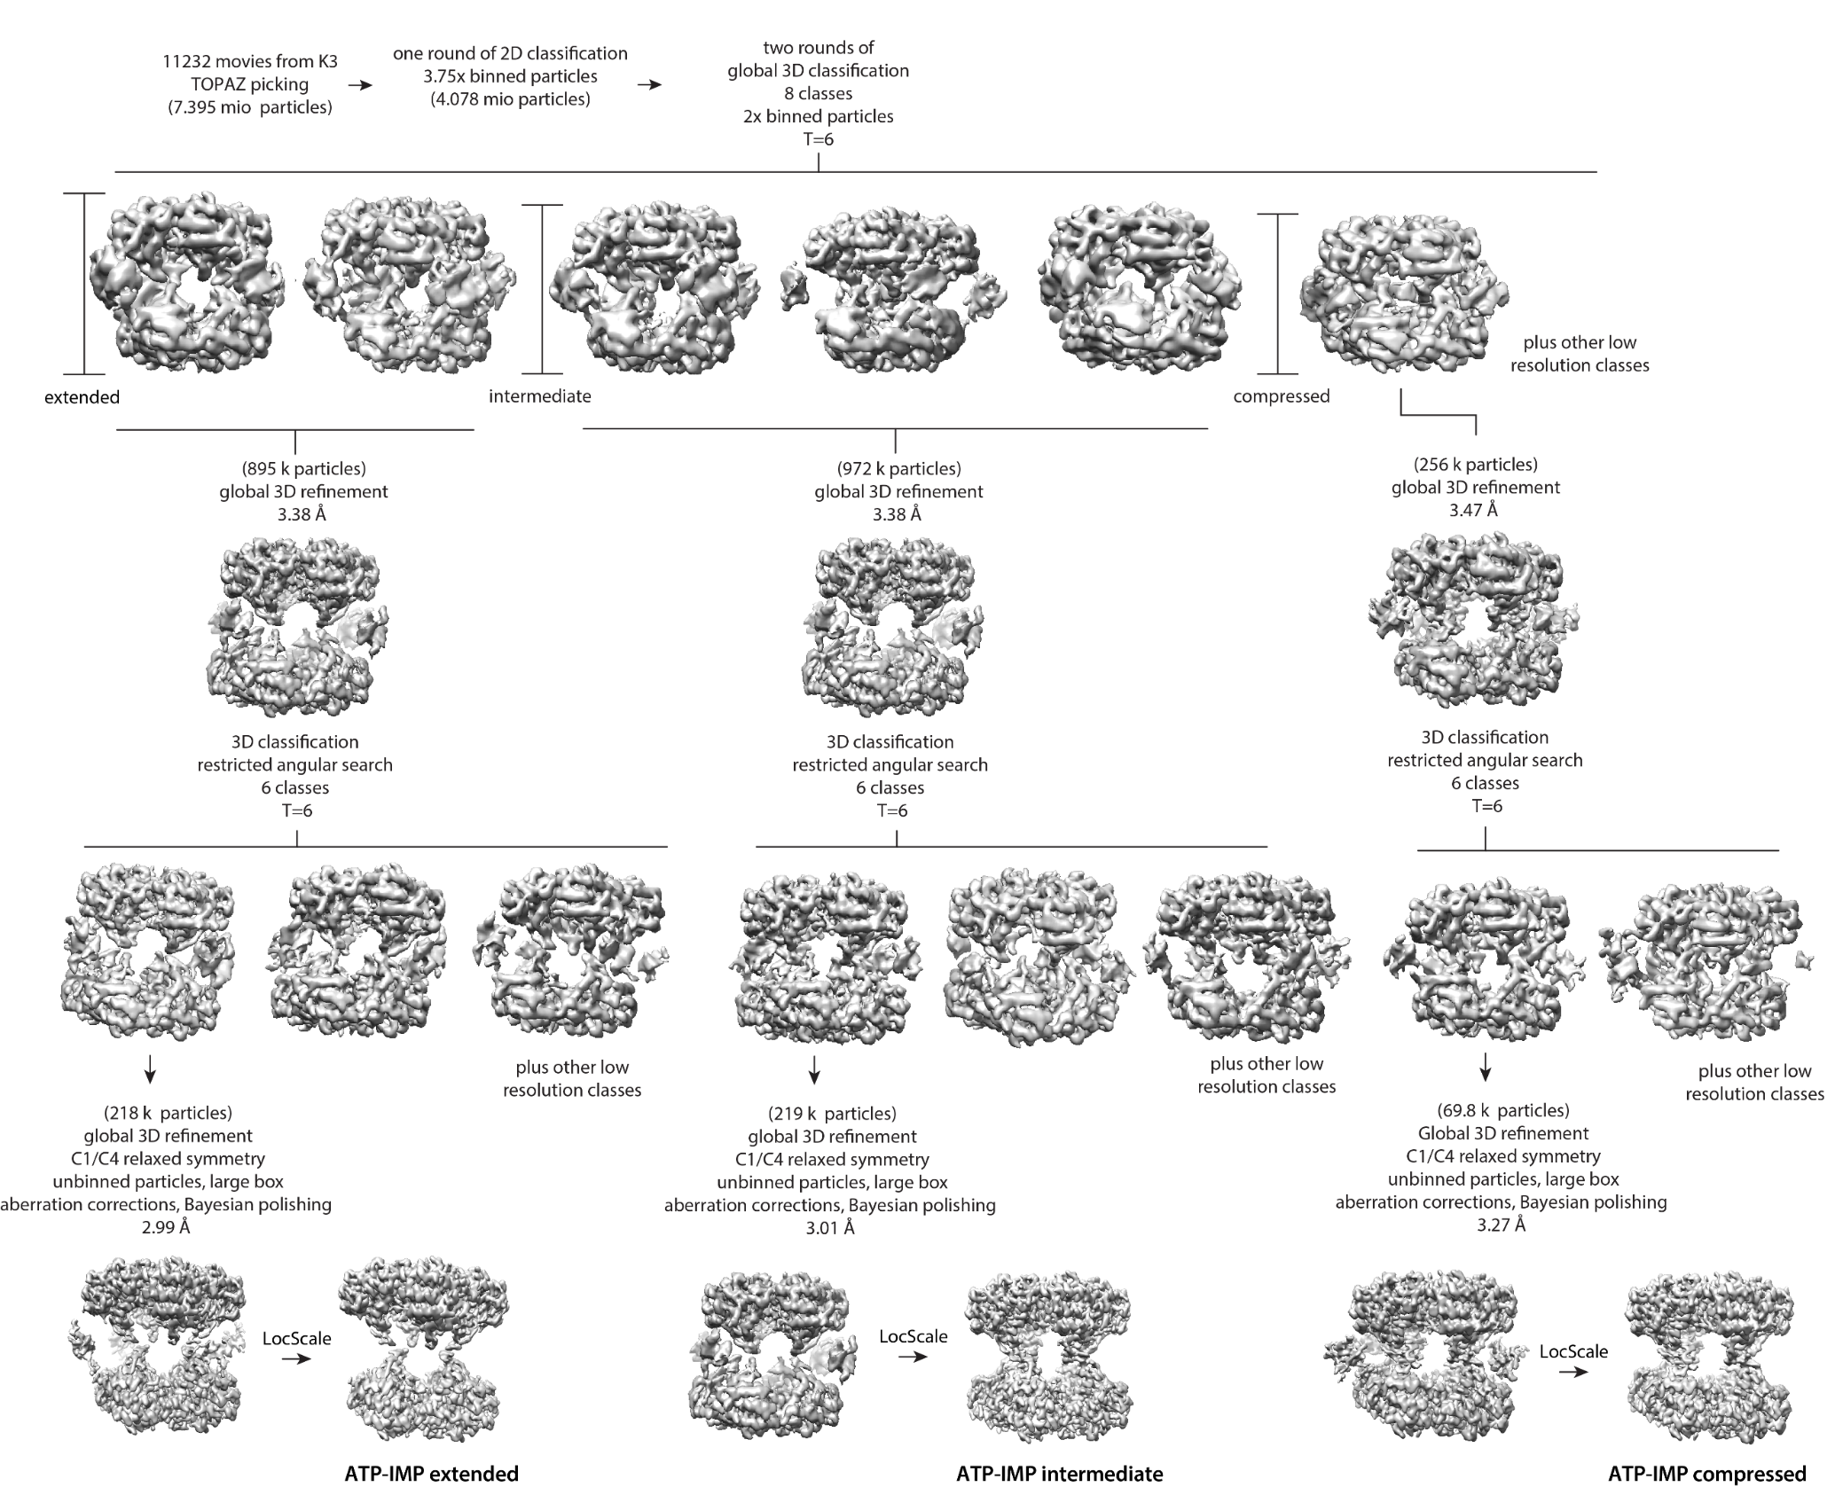
Figure EM-6: Cryo-EM data 3D classification and refinement scheme of the Gua2B ATP-IMP bound complexes
Final cryo-EM maps were refined and post-processed with a respective mask in RELION 4.0³ and filtered by LocScale⁴.

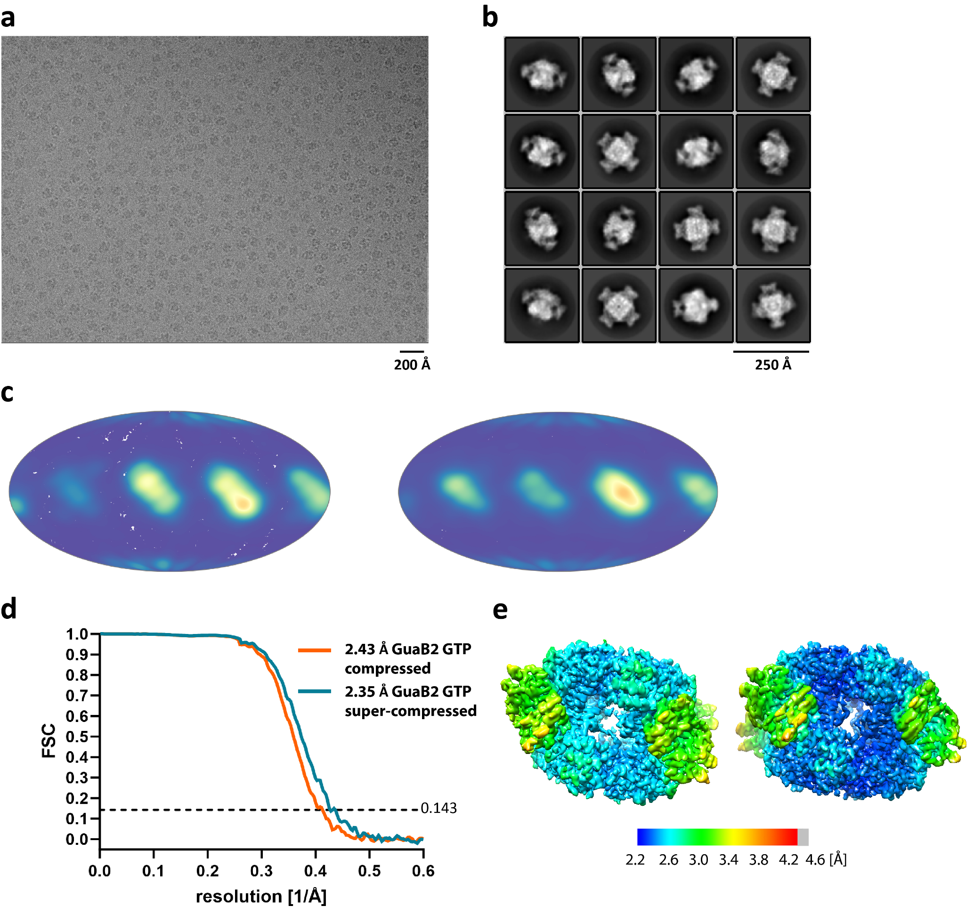Figure EM-7: Cryo-EM of the Gua2B GTP-ATP-bound complexes
a, Micrograph of the Gua2B GTP-ATP-bound complexes in free standing ice after MotionCor2¹ correction at defocus of ~2.5 µm. b, 2D-class averages of the Gua2B GTP-ATP-bound complexes. c, Angular distribution for particles of the Gua2B GTP-ATP-bound complexes in compressed and less compressed form, respectively, visualized on a globe-like plane. d, FSC curves for the Gua2B GTP-ATP-bound complexes. The plot of the FSC between two independently refined half-maps shows the overall resolution of the two maps as indicated by the gold standard FSC 0.143 cut-off criteria². e, Surface representation of local resolution distribution of the Gua2B GTP-ATP-bound complexes in compressed and super-compressed form, respectively. The maps are colored according to the local resolution calculated within the RELION 4.0³ software package. Resolution is as indicated in the color bar.
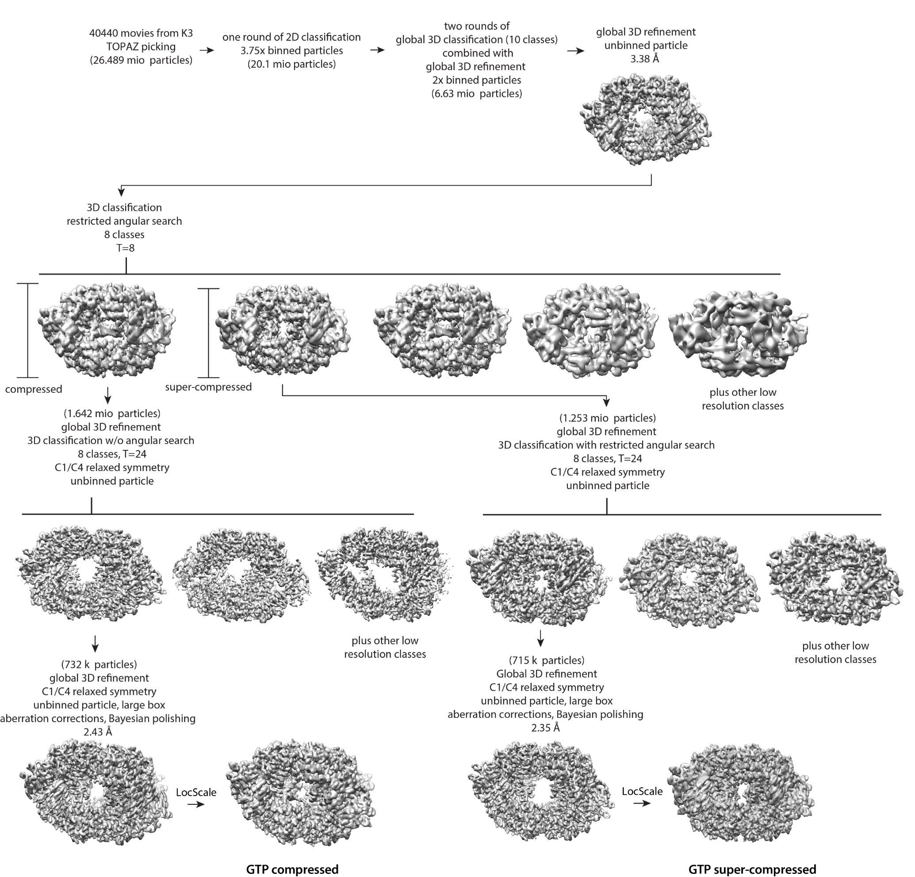
Figure EM-8: Cryo-EM data 3D classification and refinement scheme of the Gua2B GTP-ATP bound complexes
Final cryo-EM maps were refined and post-processed with a respective mask in RELION 4.0³ and filtered by LocScale⁴.
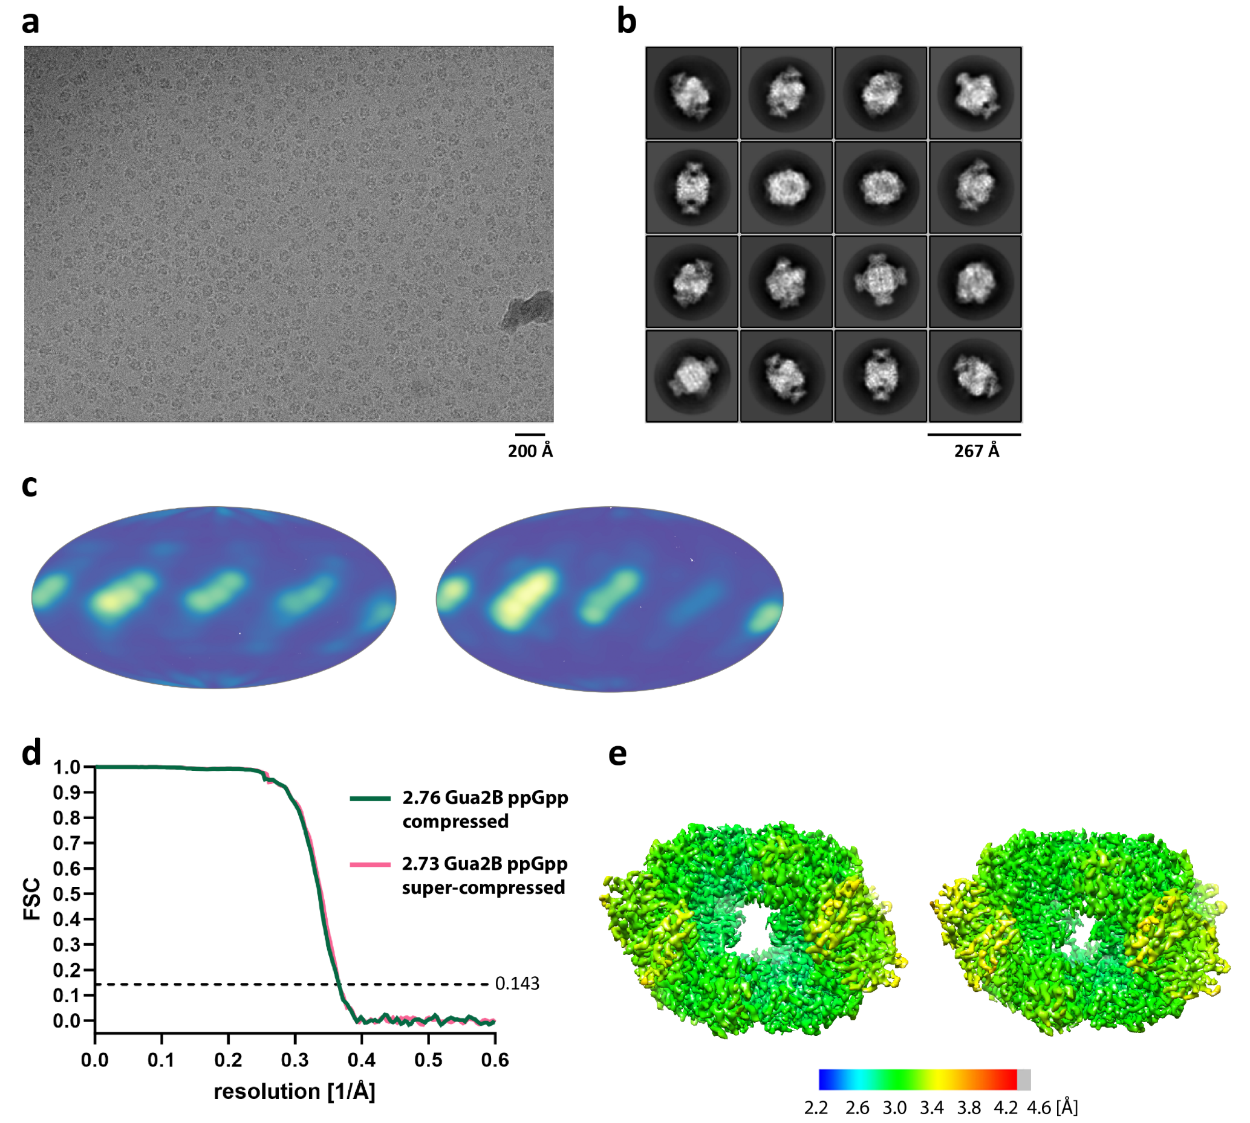
Figure EM-9: Cryo-EM of the Gua2B ppGpp-ATP-bound complexes
a, Micrograph of the Gua2B ppGpp-ATP-bound complexes in free standing ice after MotionCor2¹ correction at defocus of ~2.5 µm. b, 2D-class averages of the Gua2B ppGpp-ATP-bound complexes. c, Angular distribution for particles of the Gua2B ppGpp-ATP bound complexes in compressed and super-compressed form, respectively, visualized on a globe-like plane. d, FSC curves for the Gua2B ppGpp-ATP-bound complex. The plot of the FSC between two independently refined half-maps shows the overall resolution of the two maps as indicated by the gold standard FSC 0.143 cut-off criteria². e, Surface representation of local resolution distribution of the Gua2B ppGpp-ATP-bound complexes in compressed and super-compressed form, respectively. The maps are colored according to the local resolution calculated within the RELION 4.0³ software package. Resolution is as indicated in the color bar.
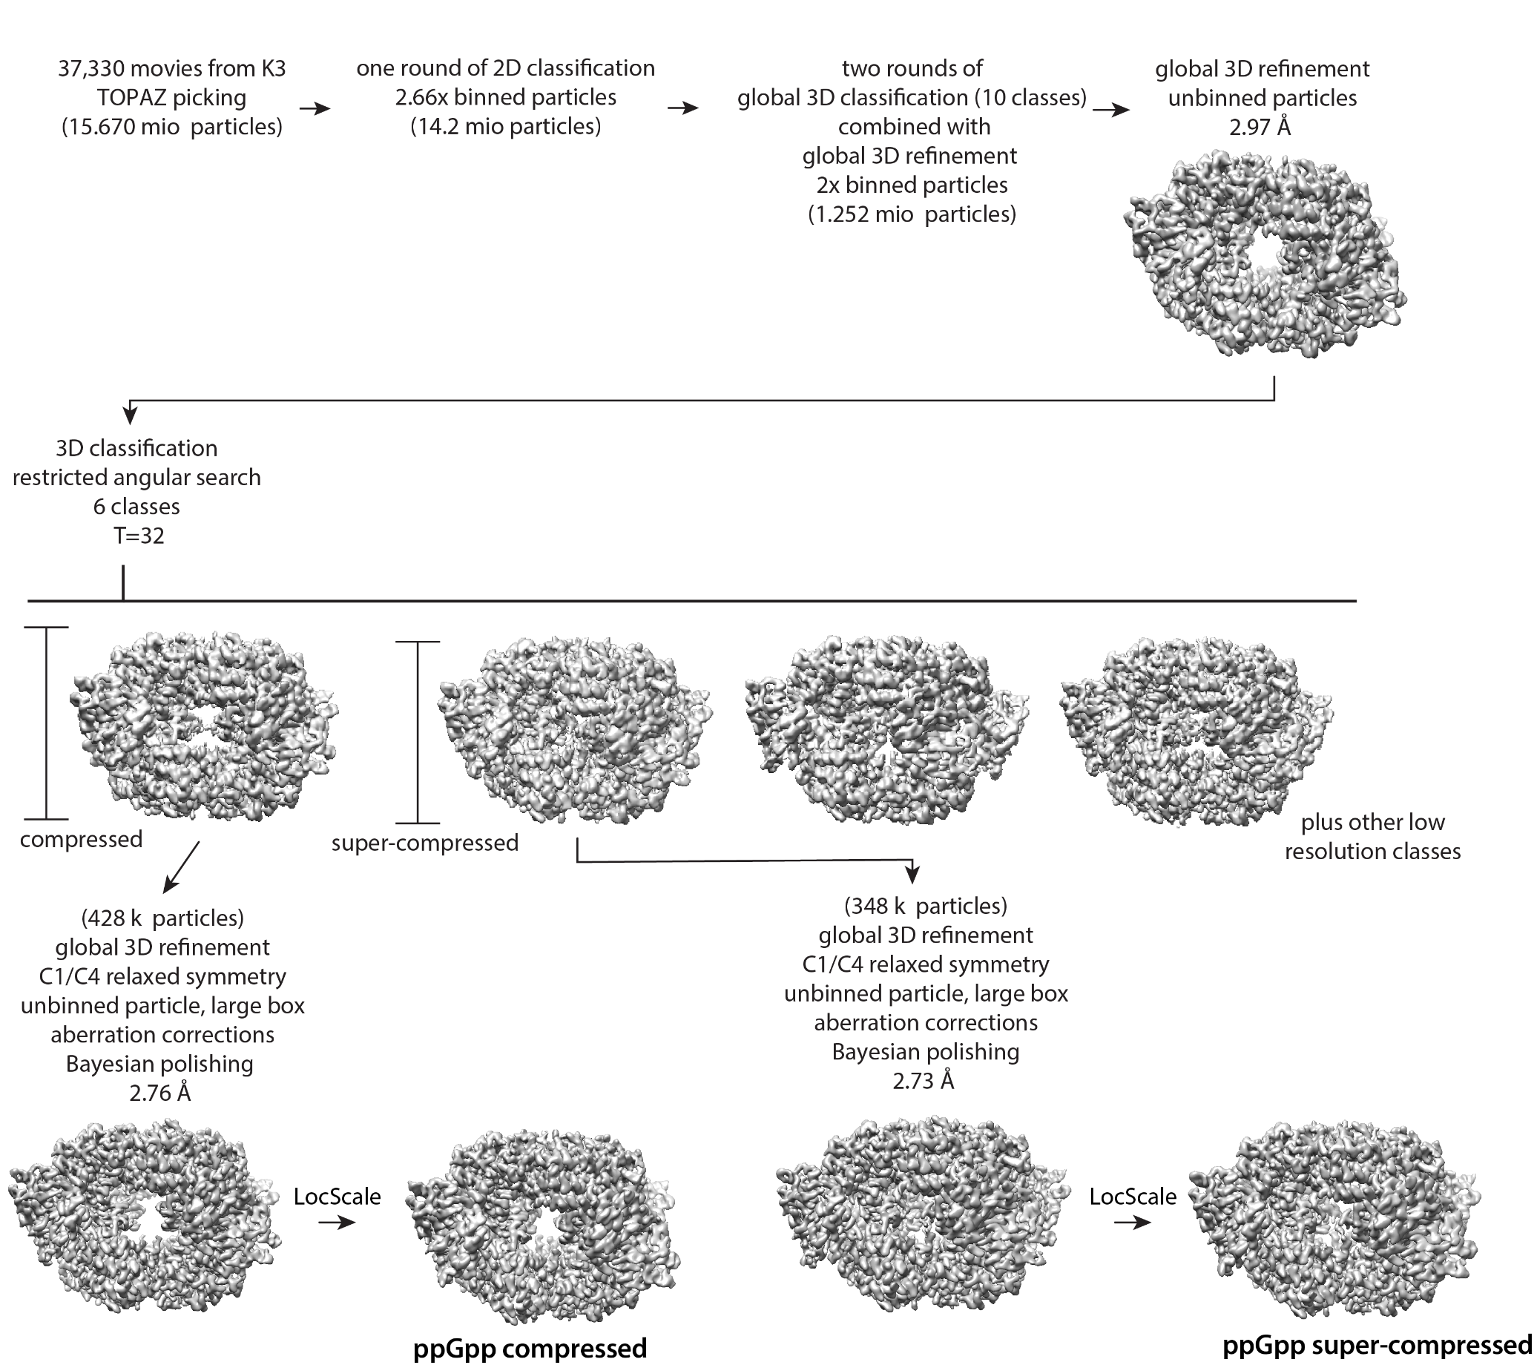
Figure EM-10: Cryo-EM data 3D classification and refinement scheme of the Gua2B ppGpp-ATP bound complexes
Final cryo-EM maps were refined and post-processed with a respective mask in RELION 4.0³ and filtered by LocScale⁴.

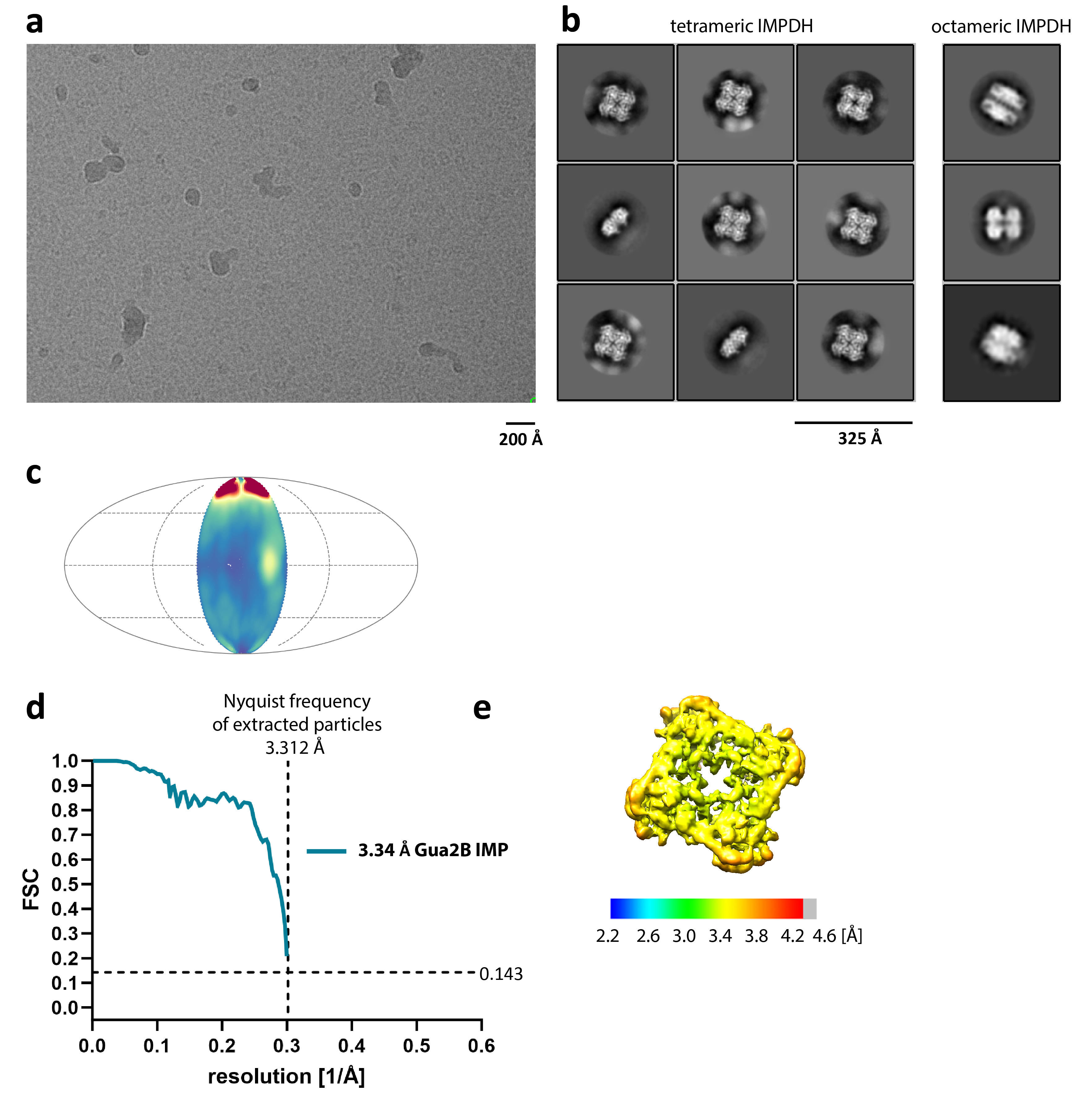Figure EM-11: Cryo-EM of the Gua2B IMP-bound complexes
a, Micrograph of the Gua2B IMP-bound complex in free standing ice after MotionCor2¹ correction at defocus of ~2.5 µm. b, 2D-class averages of the Gua2B IMP-bound complex. c, Angular distribution for particles of the Gua2B IMP-bound complex in extended, compressed and intermediate form, respectively, visualized on a globe-like plane. d, FSC curves for the Gua2B IMP-bound complex. The plot of the FSC between two independently refined half-maps shows the overall resolution of the two maps as indicated by the gold standard FSC 0.143 cut-off criteria². e, Surface representation of local resolution distribution of the Gua2B IMP-bound complex. The map is colored according to the local resolution calculated within the RELION 4.0³ software package. Resolution is as indicated in the color bar.
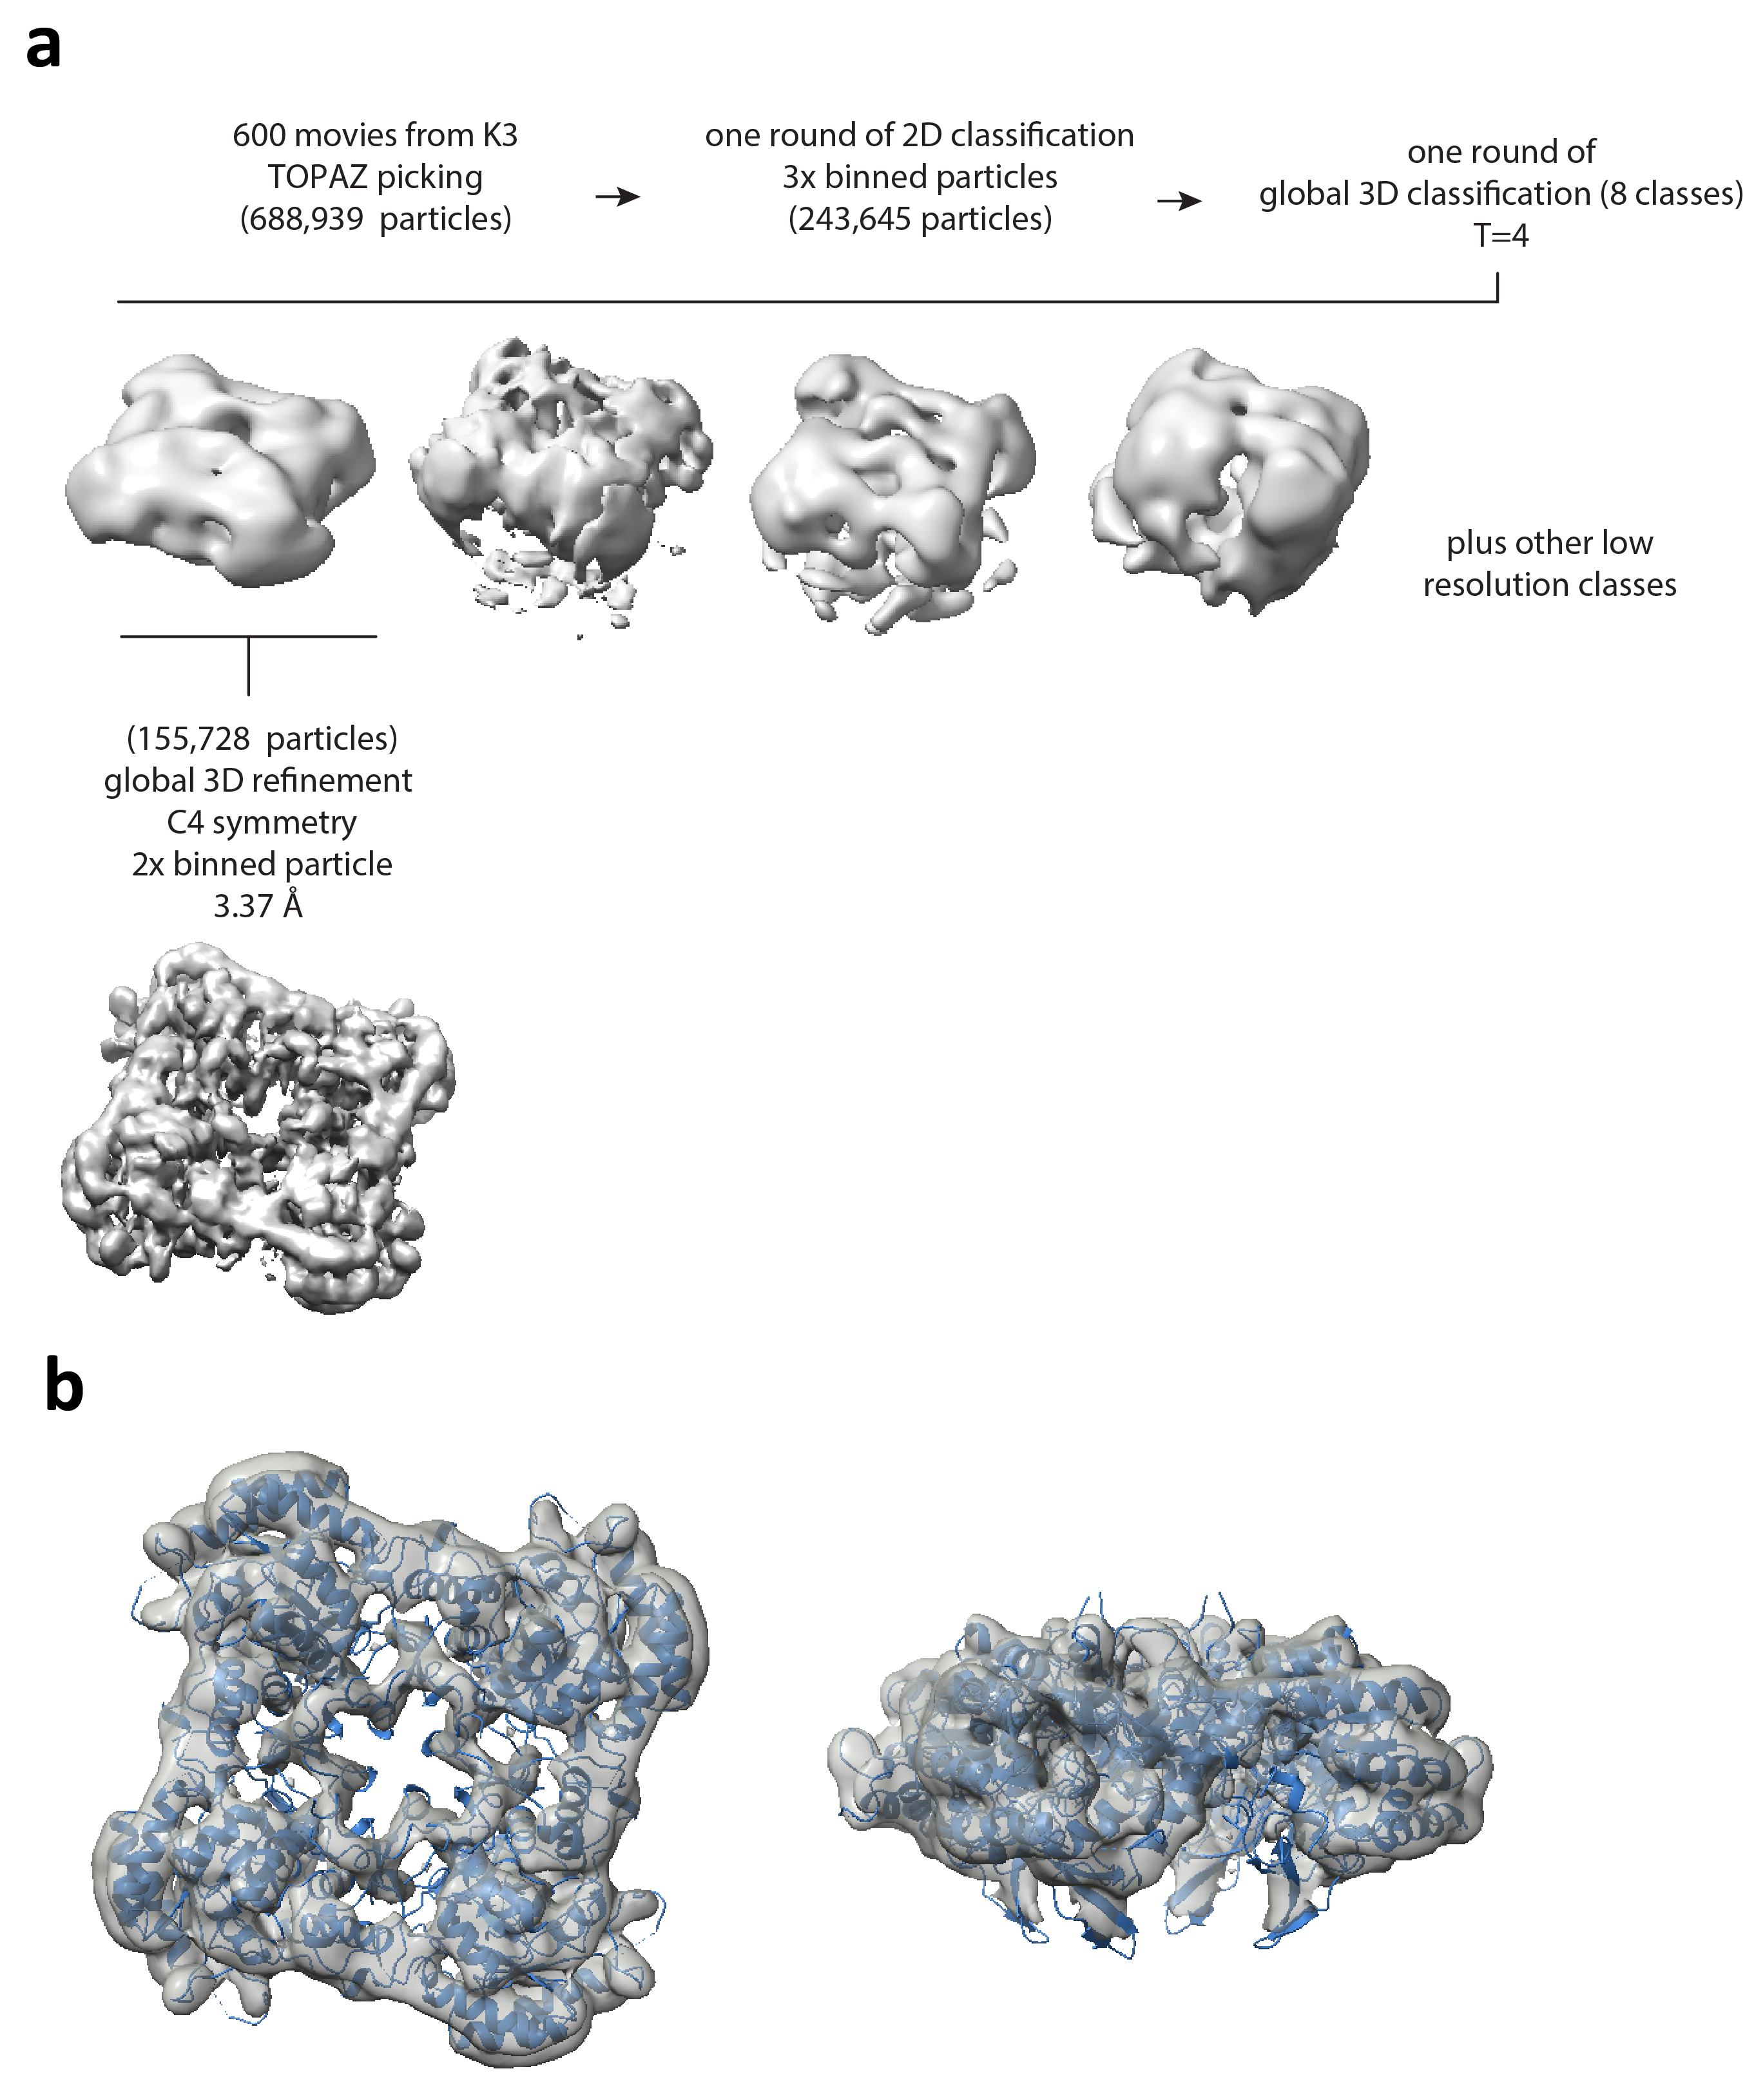
Figure EM-12: Cryo-EM data 3D classification scheme and model fitting of the Gua2B IMP-bound complex
a, Summary of the cryo-EM 3D classification and refinement scheme of the Gua2B IMP-bound complex. Final cryo-EM map was refined and post-processed with a respective mask in RELION 4.0³ and filtered by LocScale⁴.
b, Atomic model of the Gua2B IMP-bound tetramer, derived from the ATP-IMP-bound complexes structures was rigid body fitted into cryoEM map by MolRep⁵ within CCP-EM package⁶.
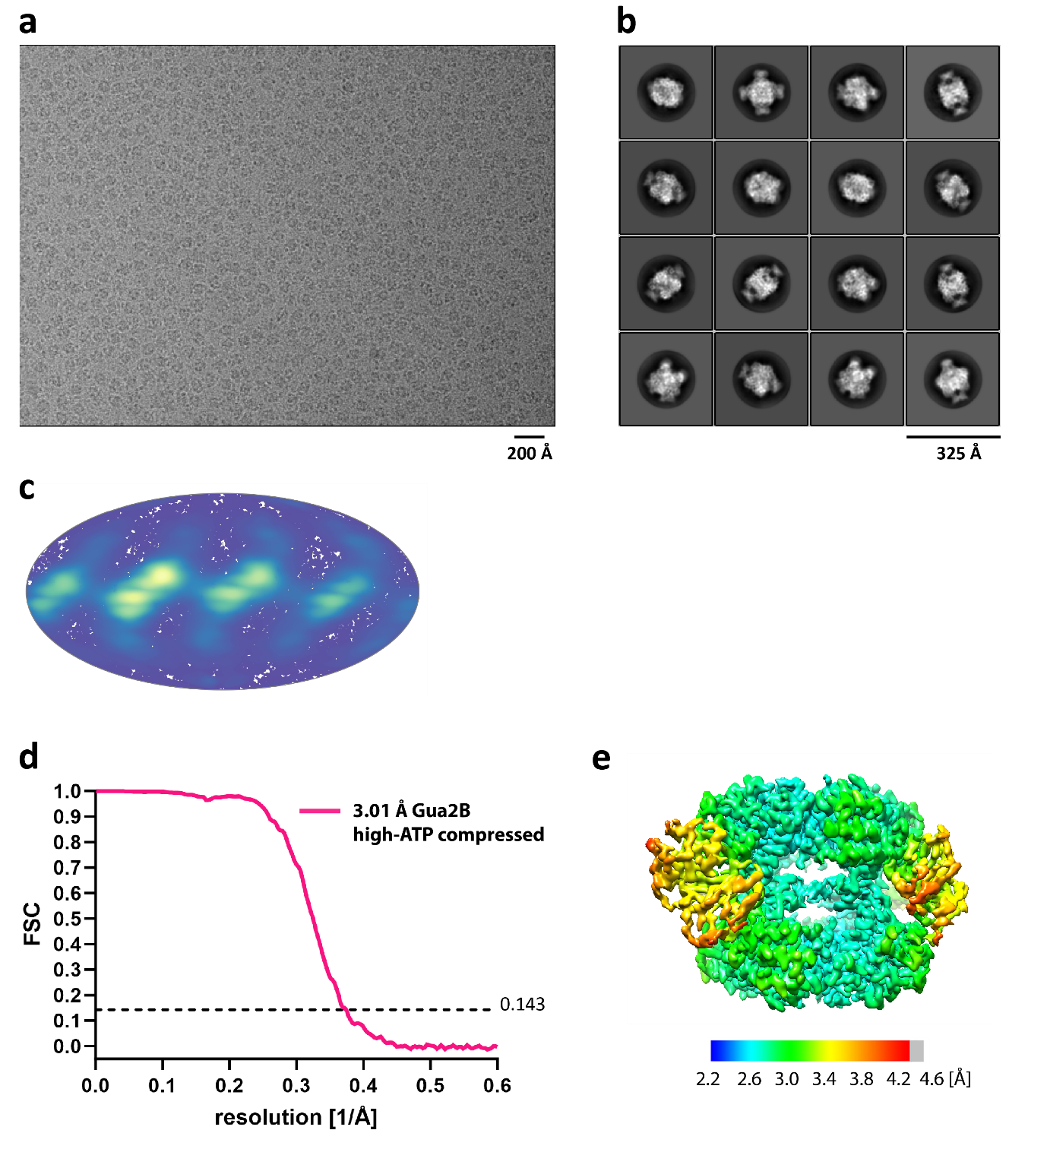
Figure EM-13: Cryo-EM of the Gua2B high concentration ATP bound complexes
a, Micrograph of high concentration ATP bound complex in free standing ice after MotionCor2¹ correction at defocus of ~2.5 µm. b, 2D-class averages of the high concentration ATP bound complex. c, Angular distribution for particles of the high concentration ATP bound complex on a globe-like plane. d, FSC curves for the high concentration ATP bound complex. The plot of the FSC between two independently refined half-maps shows the overall resolution of the two maps as indicated by the gold standard FSC 0.143 cut-off criteria². e, Surface representation of local resolution distribution of the high concentration ATP bound complex. The map is colored according to the local resolution calculated within the RELION 4.0³ software package. Resolution is as indicated in the color bar.

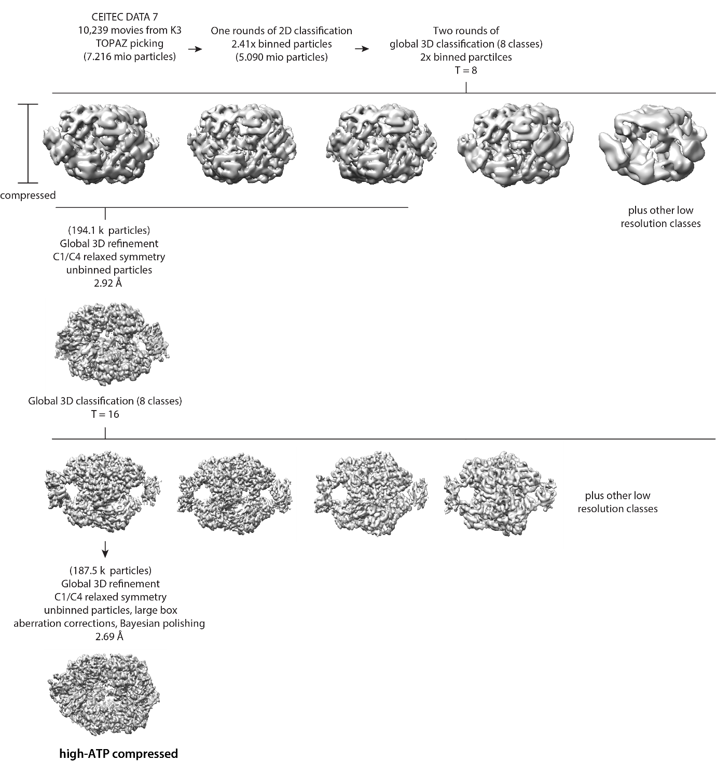
Figure EM-14: Cryo-EM data 3D classification and refinement scheme of the Gua2B high concentration ATP bound complexes
Final cryo-EM map was refined and post-processed with a respective mask in RELION 4.0³ and filtered by LocScale⁴.

References
1. Zheng, S. Q. et al. MotionCor2: anisotropic correction of beam-induced motion for improved cryo-electron microscopy. Nat Methods 14, 331–332 (2017).
2. Rosenthal, P. B. & Henderson, R. Optimal determination of particle orientation, absolute hand, and contrast loss in single-particle electron cryomicroscopy. J Mol Biol 333, 721–745 (2003).
3. Kimanius, D., Dong, L., Sharov, G., Nakane, T. & Scheres, S. H. W. New tools for automated cryo-EM single-particle analysis in RELION-4.0. Biochem J 478, 4169–4185 (2021).
4. Jakobi, A. J., Wilmanns, M. & Sachse, C. Model-based local density sharpening of cryo-EM maps. eLife 6, e27131 (2017).
5. Vagin, A. & Teplyakov, A. Molecular replacement with MOLREP. Acta Crystallogr D Biol Crystallogr 66, 22–25 (2010).
6. Burnley, T., Palmer, C. M. & Winn, M. Recent developments in the CCP-EM software suite. Acta Crystallogr D Struct Biol 73, 469–477 (2017).

