Supplementary Information
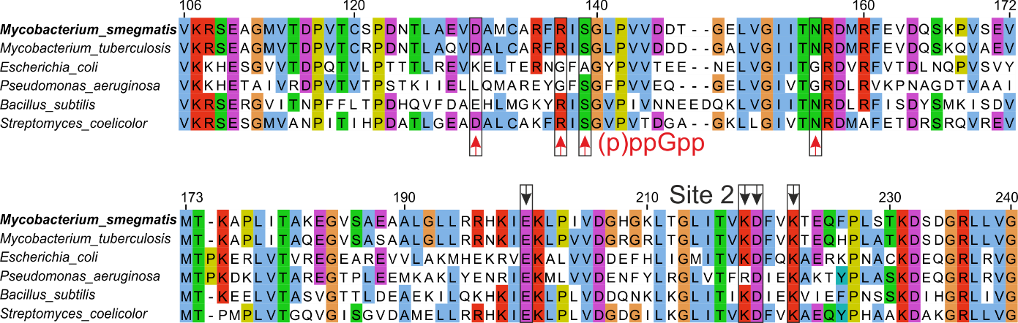
Supplementary Fig. 1 | Conservation of nucleotide binding sites in the CBS domains of bacterial IMPDHs. Multiple sequence alignment of CBS domains for selected bacterial IMPDHs shows the conservation of canonical binding Site 2. The most important residues for nucleotide binding are indicated by red arrows for (p)ppGpp and black arrows for Site 2.

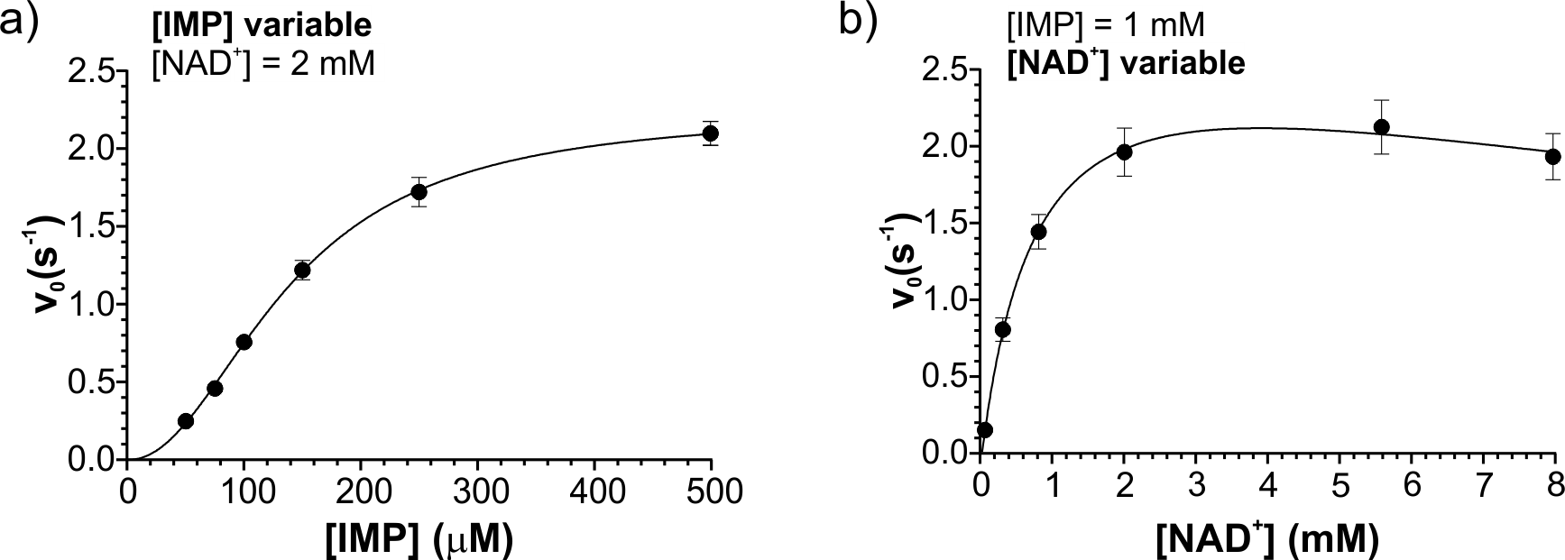
Supplementary Fig. 2 | Plots of the reaction rate versus IMP and NAD⁺ concentrations. a,b, IMPDH reaction kinetics indicate Hill dependence and Michaelis–Menten dependence on IMP (a) and NAD⁺ (b) concentrations (n = 3), respectively. MsmIMPDH was inhibited by NAD⁺ due to the formation of a dead-end E~XMP intermediate NAD⁺ complex.

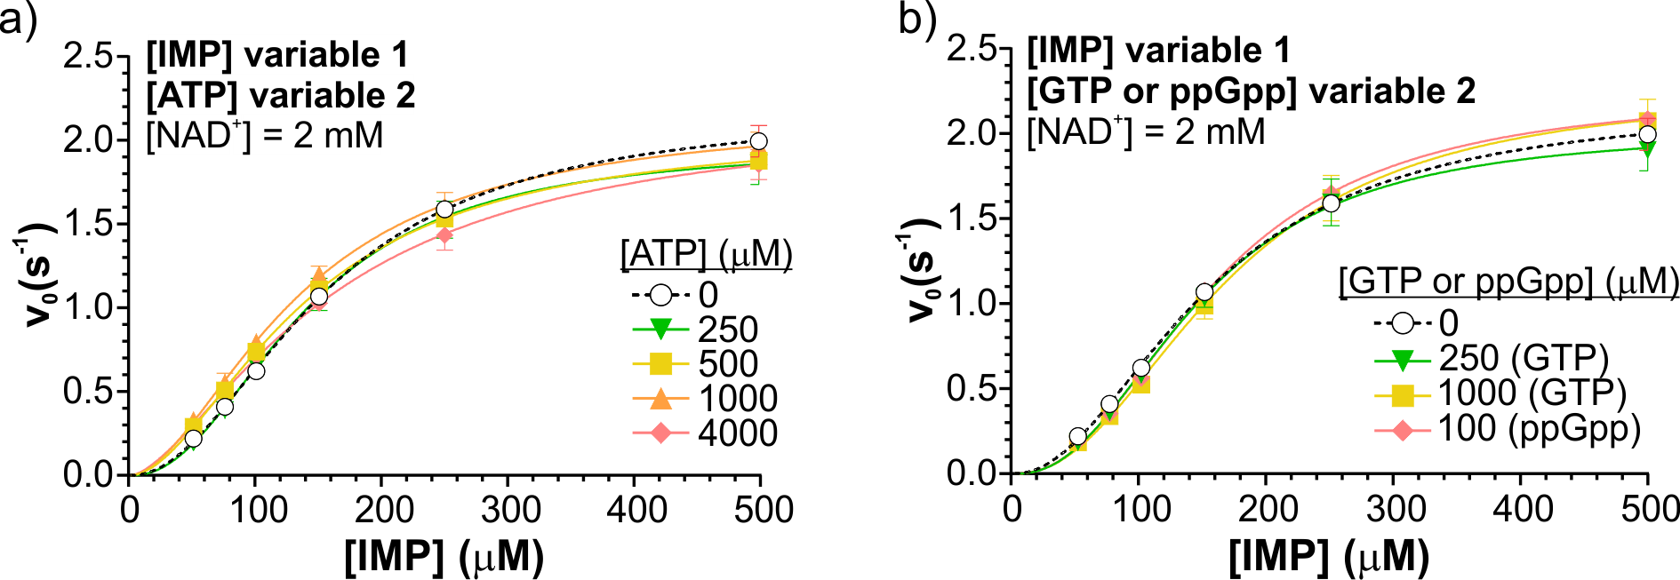
Supplementary Fig. 3 | Plots of the reaction rate versus IMP in the presence of different variables. a,b, The reaction rates versus IMP concentration (n = 3) in the presence of ATP alone (a) and GTP alone or ppGpp alone (b) are given. The Hill equation was fitted to the initial velocity versus IMP concentration. The control reaction without nucleotides is shown in black dashed line. Individually, ATP, GTP, and ppGpp do not influence MsmIMPDH kinetics.

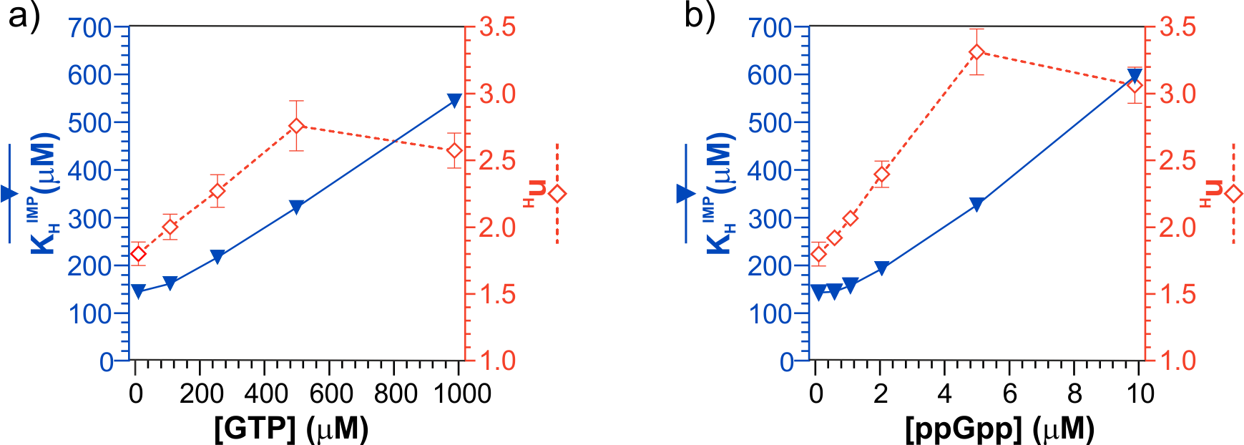
Supplementary Fig. 4 | Plots of Hill equation parameters for GTP- and ppGpp-inhibited reactions. a,b, Hill equation parameters (K_{H}^{IMP} and n_{H}) are plotted as a function of GTP (a) or ppGpp (b) concentration.

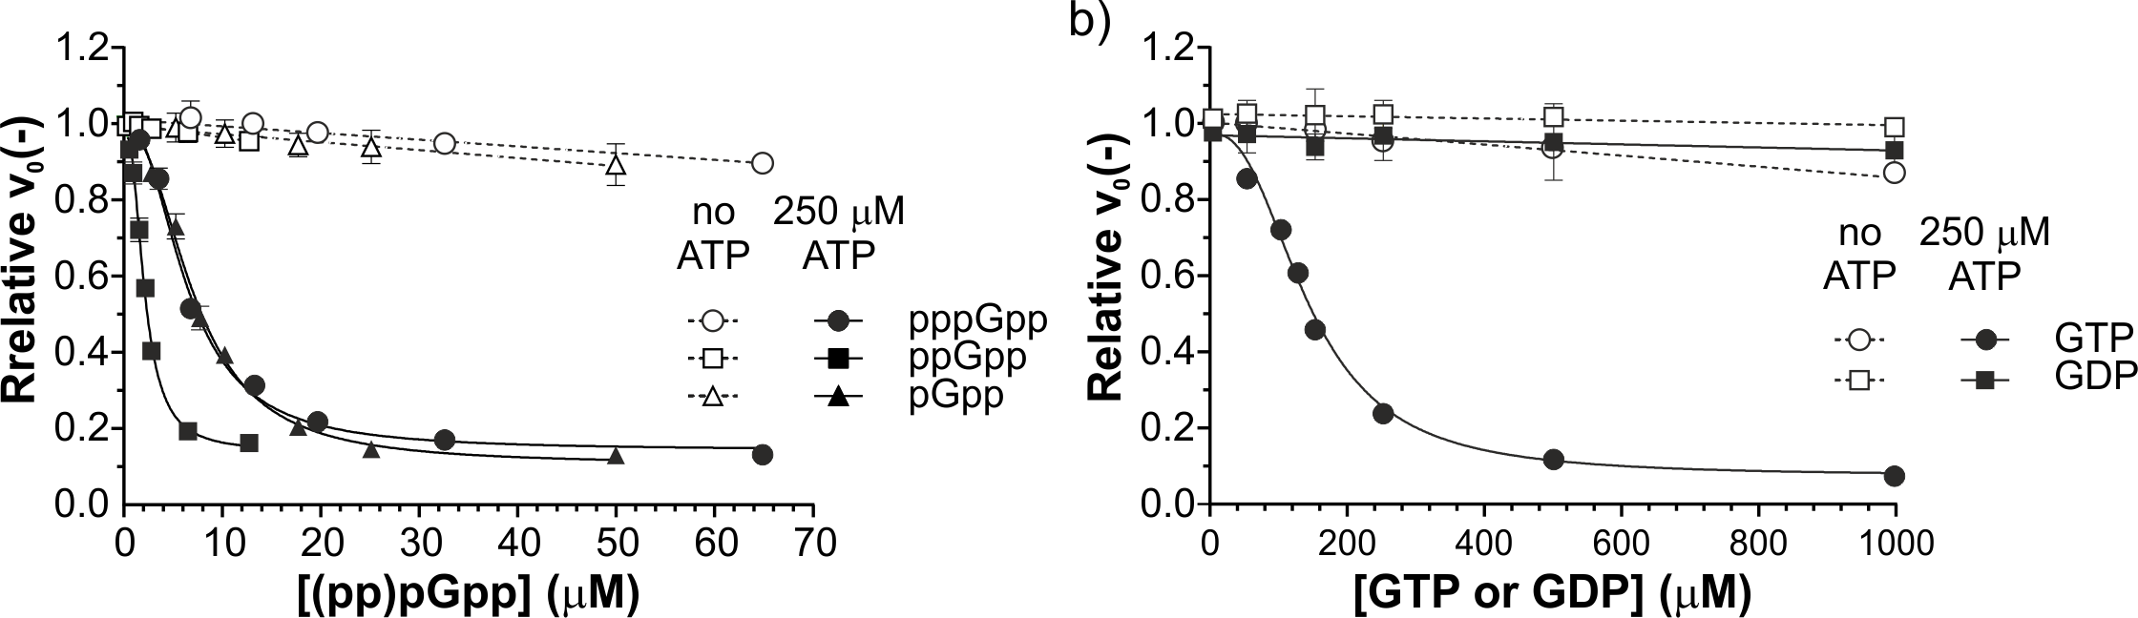
Supplementary Fig. 5 | Plots of relative velocity versus concentration of purine effectors. a,b, Relative velocities are plotted against pppGpp, ppGpp, or pGpp (a) and GTP or GDP (b). NAD⁺ and IMP substrates were fixed at concentrations of 100 µM and 2 mM (n = 3), respectively. The initial velocity is presented in ratio to the control reaction (y axis) in the presence of varied concentrations of guanine nucleotides (x axis) with and without 250 µM ATP.
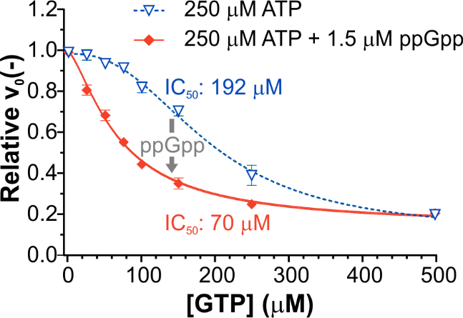
Supplementary Fig. 6 | Effect of ppGpp on MsmIMPDH sensitivity to GTP-induced inhibition. The plot of the relative velocity versus GTP concentration (n = 3) alone and with 1.5 µM ppGpp. Initial velocities were measured as a function of GTP concentration under fixed substrate conditions (100 µM IMP and 2 mM NAD⁺), along with a constant ATP concentration (250 µM), with and without ppGpp. Relative velocity was calculated as the ratio of the velocities in the presence of the corresponding concentration of GTP to the velocity of the control reaction containing only ATP and ppGpp (n = 3). The presence of 1.5 μM of ppGpp increased the GTP inhibitory effect, shifting the IC₅₀ value from 192 ± 6 μM to 70 ± 2 μM.

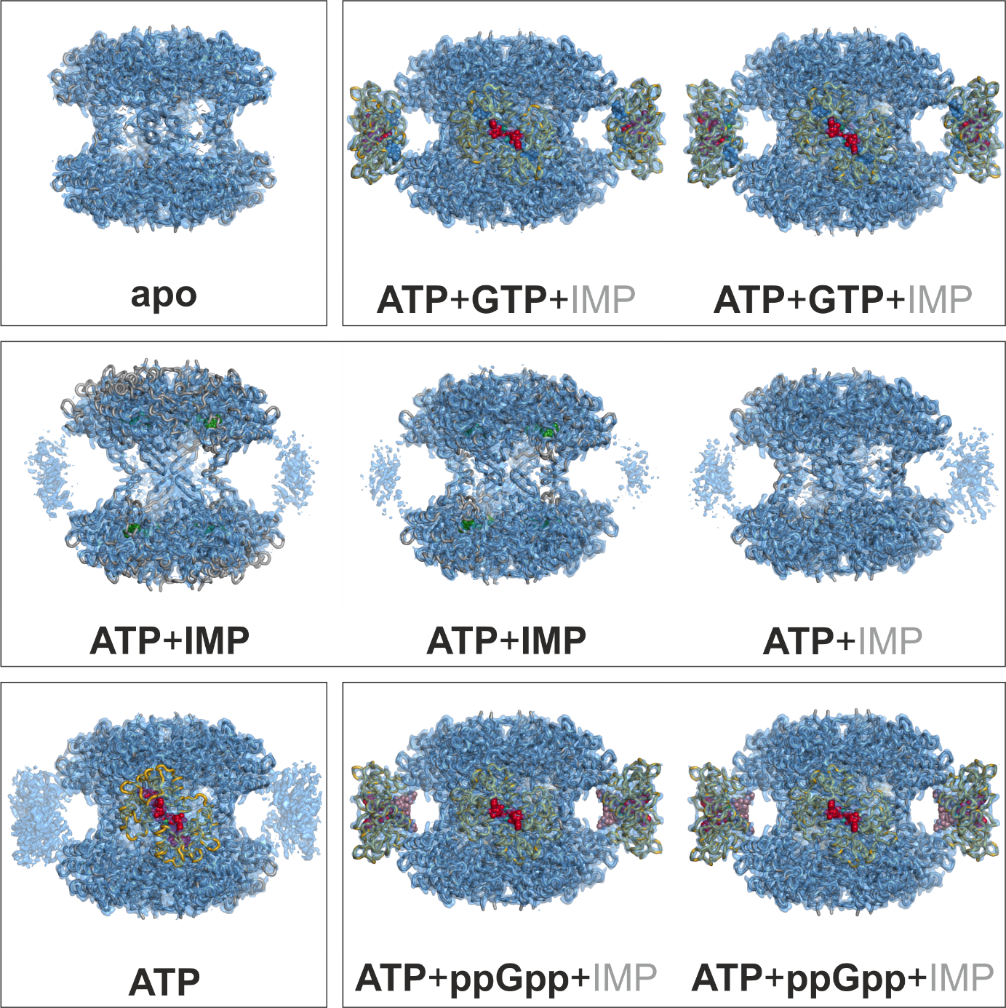
Supplementary Fig. 7 | Overview of MsmIMPDH structures obtained by cryo-EM. Experimental cryo-EM maps (in blue) are overlaid with atomic models of MsmIMPDH. The black frames group the structures obtained from the same dataset. Bold text indicates which ligands are bound in a given structure, while grey text indicates the ligands that are present under experimental conditions but not in the structure. ATP is shown as red spheres, IMP as purple, GTP as blue, and ppGpp as pink.

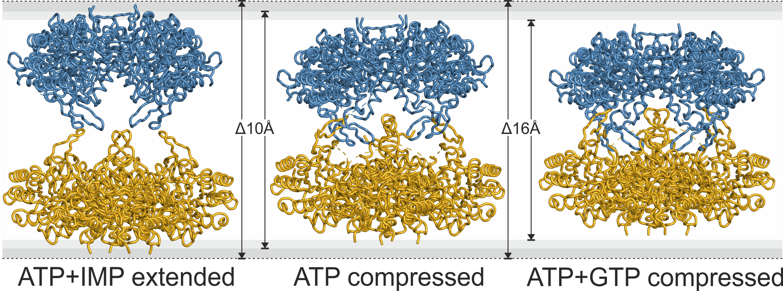
Supplementary Fig. 8 | Conformation dynamics of MsmIMPDH octameric assembly. Only catalytic domains of MsmIMPDH are visualized. One of the tetramers is depicted in blue, and its opposite tetramer in gold. The tetramers in the extended conformation lose nearly all mutual contacts; the compressed conformation is facilitated by the extensive interactions of the finger and flap loops.

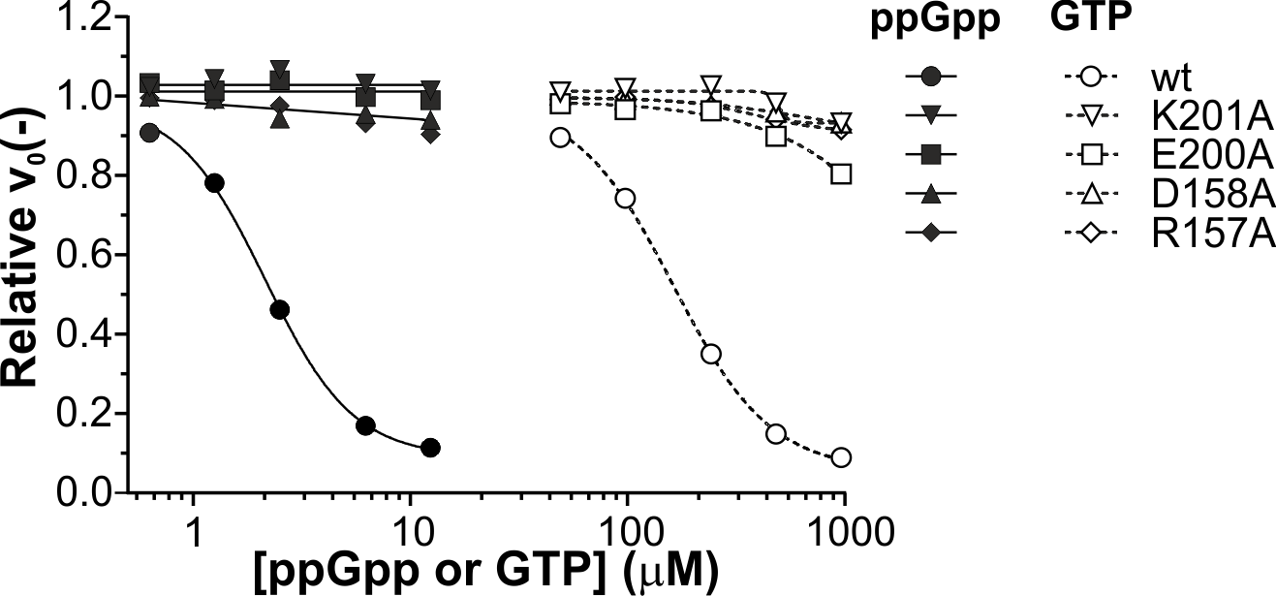
Supplementary Fig. 9 | Sensitivity of ATP site-1 MsmIMPDH mutants to GTP- or ppGpp-induced inhibition. NAD⁺ and IMP substrates were fixed at concentrations 100 µM and 2 mM, respectively; ATP was fixed at 500 µM. The relative velocity value was calculated as the ratio of the initial velocity of the reaction to the control reaction of the wild-type enzyme. Mutations in the residues involved in Site 1 abrogate inhibition by both GTP and ppGpp.

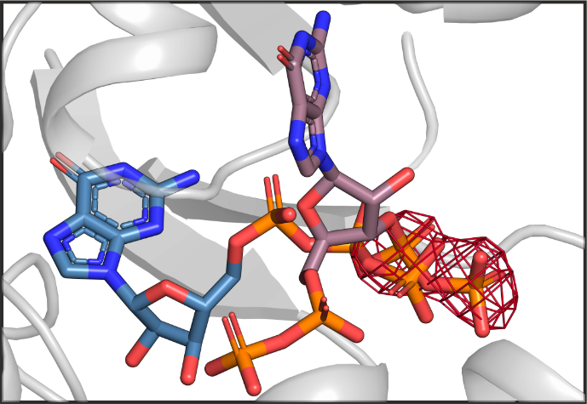
Supplementary Fig. 10 | The binding of GTP at site 2 and ppGpp at the dedicated ppGpp site is mutually exclusive. The GTP molecule is depicted in blue, and the ppGpp molecule in pink. The red mesh illustrates the potential clash of the δ- and ε-phosphates of ppGpp with the β- and γ-phosphates of GTP.

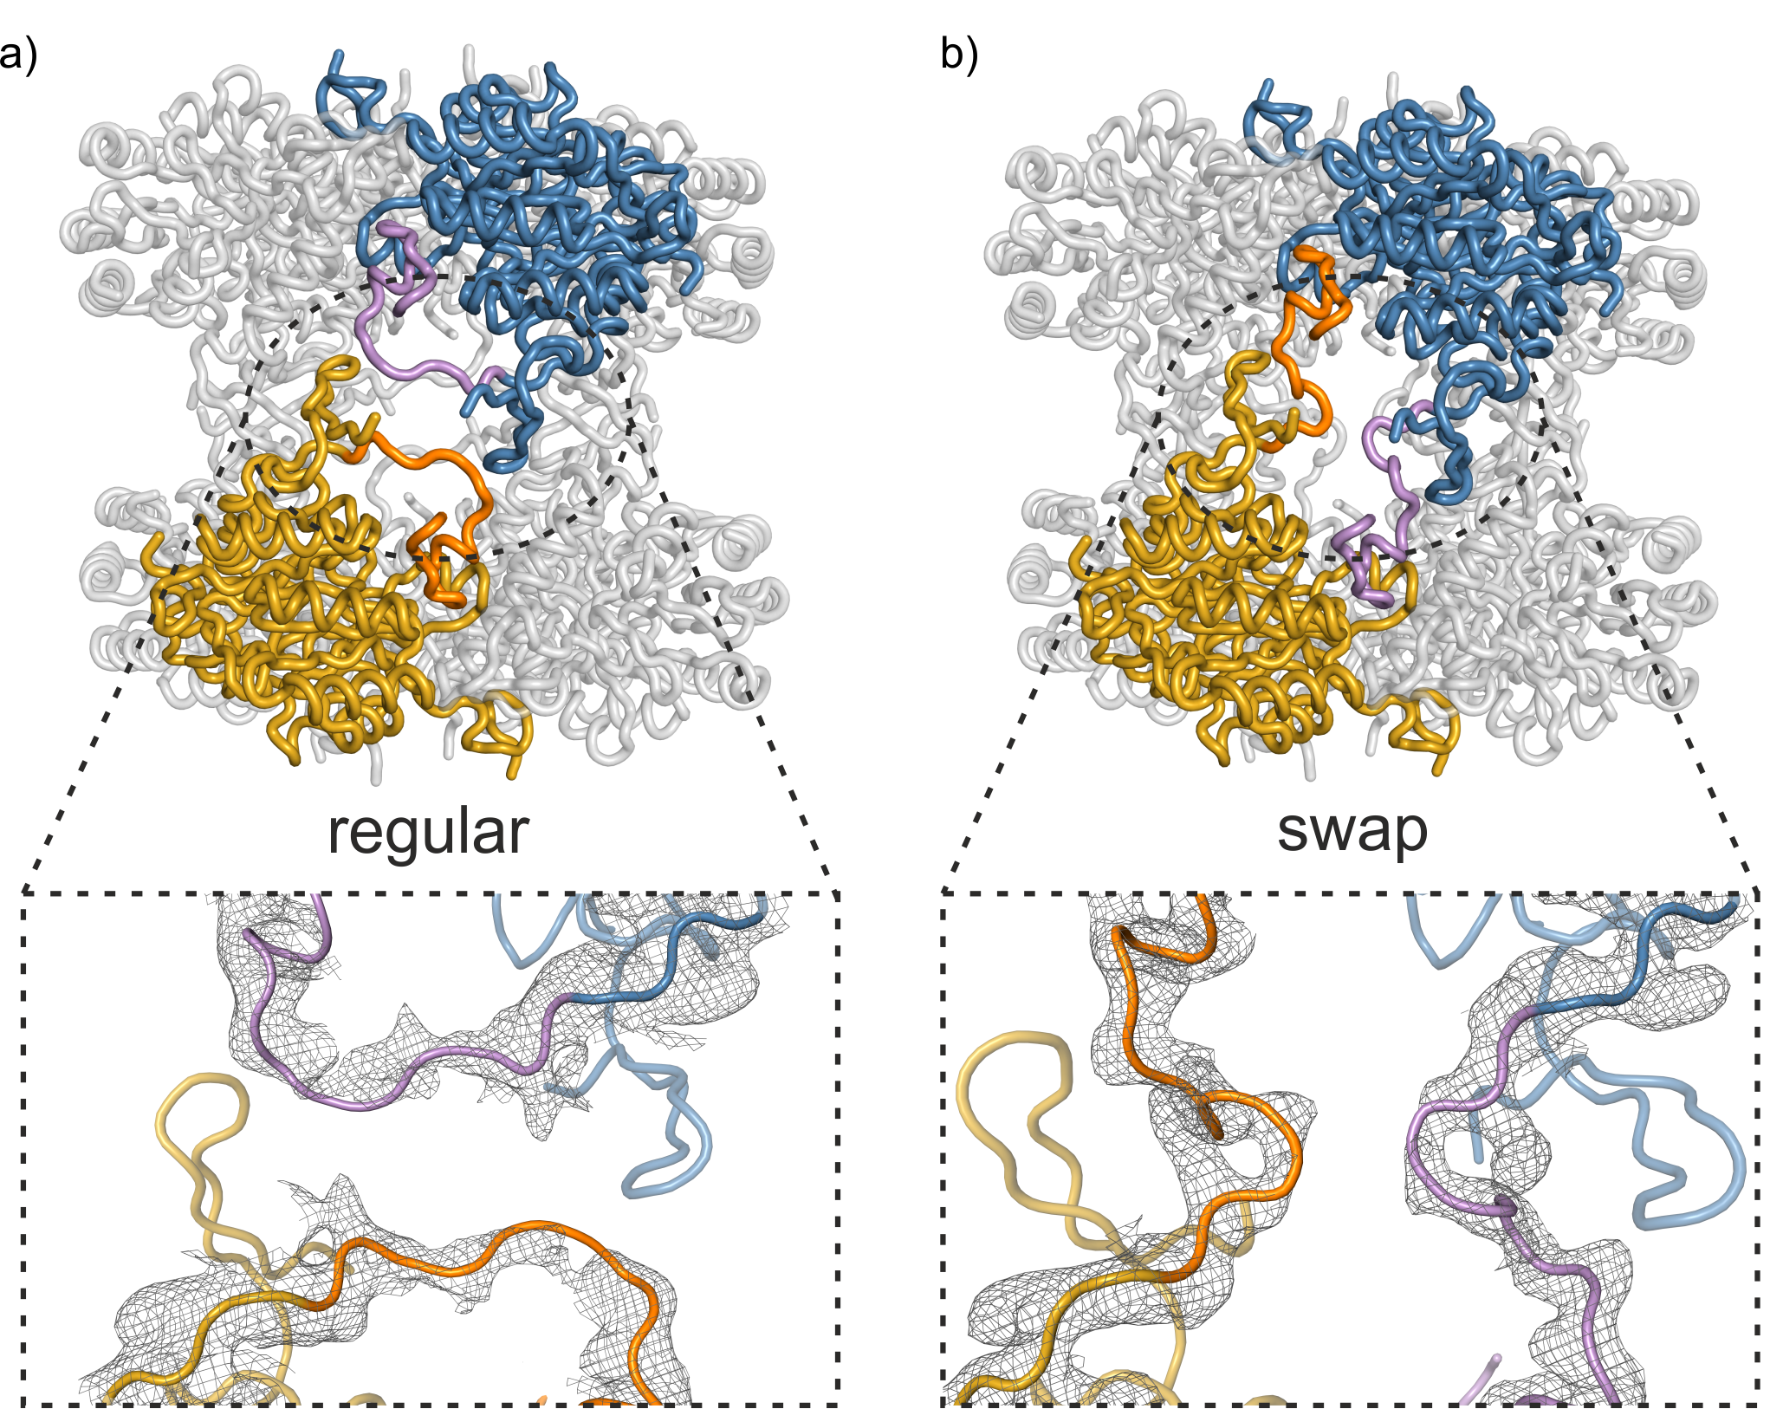
Supplementary Fig. 11 | Swap of flap loops upon 'super-compression' of MsmIMPDH. a, In the regular arrangement, the flap loops bind to the active site of the resident protomer. Upon tight compression of MsmIMPDH, the flap loops reach towards the active site of the opposite protomer. b, This movement enables the flap loops to swap from a cis to a trans configuration; the two opposite MsmIMPDH protomers are depicted in gold and blue, respectively. The flap loops are highlighted in orange for the gold protomer and purple for the blue protomer.

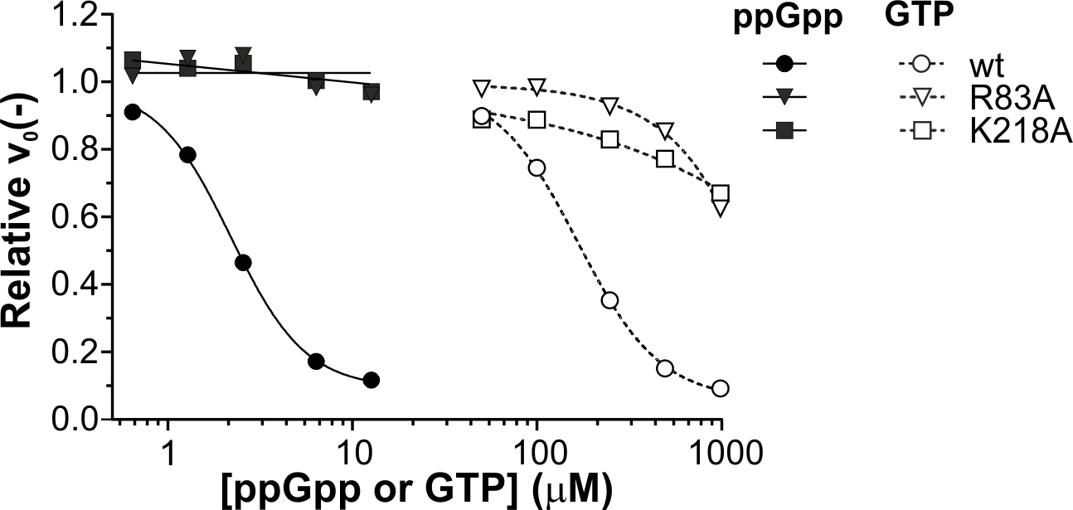
Supplementary Fig. 12 | Sensitivity of mutants in the CBS allosteric site of MsmIMPDH to GTP- or ppGpp-induced inhibition. NAD+ and IMP substrates were fixed at concentrations of 100 µM and 2 mM, respectively; ATP was fixed at 500 µM. The relative velocity value was calculated as the ratio of the initial velocity of the reaction to the control reaction of the wild-type enzyme. The mutation of the residues involved in the hinge regions strongly reduced the responsiveness of MsmIMPDH to ppGpp and GTP inhibition.

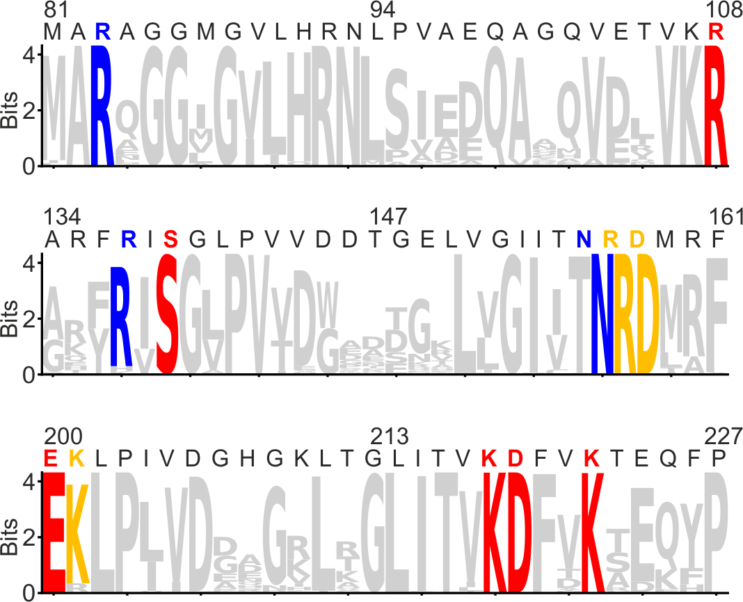
Supplementary Fig. 13 | Conservation of ligand binding sites of actinobacterial IMPDHs. Sequence logo showing the degree of conservation of the CBS-domain binding sites in the IMPDH sequences of all available representatives (2,846 sequences) of the Actinomycetia class. The coloured amino acid residues directly participate in ligand binding, where yellow is ATP binding Site 1, red is Site 2, and blue is the (p)ppGpp site. The x axis represents the position of the amino acid in the consensus sequence, and the y axis represents the information content in bits.

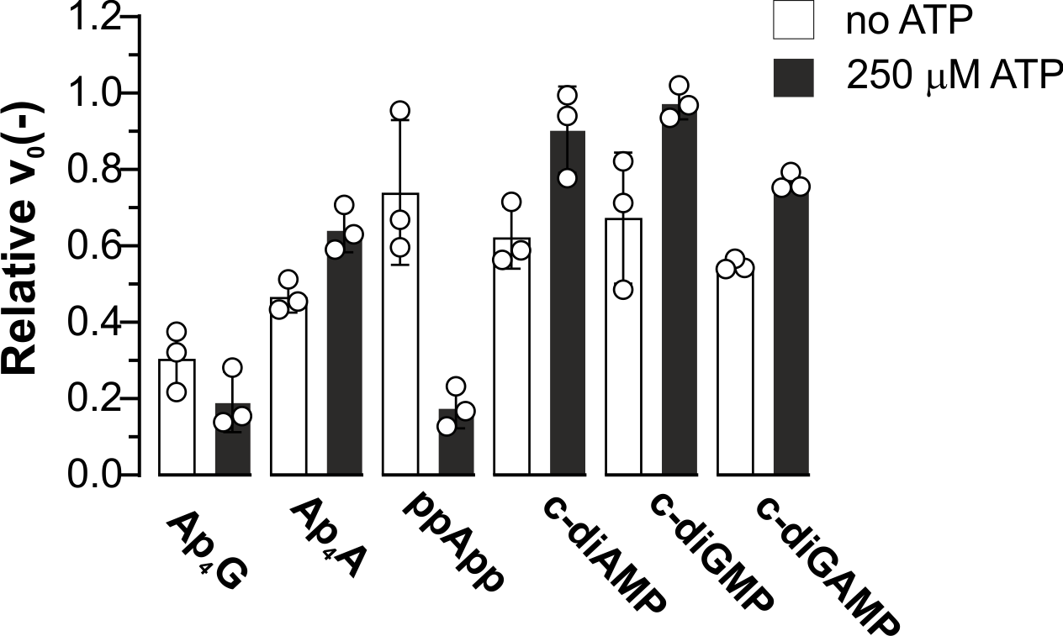
Supplementary Fig. 14 | Effect of selected signalling nucleotides on MsmIMPDH activity. The relative velocity of 500-µM nucleotides on their own and with 250 µM ATP was calculated as the ratio of the initial velocities of the reaction containing the tested nucleotides to the control reaction (n = 3). Initial velocities were measured at fixed concentrations of 100 µM and 2 mM for the IMP and NAD⁺ substrates, respectively.

Supplementary Table 1 | MsmIMPDH kinetic parameters (n = 3)
Parameter | Fixed [NAD⁺], 2 mM  Variable [IMP] | Fixed [IMP], 1 mM  Variable [NAD⁺]
k_{cat} (s⁻¹) | 2.24 ± 0.05 | 3.0 ± 0.3
K_{h} (µM) | 139 ± 4
n_{H} | 2.1 ± 0.1
K_{m} (mM) |  | 0.80 ± 0.17
Ki (mM) |  | 19 ± 7

Supplementary Table 2 | MsmIMPDH kinetic parameters of various ligands (n = 2–3)
[ATP]  (mM) | [GTP]  (mM) | [ppGpp]  (μM) | [MgCl2]  (mM) | k_{cat}  (s⁻¹) | K_{h}  (µM) | n_{H}
 |  |  |  | 2.24 ± 0.05 | 139 ± 4 | 2.07 ± 0.09
 |  |  | 1 | 2.18 ± 0.05 | 154 ± 5 | 2.03 ± 0.09
0.25 |  |  | 1.25 | 1.97 ± 0.07 | 139 ± 7 | 2.18 ± 0.17
0.5 |  |  | 1.5 | 2.07 ± 0.02 | 139 ± 2 | 1.79 ± 0.03
1 |  |  | 2 | 2.16 ± 0.07 | 135 ± 7 | 1.77 ± 0.11
4 |  |  | 5 | 2.17 ± 0.09 | 161 ± 12 | 1.56 ± 0.1
 | 0.25 |  | 1.25 | 2.03 ± 0.07 | 146 ± 7 | 2.31 ± 0.17
 | 1 |  | 1 | 2.27 ± 0.09 | 168 ± 9 | 2.20 ± 0.16
 |  | 100 | 1.1 | 2.25 ± 0.04 | 158 ± 4 | 2.24 ± 0.07
0.5 | 0.1 |  | 1.6 | 2.06 ± 0.05 | 156 ± 6 | 2.00 ± 0.10
0.5 | 0.25 |  | 1.75 | 2.03 ± 0.04 | 213 ± 6 | 2.27 ± 0.13
0.5 | 0.5 |  | 2 | 2.03 ± 0.05 | 320 ± 9 | 2.77 ± 0.19
0.5 | 1 |  | 2.5 | 2.01 ± 0.04 | 549 ± 12 | 2.58 ± 0.14
0.5 |  | 0.5 | 1.5 | 2.11 ± 0.02 | 141 ± 3 | 1.91 ± 0.05
0.5 |  | 1 | 1.5 | 2.12 ± 0.03 | 154 ± 3 | 2.06 ± 0.05
0.5 |  | 2 | 1.5 | 2.10 ± 0.03 | 190 ± 4 | 2.39 ± 0.10
0.5 |  | 5 | 1.5 | 2.12 ± 0.04 | 325 ± 6 | 3.32 ± 0.18
0.5 |  | 10 | 1.5 | 2.45 ± 0.05 | 598 ± 11 | 3.07 ± 0.14
 |  |  | 1 | 2.07 ± 0.03 | 163 ± 5 | 1.15 ± 0.03
 |  |  | 1 | 2.16 ± 0.06 | 252 ± 17 | 1.06 ± 0.05
 |  |  | 1 | 2.22 ± 0.09 | 369 ± 36 | 1.10 ± 0.06
0.5 | 0.5 |  | 2 | 2.18 ± 0.04 | 332 ± 15 | 1.26 ± 0.04
0.5 |  | 5 | 1.5 | 2.22 ± 0.04 | 367 ± 17 | 1.12 ± 0.03
Supplementary Table 3 | IC₅₀ values of guanine nucleotides at 250 µM ATP and fixed substrate concentrations (100 µM IMP, 2 mM NAD⁺) (n = 3)
Nucleotide | IC₅₀ at 250 µM ATP  (µM)
pppGpp | 6.2 ± 0.1
ppGpp | 1.8 ± 0.1
pGpp | 6.9 ± 0.2
GTP | 140 ± 3
GDP | No inhibition

Supplementary Table 4 | Cryo-EM data collection, refinement, and validation statistics
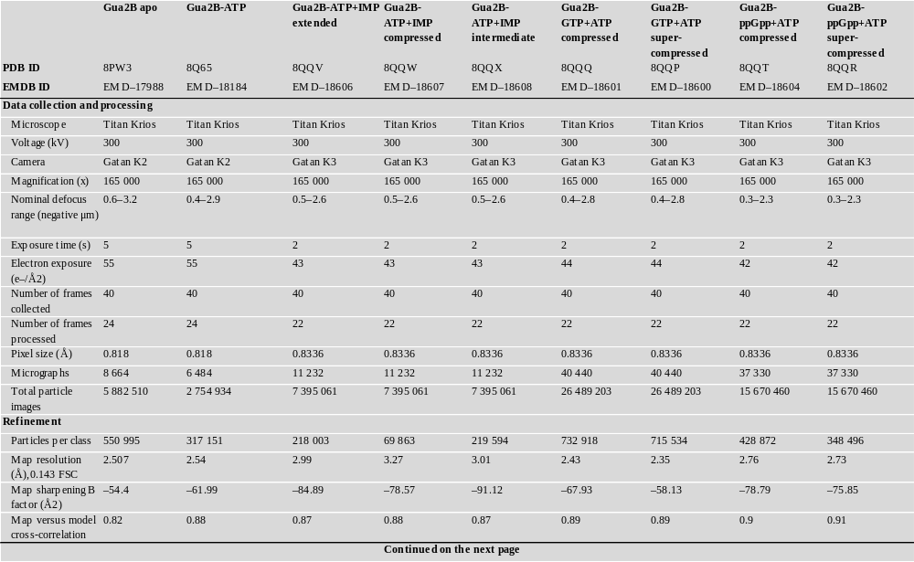
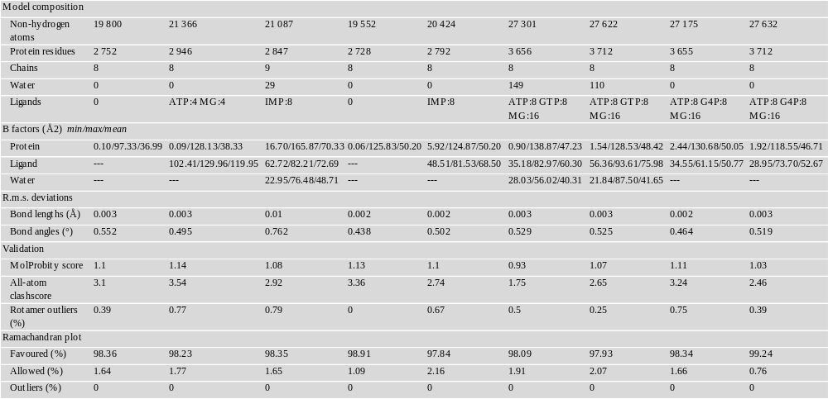
Supplementary Table 5 | List of plasmids used in this study
Plasmid | Source
pRSF-HisTEV | Laboratory stock
pRSF-HisTEV-MsmGuaB2 | This study
pRSF-HisTEV-MsmGuaB2-K201A | This study
pRSF-HisTEV-MsmGuaB2-E200A | This study
pRSF-HisTEV-MsmGuaB2-D158A | This study
pRSF-HisTEV-MsmGuaB2-R157A | This study
pRSF-HisTEV-MsmGuaB2-K222A | This study
pRSF-HisTEV-MsmGuaB2-R108A | This study
pRSF-HisTEV-MsmGuaB2-R83A | This study
pRSF-HisTEV-MsmGuaB2-K218A | This study

Supplementary Table 6 | List of oligonucleotides used in this study
Primer number | Description | Sequence
#1 | MsmGuaB2 WT for | caggatccgaattcgGAAAACCTGTATTTTCAGGGCTCGATCGCTGAAAGCA  GCGTTCCCATCGCCG
#2 | MsmGuaB2 WT rev | cctgcaggcgcgccgTCAGCGGGTGTAGTAGTTGGGTG
#3 | MsmGuaB2 K201A for | CGCAGGCACAAGATCGAGGCACTGCCGATCGTG
#4 | MsmGuaB2 K201A rev | GATCTTGTGCCTGCGCAGCAG
#5 | MsmGuaB2 E200A for | CTGCGCAGGCACAAGATCGCAAAGCTGCCGATC
#6 | MsmGuaB2 E200A rev | GATCTTGTGCCTGCGCAGCAG
#7 | MsmGuaB2 D158A for | GGCATCATCACCAACCGCGCAATGCGCTTCGAG
#8 | MsmGuaB2 D158A rev | GTTGGTGATGATGCCCACCAA
#9 | MsmGuaB2 R157A for | GTGGGCATCATCACCAACGCAGACATGCGCTTC
#10 | MsmGuaB2 R157A rev | GTTGGTGATGATGCCCACCAA
#11 | MsmGuaB2 K222A for | ATCACCGTCAAGGACTTCGTCGCAACCGAGCAGTTC
#12 | MsmGuaB2 K222A rev | GACGAAGTCCTTGACGGTGAT
#13 | MsmGuaB2 R108A for | GGCCAGGTCGAGACGGTCAAAGCCTCCGAGGCGGGCATG
#14 | MsmGuaB2 R108A rev | TTTGACCGTCTCGACCTGGCC
#15 | MsmGuaB2 R83A for | CGCATGGCCATCGCGATGGCGGCAGCGGGCGGCATG
#16 | MsmGuaB2 R83A rev | CGCCATCGCGATGGCCATGCG
#17 | MsmGuaB2 K218A for | ACGGGCCTCATCACCGTCGCAGACTTCGTCAAG
#18 | MsmGuaB2 K218A rev | GACGGTGATGAGGCCCGTGAG

Supplementary Methods

Nucleotides
Sodium salts of ATP, ADP, IMP, and NAD⁺ were purchased from Santa Cruz. A GTP solution of 100 mM was purchased from Roth. Nucleotide solutions of 50–100 mM were prepared in water, and the pH was immediately adjusted to a pH of 7.0 using 1 M NaOH. The exact concentration of the stocks was determined spectrophotometrically at the absorption maxima using the following absorption coefficients: ε^{260 nm} (ATP) 15.4 mM⁻¹cm⁻¹; ε^{253 nm} (GTP, GDP) 13.7 mM⁻¹cm⁻¹; ε^{260 nm} (NAD⁺) 17.4 mM⁻¹cm⁻¹; ε^{249 nm} (IMP) 12.2 mM⁻¹cm⁻¹. The aliquoted stocks were stored at −70°C. The following molecules were obtained from Jena Biosciences in solutions of 10 or 20 mM: 3',5'-cyclic diguanylic acid (c-diGMP); 3',5'-cyclic diadenylic acid (c-diAMP); cyclic guanosine-2'5'-monophosphate-adenosine-3'5'-monophosphate (c-GAMP); P1-(5'-adenosyl) P4-(5'-guanosyl) tetraphosphate (Ap4G); and P1-(5'-adenosyl) P4-(5'-adenosyl) tetraphosphate (Ap4A). ppGpp and pppGpp were synthesized enzymatically, as previously described¹. pGpp and ppApp were synthesized chemically, as previously described^{2,3}.

Detailed conditions and parameters of LC–MS analysis
Peptides were identified by tandem mass spectrometry of non-deuterated protein. Samples were injected into a refrigerated NanoAcquity UPLC M-Class System (Waters), with chromatographic elements held at 0 °C. Samples were passed through a protease column with co-immobilized pepsin and nepenthesin-2 proteases (Affipro, AP-PC-006, 2.1 mm x 20 mm) at 15 °C with a flow rate of 100 µl min⁻¹ (0.1% v/v FA). The generated peptides were trapped and desalted for 3 min on an Acquity UPLC BEH C18 VanGuard pre-column (Waters, 2.1 mm x 5 mm, pore size 1.7µm). Subsequently, peptides were separated over an Acquity UPLC BEH C18 column (1 mm x 100 mm, pore size 1.7 µm) for 12 min (10–35% CH₃CN v/v and 0.1% v/v FA, flow rate 40 µl min⁻¹). MS spectra were acquired using the Synapt G2-Si mass spectrometer (Waters) configured with electrospray ionization (ESI) and quadrupole/time-of-flight (Q/TOF) within a mass range of 50 to 2000 m/z; scans were performed every 0.4 s. Leucine enkephalin served as the continuous (lock-spray) calibration standard.

Detailed parameters for MS data processing using Waters software
ProteinLynx Global SERVER (PLGS) v.3.0.2
The PLGS processing parameters for MS/MS data were as follows: chromatographic peak width – automatic; MS TOF resolution – automatic; lock mass for charge +1 – 556.2771 Da/e; lock-mass window – 0.25 Da; low-energy threshold – 135.0 counts; elevated energy threshold – 30.0 count; and intensity threshold – 750.0 counts. PLGS workflow parameters were as follows: fasta file search containing forward and reverse sequences of the examined protein, namely pepsin (UniProt code P00791) and nepenthesin-2; peptide tolerance and fragment tolerance – automatic; minimum fragment ion matches per peptide – 3; minimum fragment ion matches per protein – 7; minimum peptide matches per protein – 1; primary digest reagent – non-specific; number of missed cleavages – 3; oxidation of methionines as a variable modifier reagent; false discovery rate – 5; monoisotopic mass of peptides with charge +1 used for the ESI-QUAD-TOF instrument type.
DynamX v.3.0
DynamX v.3.0 (Waters) was used to filter peptides, selecting those presenting 0.3 fragments per amino acid and a mass error for the precursor ion below 10 ppm. In addition, only peptides identified in at least 3 out of 5 acquired MS/MS files, with a maximum length of up to 25 amino acids, a minimum signal intensity of 3000, and a retention time of up to 5 % RSD, were used for further analysis.
For processing of MS files, the following parameters were used: both chromatographic peak width and MS TOF resolution were set as automatic, with 556.2771 Da used as a lock mass for charge +1, a lock-mass window of 0.25 Da, a low-energy threshold of 130, and an elution time range of 2.5–9 min to conduct the data search. DynamX advanced processing parameters were not applied.
Statistics and visualization of results in HDX-MS experiments
DynamX 3.0 was used to calculate the deuterium contents of peptides generated from labelled proteins. Statistically significant differences in deuterium incorporation between each two considered protein states at the peptide level were determined by applying the threshold for the 98% confidence interval. This was calculated using the root-mean-square of the standard deviations of peptide deuterium contents for time points performed in triplicate, followed by application of the Student’s t-test. Finally, the deuterium uptakes of common peptides were shown in exchange plots to illustrate differences in peptide accessibility and protectability across the states.

References
1. Tamman, H. et al. Structure of SpoT reveals evolutionary tuning of catalysis via conformational constraint. Nat Chem Biol 1–12 (2022)
2. Horvatek, P. et al. Inducible expression of (pp)pGpp synthetases in Staphylococcus aureus is associated with activation of stress response genes. PLOS Genetics 16, e1009282 (2020).
3. Kurata, T. et al. RelA-SpoT Homolog toxins pyrophosphorylate the CCA end of tRNA to inhibit protein synthesis. Molecular Cell 81, 3160-3170.e9 (2021).

