SUPPORTING INFORMATION
Note S1. Experimental part related to support synthesis
As catalyst support, a selection of materials was chosen based on their activity in the CO₂RR, overall conductivity, wettability, high-surface area, diverse heteroatom functionalities, scalability and overall economics from inhouse developed¹ as well as the literature inspired syntheses (Figure S1).^{2,3, 4,5,6} In brief, the materials produced which were N-edge functionalized (Figure S1A, B) were synthesized by mixing graphene nanoplatelets (Graphene Supermarket AO-4, 1 g) or multiwalled carbon nanotubes (PlasmaChem Gmbh, 1g) with urea (Sigma Aldrich >99%, 3 g) and ball milled at 500 rpm for 48 hr at 20:1 ball (ZrO₂) to reactant mass ratio under nitrogen atmosphere.^{5,6} The products were washed and collected in i-PrOH reaching a concentration of 30 mg mL⁻¹. The N-doped carbon black based material was synthesized via a protocol adapted from Yang et al. (Figure S1C).⁴ In brief, Vulcan carbon black (FuelCellStore, 900 mg) was oxidized by means of mixing with an aqueous HNO₃ solution (Sigma Aldrich ≥65%, 30 mL) and heated to 80 °C whilst stirring under reflux for 3 hrs. The oxidized carbon black was collected with 50 mL of water and washed until neutral pH ~6.8 was reached. The washed product was dried overnight under vacuum of which 150 mg was mixed with urea in a mortar (Sigma Aldrich >99%, 1.5 g). The mixture was placed in a ceramic boat and heated to 800 °C in 80 min, kept for 60 min at 800 °C and then cooled naturally to r.t. all under Ar atmosphere. The 500 mg of NCB-NP were washed and collected with i-PrOH reaching a concentration of 30 mg mL⁻¹. Graphene oxide nanoparticles were produced according to a previously reported synthesis (Figure S1D).¹
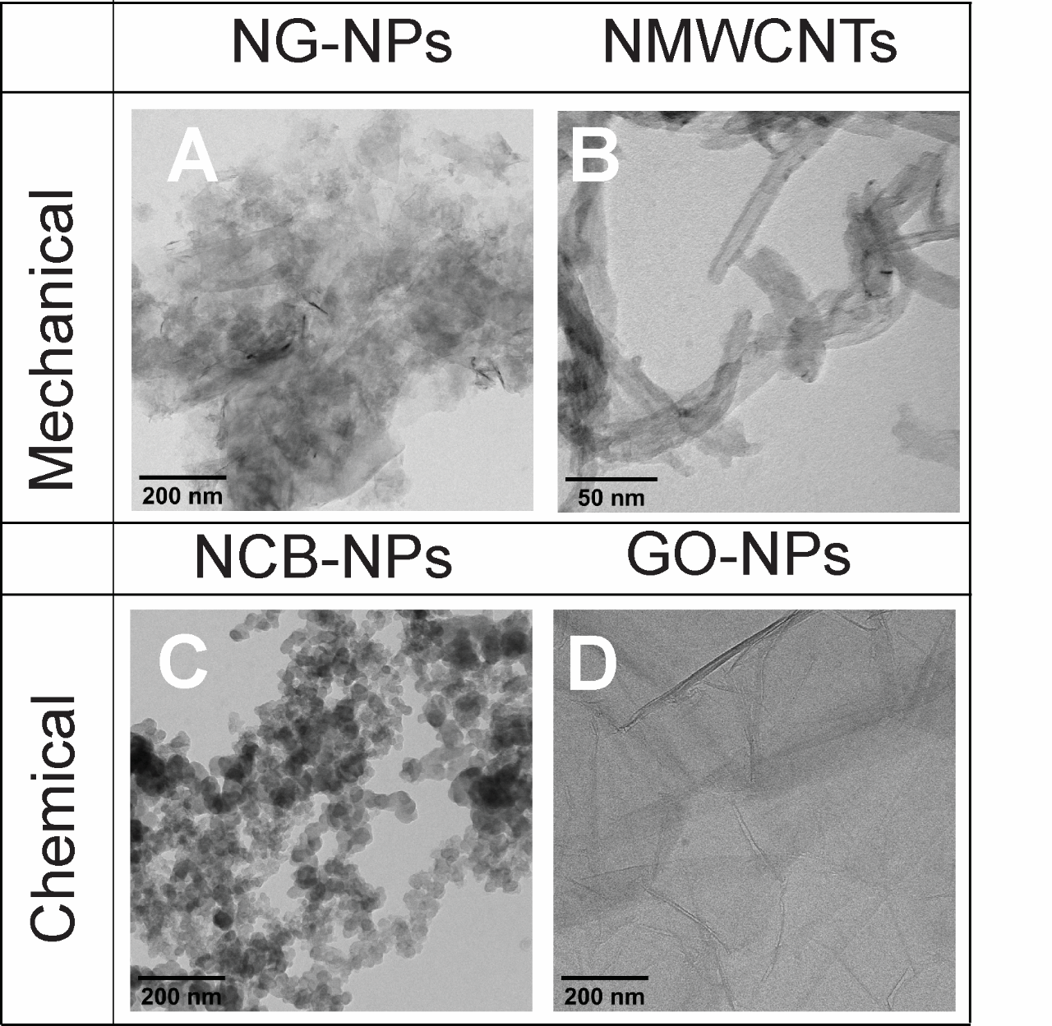
Figure S1. BF-TEM images of the carbonaceous support materials synthesized for cluster immobilization. A-B) Produced via the mechanical route i.e. ball milling that are nitrogen rich: NG-NPs⁵, NMWCNTs.^{5,6} C-D) Produced via chemical routes i.e. pyrolysis and oxidation: NCB-NPs⁴ and GO-NPs¹, respectively. A) N-edge functionalized graphene nanoparticles. B) N-edge functionalized multiwalled carbon nanotubes. C) N-doped carbon black nanoparticles. D) Graphene oxide nanoparticles.
Note S2. Experimental part related to cluster production
In order to achieve a scalable synthesis of metal oxide clusters of controllable size, composition and (surface) loading, we investigated the production of metal oxide clusters via spark ablation, in which two metal electrodes of arbitrary composition are ablated via a spark generated plasma (>20000 K, Ar) to produce particles in the aerosol.^{7,8,9,10,11} Traditionally, spark ablation has been used to produce nanoparticles of a single element in the size range 5-20 nm (i.e. C, Ag, Pd, Zr, and Nb).^{7,8} More recently, multicomponent materials have been produced as well including immiscible mixtures and high-entropy alloys on various substrates but all of sizes > 5 nm.^{12,9,10} On the other hand, spark ablation has also been used to produce atomically precise metal (oxide) clusters (<2 nm) but only of single element (Ag, and Au) and purely in the aerosol and more importantly, not at practically relevant production levels (~pg/hrs).^{13,11} In here, we have achieved a scalable synthesis of Cu(Ag) metal oxide clusters <2 nm with a 6-orders higher mass production rate (~1 μg/hrs). To produce such clusters of well-defined size and composition, and especially at high production rates, a highly specific spark generator configuration was chosen that optimized a set of parameters to control 1) the size, 2) the production rate and finally 3) the composition (Figure S2).
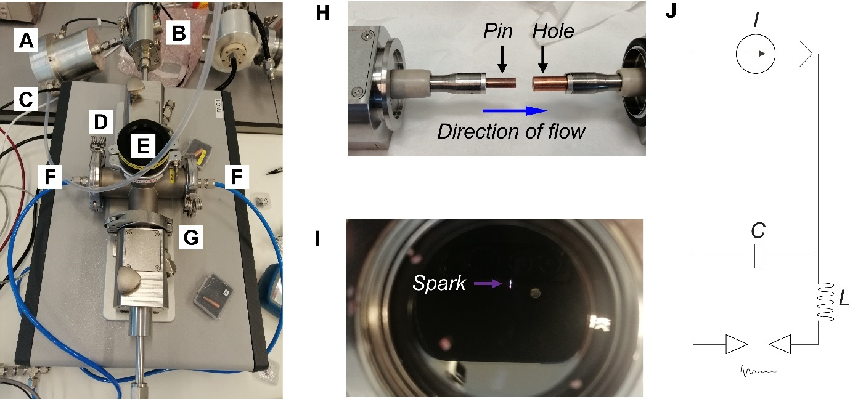
Figure S2. Description of the spark ablation and electrostatic deposition experimental set-up, operation, and electrical components. (A) Faraday cup used to collect either negatively or positively charged particles from the aerosol. The measured current (via an electrometer) allows to determine the number of ions hitting the cup per unit of time giving a measure of the ablation rate (cluster production rate). (B) Deposition chamber allowing for a filter deposition in which the entire aerosol flow is passed through a substrate as well as an electrostatic deposition method¹⁴ in which a bias is applied to a substrate and as such only particles of opposite polarity are adhered to it. (C) Aerosol exhaust. (D) Positive electrode (grounded). (E) Spark chamber. (F) Carrier gas (Ar) flow inlet. Direction of flow is from (E) to (B). (G) Negative electrode. (H) Pin-to-hole configuration of the electrode set-up of the spark ablator showing two Cu electrodes. Exchanging the pin or negative electrode for Ag allows for the production of bimetallic clusters. (I) Picture of the spark in operation. (J) Resistance-inductance-capacitance (RLC) electrical circuit, in which I denote the power supply. C denote(s) the capacitor, L denotes the inductor needed to store potential energy via the magnetic field needed for the oscillatory nature of the spark. The spark is indicated by the damped exponential with a ~100 ns time constant of the oscillation of the spark between the grounded and negative electrode.
Note S2.1 Controlling the particle size
The first objective, was to reduce the particle size, which can be estimated based on Eq. 1:
 | $$D≈{\left(\frac{3βV_{eff}\dot{m}}{ρπQ^{2}}\right)}^{1/3}$$ | (1)
in which Q carrier gas flow rate in this case Ar [m³ s⁻¹], V_{eff} the effective volume in the spark chamber [m³], β the coalescence kernel [m³ s⁻¹], which is rate at which two particles coalesce, $\dot{m}$ the mass production rate [kg s⁻¹]and ρ the density of the material ablated [kg m⁻³].^{15,16,9} Therefore, three parameters needed to be optimized: 1) the V_{eff} should be kept at a minimum, 2) the flow rate should be maximized and, finally, 3) the mass production rate should be minimized. To keep the effective volume as small as possible, we opted for a dual-mixed flow geometry using two inlets (Figure S2A-G) and a pin-to-hole configuration (Figure S2H).¹⁷ Further, we chose a gas flow rate of a factor of 2.5 higher with respect to a conventional nanoparticle spark generated synthesis (~6 nm Au)¹⁵, effectively reducing the particle size by a factor ~2. And lastly, we reduced the ablation rate, which is given by Eq. 2:
 | $$\dot{m}= ∆mf≈ E_{s}cf$$ | (2)
in which Δm denotes the change in the electrode mass or ablated mass [kg] and f the repetition frequency of the spark [s⁻¹], which roughly equates to the product of the energy per spark (E_{s}) and c, a material dependent constant [kg J⁻¹], by reducing the energy per spark (Figure S2I). The E_{s}, can be determined via Eq. 3:
 | $$E_{s}= \frac{1}{2}CU^{2}$$ | (3)
in which U denotes the breakdown-voltage [V] and C the capacitance [F] (Figure S2J). By bringing the energy per spark down by an order of magnitude (1 nF), the particle size should be reduced further by an estimated factor of ~2.2, effectively pushing the particle size in to the cluster regime (~1 nm).
Note S2.2 Optimizing the ablation rate
The second objective, was to enhance the production rate. Therefore, we maximized the spark repetition frequency to ~1 kHz by enhancing the charging current of the capacitor banks whilst maintaining a stable spark and preventing continuous plasma formation, which would destroy the size distribution as the well-defined nature of the particles is a direct consequence of the pulsating nature of the spark (1 mA).¹⁸ Further, as the ratio between positively and negatively charged particles differs in the cluster regime as well as their most frequently observed size¹¹, we investigated the effect of charge as well. Figure S3 shows the effect of capacitance and cluster charge on both the particle size and production rate for a Cu-Cu electrode configuration (i.e. Figure S2H).
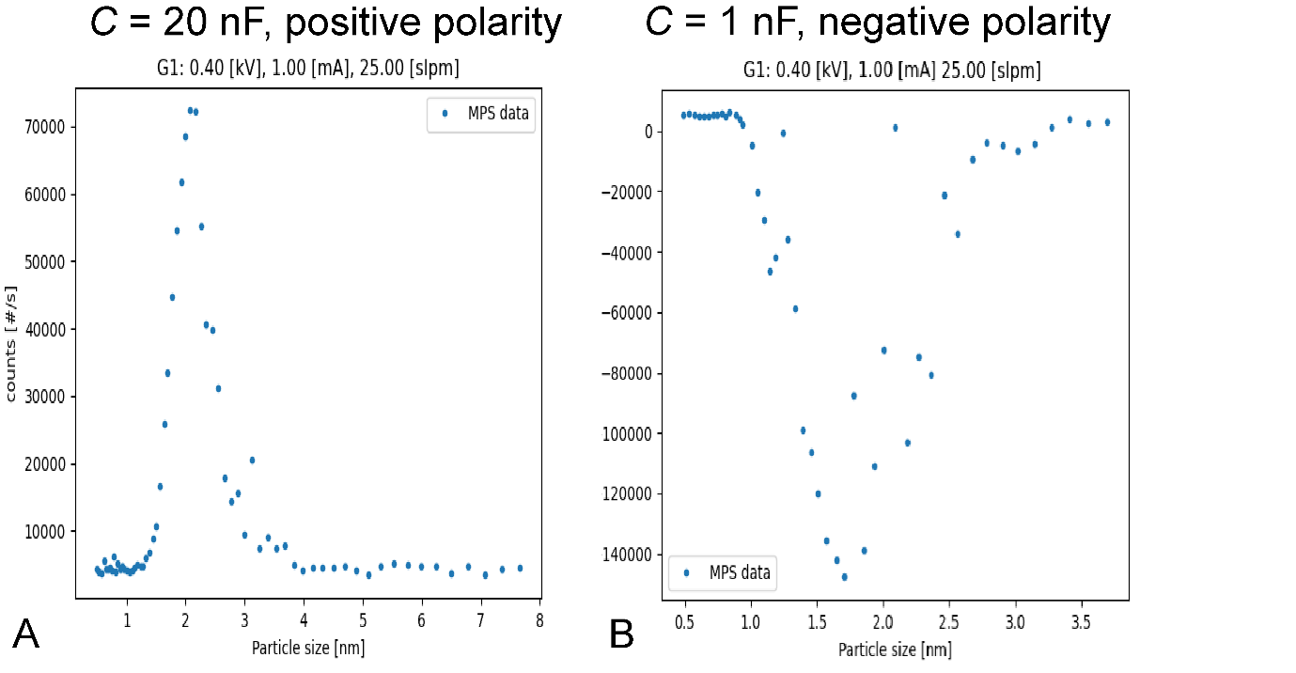
Figure S3. Size distributions of charged clusters produced in the aerosol as measured by a differential mobility analyzer (DMA) to determine the particle mobility (and thus size) and the production rate measured via the Faraday cup depicted in Figure S2A and an electrometer. The voltage scan of the DMA is converted to a particle size. The current measured by the electrometer is converted to a number concentration and thus the production rate (min losses). (A) The Cu oxide positively charged particle size distribution with an average size of ~2.1 nm, a 7 10⁵ s⁻¹ production rate, at 0.4 kV spark discharge voltage, 1 mA charging current, 25 lpm aerosol gas flow and 20 nF capacitance. (B) The Cu oxide size distribution of negatively charged particles with the average size of 1.6 nm and double the production rate at 1 nF capacitance but all other parameters kept the same (1.4 10⁶ s⁻¹).
Note S2.3 Controlling the particle composition
The third and final objective was to control the particle composition by mixing in a second element. This can be achieved simply by switching out either the pin or the hole electrode for one of a different element (in this case Ag).¹⁰ Since the negatively charged electrode will have the highest relative ablation rate due to its attraction of the Ar⁺ ions existing in the plasma resulting in rapid ion bombardment¹⁹, and we need a majority Cu for a good electrochemical performance, we opted to swap this electrode. Figure S4 shows the size distribution with a Cu-pin, Ag-hole configuration.
Figure S4. Size distribution and production rate of the positively charged Cu-Ag oxide clusters with an average size of 1.5 nm, which showed the smallest size and highest production rate whilst maintaining a stable spark.
Note S3. Experimental part related to electrostatic precipitation deposition.
In order to accurately deposit the metal oxide clusters on a substrate with a well-defined spot size to control the loading/dispersion on various substrates, we opted for the use of electrostatic precipitation.¹⁴ Since metal oxide clusters carry for the large part a charge, they are well suited to be extracted from the aerosol using an applied bias. Therefore, we placed a TEM grid coated with support material orthogonal to the particle beam (to minimize diffusion deposition) in the deposition chamber indicated in Figure S2B. By applying a bias of (+/-)60 V, all the particles of opposite polarity could thereby be deposited on to the TEM grid by concentrating the particle beam into a spot size equal to the TEM grid diameter. An optimized loading of 1.0 mg cm⁻² MWCNTs, 0.27 mg cm⁻² NG-NPs, 0.13 mg cm⁻² NCB-, 0.050 mg cm⁻² GO-NPs support was used for uniform sub-monolayer coating of the TEM grid (Figure S1). The particle spot size can be determined via Eq. 4:
 | $$r_{spot}= \sqrt{\frac{Q}{πV_{d}}}$$ | (4)
in which Q is the aerosol flow rate [m³ s⁻¹]and V_{d} is the particle velocity [m s⁻¹], which can be estimated based on the particle mobility (measured via the DMA) and the electric field applied. The projected 2D coverage of such an electrostatic precipitation deposition can then be estimated via Eq. 5:
 | $$coverage= \frac{N_{p}4π{r_{p}}^{2}t_{d}}{4π{r_{spot}}^{2}}$$ | (5)
in which N_{p} denotes the particle production rate [s⁻¹], r_{p} the particle radius [m],and t_{d} the deposition time [s]. For the electrostatic precipitation experiments, we report coverage in the form of partial monolayers as determined for a 2D projection on a flat surface. The actual coverage is factors smaller due to the added depth-profile of the 3D surface.
Note S4. Experimental part related to cluster immobilization.
Since the clusters produced have >70% of their atoms at the surface, which are highly undercoordinated, they are extremely reactive and agglomerate and sinter easily. Therefore, cluster immobilization is no mean task. Here, we have studied the stability of (bi)metal oxide clusters on various carbonaceous supports: N-doped carbon black NPs (NCBNPs), graphene oxide NPs (GONPs), N-edge functionalized graphite NPs (NGNPs), and finally N-edge functionalized multiwalled carbon nanotubes (NMWCNTs). The synthesis of these substrates is described in the Methods section of the main manuscript. Here we report the cluster immobilization and stabilization via the electrostatic precipitation deposition study, described in Note S3, instead. We observed a deposition equivalent of 0.5 mono layers (ML) of CuO and CuAgO clusters in 2D projection with BF-TEM on all four supports (Figure S5). For NCB, GO and NG, coated with CuO, no apparent particles could be observed (Figure S5A, C-D), which is a direct result of the low thickness contrast and low density of CuO. Instead, for the NMWCNTs-based sample, particle agglomeration had occurred as particles >20 nm could be distinguished (Figure S5B). Interestingly, for the CuAgO particles, a similar effect could be discerned as here larger particles could be observed likewise (Figure S5F). Contrarily, particle agglomerates were absent for the NCB, NG, and GO coated materials with particles <2 nm clearly visible (Figure S5E, G-H).
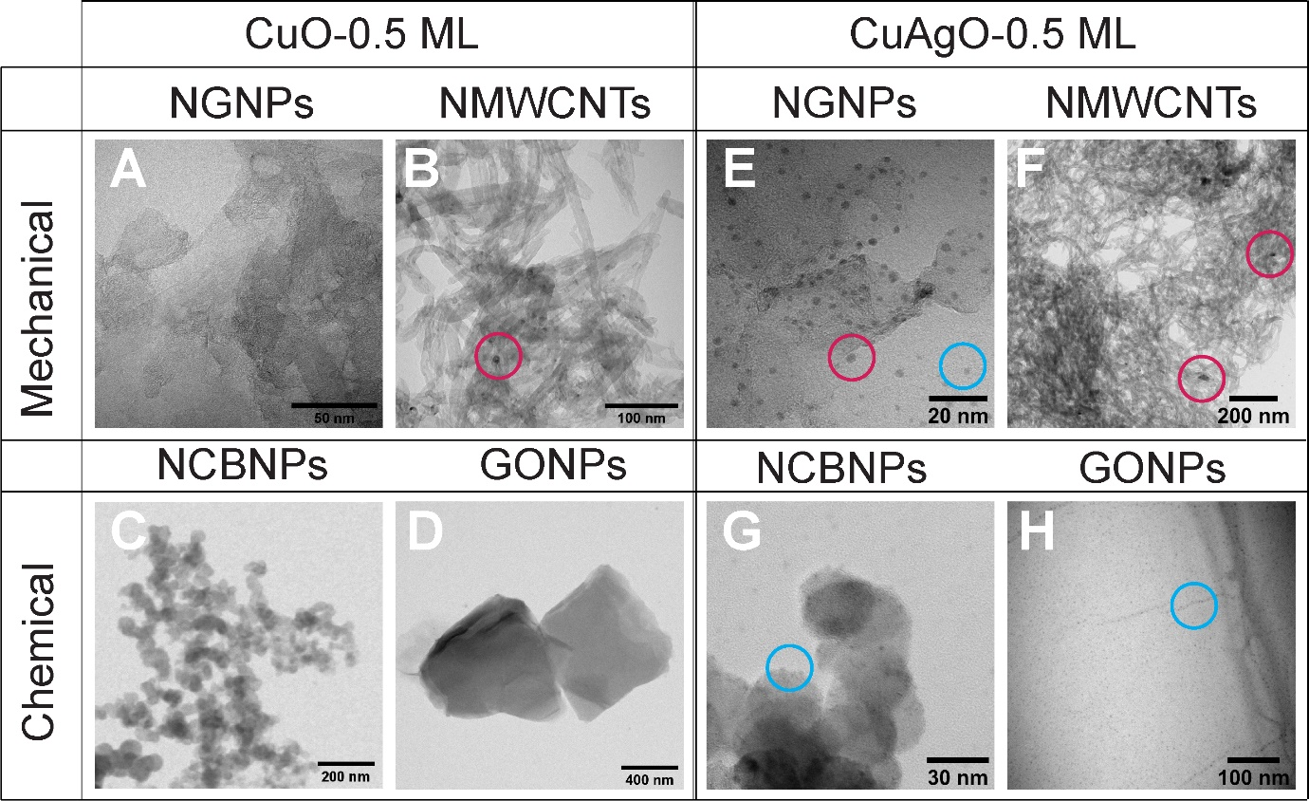
Figure S5. BF-TEM images of the electrostatic precipitation deposition of 0.5 mL equivalent of 1.6 nm CuO and 1.5 nm CuAgO clusters on four different carbonaceous supports. (A-D) NGNPs and NMWCNTs (produced mechanochemically) and NCBNPs and GONPs (produced chemically) coated with CuO clusters, respectively. No apparent particles can be observed with BF-TEM other than in (B). This is due to the small particle size, low relative density of CuO (6.31 g cm⁻³) and therefore low contrast in bright-field mode. Instead, in (B), particle agglomeration had occurred resulting in the observed particle size >20 nm. (E-H) NGNPs, NMWCNTs, NCBNPs, and GONPs coated with CuAgO clusters, respectively. Particles <2 nm could clearly be observed for NCB, NG and GO based supports and indicated by the blue circles. However, the particle size distribution for the NG-NPs indicated some form of sintering as the mean size shifted from ~1.5 to 2.1 ±0.6 nm (>2 nm particle indicated by red circle). Further, for the NMWCNTs, particle agglomerates >20 nm could be observed similar to the CuO coated system confirming the high surface mobility on carbon nanotubes (red circles, respectively).
To further investigate the nature of the particles (or the absence thereof) deposited on the various supports as well as their apparent agglomeration when deposited on NMWCNTs, we conducted a STEM-HAADF/EDXS study. Here, we selected one unstable material, MWCNT, and a stable one, NCB, and investigated both the CuO as well as CuAgO functionalization more thoroughly. Figure S6 shows the outcome of CuO deposition on NCB. Indeed, a homogenous distribution of Cu particles ~1.5 nm can be observed at the particle surface comparing well with the measured size prior to deposition.
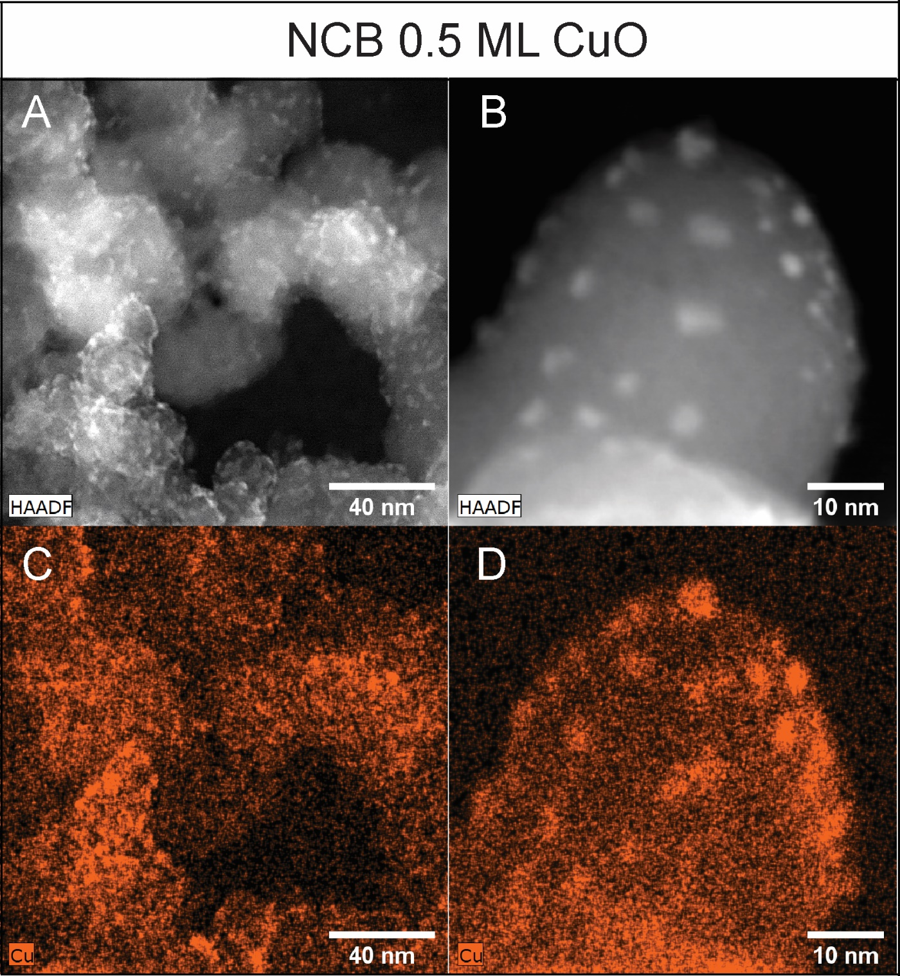
Figure S6. Advanced EM investigation of the 0.5 ML of CuO clusters electrostatically precipitated on the NCB support. (A-B) STEM-HAADF image at 0.45 and 1.25 MX magnification, respectively, showing a homogeneous distribution of higher contrasting particles at the amorphous carbon substrate surface. The average particle size of 1.5±0.5 nm compares well to the 1.6 nm determined by the DMA prior to deposition. (C-D) STEM-EDXS Cu elemental map of the images depicted in (A-B) confirming the Cu nature of the particles.
Instead, for the mass equivalent CuO deposition on the MWCNTs, larger agglomerates >10 nm are directly visible in the STEM-HAADF image (Figure S7). STEM-EDXS further confirms the Cu nature of the particles.
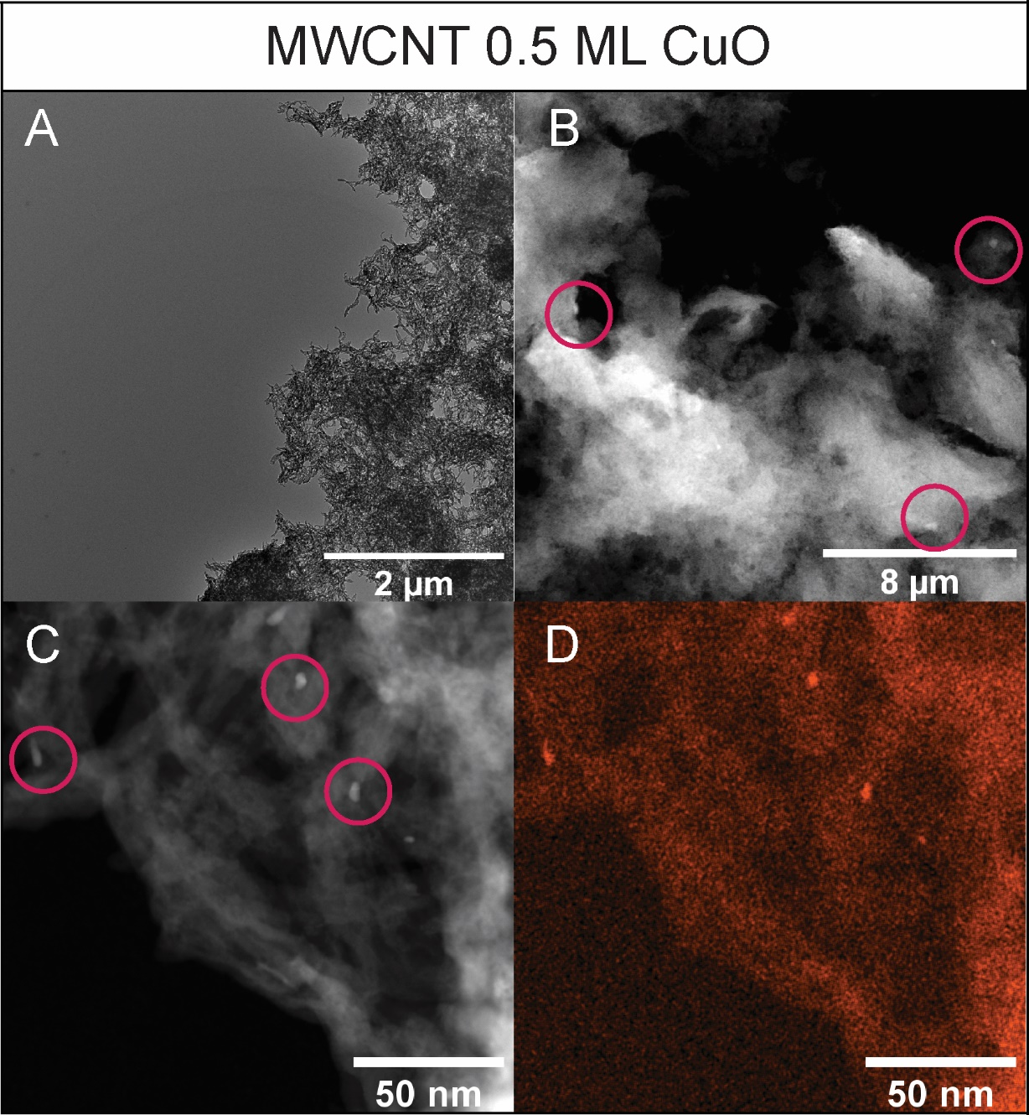
Figure S7. Advanced EM investigation of the 0.5 ML of CuO clusters electrostatically precipitated on the MWCNT support. (A) BF-TEM image of the substrate. (B) STEM-HAADF image of the coated substrate with >10 nm agglomerates visible indicated by the red circles. (C) STEM-HAADF image with clearly identifiable agglomerates. (D) STEM-EDXS elemental map of the image in (C) showing the Cu nature of the agglomerates.
Figure S8 shows the outcome of CuAgO deposition on NCB. The average cluster size determined with STEM-HAADF of 1.4±0.33 nm overlays well with the DMA determined ~1.5 nm (Figure S8A). Therefore, we can conclude that the particles produced by the spark have been successfully deposited without agglomeration. The high N-content in the NCB samples as well as the high surface area (average C-NP size ~50 nm) facilitate immobilization and stabilization of the clusters (Figure S8B). STEM-EDXS puts the composition of the CuAgO clusters at Cu_{0.42}Ag_{0.08}O_{0.5} (Figure S7C). Further, a second particle mode could be detected that was rich in Ag (Figure S8D-F). However, its relative abundance was about two orders smaller and could therefore be neglected in the electrochemical performance considerations (Figure S8G-F).
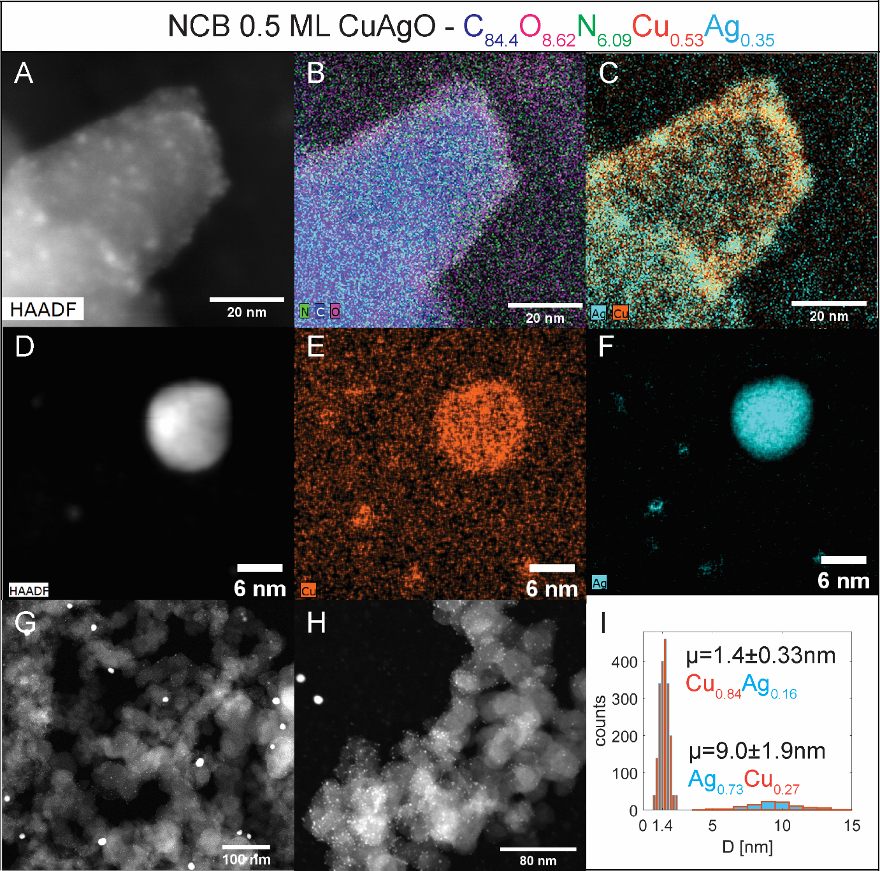
Figure S8. Advanced EM investigation of the 0.5 ML of CuAgO clusters electrostatically precipitated on the NCB support. The TEM grid used was of Au to minimize interference. The composition presented in the title was determined by STEM-EDXS analysis. Note that the grid contains C as well. (A) STEM-HAADF image of the CuAgO clusters with average size of 1.4±0.33 nm. The measured size distribution compares well to the one measured via the DMA at 1.5 nm. (B) STEM-EDXS elemental map of the HAADF image in (A) showing N, C, O, in green, blue, and magenta, respectively. The N doping is as high as 6 at. %. (C) STEM-EDXS elemental map of the HAADF image in (A) of Cu and Ag in orange and turquois, respectively. Determined Cu:Ag ratio ~5:1. (D) STEM-HAADF image of large 9±1.9 nm particle. (E) STEM-EDXS elemental map of the HAADF image in (D) showing Cu in orange. (F) STEM-EDXS elemental map of the HAADF image in (D) showing Ag in turquois. Determined Cu:Ag ratio: ~1:2.7. This particle represents the second mode that is being produced at the 0.6 kV, 2.5 mA, and 15 lpm spark generator settings. (G) STEM-HAADF low-magnification image showing the relative abundance of the Ag rich particle. (H) STEM-HAADF image showing the high relative abundance of the CuAgO clusters. (I) Quantification of the relative abundance of both particle modes by observing a 630x630 nm area. Nearly 2-order larger abundance of CuAgO clusters vs Ag-rich NP. Average Cu:Ag composition calculated considering both relative abundance and particle mass is 2.1:1, which compares well to the composition determined via XPS (see Figure S16, Table S1).
Figure S9 shows the outcome of CuAgO deposition on MWCNTs. Similar to what could be observed in BF-mode, STEM-HAADF pointed towards various agglomerates >20 nm (Figure S9A, C). STEM-EDXS suggested Ag-species as the most mobile as most agglomerates where rich in Ag (Figure S9B, D). Cu instead, showed stronger interaction with the support and remained relatively well dispersed, similar to what had been observed for CuO clusters. Finally, as a control experiment, we acquired a STEM-EDX spectrum confirming the absence of both Cu and Ag in the uncoated MWCNTs (Figure S9E, F).
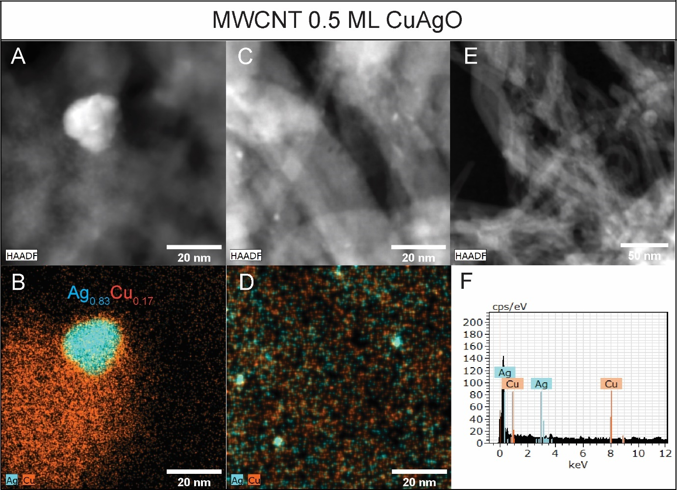Figure S9. Advanced EM investigation of the 0.5 ML of CuAgO clusters electrostatically precipitated onto the MWCNT support. (A) STEM-HAADF image of agglomerate >20 nm. (B) STEM-EDXS elemental map of the image in (A) with Cu in orange and Ag in turquois. The particle composition is given in the inset. (C) STEM-HAADF image of > 2 nm particles. (D) STEM-EDXS elemental map of the image in (C), which shows the high Ag content in the particles. (E) STEM-HAADF image of uncoated MWCNTs. (F) STEM-EDX spectrum of the image in (E) showing the absence of both Cu and Ag prior to deposition.
Note S5. Experimental part related to the cluster-support interaction.

An attempt was made to explain the weaker bonding of the clusters to the MWCNTs by investigating the work function of the supports arguing that stronger bonding should occur for the support with the lowest binding energy (Figure S10). Interestingly, the secondary electron cut-offs (SECO) of the support materials, which is equivalent to the work function, could not explain the trend. Following the work function, bonding to the MWCNTs should be second best to NCB supported clusters.
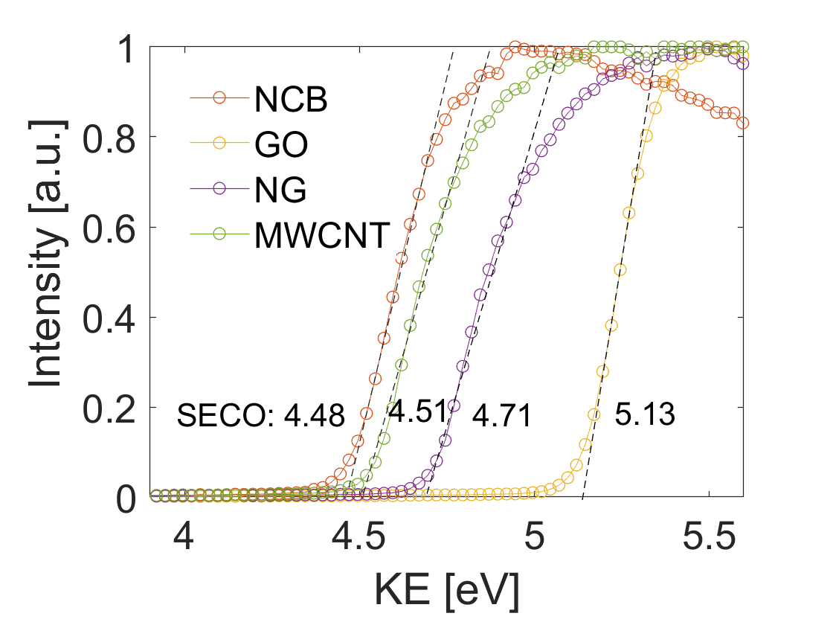
Figure S10. Secondary electron cut-off measured with XPS of the heteroatom doped carbonaceous supports.
Instead, we explain the agglomeration of the CuO/CuAgO clusters on the MWCNT substrate by their poor adhesion. The MWCNTs produced in this study, consist of rolled-up graphene nanosheets with possible amine, imines and amides, bond at their tips. The majority of the structure, however, is highly-crystalline, graphene (Figure S11). Dietsche et al. showed that in order to stabilize Ag₁₃ clusters on highly-ordered graphite, defects introduced by sputtering were necessary.²⁰ Further, both Cu and Ag are fully oxidized as determined by XPS (Figure S17). And Ag clusters ~5 nm on TiO₂(110) have shown to undergo Ostwald ripening at room temperature when exposed to O₂ as determined by STM proposing a potential growth pathway.²¹ It was argued that Ag₂O was the relevant species to undergo surface diffusion due to its higher mobility than its metallic counterpart. This explains the larger Ag-rich agglomerates observed for the CuAgO MWCNTs coated materials vs the CuO coated ones. Upon the failure of Ag₂O to find a stable ligation site, Ag₂O diffuses rapidly over the surface and agglomerates. Instead, the Cu oxides bond relatively well to the surface and stays better dispersed. Nevertheless, for their high relative instability, we have excluded MWCNTs for any further consideration. Likewise, due the shift in particle size distribution of roughly 33% larger of the CuAgO clusters on NG-NP support, we have excluded them as well.
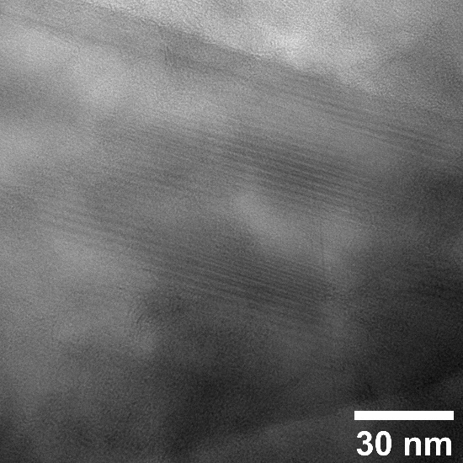
Figure S11. BF-TEM image of the bare MWCNTs. Lattice fringes can be discerned showing the crystalline nature of the nanotubes.
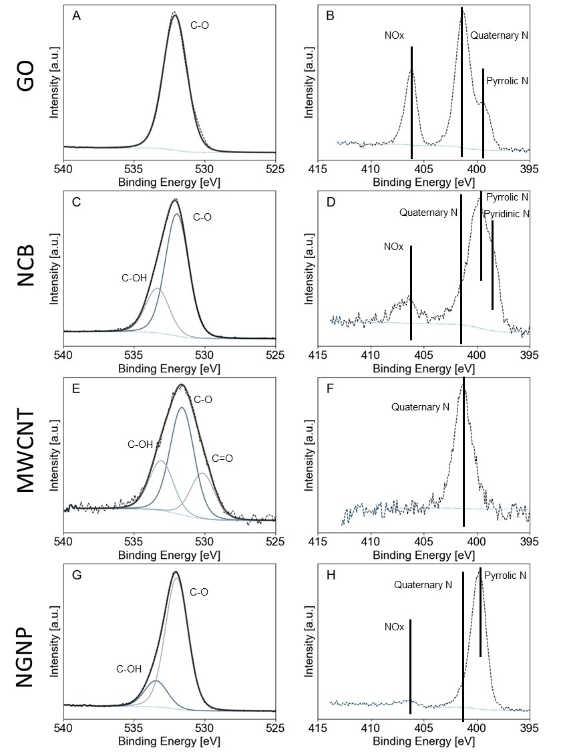Figure S12. (A-B) the O 1s and N 1s scan of the GO support, (C-D) the O 1s and N 1s scan of the NCB support, (E-F) the O 1s and N 1s scan of the MWCNT support and (G-H) the O 1s and N 1s scan of the NGNP support.

Table S1. Relative ratio of the surface composition of N/O/C species of the support as determined by XPS analysis as performed in Figure 21. O 1s, N 1s and C 1s sensitivity factor takes as 0.66, 0.42 and 0.25, respectively.
Name | Peak Area |  |  | Peak ratio
 | C 1s | N 1s | O 1s | O 1s/C 1s | N 1s/C 1s
GO | 34221 | 4274 | 43949 | 0.486 | 0.0743
NCB | 34415 | 1815 | 11260 | 0.124 | 0.0314
MWCNT | 43790 | 277 | 2772 | 0.024 | 0.00038
NGNP | 33586 | 2941 | 11072 | 0.125 | 0.0521

Note S6. Experimental part related to cluster composite electrode production.
To test the metal oxide clusters in the electrochemical CO₂ reduction reaction, it is adamant that the cluster carbonaceous support composite will be scaled. Further, for potential flow and membrane assembled electrode cell configurations, the use of a gas diffusion layer support is highly advantageous. Further, to ensure homogeneous cluster coverage and good exposure to the electrolyte, cluster deposition via filtration in which the aerosol gas is directly flowed through a porous support is optimal. Therefore, we designed a Toray TGP-H-60 carbon paper-based gas diffusion electrode with a carbonaceous support catalyst layer air brushed on top (Figure S12).
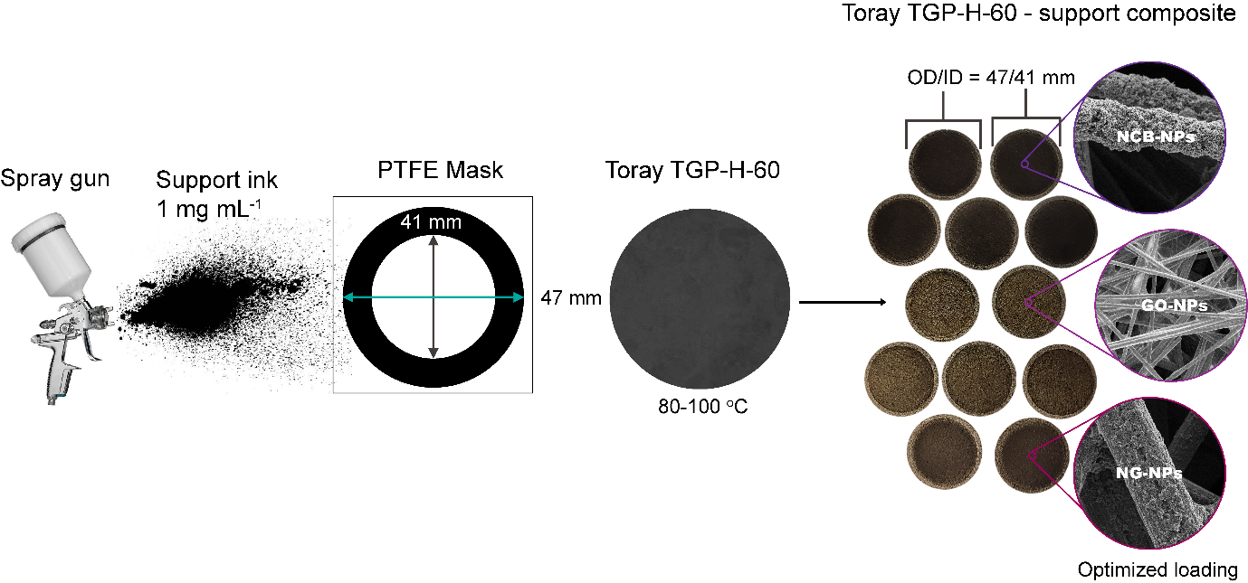
Figure S13. Air brush experiment to produce heteroatom-doped carbonaceous support-carbon paper composites. Ink was existed of 3:1 isopropanol:H₂O in case of the NCB-, NG-NPs based inks and pure H₂O for the GO-NPs based ink to prevent flocculation. The carbon paper was heated to 80, and 100 °C, respectively to facilitate solvent evaporation. All inks were sonicated for 30 min prior to spraying.
In order to achieve homogeneous coverage of the carbonaceous heteroatom doped support NPs on the carbon paper, a loading study was performed at different mass loadings for the GO-, NG-, and NCB-NPs based catalyst support inks at 1 mg mL⁻¹ (Figure S13).
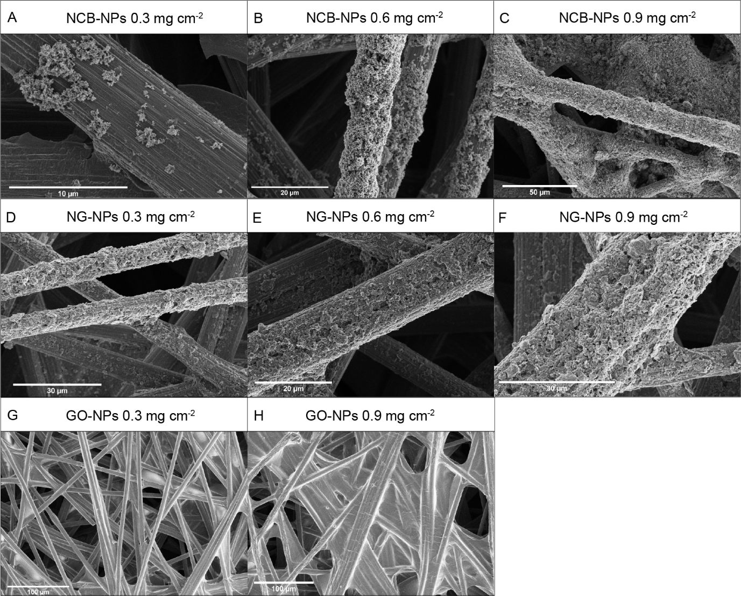
Figure S14. Loading study of the airbrushed heteroatom doped carbonaceous support. (A-C) SEM images of NCB-NPs coated on carbon paper at 0.3, 0.6 and 0.9 mg cm⁻². (D-F) SEM images of NG-NPs coated on carbon paper at 0.3, 0.6 and 0.9 mg cm⁻². (G-H) SEM images of GO-NPs coated on carbon paper at 0.3 and 0.9 mg cm⁻². Optimal loading was achieved at 0.3 mg cm⁻² for the GO-NPs, and 0.6 mg cm⁻² for the NCB-, NG-NPs-based composites in that pore blockage was prevented whilst maintaining good coverage allowing for facile aerosol filtration and electrolyte penetration. All cluster immobilization experiments were performed at the optimized catalyst support loading.
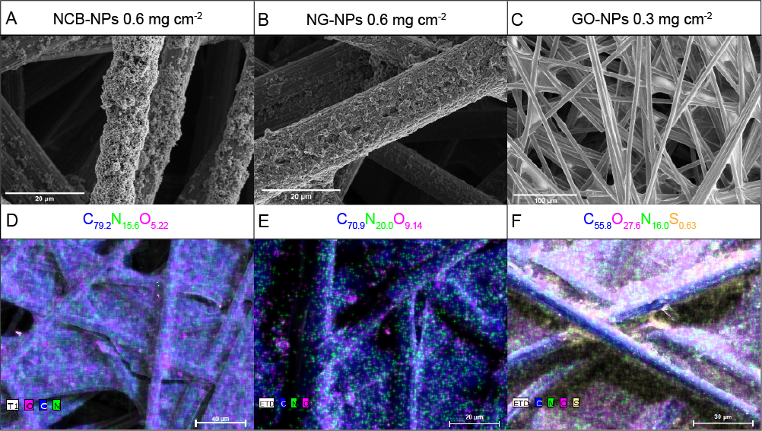
Figure S15. Composition study using SEM-EDXS. (A-C) SEM images of the composite materials produced in Figure S13. (D-F) SEM-EDXS elemental maps of the composite materials depicted in A-C in which pixels in blue, green, magenta, and yellow depict C, N, O and S, respectively.
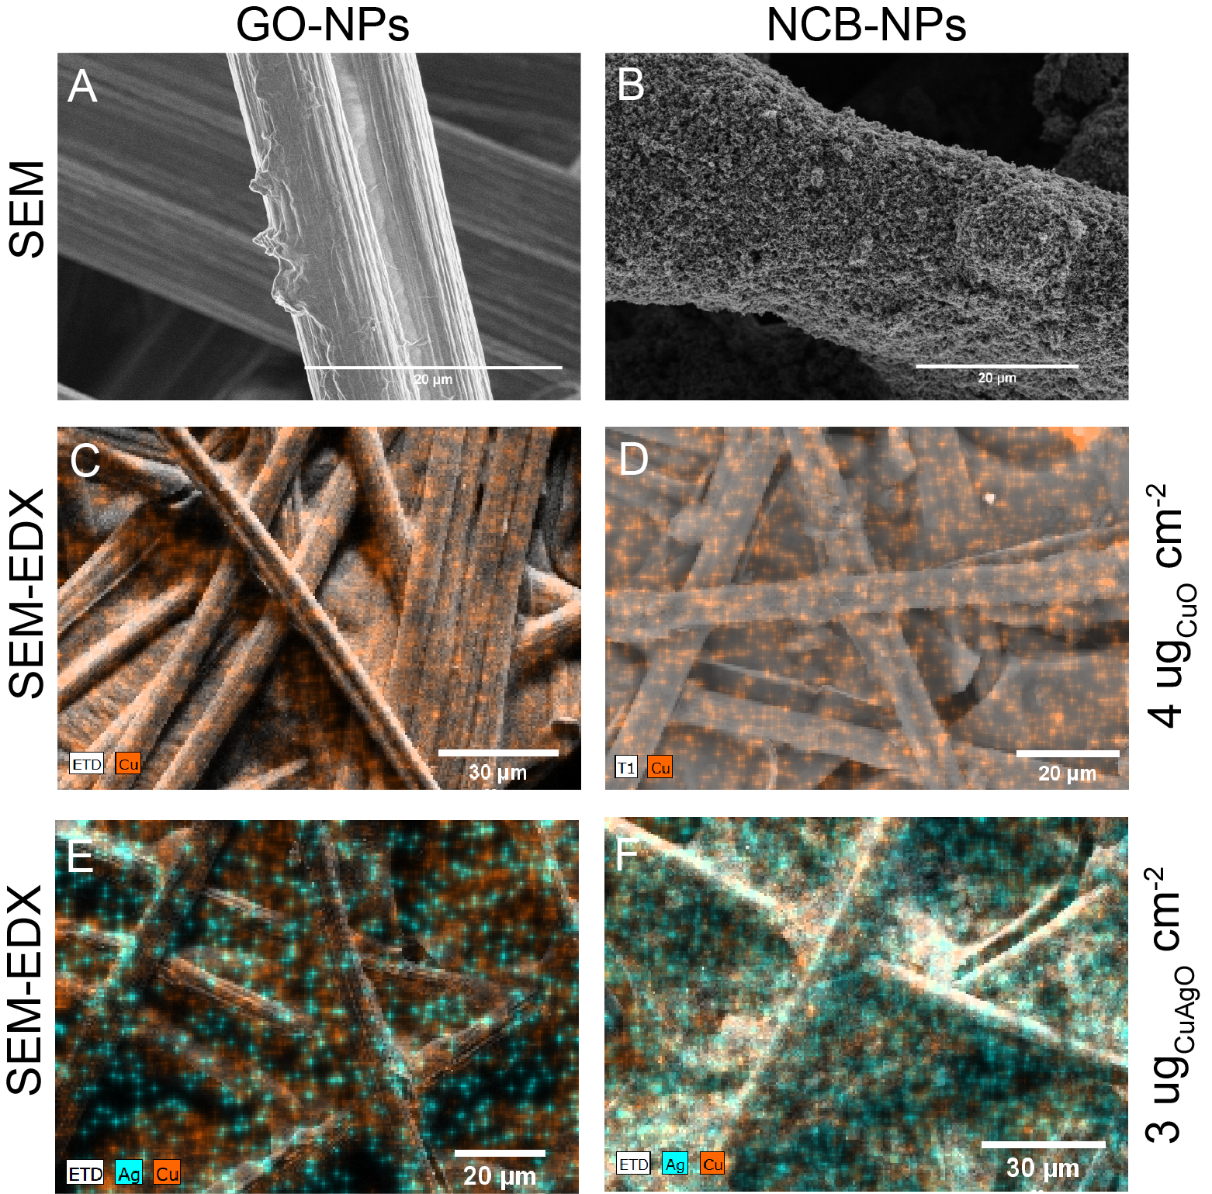
Figure S16. Filtration of metal oxide clusters produced via spark ablation on heteroatom doped carbonaceous support composited. Deposition time in all instances 10 hrs. (A,B) SEM image of the Cu oxide cluster coated GO- and NCB-NP composites showing no clear difference with uncoated samples in Figure S13. This is because the cluster size is below the limit of detection of SEM. (C-D) SEM-EDXS elemental map of the Cu oxide cluster coated GO-, NCB-NP coated composites, respectively, clearly showing a homogenous Cu signal (in orange) proving the successful coating step. Ablation rate calculated mass loading of 4 ug cm⁻². ICP-MS measured Cu mass post processing 375 ± 103 ng cm⁻². (E-F) SEM-EDXS elemental maps of the CuAg oxide cluster coated GO- and NCB-NP coated composite materials, respectively, showing a homogeneous distribution of Cu and Ag indicated in orange and turquoise, respectively. Ablation rate estimated mass loading of 3 ug cm⁻².
Note S7. Experimental part related to cluster characterization using XPS.
To investigate the oxidation state of both Cu and Ag in the bimetallic clusters excluding the influence of the support we deposited an equivalent amount of CuAg oxide clusters as indicated in Figure S15 on pure carbon paper and performed XPS (Figure S16). To determine the oxidation state after deposition, we performed XPS measurements on the composite 2 hrs (directly) after production (Figure S16A-D) and after 7 days (Figure S16E-H). Fitting of the Cu 2p and Cu LMM Auger spectrum suggested the presence of both CuO as well as Cu(OH)₂ with the CuO the majority species at no less than 65 at.%. Determination of the Auger parameter for Ag based on the MNN Auger spectrum of Ag indicated Ag₂O as the produced species.²² The high relative presence of -OH species in Cu suggest the oxidation of the clusters had already happened prior to deposition meaning in the aerosol. This can be understood from the following. In air, ~21% is O₂ and ~78% N₂. This, leaves <1 % for H₂O. Instead, in Ar, the relative ratio between O₂ and H₂O is ~1:1, explaining the relatively high OH content in the clusters.
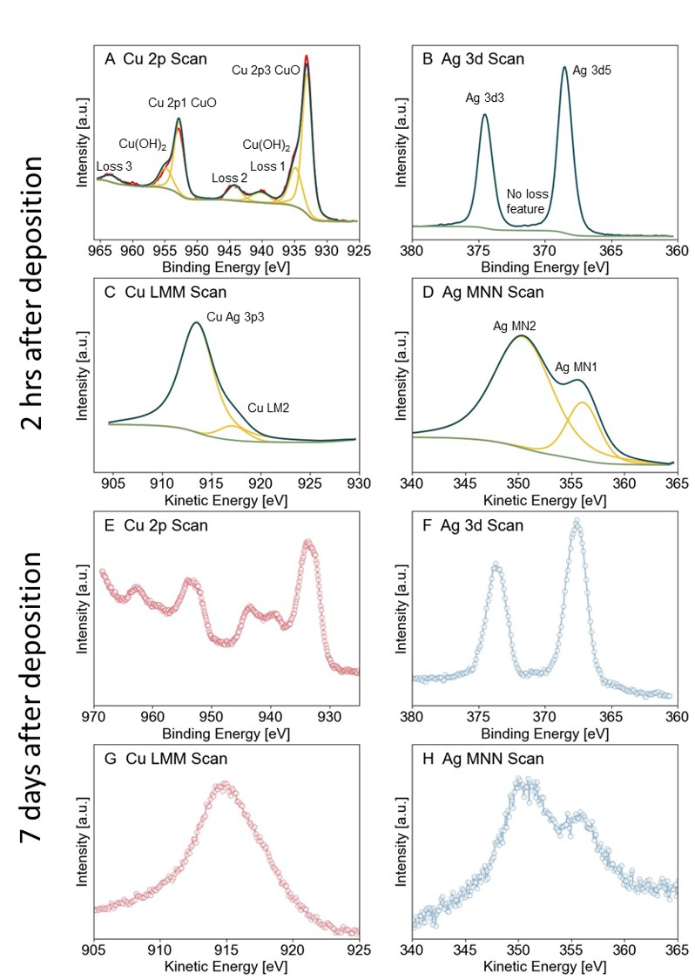Figure S17. XPS study of the oxidation state of the CuAg oxide clusters deposited on carbon paper, 2 hrs (A-D) and 7 days after deposition (E-H). (A) Cu 2p spectrum of the CuAg oxide clusters. Fitting of the 2p spectrum suggests a combination of both CuO (933 eV) and Cu(OH)₂ (935 eV) species, with the relative composition of CuO between 65-75 at.% and 25-35 at.% for Cu(OH)₂. (B) Ag 3d spectrum showing no loss feature. From the 3d spectrum alone, it is not possible to determine the oxidation state of Ag. (C) Cu LMM Auger spectrum showing a combination of the Ag 3p3/2 peak and the Cu LMM Auger peak. Position of the Cu Auger peak estimated at 917 eV through a fit. (D) Ag Auger spectrum showing the two MNN Ag peaks. The peak position at 356 eV used to determine the Auger parameter. Auger parameter of Ag of 724 eV, which is much lower than metallic Ag proving the oxidized state of Ag after deposition. (E) Cu 2p spectrum of the CuAg oxide clusters 7 days after production. (F) Ag 3d spectrum 7 days after production showing again no loss feature. (G) Cu LMM Auger spectrum again showing the presence of the Ag 3p3/2 peak. (H) Ag MNN Auger spectrum with the Auger parameter estimated at 718 eV confirming the oxidized state of Ag.
Table S2. Composition of the CuAgO clusters as deposited on pure carbon paper (Figure S16) containing two modes of particles: clusters of ~1.5 nm and particles of ~9 nm (Figure S9). XPS surface composition and the weighted STEM-EDX composition (Cu₈₄Ag₁₆ and Ag₇₃Cu₂₇, 132:1) shows matching results with <5% error showing the extreme conformity of the particle beam produced with the spark.
CuAgO clusters  4 μg cm⁻² | CuAg composition
XPS | Cu₇₈Ag₃₂
STEM-EDX | Cu₇₅Ag₃₅

Note S8. Experimental and computational part related to as-synthesized cluster characterization using XAS.
Figure S18. The k³-weighted EXAFS of the as-synthesized Cu-NCB and the respective fit plotted in k-space (A) and in R-space (B). The window is the k-range included in the fit. The window of the R-space included in the fit is 1-3 Å.
Table S3. Extended X-ray absorption fine structure (EXAFS) fitting parameters of the as-synthesized Cu-NCB catalyst.
Coordination shell | ªS²_{0,Cu} | Coordination number | ^{b}ΔE_{o} [eV] | ^{c}ΔR [Å] | ^{d}σ² [Å²] | R-factor
Cu-O (CuO) | 0.8503 ± 0.089 | 3.2 ± 0.16 | 9.1 ± 1.7 | -0.0075 ± 0.011 | 0.0038 ± 0.0009 | 0.016
Cu-Cu (CuO) | 0.8503 ± 0.089 | 0.82 ± 0.16 | 9.1 ± 1.7 | -0.011 ± 0.016 | 0.0038 ± 0.0009 | 0.016
Fourier-transform parameters: k =3.0-9.5 Å⁻¹, R = 1.0-3.0 Å. ªAmplitude attenuation factor (obtained by fitting a Cu foil reference), ^{b}Energy shift, ^{c}Change in coordination distance with respect to reference (CuO): 1.956 Å and 2.939 Å, respectively, ^{d}Debye-Waller factor.

Figure S19. The k³-weighted EXAFS of the as-synthesized Cu-GO and the respective fit plotted in k-space (A) and in R-space (B). The window is the k-range included in the fit. The window of the R-space included in the fit is 1-3 Å.
Table S4. Extended X-ray absorption fine structure (EXAFS) fitting parameters of the as-synthesized Cu-GO catalyst.
Coordination shell | ªS²_{0,Cu} | Coordination number | ^{b}ΔE_{o} [eV] | ^{c}ΔR [Å] | ^{d}σ² [Å²] | R-factor
Cu-O | 0.8503 ± 0.089 | 3.6 ± 0.33 | 7.1 ± 1.1 | -0.016 ± 0.009 | 0.0044 ± 0.0011 | 0.006
Fourier-transform parameters: k =3.0-9.5 Å⁻¹, R = 1.0-3.0 Å. ªAmplitude attenuation factor (obtained by fitting a Cu foil reference), ^{b}Energy shift, ^{c}Change in coordination distance with respect to reference. Reference CuO distance: 1.956 Å, ^{d}Debye-Waller factor.

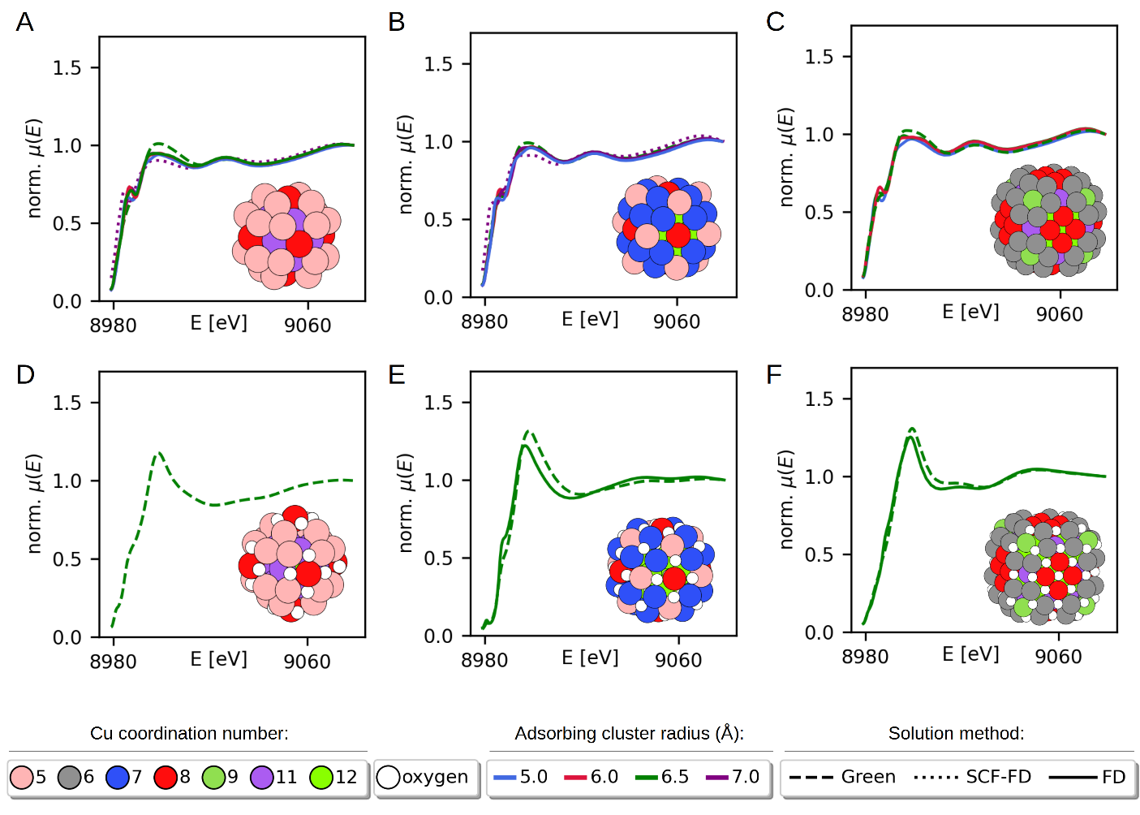
Figure S20. Convergence in the parameters used by the FDMNES²³ software for the simulated XANES spectra for varying adsorbing atom cluster radius and solution method (Green: Green’s function formalism, SCF-FD: Self-consistent field - finite difference formalism, FD: Finite difference formalism). (A) Cu₄₃, (B) Cu₅₅, (C) Cu₁₃₅, (D) Cu₄₃O₂₄, (E) Cu₅₅O₄₆, (F) Cu₁₃₅O₇₈. The Green’s function formalism with a 6.5 Å cluster radius shown with dashed green lines provided an excellent trade-off between accuracy and time for clusters where comparisons were calculated.
Figure S21. XANES spectra of the as-synthesized catalysts Cu-NCB/GO and Cu foil, CuO powder and Cu₂O reference materials and their simulated counterparts.

Note S9. Evaluation of the electrochemical performance in the CO₂RR
Note S9.1 Cathode preparation.
Conical pieces of Toray TGP-60r carbon paper coated with 0.6 or 0.3 mg cm⁻² of NCB or GO respectively and functionbalized with ~4 ug cm⁻² Cu(-Ag) clusters were cut out with a geometrical surface area of 0.5 cm². Finally, 20 μL of 0.83 wt% Nafion dispersed in iso-propanol were added as binder.
Note S9.2 Electrochemical measurements.
The electrodes were evaluated in a commercial gas-tight H-cell from Gaoss Union using constant potential mode controlled by a potentiostat (Autolab PGSTAT302N). All measurements were carried out at in 0.1 M KHCO₃, which fungated as both catholyte and electrolyte (25 mL per chamber). Chamber were kept separate by means of a cation exchange (Nafion) membrane. Prior to electrochemical testing, the electrolyte was saturated with CO₂ by bubbling at 25 ml·min⁻¹ for at least 15 min. Also, during any measurement, CO₂ was bubbled through the catholyte continuously to ensure sufficient CO₂ supply during the measurement. A Pt wire was used as counter electrode for the oxygen reduction reaction. An Ag/AgCl electrode was used as reference. All measurements were carried out at -1.1 V vs RHE. The value of the potential versus Ag/AgCl was converted to the scale of the reversible hydrogen electrode (RHE) using the equation: E (versus RHE) = E (versus Ag/AgCl (3 M KCl)) + 0.21 V + 0.059 * pH. The potential was mathematically compensated for the ohmic resistance that was determined by the electrochemical impedance spectroscopy (EIS). The FEs and currents were repeatedly measured on three individual electrodes for each material evaluated.
Note S9.3 Quantification of the gaseous products.
Gas products were analysed online (10 min interval) using a gas chromatography (GC, SRI Instrument 8610C) with the auto-sampling loop (1 ml) connected to CO₂ off-gas of the H-cell catholyte chamber. H₂ was analysed using thermal conductive detector (TCD) and CO, CH_{4,} and C₂H₄ were analysed using flame ionization detector (FID) with a methanizer.
Note S9.4 Quantification of the liquid products using NMR.
Quantification of the liquid products was achieved according to a previously reported method and a derivation of the Kuhl et al method.^{24,25} In brief, the liquid products of all electrodes were quantified using nuclear magnetic resonance (NMR, Bruker 400 MHz AVIIi HD). Figure S21 and S22 shows ta typical 1D ¹H NMR spectrum obtained for a standard solution containing typical liquid products from the CO₂RR and the internal standards (phenol and DMSO) as indicated by the arrows. The peak area ratio of a given product to that of the internal standard, as obtained by peak fitting using MestReNova software, was used to determine the concentration of the products. Identical NMR acquisition parameters were used for all measurements. In addition, the water peak was suppressed using the solvent suppression function. The acquisition time of d1 was 5 s and the number of scans was 260. Products with peaks with chemicals shifts than larger water (> 5 ppm) were quantified using phenol, all others with DMSO.
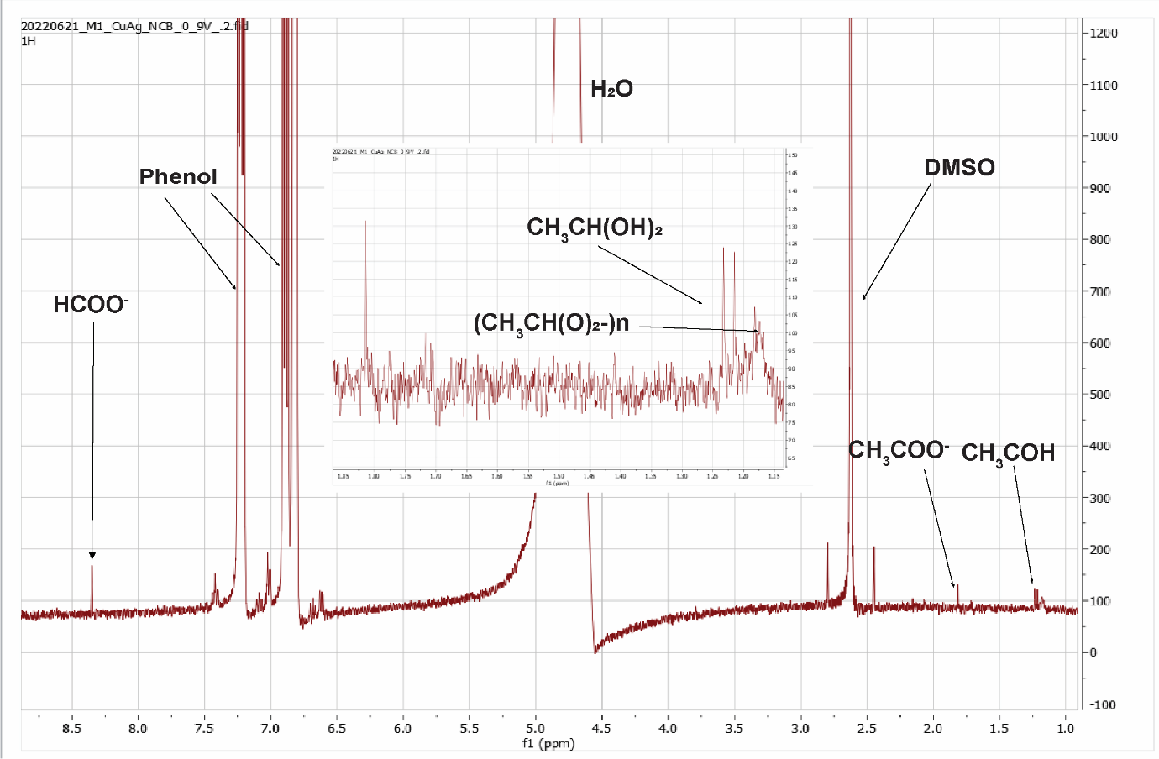
Figure S22. Typical ¹H-NMR spectrum taken of a catholyte aliquot after CO₂RR using a Cu-Ag-NCB-GDL catalyst at 0.9 V vs RHE for 1 hrs. The catholyte contains three CO2RR products: formate, acetate and acetaldehyde. The acetaldehyde exist a hydrated form²⁵ and a less soluble aggregate i.e. metaldehyde resulting in peak broadening and shift to lower ppm values. Any multimer of acetaldehyde forms chemically and is base catalyzed. See Figure S18 for a typical NMR spectrum of metaldehyde.
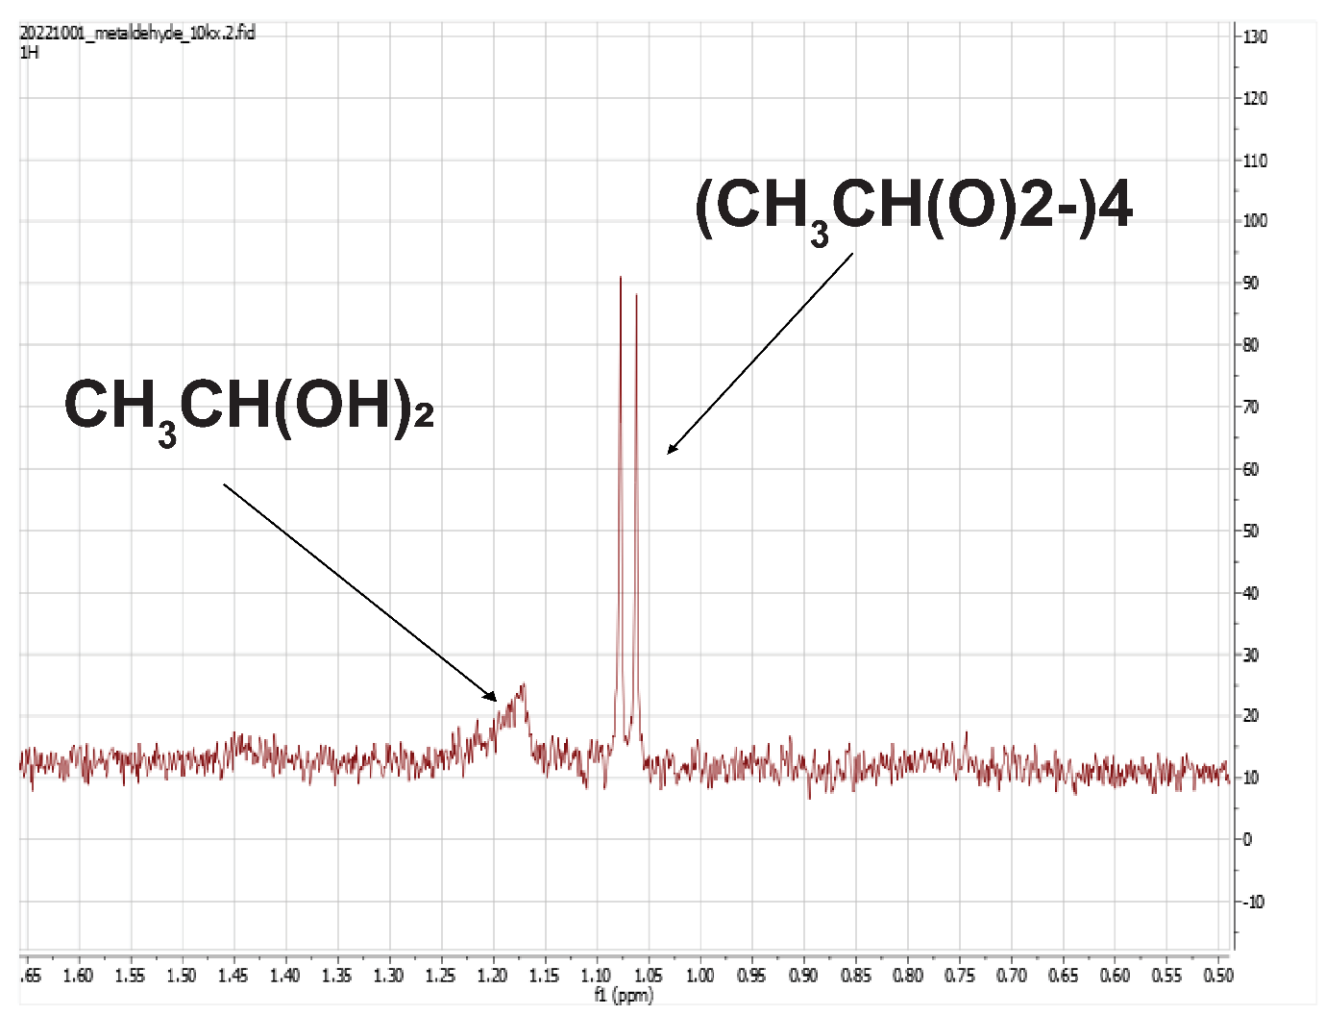
Figure S23. 1H-NMR spectrum of metaldehyde dissolved in 0.1 M KHCO₃.

Note S9.5 Calculation of the faradaic efficiency.
The faradaic efficiency (FE) was calculated for gas and liquid products, using FE =$\frac{nFC_{i}vP}{jRT}$ and FE =$\frac{nFC_{i}V}{Q}$, respectively, where n is the number of transferred electrons to produce one molecule of product i, F is the faradaic constant, C_{i} is the concentration of the product as determined by GC or NMR, v is the flow rate of CO₂, P and T are the pressure (101325 Pa) and temperature (22 ℃) of the gas sampled by the GC sample loop, respectively, j is the total current when sampling, R is the gas constant, V is the volume of the electrolyte, and Q is the total charge transferred to produce the target product.
Note S9.6 Determination of the support activity in CO₂RR.
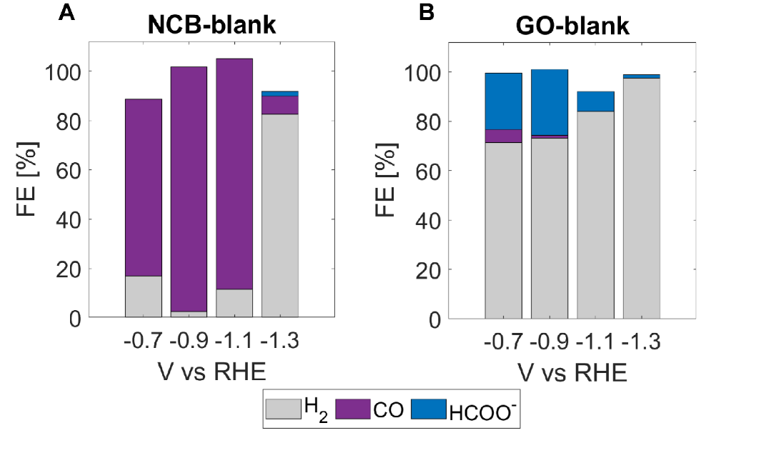
Figure S24. (A) Selectivity as a function of potential of the as-synthesized NCB-GDL composite. (B) Selectivity as a function of potential as the as-synthesized GO-GDL composite. All measurements were performed in CO₂ saturated 0.1 M KHCO₃. The reaction was let to equilibrate for 10 min before the first sampling of the gas products was performed. An average over 30 min has been reported. Several washing steps with HNO₃ was performed to remove trace metal species from the supports.

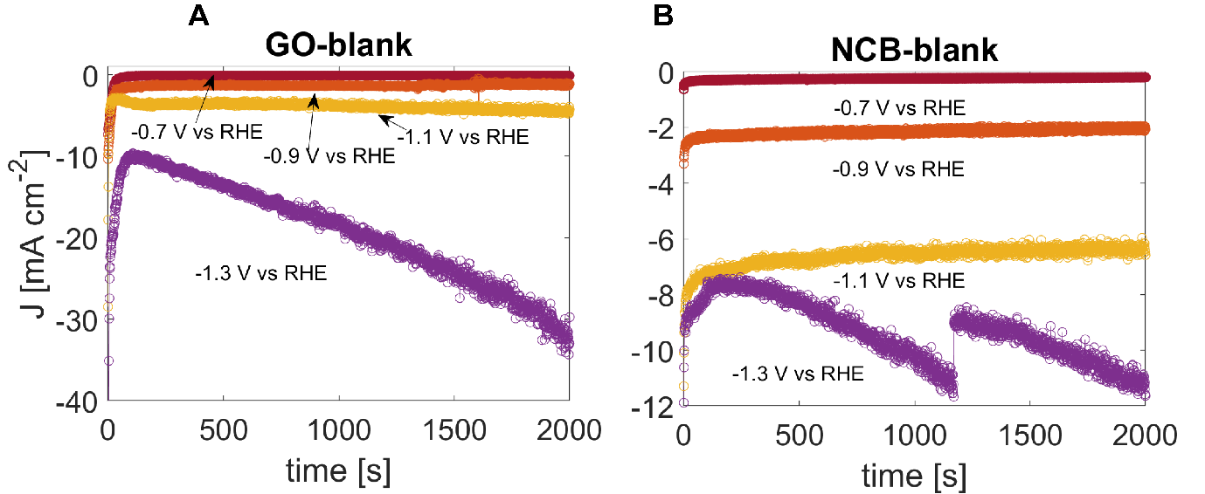
Figure S25. (A) Geometrical current density as a function of potential of the as-synthesized GO-GDL composite. (B) Geometrical current density as a function of potential as the as-synthesized NCB-GDL composite.

Table S5. Faradaic efficiencies of Cu-NCB per potential and product.

 | H₂ | CO | CH₃CHO | CH₃COO⁻ | HCOO⁻
Cu_NCB_0.5V | 16.09 | 0.00 | 66.43 | 9.50 | 2.50
Cu_NCB_0.6V | 46.50 | 0.00 | 42.53 | 4.50 | 3.08
Cu_NCB_0.7V | 30.49 | 11.49 | 46.44 | 10.78 | 2.15
Cu_NCB_0.8V | 64.60 | 9.17 | 20.51 | 1.88 | 2.46
Cu_NCB_0.9V | 7.41 | 75.75 | 21.83 | 1.49 | 0.79
Cu_NCB_1.1V | 35.18 | 46.02 | 8.94 | 1.56 | 2.00
Cu_NCB_0.5V_STDEV | 16.09 | 0.00 | 20.27 | 1.96 | 2.50
Cu_NCB_0.6V_STDEV | 11.42 | 0.00 | 21.54 | 1.95 | 2.87
Cu_NCB_0.7V_STDEV | 21.38 | 16.25 | 19.86 | 4.43 | 1.58
Cu_NCB_0.8V_STDEV | 12.80 | 1.98 | 4.30 | 0.21 | 0.82

Table S6. Faradaic efficiencies of Cu-GO per potential and product.
 | H₂ | CO |  | CH₃CHO | CH₃COO⁻ | HCOO⁻
Cu_GO_0.5V | 0.00 | 0.00 | 92.55 |  | 9.18 | 0.00
Cu_GO_0.6V | 56.02 | 0.00 | 31.84 |  | 5.08 | 1.69
Cu_GO_0.7V | 27.98 | 0.00 | 48.46 |  | 5.34 | 5.98
Cu_GO_0.8V | 82.60 | 0.00 | 19.57 |  | 2.81 | 3.75
Cu_GO_0.9V | 60.46 | 1.03 | 33.89 |  | 2.35 | 3.74
Cu_GO_1.1V | 88.58 | 2.50 | 3.20 |  | 0.52 | 2.61
Cu_GO_0.5V_STDEV | 0.00 | 0.00 | 1.87 |  | 0.02 | 0.00
Cu_GO_0.6V_STDEV | 2.12 | 0.00 | 1.16 |  | 1.85 | 0.60
Cu_GO_0.7V_STDEV | 18.34 | 0.00 | 26.81 |  | 3.47 | 2.76

Table S7. Faradaic efficiencies of Cu-Ag-NCB per potential and product.

 | H₂ | CO | CH₃CHO | CH₃COO⁻ | HCOO⁻
CuAg_NCB_0.5V | 0.00 | 0.00 | 88.42 | 11.34 | 0.83
CuAg_NCB_0.6V | 0.00 | 0.00 | 83.45 | 18.25 | 2.85
CuAg_NCB_0.7V | 15.98 | 54.36 | 29.26 | 4.32 | 3.04
CuAg_NCB_0.8V | 36.32 | 39.58 | 15.06 | 1.92 | 5.44
CuAg_NCB_0.9V | 19.28 | 71.17 | 11.34 | 2.00 | 1.14
CuAg_NCB_1.1V | 39.06 | 49.72 | 0.00 | 1.21 | 8.99
CuAg_NCB_0.5V_STDEV | 0.00 | 0.00 | 0.97 | 0.40 | 0.83
CuAg_NCB_0.6V_STDEV | 0.00 | 0.00 | 2.66 | 3.99 | 0.81
CuAg_NCB_0.7V_STDEV | 0.91 | 1.12 | 3.16 | 0.09 | 0.44

Table S8. Faradaic efficiencies of Cu-Ag-GO per potential and product.

 |  | H₂ | CO | CH₃CHO | CH₃COO⁻ | HCOO⁻
CuAg_GO_0.5V | 0.00 |  | 0.00 | 68.48 | 4.56 | 1.88
CuAg_GO_0.6V | 57.04 |  | 0.00 | 39.20 | 0.46 | 1.10
CuAg_GO_0.7V | 23.21 |  | 0.00 | 72.03 | 7.21 | 4.04
CuAg_GO_0.8V | 72.54 |  | 0.00 | 13.52 | 4.06 | 5.51
CuAg_GO_0.9V | 70.59 |  | 1.98 | 19.05 | 5.95 | 2.21
CuAg_GO_1.1V | 88.88 |  | 0.25 | 7.35 | 0.68 | 2.09
CuAg_GO_0.5V_STDEV | 0.00 |  | 0.00 | 4.95 | 0.80 | 1.62
CuAg_GO_0.6V_STDEV | 0.25 |  | 0.00 | 1.97 | 0.23 | 0.88
CuAg_GO_0.7V_STDEV | 3.75 |  | 0.00 | 4.40 | 7.84 | 2.30

Figure S26. Geometrical current densities as a function of potential for the screened Cu-(ag)-NCB/GO GDL catalysts at low overpotential.
Figure S27. Reused Cu-NCB catalyst offered a stable and comparable current density (-148 uA cm⁻²) and acetaldehyde FE (41%) as observed for the first 3 hrs (-193±45 µA cm⁻² and 43±22%, respectively). After 27 hrs, the acetaldehyde FE had dropped to 12%, and the total FE to 51%. Loss of acetaldehyde to the gas phase (b.p. 20.2 °C) explains this difference, similar to what we previously reported in ethanol electrosynthesis.²⁴ This stresses the need for different cell design for low boiling point liquid products.

Table S9. Cu mass loading pre and post catalysis as determined by ICP-MS.
PRE Cu-NCB [ng_{Cu} cm⁻²] | PRE Cu-GO [ng_{Cu} cm⁻²] | POST Cu-NCB [ng_{Cu} cm⁻²]
307 | 285 | 429
below LOD | 548 | 183
below LOD | 359 | 379
 | AVERAGE PRE | STDEV PRE
 | 397 | 111
 | AVERAGE POST | STDEV POST
 | 330 | 106

Note S8.7 In Situ XAS experiment
Table S10. Airbrush experiment of the CuO-NCB catalyst on Kapton foil.

Electrode | Mass loading [mg/cm²] | SD (3 independent measurements)
Cu-NCB-1x-N1 | 0.33 | 0.03
Cu-NCB-1x-N2 | 0.38 | 0.04
Cu-NCB-1x-N3 | 0.41 | 0.03
Cu-NCB-1x-N4 | 0.39 | 0.01
Cu-NCB-1x-N5 | 0.35 | 0.06
Average | 0.37 (0.29 mg/cathode) | 0.02

Figure S28. Comparison of metallic FCC and BCC clusters.
Figure S29. Comparison of simulated XANES spectra for Cu₄₃ (A), Cu₅₅ (B), and Cu₁₃₅ (C) clusters of varying oxidation state. Comparisons to bulk Cu fcc, Cu(I) oxide and Cu(II) oxide are made in each plot.
Table S11. Extended X-ray absorption fine structure (EXAFS) fitting parameters of the Cu-NCB catalyst at -300 mV vs RHE.
Coordination shell | ªS²_{0,Cu} | Coordination number | ^{b}ΔE_{o} [eV] | ^{c}ΔR [Å] | ^{d}σ² [Å²] | R-factor
Cu-Cu | 0.8503 ± 0.089 | 7.5 ± 2.2 | -7.3 ± 3.3 | -0.104 ± 0.019 | 0.0120 ± 0.0026 | 0.030
Fourier-transform parameters: k =3.0-9.5 Å^{-1,} R = 1.0-3.0 Å. ªAmplitude attenuation factor (obtained by fitting a Cu foil reference), ^{b}Energy shift, ^{c}Change in coordination distance with respect to reference (Cu): 2.561 Å, ^{d}Debye-Waller factor.

Figure S30. The k³-weighted EXAFS of the Cu-NCB catalyst at -300 mV vs RHE and the respective fit plotted in k-space (A) and in R-space (B). The window is the k-range included in the fit. The window of the R-space included in the fit is 1-3 Å.
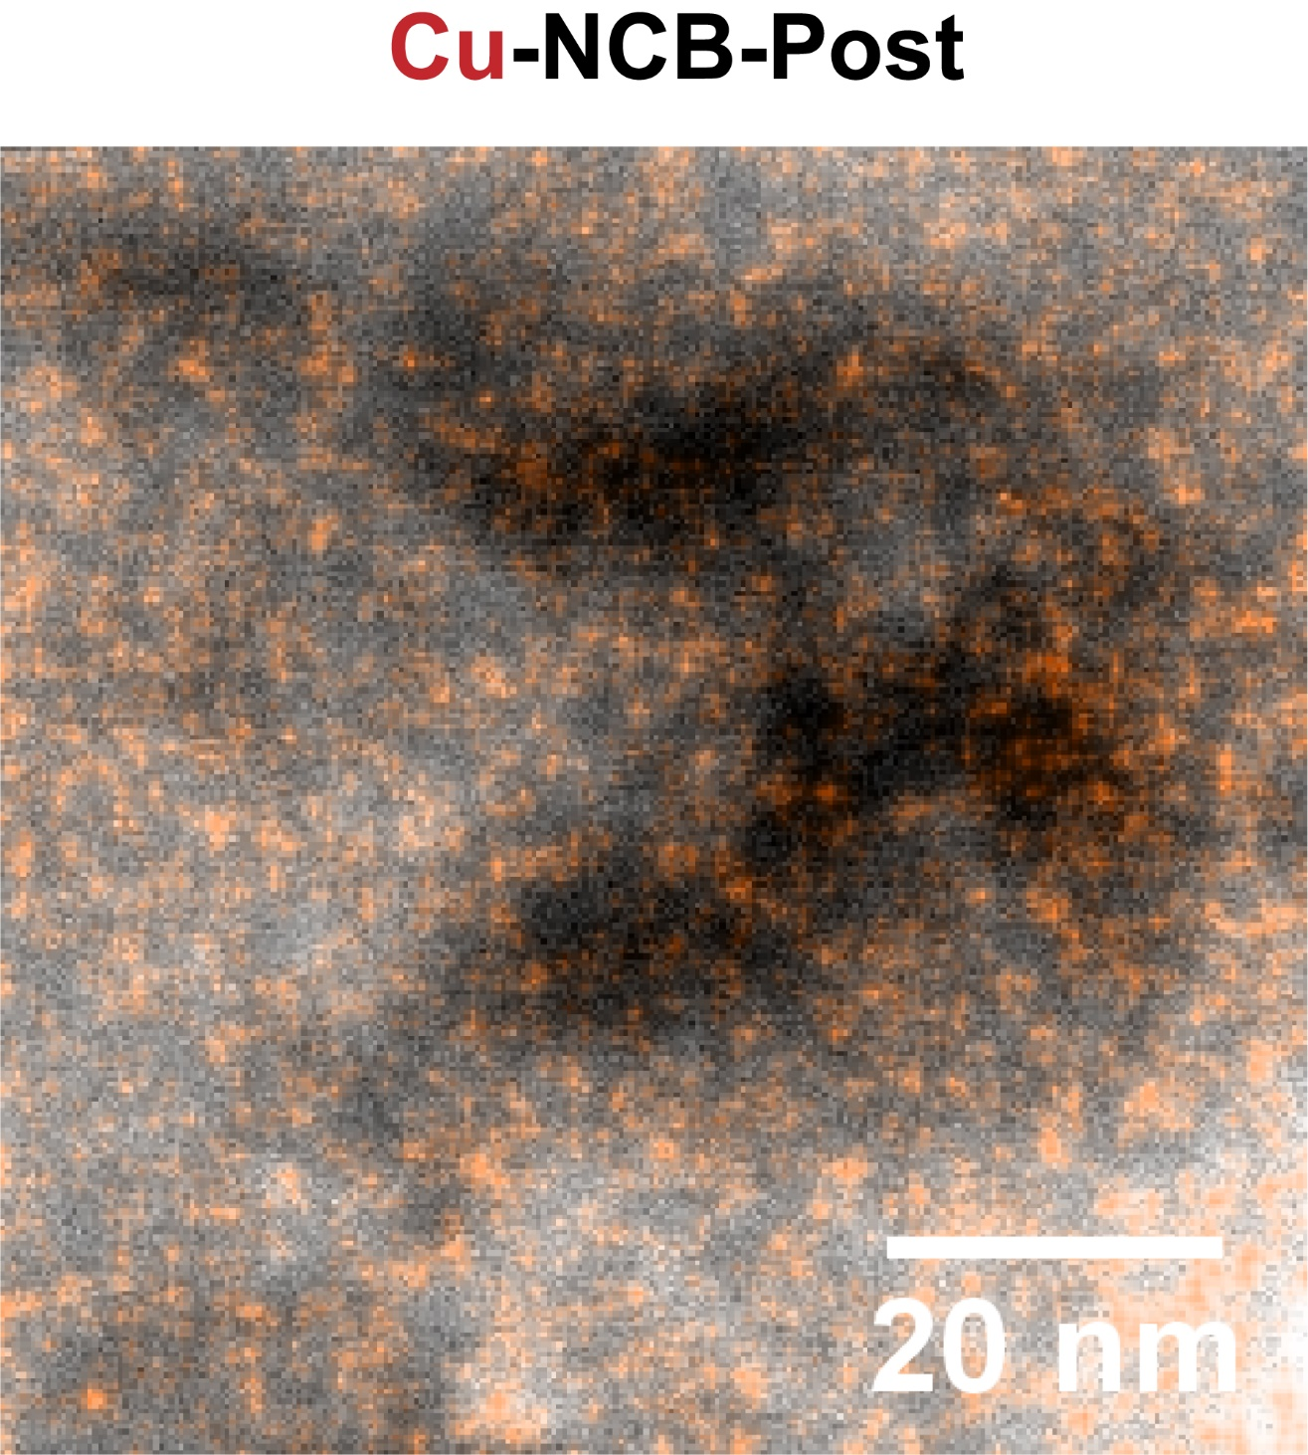
Figure S31. Overlay of the STEM-HAADF and EDXS map of the Cu-NCB catalyst post catalysis.

Figure S32. A) EXAFS spectrum of Cu-GO composite catalyst post catalysis (-0.5 V vs RHE) and metallic Cu as reference. B) EXAFS spectrum of Cu-NCB composite catalyst post catalysis (-0.5 V vs RHE) and metallic Cu as reference. C) XANES spectra post catalysis of the Cu-NCB/GO composite catalysis (-0.5 V vs RHE). D) STEM-HAADF EDXS map overlay of the Cu-NCB composite catalyst after catalysis.
Figure S33. The k³-weighted EXAFS of the Cu-GO catalyst after catalysis (-500 mV vs RHE) and the respective fit plotted in k-space (A) and in R-space (B). The window is the k-range included in the fit. The window of the R space included in the fit is 1-3 Å.
Table S12. EXAFS fitting parameters of the Cu-GO catalyst post catalysis.
Coordination shell | ªS²_{0,Cu} | Coordination number | ^{b}ΔE_{o} [eV] | ^{c}ΔR [Å] | ^{d}σ² [Å²] | R-factor
Cu-Cu | 0.8503 ± 0.089 | 7.4 ± 3.6 | 5.4 ± 2.1 | 0.0029 ± 0.022 | 0.0102 ± 0.0035 | 0.027
Cu-O | 0.8503 ± 0.089 | 1.8 ± 0.6 | 5.4 ± 2.1 | 0.0022 ± 0.017 | 0.0102 ± 0.0035 | 0.027
Fourier-transform parameters: k =3.0-9.5 Å⁻¹, R = 1.0-3.0 Å. ªAmplitude attenuation factor (obtained by fitting a Cu foil reference), ^{b}Energy shift, ^{c}Change in coordination distance with respect to reference (Cu and CuO): 2.561 and 1.956 Å, respectively, ^{d}Debye-Waller factor.

Figure S34. The k³-weighted EXAFS the Cu-NCB catalyst after catalysis (-500 mV vs RHE) and the respective fit plotted in k-space (A) and in R-space (B). The window is the k-range included in the fit. The window of the R space included in the fit is 1-3 Å.
Table S13. Extended X-ray absorption fine structure (EXAFS) fitting parameters of the Cu-NCB catalyst post catalysis.
Coordination shell | ªS²_{0,Cu} | Coordination number | ^{b}ΔE_{o} [eV] | ^{c}ΔR [Å] | ^{d}σ² [Å²] | R-factor
Cu-Cu | 0.8503 ± 0.089 | 6.2 ± 1.4 | 4.6 ± 2.3 | -0.0097 ± 0.003 | 0.0095 ± 0.014 | 0.001
Cu-O | 0.8503 ± 0.089 | 1.1 ± 0.44 | 4.6 ± 2.3 | -0.0072 ± 0.010 | 0.0095 ± 0.014 | 0.001
Fourier-transform parameters: k =3.0-9.5 Å⁻¹, R = 1.0-3.0 Å. ªAmplitude attenuation factor (obtained by fitting a Cu foil reference), ^{b}Energy shift, ^{c}Change in coordination distance with respect to reference (Cu foil and CuO): 2.561 and 1.956 Å, ^{d}Debye-Waller factor.

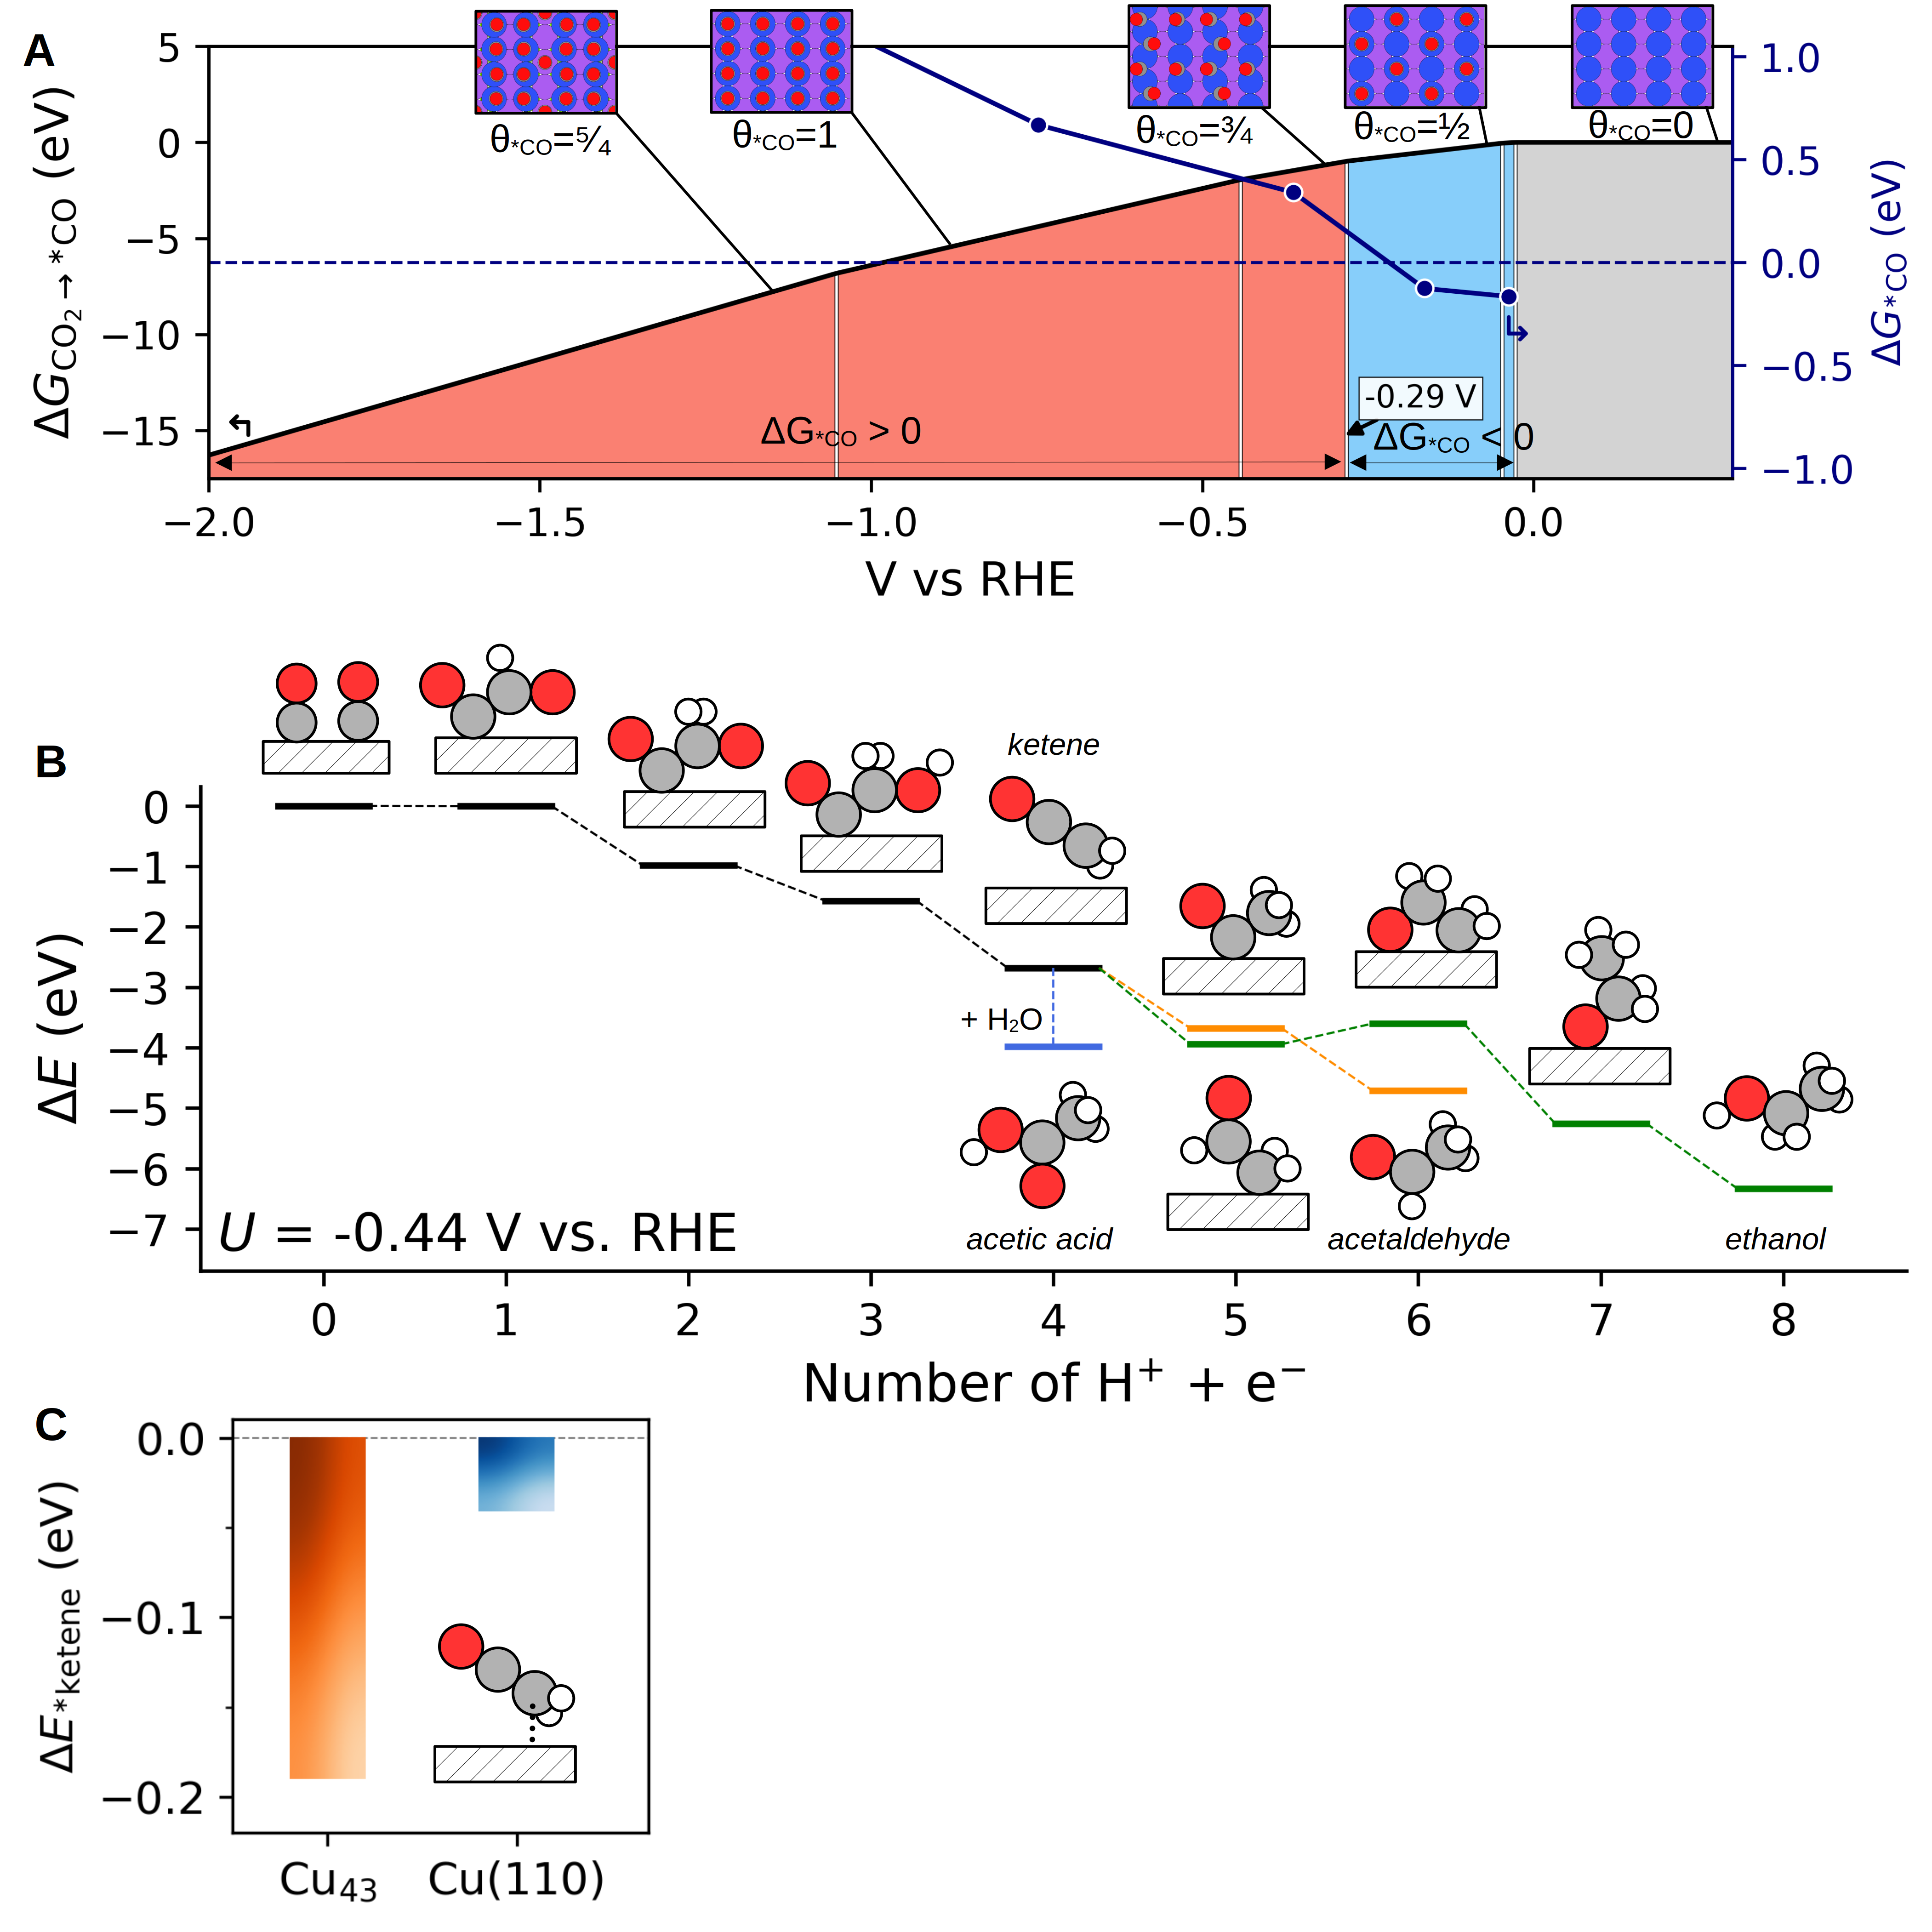Figure S35. (A) Simulated energy profiles illustrating diverse *CO coverages on a Cu(110) facet obtained via CO₂ reduction, as a function of applied potential. The color coding differentiates states with no adsorbed *CO, stably adsorbed *CO, and unstably adsorbed *CO (grey, blue, and red regions, respectively). (B) Energy diagram depicting a proposed reaction mechanism for acetaldehyde formation on the Cu(110) facet where the coupling is between the last two added *COs at the potential where all reaction steps are downhill. (C) Comparison of the simulated adsorption energy of ketene on the Cu₄₃ cluster and the Cu(110) facet.

Table S14. Corrections used to convert electronic energies to free energies for reductive *CO adsorption (CO₂(g) + * + H₂(g) → *CO + H₂O(l)) and *CO desorption (*CO → CO(g) + *) at 298.15 K from Chan et al., Table S1 and S2.²⁶
The free energy was calculated as ΔG = ΔE + ΔZPE + Δ (∫ C_{p} dT) - TΔS + ΔE_{sol} + ΔE_{RPBE}, where ΔE is the change electronic energies obtained with the RPBE functional.
Species | ZPE  (eV) | ∫ C_{p} dT  (eV) | -TS  (eV) | ΔE_{sol}  (eV) | ΔE_{RPBE}  (eV)
CO₂ (g, 1 bar) | 0.31 | 0.10 | -0.66 |  | 0.33
CO (g, 1 bar) | 0.13 | 0.09 | -0.61
H₂ (g,1 bar) | 0.28 | 0.09 | -0.40 |  | 0.09
H₂O (l) | 0.57 | 0.10 | -0.67
*CO | 0.19 | 0.08 | -0.16 | -0.1

References
1. Lee, D. C., Yang, H. N., Park, S. H. & Kim, W. J. Nafion/graphene oxide composite membranes for low humidifying polymer electrolyte membrane fuel cell. Journal of Membrane Science 452, 20–28 (2014).
2. Zhang, J., Xia, Z. & Dai, L. Carbon-based electrocatalysts for advanced energy conversion and storage. Science Advances 1, e1500564 (2015).
3. Duan, X. et al. Metal-Free Carbon Materials for CO2 Electrochemical Reduction. Advanced Materials 29, 1701784 (2017).
4. Yang, F. et al. Highly Efficient CO2 Electroreduction on ZnN4-based Single-Atom Catalyst. Angewandte Chemie International Edition 57, 12303–12307 (2018).
5. Fouda, A. N., Duraia, E. S. M. & Almaqwashi, A. A. Facile and scalable green synthesis of N-doped graphene/CNTs nanocomposites via ball milling. Ain Shams Engineering Journal 12, 1017–1024 (2021).
6. Jeon, I.-Y. et al. Direct nitrogen fixation at the edges of graphene nanoplatelets as efficient electrocatalysts for energy conversion. Sci Rep 3, 2260 (2013).
7. Schwyn, S., Garwin, E. & Schmidt-Ott, A. Aerosol generation by spark discharge. Journal of Aerosol Science 19, 639–642 (1988).
8. Peineke, C., Attoui, M. B. & Schmidt-Ott, A. Using a glowing wire generator for production of charged, uniformly sized nanoparticles at high concentrations. Journal of Aerosol Science 37, 1651–1661 (2006).
9. Feng, J., Ramlawi, N., Biskos, G. & Schmidt-Ott, A. Internally mixed nanoparticles from oscillatory spark ablation between electrodes of different materials. Aerosol Science and Technology 52, 505–514 (2018).
10. Feng, J. et al. Unconventional Alloys Confined in Nanoparticles: Building Blocks for New Matter. Matter 3, 1646–1663 (2020).
11. Maisser, A. et al. Characterization of atmospheric-pressure spark generated atomic silver and gold clusters by time-of-flight mass spectrometry. Journal of Aerosol Science 156, 105780 (2021).
12. Tabrizi, N. S., Xu, Q., van der Pers, N. M. & Schmidt-Ott, A. Generation of mixed metallic nanoparticles from immiscible metals by spark discharge. J Nanopart Res 12, 247–259 (2010).
13. Maisser, A., Barmpounis, K., Attoui, M. B., Biskos, G. & Schmidt-Ott, A. Atomic Cluster Generation with an Atmospheric Pressure Spark Discharge Generator. Aerosol Science and Technology 49, 886–894 (2015).
14. Preger, C., Overgaard, N. C., Messing, M. E. & Magnusson, M. H. Predicting the deposition spot radius and the nanoparticle concentration distribution in an electrostatic precipitator. Aerosol Science and Technology 54, 718–728 (2020).
15. Feng, J., Biskos, G. & Schmidt-Ott, A. Toward industrial scale synthesis of ultrapure singlet nanoparticles with controllable sizes in a continuous gas-phase process. Sci Rep 5, 15788 (2015).
16. Feng, J. et al. General Approach to the Evolution of Singlet Nanoparticles from a Rapidly Quenched Point Source. J. Phys. Chem. C 120, 621–630 (2016).
17. Megyeri, D., Kohut, A. & Geretovszky, Z. Effect of flow geometry on the nanoparticle output of a spark discharge generator. Journal of Aerosol Science 154, 105758 (2021).
18. Feng, J. Scalable Spark Ablation Synthesis of Nanoparticles: Fundamental Considerations and Application in Textile Nanofinishing. (Delft University of Technology, 2016). doi:10.4233/UUID:FB6C0122-587B-471D-8009-B52EF9B69B07.
19. Voloshko, A., Itina, T. E., Voloshko, A. & Itina, T. E. Nanoparticle Formation by Laser Ablation and by Spark Discharges — Properties, Mechanisms, and Control Possibilities. Nanoparticles Technology (IntechOpen, 2015). doi:10.5772/61303.
20. Dietsche, R. et al. Comparison of electronic structures of mass-selected Ag clusters and thermally grown Ag islands on sputter-damaged graphite surfaces. Appl. Phys. A 90, 395–398 (2008).
21. Lai, X., St.Clair, T. P. & Wayne Goodman, D. Oxygen-induced morphological changes of Ag nanoclusters supported on TiO2(110). Faraday Disc. 114, 279–284 (1999).
22. Bera, S., Gangopadhyay, P., Nair, K. G. M., Panigrahi, B. K. & Narasimhan, S. V. Electron spectroscopic analysis of silver nanoparticles in a soda-glass matrix. Journal of Electron Spectroscopy and Related Phenomena 152, 91–95 (2006).
23. Bunău, O. & Joly, Y. Self-consistent aspects of x-ray absorption calculations. J. Phys.: Condens. Matter 21, 345501 (2009).
24. Zhang, J., Luo, W. & Züttel, A. Crossover of liquid products from electrochemical CO2 reduction through gas diffusion electrode and anion exchange membrane. Journal of Catalysis 385, 140–145 (2020).
25. Kuhl, K. P., Cave, E. R., Abram, D. N. & Jaramillo, T. F. New insights into the electrochemical reduction of carbon dioxide on metallic copper surfaces. Energy Environ. Sci. 5, 7050–7059 (2012).
26. Chan, K., Tsai, C., Hansen, H. A. & Nørskov, J. K. Molybdenum Sulfides and Selenides as Possible Electrocatalysts for CO2 Reduction. ChemCatChem 6, 1899–1905 (2014).

