Supplementary information
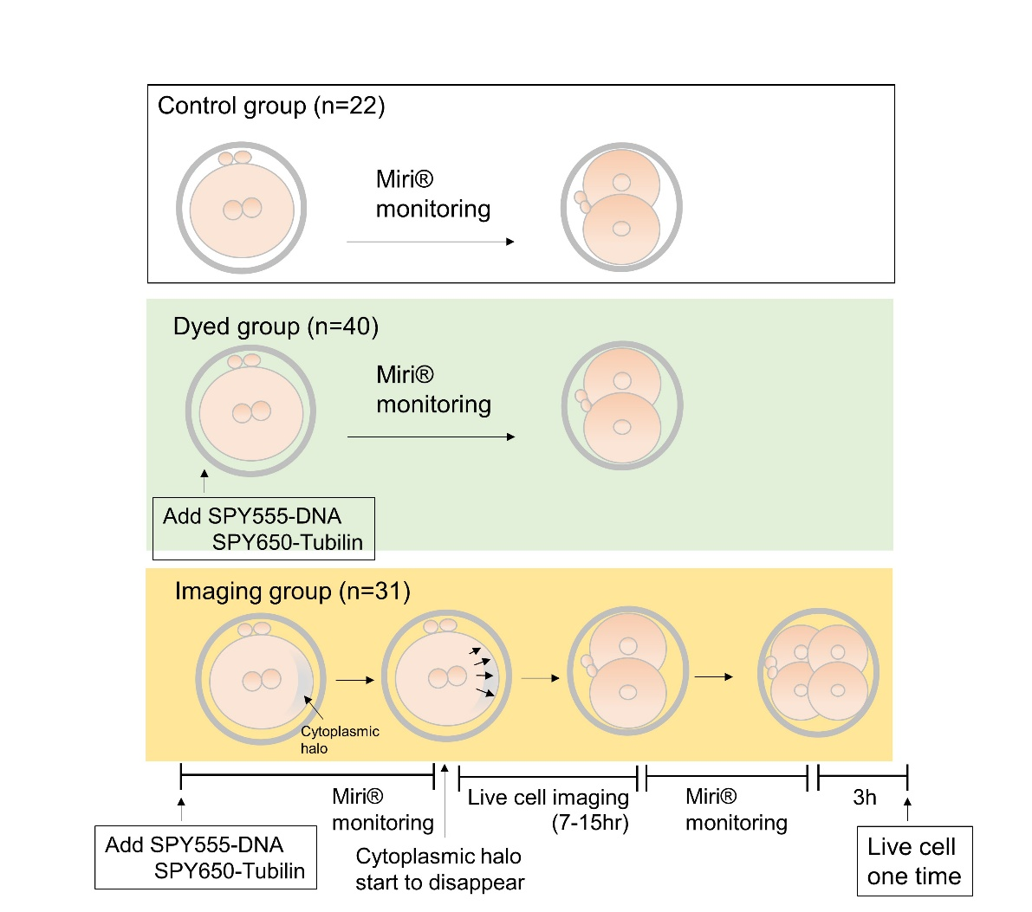
Supplementary Figure 1. Embryos used in this study. Schematic outlining steps for embryos in control, dyed, and imaged groups.

Figure S2
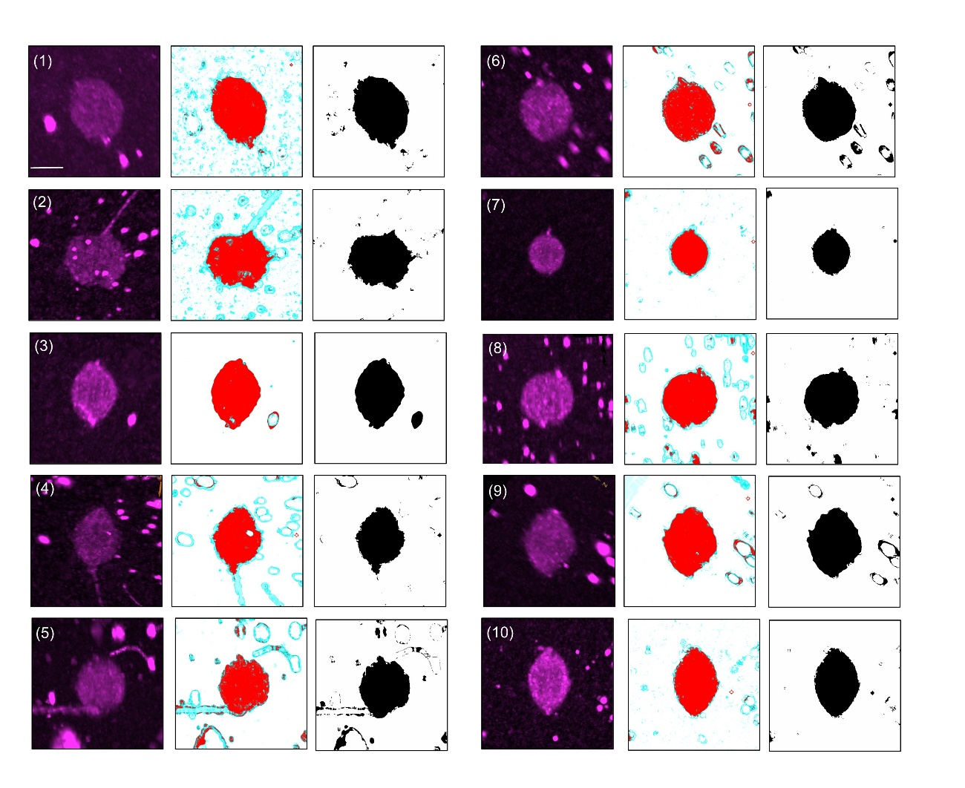Supplementary Figures 2. Spindle images for embryos 1 – 10 analyzed in this study.
The numbers in the images represent the embryo numbers, which correspond to Supplementary Table 1. The image at the end of metaphase from an angle shows chromosomes aligned linearly and where the spindle appears to have the maximum area (left). Image processing using Ilastik. The objects were classified using an image recognition algorithm, and the shape of the spindle was extracted as a red area. The background and parts of the sperm tail were excluded as they were blue (middle). The binarized image (middle) was created by extracting only the red area (right). Scale bar: 10 µm

Figure S3
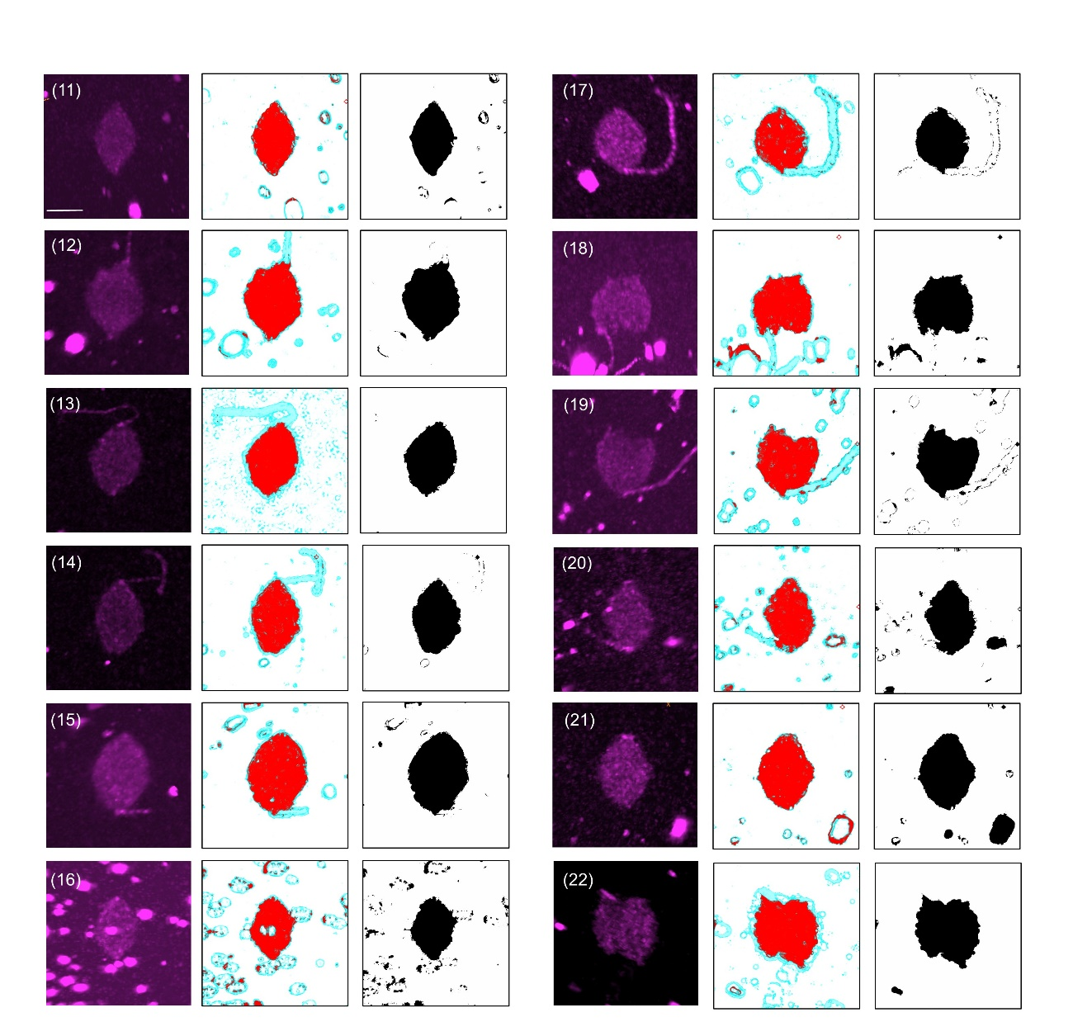
Supplementary Figures 3 Spindle images for embryos 11 – 22 analyzed in this study.
The numbers in the images represent the embryo numbers, which correspond to Supplementary Table 1. The image at the end of metaphase from an angle shows chromosomes aligned linearly and where the spindle appears to have the maximum area (left). Image processing using Ilastik. The objects were classified using an image recognition algorithm, and the shape of the spindle was extracted as a red area. The background and parts of the sperm tail were excluded as they were blue (middle). The binarized image (middle) was created by extracting only the red area (right). Scale bar: 10 µm

Figure S4
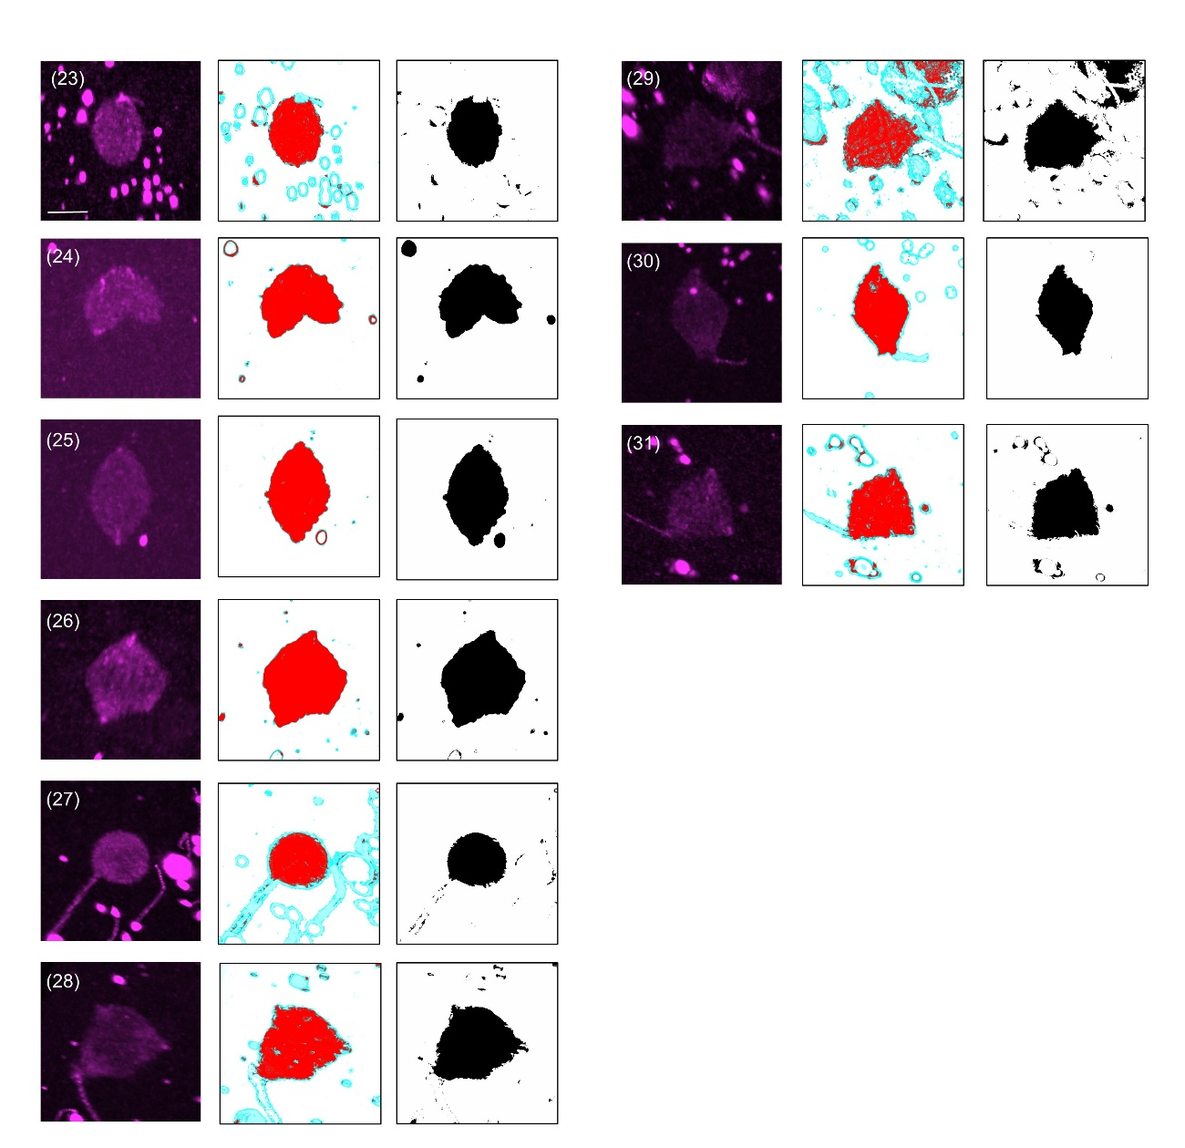
Supplementary Figures 4 Spindle images for embryos 23-32 analyzed in this study. The numbers in the images represent the embryo numbers, which correspond to Supplementary Table 1. The image at the end of metaphase from an angle shows chromosomes aligned linearly and where the spindle appears to have the maximum area (left). Image processing using Ilastik. The objects were classified using an image recognition algorithm, and the shape of the spindle was extracted as a red area. The background and parts of the sperm tail were excluded as they were blue (middle). The binarized image (middle) was created by extracting only the red area (right). Scale bar: 10 µm

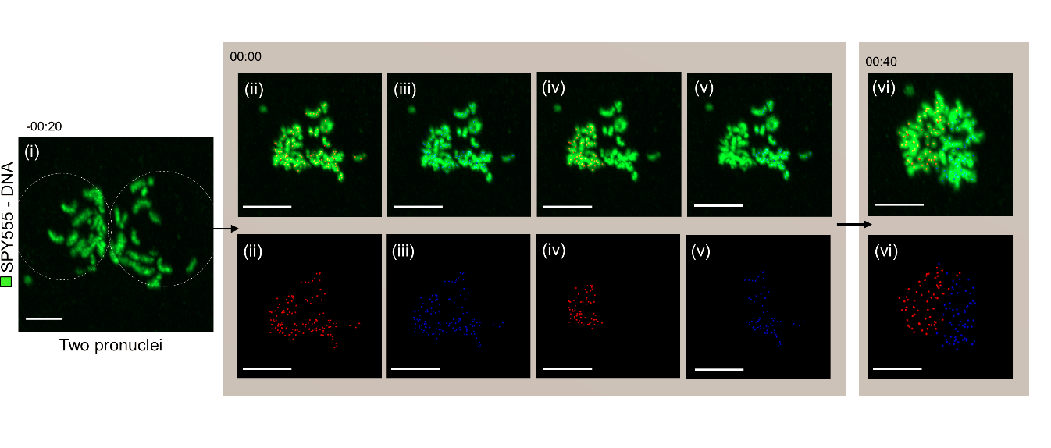
Supplementary Figure 5. Representative images of the chromosomes tracked from prometaphase to anaphase.
(ii) Red spheres were marked on all the chromosomes derived from pronuclei. (iii) Blue spheres were marked on all the chromosomes. (iv) and (v) The red spheres on chromosomes derived from one side of the pronucleus were deleted. Similarly, blue spheres were deleted. (vi) The rest of the red and blue spheres were merged and were tracked until anaphase began. Scale bar: 10 µm
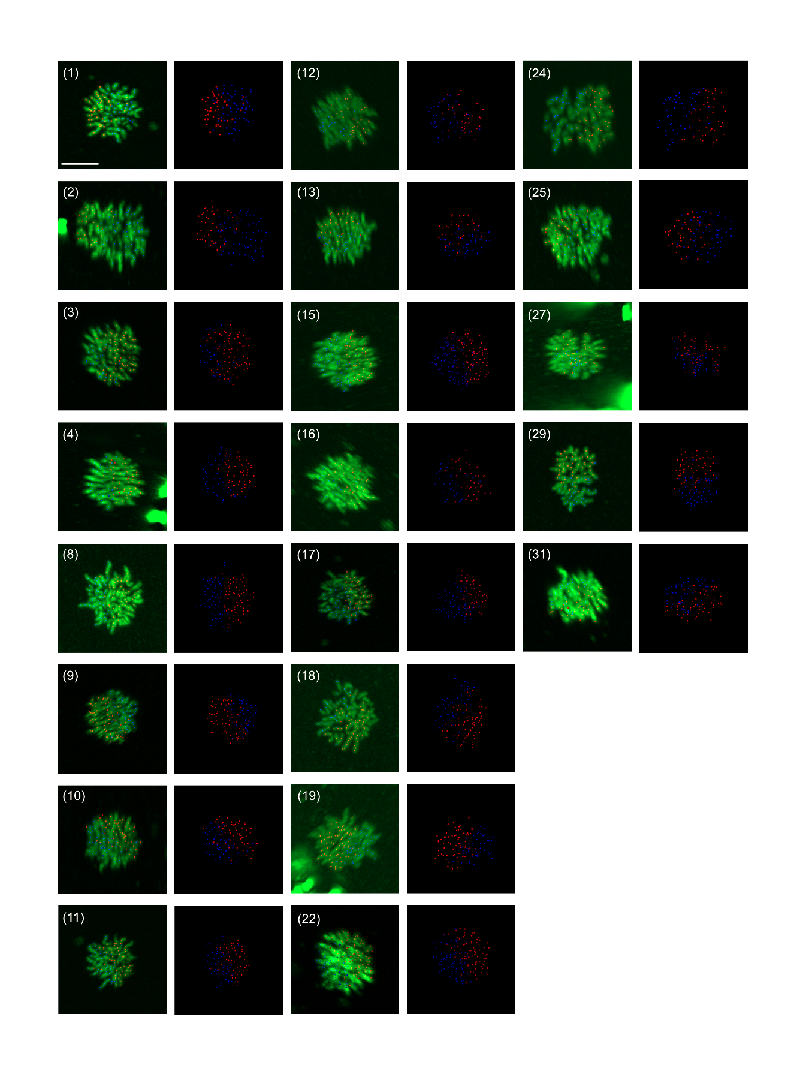
Supplementary Figure 6. All images of chromosomal tracking
All images of the spheres on chromosomes arraying at the end of metaphase (left), spheres only (right) (n =21). All images were captured from the angle where the chromosomes appear to have the maximum area. All the spheres were tracked from PNBD to anaphase. Scale bar: 10 µm

Supplementary Table 1. All embryos were imaged during the first mitosis, segregation status, aspect ratio of the spindle, spindle status, and nucleation status.

