Supplementary Figures & Tables
Fig. S1
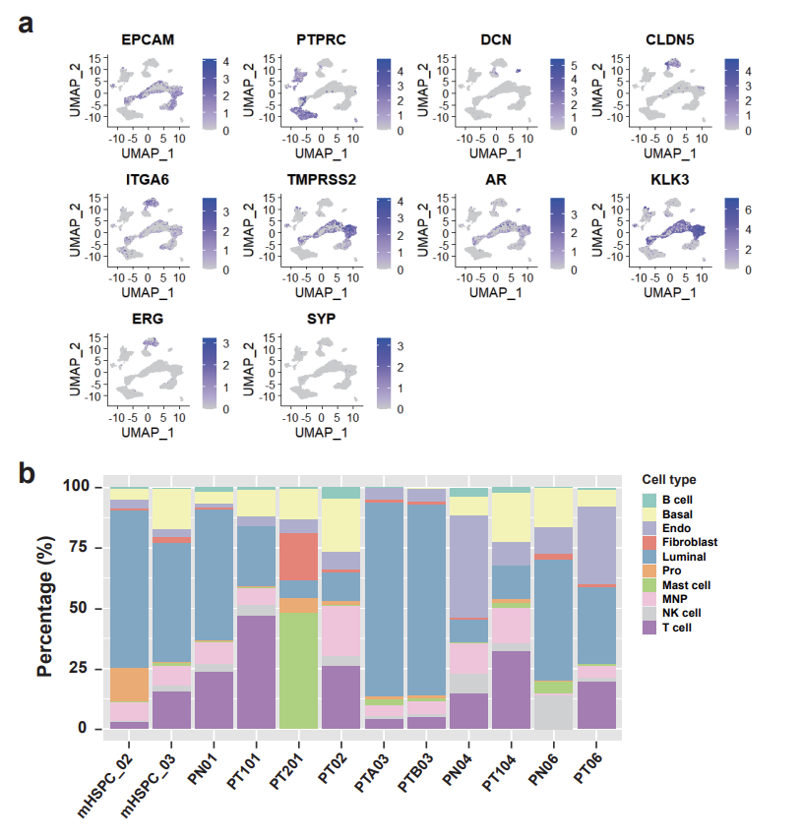
Fig. S1. Overall landscape of single-cell RNA-sequencing (scRNA-seq). (a) Cell type feature plots measured by lineage markers. Color represents expression level, from no expression (gray) to high level expression (dark blue). (EPCAM, Epithelial; PTPRC, Immune; DCN, Fibroblast; CLDN5, Endothelial; SYP, Neuroendocrine; ITGA6, Basal; TMPRSS2, Luminal; AR, AR-high; KLK3, PSA-high, ERG, ETS-fusion). (b) Percentage of cell types according to the corresponding patient origins.

Fig. S2
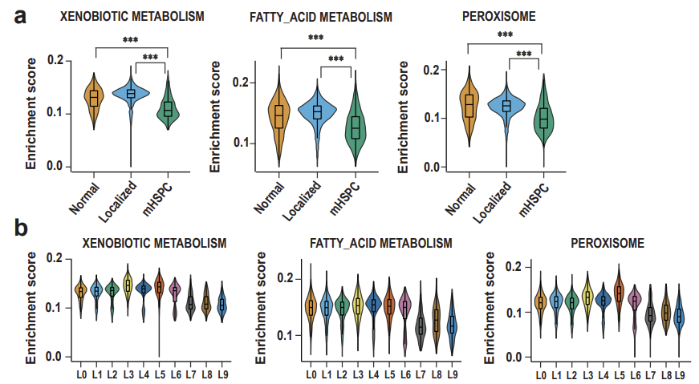
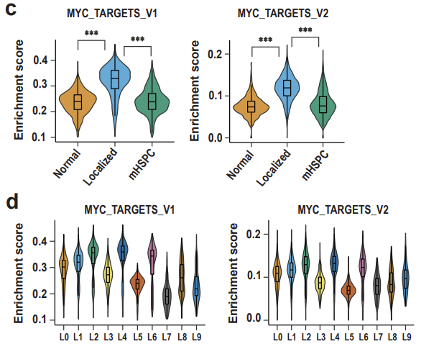
Fig. S2. Single-sample gene set enrichment analysis (ssGSEA) for luminal cell subclusters using Hallmark gene sets.
(a, b) Violin plots showing the ssGSEA of metabolism related gene sets including xenobiotic, fatty acid, and peroxisome by (a) tissue type and (b) by luminal subclusters. (c, d) Violin plots showing the ssGSEA of myc related gene sets including myc targets v1 and v2 by (c) tissue type and (d) luminal subclusters. (p-value for violin plots is calculated by student t-test for two groups; *** p <1ⅹ10⁻⁴).

Fig. S3
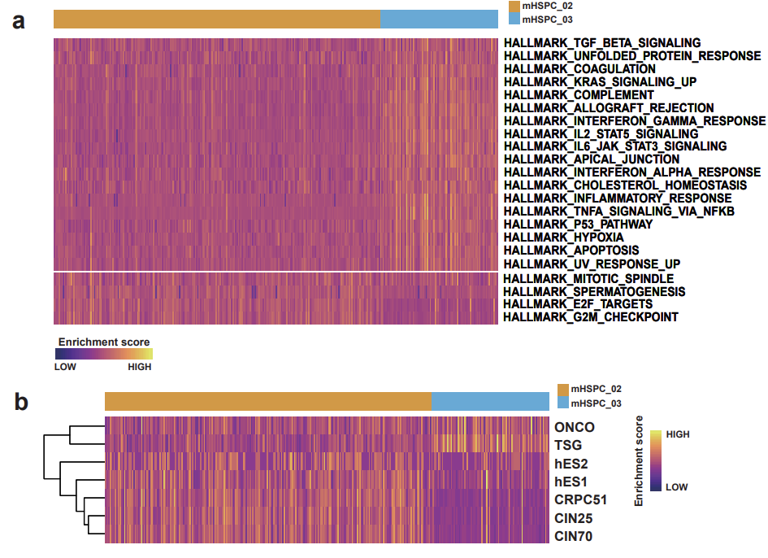
Fig. S3. Gene set enrichment test between mHSPC_02 and mHSPC_03.
(a) Heatmap of the single-sample gene set enrichment analysis (ssGSEA) showing the enrichment scores of HALLMARK gene sets. (b) Heatmap of the ssGSEA showing the enrichment scores of aggressive related gene sets including ONCO, TSG, CIN25, CIN70, ES1, ES2, and CRPC51. (ONCO, oncogene; TSG, tumor suppressor gene; CIN25 and CIN70, chromosome instability; hES1 and hES2, human embryonic stem cell; CRPC51, pre-existing CRPC-like cells).

Fig. S4
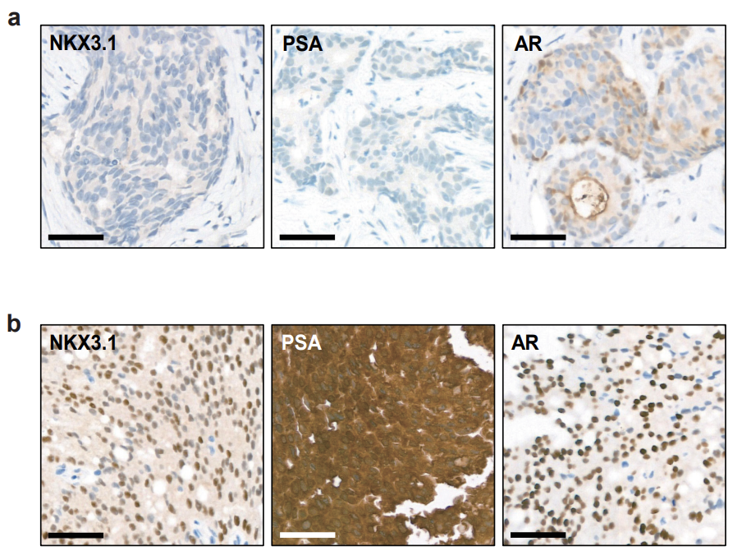
Fig. S4. Immunohistochemistry for NKX3.1, prostate-specific antigen (PSA), and androgen receptor (AR).
Immunohistochemistry images for (a) NKX3.1, PSA, and AR in mHSPC_02, and (b) NKX3.1, PSA, and AR in mHSPC_03 tissues (scale bar = 50 μm).

Fig. S5
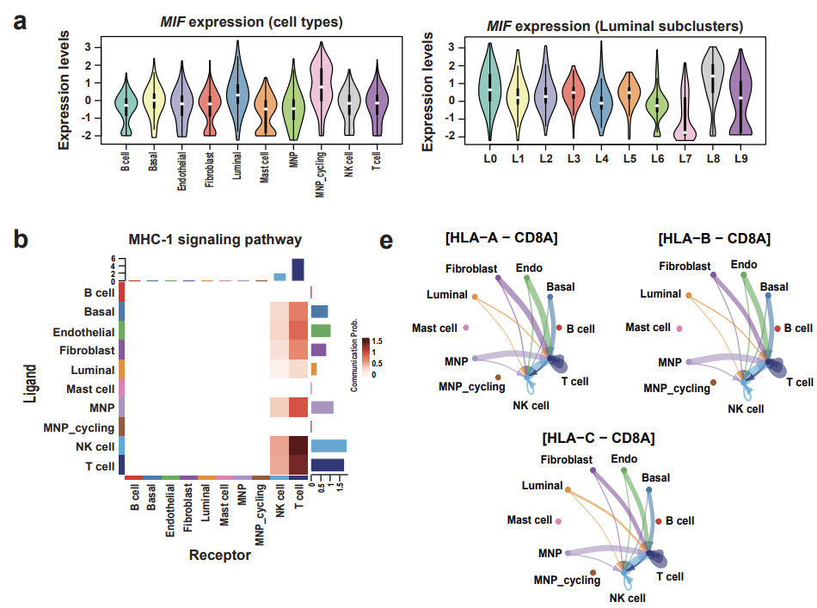
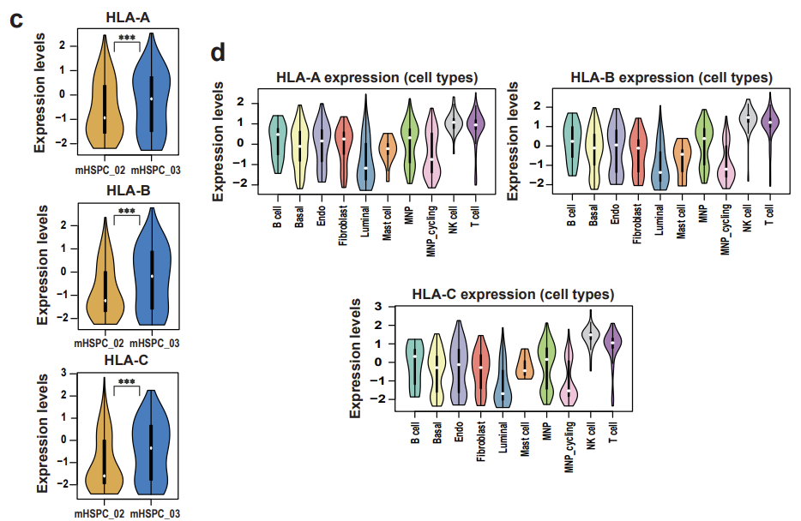
Fig. S5. Cell-cell interaction between mHSPC_02 and mHSPC_03. (a) Violin plots showing expression levels of macrophage migration inhibitory factor (MIF) gene by cell types (left) and by luminal subclusters (right). (b) Heatmap plot displaying the communication (ligand-receptor) probability of MHC-1 signaling pathway in cell type clusters in mHSPC_03. (c) Violin plot showing the expression levels of MHC class 1 genes including HLA-A, HLA-B, and HLA-C between mHSPC_02 and mHSPC_03 (p-value for violin plots is calculated by student t-test for two groups; *** p <1ⅹ10⁻⁴). (d) Violin plot showing the expression levels of MHC class 1 genes including HLA-A, HLA-B, and HLA-C by cell types. (e) Circle plots showing the numbers and strengths of interactions in HLA-A-CD8, HLA-B-CD8 (top) and HLA-C-CD8 (bottom) (the round loops along with cell type represent the interactions within the same cell type).

Fig. S6
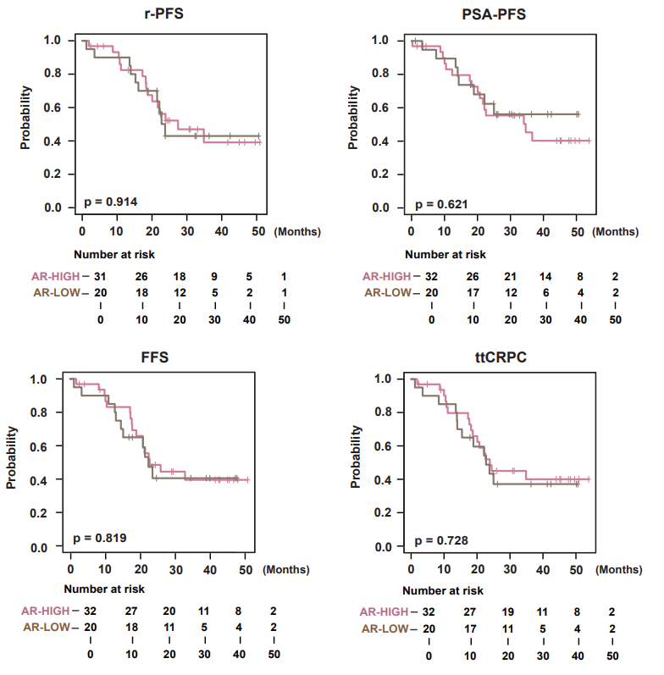
Fig. S6. Survival analysis of androgen receptor (AR) subtypes.
Kaplan–Meier plots showing r-PFS, PSA-PFS, FFS, and ttCRPC between the AR-HIGH and AR-LOW groups stratified by above- or below-average ssGSEA of the AR signature (r-PFS, radiographic-progression-free survival; PSA-PFS, prostate-specific antigen-progression-free survival; FFS, failure-free survival; ttCRPC, time-to-castration-resistant prostate cancer).

Fig. S7
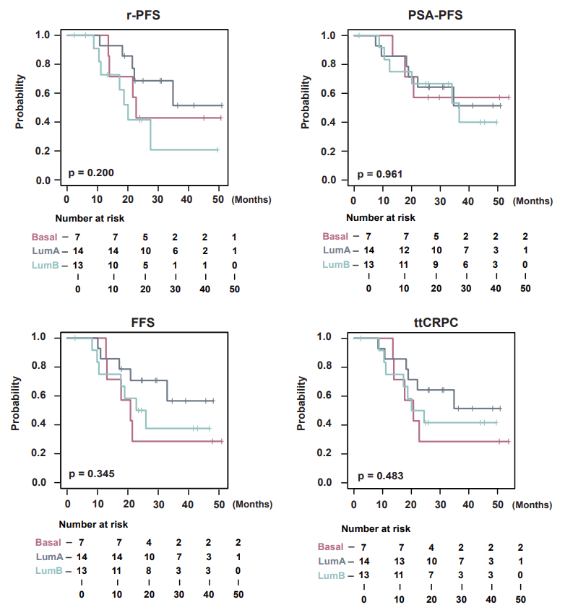 Fig. S7. Survival analysis of PAM50 subtypes.
Kaplan–Meier plots showing r-PFS, PSA-PFS, FFS, and ttCRPC based on the PAM50 subtypes, including luminal A, luminal B, and basal. (LumA, luminal A; LumB, luminal B; r-PFS, radiographic-progression-free survival; PSA-PFS, prostate-specific antigen-progression-free survival; FFS, failure-free survival; ttCRPC, time to castration-resistant prostate cancer).

Fig. S8
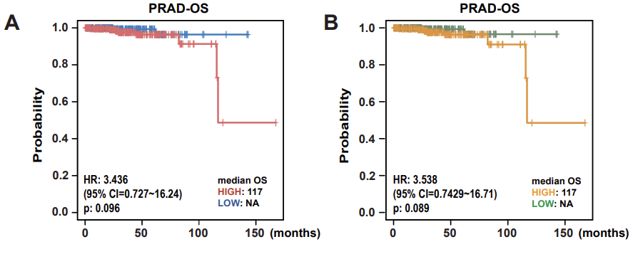
a
b
Fig. S8. Survival analysis of 87 network genes and 14-gene signature. (a) Kaplan–Meier plot showing overall survival (OS) between the patients group stratified by above or below the average ssGSEA of the 87 network genes in TCGA-PRAD. (b) Kaplan–Meier plot showing overall survivals (OS) between the patients group stratified by above or below the average ssGSEA of the 14-gene signature in TCGA-PRAD.

Fig. S9
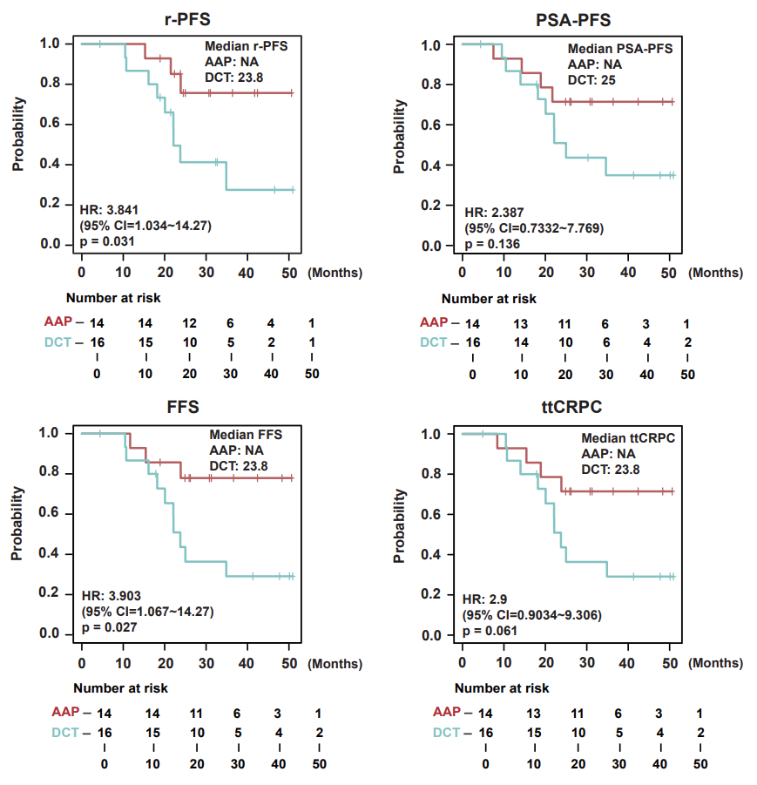
Fig. S9. Survival analysis of treatment arms in low subtype of the 14-gene signature. Kaplan–Meier plots show r-PFS, PSA-PFS, FFS and ttCRPC between AAP and DCT in the low-expression group of the 14-gene signature (r-PFS, radiographic-progression free survival; PSA-PFS, prostate specific antigen-progression free survival; FFS, failure free survival; ttCRPC, time to castration resistant prostate cancer; DCT, docetaxel; AAP, abiraterone acetate).

Fig. S10
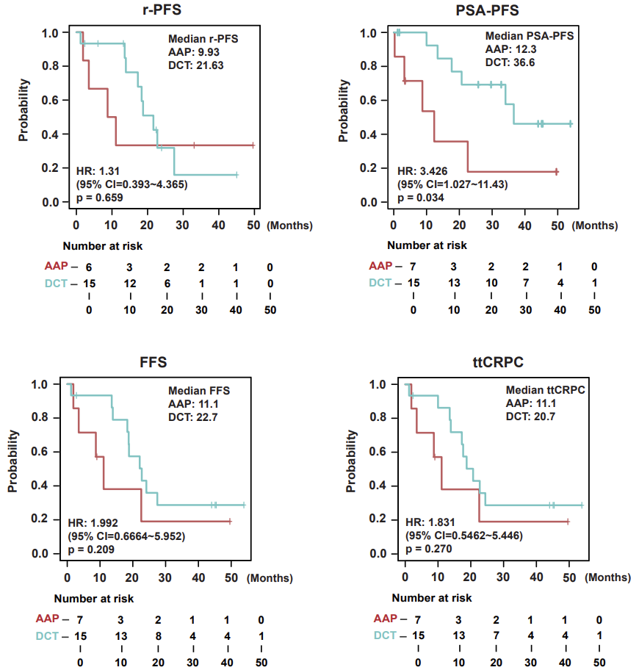
Fig. S10. Survival analysis of treatment arms in high subtype of a 14-gene signature. Kaplan–Meier plots show r-PFS, PSA-PFS, FFS and ttCRPC between AAP and DCT in high-expression group of the 14-gene signature (r-PFS, radiographic-progression free survival; PSA-PFS, Prostate Specific Antigen-Progression Free Survival; FFS, failure free survival; ttCRPC, time to castration resistant prostate cancer; DCT, docetaxel; AAP, abiraterone acetate and prednisone).

Table S1. The number of samples using scRNA-sequencing
# of sample | Sample ID | Sample name | Tissue type | Surgical procedure
1 | Pca_01 | Pca_01_N | Normal | radical prostatectomy
1 | Pca_01 | Pca_01_T1 | Localized tumor | radical prostatectomy
1 | Pca_01 | Pca_01_T2 | Localized tumor | radical prostatectomy
2 | Pca_02 | Pca_02_T | Localized tumor | radical prostatectomy
3 | Pca_03 | Pca_03_TA | Localized tumor | radical prostatectomy
3 | Pca_03 | Pca_03_TB | Localized tumor | radical prostatectomy
4 | Pca_04 | Pca_04_N | Normal | radical prostatectomy
4 | Pca_04 | Pca_04_T1 | Localized tumor | radical prostatectomy
5 | Pca_06 | Pca_06_N | Normal | radical prostatectomy
5 | Pca_06 | Pca_06_T | Localized tumor | radical prostatectomy
6 | mHSPC_02 | mHSPC_02 | mHSPC | Needle biopsy
7 | mHSPC_03 | mHSPC_03 | mHSPC | Needle biopsy

Table S2. Gene ontology of differentially up-regulated genes in cluster 12
Annotation Cluster 1 | Enrichment Score: 14.143973089504485
Category | Term | PValue | FDR
GOTERM_BP_FAT | GO:0022402~cell cycle process | 9.81E-34 | 1.16E-30
GOTERM_BP_FAT | GO:0007049~cell cycle | 2.43E-33 | 1.43E-30
GOTERM_BP_FAT | GO:1903047~mitotic cell cycle process | 5.26E-32 | 2.07E-29
GOTERM_BP_FAT | GO:0000278~mitotic cell cycle | 3.42E-31 | 1.01E-28
GOTERM_BP_FAT | GO:0051301~cell division | 4.45E-28 | 1.05E-25
GOTERM_BP_FAT | GO:0000280~nuclear division | 3.66E-27 | 7.20E-25
GOTERM_BP_FAT | GO:0048285~organelle fission | 2.97E-26 | 5.00E-24
GOTERM_BP_FAT | GO:0000819~sister chromatid segregation | 1.74E-24 | 2.57E-22
GOTERM_BP_FAT | GO:0007059~chromosome segregation | 8.27E-24 | 9.73E-22
GOTERM_BP_FAT | GO:0000070~mitotic sister chromatid segregation | 8.45E-24 | 9.73E-22
GOTERM_BP_FAT | GO:0098813~nuclear chromosome segregation | 9.07E-24 | 9.73E-22
GOTERM_BP_FAT | GO:0007067~mitotic nuclear division | 3.89E-23 | 3.82E-21
GOTERM_BP_FAT | GO:0051726~regulation of cell cycle | 3.81E-22 | 3.45E-20
GOTERM_BP_FAT | GO:0044772~mitotic cell cycle phase transition | 9.61E-19 | 8.09E-17
GOTERM_BP_FAT | GO:0051983~regulation of chromosome segregation | 1.33E-18 | 1.04E-16
GOTERM_BP_FAT | GO:0010564~regulation of cell cycle process | 3.07E-18 | 2.26E-16
GOTERM_BP_FAT | GO:0007088~regulation of mitotic nuclear division | 4.75E-18 | 3.30E-16
GOTERM_BP_FAT | GO:0051304~chromosome separation | 7.54E-18 | 4.94E-16
GOTERM_BP_FAT | GO:0044770~cell cycle phase transition | 8.18E-18 | 5.07E-16
GOTERM_BP_FAT | GO:0051783~regulation of nuclear division | 3.37E-17 | 1.89E-15
GOTERM_BP_FAT | GO:0007346~regulation of mitotic cell cycle | 3.92E-17 | 2.10E-15
GOTERM_BP_FAT | GO:1905818~regulation of chromosome separation | 4.43E-17 | 2.27E-15
GOTERM_BP_FAT | GO:0051276~chromosome organization | 4.77E-17 | 2.34E-15
GOTERM_BP_FAT | GO:0030071~regulation of mitotic metaphase/anaphase transition | 1.87E-14 | 7.36E-13
GOTERM_BP_FAT | GO:1902099~regulation of metaphase/anaphase transition of cell cycle | 2.61E-14 | 9.93E-13
GOTERM_BP_FAT | GO:0007091~metaphase/anaphase transition of mitotic cell cycle | 3.40E-14 | 1.24E-12
GOTERM_BP_FAT | GO:0044784~metaphase/anaphase transition of cell cycle | 3.58E-14 | 1.24E-12
GOTERM_BP_FAT | GO:0010965~regulation of mitotic sister chromatid separation | 3.58E-14 | 1.24E-12
GOTERM_BP_FAT | GO:0051306~mitotic sister chromatid separation | 4.87E-14 | 1.64E-12
GOTERM_BP_FAT | GO:0007094~mitotic spindle assembly checkpoint | 6.05E-14 | 1.93E-12
GOTERM_BP_FAT | GO:0071173~spindle assembly checkpoint | 6.05E-14 | 1.93E-12
GOTERM_BP_FAT | GO:0033047~regulation of mitotic sister chromatid segregation | 1.52E-13 | 4.73E-12
GOTERM_BP_FAT | GO:0071174~mitotic spindle checkpoint | 1.97E-13 | 5.95E-12
GOTERM_BP_FAT | GO:0031577~spindle checkpoint | 2.36E-13 | 6.95E-12
Annotation Cluster 2 | Enrichment Score: 11.838570325667956
Category | Term | PValue | FDR
GOTERM_BP_FAT | GO:0007067~mitotic nuclear division | 3.89E-23 | 3.82E-21
GOTERM_BP_FAT | GO:0007051~spindle organization | 2.85E-17 | 1.68E-15
GOTERM_BP_FAT | GO:0007052~mitotic spindle organization | 1.03E-16 | 4.84E-15
GOTERM_BP_FAT | GO:1902850~microtubule cytoskeleton organization involved in mitosis | 1.13E-16 | 5.15E-15
GOTERM_BP_FAT | GO:0000226~microtubule cytoskeleton organization | 1.69E-16 | 7.40E-15
GOTERM_BP_FAT | GO:0051225~spindle assembly | 2.47E-16 | 1.04E-14
GOTERM_BP_FAT | GO:0007017~microtubule-based process | 3.09E-15 | 1.26E-13
GOTERM_BP_FAT | GO:0090307~mitotic spindle assembly | 4.67E-13 | 1.22E-11
GOTERM_BP_FAT | GO:0007010~cytoskeleton organization | 1.03E-10 | 1.99E-09
GOTERM_BP_FAT | GO:0070925~organelle assembly | 2.92E-10 | 5.38E-09
GOTERM_BP_FAT | GO:0022607~cellular component assembly | 3.53E-07 | 4.79E-06
GOTERM_BP_FAT | GO:0044085~cellular component biogenesis | 1.65E-06 | 2.10E-05
GOTERM_BP_FAT | GO:0051649~establishment of localization in cell | 0.002565 | 0.02115
GOTERM_BP_FAT | GO:0051641~cellular localization | 0.005185 | 0.039442
Annotation Cluster 3 | Enrichment Score: 6.049484458409801
Category | Term | PValue | FDR
GOTERM_BP_FAT | GO:0030261~chromosome condensation | 1.22E-07 | 1.80E-06
GOTERM_BP_FAT | GO:0006323~DNA packaging | 1.92E-07 | 2.70E-06
GOTERM_BP_FAT | GO:0071103~DNA conformation change | 1.79E-06 | 2.22E-05
GOTERM_BP_FAT | GO:0007076~mitotic chromosome condensation | 1.51E-05 | 1.69E-04
Annotation Cluster 4 | Enrichment Score: 5.020942445688807
Category | Term | PValue | FDR
GOTERM_BP_FAT | GO:0051303~establishment of chromosome localization | 1.38E-09 | 2.37E-08
GOTERM_BP_FAT | GO:0050000~chromosome localization | 1.63E-09 | 2.75E-08
GOTERM_BP_FAT | GO:0051310~metaphase plate congression | 1.48E-08 | 2.40E-07
GOTERM_BP_FAT | GO:0008608~attachment of spindle microtubules to kinetochore | 2.48E-08 | 3.90E-07
GOTERM_BP_FAT | GO:0051315~attachment of mitotic spindle microtubules to kinetochore | 1.81E-07 | 2.57E-06
GOTERM_BP_FAT | GO:0007080~mitotic metaphase plate congression | 2.65E-07 | 3.68E-06
GOTERM_BP_FAT | GO:0045931~positive regulation of mitotic cell cycle | 3.42E-07 | 4.69E-06
GOTERM_BP_FAT | GO:0051656~establishment of organelle localization | 9.66E-07 | 1.24E-05
GOTERM_BP_FAT | GO:0090232~positive regulation of spindle checkpoint | 3.79E-04 | 0.003574
GOTERM_BP_FAT | GO:0090267~positive regulation of mitotic cell cycle spindle assembly checkpoint | 3.79E-04 | 0.003574
GOTERM_BP_FAT | GO:1901978~positive regulation of cell cycle checkpoint | 9.71E-04 | 0.008807
GOTERM_BP_FAT | GO:0090231~regulation of spindle checkpoint | 0.001189 | 0.010382
GOTERM_BP_FAT | GO:0090266~regulation of mitotic cell cycle spindle assembly checkpoint | 0.001189 | 0.010382
GOTERM_BP_FAT | GO:1903504~regulation of mitotic spindle checkpoint | 0.001189 | 0.010382
Table S3. Gene ontology and KEGG pathways of differentially up-regulated genes in L4 luminal subcluster.
Annotation Cluster 1 | Enrichment Score: 7.743699922967772
Category | Term | Count | FDR
GOTERM_BP_FAT | GO:0006986~response to unfolded protein | 16 | 3.85E-12
GOTERM_BP_FAT | GO:0035966~response to topologically incorrect protein | 16 | 1.68E-11
GOTERM_BP_FAT | GO:0042026~protein refolding | 8 | 7.32E-08
GOTERM_BP_FAT | GO:0006457~protein folding | 14 | 3.51E-07
GOTERM_BP_FAT | GO:0006458~'de novo' protein folding | 8 | 1.26E-06
GOTERM_BP_FAT | GO:0009266~response to temperature stimulus | 12 | 1.44E-06
GOTERM_BP_FAT | GO:0061077~chaperone-mediated protein folding | 9 | 2.62E-06
GOTERM_BP_FAT | GO:0051085~chaperone mediated protein folding requiring cofactor | 7 | 4.57E-06
GOTERM_BP_FAT | GO:0051084~'de novo' posttranslational protein folding | 7 | 7.29E-06
GOTERM_BP_FAT | GO:0009408~response to heat | 9 | 1.02E-05
GOTERM_BP_FAT | GO:0009628~response to abiotic stimulus | 23 | 3.63E-05
GOTERM_BP_FAT | GO:0034605~cellular response to heat | 7 | 4.29E-05
GOTERM_BP_FAT | GO:0070841~inclusion body assembly | 4 | 0.004780847
GOTERM_BP_FAT | GO:0090084~negative regulation of inclusion body assembly | 3 | 0.01910455
GOTERM_BP_FAT | GO:0090083~regulation of inclusion body assembly | 3 | 0.038156638
Annotation Cluster 2 | Enrichment Score: 7.691520033472464
Category | Term | Count | FDR
GOTERM_BP_FAT | GO:0010033~response to organic substance | 48 | 2.16E-08
GOTERM_BP_FAT | GO:0070887~cellular response to chemical stimulus | 43 | 2.62E-06
GOTERM_BP_FAT | GO:0071310~cellular response to organic substance | 36 | 1.17E-05
GOTERM_BP_FAT | GO:0009719~response to endogenous stimulus | 26 | 2.83E-04
Annotation Cluster 3 | Enrichment Score: 6.451415054171942
Category | Term | Count | FDR
GOTERM_BP_FAT | GO:0010941~regulation of cell death | 33 | 3.51E-07
GOTERM_BP_FAT | GO:0097190~apoptotic signaling pathway | 19 | 2.62E-06
GOTERM_BP_FAT | GO:0097193~intrinsic apoptotic signaling pathway | 14 | 4.47E-06
GOTERM_BP_FAT | GO:0042981~regulation of apoptotic process | 29 | 4.57E-06
GOTERM_BP_FAT | GO:0043067~regulation of programmed cell death | 29 | 6.16E-06
GOTERM_BP_FAT | GO:0008219~cell death | 34 | 7.21E-06
GOTERM_BP_FAT | GO:0006915~apoptotic process | 31 | 1.02E-05
GOTERM_BP_FAT | GO:2001233~regulation of apoptotic signaling pathway | 15 | 1.02E-05
GOTERM_BP_FAT | GO:0010942~positive regulation of cell death | 18 | 2.65E-05
GOTERM_BP_FAT | GO:0012501~programmed cell death | 31 | 4.29E-05
GOTERM_BP_FAT | GO:2001242~regulation of intrinsic apoptotic signaling pathway | 10 | 6.60E-05
GOTERM_BP_FAT | GO:0033554~cellular response to stress | 30 | 8.78E-05
GOTERM_BP_FAT | GO:0043066~negative regulation of apoptotic process | 19 | 1.87E-04
GOTERM_BP_FAT | GO:0060548~negative regulation of cell death | 20 | 2.22E-04
GOTERM_BP_FAT | GO:0043069~negative regulation of programmed cell death | 19 | 2.47E-04
GOTERM_BP_FAT | GO:0043065~positive regulation of apoptotic process | 15 | 4.03E-04
GOTERM_BP_FAT | GO:0043068~positive regulation of programmed cell death | 15 | 4.55E-04
GOTERM_BP_FAT | GO:0035556~intracellular signal transduction | 33 | 6.66E-04

Category | Term | Count | Genes | FDR
KEGG_PATHWAY | hsa04010: MAPK signaling pathway | 14 | DUSP4, HSPA8, JUN, DUSP2, JUND, DUSP1, HSPA6, HSPB1, FOS, STK4, MYC, STMN1, HSPA1B, HSPA1A | 2.41E-04
KEGG_PATHWAY | hsa04141: Protein processing in endoplasmic reticulum | 11 | DNAJA1, BCAP31, PPP1R15A, HSPA8, DNAJB1, DNAJC1, HSP90AA1, HSPH1, HSPA6, HSPA1B, HSPA1A | 2.41E-04
KEGG_PATHWAY | hsa03010: Ribosome | 9 | RPS14, RPS16, RPS7, RPL18A, RPS19, RPS18, RPS5, RPS6, RPS3 | 0.003137
KEGG_PATHWAY | hsa05208: Chemical carcinogenesis - reactive oxygen species | 10 | MT-ATP6, MT-ND4L, JUN, MT-CO1, MT-CO2, FOS, MT-CO3, PIK3R1, MT-CYB, MT-ND1 | 0.003782
KEGG_PATHWAY | hsa00190: Oxidative phosphorylation | 7 | MT-ATP6, MT-ND4L, MT-CO1, MT-CO2, MT-CO3, MT-CYB, MT-ND1 | 0.020674

Table S4. Clinicopathological characteristics using total metastatic hormone-sensitive prostate cancer (mHSPC)
Variables | Total (N=52)
Age (Median, SD, years) | 67 ± 6.9
PSA (Median, Range, ng/ml) | 376.5 (1.34~4193.78)
ECOG (N, %)
0 | 29 (56)
1-2 | 23 (44)
Gleason score (N, %)
High (≥ 8) | 48 (92)
Low (7) | 3 (6)
Unknown | 1 (2)
Primary Tumor stage (N, %)
cT3 | 26 (50)
cT4 | 24 (46)
Unknown | 2 (4)
Reginal node status (N, %)
N0 | 10 (19)
N+ | 42 (81)
Visceral (N, %)
No | 36 (69)
Yes | 16 (31)
CHAARTED (N, %)
Low volume | 9 (17)
High volume | 43 (83)
LATITUDE (N, %)
Low risk | 8 (15)
High risk | 44 (85)
PAM50 (N, %)
Basal | 7 (14)
LumA | 14 (27)
LumB | 13 (25)
HER2 & Normal | 18 (35)
Treatment modality (N, %)
AAP | 21 (40)
DCT | 31 (60)
PSA, prostate-specific antigen; ECOG, Eastern Cooperative Oncology Group; LumA, luminal A; LumB, luminal B; AAP, abiraterone acetate and prednisone; DCT, docetaxel; SD, standard deviation.

Table S5. Comparison of clinicopathologic characteristics according to two molecular subtypes (subtypes 1 and 2)
Variables | Subtype 1 (N=29) | Subtype 2 (N=23) | p-value
Age (Median, SD, years) | 67 ± 7.1 | 69 ± 6.6 | 0.264
PSA (Median, Range, ng/ml) | 491 (34.90~4193.78) | 219 (1.34~1443) | 0.238
ECOG (N, %) |  |  | 0.456
0 | 18 (62) | 11 (48) | 0.456
1-2 | 11 (38) | 12 (52) | 0.456
Gleason score (N, %) |  |  | 0.805
High (≥ 8) | 28 (97) | 20 (91) | 0.805
Low (7) | 1 (3) | 2 (9) | 0.805
Unknown | 0 (0) | 0 (3) | 0.805
Primary Tumor stage (N, %) |  |  | 0.415
cT3 | 17 (59) | 9 (39) | 0.415
cT4 | 12 (41) | 12 (52) | 0.415
Unknown | 0 (0) | 2 (7) | 0.415
Reginal node status (N, %) |  |  | 1.000
N0 | 6 (21) | 4 (17) | 1.000
N+ | 23 (79) | 19 (83) | 1.000
Visceral (N, %) |  |  | 0.798
No | 21 (72) | 15 (65) | 0.798
Yes | 8 (28) | 8 (35) | 0.798
CHAARTED Criteria (N, %) |  |  | 0.262
Low volume | 3 (14) | 6 (20) | 0.262
High volume | 19 (86) | 24 (80) | 0.262
LATITUDE Criteria (N, %) |  |  | 0.129
Low risk | 2 (7) | 6 (14) | 0.129
High risk | 27 (93) | 17 (86) | 0.129
PAM50 (N, %) |  |  | 0.001
Basal | 2 (7) | 5 (22) | 0.001
LumA | 13 (38) | 1 (4) | 0.001
LumB | 3 (10) | 10 (44) | 0.001
HER2 & Normal | 11 (45) | 7 (30) | 0.001
Treatment modality (N, %) |  |  | 0.654
AAP | 13 (45) | 8 (35) | 0.654
DCT | 16 (55) | 15 (65) | 0.654
PSA, prostate-specific antigen; ECOG, Eastern Cooperative Oncology Group; LumA, luminal A; LumB, luminal B; AAP, abiraterone acetate and prednisone; DCT, docetaxel; SD, standard deviation.

